5. Report of the Portfolio committee on Home Affairs on the Annual Performance Plans and Budget Vote 5 of the Department of Home Affairs, Dated 9 July 2019

The Portfolio Committee on Home Affairs (the Committee) having met with the Department of Affairs (DHA) the Electoral Commission of South Africa (IEC) and the Government Printing Works (GPW) on their Annual Performance Plans (APPs) and budget for 2019/20 on 2 July 2019, reports as follows:

- The department of Home Affairs

The Vision of the DHA is to ensure a safe, secure South Africa where all its people are proud of, and value, their identity and citizenship. The primary mandate of the DHA is to secure and manage identity and international migration through the delivery of enabling services to all citizens, foreign nationals, government and the private sector.

Policy priorities for 2019/20 and alignment with national, regional, continental and global agendas

In fulfilling its mandate, the DHA contributes to the attainment of the National Development Plan’s (NDP) vision of building a South Africa that is safe and conducive to development. The DHA’s key functions include the issuing of enabling documents such as birth certificates, identity documents, passports, visas and permits; ensuring the secure entry and exit of persons through designated ports of entry; and enforcing immigration legislation. These key functions are closely aligned with Government’s 2014 – 2019 Medium Term Strategic Framework:

- Outcome 3: All people in South Africa are and feel safe;
- Outcome 4: Descent employment through inclusive growth; and
- Outcome 12: An efficient, effective and development-oriented public services.

Whilst the DHA is not listed as a lead department in the Nine Point Plan announced in the 2015 State of the Nation Address, it forms part of the departments that plays a significant role in Operation Phakisa, within the context of ocean economy. The ocean economy creates a platform for all stakeholders in the maritime and marine space to accelerate the growth of the economy by 0.8 per cent in the short term, and 1 per cent in the medium to long term. DHA in this regard is tasked with cross syndicating all issues surrounding human movement within the context of maritime governance, of which Immigration Services are central.

The Southern Africa Development Community (SADC) Protocol on the Facilitation of Movement of Persons was adopted in 2005 to facilitate the free movement of people, encompassing the right to visa-free entry, residence (temporary and permanent), and establishment (income generating activities). The main challenge with the implementation of the Protocol relates to the development of critical enabling conditions, such as compatible immigration policies, laws, systems and accurate population registers. Whilst the Protocol is not in operation as yet, it makes provision for Member States to conclude bilateral agreements for visa exemptions. South Africa has unilaterally or bilaterally adopted visa-free entry for nationals from 11 SADC countries. It also offers special permits to irregular migrants from neighbouring Zimbabwe and Lesotho.

Agenda 2063 is a fifty-year strategy for the African continent that was set in motion following the 50th anniversary of the African Union (AU) in 2013. South Africa contributed to the formulation of Agenda 2063; therefore, the strategy is already aligned with South Africa’s development goals. The aspirations expressed in the strategy are consistent with the mandate of the DHA and South Africa’s International Immigration Policy finalised in 2018. The International Immigration Policy acknowledges at least two resolutions adopted by the Assembly, which set clear parameters for South Africa’s immigration policy, namely, the establishment of a Continental Free Trade Area (CFTA) and a continent-wide visa-free regime, including the issuing of visas on arrival at ports of entry for African citizens. As a result, visa-free entry should be the norm once bilateral return agreements are concluded. In fact, the DHA has been issuing 10-year multiple entry visas to frequent travellers from other African countries. Where visas are still required, entry is easy as possible for bona fide travellers.

In September 2015, the United Nations (UN) member states agreed on a set of 17 Sustainable Development Goals (SDGs), which pays particular attention to the people, planet and prosperity. The SDGs’ central reference to migration is made in target 10.7 to facilitate orderly, safe, regular and responsible migration and mobility of people, including through the implementation of planned and well-managed migration policies. South Africa is regarded as a leader on the African continent for recognising forcibly displaced persons (refugees) within its territory. The South African Constitution, 1996 makes provisions for freedom of movement and the right to choose where to live, work, study and access to social services. These fundamental human rights are also afforded to refugees in the country.

The outcomes translate into three performance and budget programmes, namely Administration, Civic Services and Immigration Services. The core mandate of the DHA are Civic and Immigration Services.

The purpose of Civic Services is to ensure secure, efficient and accessible services and documents for citizens and ensure lawful documents for residents through the execution of the following core functions:
- Management of legislation and records relating to issuance of identity documents; births, marriages and deaths (BMD); passports and travel documents.
- Maintain secure, accurate and accessible systems such as the National Population Register (NPR), National Identity System (NIS) and related data.
- Affirm and regulate official identity, civic status and the acquisition and loss of citizenship.
- Provide access to secure and efficient services through enabling documents.

The core immigration mandate is to:
- Facilitate and regulate the secure movement of people through ports of entry into and out of the Republic of South Africa.
- Confirm and provide documents to foreign visitors legally residing within the Republic of South Africa.
- Enforce immigration legislation and effect deportations.
- Determine the status of asylum seekers and regulate refugee affairs.
- Contribute towards realising a positive migration trends into the Republic that enhances the skills base and support foreign direct investment.

  - DHA Annual Performance Plan for 2019/20 Financial Year
A delegation from the DHA was led and introduced by the newly appointed Minister of Home Affairs and the presentation was made by the Acting Director-General (DG)(Deputy Director General for Immigration).

The Minister made an introduction indicating that the several acting positons in the DHA were outstanding including the DG since August 2018; the Deputy Director General Civic Services since August 2017 and DDG’s of Information Systems and Counter Corruption since late 2014. The appointment of DG and DDG’s was in part due to a moratorium on appointment till after the 2019 elections and the latter two were due to not being able to find suitable candidates and will now be head hunted.
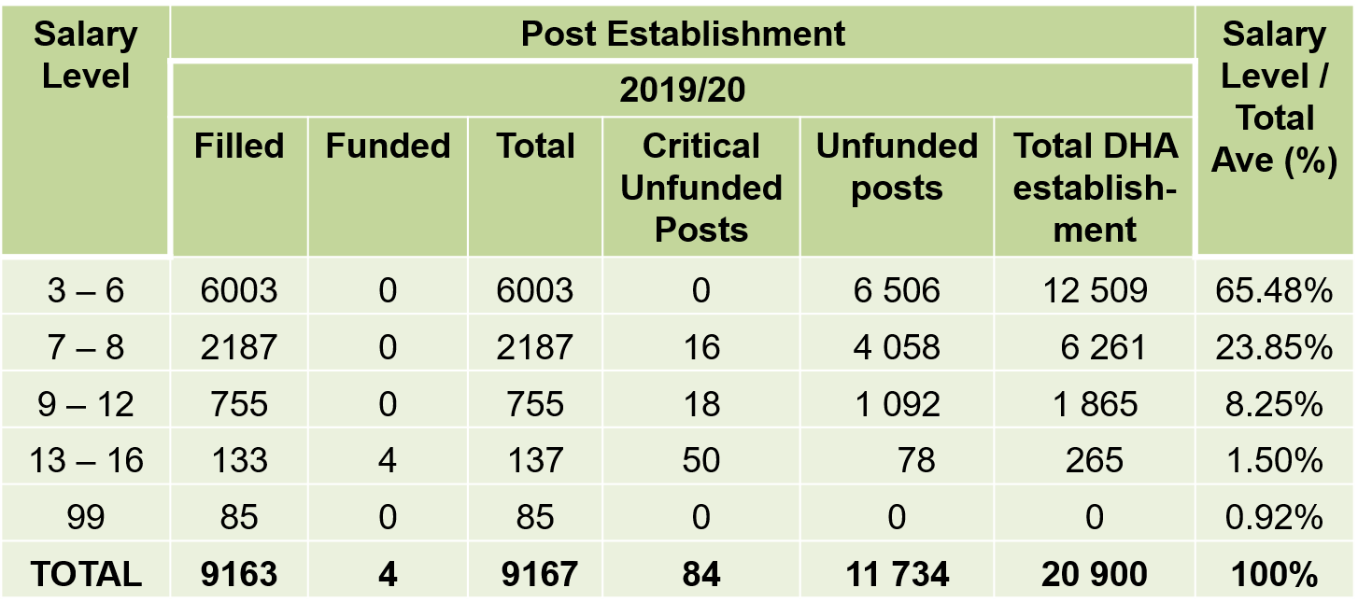
The DG then reported on other vacancies in the DHA as follows:

The DG then gave an overview of the service delivery footprint as follows:

Channel | Quantity
Number of DHA offices (Small, Medium and Large Offices)  - Urban (164)  - Rural (248) | 412
Number of modernised offices (live capture offices)  - Rural (81)  - Urban (112) | 193
Banks hosting DHA service points using an online “e-Home Affairs”  - Gauteng (13)  - Western Cape (1) | 14
Health facilities equipped for birth and death registration  - Urban (203)  - Rural (188) | 391
Designated ports of entry (PoEs) | 72
DHA represented abroad at South African missions | 30
Refugee Reception Centres | 5
Repatriation Centre | 1
Premium visa and permit centres | 4

The DG mentioned that performance had gradually increased since 2013 where only 53% of annual targets were met to 2018 where 86% were met. A decline to 77% achievement against targets in 2019 was recorded but was as yet unaudited. The improvements were attributed to a number of factors:
  - Planning is more outcomes-focused with emphasis on strategic priorities.
  - Cascading of the DHA strategy throughout the organization and increased emphasis on the importance of integrated planning to identify and address key dependencies and risks.
  - Intensified monitoring of progress in achieving targets.
  - Development of clear Planning and monitoring and evaluation guidelines, tools and capacity building.
  - Improved governance practices such as the formation of planning and performance related structures and high level of visibility and accountability for APP targets (e.g. reporting at formal quarterly review meetings, reporting to Parliament, participation of Internal Audit in strategic management process,

The DG reported that the following are the priorities of the DHA for 2014 – 2019 MTSF:
- Establishment of the Border Management Authority (BMA).
- Complete the Modernisation Programme.
- Upgrade key ports of entry (6).
- Comprehensive review of Immigration Policy; and
- Improved client experience through leadership (Moetapele).

The DG reported that the BMA Bill was still with Parliament at the National Council of Provinces (NCOP). The BMA was supposed to be operational by 2017/18. This commitment has not been met. The DHA encourages Parliament to revive the BMA bill in the 6th Parliament.

The DHA presentation included some of the following Critical Challenges and Responses:
- Need for the effective and efficient management of migration and the asylum seeker / refugee environment to embrace global opportunities while safeguarding our sovereignty and ensuring public safety and national security. Current and Planned responses are:
  - New Policy on International Migration developed and amendment of relevant legislation in process;
  - Use of technology as part of the modernisation programme;
  - Use of PPP process for relocation of refugee reception offices closer to the country’s border;
  - Partner and share responsibilities with key stakeholders (“Whole-of-Government” and “Whole-of- Society” approach);
  - Focused attention on law enforcement operations;
  - Use of CARA Funding (R70 million for the procurement of vehicles and equipment to strengthen the inspectorate function; biometric system functionality at ports of entry and record management at refugee reception centres);
  - Significant improvements in the permitting environment in respect of efficiencies and the ease of facilitation of movement of bona fide foreign travellers; and
  - Introduction of special dispensations.
- Lack of an integrated approach to border management and inadequate provision of acceptable port infrastructure. Current and Planned responses are:
  - Establish a Border Management Authority;
  - Redevelopment of 6 major land ports of entry infrastructure / relocation of refugee reception offices closer to the country’s border through the use of public-private partnerships; and
  - Infrastructure development / improvement at selected ports of entry.
- Capacity and resource constraints resulting in poor service delivery in respect of historical under-funding of the DHA and slow footprint and infrastructure growth. Current and Planned responses are:
- Repositioning of the DHA as a modern, secure and professional department, including new funding, operational and organizational models;
- Proposed establishment of a project management capability to drive the repositioning programme;
- Strengthen and expand partnerships (PPP with banks and other organizations) to deal with footprint limitations;
- Initiatives to improve leadership and service delivery such as Moetapele and the “war-on-queues”;
- Continued engagements and requests for additional funding from National Treasury; and
- Rationalisation of offices: Proposal to be developed due to funding and capacity constraints, including cost-benefit analysis running an office, risk assessment of capacity constraints, stakeholder management, working hours, service delivery model.
- Dependency on the Departments of Public Works (DPW) and SITA for timeous service delivery (Lack of DHA purpose-built infrastructure and unreliable networks). Current and Planned responses are:
- Sign Memoranda of Understanding with the Department of Public Works and State Information Technology Agency (SITA); and enter into trilateral agreements with specific service providers.
- Future-fit DHA: Project team set up with DPW to deal with infrastructure issues – current pressing needs and long term plan.
Outcome | MTSF 2014 - 2019 | MTSF 2019-2024(Proposed) | Notes
3: All people in SA are and feel safe | - | National targeting Centre (NTC) operational | DHA Immigration priority driven by the BMA Project office to modernise and streamline admission and enforcement functions.
 | BMA established and operational (2017/18) | BMA operational as per BMA Road Map (Phased approach) | Target is subject to the passing of legislation
 | IBMS fully implemented by 2018/19 | - | Included in DHA Ops Plan for 2019/20.
 | Immigration and Refugees Bills submitted to Parliament by 2018/19 | New legislation implemented (2023/24) | Target rolled over from previous MTSF cycle.  Need to factor in possible financial implications with implementation.
 | 74% or 810 000 of all births captured within 30 days by 2018/19 | 810 000 | Challenges:  Inability to fill posts becoming vacant;  Inability to work extended hours or over weekends; and  Challenges with connectivity at health facilities.
 | National Identity System (NIS) operational (2019/20) | NIS operational | Need to re-scope the NIS based on new developments.
 | 100% of all designated ports of entry equipped with biometric systems capable of processing 100% of travellers (for ports equipped with Electronic Movement Control System) by 2018/19 | 100% of all designated ports of entry equipped with biometric movement control system | Rollover from previous cycle  Full scope biometrics.
4: Decent employment through inclusive economic growth | 85% of critical skills visas adjudicated within 4 weeks for applications processed within the RSA | 85% of critical skills visas adjudicated within 4 weeks for applications processed within the RSA | Achieved in previous cycle.  DHA has a teaming agreement with DTI for the creation of one-stop service centres.
12: An efficient, effective and development oriented public service | Establishment of the DHA Contact Centre (2015/16) | - | Achieved in previous cycle.

The following were reported in terms of progress on Medium Term Strategic Framework Outcomes for 2014 to 2019:

The DHA indicated that the overall targets in the APP for 2019/20 had been reduced from 31 to 26 for the following reasons:
- The Request for Proposal submitted to National Treasury for approval for Refugee Reception Centres) was removed from the APP due to funding constraints. One selected refugee reception centre with improved infrastructure was shifted to Property Management and placed in DHA Ops Plan and thus not allocated as earmarked funding in 2019/20.
- Three selected ports of entry with improved infrastructure were also shifted to Property Management and placed in DHA Operations Plan and thus not allocated as earmarked funding in 19/20.
- Integrated Border Management Strategy (IBMS) was placed in DHA Operations Plan and implementation is underway but with numerous dependencies.
- The Passport indicator experienced a changed formulation due to insertion of parent’s details in child passports and is focus now on adult passports in APP.
- New target added of Official Identity Management Policy to be submitted to Cabinet for approval for public consultation
- Target on networks Architecture Design and Investment Plan was placed in DHA Operations Plan.

The DHA indicated the following 2019/20 annual targets summarised by budget programme/branch:
- Administration Services Targets
- NIS developed in respect of: Request for Proposal published
- Biometric MCS (full biometric solution) piloted at additional 2 ports of entry
- E-gate piloted at 1 port of entry
- E-permit system (phase 1) rolled out to 6 missions
- 500 managers trained in leadership and management development programs
- Vacancy rate maintained at 10% or below
- 70% of reported misconduct cases submitted to a presiding officer for consideration
- Official Identity Management Policy submitted to Cabinet for approval for public consultation
- Final draft of the DHA Bill submitted to Cabinet for approval for public consultation
- Revised DHA Access Model approved by Minister’s Management Meeting
- 20 awareness initiatives on ethics, fraud prevention & counter corruption conducted
- 166% of reported cases on fraud & corruption finalised within 90 working days
- 60 Threat & Risk Assessments conducted
- 416 vetting files referred to SSA
- Communication strategy & action plan implemented – 28 media engagements, 3 campaigns and 6 izimbizo
- Civic Services Target
- Early Birth registration: 810 000 registered within 30 days
- Smart ID cards: 3 million issued to citizens 16 years old and above
- Adult Passports: 90% of new machine readable passports issued within 13 working days.
- Immigration Services and BMA Targets
- Draft Immigration Bill (including amendments to the Refugees Act) submitted to Minister for approval.
- 160 Law enforcement operations/ inspections conducted to ensure compliance with immigration and departmental legislation.
- 85% of permanent residence applications adjudicated within 8 months (selected categories for applications collected within the RSA).
- 90% of business and general work visas adjudicated within 8 weeks (applications processed within the RSA).
- 85% of critical skills visas adjudicated within 4 weeks (applications processed within the RSA).
- National Targeting Centre business case submitted to Minister for approval.
- Draft Request for Proposal (RfP) submitted to National Treasury.
- BMA operational as per BMA Road Map (Phased Approach).

1.2. DHA 2019/20 Budget
The DHA has received a voted allocation of R7.9 billion in 2018/19. This represented a real increase of 10.7 per cent above inflation from R8 4 billion in the 2017/18 financial year. The 2018/19 voted allocation, was subsequently increased to R9.047 billion during the adjusted appropriation in September of the same year.

The DHA programme structure is along the following three main programmes: Administration, Citizen Affairs, and Immigration Affairs. The Citizen Affairs programme the biggest of the three main programmes, constituting 57 percent of the overall departmental expenditure. The DHA’s 2018/19 budget increase, especially the allocation to the Electoral Commission, can be attributed to preparations towards the general elections held in June 2019.

It should be noted that the 2018/19 annual report of the Department, covering the full financial year ending 31 March 2019, will be available at the end of September 2019. Thus, the focus on this analysis is on the financial year performance as at 31 December 2018 (third quarter). The third quarter expenditure report indicates that at the end of December 2018 the DHA had spent R6.37 billion or 70.4 per cent of its R9.047 billion allocated to DHA. This was in line with what was projected for the third quarter – actual expenditure was only 0.2 per cent less that was projected by the Department.

The DHA’s 2018/19 third quarter spending was well on par with its performance in 2017/18 when it managed to spend 70.6 per cent for the same period. The DHA has a solid record of managing its budget well, and spending 100 per cent of its allocated budget by the end of each financial year.

Over the medium term, the DHA will focus on repositioning itself as a modern and secure organisation; improving and expanding client interfaces and service delivery imperatives; establishing and operationalising a border management agency; streamlining and securing international migration; and establishing public private partnership (PPP) in support of key infrastructure projects.

The 2019/20 budget supports the long-standing policy priorities of the DHA. Some of the key highlights of Vote 5 include:
- The modernisation programme of DHA is allocated an estimated amount of R1.8 billion over the medium term.
- Improving and expanding client interface an amount of R2.2 billion over the medium term for issuing of an estimated 11.9 smart Identity (ID) cards.
- To improve and expand client interface, the DHA requires adequate and skilled personnel. Therefore, R7.1 billion is set aside over the medium term for expenditure on compensation of employees.
- The DHA is still planning to establish the Border Management Agency (BMA). The BMA Bill was set to be finalised by 2019/20. However, the BMA Bill lapsed before the Select Committee on Social Services due to contention with National Treasury on the BMA taking over customs payments at border posts. To establish the Agency, amounts of R16 million in 2019/20, R28 million in 2020/21 and R40 million in 2021/22 have been earmarked. These allocations are earmarked for compensation of employees, system development, and various goods and services items.
- The DHA aims to streamline and secure international migration. In this regard, the DHA is introducing an advanced passenger processing system, which would enable passenger screening at the point of departure, instead of arrival. Over the medium term, an estimated R498 million will be spent mainly on service fees for the DHA ‘s use of the system.
- Over the medium term, DHA will continue its infrastructure projects of the redevelopment and modernisation of 6 ports of entry, as well as moving the refugee reception centres closer to the country’s borders. Amounts of R72.1 million in 2019/20, R76.6 million in 2020/21, and R80.4 million in 2021/22 have been allocated for the improvement of residential and office accommodation at ports of entry and refugee reception offices.

Table 1: overall budget of DHA 2019/20
Programme | Budget |  |  |  | Nominal Rand Change | Real Rand Change | Nominal % Change | Real % Change
R Million | 2018/18 | 2019/20 | 2020/21 | 2021/22 | 2018/19 -2019/20 |  | 2018/19-2019/20
- Administration | 2525,1 | 2340,2 | 2490,5 | 2694,5 | -184,9 | -300,6 | -7,32 | -11,9
- Citizen Affairs | 5448,7 | 4736,7 | 4922,4 | 5535,1 | -712 | -946,1 | -13,07 | -17,36
- Immigration Affairs | 1073,6 | 1262,8 | 1330,6 | 1383,1 | 189,2 | 126,8 | 17,62 | 11,81
Total | 9047,4 | 8339,7 | 8743,5 | 9612,7 | -707,7 | -1119,9 | -7,82 | -12,38

1.2.1 Main programme allocations
The DHA plays a crucial role in safeguarding the identity and status of citizens and regulate immigration to ensure security, promote development and fulfil South Africa’s international obligations. However, its budget is relatively small taking into account the growing demand from citizens for DHA services.

The voted budget allocation for the 2019/20 financial year is R8.339 billion. In comparison with the 2018/19 adjusted allocation of R9.047 billion, in Rand value, it shows a nominal decrease of R707.7 million (but when the cost of inflation is taken into consideration, the budget shows a real decrease of R1.119 billion). It should be noted, however, that over the past five years (2014/15 – 2018/19), there has been a trend for the DHA voted allocation to invariably be adjusted upward in the adjusted allocation during September.

Table 1 above, illustrates that, with inflation, the DHA 2019/20 voted budget declines with 12.38 per cent from the adjusted budget the previous year. Of its three main programmes, only the Immigration Affairs programme increases in both nominal and in real terms. In nominal terms (before inflation is taken into account), the Immigration Affairs increases by R189.2 million (17.62 per cent). However, with the inflationary effect (real terms), this increase translates into R126.8 million (11.81 per cent).

The Administration and Citizen Affairs programmes experience decreases in their respective allocations in both nominal and real terms.

1.2.2 Economic classification
About 26.1 per cent of the DHA budget is in the form of transfers and subsidies, totalling R2 .176.2 billion. This is primarily transfers to the Independent Electoral Commission (IEC) (R2.012 billion) and to the Represented Political Parties’ Fund (R157.7 million).

Capital assets (machinery and equipment) constitutes 0.15 per cent of the DHA budget, and totals R12.6 million in 2019/20.
The DHA budget is dominated by current payments, which totals R6.15 billion. This represents 73.75 per cent of the Department’s voted budget, which caters for compensation of employees, as well as goods and services. Compensation increases from R3.3 billion previously, to R3.55 billion in 2019/20. This represents an above inflation increase (real terms) of 2.27 per cent. On the other hand, the DHA’s budget for goods and services declines with 31.1 per cent in real terms. Goods and services decreases to R2.59 billion, from R3.6 billion in 2018/19.

The significant decline in goods and services are directed by amongst others:
- Stationary, printing and office supplies: from R902 million previously to R73.75 million in 2019/20.
- Travel and subsistence: from R499.98 million previously to R83.16 million in 2019/20.
- Property payments: from R397.32 million previously to R181.25 million in 2019/20.
- Operating payments: from R65.96 million previously to R22 million in 2019/20.
- Computer services: from R848 million previously to R696.14 million in 2019/20.

In contrast, the following items increases significantly in 2019/20:
- Minor assets: from R32.7 million previously to R152.48 million in 2019/20.
- Contractors: from R96.4 million previously to R341.87 million in 2019/20.
- Agency and support/ outsourced services: from R40.37 million previously to R120.77 million in 2019/20.
- Fleet services: from R14.48 million previously to R46.77 million in 2019/20.
- Operating leases: from R333.74 million previously to R464.67 million in 2019/20.

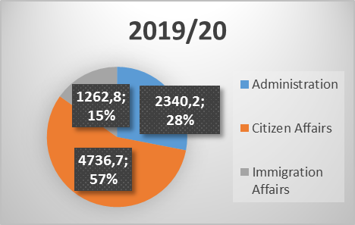
Figure 1: Proportional comparison of three main programmes, 2018/19 and 2019/20
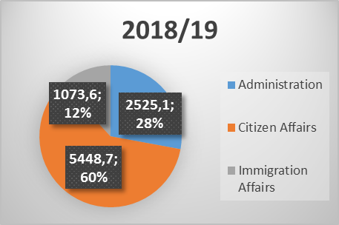
Figure 2 allows comparison of the proportional allocations per main programme between 2018/19 adjusted and 2019/20 voted funds. While Administration retains 28 per cent of the DHA allocation in both years, there is a 3 per cent shift between the Immigration and Citizen functions. In 2019/20, the Immigration programme proportionally increases with 3 per cent, while the Citizen function declines with 3 per cent.

Programme 1 Administration
Figure 2: Administration sub-programme expenditure
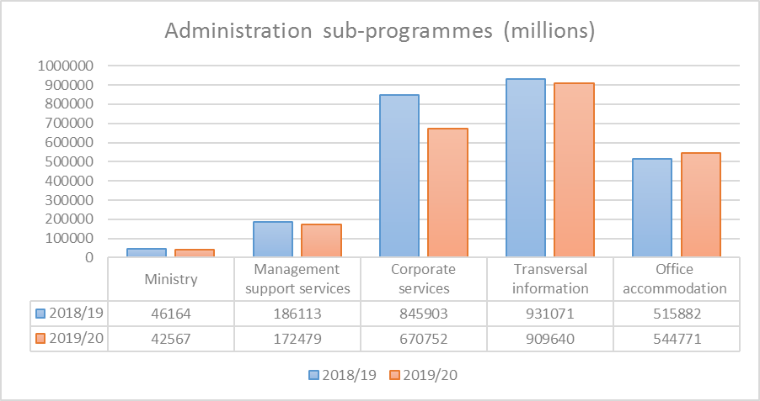
Source: Calculated by Research Unit from National Treasury (2019b)

Taking into account the costs of inflation, the Administration programme decreases by R300.6 million (11.9 per cent). While its adjusted budget was R2.525 billion in 2018/19, it is reduced to R2.34 billion currently.

Of its five sub-programmes, Transversal Information continues to dominate the expenditure, but shows strong decline in expenditure from the previous year. Since 2017/18 financial year, this sub-programme’s budget has been in decline.

The Corporate Services sub-programmes shows strong decline, from R845.9 million in 2018/19, to R670.7 million at present. Office Accommodation continues to grow in both nominal and in real terms. Since 2018/19, it nominally increases with 5.6 per cent.

After inflation, the following real increases/ decreases are recorded per sub-programme:
- Ministry: 12.36 per cent decrease.
- Management Support Services: 11.91 per cent decrease.
- Corporate Services: 24.63 per cent decrease.
- Transversal Information: 7.13 per cent decrease.
- Office Accommodation: 0.38 per cent increase.

Programme 2: Citizen Affairs
Citizen Affairs provides secure, efficient and accessible services and documents to citizens and lawful residents. The budget of this programme is allocated to 6 sub-programmes, namely: Citizen Affairs Management, Status Services, Identification Services, and Service Delivery to Provinces, Electoral Commission, and Represented Political Parties’ Fund.

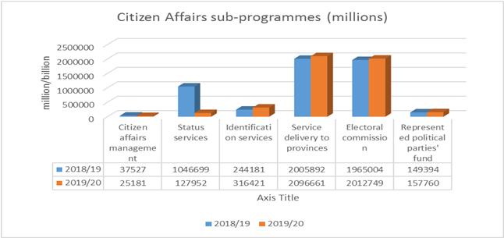
Figure 3: Citizen Affairs sub-programme expenditure
Source: Calculated by Research Unit from National Treasury (2019b)

The Citizen Affairs programme remains the biggest of the three main programmes in the DHA, constituting 57 per cent of the overall departmental expenditure. This programme receives an allocation of R4.736 billion for 2019/20, compared to the allocation of R5.448 billion in 2018/19. This represent a nominal decrease of R711.9 million or 13.1 per cent (before cost of inflation). After cost of inflation, it represents a real decrease of R946.1 million or 17.36 per cent.

The Identification Services sub-programme receives a solid budget increase in both nominal and real terms. The budget share of this sub-programme shows a nominal increase of R72.2 million (or 29.58 per cent). Calculating for inflation, it shows a real increase of R56.5 million (or 23.18 per cent).

As in the previous financial year, the Electoral Commission allocation shows a marginal real increase – for 2019/20, it increases with 0.38 per cent. The increase can be attributed to preparations towards the general elections held in May 2019.

After inflation (calculated at 5.2 percent), the following real increases/ decreases are recorded per sub-programme:
- Citizen Affairs Management: 36.22 per cent decrease
- Status Services: 88.38 per cent decrease
- Identification Services: 23.18 per cent increase
- Service Delivery to Provinces: 0.64 per cent decrease
- Electoral Commission: 2.63 per cent decrease
- Represented Political Parties’ Fund: 0.38 per cent increase

The real decrease recorded for the Service Delivery to Provinces sub-programme may pose a challenge with respect to the DHA priority of maintaining its footprint, which requires adequate and skilled personnel. In addition, functions such as client interface are funded under this sub-programme.

The Status Services sub-programme continues to experiences major decline in its funding – as was the case the previous year. For 2019/20, it declines with 88.38 per cent (real terms), while 2018/19 financial year recorded 88.92 per cent real decline. This sub-programme is tasked with one of the main mandates of the DHA. This include maintaining an accurate register of all citizens and immigrants who have acquired the right to permanent residence; registering births, deaths and marriages; providing travel and citizenship documents; providing financial assistance to citizens abroad who wish to return to South Africa, but have no means of doing so; and determining and granting citizenship.

Programme 3: Immigration Affairs
This programme is responsible for facilitating and regulating the secure movement of people through the ports of entry into and out of South Africa. It is also responsible for determining the status of asylum seekers and regulate refugee affairs. Spending on compensation of employees is the main cost driver in the programme, accounting for an estimated 63.5 percent (R2.5 billion) of its total budget over the medium term.

The Immigration Affairs programme is the smallest of the three main programmes in terms of budgetary size. Unlike in the previous financial year when it experienced a real decrease of 16.62 per cent, the programme grows with 11.8 per cent. In monetary terms, Immigration Affairs increases in real terms with R126.7 million. Its budget allocation grows from R1.073 billion in 2018/19 to R1.262 billion in the current year.

The budget under the programme is shared amongst the 4 sub-programme as outlined in the pie chart below.

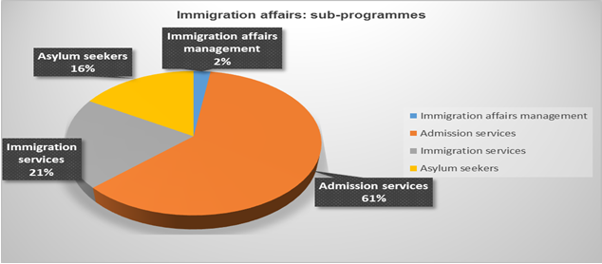
Figure 4: immigration affairs sub-programmes
Figure 4 demonstrates the DHA’s commitment to managing international migration.

The Admission Services sub-programme continues to dominate the budget share of this programme; i.e. 61 per cent. Its allocation in 2019/20 is R768.7 million, up from R609.2 million previously. The sub-programme’s allocation should be viewed in the context of past concerns about the turnaround times for processing of permits and visas. After inflation, the following real increases/ decreases are recorded per sub-programme for 2019/20 financial year:
- Immigration Affairs: 14.65 per cent decline (compared to 4.04 per cent decline in 2018/19).
- Admission Services: 19.95 per cent increase (compared to 25.85 per cent decline in 2018/19).
- Immigration Services: 0.78 per cent increase (compared to 2.23 per cent decline in 2018/19.
- Asylum Seekers: 14.06 percent increase (compared to 3.49 percent increase in 2018/19).

The increases in Asylum seekers, Admission Services, and Immigration Services sub-programmes is commendable given the current challenges with regard to asylum seekers and refugee management in the Department.

- The Electoral Commission of South Africa (IEC)

The vision of the IEC is to be a pre-eminent leader in electoral democracy. Its mission is to be an independent constitutional body which manages free and fair elections of legislative bodies and institutions through the participation of citizens, political parties and civil society in deepening electoral democracy.

In terms of Section 190 of the Constitution of the Republic of South Africa (108 of 1996), the Electoral Commission must -
- manage elections of national, provincial and municipal legislative bodies in accordance with national legislation;
- ensure that those elections are free and fair; and
- declare the results of those elections within a period that is prescribed by national legislation and that is as short as reasonably possible.

The IEC Chairperson led the delegation and mentioned that the key challenge for the institution is the ruling by the Constitutional Court in June 2016 (Electoral Commission v Mhlope and Others). Two aspects of the judgment especially continue to have a very significant impact on the operational and strategic imperatives for the period covered by this Strategic Plan, they are:
- That the Electoral Commission must by 30 November 2019 have obtained and recorded on the national common voters’ roll all addresses of voters that were reasonably available as at 17 December 2003; and
- The Electoral Commission must obtain and record all available addresses on the voters’ roll for the relevant ward segments of the voters’ roll for purposes of municipal by-elections.

2.1 IEC Annual Performance Plan for 2019/20 Financial Year

The Acting Chief Electoral Officer (CEO) made the presentation indicating that the Political Party Funding Bill was approved by Parliament in July 2018. The President assented to the Act on 23 January 2019.
- The Act provides for the regulation of the funding of political parties including requiring the disclosure of sources of party funding. The Electoral Commission will have to table a report on party funding annually to Parliament.
- The Act mandates the Electoral Commission to implement this legislation and regulations.
- Public hearings on the draft regulations are scheduled for early August 2019 on conclusion of the regulations the Electoral Commission will publish the commencement date of the new party funding regime.

The CEO added that the following are some of the key challenges facing the Electoral Commission in the medium term:
Voters’ roll clean up: Since March 2016, the Electoral Commission has made significant headway in updating the voters’ roll to include the addresses of all voters and has continued to work to narrow this gap by the November 2019 deadline.
Funding shortages: The current fiscal challenges and austerity measures come at a very difficult time for the Electoral Commission which is facing its most significant budget demands since inception. Among the funding requirements facing the Electoral Commission in the medium term are:
- the replacement of the outdated zip-zip machines with new online voter registration technology;
- deployment of technology to facilitate real time live voters’ roll
- intensified social media response mechanism. Additional resources to rebut false information on social media;
- improved results and recon processes to minimize mistakes as a result of staff fatigue;
- enhanced training requirements for election staff and party agents – introduce e-learning, videos, etc;
- new strategies for outreach and democracy development and
- implementation of party funding legislation and regulations.

The Following are the summarised strategic goals and related objectives of the IEC for the 2019/20 financial year:
Strategic Goal 1: Strengthening governance, institutional excellence, professionalism and enabling business processes, at all levels of the organization.
Strategic objectives
1.1 Exercising oversight (monitoring, evaluation and leadership) to ensure the effective implementation of the Electoral Commission’s core mandate, strategic goals and objectives, aligned with the corresponding budget allocation.
1.2 Exercise efficient oversight (monitoring, evaluation and support) by the provisioning of assurance and risk management services.
1.3 Build institutional capacity to enable the Electoral Commission to deliver on its constitutional mandate.
1.4 Manage financial resources efficiently to protect the public image of the Electoral Commission as an accountable institution.
1.5 Provide and maintain a stable, secure and scalable ICT environment that meets the functional needs of the Electoral Commission to ensure the credibility of electronic electoral processes.

Strategic Goal 2: Achieving pre-eminence in the area of managing elections and referenda, including the strengthening of a cooperative relationship with political parties
Strategic objectives
2.1 Manage free and fair elections in accordance with the applicable electoral timetables to ensure the efficient and credible execution of the mandate of the Electoral Commission;
2.2 Maintain an accurate national common voters roll to ensure the credibility of elections;
2.3 Ensure efficient election delivery by the timely establishment of accessible and suitable voting facilities and processes and by applying infrastructure and logistical resources to meet operational demands for main electoral events;

Strategic Goal 3: Strengthening electoral democracy
Strategic objectives
3.1 Encourage the electorate’s engagement with, and participation in, electoral processes in order to facilitate the right to vote as enshrined in the Constitution;
3.2 Achieve a low rate of spoilt ballots as a measure of the effectiveness of balloting education;
3.3 Enhance the Electoral Commission’s reputation as a credible and trustworthy Electoral Management Body;
3.4 Provide thought leadership in the field of electoral management and related fields as per Vision 2018 in order to strengthen electoral democracy.

2.2 Electoral Commission Budget 2019/20
The IEC received an allocation of R2,052 billion for 2019/20 compared to R1,963 billion in 2018/19. The Electoral Commission allocation shows a marginal real increase – for 2019/20, it increases with 0.38 per cent. The increase can be attributed to preparations towards the general elections held in May 2019. In 2019/20 IEC expenditure focused on its preparations for the 2019 national and provincial elections, and in the medium term it prepares for the 2021 local government elections.

Over the MTEF period, as part of the commission’s Electoral operations programme, the IEC indicated that it will be involved in updating of addresses on the voters roll in line with court judgments, the registration of new voters, and the procurement of ballot papers, ballot boxes and stationery. This is expected to result in spending of R541 million. An additional R126 million has been allocated in the Administration programme to update databases in line with electoral requirements, update and roll out the commission’s IT infrastructure, and erect 15 prefabricated offices for commission staff, increasing the number of these offices from 28 in 2018/19 to 43 in 2021/22. The has enter into a finance lease agreement to the value of R510 million to replace its zip-zip machines (voting registration devices) as they have exceeded their lifespan and are not compatible with smart ID cards.

In preparation for the August 2021 local government elections, the IEC will conduct two registration weekends aimed at increasing the number of voters, particularly young people between the ages of 18 and 25. R295 million additional funding has been allocated in 2020/21 for this purpose. This includes compensation of about 488 000 permanent, fixed-term and temporary electoral employees to work on election days at an estimated 23 000 voting stations during the main electoral events. About 68 000 of these employees are to be compensated for registration activities as well. This allocation is expected to enable commission to improve the quality of training it provides through its Electoral operations programme by increasing the number of training days for electoral staff from 2 to 3. Spending on the compensation of employees is expected to increase at an average annual rate of 5.4 per cent, from R780.4 million in 2018/19 to R913.5 million in 2021/22.

The commission undertakes extensive civic and democracy education and communication campaigns to protect the credibility and integrity of electoral processes. Through these campaigns, the commission keeps the electorate informed and aims to attain higher voter turnouts on election days. For these campaigns, R655.7 million over the MTEF period has been allocated in the Outreach programme.

Transfers to the IEC include an additional R72.1 million allocated over the MTEF period to fund a new unit to administer the Political Party Funding Bill to regulate private funding to political parties, which is expected to be finalised in 2019/20.

The commission expects to generate R15 million per year over the MTEF period though the sale of goods and services, and interest on investments.

Sub-programmes (R'000) | Audited Outcome |  |  | Unaudited | 2019 MTEF
 | 2015/16 | 2016/17 | 2017/18 | 2018/19 | 2019/20 | 2020/21 | 2021/22
Programme 1: administration | 496,057 | 597,820 | 537,463 | 618,832 | 714,136 | 698,206 | 795,910
Programme 2: electoral operations | 664,188 | 1,205,108 | 649,697 | 1,099,951 | 1,154,647 | 1,042,041 | 1,432,979
Programme 3: outreach | 255,029 | 214,931 | 108,644 | 244,301 | 183,402 | 271,581 | 200,704
TOTAL | 1,415,274 | 2,017,859 | 1,295,804 | 1,963,084 | 2,052,185 | 2,011,828 | 2,429,593

- The Government Printing Works (GPW)
3.1 Annual Performance Plan
The Acting CEO made the presentation indicating the mission and vision of the GPW was still the same and that ICT is a critical element of GPW. GPW will procure eight new high tech pieces of equipment in the current and next financial year. The GPW was also producing the Smart ID Cards in relation to client (DHA) specifications. Government Gazettes, both digital and electronic, are also still issued timeously.

It is the mandate of the GPW to deliver security printing and related services to the Government of South Africa. On 9 October 2009, GPW became a Government Component reporting to the Minister of Home Affairs with oversight by the Parliamentary Portfolio Committee. The Core Services of the GPW include:
- Security Printing: Conceptualisation, design and production of face-value documents (Passport, Identification Documents, Examination papers, Vehicle licensing/registration forms & distribution to local authorities; Road Traffic Infringement blank documents; Firearm licenses; etc.
- Non-Security Printing: Layout, design and production of government official stationery and related documents (police case dockets, hospital registers, Annual Reports, Brochures, Posters, Information Pamphlets, etc.
- Gazette Publication Services: The administration and publishing of official government notices in the Government Gazette

GPW retains the three overall strategic outcome oriented goals as follows:
Strategic outcome oriented goal 1 | Reposition the GPW business processes
Goal statement | Reposition the GPW business processes to ensure stability, sustainability and viability of the organization as a critical national security facility
Strategic outcome oriented goal 2 | Optimise processes and facilities
Goal statement | Optimize processes and facilities to increase operational effectiveness and improved customer service
Strategic outcome oriented goal 3 | People management and development
Goal statement | Recruit, develop and retain effective and efficient human capital

GPW commits to deliver on outcomes for 2019-20 as follows:
- Reposition the GPW business processes to ensure stability, sustainability and viability of the organization as a critical national security facility.
- Continue to implement the MTEF Strategic Plan and APP commitments.
- Ensure return on investment, sound financial management and sustainability.
- Long term vision – State security printer of choice (Vision 2030) that will allow GPW to pursue SADC and African Union member states to utilize GPW as a service provider for State and non-state printing services.
- Capacitate and train the workforce to meet market and client demands.

GPW was also reported to be marketing itself to most African countries, however, many countries still have contracts with their former European colonial countries. There are promising discussions with Swaziland and Namibia to produce documents.

3.2 GPW Budget for 2019/20 Financial Year

The GPW indicated that it generates its own revenue, which is expected to increase at an average annual rate of 9.4 per cent, from R1.5 billion in 2018/19 to R2 billion in 2021/22. It expects to improve its ability to generate revenue by increasing the production of passports and identity documents with the new equipment it is set to acquire. In the short term its overall average profit however is set to decline from above R500 million in the last three years to under R200 million as it plans to focus on replacing old equipment and machinery, refurbishing its production facility, and developing and attracting specialised skills. Purchased machinery will also attract depreciation costs once installed in new facilities.

R'000 | 2019/20 | 2020/21 | 2021/22
Income
Revenue | 1,532,442 | 1,749,280 | 1,960,157
Other operating income | 104,954 | 110,726 | 121,799
Interest received | 3,814 | 4,092 | 4,501
Total income | 1,641,210 | 1,864,098 | 2,086,457
Expenditure
Compensation of employees | 366,667 | 395,293 | 423,235
Goods and Services | 1,038,003 | 1,166,811 | 1,290,836
Depreciation | 83,295 | 127,067 | 176,369
Total expenditure | 1,487,965 | 1,689,171 | 1,890,440
Profit | 153,245 | 174,927 | 196,017

By upgrading its equipment, the entity will be able to do printing that used to be outsourced to private companies. This includes 2 machines to print smart identity cards, 1 machine to personalise special documents, 1 machine to print secure examination materials, and 1 offline serialisation system machine to enable document numbering. R972 million over the MTEF period has been allocated in the Production and operations programme for the purchase of this specialised equipment and machinery. A further R400 million has been set aside for the construction of a polycarbonate plant to enable the production of smart ID cards.

GPW is currently importing the plastic required to produce these cards from overseas companies. This will be insourced as part of the construction of a new security printing division in Pretoria that is expected to be completed by 2023/24 at an estimated cost of R542 million over the MTEF period as part of the organisation’s Production and operations programme. The project is managed by the Department of Public Works.

As a significant portion of the entity’s personnel are nearing retirement, it will aim to institute a comprehensive strategy to develop and attract the specialised skills required for its work through an internship programme and recruitment. As a result, the number of personnel is set to increase from 760 in 2018/19 to 899 in 2021/22, driving an increase in spending on compensation of employees at an average annual rate of 8.5 per cent, from R331 million in 2018/19 to R423.2 million in 2021/22.

- Committee Observations
After the presentation by the DHA, GPW and IEC; the Committee raised matters including the following

5.1. Department of Home Affairs
- There continue to be network challenges at the DHA offices and long queues in some offices and why offices were no longer opening on weekends.
- Although the issue of vacancies was explained by the DG as due to lack of funds, the Committee felt that vacant funded posts should nonetheless be filled urgently.
- The Committee enquired on the status of the amendment relating to Section 34 of the Immigration Act called for by the Constitutional Court Ruling (CCT 38/16) by July 2019 and the lapsed Civil Union Amendment Bill.
- The Committee noted the planned introduction of an e-visa regime but enquired as to why so many counters for immigration officials were vacant at airports even during peak season.
- The Committee enquired as to whether the mentioned 160 immigration inspection were sufficient given the amount of businesses without receipts not paying taxes and which underpaying staff in various sectors.
- The committee was curious about the capacity in Refugee Reception Offices especially in Musina, given the long delays adjudicating applications.
- There was an enquiry on the non-recognition of religious marriages such as Muslim, Jewish and Hindu in terms of why they can’t show use dowry certificate for proof like African traditional religious lobola.
- The e-Gates system where trusted travellers will be allowed to pass through immigration
at the Airports was raised as a potential security risk.
- The issue of fraudulent marriages was raised as a major concern.
- The mobile trucks were noted to not have been modernized to issue Smart ID Cards and passports, especially to rural areas.
- There was a concern with respect to the children born from undocumented migrants because there were unable to go to school since they did not have birth certificates.
- There are South African children who do not have birth certificates because their births were not registered.
- The DHA services offered in 14 was encouraged but a concern from the Committee was the issue of security of information.
- If was noted by the committee that the delegation of senior officials of the DHA are mostly males.

  - The Electoral Commission of South Africa
- The Committee was concerned about the low young voter turnout during election days for National and Provincial Elections despite significant expenditure on outreach and communication.
- The Committee was concerned with the use of private property as venues for election registration and voting given that campaigning by political parties had been blocked
- The IEC was asked if they foresee setting a “clean audit” rather than the current “unqualified audit” target as a realistic target in the forthcoming strategic plan.
- It was enquired what additional capacity and funding will be needed for the administration of the Political Party Funding Act.
- There was concern that the filling of vacancies target was set at 90% rather than 100%.
- The Committee was concerned about the double voting that happened in the 2019 National and Provincial Elections, the indelible ink that was able to be removed by voters and the number of spoilt ballot papers.
- The IEC was reported in the 2019 elections to not have Section 24A forms to complete in some voting stations where voters who needed to vote in different voting stations. The Zip-zip machines were not able to assist in real time to warn of potential double voting.
- There was a gap in communication between the IEC and the political parties and the media at the Results Operations Centre.

  - The Government Printing Works
- The Committee commended the efficiency and profitability of the GPW despite the difficulties in the economy. It was asked how the amount of profit submitted to National Treasury was determined.
- The Committee was concerned about the vetting of staff in and around the production of secure enabling documents.
- The Committee was encouraged in discussions with the Minister on the provision of printing solutions for SADC countries including Swaziland.
- The committee enquired why GPW does not print all Planning and report documents for Government Departments.
- The committee asked what had led to the long term vacancy of the positon of Chief Executive Officer of Government Printing Works.
- There was concern that client specifications for security documents did not seem to include expected delivery times.

- Recommendations
Based on the interaction between the Department of Home Affairs, the Electoral Commission and the Government Printing Works, the Committee recommends the following:

6.1. Department of Home Affairs
- National Treasury should consider increasing funding to the Department of Home Affairs, in line with its increased security mandate.
- There continued network challenges at the DHA offices and long queues in some offices should feed into the debate around changing legislation requiring the use of SITA for IT services.
- There should be increased inspection ensuring compliance of businesses with immigration regulations.
- Department of Home Affairs should ensure that all trusted travellers are registered and
more Ports of Entry are equipped with the e-Gate system once it is implemented.
- The Department of Home Affairs should plan innovative ways to better curb the matter of fraudulent marriages.
- The Department of Home Affairs should ensure that mobile trucks are modernised to issue Smart ID Card and passports, particularly in the rural areas.
- The Department of Home Affairs should ensure that children of undocumented migrants are provided with documentation accepted at schools.
- More health facilities should be equipped in the medium term to register births within the required 30 days or less, ideally prior to the child leaving the hospital.
- The Department of Home Affairs must ensure increased provision of services through banks to ease congestion for the applications and collections of ID Cards and passports.
- The Minister of Home Affairs should ensure gender parity in the senior management of the DHA.
- Rather than the proposed increase in funding to outsourced contractors from around R40 million to R120 million, the department should consider employing more permanent staff.

  - The Electoral Commission of South Africa
- The IEC should conduct more effective outreach programmes to youth in communities regarding the importance of voting in elections.
- National Treasury should consider allocating more funding to harvesting of addresses and ICT refreshment.
- The IEC should increase efforts towards achieving a “clean audit” rather than the current “unqualified audit”.
- The IEC should ensure that the issue of double voting and easily removable indelible ink investigated after the 2019 National and Provincial Elections is prevented prior to the upcoming Local Government Elections in 2021.
- The IEC should have roll out live results and ensure constant communications with political parties and the media at the Results Operations Centre.

6.3. The Government Printing Works
- The Minister of Home Affairs should ensure that the position of the Chief Executive is filled as a matter of urgency.
- The Minister of Home Affairs and GPW should continuously engage African governments to print their security documents.
- The Minister of Home Affairs should engage with the Leader of the Government Business to ensure that all National government departments and state organs print their documents with the GPW. Consideration should however be given to not negatively impact on small and medium businesses in this regard.

Report to considered.

United Nations (2018)

