

**NATIONAL CO-OPERATIVES ASSOCIATION OF SOUTH AFRICA**

PROFILE

NCASA knows as the National Co-operatives Association of South Africa is the pioneer of co-operatives in the Republic of South Africa in the dawn of new democracy.

NCASA is the National Association of various forms of co-operatives in their various sectors of Economy in the Republic and also responsible for the setting up of a number of these in the country.

Incorporated in 1996 as a co-operative under the then Co-operatives Act of 1981, NCASA took up a challenges of not only breaking the dominance of the white co-operative movement in the country which was mainly from the Agricultural and Financial sector, but it also introduced the international trends that can build the economy of the country when coordinated well.

This initiative culminated to its inclusion at Nedlac to represent the economic sector of the Community Constituency and that brought about new landscapes in the co-operative movement in the country, whereby the Registration and regulation of co-operatives was moved from the Department of Agriculture to the Department of Trade and Industry.

This opened a new chapter of co-operatives through the amendment of Act to develop the new Co-operatives Act of 2005 which NCASA spearheaded, and later the further amendments of that Act to the Act of 2013.

Sectoral Development.

NCASA is responsible for the establishment of National sectoral co-operatives, notably the South African Federation of Burial Societies (SAFOBS), leading the Insurance and Burial co-operatives, the South African Housing Co-operative Association (SAHCA), now known as the Housing and Property Tertiary Co-operative, the South African Credit Co-operative League (SACCOL), now known as NACFISA, and the South African National Apex Tertiary Co-operative (SANACO) to lead many sub-sectors that form the worker sector.

The plan and mandate of NCASA is to continue building national sectors that will respond to the three challenges of Poverty, Unemployment and Inequality in the country.

The focus is to organize co-operative enterprises within the Social and Economic cluster departments to address the above mentioned challenges.

THE BOARD:

Below is the board of NCASA and their national sectoral development mandate.

|  |  |  |  |
| --- | --- | --- | --- |
| **Name** | **Province** | **Responsibility** | **Sector Organised** |
| Loselo Segwe | North West | Supervisory committee | Tourism |
| Moahlodi Pitse | North West | **Interim Board - Deputy Secretary** | Agriculture – Agro processing |
| Mpho Mojanaga | Freestate | Supervisory committee | Professional |
| Lucy Miya | Freestate | Interim Board | Construction |
| Sabelo Mamba | Mpumalanga | Supervisory committee | Finance |
| Tau Hlongwane | Mpumalanga | Interim Board | Housing PHP |
| Tebogo Phadu | Gauteng | Supervisory committee | Consumer |
| Zacharia Matsela | Gauteng | **Interim Board - Chairpersion** | Property Professionals |
| Mzukisi Ronyuza | Gauteng | **Non-Executive Director** | General Manager |
| Lewis Chauke | Gauteng | Supervisory Committee | Agriculture – Poultry |
| Brendaline Fredericks | Western Cape | **Interim Board - Treasurer** | Housing Development |
| Victor Botha | Western Cape | Supervisory committee | Finance |
| Patrick Chan | Western Cape | Supervisory committee | Worker |
| Issy Engelbrecht | Western Cape | Supervisory committee | IT |
| Norman Rapholo | Limpopo | **Interim Board - Deputy Chairperson** | Mining |
| Vuyo Voko | Eastern Cape | Interim Board | Transport |
| Aaron Ranayeke | Eastern Cape | Supervisory committee | Training |
| Dr Zandy Makhaye | Kzn | **Interim Board - General Secretary** | Social Development |

**NCASA Organogram:**



**Below is the Co-operative system adopted by the board and address in the constitution of the organization.**

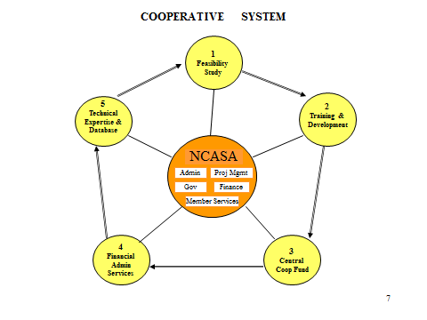

**Below is the support offered to sectors in relation to the adopted system illustrated above. It should be noted that in the event some of the sectors listed above decide to provide own capacity, new sectors shall be organized and then benefit from the system mentioned.**

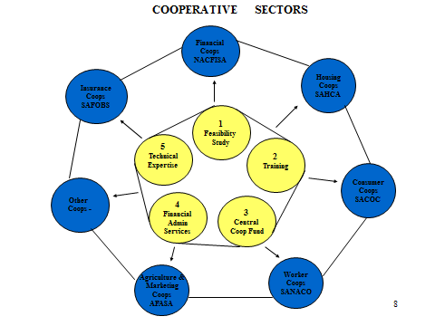

|  |  |
| --- | --- |
| Name of Organisation | National Co-operatives Association of South Africa |
| Registration no. | **K6/3/9/0767 – subject to change soon** |
| Physical Address | Room 701, Management House, Braamfontein. 2017 |
| Contact no. | 011 040 2663 or 083 513 0478. Email: **ncasa.coops@gmail.com** |
| Contact Person | Mr Mzukisi Ronyuza |
| Position | General Manager |