REPORT ON HOME AFFAIRS ACCOMMODATION PORTFOLIO
26 FEBRUARY 2019

DEPARTMENT OF HOME AFFAIRS ACCOMMODATION PORTFOLIO OVERVIEW

The Department of Home Affairs (DHA) is currently operating in various State-owned buildings, private leased buildings and Ports of Entry across the country. Accommodation projects are managed under Capital Projects, Planned Maintenance Projects and Acquisitions (Private leases). Capital Projects and Acquisitions are funded by the client, whereas planned maintenance projects are funded under the Department of Public Works’ Capital budget.
Capital Projects
DHA has 32 Capital Projects currently registered on the Works Control System (WCS) in the 2018/19 financial year. Out of the 32 registered projects, 18 projects are funded in the 2018/19 financial year; 4 projects are at site clearance stage of the process; 3 Projects are at the Acquisition of Sites stage; 16 projects are at Planning stage; 1 project is at construction stage; 1 project is at finale stage (was finalised by the client) and 7 are at Final Completion Stage. The total approved baseline budget for 2018/19 is R31 641 197 00 and expenditure is at R21 009 269 00 as at the end of January 2019.
Planned Maintenance Projects
There are 6 Planned Maintenance projects currently registered and managed for the 2018/19 financial year. 4 projects are funded in the 2018/19 financial year under the Planned Maintenance budget; 2 projects are at the pre-planning stage, 1 at planning stage, 2 at construction stage and 1 is at first delivery stage. The total approved baseline for the 2018/19 financial year is R10 939 323 00 and expenditure stands at R3 040 132 00 as at end January 2019. The number of planned maintenance projects is small owing to the fact that DHA shares some buildings with the Department of Justice and Constitutional Development and also occupies Thusong Centres or buildings owned by other spheres of Government (e.g. SAPO; Municipalities; etc.). The maintenance of buildings under the Justice and Constitutional Development portfolio is funded under the Planned Maintenance budget. Thusong Centres or buildings owned by other spheres of Government, utilisation of these properties needs to be formalised with the property owners to ensure that the property owners take responsibility for the maintenance of the properties.
Private Leases
DHA is accommodated in 223 private leased buildings. DPW is busy with negotiations with landlords for renewal of leases. DPW is working towards reducing the private lease portfolio through the Government Precinct programme (construction of State-owned accommodation). The DHA head office forms part of DPW’s priority projects and the below scenario articulates progress in this regard.

DEPARTMENT OF HOME AFFAIRS NEW HEAD OFFICE CONSOLIDATION

CONSTRUCTION OF NEW HEAD OFFICE FOR DEPARTMENT OF HOME AFFAIRS

PHASE 1: HEAD OFFICE PROJECT | SALVOKOP GOVERNMENT PRECINCT
INCEPTION: | 2017
USER: | Department of Home Affairs
SITE: | State-owned: Salvokop Ext.5, portion of Erf 17 (portion of 34,427m²). To be allocated. (Previously Ext. 4 portion of Erf 7)
PROCUREMENT: | Registered PPP 14 June 2018

- ESTIMATED PROJECT EXECUTION PLAN
Deliverables | Action items | Due date | Responsible | Status/Comments
- Township approval | - Township approval obtained | March 2017 | PPD (Planning and Precinct Development) | Completed
 | - Division of Township to align to phasing of bulk service installation | May 2018 | PPD | Completed
 | - Signing of service agreements | February 2019 | PPD | City of Tshwane (CoT) to prepare service agreements for signature by DPW – In progress
 | - Provisional allocation of portion of Erf 17 as part of Ext. 5 to DHA | March 2018 | PPD | Completed
- Service installation | - Design for bulk and internal services | Completed Nov 2016 | PPD | Completed and ready for tender upon signing of service agreements
 | - Tender process for installation of engineering services | February 2019 | PPD | Planned – Linked to approval of Service Agreements
 | - Installation of bulk and internal services | May 2019 – May 2021 | PPD | Planned – Linked to approval of Service Agreements
- Packaged solution | - Location analysis report (due diligence investigation) | Completed 25 May 2016 | PPD | Completed
 | - DPW Pre-Feasibility study | Completed 7 September 2016 | IA | Completed. Request for funding model options analysis based on DHA Minister approval of Salvokop location.
 | - SWOT analysis for optimum location in Tshwane | April 2017 | PPD | Completed
 | - Commitment from DHA Minister received 4 September 2017, for construction of head office at Salvokop. | 4 September 2017 | DHA | Commitment via letter from DHA Accounting Officer.
 | - Commitment letter received from DHA Accounting Officer, 31 October 2017 | 31 October 2017 | DHA | Registered PPP 14 June 2018
 | - Provisional Site allocation certificate | March 2018 | PPD | Completed, based on approval of division from CoT
 | - Draft Precinct, architectural and landscape guidelines | March 2019 | PPD | In progress

*NOTE: The above project timeframe is estimated and is subject to receiving various project approvals.

- ESTIMATED COST OF SERVICED SITE AT SALVOKOP
Department | Estimated GLA (m²) | R672/m² service contributions for a serviced site
Department of Home Affairs | 49,132m² (to be confirmed at funding stage, and currently excludes the archives) | 49,132m² x R672/m² (external and internal bulk) =
TOTAL ESTIMATED CONTRIBUTION (based on est. GLA) |  | R33,016,704.00

- PROPOSED TIMEFRAMES FOR DPW PROJECT DEVELOPEMENT PACKAGE TO DHA
Activity | Delivery Period | Activity | Overall delivery period
Part 1 – Project Inception | 1 month – January 2018 | Part 4 – Salvokop Implementation Framework | March 2019
Part 2 – Salvokop Precinct Master Plan (Urban design-, landscape design- and architectural design guidelines) | 6 months – July 2018
Part 3 – Salvokop Management Framework | 3 months – October 2018
Part 5 – Project close out | 1 month – March 2019

- RECOMMENDATIONS

- Note the planned installation of bulk services in May 2019.
- DHA note that the earmarked State-owned site in Salvokop Precinct will allow for co-development and based on the division of the Township is now known as portion of Erf 17 Salvokop Extension 5.
- DHA to kindly respond in writing hereto as confirmation of co-development as per provisional land allocation issued in March 2018.
- Confirm the appointment of TAs as well as the allocated Project Officer to DPW in writing.
- DHA to issue DPW with updated approved construction needs, as aligned to the commitment to construct at Salvokop and the exclusion of the Archives, as it responds to the required bulk service contribution.
- DHA to budget for the installation of services at Salvokop is estimated at R33 million, to be budgeted for in 2020/21 FY.
- Real Estate Management Services are engaged in processing leasing requirements aligned to the head office development project plan.
- DPW and DHA constitute a Project Technical Task Team to ensure coordination and monitoring of works.

PROGRESS SUMMARY ON DEPARTMENT OF HOME AFFAIRS INFRASTRUCTURE
A | B | C | D | E | F | G | H
No | PROVINCE | OFFICE | TYPE OF REQUEST | DHA PROGRESS | INTERVENTION REQUIRED | DPW STATUS AS OF 21 FEBRUARY 2019 (In response to DHA report in columns A - F) | RESPONSIBLE
 | GAUTENG | Hallmark (lease) | Current lease expired on 31 October 2017. Status of current lease not formalised. | DHA submitted request to DPW in November 2014 for alternative accommodation. | DPW to resolve status of current lease and expedite alternative accommodation. | Current lease was extended for 12 months until January 2019.  Alternative accommodation: The submission for open tender strategy was referred back from National Bid Adjudication Committee (NBAC) (09/11/2018) to review the functionality criteria before going out on tender.  The submission has been referred back again on 12/02/2019 for recalculation of the cost as the cost are not in line with the current market price. Documentation being prepared for resubmission by DPW Key Accounts Management (KAM) for client funds confirmation. | DDG:REMS  RM: T. Phiri  D: N Mathivha
 |  | Hallmark (facilities maintenance) | Lifts not working at most times. | Matter reported to DPW. | DPW to put the Landlord on terms to ensure that the lifts in the building are maintained and that technicians are available on call. | Matter Resolved; the lifts are checked every morning as the commitment from the landlord; (Inspection started in January 2018). Finalised | DDG:REMS  RM: T. Phiri  D: N Mathivha
 |  | Centurion | DHA submitted a request to DPW for renewal with request to reconfigure the space in ground floor to accommodate officials from 1st floor. | DHA: Needs assessment submitted and funding confirmation. | DPW to expedite the process of renewal of lease. | The negotiations for renewal with the landlord is done. Lease offer approved by NBACL, DPW in the process of drafting the lease to send to the landlord for signature. | DDG:REMS  RM: T. Phiri  D: N Mathivha
 |  | New Corporation Building (BVR) | Air conditioners in the server room and offices not maintained and frequently not functioning optimally. DHA at times forced to shut down systems when the temperature is too high.  UPS Batteries need to be replaced | Matters reported to DPW | DPW to appoint a competent contractor for the air-conditioning or hand over the management and maintenance thereof to DHA.  DPW to attend to the replacement of UPS Room Batteries | A contractor was appointed 22 December 2017, the air-conditioning matter has been finalised during the first week of 18 January 2018.  The 3 UPS batteries were replaced and working. Matter is finalised | DDG: CPM  RM: T. Phiri  D: D Sewada
 | EASTERN CAPE | Maclear Service Point | New office accommodation. | Procurement instruction issued by DPW in June 2012. Tender was advertised and it was non-responsive. Re-advertisement was done on 25/02/2015 closing on 24/03/2015.  The municipality has offered space to DHA. | DPW to prioritise evaluation of the bids. Alternatively  DPW must engage the municipality or come up with a different strategy. Municipality is ready to assist both DPW/DHA | A special submission to include the office in procurement plan has been prepared to HO as per the resolution taken at the meeting of 07/11/2018. The Project was the reprioritised and client approved the 2018/19 priority list. | DDG/REMS  RM: R Mabandla  H/Leasing: L Ndabeni
 |  | Flagstaff | Request for alternative accommodation. Current building has roof leaks and is structurally unsound. | DPW are able to obtain premises in the area. South African Post Office has offered a DPW/DHA a building that used to house a post office. | DPW to negotiate with SAPO for the building. | The tender has been advertised more than 2 times with no positive from the market. REMS will meet with National Treasury and DHA to decide on alternative strategy  BSC was convened on 11/09/2018 to discuss the strategy and open tender was recommended. The approval for open tender to be presented to RBAC during on the 20/11/2018. Anticipated Tender date 26/07/2019. | DDG/REMS  RM: R Mabandla  H/Leasing: L Ndabeni
 |  | Willowvale | New accommodation. | Formalisation of the lease agreement. | DPW to expedite the formalisation of the lease agreement with municipality. | The meeting with the Municipality for lease negotiation held on 30/10/2018 and had recommended 9 years 11 months. Lease to be signed by both parties after approval of Municipal offer by NDPW Bid Committee. | DDG/REMS  RM: R Mabandla  H/Leasing: L Ndabeni
 |  | Mount Fletcher | Alternative accommodation requested. Current office not adequate for DHA needs.  Department of Labour has given the office a contravention of notice for closure of the office due to the office not complying with OHSA. | SAPO has offered DPW/DHA a vacant building. | DPW to negotiate with SAPO for the building. | The lease agreement has been signed (2 years) with the Municipality for interim temporary accommodation. DHA to do tenant installation and reconfiguration of space to suit the client’s needs. Copy of the lease agreement given to the client. Finalised  Alternative accommodation: the tender closed 27 June 2018.  The evaluation report was presented to RBAC in August and was returned back for corrections, currently with SCM for RBAC sitting again. The adjudicated will be on the Monday 25/02/2019.  Permanent Solution: PPD is busy with a site clearance in Mt Fletcher to for government precinct as a permanent accommodation. However due to the long term nature of this solution, alternative leased accommodation should be secured for at least five years. (Refer to Annexure A containing PPD’s progress with precincts | DDG/REMS  RM: R Mabandla  H/Leasing: L Ndabeni
 |  | Port St John’s | Current office structurally unsound. | There is a state owned building available in the area that can be renovated. | DPW to expedite the refurbishment project of this State-owned building. | DPW has sourced funds for the minor refurbishments of the vacant state owned building.  Tender advertisement for the refurbishing of the state owned property was 25th May and closed 15th June 2018. The tender evaluation completed week of 17th August and the submission will serve at ad-hoc RBC for tender award approval (31/08/2018). Contractor is on site since 17/10/2018. | DDG/CPM  RM: R Mabandla
 |  | Ngqamakwe | Request for alternative accommodation. Current building not suitable for DHA needs. | There is a State-owned building available in the area that can be renovated. | DPW to expedite the refurbishment of this State-owned building. | Permanent Solution: The Investment Analysis was conducted and recommended demolition of existing structure and construction of new office. DPW will be funding the project for demolition and re-construction.  Interim Solution: DPW together with DHA have identified Park-homes belonging to DPW that must be relocated from Bizana Magistrate Court to Ngqamakwe. Site clearance process completed and certificate has been issued.  The PI issued to the executing unit (17/8/2018) for relocating the park homes and installing required service issued. The service was delayed due to not been part of the approved acquisition plan for this financial year. The project scope of work meeting is scheduled for 16/11/2018. RO has compiled the Layout Plans for approval of HO Professional Services. The anticipated date of approval will be the 12/03/2019. | DDG/REIS and REMS  CD: M Chabalala  D: N Mbukushe  RM: R Mabandla
 |  | Lusikisiki | Construction of a new office accommodation. | DPW to commence with the construction. | DPW to expedite the construction. | The contractor is appointed and site hand over done 30/8/2018. Bulk earthworks and site services are in progress and no challenges so far. | DDG/CPM  RM: R Mabandla
 |  | Sterkspruit | Alternative accommodation requested. Current building in poor state. The office closed down by department of Labour for safety issues. | Municipality has offered DPW/DHA a building to accommodate DHA office. | DPW to expedite alternative accommodation | The lease agreement is signed and renovations completed  The client took occupation 01 March 2018. Finalised | DDG/REMS  RM: R Mabandla  H/Leasing: L Ndabeni
 |  | Aliwal North | The landlord was not maintaining the building in contravention of occupational health and safety standards | DPW was not enforcing conditions of the lease agreement. | Department of Labour has given the office a contravention of notice for closure of the office due to the office not complying with OHSA. | The landlord has attended to all OHS issues and work is completed. Finalised | DDG/REMS  RM: R Mabandla  H/Leasing: L Ndabeni
3. | FREE STATE | Parys | Request for alternative accommodation. The office is too small to efficiently deliver services. | Bid/Tender advertised and closed by DPW. Awaiting DPW to confirm site viewing date. | DPW to fast track the accommodation procurement process. | DPW went on open market more than once and no responses received from the open bid process.  Due to non-responsiveness of the market, the procurement process restarted. Tender advertised 17/8/2018 and closed 11/09/2018. Bids received were non responsive and therefore, the tender was cancelled 23/10/2018.  Procurement process restarted. Bid Specification Committee meeting to be held on 06 March 2019. | DDG/REMS  RM: T. Zulu  D: J Jabari
 |  | Bethlehem | Request for alternative accommodation. The office is too small to efficiently deliver services. | Procurement Instruction issued on the 09/09/2016 to acquire alternative accommodation. | DPW to fast track the accommodation procurement process | The required office space is about 455 square metres.  Tender was advertised 16 February 2018 and closed 13 March 2018. No positive response received from the market.  Due to non-responsiveness of the market, the procurement process restarted. Tender advertised 17/8/2018 and closed 11/09/2018.  Bid received were non responsive and therefore, the tender was cancelled 23/10/2018. Bid Specification Committee meeting to be held on 06 March 2019. | DDG/REMS  RM: T. Zulu  D: J Jabari
 |  | Ladybrand | Office currently operating from a dilapidated building. The office is inadequate for DHA needs. | Procurement Instruction issued for alternative accommodation on the 11/12/2008.  A tender for premises was advertised for several occasions. DPW did not obtain any bidders | DPW to consider a different procurement strategy as advertising is not yielding positive results. | DPW went on open market more than once and no responses received from the open bid process.  Due to non-responsiveness of the market, the procurement process to restart. The submission served strategy specification approval on the 21 August 2018, will serve RBAC 04 September 2018 for advertisement. DPW went on open market couple of times and also called for quotations but non yielded positive results. The office will advertise again, because no response has been received from the open market. Approval to negotiate directly with the Municipality did not yield any results.  Due to non-responsive of the market, the procurement process has restarted. The Bid Specification is finalised with recommendation for open tender strategy. Procurement Strategy to serve at the Regional Bid Adjudication Committee on 05 March 2019. | DDG/REMS  RM: T. Zulu  D: J Jabari
4. | GAUTENG | Randburg | Finalisation of the Repair and Maintenance Programme (RAMP) and additional ablutions | DHA: Needs assessment submitted to DPW on 18/01/2013 for DPW to commence with project. | Urgent issuing of Procurement Instruction (PI) to the Regional Office for the construction of ablution unit and RAMP project. | Request for construction of ablution facilities was received from client and Professionals are busy with the norm document. | D: Professional Services  Ms H Nienaber  RM: J Monare
 |  | Randfontein | Construction of new office accommodation |  |  | Conceptual design approved and the sketch plan approved on 8th December 2016. The project was put on hold due to funding challenges. Project received allocation 2018/19 and the Sketch Plan was approved 29th July 2018, with some amendments on Mechanical installations.  The strategy served at NBAC 31st January 2019 and was returned for amendments. The strategy to serve again on 25th February 2019. | DDG/CPM  RM: J Monare  D: I Molosi
 |  | Benoni | The office is too small for DHA operations and is dilapidated and does meet the OHSA standards. Not suitable for both DHA clients and staff. | Need Assessment submitted to DPW. | DPW to finalise procurement of alternative accommodation. | The current lease renewed for 3 years from 01/05/2016 till 30/4/2019. Concluded. | DDG/REMS  RM: J Monare
 |  | Kempton Park | The office is too small for DHA operations and is dilapidated and does meet the OHSA standards. Not suitable for both DHA clients and staff. | Need Assessment submitted to DPW. | DPW to finalise procurement of alternative accommodation. | The lease agreement is running for a period of three (3) years which commenced on 01 May 2017 and will expire on 30 April 2020. Concluded. | DDG/REMS  RM: J Monare
5. | KWAZULU-NATAL | Umlazi | The office currently operating from a Thusong Centre, which is too small for DHA’s needs. The KZN Provincial Government has offered a building to DHA. The building was inspected by DHA and it meets DHA’s requirements. | DPW advised of the offer by the KZN Provincial Government. DPW however unable to conclude lease with the Provincial Government. | DPW to engage the KZN-DPW and finalise the lease agreement. | DPW has submitted the requested needs assessment to KZN Provincial Government.  A meeting took place on the 03 April 2018 to discuss progress and KZN DPW requested that the needs assessment be resent. The needs were resent on 11 April 2018.  NDPW is waiting for Provincial Public Works to confirm availability of the building that was identified by DHA. | DDG/REMS  RM: N Vilakazi  H/Leasing: P Shozi
 |  | Melmoth | DHA seeks alternative accommodation. Current office too small and complemented by a mobile truck. | Need Assessment submitted to DPW. | DPW to urgently finalise the procurement process. | The client is currently occupied in a mobile truck, because the Municipality recalled its building previously occupied by DHA for their own usage.  The Municipality identified an alternative site for DHA but later withdrawn it citing that the site is earmarked for future developments. This led to DPW resorting to SCM open tender procurement process.  Procurement process restarted and Strategy served at the Bid 21/08/2018 but was not approved, committee requested the client to confirm the preferred lease period.  The region is investigating the available state land through Regional Town Planning team. Project to be presented in the next RBSC | DDG/REMS  RM: N Vilakazi  H/Leasing: P Shozi
 |  | Hlabisa | DHA was evicted at the Magistrate Buildings by the Department of Justice (DOJ). The office currently operating from a mobile truck. DHA has registered a project for the refurbishment of a State-owned premises identified for use by DHA. | DPW to refurbish the premises as per DHA standards. | DPW to finalise the rehabilitation of the identified premises. | DPW has commenced with the Site Clearance process and the Big 5 Hlabisa Municipality confirmed that the land belong to NDPW.  The Permission to Occupy and Built was approved by Big 5 Hlabisa Municipality.  Municipality has confirmed the Municipal bulk Services. Eskom confirm the availability of electricity bulk service. The site clearance certificate issued 20th July 2018.  PI for construction issued to the region 17/08/2018. The region is busy with the project plans. | DDG/REMS  RM: N Vilakazi  H/Leasing: P Shozi
 |  | Nquthu | The Department of Justice (DOJ) has requested DHA to vacate the space currently occupied in their Magistrate Building. | Needs assessments for construction of office were submitted to DPW. | DPW to request DOJ not to lock out DHA from Magistrate’s building before alternative accommodation is found. DPW to fast track alternative accommodation. | DPW engaged DOJ and resolved the matter of lock out.  DPW is currently busy with the feasibility study and investment analysis to identify the state of the site for construction of permanent office. | DDG/REMS  RM: N Vilakazi  H/Leasing: P Shozi
 |  | Nongoma | Alternative accommodation required. Office currently operating from a Magistrate Building. The office is inadequate for DHA needs and there are Health and Safety concerns. | A tender for premises was advertised during 2014 for the third time since 2011. DPW did not obtain any bidders. | DPW to consider a different procurement strategy as advertising is not yielding positive results. | The current lease will be negotiated and renewed as per above negotiations process highlighted above under the Private Leases heading.  Negotiated strategy to negotiate with Telkom will be finalised by March 2019. | DDG/REMS  RM: N Vilakazi  H/Leasing: P Shozi
 |  | Ulundi | Procurement of additional space (Office currently operating from a KZN Provincial Building) | Procurement Instruction was issued in November 2014. To date no feedback has been received. | Expedite the process of additional space. | The KZN Provincial Government has offered a building to DPW. The building was inspected by DHA and it meets DHA’s requirements.  A meeting took place on the 03 April 2018 to discuss progress and KZN.  NDPW is awaiting confirmation of the availability of additional space from KZN DPW. | DDG/REMS  RM: N Vilakazi  H/Leasing: P Shozi
 |  | Pinetown | Alternative accommodation required. Office currently operating from a dilapidated building. The office is inadequate for DHA needs. | A tender for premises was advertised during 2016 for the third time. DPW obtained one positive bid which was rejected by the DPW BAC. | DPW to expedite the procurement of alternative office as current one does not have sufficient waiting area to accommodate all clients. | The request is on adjudication, upon recommendation by the Regional Bid the anticipated conclusion date for this process is end March 2019. | DDG/REMS  RM: N Vilakazi  H/Leasing: P Shozi
 |  | (PINK Area Offices)  Phoenix, Inanda, Ntuzuma and Kwamashu) | Request for a new office. Submit to DPW. | A tender for premises was advertised for several times. DPW did not obtain any bidders. | DPW must still expedite the negotiation strategies for acquisition of office accommodation. | DHA was advised to submit the revised needs assessment in alignment of PINK area for all the 4 offices | DDG/REMS  RM: N Vilakazi  H/Leasing: P Shozi
 |  | Pietermaritzburg | Alternative accommodation required. Office currently operating from a dilapidated building. The office is inadequate for DHA needs. | DHA submitted the Needs Assessment | DPW to prioritise evaluation of the bids or alternatively do a different procurement strategy. | The Specification served 21 August 2018 and recommended for open tender. Project to be presented in the next RBAC for strategy approval  Permanent Solution: PPD is busy with the identification of a site for Government Precinct Development which will create a long term solution. The long term solution will however only be ready in five year’s times. | DDG/REMS  RM: N Vilakazi  H/Leasing: P Shozi
 |  | Stanger | Stanger construction of new office |  |  | PA-01 (Procurement strategy) presented to the RBAC 14/11/2018 for consideration.  Procurement Strategy was returned by RBAC to address amendments on the 19/02/2019. | DDG/CPM  RM: N Vilakazi  PM: J Rindel
6. | LIMPOPO | Polokwane | Relocation to the new site (Alternative accommodation) | DHA: Needs assessment submitted to DPW | DPW to expedite the procurement of alternative office as current one does not have sufficient waiting area to accommodate all clients. | The last tender was advertised and closed under PLK18/11. No Bidders responded to the advert. The tender to be re-advertised again. The specification meeting took place on the 23 January 2019 and the procurement strategy served before the RBAC on the 12 February 2019 and was referred back for corrections. The strategy to be revised and be presented at the next Bid sitting. | DDG/REMS  RM: M Ntshani  H/Leasing:  Y Siweya
 |  | Bela Bela | Request for alternative accommodation. | Tender was advertised and it was non responsive (no bidders). DPW to re-advertise the tender. | DPW to consider alternative procurement strategy to source accommodation. | The lease was advertised on 19 January 2017 and closed on 20 February 2017. No bid was received on the closing date.  Due to non-responsiveness of the market, the procurement process had to restart. The tender was advertised and closed under tender no PLK18/13 and no bidders responded to the advert. The tender to be re-advertised again.  The specification meeting took place on the 23 January 2019 and the procurement strategy served before the Regional Bid Adjudication Committee (RBAC) on 12 February 2019 and was referred back for corrections. The strategy to be revised and presented at the next Bid sitting. | DDG/REMS  RM: M Ntshani  H/Leasing:  Y Siweya
 |  | Bochum | Request for relocation to a new site.  Municipality donated land to DHA. National Treasury approved donation. | DHA: Needs assessment submitted. | DPW to expedite the site clearance process and proceed to construction of a new office. | A Council Resolution is awaited for the municipality to donate the land parcel. | DDG/REMS  RM: M Ntshani  H/Leasing: Y Siweya
7. | MPUMALANGA | Mapulaneng | Relocation to a new site. Currently located in a Magistrate Court. Officials have to climb over the counter to access the office. | DPW have advertised bids for this office on numerous occasions over the past +5 years without a positive response. | DPW needs to adopt a different procurement approach for the office as normal process has not yielded any positive outcome. | Lease was awarded to Mite Investments. Office layout was approved and sent to the landlord on the 31/05/2018. Landlord was then requested to send the tenant installation cost which was received and confirmation of budget was sent and received from the client on the 04/10/2018. Landlord is requesting the extension of lease from 3 to 9 year 11 month in order for him to carry the total cost for tenant installations.  Confirmation of budget for a 9 year 11 months lease period was sent to the client and client confirmed that they do not want a 9 year lease but it can be a 5 year lease instead. The Client proposal of 5 years to be finalised before end March 2019. | DDG/REMS  RM: P. Mashiane  D: M Mokgohloa
 |  | Inkomazi | Relocation to the new site Currently located in a Magistrate Court. | DPW have advertised bids for this office in the past without a positive response. | DPW needs to adopt a different procurement approach for the office as normal process has not yielded any positive outcome. | Tender is awarded to P&L General Trading for the period of five (5) years. Landlord is currently busy with Tenant Installation. Last inspection was on the 13th February 2019. The proposed date for occupation is 1st May 2019. | DDG/REMS  RM: P. Mashiane  D: M Mokgohloa
 |  | Kwamhlanga | Operating in small office which is inadequate for clients and DHA officials. Request to be relocated to an alternative office accommodation. | DPW have identified a building which was vacated by SAPS. The office meets DHA requirements with minor modifications. | DPW to urgently finalise the process of occupation by DHA. | The region went on open tender for numerous occasions but no response was received from the market.  The new procurement strategy to negotiate with Provincial Public Works submitted at NBACL on the 08 May 2018. It was supported and sent to NT but was referred back to address comments.  Supported Strategy by National Treasury was received and Bid Offer for rates was sent to Province on the 11th February 2019 after the meeting held on 07 February 2019 to check whether the building was still available.  Province has not yet responded with regards to the rates they charging. | DDG/REMS  RM: P. Mashiane  D: M Mokgohloa
 |  | Matsamo | Procurement of new office |  |  | Procurement Instruction issued May 2018 however the property allocated to DHA by the Municipality has less space than what the client required. DHA withdrew the PI and submitted the revised needs aligned to the space allocated by Municipality.  DPW requested DHA to approve preliminary cost on the 21/02/2019 for a PI to be issued. | DDG/REMS  RM: P. Mashiane  D: M Mokgohloa
 |  | Siyabuswa | DHA offices in the DOJ magistrate court. The office is too small and is inadequate for clients and DHA officials. | DHA has submitted all the relevant documents for alternative accommodation. | DPW to urgently commence with the procurement of alternative accommodation. | The procurement instruction request for the procurement of 1092m² and 8 parking bays was received. A tender was advertised and no response was received from the market. The available space was identified at Provincial Public Works offices in Siyabuswa which was previously used as school and is measuring approximately 541m² which is less than the required space of 1092m².  DHA submitted revised needs and preliminary cost analysis was submitted to back to DHA for approval of funds on the 19/02/2019. | DHA CD: Mr Nxasana
 |  | Middelburg | DHA officials were locked out by the landlord on the 21 December 2017 for non-renewal of lease which expired on 31 May 2017 | DHA has submitted all the relevant documents for the renewal of the lease. | DPW to urgently commence finalise the lease agreement. | The lease agreement was renewed from July 2018 for a period of three (3) years. Finalised  Permanent Solution: PPD is in the process to identify a site for a social precinct to provide permanent accommodation. The site will only be ready in five year time | DDG/REMS  RM: P. Mashiane  D: M Mokgohloa
8. | NORTH WEST | Mafikeng (Provincial Office) | The landlord is not maintaining the building. DHA has requested for alternative office accommodation from DPW. | DHA: Needs assessment submitted  DPW currently in procurement phase. | Urgent finalisation of the procurement process by DPW required. | Bid advertised and closed 22 December 2017 - but no bids were received.  Due to non-responsiveness of the market, DPW restarted the process.  The tender advertised and closed 29/08/2018. Nine bidders responded and while SCM was busy with screening of the documentations, the Tender Validity period lapsed, So the RO is now compelled to restart the Procurement.  Permanent solution: PPD has identified a site for the development of a social cluster in Mafikeng. Permanent accommodation will be provided on the site. The procurement process for the site which belongs to the municipality is underway. The site will only be ready for construction in five years times. | DDG/REMS  RM: M Matlala  H/Leasing: I Mahlaule
 |  | Taung | Construction of new office accommodation. DHA still waiting for the lay-out to be submitted for approval. | DHA: Needs assessment submitted | Urgent finalisation of the site clearance and procurement process in order to commence with construction. | Site clearance completed.  Procurement Strategy was approved on the 12th February 2019  Project will be advertised on the 1st March 2019  Compulsory site inspection is on the 14th March 2019  Closing Tender date is the 3rd April 2019. | DDG/CPM  RM: M Matlala  D: K Nel
 |  | Rustenburg | Alternative accommodation required urgently. The building is not OHS Act compliant. Condemned by both DHA Employee Wellness and the Department of Labour. | DHA: to submit needs assessments for alternative office. | DPW to fast track SCM process once all documents are in place. | Lease agreement was signed for 5 years and while the bidder was waiting for plans approval by the Municipality, then the bidder cancelled the lease due to unforeseen circumstances: (week of 24/08/2018).  Procurement process restarted and PA 25 approved. Bid Specification met 29/10/2018 and procurement strategy was tabled at RBAC on 13/11/2018. Tender Advertised 01/02/2019 and closing 06/03/2019. | DDG/REMS  RM: M Matlala  H/Leasing: I Mahlaule
 |  | Mabopane | Finalisation of the relocation from 1st to ground floor. The current office is dilapidated and in need of extensive refurbishment. | The building owned by the Public Investment Corporation and DPW unable to finalise agreement with them. The PIC has offered to renovate the ground floor at their cost however this is depended on the finalisation of the lease. | Urgent finalisation of the procurement process with the PIC by DPW required. | HO negotiating Committee finalised the negotiation with the landlord. The actual cost received from the client. DPW to finalise the lease agreement | DDG/REMS  RM: M Matlala  H/Leasing: I Mahlaule
9. | NORTHERN CAPE | Postmasburg | DHA operating and rendering services in a small dilapidated house. Request for alternative accommodation submitted to DPW in 2009. | DPW has advertised and invited BIDS. There has been no positive response to date. | DPW needs to adopt a different procurement strategy as this is a small town with few buildings available. | The Lease was awarded by NBAC: L 15 December 2017. Building handover to DHA was done 04 June 2018. Finalised | DDG/REMS  RM: R Baulackey  H/Leasing: M Machi
 |  | Jan Kempdorp | Current office structurally unsound. | The building does not have ablution system for the public. | DPW to expedite the refurbishment of the ablution system. | The building is currently leased from the Municipality through a nominal Lease Agreement at R1.00 per month. The Municipality has acknowledged that the ablution facilities must be refurbished but no budget available to address the matter as the client is not paying any rent.  DHA was given permission by DPW RO for temporary placement of ablution facilities at the client department’s own cost. | DDG/REMS  RM: R Baulackey  H/Leasing: M Machi
10. | WESTERN CAPE | Mitchells Plain | Alternative accommodation required urgently. The building is not OHS Act compliant The current building is too small and is dilapidated house | Bid/Tender advertised and closed by DPW. Awaiting DPW to confirm finalisation of procurement process. | DPW to fast track the procurement of office accommodation. | DPW has engaged DHA to obtain confirmation / commitment of funding for a 5 year lease period. The client has confirmed funding on 22 January 2018.  The client reviewed their request from renewal to alternative accommodation.  Revised Procurement Instruction issued 04 May 2018.  The request was not part of the approved procurement plan of 2018, however was approved as additional Procurement Plan by CFO.  The bid Specification Committee for the 3rd-time will be held on the 22/02/201 and is anticipated to be approved on the 05/03/2019.  RO anticipate to go on Tender on the 15 March 2019. | DDG/REMS  RM: Nomalanga Kani  D: Nolizwi Hlengwa
 |  | Malmesbury | The landlord evicted the department on the 30 November 2017. The DPW have been requested to source alternative accommodation. | The office is currently operating from mobile trucks offering minimum services. No Smart ID card and Passport applications are being processed and clients have to travel +- 80 Km to apply for ID smart Card and passports. | The landlord evicted the department on the 30 November 2017. The DPW have been requested to source alternative accommodation. | The open tender closed and viewing of tenders 26 April 2018  Evaluation of tenders was scheduled for 21 May 2018  One Bidder accidently submitted the wrong address on the DPW 08. The tender will be re-advertised on 23 November and closing date is 14 December 2018.  3 bids were received and one was non-responsive. Site Viewing was held from the 15 to 20 of February 2019. DPW awaits DHA site approval. (The report was sent on the 21/02/2019) | DDG/REMS  RM: Nomalanga Kani  D: Nolizwi Hlengwa
 |  | Ceres Thusong Service Centre | Lease expired in 2016 and currently on a month-to month. DPW to fast track the signing of a 3 year lease agreement. | Needs assessment submitted to DPW | Ceres Thusong Service Centre | The lease is on month-to-month. An offer was received from the landlord, and the landlord (Municipality) was requested to confirm if a long term lease of 9 years and 11 months will be acceptable. A response is awaited. | DDG/REMS  RM: Nomalanga Kani  D: Nolizwi Hlengwa
 |  | Plettenberg Bay (KwaNokuthula) Thusong Service Centre | Lease expired in 2016 and currently on a month-to month. DPW to fast track the signing of a 3 year lease agreement. | Needs assessment submitted to DPW | Plettenberg Bay (KwaNokuthula) Thusong Service Centre | Lease is month-to-month. Approval was granted by the RBAC to renew the lease for 9 years and 11 months. The client must confirm funding before the lease will be signed. Funding confirmation is awaited. | DDG/REMS  RM: Nomalanga Kani  D: Nolizwi Hlengwa

PROGRESS SUMMARY FOR DEPARTMENT OF HOME AFFAIRS CRITICAL MARITIME PORTS OF ENTRY OFFICE LEASES
A | B | C | D | E | F | G | H
No | PROVINCE | OFFICE | TYPE OF REQUEST | DHA PROGRESS | INTERVENTION REQUIRED | DPW STATUS AS OF  21 FEBRUARY 2019  (In response to DHA report in columns A - F) | RESPONSIBLE
1. | EASTERN CAPE | East London | The Department needs to open a Port of Entry Control Centre (PECC) to process vessels and crews | Needs submitted to DPW and Transnet awaiting DPW | DPW to fast track the procurement of office accommodation | PI issued in 2013. Transnet National Ports Authority recently confirmed that space is now available for consideration to accommodate DHA.  Revised PI issued 16/03/2018.  DPW is waiting for DHA committee to unpack the strategic objectives of BMA/ IACF and operational requirements, its stakeholders and future plans. The site meetings will then be arranged, debriefing and establishment of success criteria, reviewing draft norms reconciliation.  DPW will approach National Treasury for the negotiated procedure after identification of the property owner. DPW is waiting for DHA | DDG: REMS  RM: J Van der Walt  Head leasing: M Mangia  CD /DHA : V Nxasana
 |  | Port Elizabeth | The Department needs to open a Port of Entry Control Centre (PECC) to process vessels and crews | Needs submitted to DPW and Transnet awaiting DPW | DPW to fast track the procurement of office accommodation | PI issued in 2013. Transnet National Ports Authority recently confirmed that space is now available for consideration to accommodate DHA.  Revised PI issued 16/03/2018  DHA to form a committee to unpack the strategic objectives of BMA/ IACF and operational requirements, its stakeholders and future plans. The site meetings will then be arranged, debriefing and establishment of success criteria, reviewing draft norms reconciliation.  DPW will approach National Treasury for the negotiated procedure after identification of the property owner. DPW is waiting for DHA | DDG: REMS  RM: J Van der Walt  Head leasing: M Mangia  CD /DHA : V Nxasana
 |  | Ngqura (Coega) | The Department needs to open a Port of Entry Control Centre (PECC) to process vessels and crews | Needs submitted to DPW and Transnet awaiting DPW | DPW to fast track the procurement of office accommodation | PI issued in 2013 but Transnet had no space available. Transnet National Ports Authority recently confirmed that space is now available for consideration to accommodate DHA.  Revised PI issued  DHA to form a committee to unpack the strategic objectives of BMA/ IACF and operational requirements, its stakeholders and future plans. The site meetings will then be arranged, debriefing and establishment of success criteria, reviewing draft norms reconciliation.  DPW will approach National Treasury for the negotiated procedure after identification of the property owner. DPW is waiting for DHA | DDG: REMS  RM: J Van der Walt  Head leasing: M Mangia  CD /DHA : V Nxasana
2. | KWAZULU-NATAL | Durban Harbour | The Department needs to open a Port of Entry Control Centre (PECC) to process vessels and crews | Needs submitted to DPW and Transnet awaiting DPW | DPW to fast track the procurement of office accommodation | Procurement strategy (deviation – sole supplier) for Transnet National Ports Authority to be finalised by end of March 2019. | DDG/REMS  RM: N Vilakazi  Head of Leasing: P Shozi
 |  | Richards Bay Harbour | The Department needs to open a Port of Entry Control Centre (PECC) to process vessels and crews | Needs submitted to DPW and Transnet awaiting DPW | DPW to fast track the procurement of office accommodation | Procurement strategy (deviation – sole supplier) for Transnet National Ports Authority to be finalised by end of March 2019. | DDG/REMS  RM: N Vilakazi  Head of Leasing: P Shozi
3. | WESTERN CAPE | Saldanha Bay | The Department needs to open a Port of Entry Control Centre (PECC) to process vessels and crews | Needs submitted to DPW and Transnet awaiting DPW | DPW to fast track the procurement of office accommodation | Client took occupation in February 2018. Finalised | DDG/REMS  RM: Nomalanga Kani  D: Nolizwi Hlengwa
 |  | Mossel Bay | The Department needs to open a Port of Entry Control Centre (PECC) to process vessels and crews | Needs submitted to DPW and Transnet awaiting DPW | DPW to fast track the procurement of office accommodation | PI issued in 2013 but Transnet had no space available. Transnet National Ports Authority recently confirmed that space is now available for consideration to accommodate DHA.  Revised PI issued 16/03/2018.  The Strategy to follow a Negotiated / Sole source is approved. Department will request an offer from Transnet. Department of Home Affairs was requested to provide the Cape Town office with the required details of the preferred building in the Harbour. DPW await response from DHA. | DDG/REMS  RM: Nomalanga Kani  D: Nolizwi Hlengwa

PROGRESS SUMARY FOR DEPARTMENT OF HOME AFFAIRS REFUGEE RECEPTION CENTRES CRITICAL LEASES
A | B | C | D | E | F | G | H
No | PROVINCE | OFFICE | TYPE OF REQUEST | DHA PROGRESS | INTERVENTION REQUIRED | DPW STATUS AS OF  21 FEBRUARY 2019  (In response to DHA report in columns A - F) | RESPONSIBLE
1. | EASTERN CAPE | Port Elizabeth | The Department has been instructed by a court judgement to re- open the Reception Centre in PE | Needs submitted to DPW and condition of lease to be incorporated to the tender | DPW to fast track the procurement of office accommodation in order not to be in contempt of court | Lease agreement was signed and landlord completed the refurbishment. Department of Home Affairs took physical occupation as from 1 June 2018 and the lease will only commence from 1 November 2018.  Finalised | DDG/REMS
2. | WESTERN CAPE | Cape Town | The Department has been instructed by a court judgement to re- open the Reception Centre in Cape Town | DHA to submit the Needs to DPW including conditions to be put on tender and lease. | DPW to fast track the procurement of office accommodation in order not to be in contempt of court | The tender was Advertised and closed on the 17/10/2018. The Validity Period was extended as the bidders were not available for site meeting. The Client confirmed budget in February 2019. The Regional adjudication meeting was held on the 19/02/2019, thereafter the bid will served at the National Bid Committee on the 28/02/2019 | DDG/REMS  RM: Nomalanga Kani  D: Nolizwi Hlengwa
3. | MPUMALANGA | Lebombo Refugee Processing Centre | The Department intends opening the centre on site identified by DPW. A PPP has been registered with the National Treasury. | DPW to assist and work with DHA and NT in bringing the centre into operation | DPW to assist and work with DHA and NT in bringing the centre into operation | DHA has appointed the Transactional Advisors to manage the PPP project registered with National Treasury by DHA. Town Planning is busy with site clearance process.  DHA met with DPW team to introduce the appointed Transactional Advisors also to outline the scope of work between DPW and DHA team.  Project Team (DHA/TA/DPW) meeting took place 5th September 2018. Town Planning Service is in the procurement process to acquire service provider to render site clearance process and rezoning of portion 14 of the farm Komatipoort, Townlands 182. The tender briefing was on the 30 October 2018 and is closing on the 14 November 2018. | DDG/REIS  D/Malusi Ganiso
4. | LIMPOPO | Musina Refugee Reception Centre |  | DHA submitted the needs. PI was issued to Polokwane Regional office. | DPW to expedite the renewal / procurement of the lease. | Procurement Instruction issued  Negotiation with the landlord finalised, offer received on 07/11/2018 and lease agreement prepared for the landlord’s signature by 25th February 2019. | DDG/REMS  RM: M Ntshani  H/Leasing: Y Siweya

STRATEGY TO ACCOMMODATE DEPARTMENT HOME AFFAIRS IN STATE OWNED ACCOMMODATION
In addition to the precincts planned in urban and rural municipalities, which forms part of a longer term solution, DPW Planning and Precinct Development (PPD) is working on a strategy to provide access points in rural areas where there is little or no facilities. Areas with State-owned facilities are being identified where complementary user departments could accommodate a small portion of an existing administrative building used by another user department such as SAPS and Department of Justice.
A strategy is being developed by the department (REIS) to address the requirements for offices of DHA throughout the country. The strategy assumes that because of the DHA digital drive a small presence may be required in some rural or remote areas where they currently do not provide services. This implies that DHA could in the short term be satisfied with sharing a small office with other State client departments as a short term solution, while DPW is working to provide permanent accommodation solutions in Government precincts or long term leases.
The Short term strategy is to utilise the GIS Mapping capabilities of the department to spatially indicate where DHA requires services. Then to map State-owned administrative assists including buildings occupied by Department of Labour, SAPS, Justice, Social Development and Post Offices. When these options have been investigated and it is found that National Government does not have any State assets, especially in rural areas, then existing schools will be investigated to accommodate a small office for DHA.
The strategy will require that viable options be investigated through site visits and internal communication between affected client departments to confirm space availability and short term sub-leasing arrangements.
This short term strategy does not impact on the rolling out of a longer term strategy where the planning of Government precincts are underway in 40 urban and 40 rural municipalities throughout the country. Precinct solutions are however intended to be provided where client departments have an accommodation need for 400m² or more per client and may not address the need for a very small presence.
In areas where there are no built facilities State-owned land could be used to provide “Plug-and Play” facilities to accommodate mobile units of client departments. The concept is to provide a site with an electricity connection, water point, ablution facilities, shade and caretaker’s facility as the basic infrastructure. These points could also include a small office to accommodate Wifi and online access for users such as Home Affairs with their electronic campaign. Such facilities could be provided for less than R200 000 and could be located in school yards and localities selected by Traditional leaders for such purposes.

CLIENT ENGAGEMENTS
A number of planning engagements were undertaken with the DHA for the Department to emphasize importance of the Government precinct programme, to ensure infrastructure planning alignment, to present a list of priority urban and rural areas, to obtain client needs, and commitment in Government precincts, which are at an advanced stage such as Carolina, Howick, and Mount Fletcher, among others.
INTERVENTION REQUIRED | RESPONSIBLE
A task team will be put together towards the implementation of this strategy:  Meet with the DHA officials to obtain their needs and requirements for the prioritised short term interventions  Develop the concept strategy into a proper strategy involving other branches of the PMTE  Identify a number of projects for implementation  Develop project plans per project  Do site and building assessment  Develop the governance and occupational arrangements including user charges  Compile high level costing per project  Develop moveable asset requirements and provisioning strategies with DHA | PPD/ PMTE

The following maps illustrate a high level attempt at a strategy for the short term proposal discussed above. This concept strategy should however be developed into a fully-fledged strategy involving all branches of the PMTE.

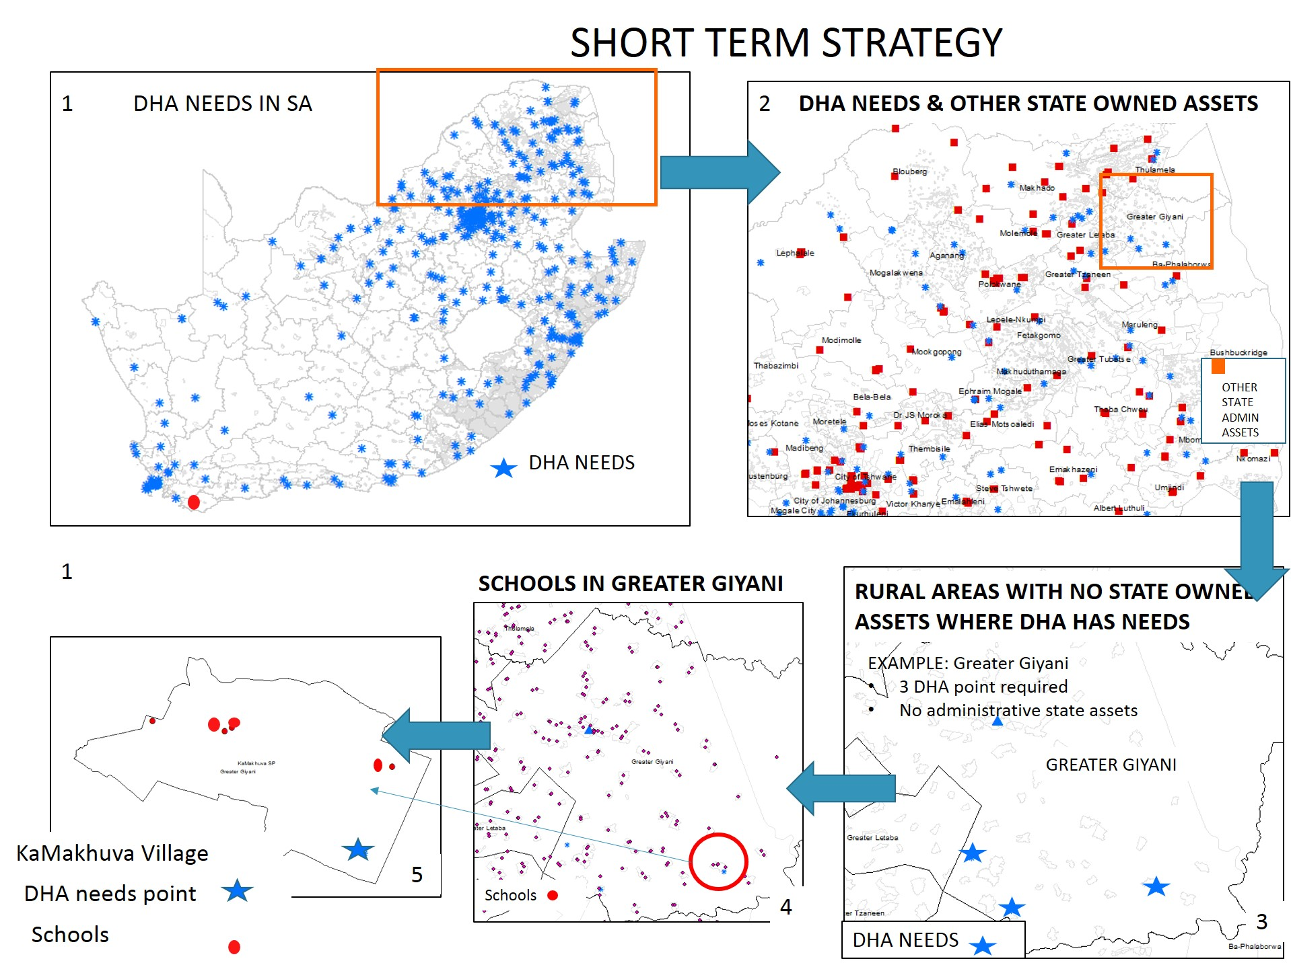

LONGER TERM STRATEGY FOR NEEDS OVER 400m²- GOVERNMENT PRECINCTS
The municipalities targeted for the LONGER TERM Government Precinct Developments are depicted in the image below:
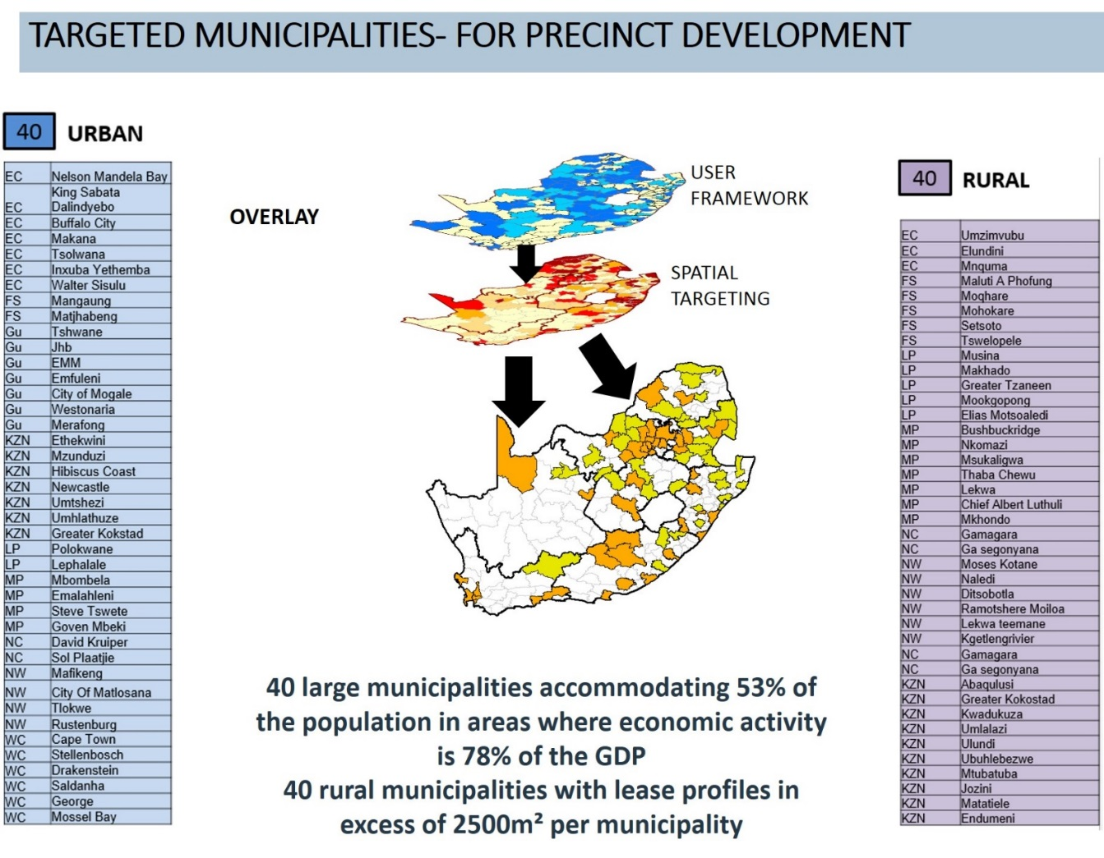

INTERIM SOLUTION – ACCESS POINT FOR MOBILE UNITS IN DEEP RURAL AREAS
The following images demonstrate the concept for an interim low cost solution where National Government do not own any buildings that could be shared with DHA. This solution is proposed where the needs are too small to justify a Government precinct.

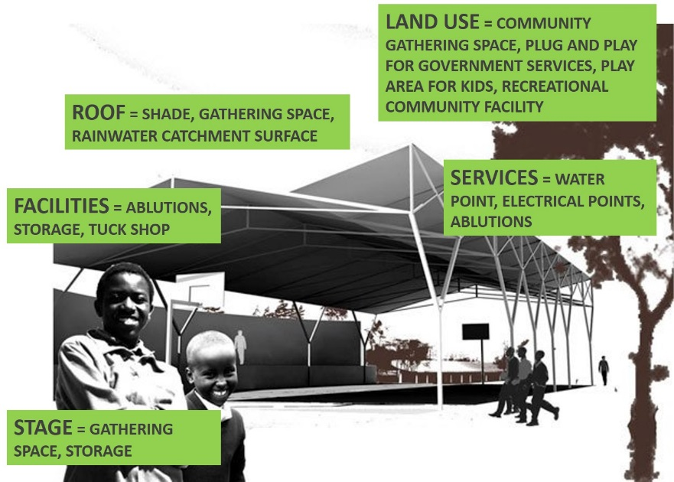 | 