Community benefits from trophy hunting: realities vs pretence
By Dr Louise de Waal - EMS Foundation

Slide 2
It is generally accepted that the greatest threats to wildlife and nature conservation is the ever-increasing footprint of the human population that is set to double by 2050. This has led to habitat loss, degradation, and fragmentation, as well as so-called “human-wildlife conflict”. Trophy hunting acts as an added threat to wildlife already under intense pressure from people.

Slide 3
Weak governance, corruption, lack of transparency, lack of a critical mass of scientific data, illegal activities, greed, current government policies, and poor monitoring and enforcement are some of the concerns around trophy hunting in Africa that hamper ethical conservation and prevent communities from receiving ethical and sustainable benefits, and these require urgent action and reform.

In the APNR, current and historical mismanagement, breaches of the Greater Kruger Hunting Protocols, and sometimes even negligence during trophy hunts, reflect not only badly on the hunting fraternity, but also on the photographic safari or eco-tourism sector in the Greater Kruger National Park and South Africa as a whole.

Slide 4
Examples include:
- Early 2005, an elephant hunted in the Klaserie was shot 21 times before it succumbed.
- In June 2005, an American hunter wounded an elephant in Balule, but only killed it 24 hrs later.
- In March 2006, a lion, one of a well-known pair known as the "Sohebele brothers" was shot and wounded in the Umbabat, but the hunter was unable to kill the animal, as its brother refused to leave the scene. The hunter later repeatedly drove a tractor at the lions in an attempt to separate them but failed. The lion was killed by rangers only the following morning.
Later that month, a large, one-tusked male elephant was shot and wounded by a Spanish hunter in the Umbabat, believed to have fled into the KNP and was not found since.
- March 2013, an elephant was shot in the very close proximity to Ingwelala’s eastern boundary. The wounded animal ran directly south towards Motswari Lodge and was followed by the hunting party, who continued to fire 20+ shots before it was finally killed in the close proximity to the lodge with many guests. Motswari Lodge was never informed that this hunt was to take place and was caught completely off guard. The effect on their guests and staff was devastating.
- In June 2018, an incident of non-compliance in the hunt of the male lion in Umbabat, a pride male of approximately 6 years old. It’s a contravention of the hunting protocol, which stipulates that pride males under the age of 8 years cannot be taken.
- In August 2018, a scheduled elephant hunt conducted in Balule led to the illegal killing of a collared male elephant. Mpumalanga Tourism and Parks Authority (MTPA) laid criminal charges and the warden was subsequently convicted.
- In December 2018, a young elephant was shot multiple times in Balule in front of photographic safari tourists staying at a neighbouring property.

These incidents reflect a long history of non-compliance with the Greater Kruger Hunting Protocol.

Slide 5
Overview of trophy hunting in South Africa

The proposition that trophy hunting is imperative to the future of conservation and to generate local community benefits has generally been developed and accepted without compelling empirical support. A lack of reliable information on its economic significance is also apparent within South Africa’s trophy hunting industry.

The total number of foreign hunters South Africa receives annually is about 9,000 (2015 - DEA), killing around 54,000 animals per year and providing 5,000-6,000 jobs.

As is evident from the figures in this table, there is no consensus on the gross annual revenue from trophy hunting in South Africa and estimates range from US$ 100 million in 2005, to US$68 million in 2012, and US$120 million in 2015.

We also need to question the accuracy of some of the data obtained using wide ranging methodologies. Often the only data from grey literature is available or provided by trophy hunting associations, who have a vested interest in the industry and therefore the potential for bias is huge

Gross annual revenue | Number of jobs supported | Source
US$ 68 million in 2012 |  | Di Minin, et al., 2016
US$ 100 million in 2005 | 5,000-6,000 | Lindsey, et al., 2006
US$ 120 million in 2015 |  | DEA,2018 *
US$ 130 million in 2015 | 12,000 | PHASA, 2017
US$ 206 million in 2014 | 12,742 (FT & PT) | Southwick Associates, 2015  On behalf of Safari Club International
* source unvalidated but quoted by DEA in Portfolio Committee colloquium on captive lion breeding.

Slide 6
Economic insignificance of trophy hunting

The significance of the economic benefits associated with trophy hunting however needs to be compared to the benefits of the whole tourism spending and other economic aspects of South Africa as a country.

In 2017, the total contribution (direct and indirect) of the tourism sector in South Africa was US$31 billion or 8.9% of South Africa’s GDP, according to the World Travel & Tourism Council.

The tourism sector supported directly 726,500 jobs and this number is expected to increase to 980,000 jobs by 2028. The total contribution of the sector to employment, including jobs indirectly supported by the tourism industry, was 1.5 million jobs in 2017 or 9.5% of total employment. This means nearly 1 in every 10 working people in South Africa is dependent on tourism for their livihood.

Various people have calculated the trophy hunting income as a percentage of this tourism revenue for South Africa, which is about 1.3%. So, economically speaking trophy hunting can be considered as a marginal activity, but one that requires a lot of protected space.

With about 8,000-9,000 arrivals per year, South Africa has one of the highest numbers of foreign trophy hunters in Sub-Saharan Africa, but in contrast receives 10.4 million foreign tourists per year (2017). This means that for every trophy hunter, South Africa receives 1,200-1,300 ordinary tourists.

By 2028, international tourist arrivals in South Africa are forecast to increase to 14.6 million (World Travel & Tourism Council, 2018). The annual growth in tourist numbers over one year is about six times larger than the total annual economic value of all trophy hunting tourists in South Africa (Murray, 2017).

Justification of trophy hunting in the Association of Private Nature Reserves (KNP western boundary)

At present, trophy hunting takes place in some sections of the APNR, namely, the Timbavati, Klaserie, Umbabat and Balule.,

Slide 7
They justify trophy hunting as a means of generating revenue for the reserve’s operating budget, which includes security and anti-poaching, however this affects all reserves in and around Kruger. The APNRs that allow trophy hunting have three funding streams, photographic safari tourists, hunters and landowner levies.

In 2016, the Timbavati generated 61% of its revenue for the reserve’s upkeep from trophy hunting, claiming that 46 trophy hunters yielded more revenue per capita than the 24,000 photographic tourists.

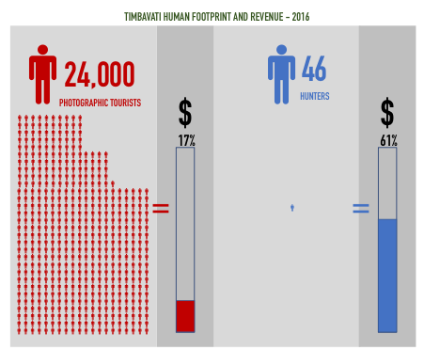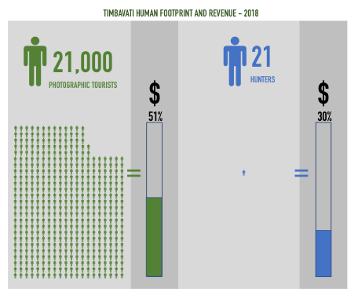

However, in the face of reducing trophy hunter numbers, they make up for revenue shortfall by increasing the visitor’s conservation and landowner levies – they obviously found strength in numbers to readdress the imbalance and at the same time making an extremely good case against trophy hunting.

In 2018, the photographic safari tourists outnumbered their hunters by 1,000 : 1. Hence, by changing their conservation levy model from a “per stay” to a “per day” model and by increasing the fee from R160 to R328 per person, the Timbavati now creates more than half of their operating budget from eco-tourism, whilst its environmental footprint remained more or less the same.

They will further increase the conservation fee to R368 per person per day this year, boosting their eco-tourism income further. This conservation fee is now also more in line with that for KNP, which is ZAR372 per person per day.

This clearly demonstrates that trophy hunting is not absolutely essential for the upkeep of the reserves.

Slide 8
The Timbavati further justifies their consumptive wildlife use by the substantially growing wildlife numbers on their reserve since 1998, which they establish by annual aerial census. Their infographics show a more than 145% growth in overall animal population and 240% growth in elephant population.

Although the wildlife numbers may well have grown over this 20-year period, this two-point approach is however fundamentally flawed. Wildlife numbers fluctuate as a result of environmental changes and hence we need to look at population size as a trend over a period of time.

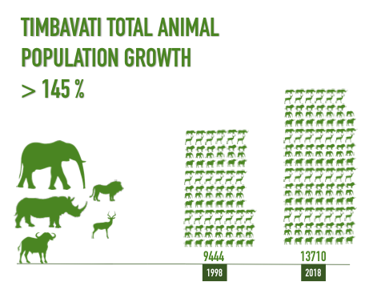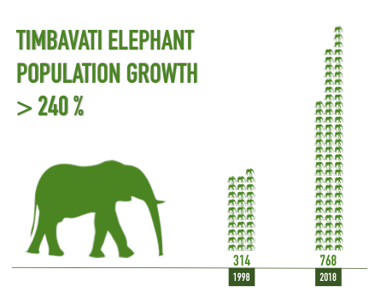

Slide 9
In this case, if we look at the precipitation in the Kruger in the decade preceding 1998, there were four drought years, three with pronounced below-average rainfall (1991, 1992 and 1998), which could have had major implications for wildlife numbers.

It is also important to note that in 1997 KNP started closing down artificial waterpoints principally to naturally control elephant numbers without resorting to culling, with over half of its water holes now closed down. Elephants will naturally move into areas where water is more freely available, such as the Timbavati, where almost all lodges have artificial waterpoints.

Furthermore, it is around the same time when the fences between Kruger NP and most of the private nature reserves came down.

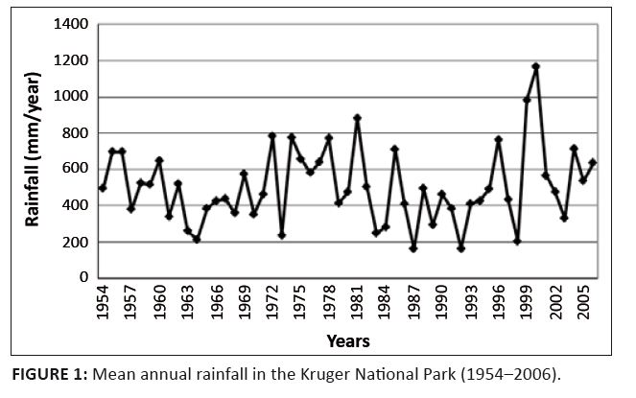 (Source: Seydack et al., 2012)

Slide 10
Why have they cherry picked 1998, as a starting point against which to measure changes in wildlife populations? This baseline was obviously significantly impacted by the severe droughts in the Kruger with 1998 an exceptional El Niño year, impacted by the closure of water holes and the dropping of the fences, and therefore shows inflated the wildlife population growth as represented in these infographics

Slide 11 - Benefits from tourism to local communities

It is widely accepted that the creation of incentives for local communities to engage in wildlife conservation, the sharing of conservation benefits, and establishment of mitigation measures, is essential to reduce poaching, human-wildlife conflict, agricultural encroachment on wildlife habitat, and to ensure the sustainable and ethical management of any wildlife area.

Slide 12
One of the objectives stated in the Greater Kruger Hunting Protocol for trophy hunting is “to support social investment initiatives within communities as per reserve specific programmes” (October 2018). It continues that “hunting within the GKNP reserves are guided through the following principles…., including the commitment to local community involvement and empowerment, contributing a percentage of proceeds to identified community development programmes”.

Slide 13
With a lack of transparency of financial and employment figures from trophy hunting in the APNR, we can only guestimates the true revenue from hunting. There is a general decline in the number of trophy hunters in South Africa, partly due to issues such as bad press from canned lion hunting, airlines banning trophies, Safari Club International putting a stop to canned hunting, and a general global decline in the number of trophy hunters.

The Timbavati states that they received 46 hunters in 2016 dropping to 21 in 2018. However, they still have one of the highest numbers of trophy hunters compared to the other APNRs, and anticipate the number for 2019 at 29 hunters.

However, if all four APNRs receive on average 20 hunters per year, this would equate to 80 hunters in 2018. Using the income stats from DEA presented earlier, trophy hunting in the APNRs would therefore generate less than 1% of the total hunting gross revenue received annually in South Africa, i.e. about US$1.2 million annually for all APNRs combined. Even if we use the Professional Hunter’s Association South Africa (PHASA) rather generous average spending per trophy hunter in South Africa of US$20,000, the total maximum income would still not be more than US$1.6 million.

Slide 14
How much of this money does actually trickle down to community level and where is the evidence? Who are these Kruger local communities? How many people live in these communities?

From the report Ending Wildlife Trafficking by Hübschle and Shearing (2018), the local Kruger community is estimated at a population of around 2.3 million people. However, we need to be cognisant when referring to local communities, as these constitute by no means a homogeneous group of people.

It is generally accepted that rural communities living in or near wildlife areas rarely benefit adequately from trophy hunting activities (e.g. Lindsey, 2008). Again, little empirical data is available for South Africa to quantify these community benefits.

The trophy hunting APNRs claim that some of their revenue is invested in community outreach programmes, as prescribed by the Hunting Protocol, but there is no transparency in terms of how much money eventually reaches down to community level.

Slide 15
No doubt some money is invested in socio-economic projects, supported by the APNR as a whole, including the photographic safari lodges. A SANParks report on the economic impact of the Greater Kruger Protect Area Network states that limited quantitative data from two private reserves indicate a direct financial investment of ZAR 2.1 million in 2016, but this is consumptive and non-consumptive combined. Some of these projects include the Timbavati Environmental School, Balule Black Mambas and Bush Babies, and the Klaserie Eco-Children programmes.

In addition, to financial and in-kind contributions from the ANPRs to these community development projects, donations are also made by tourists and philanthropist.

SANParks report (2016) goes as far as to say that “social investment does not appear to be a legitimate component of reserve operations and aspect of reserve strategy/management plan”.

The Timbavati states e.g. on their website that for 2019 the revenue earned from hunting two bull buffalos will be donated to the local neighbouring communities, but they don’t specify how much the contribution is. Is it the total spending per hunter or just the permit fee? The other three ANPRs don’t publicly allude to any kind of monetary contribution to community projects.

Slide 16
Segage (2015) concludes that “the Timbavati Nature Reserve is yet to contribute towards local economic development, because its practice is devoid of community development principles”.

A study by Spencer & Goodwin (2007) into the impacts of private sector and parastatal enterprises in and around Kruger National Park demonstrates that isolated efforts from individual tourism companies have little tangible impact on the majority of people living in these highly populated rural communities. However, the impacts can be substantial for the few people who directly benefit from these projects.

Slide 17
We know from letters sent by SANParks in February 2018 to the APNRs in response to their requested “off-takes”, letters obtained through the PAIA process, that SANParks commented on various non-compliance issues relating to the Greater Kruger Hunting Protocol for all four APNRs.

SANParks specifically asked for further information from Balule and Umbabat on the following governance issues relating to local communities:

“Report on how revenue generated through off-takes was spent. KNP cannot comment on the revenue report received, since it is not clear from the report how the various [APNR] sub-regions, or the [APNR] as an entity, regulate and monitor income generated as result of the animal off-takes. It is also not clear towards which conservation, management and socio-economic activities the revenue generated is being directed.”

However, LEDET and MTPA are ultimately responsible for verification of these issues and thus enforcement of legal agreements, like the Hunting Protocol is absolutely vital. The debacle among others with Skye shows that this is not being done.

Slide 18
Realistically, a marginal industry like trophy hunting can never make a meaningful contribution to a 2.3 million large local population, which continues to grow.

Slide 19
Successful eco-tourism sector in the APNRs

As said earlier, the private reserves bordering the Kruger also offer photographic safari opportunities to tourists in many upmarket lodges. The Timbavati for example received 21,000 photographic tourists against 21 trophy hunters.

The eco-tourism sector in the Greater Kruger is a growing industry. Only a couple of weeks ago Tourism Update reported on &Beyond opening another upmarket lodge in Sabi Sand.

The Association of British Travel Agents (ABTA) annual travel trends now talks about sustainability and responsible tourism going mainstream in the international holiday market, including more focus on environmental governance, welfare of animals and social enterprise projects. All boxes ticked by the photographic safari industry.

Slide 20
There are many examples of great socio-economic community initiatives within the Great Kruger, for example:
- SANParks charging a 1% community levy on top of the cost of accommodation and activities to uplift communities in and around the Greater Kruger.
- The newly established Tourism Conservation Fund is set up to address the non-inclusion of South Africa’s rural neighbouring communities into the tourism and wildlife economies at scale with voluntary contributions from the tourism industry.
- The Singita Community Culinary School that offers commis chef training for graduates from the local community.

These kinds of initiatives make a huge difference in some people’s lives. However, realistically for tourism to make a significant contribution to a local community of 2.3 million people is by job creation, which is a more meaningful way of uplifting communities.

Slide 21
Unemployment in the local municipalities neighbouring the ANPRs and in particular youth employment is high, some figures indicate unemployment up to 50-65% (SANParks, 2016). The five APNRs collectively employ 326 people on a permanent basis, of which 95% (311) are local, plus 54 outsources employees (primarily for security).

A SANParks report (2016) states that consumptive tourism operations have relatively minimal employment needs.

IUCN/PACO research shows that photographic safaris or eco-tourism creates 39 times more jobs than the trophy hunting for the equivalent surface area (2009). It would therefore make sense to increase the eco-tourism footprint within the APNR to uplift local people through employment and skills development.

Slide 22 Potential reputation damage to the eco-tourism industry in the APNRs

Ross Harvey (2018) from the South African Institute of International Affairs looked at the potential damage to Brand SA as a result of the captive predator breeding industry. He concluded that the opportunity costs and negative externalities associated with the predator breeding industry may, along with other threats facing wild lion survival, undermine South Africa’s brand attractiveness as a tourism destination by up to ZAR 54.5 billion over the next decade.

Even if the potential reputational damage is only a small proportion of this ZAR 54.5 billion, the losses would be significant, especially as much of this tourism revenue currently aids conservation objectives in large wilderness areas, such as the Kruger National Park and the KZN reserves.

Slide 23
The negative publicity around trophy hunting in general and the on-going irregularities in the APNR, like the recent Skye lion hunt in Umbabat and the Balule elephant hunt, can cause serious reputational damage in exactly the same way as the captive predator breeding industry. It can bring the profitable and successful photographic safari tourism sector in the APNRs and Kruger itself in disrepute.

These are only two of the recent examples that got into the public domain. The lack of transparency and openness by the trophy hunting industry generally means that many more transgressions and illegal activities may be taking place, but these are kept out of the public space.

The reputational damage that trophy hunting does to the income of the upmarket photographic safari lodges and local communities is the main reason why the Sabi Sand chose to ban trophy hunting on their reserve. They now raise all their income from the gate fees, bed nights and levies.

Furthermore, in the ANPR, where consumptive and non-consumptive wildlife use is combined, hunting may indirectly generate negative net conservation outcomes, by reducing wildlife populations, removing individual animals most highly prized by photo tourists, and/or driving wildlife to flee or hide from humans.

Slide 24
The economic value of iconic species for the photographic safari industry should not be underestimated.

Dereck Joubert worked out the value of a lion as a trophy and compared that to the lifetime value for photographic safaris (US$ 15,000 and US$ 2 million respectively, excluding the cascading economic effects), meaning a lion alive is worth 130x more than a dead one.

The Sheldrick Wildlife Trust did a similar exercise valuing an elephant poached for its ivory and its tourism value (US$21,000 raw value and US$1.6 million respectively), meaning an elephant alive is worth 75x more than its tusks.

As Balule warden Craig Spencer said to the Mail & Guardian in 2016: “It’s not a great policy to burn your furniture to heat your house”.

Slide 25
I would therefore like to pose the following question: Why would we risk our well-established, successful, growing and highly valuable eco-tourism sector on the western boundary of Kruger for trophy hunting, which is worth a fraction of the overall tourism sector?

Rejecting trophy hunting as a conservation and community development tool is often seen as an impossibility, but it’s not, quite to the contrary, it can actually open up much-needed space for innovation and creativity.

In addition, trophy hunting is believed to have little scope for sustained future growth, so even a small effect of trophy hunting deterring growth in other tourism sectors may overwhelm its own economic benefits (Murray, 2017), especially considering its poor track record in terms of governance.

References
Di Minin, E., Leader-Williams, N. & Bradshaw, C. J., 2016. Banning Trophy Hunting Will Exacerbate Biodiversity Loss. Trends in Ecology & Evolution, 31(2), pp. 99-102.
Harvey, R., 2018. The Economics of Captive Predator Breeding in South Africa, s.l.: South African Institute of International Affairs (SAIIA).
Hübschle, A. & Shearing, C., 2018. Ending Wildlife Trafficking: Local Communities as Change Agents, Geneva, Switzerland: GLobal Initiative Against Transnational Organized Crime.
IUCN/PACO, 2009. Big Game Hunting in West Africa. What is its contribution to conservation?, Gland, Switzerland: Produced by the International Union for the Conservation and Programme Afrique Centrale et Occidentale.
Lindsey, P. A., 2008. Trophy Hunting in Sub-Saharan Africa: Economic Scale and Conservation Significance. In: R. D. Baldus, G. R. Damm & K. Wollscheid, eds. Best Practices in Sustainable Hunting - A Guide to Best Practices from Around the World. s.l.:CIC - International Council for Game and Wildlife Conservation, pp. 41-47.
Lindsey, P., Roulet, P. & Romañach, S., 2006. Economic and conservation significance of the trophy hunting industry in sub-Saharan Africa. Biological Conservation, Volume 134, pp. 455-469.
Murray, C. K., 2017. The lion’s share? On the economic benefits of trophy hunting., s.l.: A report for the Humane Society International, prepared by Economists at Large, Melbourne, Australia.
SANParks, 2016. Assessment of the economic impact of the Greater Kruger protect area network. Phase one.
Segage, Martina, 2015. The effects of nature conservation on local economic development in Timbavati, Mpumalanga Province. MSc dissertation, University of Limpopo.
Seydack, A.H., Grant, C.C., Smit, I.P., Vermeulen, W.J., Baard, J. and Zambatis, N., 2012. Climate and vegetation in a semi-arid savanna: Development of a climate-vegetation response model linking plant metabolic performance to climate and the effects on forage availability for large herbivores. koedoe, 54(1), pp.1-12.
Southwick, 2015. The Economic Contributions of Hunting-Related Tourism in Eastern and Southern Africa, s.l.: Southwick Associates for Safari Club International Foundation.
Spencer, Anna & Goodwin, Harold (2007) Nature-Based Tourism and Poverty Alleviation: Impacts of Private Sector and Parastatal Enterprises In and Around Kruger National Park, South Africa. Current Issues in Tourism, Vol 10/Issues 2-3. pp 255-277.
World Travel & Tourism Council, 2018. Travel & Tourism: Economic Impact 2018 South Africa, s.l.: s.n.

