5. Report of the Select Committee on Land and Mineral Resources (DMR) on the oversight visit to the Free State Province, dated 27 November 2018

The Select Committee on Land and Mineral Resources, having conducted oversight in the Free State Province from 15 – 19 October 2018 reports as follows:

- Oversight Approach

The Committee resolved, during its strategic planning sessions of the 5th Parliament to focus on the provincial and local government level service delivery of national departments. Smallholder and black commercial farming activity has been identified as priority areas for government to support and expand, and large amounts of money has been allocated to this cause. In annual reporting to the Committee, both departments have reported on their activities in terms of financial allocations and expenditure, but seldom provide details of the impact of the expenditure. This oversight is designed to:

- Start a process of identifying the information required from provincial departments, stakeholders and implementing agents in order to assess the impact and sustainability of government expenditure in the agriculture sector;
- Perform specific site visits to visit large projects to be able to gather useful information on the value for money of expenditure; and
- To combine information obtained from these activities with the analysis of programme design and financial allocation currently used to evaluate government service delivery achievement.
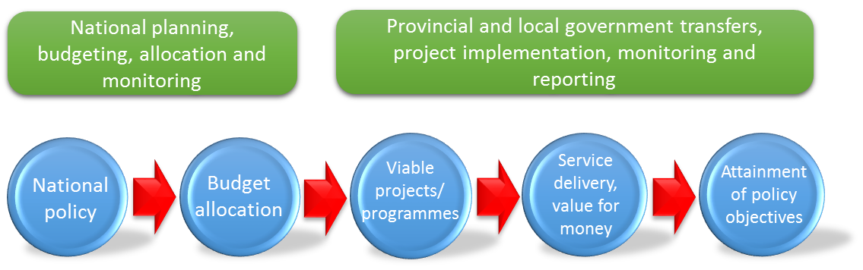
The Division of Revenue Act (DORA) specifies the roles and responsibility of the different spheres of government during the transfer of funds from National and Provincial / Local government, and also highlights what planning, tracking and reporting channels have to exist between the three spheres of government in order to comply with the financial management requirements of the DORA.

The DORA also stipulates the responsibilities of the transferring and receiving officers. These are highlighted in order to inform the committee of the degree to which the national department ought to be informed about activities in provinces should such questions be put to a representative of the national department.

Responsibilities of the national department

- Agree on outputs and targets with provincial departments in line with grant objectives for 2016/17
- Provide the guidelines and criteria for the development and approval of business plans
- Provide template for project registration and reporting
- Monitor monthly financial expenditure by provinces and conduct sampled project site visits quarterly
- Submit monthly financial reports to National Treasury 20 days after the end of the month
- Submit quarterly performance reports to National Treasury within 45 days after the end of each quarter
- Submit annual evaluation of performance report to National Treasury within four months after the end of the financial year
- Oversee and monitor implementation of the grant during ministerial technical committee on agriculture and quarterly review meetings

Responsibilities of the provincial departments

- Provinces to adhere to the conditions of this framework and DORA
- Provinces to report monthly (financial) 15 days after the end of each month, and quarterly (nonfinancial) 20 days after the end of each quarter, and annually two months after the end of the financial year on the progress and achievements of the programme
- Provinces to implement the approved CASP business plans
- All receiving departments must abide by the PFMA, Treasury Regulations and the DoRA when executing projects as well as for reporting purposes
- Provinces to inform the transferring officer of any changes from plans and allocations approved by the Director-General for DAFF, within seven days of such a change, and such changes must be approved by the transferring officer before they are implemented
- Assign and delegate officials to manage and monitor the implementation of the programme before April 2017
- Keep record of projects supported and a farmer register
- Monitor project implementation on a quarterly basis and evaluate the impact of projects in achieving CASP goals
- Submit quarterly performance reports on disaster allocations to the provincial disaster management centres and DAFF, within 20 days after the end of each quarter
- Submit quarterly project performance reports to DAFF

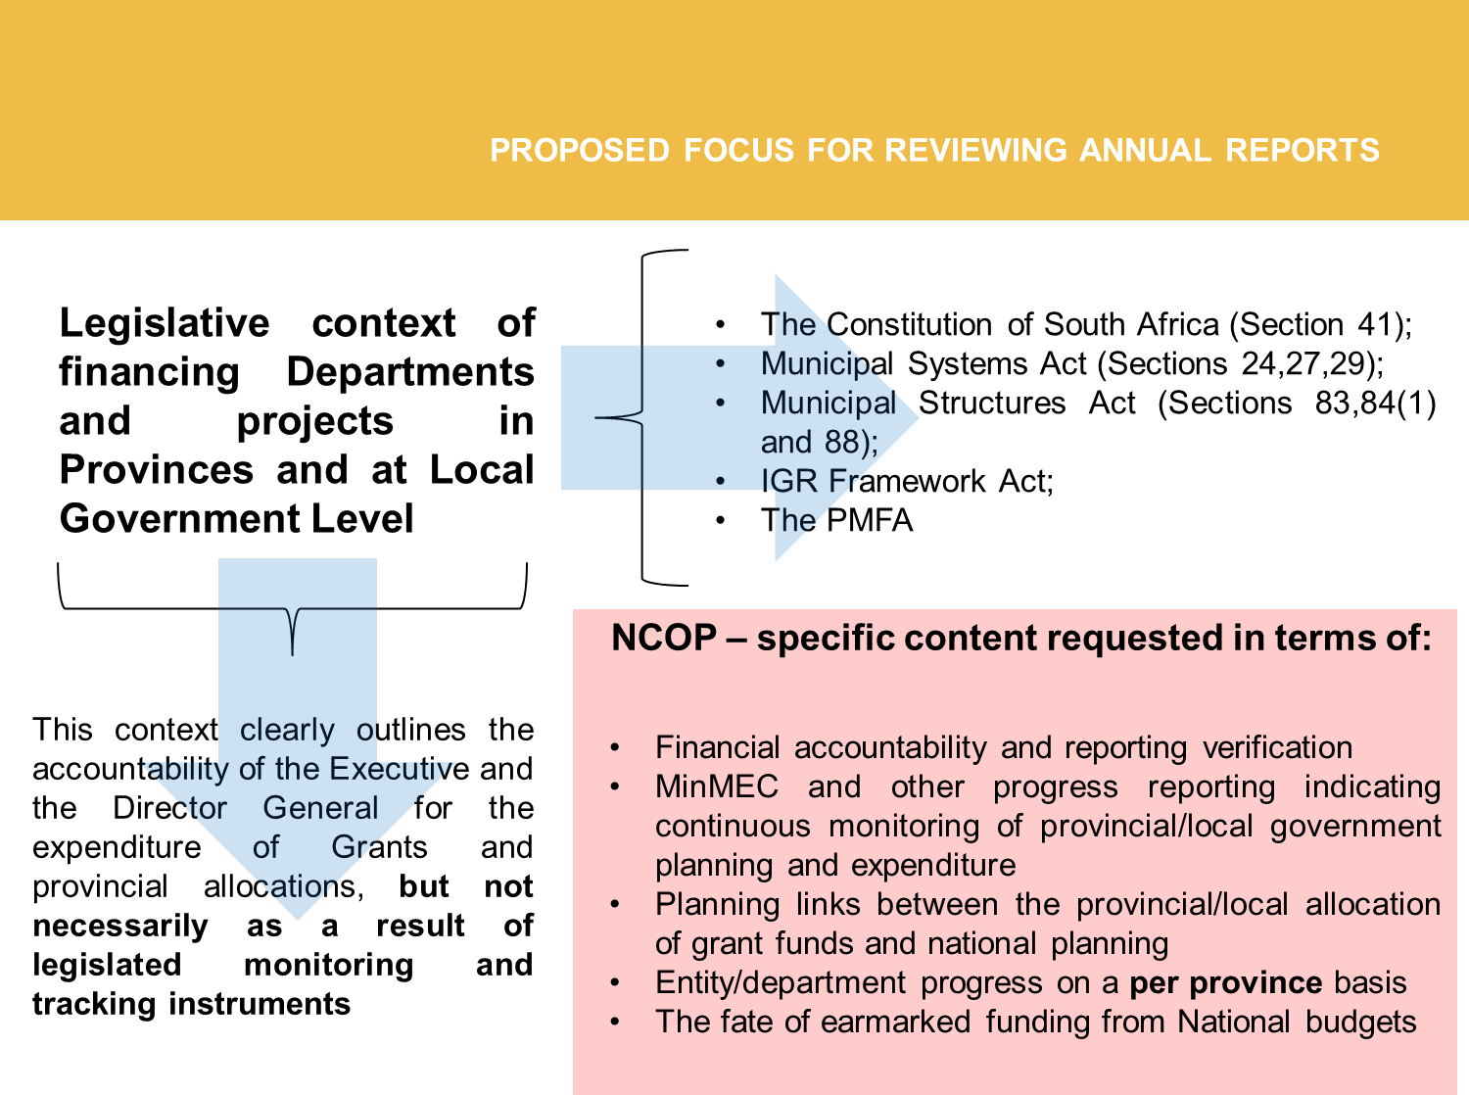
To recap, therefore, the Committee, in line with the proposed oversight mechanism developed during strategic planning, resolved to focus on the legislative context of financing Departments and projects Standing Committees.

- A review of the state of IGR and the challenges/successes experienced in provinces with attaining medium and long term strategic objectives of government planning and expenditure
- Legislative review of the legislation currently governing the management of provincial budgets and reporting and monitoring structures in existence between provincial governments and the Executive.
- A review of the processes followed during the allocation and release of earmarked funding and grants to provinces
- The effectivity of Executive oversight over provincial expenditure in order to ensure that Provincial and National priorities and Annual Reporting targets are aligned. Alternatively, in the absence of clear correlation between National and Provincial Annual Reporting, a critical evaluation of the reporting on targets as presented by the Executive
- A critical evaluation of the link between provincial and local government priorities and National-level planning and reporting.

- Background and Introduction

The Select Committee prioritized agriculture support as well as rural development and land reform projects during its strategic planning session this year, but also through-out the 5th parliament term. The Committee has been briefed by both the Department of Agriculture, Forestry and Fisheries, as well as the Department of Rural Development and Land Reform on programmes designed to support emerging black farmers, but reports received by committee members from their constituencies creates a picture of poor delivery related to these programmes. The Departments presents national figures to the committee, but are seldom able to provide details on provincial-level delivery.

The Committee resolved to visit the Free State province in order to investigate the efficiency of programmes of DAFF and DRDLR there. This province has not seen any committee oversight visits during the 5th parliament. The Committee deemed it an urgent necessity to visit this province, but also to ascertain for themselves how the province is fairing in terms of farmer support. The committee had noted, with concern, recent reports that Agri-Parks, meant to support emerging farmers with advice, resources and market access, was dysfunctional in at least two provinces. It was therefore decided that the Committee would use its first available oversight week to visit the Free State province in order to determine the state of farmer support there.

The delegation consisted of the following members of Parliament, Mr OJ Sefako (Chairperson, ANC), Ms Z Nchita (ANC), Ms E Prins (ANC), Mr JP Parkies (ANC), Mr EM Mlambo (ANC), Mr CFB Smit (DA), Ms C Labuschagne (DA) and Parliamentary support staff, Mr AA Bawa (Committee Secretary), Mr J Jooste (Content Adviser), and Ms A Zindlani (Committee Assistant).

- Aims and Objectives of the Committee

The Department of Agriculture, Forestry and Fisheries have launched a large array of efforts, programmes and interventions around the development of small-scale commercial agriculture, interventions to combat food insecurity and efforts to improve the productivity on redistributed farms. Central to many of these interventions has been the creation or promotion of co-operatives (in conjunction with the use of similarly-constituted Communal Property Associations (CPAs) by the DRDLR). The only thorough investigation into co-operatives, and annual reports on CPAs indicates that both are not performing as organizational structures. It will be impossible for government commitments to be reached when the structures into which recipients of support are structured are prone to failure. In the 2017 SONA, the President referred to the launch of an initiative to lift 450 small-scale farmers into the commercial agriculture sphere. While commendable, the statement did not provide details on the funding method or indeed the departmental programme responsible for the initiative.

The Department has as one of its goals set out in the NDP the creation of 1 million jobs in agriculture and returning a million hectares of under-utilised agricultural land to production. The performance indicators of the Departmental budget do not speak clearly to these objectives and further details are required regarding putting land into production, as annual targets are stated without evidence required that previous land returned to production is still being utilized. The job creation targets of the Department is clearly less than the million jobs set as an NDP target in past years. It is also known that activity and employment in agriculture is stagnant or decreasing, seldom showing any sustained trend of growth. Economic stimulation in a sector such as agriculture, which employs significant numbers of the rural workforce, need to be improved and it is not clear how this “status quo” budget will achieve this. The financial support set aside for the development of small scale farmers, agri-hubs and agri-villages need to be interrogated further in order to determine whether these are sufficient to reach the stated objectives for these programmes. It is a fraction of the resources spent by the commercial sector each year, thus it is debatable whether the targets set in the budget is realistic.

The Committee is actively tracking the progress of Agri-villages and associated Agri-hubs). These support-hubs are critical in uplifting and developing black commercial, small-scale and subsistence farming efforts around the country. The 2017/18 ENE gives a useful breakdown of the programme’s implementation to date, highlighting that:

- Agri-hubs are expected to contribute to government’s targets of creating 1 million new jobs in rural economies by 2030, through the development of 300 000 new small-scale farmers and the creation of 145 000 agro-processing jobs by 2019.
- Since the inception of the initiative in 2015/16, approximately 10 566 smallholder farmers have been identified to benefit from agri-hubs, and 69 692 hectares of land has already been distributed.
- A total of R2 billion per year, over a 10-year period beginning in 2015/16, was allocated for the development of agri-hubs in 44 districts.

- Meeting with the Department of Agriculture, Forestry and Fisheries (DAFF) and the Department of Rural Development and Land Reform (DRDLR)

Prior to departing on the oversight, the Committee secretariat sent communications to the DRDLR, DAFF and provincial department. Specific information was requested in terms of budget, planning, monitoring and reporting structures that would be in place to monitor the expenditure of conditional grants and the provincial department’s budget. The request follows on the planned objectives of the oversight. It is repeated in the report in full for emphasis:

The Strategic objectives of the Provincial Department contains the following targets, set for attainment by 2020. Please note that these are not all the objectives but selected ones only. Considering that 2018 is nearly at an end, the Committee feels that it is a good time to request an update on progress made towards completion of the objectives:

- To provide comprehensive agricultural services to 14 700 producers by 2020
- To ensure household food and nutrition security to 25 625 households by 2020
- To ensure healthy animals, food safety, and access to export markets through provision of veterinary service to clients by 2020.
- To improve the agricultural production through conducting, facilitating and coordinating 16 mediums to long term research and technology development projects by 2020
- To provide Agri-Business support as well as macroeconomic and statistical information to 2 008 clients by 2020
- To enhance agricultural education and training capacity by 2020
- To plan, facilitate and coordinate the development of rural enterprises and industries through establishment of 5 Agri-Villages by 2020

Of greatest interest to the committee is the development of Agri-Villages, the support for small-scale and black commercial farmers and the attainment of food security targets for households. When presenting to the committee, it would be appreciated if the department expands on how it quantifies whether an objective is being met and how targets are being maintained, if met. Breakdowns in tractors, for example, need to be accounted for with regards to farmer support and it cannot be assumed that the target is met if 30% of the tractors originally acquired are now out of commission.

The Committee is also interested in the expenditure, and management of expenditure, of conditional grants in provinces and therefore is requesting a briefing from the relevant stakeholders on the application of conditional agriculture grants in provinces, with reference to where targets mentioned above are being met without the use of grant funding. Grants funding in the DORA is highlighted as being for CASP, Ilima/Letsema and Land Care projects. The National Department is increasingly presenting annual reporting information to the committee in the form of expenditure, with insufficient levels of detail regarding how these targets are being monitored, tracked and reported on between spheres of government. DORA prescribes specific planning, monitoring and financial management actions from National and Provincial government transferring and receiving officers during grant expenditure and the committee is interested in receiving more background regarding the compliance with this piece of legislation.

The Departments proceeded with presenting general overviews of departmental activity, funding allocations and projects of the Department (provincial). During a break in the presentations, the Committee secretariat requested a meeting with members in order to highlight the fact that the presentations were not focused on the oversight topic and that the information being provided will not assist the Committee. The Departmental delegation was asked whether they had received the communication from the Committee secretariat and whether any of the requested information was available for members to interrogate. It was communicated to the Committee that the specifics requested was not prepared. The Committee received the presentations and interrogated the information requested, but in terms of the oversight objective, did not receive the kind of input required to make a detailed assessment of the planning, allocation, monitoring and reporting on farmer support allocations.

  - The Department highlighted some challenges to projects in their presentations, which included:

- The inheritance of non-compliant projects from former homelands where correct environmental impact assessments were not performed, and costly non-compliance orders have to be dealt with in order to complete projects;
- Non-payment of services on some projects were also a challenge, even when the Department had made attempts to settle the outstanding accounts in order to re-establish projects. When this offer was made, it became apparent that the entity it was supporting no longer had the required tax clearance required;
- The development of agri-hubs are in planning phase, but in some cases are taking longer than expected as a result of the delays caused by adhering to all impact assessment requirements. The R2 billion per annum made available is a national total and will be released to provinces once project designs are approved and all required applications have been made;
- Roughly 48% of supported 1 Hectare one household farmers are female, while data on women supported in other projects were not directly on hand. Support is provided to households and CPA’s. The Department was not in a position to provide a final breakdown of the total number of women farmers supported;
- The Department stated that they have experienced challenges with mechanization support. It stated that the life expectancy of tractors supplied did not exceed 5 years and that many new tractors were delivered in a faulty state. The Committee did not accept this explanation, especially in terms of faulty equipment being delivered and not returned. It was later noted that broken-down tractors observed at one site visited were of a manufacturer that did not have any service support in that region. This would have obvious implications for even routine maintenance. The Department did not provide clarity on exactly how equipment maintenance is budgeted for and who (recipient or Department) is responsible for maintenance;
- The Department stated that financial constraints limited the extent to which they could support emerging farmers. This is what resulted in the reduction in the target of 50 farmers to be supported per financial cycle. The number was reduced to 24. The Department further highlighted the fact that many farmers that has been supported in the past are slow to become self-sustaining, even though the Department felt that they should be able to operate without its support. There was thus a challenge with what farmers and the Department consider to be a point of self-sufficiency;
- The Department had been requested to provide a detailed and up-to-date asset register to verify where all tractors provided to farmers were located, and in what state of repair these were. While the DRDLR officials present stated later that such a register could be produced for projects that they supported, no response was received from DAFF in this regard;
- In discussions with Officials from the Provincial Department, it was stated that all projects approved by the Provincial Department for financial support is presented to Treasury. The latter gazetted approved projects. It would therefore be possible to study such gazettes in order to obtain information on the type of ventures supported, and the financial allocation made. This information, however, does not answer questions on sustainability of projects after support, and the efficacy of support supplied;
- The Committee was informed that agricultural economics dictated that not all commodities in the province can be economically supported. Selected commodities such as red meat and a small number of traditional crops had been identified for support;

  - In the communication sent to all Departments, the Committee requested an opportunity to meet with farmers that have benefitted from conditional grants administered by the DAFF. The meeting was supposed to provide greater insights into the experiences of the farmers themselves. As stated in the introduction of the report, the Committee wished to develop a system of oversight-based verification of reporting received from the DAFF during annual reporting. These reports detail expenditure without providing any information regarding the impact of expenditure. The Committee hoped to gather information on:

- The production impact of assistance. The Committee is interested in determining what changes in agriculture outputs result from grant support, as this data is not supplied in Annual Reports;
- The duration of support and its impact on sustainability. Reporting by DAFF would outline support given in a financial year, but would not outline which enterprises became self-sustainable as a result of support;
- Challenges experienced by grant recipients. The Committee was hoping to interact with farmers about the duration, amount and type of support received. It was expected that this discussion would assist the Committee in developing a better understanding of farmer requirements compared to grant focus. A disconnection between these two aspects of funding planning could then be contrasted in order to comment on the applicability of current grant funding expenditure and focus.

Unfortunately, the DAFF failed to arrange any such grant recipients to meet with the Committee. The request was sent in a communication that was received by both DRDLR and DAFF. The DRDLR correctly interpreted the communication as a request from the committee to interact with recipients of conditional grant funding (as administered by the DAFF), but officials from DAFF present at the meeting appeared to have interpreted the request differently.

There was no opportunity to arrange to meet any farmers at short notice after the omission of DAFF to prepare for the afternoon session was discovered and this aspect of the oversight was abandoned.

- Site Visits

The two districts that will be visited by the Committee are Thaba ‘Nchu and Xharieb. Both districts were earmarked for the development of Agri-Parks, and are also the location for a number of grant-funded projects and CPA’s. The following sites were visited, Thaba Nchu Abbatoir; Khumo Farm; Milton Farm; and the Sedibea Irrigation Scheme.

  - Thaba Nchu Abattoir

    - Overview of the Project

As previously explained by the DAFF, the abattoir which was constructed by the previous Bophuthatswana government forms part of an Agri – Hub being established in Thaba Nchu (Mangaung) by the department which will eventually consist of an abattoir, pack house and retail facility.

The project is a long term initiative with upgrades to the abattoir valued at R30 million. The project planning is in an advance stage and upgrades has gone to tender. The construction of the second and third phase of the project, being the pack house and retail facility should be commencing in 2021 and 2024, respectively. The total number of jobs created during this project will be 110. The structure as it was developed is not compliant with current regulations covering abattoirs, and a significant part of current activity is aimed at ensuring that the enterprise is made compliant with all regulations.

    - Observation by delegation

After a tour of the facilities, members were satisfied that the project was established and designed by taking into account the market commodity of the region and the needs of the community. In response to questions posed by members of the delegation, the project supervisor explained to the delegation that to date, R6 million has been spent and that the project is being delayed because of a Section 24G non – compliance fines issued to them by the Department of Environmental Affairs (DEA). The non-compliance relates to the nature of the development prior to the intervention of the Department, and efforts to clarify the situation with DEA has become a protracted affair. Members were however concerned about the amount of “downtime” (1 month) when the upgrades of the current facility are joined to the new abattoir.

    - Recommendations

The delegation requested the DAFF to intervene and assist the beneficiaries by becoming compliant and engage with the DEA on the issue of the Section 24G non-compliance fines.

  - Khumo Farm

    - Overview of the Project

The farm was established in 1988 by the Department of Agriculture, Forestry and Fisheries, and supported by the Provincial Department of Agriculture and Land Reform from 2012 until the 2017/18 financial year. The farm is currently owned by Mr R Thekiso and his family (6 beneficiaries) who employ three full time workers, is situated on a homogeneous agricultural area north of Thaba Nchu that is characterized as having a marginal production potential. Most of the region is semi – arid land, experiencing frequent dry spells and with soil susceptible to degradation. The current financial investment by the Department in the project stands at R 6 431 566.

The farm is situated on 669 hectares (ha) of land of which 437 is natural grazing and the remaining hectares being arable land. The farm is fully fenced and subdivided into 18 grazing camps and 10 arable parcels of land, all provided with stock watering systems, implements and inputs. The farm currently boasts 187 head of cattle, 87 sheep and 21 pigs. Beneficiaries have planted and harvested 95 ha of maize to use for the making of their own feed. The current maize production is 2.3 tons per ha and 35 ha of eragrostis grass which is used for as roughage in their feed.

    - Observation by the Delegation

The delegation was pleased to see that Mr Thekiso was able to reach self-sufficiency and enter the commercial market. After a tour of the facility, members were all in agreement that Mr Thekiso was to be commended for taking the initiative of expanding his activities to include that of making their own feed which was now being sold to also supplement their main farming operation. The delegation however expressed concern about the huge stock theft problem in the area as the magnitude of these stock thefts were able to cripple emerging farmers.

    - Recommendations

The delegation requested both the DAFF and the DRDLR to assist with identifying solutions to the stock theft issue and engage the South African Police Service for a planned intervention. The delegation also recommended that the DAFF should assist Mr Thekiso with maximizing the use of his land by perhaps diversifying into other farming ventures.

  - Milton Farm

    - Overview of the Project

The Milton farm is a privately-owned farm that is managed and run by the Kodisang family. The farm consists 311 hectares (ha) of which 200 ha is arable. This section of the farm is used for pasture production for livestock supplementary feeding and 111 ha is used for grazing purposes. The farm has a small borehole which can be used for irrigation, supported by water from the Sediba Dam, which also happens to border onto the farm. The farm was previously (2009/10) supported by the DAFF with water reticulation and fencing. The lack of rain in the region has had a negative effect on their maize, sunflower and beans production but with the help of late rains, were able to grow 20 ha of sunflower.

In 2018 the DRDLR through the Rural Enterprises and Industry Development (REID) programme supported them entity with 19 Bonsmara cows, a bull, Medication and feeds, as well as being afforded the opportunity to be trained in Business skills.

    - Observation by the Delegation

The delegation noticed that most farming projects only used Bonsmara cattle, highlighting the need to keep various types and breeding them accordingly. Members observed that even though the Department stated that Bonsmara cattle was procured for the farm, there were already signs that the herd did not consist only of pure Bonsmara cattle. It was clear that cross-breeding has occurred. This prompted another question pertaining to how cattle were allocated to various projects, which the DAFF explained that the size of the land and the availability of adequate water determined how much cattle can be kept. The department also explained that although the project is a crops production farm, they do not want to start a new cattle farm in close proximity to others, potentially starting a competition with other farmers in the area.

Members of the delegation voiced their concerns when divergent answers to their questions were given by the department and the project beneficiaries, prompting members to become suspicious. Additionally, it was noted that the project was in urgent need of functional implements and tractors, but on the farm were 7tractors in various states of functionality and disrepair. During the visit to this project, members of the delegation struggled to ascertain the truth as no one could explain why a project of that size was given 7 tractors and especially why they were laying idle.

    - Recommendation

The delegation requested that the DAFF compile a report for the Committee on how 7 tractors ended up on this small farm when tractors were supposedly provided to various farming projects across the district. The department was further instructed to provide the Committee with a full provincial report on how many tractors were purchased; how many of them were new and how many were used tractors; where they were purchased from; what type of maintenance plan came with the tractors; who were the recipients of these tractors and how many are still in good working together.

The delegation further recommended that after receiving the department’s report, they will return to see what progress was made.

  - Sediba Irrigation Scheme

    - Overview of the Project

The project is located at the Sediba Village, situated 30 km north of the town of Thaba Nchu which was established in 1964 by people forcefully moved from the areas of Mpharane, Phatlha, Lehurutshe and Digogeng. At the time these villages were not organized and thus moved by the authorities to a new area which is today known as Sediba. The new area was divided into two parts, commonly known as Sediba Scheme which had irrigation lands and the Sediba Trust which was situated on dry land. Both the villages are headed by the Barolong Tribal Authority representatives, under the chieftaincy of the Moroka family. The Community was issued with Permission to Occupy documents which is currently serving as a proof that they were given land to erect a house, harvest crops and house and care for livestock.

The Sediba irrigation scheme is located at Sediba and is one of three irrigation schemes in Thaba Nchu, with Feloane and Woodbridge being the other two. The purpose of these schemes was to provide the Thaba Nchu town and surrounding areas with food security in winter and extreme drought. The dam at Sediba was built in 1933 while the irrigation systems was introduced in 1965. The canal was completed in 1966. The original design of the dam allowed the opening of outlet valves, which would release water to furrow canals, thus transporting water from the dam to the croplands employing a flood irrigation technique. There are currently 82 households residing at the Sediba Scheme with another 214 households living on the other side of the dam, which results in a community of 660 inhabitants residing in the proximity of Sediba dam.

In 2015/16, the provincial Department of Agriculture and Rural Development made a decision to revitalise the three irrigation schemes, contracting an implementing agent known as Rekgonna Community Projects which also contracted SMEC to assist with the developing the Project Implementation Plan which was completed in 2016. Soon after, national government tasked the DRDLR to implement the Agri – Parks Programme in all the provinces with the aim to support small – scale agricultural production and stimulate agro – processing in rural areas The programme to be implemented consisted of three parts / components, namely a Farmer Production Support Unit (FPSU); Agri – Hub and a Rural Market Urban Centre (RMUC).

The FPSU is essentially a rural outreach unit with a Agri – Hub, focusing on primary collection, storage, processing and extension services which includes mechanization. The FPSU is designed to have a catchment area of approximately a 30 km radius, with the main FPSU being built at Sediba. The advantages of the irrigation scheme and the access to irrigation water was the main reason why the FPSU for Mangaung was built at Sediba.

    - Observation by Delegation

During their site visit the delegation was fortunate enough to meet some of the local inhabitants who expressed their gratitude because the irrigation scheme when completed will uplift their lives and bring about food security in the area. The inhabitants further explained that even though the dam is not completed, they still get assisted by the DAFF and DRDLR when requested. The delegation was very pleased with what they saw at the irrigation scheme.

    - Recommendation

The delegation requested the department to ascertain how the process can speed up so that the local inhabitant could be assisted sooner.

  - Concluding Remarks and Recommendations by the Delegation

The Committee was able to interact with the Provincial Department of Agriculture and Land Reform officials, as well as officials from DAFF and DRDLR, and even though there were clarity obtained on some matters, the over-arching goal of the oversight trip was not attained.

Despite very clear requests for an opportunity to discuss grant funding support with beneficiary farmers and to be briefed on the mechanisms employed by the provincial and national departments when allocating, spending, monitoring and reporting on grant funding, these requests were not met. Without the opportunity to develop an understanding of how the questions of sustainability, successful commercialisation, increased production or increased employment in agriculture can be assessed. To refresh, the following MTSF targets that the Department of Agriculture and Land Reform are set to be met in 2020:

- To provide comprehensive agricultural services to 14 700 producers by 2020
- To ensure household food and nutrition security to 25 625 households by 2020
- To ensure healthy animals, food safety, and access to export markets through provision of veterinary service to clients by 2020
- To improve the agricultural production through conducting, facilitating and coordinating 16 medium to long term research and technology development projects by 2020
- To disseminate information on research and technology developed to clients, peers and scientific communities through twenty research presentations and twenty one improvement schemes by 2020
- To provide Agri-Business support as well as macroeconomic and statistical information to 2008 clients by 2020
- To enhance agricultural education and training capacity by 2020
- To plan, facilitate and coordinate the development of rural enterprises and industries through establishment of 5 Agri-Villages by 2020

The Committee wanted to be in a better position to determine how the targets are assessed, but the oversight did not provide the information required.

Interacting with officials from the Department, it was possible to determine that in some of the sites that the committee wished to visit, detailed information on the planning, financial allocation and performance monitoring was available. This information was also made available to committee officials after the oversight visit. It is clear from the information received that detailed project management systems were in place for the projects co-ordinated by the DRDLR, and that follow-up questions could be made to officials.

From the Perspective of the Committee’s interaction with DAFF, the information forthcoming was less useful. Apart from providing introductory presentations that did not contain the critical information requested by the Committee prior to the visit, the Department failed to provide any opportunity to interact with farmers. From the information provided during the oversight, it also became clear that there are areas of concerns for the committee, particularly:

- the lack of detail provided in terms of how beneficiaries are supported to become commercialised. The Committee visited two adjoining farms with vastly different levels of support. Milton farm, apart from the 7 tractors and a uneconomically small herd of cattle, had very little other visible signs of support. Khumo farm, by contrast, had received significantly more support in terms of the provision of fencing, cattle, watering troughs, mechanisation and inputs for planting and feed production. DAFF need to clarify how projects are conceptualised and what objectives are to be reached by the support provided.;
- how the mechanisation support is managed. The DAFF could not provide detailed accounts of where all tractors were located, while a single farm visited contained 7 tractors without any sign of significant use for these. In discussions with officials from DRDLR, it became apparent that there are no service agents for Massey Ferguson tractors in the district. Most of the tractors observed at Milton farm that were in a state of disrepair were Massey Ferguson.
- The number of challenges that the provincial department is experiencing in terms of fines being issues by DEA in terms of illegal developments or non-compliance regarding impact assessment requirements is of concern. This was explained in some instances as a result of inheriting projects initiated under previous government structures. This explanation does not resolve all the fines incurred. Such fines are substantial and would not be incurred if due diligence was applied to all projects at all times.
- The Agri-hub developments visited were in an advanced stage of planning. The presentation given by the Department was detailed, and provided good insights into where the focus of the hub will be post-development. The types of commodities that can be supported was identified through careful economic studies, and the rationale behind the economic objectives of the hubs were clearly articulated. What became clear, however, was that the level of provincial specialisation invested into the planning and development of the hub differed substantially from the generic presentation provided to the Committee in the past by national DRDLR. The fine incurred at the Gariep Agri-hub site was, according to opinions expressed during oversight, a result of DAFF ignoring advice not to fence the property earmarked for the development during planning. There is a need to determine what lead to the situation as it has unfolded and whether the non-compliance fine issued by DEA could have been avoided.
- The DAFF did not provide sufficient information for the Committee to evaluate how expenditure of conditional grants are planned, monitored and reported, and what criteria defines the outcomes recorded in the finalisation of projects on supported farms or in support of specific farmers. Without this information, the Committee cannot determine what criteria is used when evaluating grant expenditure. This, in turn, implies that the Committee is not in a position to evaluate whether it supports the DAFF’s annual reporting on meeting of targets of the MTSF. It is a stated objective of the Committee to develop an oversight mechanism that focuses on the value-for-money and impact of grant expenditure by DAFF, and therefore the fact that the Department did not supply the requested information creates delays for the development of an oversight mechanism. One positive outcome of the oversight is the development of a clearer understanding of how approved projects are published. This information will be used to develop an alternative database of funded projects, from where an oversight mechanism can be developed.

Report to be Considered

