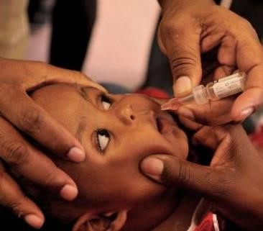
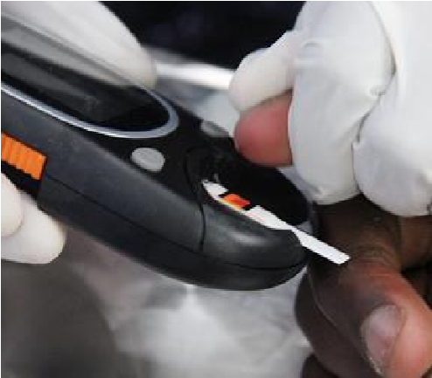
Slide 1
Director: Medical Bureau for
Occupational Diseases
October 2018
Class Action Settlement for Silicosis and TB
Dr Nhlanhla Mtshali
- Team
- Settlement
Overview
- Readiness activities
Slide 2

Team
- Department of Health
- Gold Mining Companies
- Minerals Council of South Africa
- Claimant lawyers
Occupational Diseases in Mines and Works Act,
78 of 1973 (ODMWA )
Slide 4

The Parties in the Settlement
- Three claimant lawyers
- Richard Spoor Inc
- Abrahams Kiewitz Inc
- Legal Resources Centre
- Six gold mining companies
- African Rainbow Minerals
- Anglo American SA
- AngloGold Ashanti
- Gold Fields
- Harmony
- Sibanye-Stillwater

Class Action Settlement
- Signing ceremony – 3 May 2018 (Parktown, Johannesburg )
- Three years of extensive negotiations
- Unique
- Worked with government
- Multiple companies and multiple claimants
- Two diseases (Silicosis and Tuberculosis)
- Covers dependents (where claimant is deceased)
- Separates out funds for the benefits, funds for administration and funds for legal fees
- Aligned to the Department of Health processes

Class Action Settlement
- From 1965 to date when court approves
- Ensure publicity, coverage and response to track and trace claimants
- Benefits and amounts are finalised – 10 classes
- Covers services and medical assessments
- Sets up a Trust - The Tshiamiso Trust
- Advisory Committee (stakeholders)

Readiness Activities
- Dept of Health working closely with Gold Mining Companies and Claimant
Lawyers
  - Preparation of list of claimants
  - Record of service for attribution of cost to each company
  - Needs approval by court
- Briefed Ministers (Presidency, Health, Labour & Mineral Resources)
- Briefed Inter-Ministerial Committee (Distressed Mining Communities)
- Hosting stakeholder workshops in South Africa and neighbouring countries
- Partnership with Banking Association of South Africa (BASA) and social protection funds in mining sector
- Information regulator approval for sharing of information (POPI) across social protection funds, banks and DOH (CCOD)

Readiness Activities
- Alignment of categories of claimants according to settlement classes (TB, first and second degree, dependents)
- Biometric identification of claimants
- Targeted medical examinations based on risk work
- Training of health professionals to undertake medical assessments
- Quality assurance of claimant submissions
- Communication, outreach and awareness activities (Eastern Cape Provincial Government initiative)
- Briefing to Parliamentary Portfolio Committees (Health and Mineral Resources)
- Working with Minerals Council for other commodities to consider settlement rather than legal process
Slide

Legal Amendments
- Compensation Fund (DOH -ODMWA) to cover current & ex-mineworkers
- New workers to go to COIDA (‘clean-break’)
- New governance and administration model for ODMWA
- Levy to cover costs of administration, medical assessments & health care in amended ODMWA
Slide

Thank You
Slide

