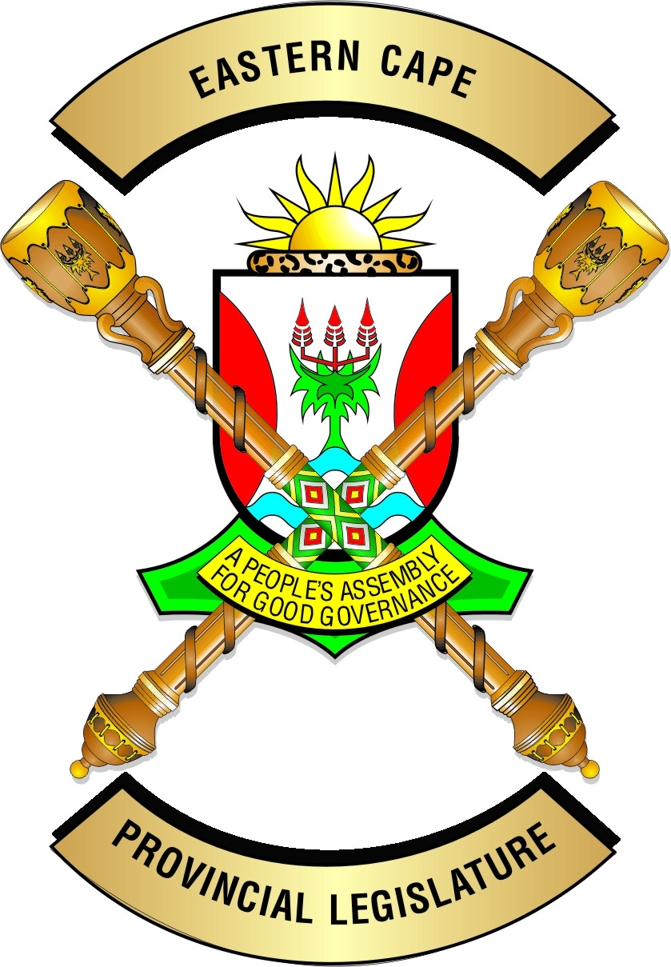 E A S T E R N C A P EP R O V I N C I A L L E G I S L A T U R E

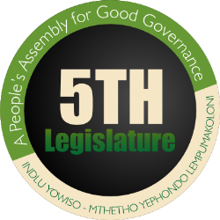

**OFFICE OF THE CHAIRPERSON OF THE PORTFOLIO COMMITTEE ON HEALTH**

**Tel: 040-609 1637 Enquiries: Mr L Sopela**

**Fax: 086-645 9143 Date: 05 September 2018**

**E-mail:** [**lsopela@ecleg.gov.za**](mailto:lsopela@ecleg.gov.za) **Reference: NHLS Amendment Bill**

**NEGOTIATING MANDATE**

**To:** The Chairperson:

Select Committee on Social Services

**Name of Bill:**  National Health Laboratory Services Amendment Bill

**Number of Bill:** [B15B - 2017]

**Date of Deliberation:** 05 September 2018

**1. Vote of the Legislature**

The province votes in favour of the Bill and mandates the Eastern Cape delegate to the

NCOP to negotiate within the following parameters:

1. **Deletion of the word technikons**
2. It is proposed that the word “technikons” in section 5 (2) (d) be deleted. This is motivated by the fact that “technikons” no longer exist in South Africa and instead there exist universities or universities of technology.
3. **Reappointment to serve on the board**
4. It is proposed that current provision in the principal act (section 9 (4)) is vague in as far as it does not provide how many times may a board member be re-appointed into the board. This may lead to the NHLS having lifetime board members. In the view of the Eastern Cape Provincial Legislature, a board member must not serve more than 2 terms.
5. It is therefore proposed that section 9 (4) be amended as follows:

“(4) The members of the Board may hold office for a period of at least three years, as the Minister may determine at the time of appointment, but must be eligible for reappointment, which re-appointment shall not be more than once.”.

1. **Appointment of former board members of the dissolved board**
2. It is appreciated that the Bill gives the Minister powers to dissolve a board as outlined in section 10A. However the bill in section 10A (5) allows for the re-appointment of persons that were part of the dissolved board without limiting the number of the members of the dissolved board that can form part of the new board. The Eastern Cape is of the view that if this clause is left as it is the Minister can appoint people who were in the old board who would constitute the majority of the new board. The reasons why they were dissolved would again manifest themselves in the new board.
3. It is proposed that section 10A (5) of the Bill be amended as follows:

“ (5) The Minister may appoint to the new Board a person who was a member of the Board that was dissolved in terms of this section: Provided that persons that were members of the dissolved Board shall not constitute more than 40 % of the new Board.”.

**General Comments**

1. The report of the Portfolio Committee attached hereto highlights other issues raised by the stakeholders, relating to the Bill before the Portfolio Committee and are matters that ought to be given consideration by the Department of Health.

 **04 October 2018**

**_______________ _____________**

**MM DIMAZA (MPL) DATE**

**CHAIRPERSON OF THE PORTFOLIO COMMITTEE ON HEALTH**