Parmed
2019 AD HOC REPORT

OCTOBER 2018

InDEX
1. INTRODUCTION 3
2. SCENARIOS INCLUDED 3
3. SCENARIOS 4
3.1 SCENARIO 1 4
3.2 SCENARIO 2 5
3.3 SCENARIO 3 6
3.4 SCENARIO 4 7
3.5 SCENARIO 6 9

INTRODUCTION

This document has been prepared by an actuarial team and the Parmed Medical Fund’s (the Scheme’s) Principal Officer in preparing for the meeting with the Parliamentary Ad Hoc Committee on 3 October 2018.

SCENARIOS INCLUDED

The report includes the following scenarios :

- Scenario 1: “An outline of what Parmed reserves would look like if we did the predictable industry related increases over the next 3 years with minimal growth of approx. 300 members in the election year of 2019”

- Scenario 2: “A scenario of the Scheme based on the exodus of members i.e. those from all the legislatures approx. minus 400 members”

- Scenario 3: “A scenario of adding approx. an additional 2000 members ( each with an average of 2 dependants)….with an average age of 48yrs”

- Scenario 4: “Then adding another benefit option (new generation type) with 100% Hospitalisation, limited benefits and a savings pool for day to day benefits. Option design should ideally be to accommodate younger members.”

- Scenario 5:”Unpack the administrative costs to the Scheme in light of CMS’ claim that Parmed admin costs are above average to industry norms.”
This has been dealt with via email correspondence from the Fund Manager.

- Scenario 6: “Impact on the Scheme and reserves if the member numbers were expanded to include local government councillors and director generals. Kindly note that this scenario should include approximately 395 additional members with an assumption of the average family size of 2 adults and 2 dependants. Average age of 50”

SCENARIOS

SCENARIO 1

“An outline of what Parmed reserves would look like if we did the predictable industry related increases over the next 3 years with minimal growth of approx. 300 members in the election year of 2019”

Assumptions used:
- The members will join uniformly throughout 2019, with the cumulative increases totaling 300 members by December 2019, ie the average membership for 2019 will be 2507 members
  - Thereafter membership is assumed to stay constant
- Increases of 10% in the contribution rate has been assumed (“predictable industry related increases”) for 2019 onwards
- Increases of 8% in claims have been assumed for 2019 onwards.
- No change in the mix of lives (ie age/chronic status/gender) has been assumed.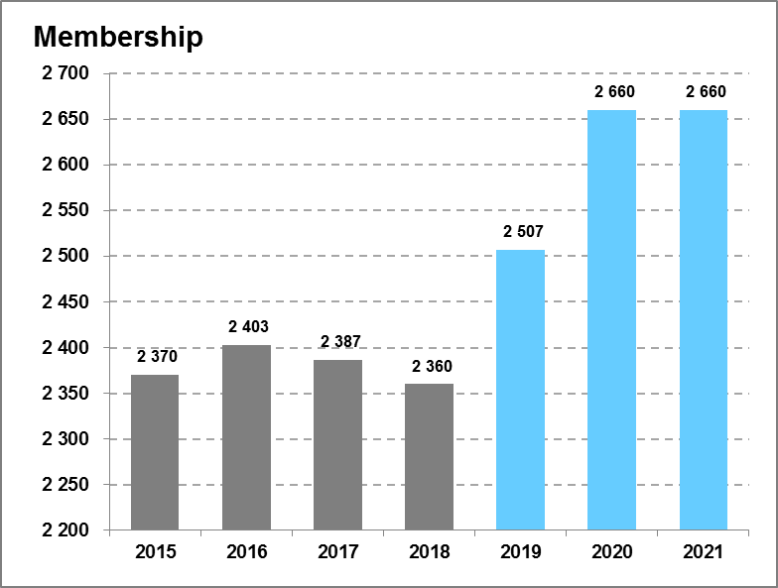 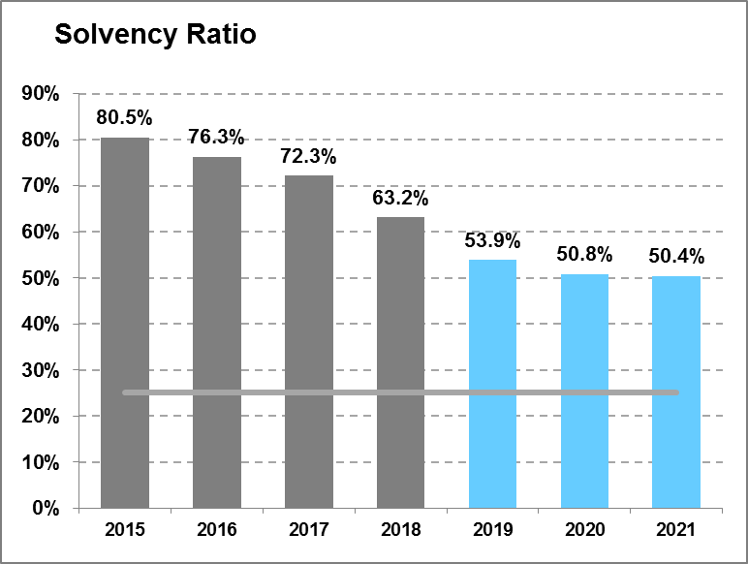

Comments:
- The scheme’s reserves in 2019 will drop due to the projected deficit for year-end 2018 as well as the inflow of new members.
- As the solvency ratio is expressed as accumulated funds divided by membership income, bigger membership income (all else equal) will lead to a percentage-wise drop in the reserves.
- Over time the slightly bigger membership base will lead to claims experience being slightly less volatile and scheme overheads spread over a bigger membership base.
- Investment income on a per-member per month basis will be diluted.

SCENARIO 2

“A scenario of the Scheme based on the exodus of members i.e. those from all the legislatures approx. minus 400 members”

Assumptions used:
- The members will leave uniformly throughout 2019, with the cumulative decreases totaling 400 members by December 2019, ie the average membership for 2019 will be 2 154 members
  - Thereafter membership is assumed to stay constant
- Increases of 10% in the contribution rate has been assumed (“predictable industry related increases”) for 2019 onwards
- Increases of 8% in claims have been assumed for 2019 onwards.
- No change in the mix of lives (ie age/chronic status/gender) has been assumed.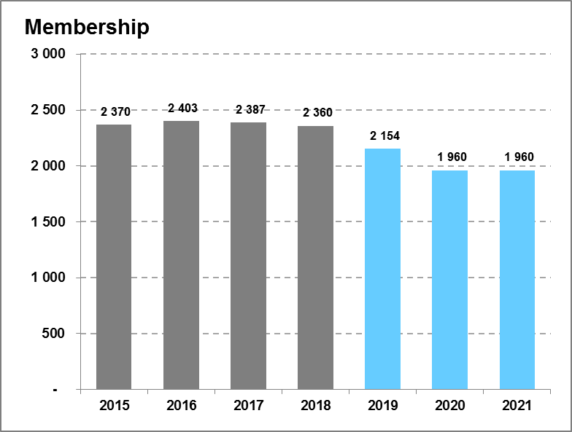 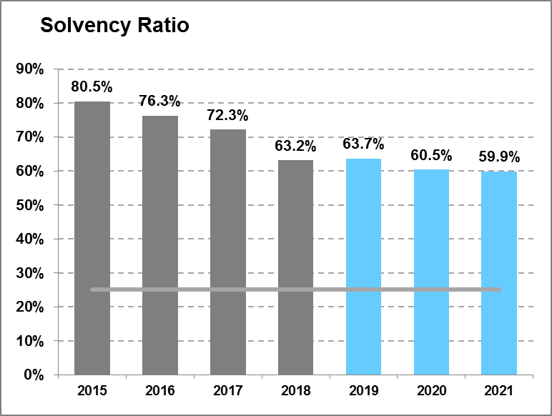
Comments:
- The scheme’s reserves in 2019 will increase due to exodus of members.
- As the solvency ratio is expressed as accumulated funds divided by membership income, smaller membership income (all else equal) will lead to a percentage-wise increase in the reserves initially.
- Over time the smaller membership base will lead to claims experience being more volatile and scheme overheads spread over a smaller membership base.
- Investment income on a per-member per month basis will be higher initially.

SCENARIO 3

“A scenario of adding approx. an additional 2000 members (each with an average of 2 dependants)….with an average age of 48yrs”

Assumptions used:
- The members will join uniformly throughout 2019, with the cumulative increases totaling 2000 members by December 2019, ie the average membership for 2019 will be 3 267 members
  - Thereafter membership is assumed to stay constant
- Increases of 10% in the contribution rate has been assumed (“predictable industry related increases”) for 2019 onwards
- Increases of 8% in claims have been assumed for 2019 onwards.
- A change in the mix of lives in terms of age has been assumed.
  - The average member age for Parmed will drop from 64.7 to 57.

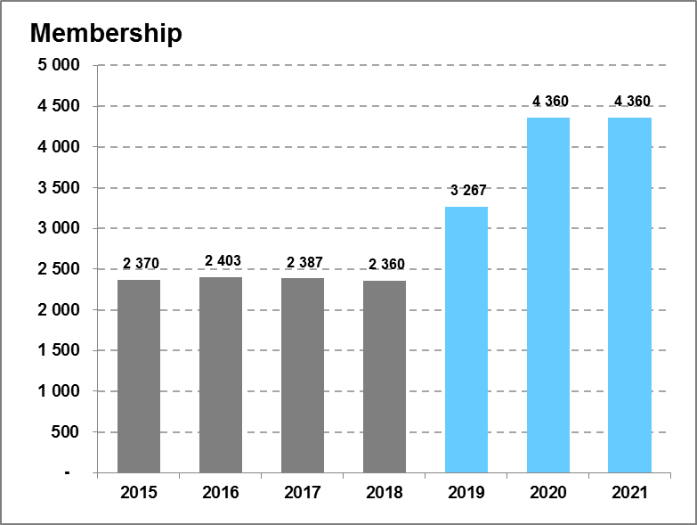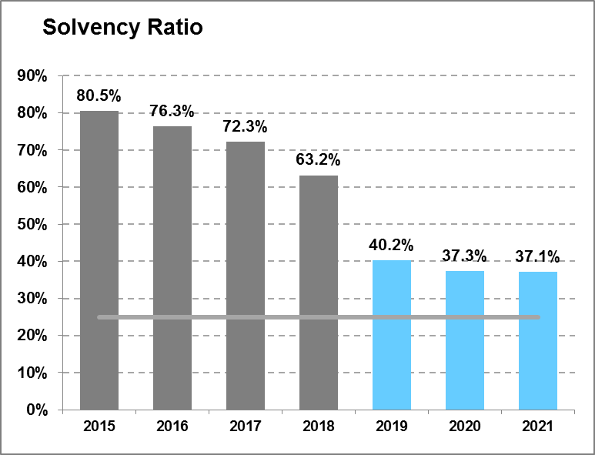

Comments:
- The scheme’s reserves in 2019 will drop due to the projected deficit for year-end 2018 as well as the inflow of new members.
- As the solvency ratio is expressed as accumulated funds divided by membership income, bigger membership income (all else equal) will lead to a percentage-wise drop in the reserves.
- Over time the bigger membership base will lead to claims experience being less volatile and scheme overheads spread over a bigger membership base.
- Investment income on a per-member per month basis will be diluted.
- Claims – on average – will be lower over the longer term due to the reduction in the average member age.

SCENARIO 4

“Then adding another benefit option (new generation type) with 100% Hospitalisation, limited benefits and a savings pool for day to day benefits. Option design should ideally be to accommodate younger members.”

In order to determine the potential impact on the scheme overall, one should consider the current age distribution and associated costs of the Parmed lives:

In the graph above one can see the differences in average claims between child, young adult and older adult on a per-life-per-month (plpm) basis. It is typically the younger and healthier members (i.e. the lower claiming lives) that will buy down to a hospital plan.

To show the potential rand value impact on existing plpm claims, an age distribution for the proposed hospital plan had to be assumed. This was based on a comparative hospital plan in the open market to help estimate what a likely profile for the proposed option will look like. This is depicted by the line in red in the graph below. The blue bar graph shows the existing age distribution of Parmed lives.

It was assumed that 25% of the existing membership will move to the hospital option. This then inferred what the resultant profile on the rest of the lives will be that remain on the traditional option.

Under this scenario, if the new hospital plan is priced competitively, this will lead to increases for the existing traditional option’s claims outgo of approximately 10% on a per-life per month basis. This will imply an approximately 17% increase when also taking into account the tariff (~5%) and utilization increases (~3%)).

If the traditional option’s contribution are not increased substantially, the Scheme will incur a much bigger deficit for 2019 due to the increase in claims cost without the commensurate increase in contributions.

The size of the deficit will depend to what degree the proposed hospital plan will be priced competitively or, alternatively, priced to cross-subsidise the losses on the traditional option.

Note that there will be second order impacts as well; for example, more members – after the seeing the price differential – might move to the hospital option after the first year.

Other considerations
- By creating another option, the scheme is splitting the risk pool. This will lead to increased claims volatility on both options.
- Due to the increase in contributions required for older lives, the bigger projected deficit and the increased volatility in results, there is a high chance that the CMS might not approve the new hospital option, especially given the scheme’s small size.

SCENARIO 6

“Impact on the Scheme and reserves if the member numbers were expanded to include local government councillors and director generals. Kindly note that this scenario should include approximately 395 additional members with an assumption of the average family size of 2 adults and 2 dependants. Average age of 50”

Assumptions used:
- The members will join uniformly throughout 2019, with the cumulative increases totaling 395 members by December 2019, ie the average membership for 2019 will be 2553 members
  - Thereafter membership is assumed to stay constant
- Increases of 10% in the contribution rate has been assumed (“predictable industry related increases”) for 2019 onwards
- Increases of 8% in claims have been assumed for 2019 onwards.
- A change in the mix of lives in terms of age has been assumed.
  - The average member age for Parmed will drop from 64.7 to 62.6.

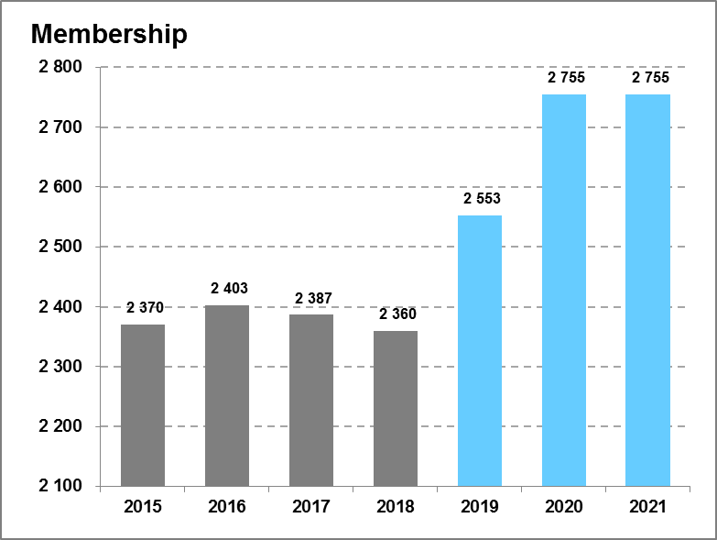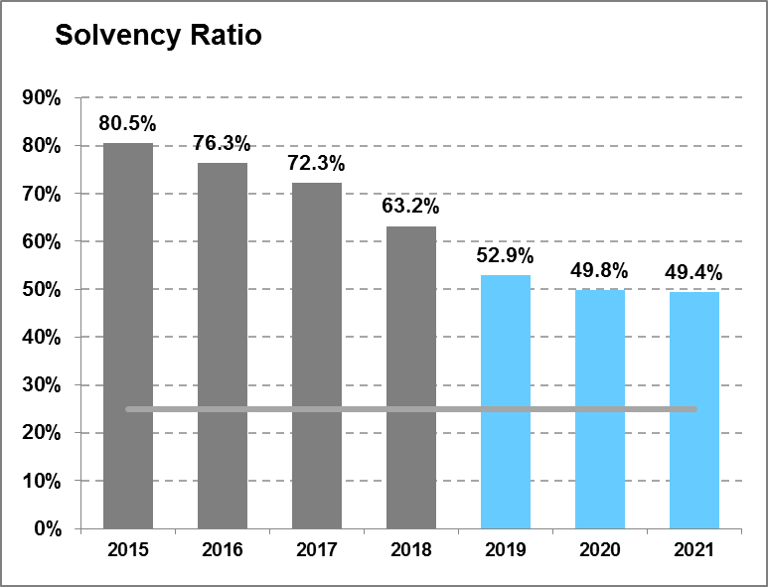

Comments:
- The scheme’s reserves in 2019 will drop due to the projected deficit for year-end 2018 as well as the inflow of new members.
- As the solvency ratio is expressed as accumulated funds divided by membership income, bigger membership income (all else equal) will lead to a percentage-wise drop in the reserves.
- Over time the bigger membership base will lead to claims experience being less volatile and scheme overheads spread over a bigger membership base.
- Investment income on a per-member per month basis will be diluted.
- Claims – on average – will be lower over the longer term due to the reduction in the average member age.

