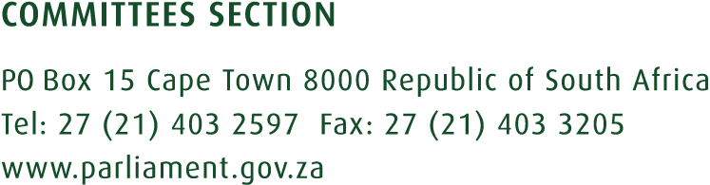

31 August 2018

Public comments on the Films & Publication Bill (B37B-2015)

FILMS & PUBLICATION AMENDMENT BILL (B37B-2015)
 | SUBMISSION | DATE | CONCERN | CLAUSE
 | 1.Brent Eichstadt  2.James Kroon  3.Dylan van der Merwe  4.Isabella de Bruyn  5.Richard Mun-Gavin  6.Morgan Pillay  7.Nicole Riekert  8Philippa Duffy  9.Anita Du Plessis, etc | 06 August  11 August  25-August  27 August  27 August  28 August  28 August  28 August  28 August | The classification of XX material to only mean, “explicit sexual conduct accompanied by explicit violence.” This classification excludes the “violation and disrespect for the right to human dignity.” The clause should remain as it was before or should be redrafted to align it with the constitution on human dignity. | 1. Section 15 (i), (b), (i) and (ii)
 | Ryan Smit (Cause for Justice) | 17 August | An extension of the deadline for written submissions to 06 September 2018 so as to make oral or written submissions
 | Lazola Kati (Right2Know) | 25 August | An extension of the deadline to 10 September for proper engagement
 | Francis Antonie (Helen Suzman Foundation) | 13 August | Extension for oral/written submissions

FILMS & PUBLICATION AMENDMENT BILL (B37B-2015)
SUBMISSION | DATE | CONCERN | CLAUSE
1.Media Monitoring Africa  2.SOS Supporting Broadcasting Coalition  3.The South African Editors’ Forum  4.The Interactive Advertising Bureau of South Africa  5.The Press Council of South Africa | 21-Aug | - The Bill only exempt print publications and not online video content hosted on the internet by a bona fide member of a body recognized by the Press Ombudsman. Exemption must include video content posted online.  - The deletion of Section 1 (f) and Section 15 (f) on hate speech since its inclusion is a duplication and is also in contradiction to the Prevention and Combating of Hate Crimes and Hate Speech Bill (B9-2018).  - To give clarity to the meaning of “commercial purposes” an insertion of the word “for a fee” must be included.  - The definition of a “distributor” in Section 1 (f) should exclude a “non-commercial online distributor”- e.g uploading family videos.  - The Bill uses the term “online distributor” and yet it is no defined. It should be deleted wherever is used in the Bill and replaced with the defined term “distributor.” | - Section 15 (a),(1)_(B37B-2015)  - Section 1 (f) and Section 15 (f)  - Section 1(d)  - Section 1 (f)
Nadene Badenhorst (Freedom of Religion SA) | 21 August | The definition of “Hate Speech” must be aligned to that of the Constitution as its current definition in the Bill contradict that of the Constitution. | - Section 1 (k)

