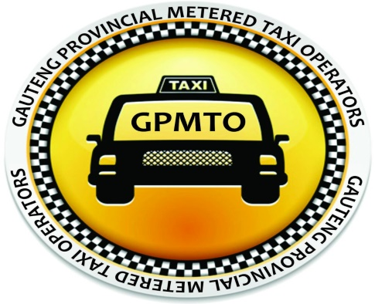
12 Kruis & Albert Streets
Factor House, 3rd floor, 305
Johannesburg
2001
Contacts: Email mjlebea@gmail.com
Cell: 082 689 6891 / 083 428 7172
Office: 011 039 1501

Date: 15 August 2018

HONORABLE:
To: National Transport Portfolio Chairperson.
CC: National Speaker of Parliament.
RE: Metered Taxi Industry SA
Gauteng Provincial Metered Taxi Operators (GPMTO) is an organization that represents all registered metered taxi operators in the Gauteng Province. The operators fall under Gauteng Provincial Metered Taxi Council which ceded to function during the break of protests and violence against the illegal e-hailing App’s. However, it must be noted, that we are not in isolation, but we have continuous engagement with two other active provinces namely, Kwazulu Natal in Durban represented by Sizwe Mvubu and Cape Town represented by Thobile Mekana.
Below are the supportive facts or points:
- The metered taxi industry, has partnered with the company by the name of Emergency Taxi (ET), which is bringing innovation that will be beneficial to the metered taxi industry at large.
- GPMTO will work in conjunction with all the other provincial metered taxi structures.
- GPMTO and ET take this initiative together with other provinces as mentioned above.
- In this initiative, we are still to engage other provincial leaders as our efforts have been hampered by lack of resources to reach all provinces. We are therefore hoping that, with the national and local government’s engagement and intervention we will reach all our expected destinations.

Why did metered taxi industry engage with Emergency Taxi?

- Metered taxi industry is not against technology and innovation.
- ET did not get preferential treatment over Uber and Taxify.
- Uber and Taxify have caused damage by creating debts and destroying employment.
- Taxify and Uber started their businesses by undermining the metered taxi industry, as they started their businesses without engaging metered taxi industry and not following regulations that govern the industry.
- Metered taxi industry on noticing that there will be conflict of interest, approached Uber and Taxify to show that they are not against technology and innovation.

Metered taxi industry had reasons for engaging with Uber and Taxify which are:

- To contribute to how Uber and Taxify could operate without causing any conflict.
- To make sure that Uber and Taxify complied with existing laws and regulations.
- To make sure that they empowered metered taxi operators.

There was no joy received from Uber and Taxify, as they told metered taxi association, that they are companies coming from overseas and their businesses are not designed for metered taxi operators. There was no goodwill to the industry from this illegal invasion. They further said that, their business model is meant for employed individuals who are well established and want to make an extra income.

Damage caused by Uber and Taxify:

- Financial Damage – debts and modern day slavery of operators/drivers who are now blacklisted, as they were given credit without their affordability being considered or checked. The drivers now are working to pay their installments for cars with very little or no profit at all, as 25% goes to Uber/Taxify, 25% to petrol, and other percentage to vehicle installment, service and repairs.
- Loss of lives – people have been hospitalized, mobility disturbed, e.g. OR Tambo airport incident, cars being burnt, people’s lives were lost, and there was property damaged as well.
- Disruption of harmony in the industry and the general public at large.

Hence the Metered Taxi Operators are suffering the consequences of these damages.

Solutions of the inconveniences caused to the metered taxi industry:

- Compliance with National Land Act and proposed Bill.
- Call Centre which operates 24 hours and 365 days.
3. Agreement that Emergency Taxi has, with metered taxi industry, is as follows, the metered taxi industry will get 50% net profit share.
- Empowerment and Development – access to vehicles for operators/drivers to newer vehicle models.
- Driver benefits – UIF, Provident fund and 3% bonus of all revenue made per annum.
- Monitoring of vehicles that provide the service to the riders.
- Discounted data bundles for drivers.
- Security features on the app for better safety of both riders and drivers.
- Affordable regulated prices for the riders and reasonable commission deducted from actual trips dispatched to operators/drivers.
- Participation in value chain- there is an ongoing relationship between ET and metered taxi industry, to expand business into other avenues such as car wash, motor car spares and tyres.
- Free driver training – ET trains the drivers on how to use the driver’s app.
- Profitable and sustainable business model, to operators/drivers and riders.

Conclusion

- It will be appreciated by GPMTO in conjunction with all the other metered taxi provincial bodies, to do a presentation before the parliamentary transport portfolio committee to showcase what we can offer and to seek guidance, advice from the committee.
- We are prepared to assist in all possible transport and passenger interventions that government is promoting to raise awareness in safety, efficiency and reliability.

