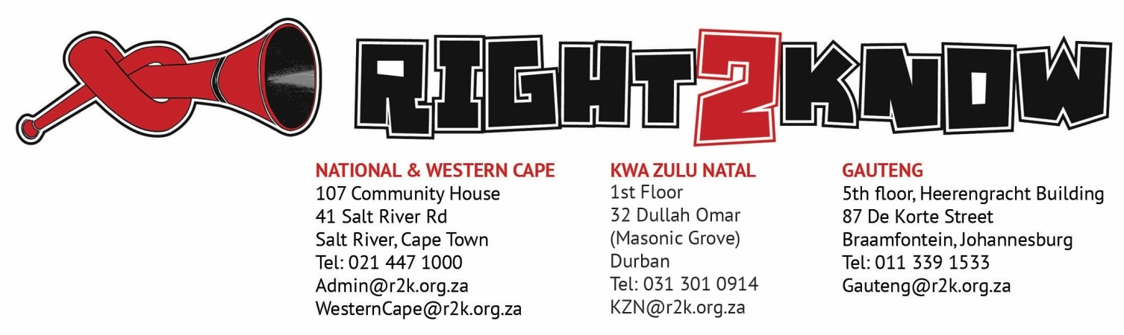

18 June 2018

To: Dikgang Stock
Chairperson Ad Hoc Committee on Political Party Funding
National Council of Provinces
Parliament of Republic of South Africa.
Parliament Street, Cape Town
PO Box 15, Cape Town, 8000
Telephone: 021 403-2911
Fax: 021 403-8219
Per Email: info@parliament.gov.za / egrunewald@parliament.gov.za

SUBMISSION ON THE POLITICAL PARTY FUNDING BILL

The Right2Know Campaign (R2K) was launched in August 2010 in response to the Protection of State Information Bill (The Secrecy Bill) and has grown into a movement centred on freedom of expression and the free flow of information. Our aims are to ensure: that people’s right of access to information is protected and that they are able to enjoy it; that everyone has the right to share information, including opinion freely and equally; that there is a free and diverse media in the country; and that values of transparency, accountability and responsiveness are a reality. It is one of our core tenets, therefore, that the free flow of information, especially information regarding donations given to political parties and politicians is critical to the health of our Constitutional democracy.

R2K has made submissions on a previous version of this Bill. Furthermore, we have also rallied behind My Vote Counts’ Constitutional Court application regarding Parliament’s failure to regulate private donations to political parties. and its subsequent High Court challenge to the effect that the Promotion of Access to Information Act (PAIA) should be declared constitutionally invalid to the extent that PAIA does not provide for the disclosure of information regarding the private funding of political parties and that PAIA be remedied so as to allow for the continuous and systematic recordal of parties’ private funding information to the people of South Africa.

In our previous submission we emphasised that people must know of the flow of money in our political arena. In that regard we argued, among other things that:

“The public has a right to know who is bankrolling the political parties and candidates that seek their votes, and those funds are spent. We therefore believe that a comprehensive legal framework is needed to promote proactive, regular disclosure of parties’ private funders. To move forward, we must first dispense with the fiction that political parties are private bodies. It is clear that political parties perform a vital public role that is at the heart of the democratic process; and this comes with the need for basic public accountability and transparency. We also believe reforms are necessary to the public funding of political parties, including greater transparency and reporting on these funds, and a reallocation of such funds to promote multiparty democracy.”

Our submission to the National Assembly is attached as many of its recommendations remain relevant to this Bill.

Our submissions are as follows:

Ensure public disclosure
Clause 9 of the Bill titled “Disclosure of donations to political party” is vague on who must the Commission disclose donations made to political parties to. The Clause merely states that:

“9(3) The Commission must publish the donations disclosed to it in terms of subsections (1) and (2)—
(a) on a quarterly basis; and
(b) in the prescribed form and manner”
It is not clear from this clause who the Commission must disclose to and exactly how it must disclose. The need for this information to be made fully public and generally available – for example, online and in an open format – should be made clear.

Prohibit donors from doing business with the state
In our previous submission we raised the issue of those doing business with the state. We still submit that all those who do business with the state should be prohibited from making donations to political parties. Donations-for-tenders schemes have been a key avenue for corruption in the past. However, we would not oppose an action by Parliament to investigate means for corporate entities to donate to a collective fund in the interests of multi-party democracy.

The bill should ban political parties’ investment vehicles from doing business with the state. In the case of Chancellor House, this has also been a key avenue for corruption.

Lower the threshold for disclosure
The current Bill exempts donations below R100,000 from being subject to disclosure. In our view this threshold is too high and may exclude the majority of donations that parties receive. The minimum threshold for disclosure should be reduced from R100 000 and should be set no higher than the average household monthly income.
Boost political diversity
The formula to allocate public funding should be adjusted to promote political diversity, with a greater proportion of funds shared equally among all political parties, and a lesser amount shared in accordance with proportional representation.

Ensure historical transparency
Lastly, as a country we need to know how much political parties have spent in the past on elections so that the Regulation that will be enacted may be enriched by that data. We therefore, submit that parties must disclose their previous spending on elections.

As R2K we are willing to engage the Committee further and to that end would appreciate an invitation to make this submission in person and to answer any questions that members may have.

