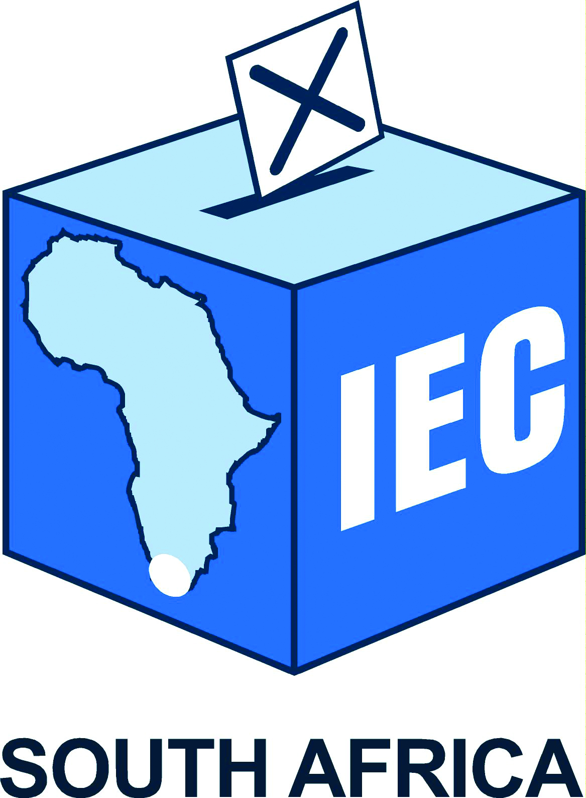

ELECTORAL COMMISSION

RESPONSES BY THE ELECTORAL COMMISSION TO MATTERS
RAISED BY MEMBERS OF THE NATIONAL COUNCIL OF
PROVINCES AD HOC COMMITTEE ON THE FUNDING OF
POLITICAL PARTIES
7 JUNE 2018

- Introduction
The Electoral Commission was invited to make a presentation on the Political Party Funding Bill [B33-2017] to the NCOP Ad Hoc Committee on Funding of Political Parties on 7 June 2018. National Treasury was also invited and made a presentation on the financial implications of the Bill. The Electoral Commission then made a presentation on the background to its involvement in the development of the Bill and key considerations for the Ad Hoc Committee in respect of the regulation of public and private funding for political parties.
The Electoral Commission was represented by:
- Mr Glen Mashinini, Chairperson
- Mr Terry Tselane, Vice Chairperson
- Mr Sy Mamabolo, Chief Electoral Officer
- Ms Ester de Wet, Acting Chief Financial Officer
- Mr Marco Granelli, Senior Manager

- Matters raised
Due to time constraints there was no opportunity to respond to the questions and issues raised by members following the presentation. The Chairperson of the Ad Hoc Committee requested the Electoral Commission to provide written responses to questions and issues raised.
For ease of reference the questions and issues have been grouped together under similar topics where relevant.
  - Proposal to implement the legislation in a phased approach

    - Why is the Electoral Commission proposing to implement the legislation in a phased approach?

The Electoral Commission made the proposal to implement the legislation (once passed and enacted) in a phased approach in response to National Treasury’s indication that insufficient funds were available within the 2018/19 year to meet the anticipated financial requirements of full implementation. Initial cost estimates for the implementation of the legislation estimated that approximately R46 million would be required in the first year to establish a business unit within the Electoral Commission capable of implementing all aspects of the legislation.

During engagements with the National Assembly’s Ad Hoc Committee on the Funding of Political Parties the Committee requested the Electoral Commission and National Treasury to collaborate to address the various financial considerations. During these consultations National Treasury indicated that due to fiscal constraints it was unlikely to provide more than R20 million during the 2018/19 financial year. In order to balance the urgency of implementation of the legislation with the current fiscal realities it was proposed to implement the legislation in a gradual or phased approach aligned to the availability of funding.

Besides the primary financial restrictions, there are also important operational considerations which support the gradual and phased implementation of any new system. A “big bang” approach to implementing a new regulatory regime carries inherently more risks for all stakeholders than a staggered approach which allows for better identification and management of risks and unforeseen challenges.

The third reason for a phased-in approach is that it will take time to recruit suitably qualified staff for the establishment of the party funding business unit within the Electoral Commission and the development and implementation of the necessary regulations, systems and processes to facilitate the annual declarations by political parties and donors and verification thereof.

Once developed, the requirements must be communicated with all stakeholders including political parties and donors to allow them reasonable opportunity to meet the requirements.

All the above is articulated against the backdrop of the steadfast position of the Commission that it will not assume an unfunded mandate.

    - Does it not undermine the core intent of the legislation if it is not fully implemented from the start?

The response relating to the total implementation of the Bill at once is addressed in 2.1.2 above.

The view of the Electoral Commission is that the draft legislation seeks to address two key aspects of party funding:

- Firstly to provide a legislative framework for the declaration of sources of party funding – i.e. to bring transparency to the process of party finances
- Secondly to provide a legislative framework for the oversight of this process and compliance by political parties and donors to various aspects of the legislation
By design this is a two-step process – the starting point of which is disclosure followed by verification. Phasing in of the legislative and regulatory framework will allow for greater transparency than is currently the position which will be an important first step to full compliance.

    - Would it not be preferable to establish the necessary regulations, processes and systems in full and when ready implement the legislation?

This is a consideration for Parliament to weigh up the benefits and risks of a gradual implementation versus a delayed full implementation.

  - Estimated costs of implementation

    - Since most of the 2018/19 financial year will have passed by the time funds are likely to be allocated (early 2019) does the Electoral Commission still require R20 million this financial year?

The estimate of R20 million for the 2018/19 financial year was developed in anticipation of the enactment of the legislation earlier and a desire expressed by the National Assembly Ad Hoc Committee for the implementation of as much of the legislation as possible prior to the National and Provincial Elections due to held next year. In light of the position provided by National Treasury in its presentation to the Ad Hoc Committee on 7 June 2019 that funding will only be made available from 1 April 2019 as part of the MTEF process, a new budget amount will have to be discussed and agreed with National Treasury.
2.2.2 The start-up costs seem high. Is the salary of the head of the entity not excessive? Is it necessary to have an investment capability and expertise when money should spend minimal time within the Funds before being transferred to political parties?
The estimated salaries of the key staff members including the head of the unit are in line with the present pay scales of the Electoral Commission. The finalisation of the structure for the party funding business unit will include a job evaluation process to confirm the levels, skills and experience necessary for each position.
Regarding investment, clause 4(1) of the bill requires that any money in the two funds, namely the Represented Political Parties Fund and Multi-Party Democracy Fund, that is not required immediately for making an allocation to represented political parties may be invested with the Public Investment Corporation.
The Commission will also be empowered in terms of clause 3(6) to charge a fee to defray the cost of administering the Multiparty Democracy Fund which may not exceed 5 percent during the financial year. In order to facilitate this administrative fee it may be required to invest a portion of the funds to provide a sustainable source of funding for administrative costs.
    - Why is fund-raising needed and so much expenditure (R5 million) anticipated in communication costs for the first year?

The Bill proposes the establishment of a new Multiparty Democracy Fund which will contain funds received from private donors. In order to promote the new fund and encourage donations to it by private corporate and individual donors the Electoral Commission will need to undertake communication, marketing and fund-raising awareness initiatives. Such initiatives will be especially necessary in the formative years of the fund.

  - Proposed entity and reporting lines

    - A number of committee members expressed a lack of clarity regarding the nature of the party funding business unit and whether it was a part of or separate to the Electoral Commission.

As noted in the Chairperson’s opening remarks, there are various approaches internationally for assigning responsibility for oversight of political party funding. In some countries this task is given to the election management agency such as the Electoral Commission. In others a completely self-standing new unit is established to undertake this oversight. And in others the responsibility is given to an existing government department or agency (such as the Auditor-General). There are pros and cons associated with each approach.

In order to prevent the party funding function from impacting on the management of elections and vice versa, the Electoral Commission has consistently advocated for the establishment of a party funding business unit which is administratively and financially separate from the administrative arm of the Electoral Commission which is already in existence and which is mandated to manage free and fair elections.

In order to limit the risks of conflict of mandate but also to benefit from synergies and potential cost-savings, the five-member Commission proposed to the legislation drafters to establish a new party funding business unit which will be separate from the present administration but which will report to the Commission.

This means the Commission will have oversight over two separate entities each with its own budget and staff:

- The Electoral Commission with its own CEO, staff and funding (as currently exists) which will continue to manage elections.
- A party funding entity with its own CEO, staff and funding which will be established to meet the requirements of the Political Party Funding Bill.
In order to reduce costs, the two entities may share certain support services and resources where feasible such as IT support and infrastructure, HR, facilities etc.

    - Some members of the committee requested clarity on Slide 6 regarding it not being an organogram or structure but a description of functional areas.

In order to begin planning for the implementation of the new legislation once enacted and to facilitate a cost estimation exercise on the financial implications, the Electoral Commission assessed the current Political Party Funding Bill to identify the key functional areas including broad responsibilities, tasks and commitments required to be performed in order to implement the Bill. It grouped these into four core functional areas:
- The management of party funding which includes investment management and planning, financial reporting, financial compliance training (for parties) and auditing
- Research, policy and regulation affairs which will be required to develop the regulations to give effect to legislation and propose any future amendments to the prescripts
- An enforcement component which will monitor compliance by political parties and donors to the requirements of the legislation and regulations and take necessary steps to ensure compliance (e.g. litigation)
- And a communications/education component which will help promote knowledge of and understanding of the new legislation and regulations as well as conducting fund-raising activities to secure contributions to the Multiparty Democracy Fund from corporate and private donors.
Each of the blocks on this diagram identify broad functional areas of work which will need to be undertaken but which may be undertaken by a single person or multiple persons.
The final proposed structure and staffing of the business unit will only be able to be done once:
- The legislation is finalised and enacted
- A determination on implementation (phased or not) is taken
- The necessary budget is agreed
This process will be done in compliance with the established human resources practices and standards.
    - The proposed “structure” or functional design seems top-heavy and the initial appointments seem focused on senior personnel. Is it necessary to staff it with so many senior people at the outset?

Mindful of the response in 2.3.2 above, within organisational development sphere it is generally accepted that the structure should be filled top down to allow for those in senior positions to focus on identifying the key objectives, mission, vision and strategies for the institution – and then identify and recruit the necessary skills for the tasks required.

In order to establish this new business unit with the minimum staff requirement the Electoral Commission is proposing the initial recruitment of the head of the entity along with three senior staff members to establish the unit and begin the process of establishing the necessary regulations, processes and systems. A further five persons are envisaged to be recruited for the start-up phase (as per Slide 19).

Given the expectation that this business unit was to be established as a matter of urgency ahead of the coming National and Provincial Elections, it was all the more reason to ensure the party funding business unit was equipped with its own staff resources as those of the Electoral Commission are currently focused on preparations for the elections.

  - Incorporation of local government

    - Does the legislation extend to local government or only parties contesting national and provincial elections?

Section 236 of the Constitution provides that to enhance multiparty democracy, national legislation must provide for the funding of political parties participating in national and provincial legislatures on an equitable and proportional basis. Therefore, the Represented Political Party Fund whose source of funding is National Treasury is constitutionally limited to parties with representation in national and provincial legislatures. With respect to allocations from the Multiparty Democracy Fund, the bill currently also refers to “represented parties” only. Represented parties are those parties with seats in the national or provincial legislatures.

However, with regards to disclosure of sources of private funding the Bill applies this to “political parties” which it defines in chapter 1 as “includes any entity that accepts donations principally to support or oppose any registered political party or its candidates in an election as defined in Section 1 of the Electoral Act 1998”. This definition extends to parties and candidates contesting municipal elections.

In previous submissions to the National Assembly’s Ad Hoc Committee the Electoral Commission advocated for the inclusion of parties and candidates registered and contesting elections at all levels of government (national, provincial, municipal) including independent candidates.

  - Provincial funds

    - Should the provincial funds (provincial RPPFs) be incorporated into this legislation?

It is the Electoral Commission’s understanding of the Political Party Funding Bill that it will cover all public funds (from the fiscus) provided to political parties (except constituency allowances). This includes all funds provided to represented political parties in the national assembly and provincial legislatures.

Clause 23 is relevant and notes that Parliament or a provincial legislature may not fund represented political parties other than for purposes of section 57(2) and section 116 (2) of the Constitution. It further provides that the accounting officer of each legislature must submit an annual report on any funding of represented political parties to the Commission.

  - Any further aspects to be considered

    - Whether there are any issues or considerations which the Electoral Commission had made to the National Assembly Ad Hoc Committee which had not been taken into account and about which the Electoral Commission feels strongly.

The Electoral Commission is satisfied that the Political Party Funding Bill [B33-2017] adequately addresses the key considerations and concerns of the Electoral Commission.

Among some alternatives and/or options which the NCOP Ad Hoc Committee may wish to consider are the following:

- Support for unrepresented parties: The current legislation and draft Bill only provides for the access to public funding (RPPF) for represented political parties. This raises an issue of how parties that are not represented in an existing legislature but which intend contesting up-coming elections may be excluded in a manner that creates unintended disadvantages for them.
One option the Committee may wish to consider might be for the newly envisaged Multiparty Democracy Fund to allow scope for funding to be provided to unrepresented political parties under certain conditions. This could be accommodated by amending Chapter 1 section 6 (Allocations and payment of money to represented political party to differentiate in the formula and recipients of funds between the RPPF and Multiparty Democracy Fund.
- Promoting additional objectives: As noted in the presentation by the Electoral Commission, a number of countries use the allocation of public funds to encourage other objectives for example making a portion of public funding dependent on meeting gender and/or disability representivity targets.
- Inclusion of all levels of elections: The current draft Bill only covers national and provincial legislatures. In order to provide a single, comprehensive piece of legislation dealing with party funding it may be a consideration to expand the current draft Bill to incorporate parties and candidates contesting local government (municipal) elections.
- Constituency allowances: In order to provide transparency and a comprehensive annual view of the totality of funding of political parties, it may be desirable to incorporate the reporting on all sources of public and private funding to represented political parties including constituency allowances and funds or support provided by provincial and/or local government to parties and/or candidates.

  - Financial and reporting matters

    - Will new parties be funded?

The allocated amount is distributed to a political party for any financial year that it is represented in the National Assembly, or any provincial legislature, or both in the National Assembly and any provincial legislature. In other words, if a new party gains enough votes during the 2019 National and Provincial Elections to obtain seats in either a provincial legislator or in the National Assembly or in both, such party will receive funding in accordance with the approved formulas.

    - What is the relationship between the PFMA and the new Act?

All financial processes and systems in the Electoral Commission are aligned to the PFMA. The current RPPF Act is administered using the financial systems and processes embedded within the Electoral Commission. In managing the new Act, the Electoral Commission continues to do so.

    - The credit balance referred to in the Bill is creating confusion

The credit balance referred to in Multi-Party Democracy Fund simply means that the funds left over at the end of a particular financial year should be added to the new allocation to parties in the following financial year.

The credit balance in the accounts of a political party means that the unspent funds at the end of the financial year, subject to the rules in the Fund, is repayable by the party to the Fund.

    - Please provide clarity on whether the Electoral Commission and the Funds contemplated in the Bill will have one Annual Report

There will be two separate Annual Reports as is the case with the current Represented Political Party Fund and the Electoral Commission.

ENDS

