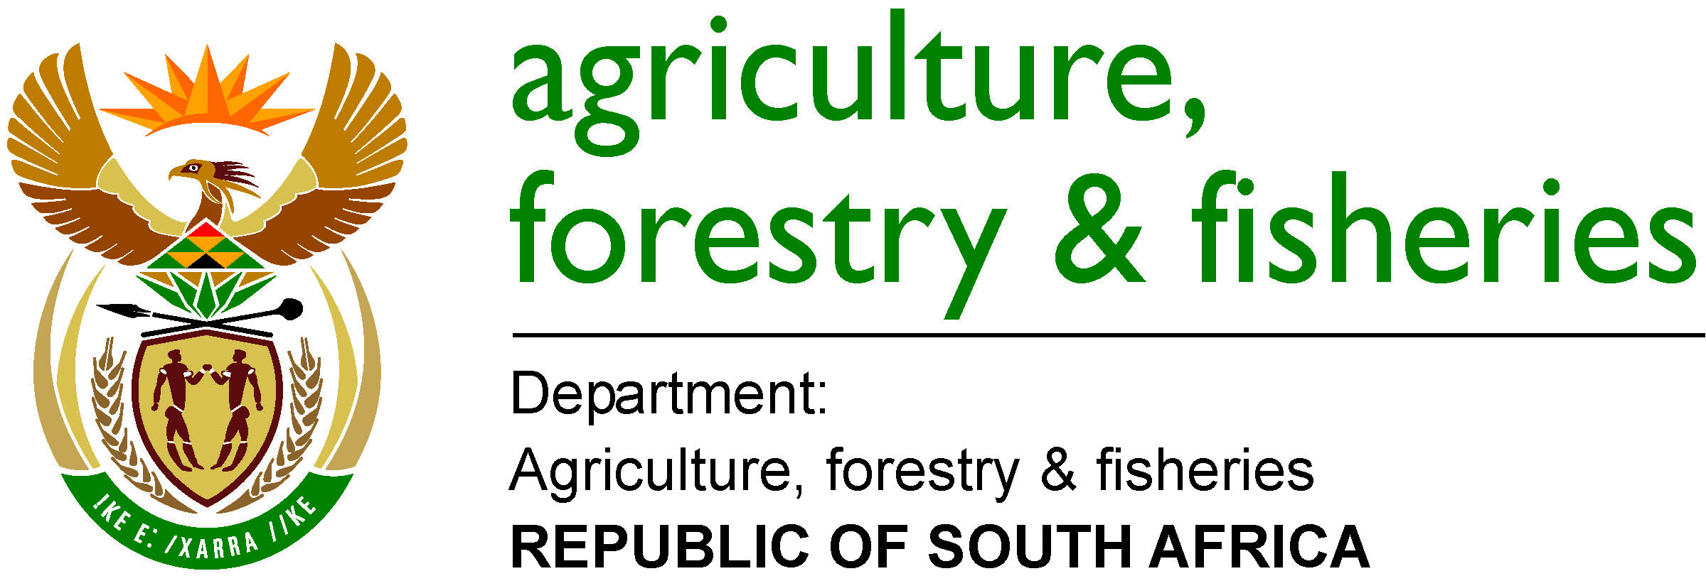

Status of the Small-Scale Fisheries Implementation Process as of 22 May 2018
Milestone Activities |  | Provinces
 |  | Northern Cape |  | Western Cape | Eastern Cape | KwaZulu-Natal
Legal Framework (Amended Act promulgated and SSF Regs approved) |  | Completed –  8 Mar 2016 |  | Completed –  8 Mar 2016 | Completed –  8 Mar 2016 | Completed –  8 Mar 2016
Closing of Expression of Interest Process for communities |  | Completed – Apr 2016 |  | Completed –  Apr 2016 | Completed – Apr 2016 | Completed –  Apr 2016
Registration and Verification of fishers per community |  | Completed – Mar – Aug 2016 |  | Completed –  Mar – Aug 2016 | Completed – Mar – Aug 2016 | Completed –  Mar – Aug 2016
Announcement of provisional lists of successful fishers |  | Completed – Aug 2016 |  | Completed –  Oct 2016 | Completed – Nov 2016 | Completed –  Jul 2017
Appeals closed |  | Completed –  Sep 2016 |  | Completed –  Dec 2016 | Completed – Apr 2017 | Completed –  Aug 2017
Tip-off info followed-up |  | None received |  | Completed –  Nov 2017 | None received | None received
Appeals assessment |  | Completed – Jun 2017 |  | Completed April 2018 | Completed – Nov 2017 | Completed –  Nov 2017
SSF Fee Structure Determination |  | Jun 2017 – Jul 2018 |  | Jun 2017 – Jul 2018 | Jun 2017 – Jul 2018 | Jun 2017 – Jul 2018
Approval of final list of fishers |  | Completed - Nov 2017 |  | May/Jun 2018 | Completed – Jan 2018 | Completed – Jan 2018
Announcement of final list of successful fishers |  | Completed – Nov 2017 |  | Jun-Jul 2018 (subject to approval of submission) | Completed- Feb 2018 | Completed- Feb 2018
Co-op Training |  | Completed- Feb 2018 |  | Jul 2018 | May/June 2018 | Completed Mar 2018
Co-op Registration |  | Feb-May 2018 |  | Aug 2018 | May 2018 | Mar-May 2018
SSF Rights Allocation |  | May/Jun 2018 (subject to co-ops registered and by-laws adopted) |  | Sep/Oct 2018  (subject to co-ops registered and by-laws adopted) | Jul 2018  (subject to co-ops registered and by-laws adopted) | Jun/Jul 2018  (subject to co-ops registered and by-laws adopted)
Conclude rights appeals |  | Jul 2018 |  | Dec 2018 | Oct 2018 | Sep 2018
Support Programmes |  | 2018 – 2021 (subject to needs of co-op) |  | 2018 – 2021 (subject to needs of co-op) | 2018 – 2021 (subject to needs of co-op) | 2018 – 2021 (subject to needs of co-op)
 | Green - Activity completed
 | Amber – In progress
 | Red – Still to be done
NB - Dates for activities still to be done are tentative and are subject to change

