Building 1, Thornhill Office Park
94 Bekker Road, Vorna Valley, Midrand
P.O. Box 12601, Vorna Valley, 1686
t +27 11 564 1600 f +27 11 564 1629
www.usaasa.org.za

- APP binding not appropriate
- The Board notes the comments of the Chairperson of the Portfolio Committee on Telecommunications and Postal Services on the binding of the Annual Performance Plans of it being inappropriate.

- The printing of the USAASA and USAF Annual Performance Plans for 2018/19 were not outsourced to be printed professionally due to the National Treasury Instruction No.2 of 2016/17 Cost Containment Measures. Paragraph 4.1 of the Cost Containment Measures requires that Accounting Authorities to develop a cost-containment plan annually as part of the institution’s strategic and/or annual performance planning exercises, which sets out specific measures to be taken to improve cost–efficiencies, the effectiveness of supply chain management processes and procedures, the elimination of wasteful expenditure as well as to ensure that value for money is achieved in the delivery of programmes and services.

- In lieu of the aforementioned rationale, the internal printing and binding of the Annual Performance Plans was executed along the lines of the Cost Containment Measures.

- Management will in future work with the DTPS SOC Oversight Branch and find innovative means of printing the Annual Performance Plans that will meet the expected standards of the Portfolio Committee.

- AGSA meeting, SMART principles
USAASA acknowledges the issues around the SMART principles as these were matters of concern by the AG in prior financial years. Subsequent to these issues, USAASA engaged in the following process to ensure compliance to SMART principles of the annual performance plan and targets.
- The Agency met the Auditor General of South Africa on 24 November 2017 at Lefika House to discuss the review of USAASA and USAF 2018/19 Final Annual Performance Plans and changes were effected to the plans accordingly.
- The USAASA and USAF Final Annual Performance Plans for 2018/19 were also sent to the Department of Planning, Monitoring and Evaluation (DPME) for review and comments received were incorporated into the USAASA and USAF Final Annual Performance Plans for 2018/19.

- USAASA also partook on the Joint DTPS/SOCs Strategic Plan Alignment Workshop hosted by the DTPS on 26 January 2018 where entities such as SENTECH, SAPO, NEMISA, SITA and .za Domain Name Authority (ZADNA) were in attendance. The purpose of the workshop was to look at alignment of the Annual Performance Plans in order to avoid possible duplications of efforts and whilst also looking into the measurability of the planned performance outcomes as per the commitments in the Annual Performance Plans.

- Following the submission of the USAASA and USAF Final Annual Performance Plans for 2018/19 as required in terms of the National Treasury Framework for Strategic Plans and Annual Performance Plans on 31 January 2018, the Agency convened another meeting with AGSA to look at the USAASA and USAF 2018/19 conformance to The National Treasury Framework for Managing Programme Performance Information (FMPPI) and the Framework for Strategic Plans and Annual Performance Plans (FSAPP), issued by National Treasury.

- The USAASA and USAF APP’s were also submitted to the Minister and the Minister’s comments were incorporated into the plans that were Tabled in Parliament
- Page 4, strategic plan instead of the APP, is not a moving target, new target to come with addendum
USAASA re-assures the Portfolio Committee that the strategic plans for USAASA and USAF effective period of 2014 – 2019 as approved by the Executive Authority has not been altered, however targets that drives the achievement of the strategy are revised on the annual basis, and in instances where gaps in the performance are identified new targets are introduced as is the case in the 2018/19 financial year.

- The Board of the Agency is fully aware of the (FSAPP) requirements that changes should be limited to revisions related to significant policy shift or changes in the service –delivery environment and the relevant institution does this by issuing an amendment to the existing plan, which may be published as an annexure to the Annual Performance Plan. The DTPS Oversight Branch which exercises oversight responsibilities on USAASA and USAF operational activities and affairs advised the Agency to submit only USAASA and USAF Plans and not submit a revised Strategic Plan and hence the addendum on changes were not attached to both USAASA and USAF Plans. The annexure reflecting changes has been included on both sets of Annual Performance Plans for 2018/19.
- Agency what will be doing in 2017-2021, out of line. Things captured incorrectly
- Both USAASA and USAF APP covers what the institution intends doing in the upcoming financial year which is 2018/19 and during the Medium – Term Expenditure Framework (MTEF) to implement its Strategic Plan. Therefore, both APPs clearly captured planned performance for 2018/19 and also include the Medium Term Targets for 2018/2019, 2019/2020 and 2020/21 as per the requirements for programme performance indicators and annual performance plans per the stipulations of the FSAPP.
- Page 5, continuous support on portfolio on telecommunication
- Management notes incorrect phrasing of the Parliamentary Committee on Telecommunications and Postal Services. The version sent by the Board to the Executive Authority by 31 January 2018 had corrected reference of the committee and the Department (DTPS) late in February 2018 DTPS requested some revisions to both USAASA and USAF Final Plans as a result not all changes have pulled through. The version that is currently being table has effected corrections.
- Minister’s signature missing
USAASA and USAF Final Plans for 2018/19 were sent during the required timeliness as per the FSAPP which is the 31st January 2018 and the Department is responsible for tabling the APPs to Parliament.

- Page 8, clause, strategic plan, current plan which one
- FSAPP requires that the Annual Performance Plans should be guided by the Strategic Plans, which reflect the government’s long term plans, the MTSF and subsequent political priorities. Therefore, the USAASA and USAF Annual Performance Plans followed the same sequence refer under page 32 of the FSAPP. The plan that is currently presented to the portfolio committee for consideration is not the strategic plan but the annual performance plan.
Official sign – off
It is hereby certified that this Annual Performance Plan:
Was developed by the management of [name of an institution] under the guidance of [name of the executive authority authority]
Was prepared in line with the current Strategic Plan of [name of an institution]
Accurately reflects the performance targets which [name of an institution] will endeavor to achieve given the resources made available in the budget for [budget year]
The Board and Management followed the FSAPP which is a guideline from National Treasury in terms of the Public Finance Management Act, 1999 which the entity is enjoined to follow.

- Page 9, Additional acronyms (20 other acronyms not explained).
The acronyms in USAF Final Plan 2018/19 are on Part A: Strategic overview section to the APP according to the FSAPP are linked to revisions to legislative and other mandates. The acronyms are directly referenced from the South Africa Connect Policy of 2013, The National Integrated Information and Communication Technologies (ICT) White Paper of 2016, and the acronyms are contained in the aforesaid policies which are Cabinet documents administered by Department of Telecommunications and Postal Services and also a public document. The same applies to the USAASA Final Annual Plan of 2018/19. The changes are effected in the revised document. Annexure A has highlighted the list of additional acronyms.
Page 17, reflecting to dates of the past, which term is it talking to
The FSAPP requires the situational analysis to be updated on the performance delivery and institutional environment based on the information gathered during the annual performance –planning process. Since USAASA is required through the legislative provisions of the Electronic Communications Act, 2005 as amended to contribute towards closure of the access gaps in the country, USAASA has been offering grant subsidy to Small Medium and Micro Enterprises awarded a license by the Independent Communications Authority of South Africa (ICASA) to rollout broadband infrastructure and the date of 2015 referred in USAF Final page 17 is an assessment of the state of affairs regarding broadband deployment in South Africa that it lags behind other peer review countries. The dates will reflect past, current and future dates for an example the commission of SEACOM and EASSy cables has not facilitated a quicker adoption of high speed broadband in South Africa particularly the under-serviced areas which has impact on the mandate of USAASA and USAF

- Page 21, unable to understand what we are talking about
The below copied table from Page 18 of the South Africa Connect: Creating Opportunities, Ensuring Inclusion South Africa’s Broadband Policy, Government Gazette No. 37119 dated 6 December 2013

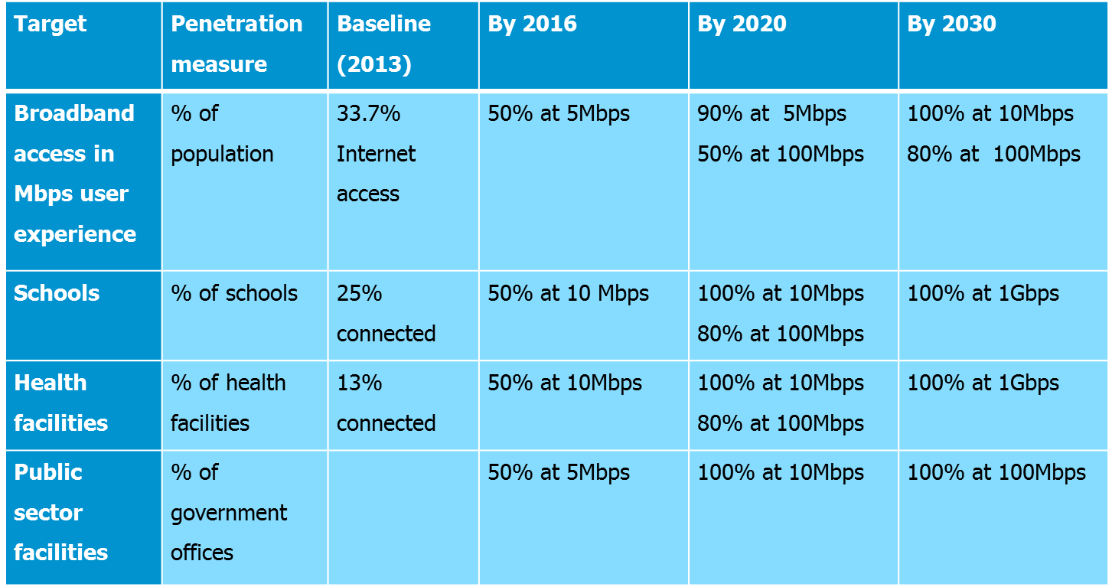
The table sets out the National Broadband Policy Targets as per South Africa Connect Policy
The targets also serve as indicators for the four interventions identified below in order to achieve the set objectives of affordable, ubiquitous broadband which is reflected in the staggered percentages toward universal access by 2030.

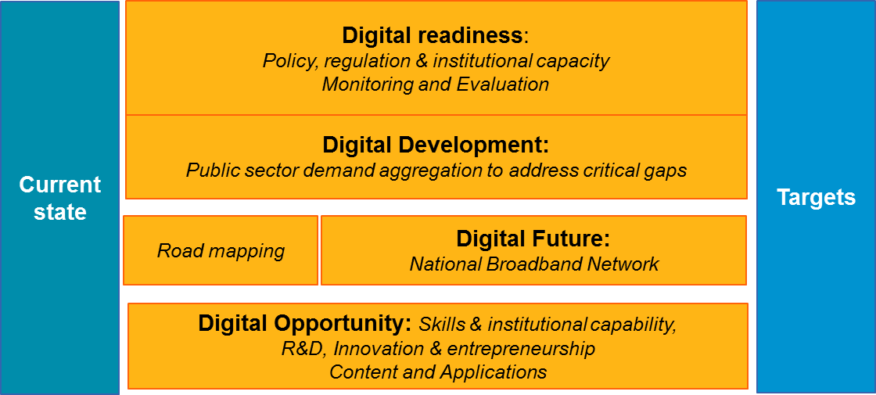
Therefore, the South Africa Connect Policy affects the performance delivery environment of USAASA and USAF as this is the national policy approved by Parliament and it has to be considered on the information gathering during the annual performance –planning process.
- 5.3.4, Things not belonging in the document being inappropriately included
Both USAASA and USAF Annual Performance Plans for 2018/19 are compiled in terms of the National Treasury Framework for Strategic Plans and Annual Performance Plans, The Framework for Managing Performance Information, National Treasury Guidelines on the preparation of Quarterly Reports for Public Entities and Constitutional Entities and National Treasury Performance Information Handbook.
The Agency is bound by the FSPAPP to consider the legislative and other mandates during the annual performance planning process. The entity is required to set out the specific constitutional and other legislative, functional and policy mandate of the institutions. Therefore, the inclusion of the Strategic Integrated Project (SIP) 15: Expanding Access to Communication Technology is done according to the requirement of planning.

Below is an extract from the Strategic Integrated Project (SIP) 15:
Strategic Integrated Project (SIP) 15: Expanding Access to Communication Technology aims to ensure universal service and access to reliable, affordable and secure broadband services by all South Africans, prioritising rural and under-serviced areas and stimulating economic growth. This includes migration nationally, from analogue to digital television broadcasting by 2015. SIP 15 is part of the PICC, a Presidency-led initiative to co-ordinate infrastructure projects (construction, fast-tracking of current projects and maintenance of existing infrastructure) across all spheres of government and state-owned enterprises. Expanding access to communication technology will be done primarily through broadband infrastructure roll-out. To this end, a national backbone infrastructure will be established which will inter alia include establishing core Points of Presence (POPs) in district municipalities, extending fibre networks across provinces linking districts and, rural and under-served areas. The coordination and integration of communications infrastructure activities within state-owned enterprises, private entities, provinces and local government will be critical in ensuring this is achieved. It is expected that the private sector and state owned enterprises will play a significant role in expanding Access to Communication Technology. Connectivity to rural and under-serviced areas including e-health, e-schools and e-government will be prioritised. By 2013, broadband connectivity will be rolled out in 125 Dinaledi schools, plus 1525 district schools. Other members of the Intergovernmental Forum are:
- Department of Public Enterprises
- Department of Science and Technology
- Department of Public Service and Administration
- Department of Trade and Industry
- Sentech
- Broadband Infraco
- Universal Service and Access Agency of South Africa (USAASA)
As a result of the above, it is empirical for USAASA and USAF to make reference to other role players mandate in order to provide context to the reader of the document.

- Page 24. Expenditure estimates,
USAASA Final Plan 2018/19 P25 Budget Estimate is R80,074m and P31 is R79,465m. What is the difference?
The difference of R609k is Program 2 on P35. If R79,465m and R609k is aggregated, the result is R80.074m.

Nontax revenue. Why is there none shown from 2017/18 to 2020/21? -
Interest revenue is not budgeted for.

USAASA Final Plan 2018/19 On P30, over previous 2 financial years ICT spend in aggregate is R52m. From 2017/18 it reduces to R4.6m and just above R5m going forward?
In the previous 2 financial years the majority of the spend was related to implementation of SAP.
From 2017/18 onwards spending was moderate to incorporate support and maintenance.

Reason for reduction of R250m?

USAASA was instructed by the Department to reduce by R250m on the BDM line item and this was per National Treasury as per attached email from the department.

Dear CFO and Mokgobo,

In terms of the revised 2018 Allocation letter from National Treasury, Please note the revised BDM allocation. Kindly include this in your planning. The official letter will be send to the office of the CEO

 | 2018/19 | 2019/20 | 2020/21
DETAIL OF TRANSFERS AND SUBSIDIES | Revised Baseline | Revised Baseline | Revised Baseline
Universal Service and Acess Agency of South Africa | 80,074 | 84,558 | 89,209
Universal Service and Access Fund | 57,781 | 61,017 | 64,373
Universal Service and Access Fund: Broadcasting Digital Migration (Prev Allocation) | 287,880 | 304,001 | 320,721
Universal Service and Access Fund: Broadcasting Digital Migration (Reduction) | -250,000 | -250,000 | -264,000
Revised Allocation on BDM | 37,880 | 54,001 | 56,721
GRAND TOTAL | 175,735 | 199,576 | 210,303

- Concerned about the programme structure, was this a mistake
Programme structure as presented in the plan is in line with the requirements of the National Treasury Framework for Strategic Plans and annual Performance Plans. The programme listed targets for the budget year and over a period the MTEF period for each strategic objective
Programme  performance indicator |  | Audited/Actual performance |  |  | Estimated performance  20XX-1 | Medium-term targets
 |  | 20XX-4 | 20XX-3 | 20XX-2 |  | 20XX | 20YY | 20ZZ
1.1 | Short name
1.2 | Short name

- Page 21, access to digital, SA targets indicates 90%, how USAASA get itself to achieve
The Agency targets setting are informed by the South Africa Connect Policy. The below extract demonstrates the targets that aligned to USAASA targets as the agency may not operate in insolation of the set targets

Broadband Policy Target | Penetration | Baseline (2013) | By 2016 | By 2020 | By 2030
 | measure
Broadband access in Mbps user experience | % of population | 33.7% Internet access | 50% at 5Mbps | 90% at 5Mbps | 100% at 10Mbps
 |  |  |  | 50% at 100Mbps | 80% at 100Mbps
Schools | % of schools | 25% connected | 50% at 10 Mbps | 100% at 10Mbps | 100% at 1Gbps
 |  |  |  | 80% at 100Mbps
Health facilities | % of health facilities | 13% connected | 50% at 10Mbps | 100% at 10Mbps | 100% at 1Gbps
 |  |  |  | 80% at 100Mbps
Public sector facilities | % of government offices |  | 50% at 5Mbps | 100% at 10Mbps | 100% at 100Mbps
USAASA is only connecting two local municipalities that are identified as part of the South Africa Connect Policy Phase 1 Implementation Plan. The targets from the South Africa Connect is a collective responsibility of all entities cited in the policy and USAASA contributes towards that by appointing SMME’s which have licenses issued by the Independent Communications Authority of South Africa and the Agency works closely with Broadband Infraco for the rollout of broadband infrastructure and connectivity of identified sites such as schools, clinics, public offices, social institutions and public spaces where free Wi-Fi is provided.
- Clarity on document signed, when was it signed,
It is the responsibility of the Department of Telecommunications and Postal Services to exercise oversight on planning, budgeting and reporting. Therefore, the signing of the APPs for tabling is the responsibility of the Department

.
- Change in the Strategic plan process, do you have adequate management and process for the board itself
The management of USAASA has a full comprehension of the regulatory instruments as per the requirements of the Public Finance Management Act, 1999. The planning process by the Agency is integrated with entities such as Sentech, Broadband Infraco, the Domain Name Authority, including the Department of Telecommunications and Postal Service and Department of Communications. These entities and departments get invited to the strategic sessions intended for information gathering for annual performance planning. The Agency also submits its plans to the Department of Planning, Monitoring and Evaluation for review and comments. The Auditor General of South Africa is also involved on the review process of the final plans in order to check compliance towards the SMART criteria.
The Agency has a planning policy in place which is informed by the following National Treasury planning instruments:
  - The Framework for Strategic Plans and Annual Performance Plans
  - The Framework for Managing Programme Performance Information
  - The Guidelines on the preparation of Quarterly Reports for Public and Constitutional Entities
  - The National Treasury Performance Information Handbook
The service delivery model is informed by available resources, the achievement of the APP will be mainly driven by the approved budget allocation, available resources with skills (all critical positions are filled with competent staff) and the Board has capacity to effectively performs its oversight role.
- Capacity to implement target, reduction does it mean less capacity
The reduction of the targets does not mean USAASA has less capacity, it is mainly to shift the Agency’s focus towards achievement of the strategic key priorities for the financial year. Majority of the targets moved from the APP to the operational plan were found to be more operational in nature during the planning phase hence the omission from the final APPs. These targets together with the APP targets will be cascaded down into individual performance agreements and tracked on a monthly basis for purposes of ensuring the Agency’s continued performance.

- USAASA, targets not achieved due to
There are various reasons why USAASA has not achieved its targets. The frequent changes of the Ministers on Telecommunications and Postal Services including the Communications portfolio had a domino effect on USAASA’s ability to deliver on its mandate. Another contributing factor is the instability of USAASA executive management, as none of the CEOs employed previously by USAASA has ever finished their employment term, this in turn brings instability and uncertainty at operational level and also triggers low morale amongst the staff members. The baseline allocation for USAASA is not according to the funded legislative mandate and the collected revenue for Universal Service and Access Fund is not prioritized for the requirements of the Fund to be fulfilled. The Agency is established under the legislative framework that is administered by the Independent Communications Authority of South Africa and the regulatory complex does not put emphasis on universal service and access as they are other critical matters the Regulator must address arising from the developmental agenda of the country. Another major contributing factor is the skills set that the Agency has at its disposal as there are a few resources with the skill and knowledge of broadband planning and project management. The Agency’s current salary scales are aligned to Public Service Regulations, yet USAASA is operating in a technically regulated sector that is driven by rapid technological development, hence the Agency’s inability to attract good skills from the sector.
- Site connected and the one to be connected, what is the proximity
The proximity of the sites connected and to be connected is determined by the geographical landscape of the particular identified local municipality. The number of sites to be connected are determined by the budget and normally USAASA engages with local authorities such as the District Executive Mayors, Municipality Managers, the various Heads of Departments for Provincial Health and Education.
- What informs the identification of the sites
The site identification is as per the South Africa Connect Policy Phase 1 Implementation, and 8 District Municipalities were identified. The Department is the one that determines which sites USAASA must prioritise given the fact the USAF is subject to policy instructions issued by the Minister of Telecommunications and Postal Services in terms of section 87(4) of the Electronic Communications Act, 2005.
No | Phase 1 District | Facilities
1 | Dr Kenneth Kaunda(NW) | 340
7 | Gert Sibande(MP) | 797
8 | O.R.Tambo(EC) | 1444
4 | Pixley ka Seme(NC) | 225
5 | Thabo Mofutsanyane(FS) | 747
6 | uMgungundlovu(KZN) | 771
7 | uMzinyathi (KZN) | 601
8 | Vhembe(LIM) | 1210
TOTAL |  | 6135

- Planning on Digital fund years to come
The National Integrated ICT White Paper published in Government Gazette No. 40325 October 2016 dated 3 was identified as one of the major policies governing the South African ICT market landscape based on information gathering during the annual performance-planning process.
The ICT Policy Review Panel recommended that the Universal Service and Access Agency of South Africa (USAASA) be dissolved and the existing Universal Service and Access Fund be transformed into a stand-alone funding agency to support the universal service and access. The Panel further proposed that the roles and responsibilities of the funding agency, regulator and the policy-maker be clarified.
This is in line with Government’s commitment to streamline roles and responsibilities of different entities to increase efficiency and public value for public resources.

In line with this, the policy making, regulatory and fund management responsibilities will be separated and allocated as follows:

- Going forward, the Ministry will be responsible for formulating policy approaches to universal service and access to communications, including defining this concept in policy and legislation, setting the objectives for policy, broadly outlining the process of reviewing the approach adopted and broadly outlining universal service and setting targets and criteria for this. Therefore, all policy-related responsibilities currently resting with USAASA and the regulator will be transferred to the Minister.

- Regulatory-related functions currently allocated to USAASA will be transferred to the regulator. Included in these regulatory functions will be the licence conditions to advance universal service and access, the monitoring of the roll-out of networks and services and the enforcement of the license conditions.
- USAASA will be dissolved and the USAF will be transformed into a new Digital-Development Fund (DDF) responsible for providing support to achieve the objectives set below.
- No where there is mention of the elephant in the corruption process, old set top boxes, procurement on the illegal process, why it’s omitted
In the prior annual performance plan, the concerns around the procurement has always been highlighted as a risk and reasons for delays articulated and presented to the Portfolio Committee. The litigation and arbitration process taken by the Board as part of addressing the 2015/16 irregularity found on procurement of Set-Top-Boxes is part of the activities that were to be included on USAF 2016/17 annual reporting. However the court decision to set aside the procurement process occurred post the preparation and the submission of USAF 2018/19 Annual Performance Plan. However, a detailed narrative will be included on the audited annual performance report.
- Role in the SA connect, impact assessment, how long has USAASA have been Implementing, support for 2 years, how many are maintained beyond pulled how many you have let go
Section 87(4) of the Electronic Communications Act, 2005 dictates that the Universal Service and Access Fund must be administered by USAASA subject to the control and in accordance with the instructions by the Minister.
The South Africa Connect Policy administered by the Department of Telecommunications and Postal Services is one of Cabinet’s approved national policies that directly affects the operational activities of the Universal Service and Access Fund. Therefore, the deployment of broadband in the identification underserviced areas as per the Phase 1 implementation of the South Africa Connect Policy is illustrated in the below image:
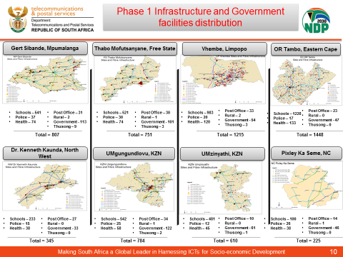

- What negotiation are underway and handover process is currently in place, who is responsible to support these sites once you work away
USAASA is currently engaging Nyandeni, Impendle, Mhlontlo and King Sabata Dalindyebo Local Municipalities to take over the connectivity of sites once the 24- months maintenance and internet connectivity contracts have elapsed. The Agency in the past has tried to negotiate with Provincial Departments of Health and Education and the respective departments insisted that it is the responsibility of USAASA in terms of the Operation Phakisa. The continuous connectivity of internet sites in the underserviced and unserved communities is also a policy issue that the Department of Telecommunications and Postal Services must address as the Universal Service and Access Fund are generally established for the purpose of connecting communities, schools and health institutions.
- Same as the set top boxes what happened once you install, who is supporting
The Set-To-Boxes come with a two - year warranty on the hardware and a one-year warranty on installation. If the Set-Top-Box is faulty and the affected household reports it to the nearest Post Office, an installer will be dispatched to investigate the box and if the box is confirmed to be faulty, a new box will be issued.
- Page 18, presentation under, rapid connectivity what is that
The rapid deployment and connectivity programme refers to connectivity of the access centres, primary health facilities and educational institutions. USAASA subsidises connectivity for 24 months in terms of section 88(1) of the Electronic Communications Act, 2005. The rapid deployment naming convention refers to a programme that was introduced by USAASA for establishment of access centres in areas where there is less penetration of internet and the centers were operated using an entrepreneurial model in order to ensure sustainability of the centres.
Therefore, the USAASA rapid deployment programme is not linked to the rapid development policy process in terms of the Electronic Communications Act,2005 initiated in 2015. The aim of the policy is to harmonise, simplify and minimise the period taken to apply for wayleaves and to issue permits.

- What is the relationship and collaboration, with SENTECH
USAASA has a Memorandum of Understanding with SENTECH, Broadband Infraco (BBI) and ICASA. The Agency is in the process of finalising the MoU with NEMISA. The Agency is collaborating with SENTECH in terms of the rollout of the Set-Top-Boxes and the collaboration is driven through the Project Management Office of the Department of Communications. USAASA intends to review the MoU with SENTECH to include the use of the high sites in underserviced areas for the rollout of broadband services to communities and the sharing of resources and expertise in terms of rollout of broadband infrastructure.
- Proposed Digital Development Fund, how has this impacted on the culture of the Organisation, (hence the transitional plan)
The Agency has a new key performance indicator to facilitate the smooth transition from USAASA/USAF into DDF as per the policy pronouncement of the National Integrated ICT White Paper published in Government Gazette No. 40325 October 2016. Therefore, the introduction of new legislation and the amendment to the current legislation needs to be accounted for as USAASA transits itself into the DDF.
- Page 29, on the document, management of risk
The target doesn’t relate to the risk appetite however it relates to percentage implementation of the Risk Management Plan. It measures the extent to which USAASA has addressed all the identified risks as per the risk register. The ability to manage risks assists the organisation to act more confidently on future decisions. The organisation’s knowledge of the risks it is facing will give management various options on how to mitigate potential problems. The indicator will be measured quarterly and the numerator will the total number of risks mitigation plans implemented by the due date and denominator will be the total number of risks mitigation plans due for the period.
- Where was the CEO working before his appointment at USAASA
Mr. Mtimde is the former head of the state-funded entity called Media Development and Diversity Agency (MDDA). When he was recruited by the Board of the Agency, he occupied the position of chief of staff in the Ministry for Agriculture, Forestry and Fisheries.
- Risk identified on contracts, done by contractor, what process is in place
USAASA has invested in a SAP ERP system and all the contracts are loaded into the system and monitored closely. The management of risks associated with contracts is also on the risk register that is closely monitored by the Risk Manager on monthly basis and reported to the Board Audit & Risk Committee quarterly as part of its oversight role.

____________________________
Mawethu Cawe
Chairperson of the Board: USAASA

Date:
___________________

ANNEXURE A- LIST OF ACCRONYMS

The acronyms are revised as per the recommendations of the copy.
USAASA
ADSL Asymmetric Digital Subscriber Line
AG Auditor General
APP Annual Performance Plan
BARC Board Audit and Risk Committee
BBBEE Broad Based Black Economic Empowerment
BDM Broadcasting Digital Migration
CAPEX Capital Expenditure
CEO Chief Executive Officer
DDF Digital Development Fund
DoC Department of Communications
DTPS Department of Telecommunications and Postal Services
EC Eastern Cape
ECA Electronic Communications Act
ERP Enterprise Resource Planning
FS Free State
FSPAPP Framework for Strategic Plans and Annual Performance Plans
GATS General Agreement on Trade in Services
GRAP Generally Recognised Accounting Practice
HR Human Resources
HRD Human Resource Development
ICASA Independent Communications Authority of South Africa
ICT Information and Communication Technology
IT Information Technology
KPIs Key Performance Indicators
KRAs Key Results Areas
KZN KwaZulu-Natal
LP Limpopo
MBPS Mega Bits per Second
MP Mpumalanga
MTSF Medium Term Strategic Framework
NC Northern Cape
NDP National Development Plan
NGP New Growth Path
NW North West
OAWN Open Access Wireless Network
OAFN Open Access Fibre Network
OD Organisational Development
PICC Presidential Infrastructure Coordinating Commission
PMU Performance Management Unit
R&D Research and Development
RDP Reconstruction and Development Plan
REMCO Human Resources & Remuneration Committee
SA Connect South Africa Connect
SANRAL South African National Roads Agency Limited
SAP ERP Enterprise Resource Planning
SAPO South African Post Office
SCM Supply Chain Management
SIP 15 Strategic Integrated Plan 15
SLA Service Level Agreement
SMME Small Medium and Micro Enterprises
SWOT Strengths, Weaknesses, Opportunities and Threats
USAF Universal Service and Access Fund
USAASA Universal Service and Access Agency of South Africa
WSIS World Summit on Information Society
WSP Work Skills Plan
WTO World Trade Organisation
3D Three Dimensional
USAF
AG |  | Auditor General
APP |  | Annual Performance Plan
BBBEE |  | Broad-based Black Economic Empowerment
BDM |  | Broadcasting Digital Migration
CEO |  | Chief Executive Officer
DDF |  | Digital Development Fund
DTPS |  | Department of Telecommunications and Postal Services
EC |  | Eastern Cape
ECA |  | Electronic Communications Act
ERP |  | Enterprise Resource Planning
FS |  | Free State
GRAP |  | Generally Recognised Accounting Practice
GATS |  | General Agreement on Trade in Services
HR |  | Human Resources
HRD |  | Human Resource Development
ICASA |  | Independent Communications Authority of South Africa
ICT |  | Information and Communication Technology
IT |  | Information Technology
ITU |  | International Telecommunication Union Busan Resolution of 2014
KRA |  | Key Result Areas
KZN |  | KwaZulu-Natal
LP |  | Limpopo
MBPS |  | Mega Bits per Second
MP |  | Mpumalanga
MTEF |  | Medium Term Expenditure Framework
NC |  | Northern Cape
NDP |  | National Development Plan
NGP |  | New Growth Path
NW |  | North West
OD |  | Organisational Development
PICC |  | Presidential Infrastructure Coordinating Commission
REMCO |  | Human Resources & Remuneration Committee
R&D |  | Research and Development
RDP |  | Reconstruction and development Plan
SANRAL |  | South African National Roads Agency Limited
SAP |  | Systems, Applications and Products
SAPO |  | South African Post Office
SCM |  | Supply Chain Management
SIP 15 |  | Strategic Integrated Plan 15
SLA |  | Service Level Agreement
SMME |  | Small, Medium and Micro Enterprises
SWOT |  | Strengths, Weaknesses, Opportunities and Threats
USAF |  | Universal Service and Access Fund
USAASA |  | Universal Service and Access Agency of South Africa
WSP |  | Work Skills Plan
WSIS |  | World Summit on the Information Society
WTO |  | World Trade Organisation

