**3. Report of the Portfolio Committee on Human Settlements on Budget Vote 38: Human Settlements, and on the strategic plan for the coming Medium Term Expenditure Framework (MTEF) period and Annual Performance Plan 2018/19, dated 3 May 2018**

The Portfolio Committee on Human Settlements, having considered Budget Vote 38: Human Settlements, and the strategic plans for the MTEF period and the annual performance plans of the Department of Human Settlements (later referred to as the Department) and its entities on 17, 18 and 19 April 2018, referred to it, reports as follows:

**1. Introduction**

The Constitution of the Republic of South Africa (1996) places an obligation on the State to provide access to adequate housing to its citizens. As the custodian of the housing sector, the Department derives its core mandate and responsibilities from section 3 of the Housing Act (1997), which allows the Department, in collaboration with provinces and municipalities, to establish and facilitate a sustainable national housing development process. The Department does this by, determining the national policy, national norms and standards for housing and human settlements development, setting broad national housing delivery goals, and monitoring the financial and non-financial performance of provinces and municipalities against these goals, building the capacity of provinces and municipalities and promoting consultation with all the stakeholders in the housing delivery chain, including civil society and the private sector.

In order to ensure the progressive realization of its mandate and the goal of sustainable and integrated human settlements, the Department has subsequently developed strategies, policies and programmes. The comprehensive plan for the development of sustainable human settlements, approved in 2004 and the revised Housing Code, published in 2009, mark a conceptual shift away from the mandate of providing shelter, to supporting the residential property market. The Housing Code allows for access to housing and services for low-income families and ensures greater choice in quality, location and ownership. Subsequently, chapter eight of the National Development Plan (NDP) provides a roadmap for the achievement of sustainable human settlements in South Africa by 2030. The Department has thus strategically aligned its plans with the NDP.

**2. Department of Human Settlements**

**2.1 Aim and mandate of the Department**

The mandate of the Department is to determine, finance, promote, co-ordinate, communicate and monitor the implementation of housing policy and human settlements. Since the formulation of the Comprehensive Housing Plan in 2004, the Department has conducted various initiatives to enhance the creation of comprehensive, integrated, coordinated and sustainable human settlements and quality housing. These initiatives include the review of the National Housing Code, which determines national norms and standards in respect of housing development, as well as the provision of the Farm Worker/Occupier Housing Assistance Programme and the establishment of the Housing Development Agency.

Subsequent to that and during the course of January 2010, the Cabinet approved an outcomes-based performance approach to the mandate of the Department with the adoption of Outcome 8 – Sustainable Human Settlements and Improved Quality of Household Life. The Outcome 8 has sub-outcomes that the Department has to adhere to such as the provision of adequate housing and improved quality living environments; a functionally equitable residential property market and enhanced institutional capabilities for effective coordination and spatial investment decisions. The Outcome 8 approach sets targets for Government in respect of four areas:

* Accelerated delivery of housing opportunities with a focus on upgrading of informal settlements and providing affordable rental housing stock;
* Providing access to basic services as part of the National Bulk Infrastructure Development Programme;
* Ensuring more efficient land utilization with a target of the acquisition of 6250 ha (net) state owned land; and
* Facilitating an improved property market through the supply of affordable housing finance.

While the timeframe of the Outcome 8 in terms of targets ended in 2014, the policy approach and focus remains relevant.

**2.2 National Development Plan**

The NDP highlights the spatial inequalities that exist in society as a major challenge to reducing inequality. A number of objectives are listed in order to transform the human settlements sector in line with the developmental vision for South Africa. These include:

* A strong and efficient spatial planning system that is well integrated across the spheres of government;
* The upgrading of all informal settlements on suitable, well-located land by 2030;
* More people living closer to where they work;
* Better quality public transport; and
* More jobs in or close to dense, urban townships.

**2.3 Medium Term Strategic Framework**

The MTSF-2014-2019 focuses on the reforms aimed at achieving the following:

* Ensuring that the poor households have adequate housing in better living environments;
* Improving the institutional capacity and coordination for better special targeting; and
* Supporting development of a functionally and equitable residential property market.

The MTSF identified the following key priorities for the Department:

* Scaling up the upgrading of informal settlements;
* Transfer of all title deeds for subsidy units;
* Developing a more coherent and inclusive approach to land;
* Implementing a coherent multi-segmented social rental-housing programme that includes backyard rentals;
* Dealing with affordable market with a particular emphasis on constructive engagement and strengthening partnerships with the private sector to improve delivery; and
* Consolidating the Development Finance Institutions.

**2.4 Revision of legislative and other mandates**

The mandate and core business of the Department of Human Settlements is underpinned by the Constitution and all other relevant legislation and policies applicable to the Department. In addressing the mandate for integrated sustainable human settlements, the review of policies particularly the development of the White Paper for Human Settlements and the revision of the Housing Act to Human Settlements Act will enhance the departments’ efforts in the provision of adequate housing by:

* Providing a framework for the realisation of sustainable human settlements and improved quality of household life.
* Providing a foundation for the establishment of a viable, socially and economically integrated communities that are located in areas allowing convenient access to economic opportunities as well as health, educational and social amenities.

**2.4.1 Policies**

The mandate of the Department is set out in the Housing Act. Section 2 of the Housing Act compels all three spheres of government to give priority to the needs of the poor in respect of housing development. In addition, all three spheres of government must ensure that housing development:

a) Provides as wide a choice of housing and tenure options as is reasonably possible;

b) Is economically, fiscally, socially and financially affordable and sustainable;

c) Is based on integrated development planning; and

d) Is administered in a transparent, accountable and equitable manner, and upholds the practice of good governance.

Following a Presidential Proclamation, the Department took over the oversights function of the Estate Agency Affairs Act, 1976 from the Department of Trade and Industry during May 2012. The objectives of the Act are to:

* Establish the Estate Agency Affairs Board (EAAB) to regulate the conduct of estate agents;
* Establish the Estate Agents Fidelity Fund;
* Monitor trends within the real estate industry; and
* Render education and training to estate agents and consumers.

**2.4.2 Policy Mandates**

Other specific constitutional, legislative and policy mandates of the Department including government policy frameworks are:

* Constitution of the Republic of South Africa
* Housing Act, 1997 (Act No 107 of 1997)
* Comprehensive Plan for the Creation of Sustainable Human Settlements (BNG)
* The Housing Consumer Protection Measures Act, 1998 (Act No 19 of 1998)
* The Housing Development Agency Act, 2008 (Act No 23 of 2008)
* Public Finance Management Act, 1999 (Act No 1 of 1999)
* The Social Housing Act, 2008 (Act No 16 of 2008)
* The Division of Revenue Act, 2011 (Act No 6 of 2011)
* The Rental Housing Act, 1999 (Act No 50 of 1999)
* Home Loan and Mortgage Disclosure Act, 2000 (Act No 63 of 2000)
* Inclusionary Housing Bill
* Sectional Titles Schemes Management Act (Act 8 of 2011)
* Community Schemes Ombud Service Act 2011 (Act 9 of 2011)
* Intergovernmental Relations Framework Act (No 13 of 2005)
* National Development Plan (NDP)
* Spatial Planning and Land Use Management Act, 2013 (Act No 16 of 2013).

**2.4.3 Planned policy initiatives**

The Department has embarked on a process of developing a White Paper on Human Settlements. The White Paper will be a fundamental policy document that carves the development path and subsequently, the implementation of Integrated Human Settlements in South Africa. This process will result in the review of a host of human settlements policy and legislation, for instance the Housing Act (No 107 of 1997) and the 2009 National Housing Code.

The Policy initiatives would provide the rationale for the establishment of Human Settlements Ombudsman (HSO) which would allow for the investigation and resolution of disputes relating to human settlements matters and the observance of the fundamental right to access to adequate housing, within the area of responsibility in the Department at National, Provincial and Local government level, including the Department’s entities.

The following are the Department’s policy and legislative priorities for 2018/19:

* Development of the Human Settlements Code
* Amendment of the Housing Act to Human Settlements Legislation
* Repealing the Housing Consumer Protection Measures Act
* Human Settlement Development Bank Bill
* Amending the Prevention of Illegal Evictions and Unlawful Occupation of Land Act
* Revision of the Social Housing Policy and Regulations
* Policy Review and Evaluations.

**2.5 Outcome 8: Sustainable human settlements and an improved quality of household life**

While the timeframe of targets stated in Outcome 8 ended in 2014, the Department is of the view that the policy approach and focus of the document remains relevant.

The following targets apply:

* Accelerated delivery of housing opportunities with a focus on the upgrading of informal settlements and providing affordable rental housing stock.
* Access to basic services as part of the National Bulk Infrastructure Development Programme.
* More efficient land utilisation with a target of acquiring 6 250 hectare of State-owned land.
* An improved property market through the supply of affordable housing finance.

**2.6 State-of-the-nation address (SONA) and the Budget Speech**

Although there was no specific reference to the Human Settlements and housing was made by the President in SONA 2018, it is important to note that given the integrated, collaborative and coordinated work of the State and Government – the Department plays a key role in a number of the strategic areas highlighted by the President. Key areas of work being undertaken as part of the Department mandate impacts on the overall strategic objectives of government related to the eradication of poverty, inequality and unemployment as well as socio-economic transformation. The policies, legislation and implementation frameworks of the Department are designed to ensure that the key mandates of government are integrated into the outputs and outcomes achieved. The Human Settlements Development Grant (HSDG) and Urban Settlement Development Grant (USDG) Frameworks ensure that the key priorities are addressed and the following are included:

* Monitoring and reporting on set asides related to procurement awards to women, youth, military veterans and persons with disabilities;
* Investment in socio-economic infrastructure which takes steps to eradicate asset and infrastructure inequality and this includes building of libraries, fire stations, community centres, energy, roads and transport infrastructure;
* Ring-fenced funding for Distressed Mining Towns and Labour Sending Areas;
* In the City of Cape Town USDG funds have been allocated to assist mitigation measures related to the drought;
* The objective of the title deeds programme is to promote and foster an increase in household wealth which promotes eradication of poverty and inequality.

The Department is in the process of finalising a concept framework on the matter of ensuring a contribution to student accommodation. However, the following should be noted:

* Department has facelifted the provision of bulk and link service through the USDG allocation to Ethekwini to allow for the Mangosuthu University of Technology to commence with the expansion of its student residents;
* Social and Rental Funding has provided for the upgrading of buildings in Braamfotein through both the SHRA and GPF which has provided the impetus for private sector investment into the area for Social and Rental Housing;

The Department is, through the Catalytic Project Programme, Distressed Mining Towns Intervention and the Employer Assisted Housing Programme, ensuring the private sector funding is crowded in therefore promoting public-private partnerships to encourage into government programmes. The Director-General has directed that the Department improves its Youth and Women Empowerment Programmes by ensuring it is underpinned by a clear strategy with concrete outcomes within the clear coordination framework, presently programmes include the EAAB One Learner – One Agency Partnership, the NHBRC Training Academy, the Scholarship Programme, the Youth Brigades but Provincial and Municipal Programmes are excluded and therefore much is being done but it is disparate and uncoordinated. In order to assist in improving the sustainability of SMME’s, the Department has already initiated monitoring mechanisms to ensure payment within the required 30-day period as provided in the Public Finance Management Act (PFMA), the Department presents to MinMec a Provincial overview of compliance.

**2.7 Summary of the Strategic Plan**

The Department’s Strategic and Performance Plans for the 2018/19 financial years indicate the following focus areas:

* Accelerating the delivery of housing as a key strategy for poverty alleviation;
* Utilizing the provision of housing as a major creation strategy;
* Ensuring that property can be accessed by all as an asset for wealth creation and empowerment;
* Leveraging growth in the economy;
* Combating crime, promoting social cohesion and improving quality of life for the poor;
* Supporting the functioning of the entire single residential property market to reduce duality within the sector by breaking the barriers between the first economy residential property boom and the second economy slump; and
* Utilizing housing as an instrument for the development of sustainable human settlements, in support of spatial restructuring.

The strategic objectives would be implemented through the following four programmes:

* Programme 1: Administration;
* Programme 2: Human Settlements Strategy, Policy and Planning;
* Programme 3: Programme Management Unit; and
* Programme 4: Housing Development Finance.

**2.8 Updated Situational Analysis**

The Department of Human Settlements is committed to facilitating and supporting the creation of sustainable and integrated human settlements across the country. This commitment is in response to the NDP proposal and is outlined in the Medium Term Strategic Framework 2014 – 2019 which includes the promotion of social inclusion, economic growth, ensuring that beneficiaries obtain security of tenure and spatial restructuring.

Though government delivered more than 3.9 million housing opportunities since the dawn of democracy, the demand for housing closer to economic opportunities continue to be the main problems facing the country. The demand for housing has been influenced by the increase in urbanization which has unintendedly resulted to an increase to informal dwellings and putting pressure in the country’s existing infrastructure. Statistics South Africa estimates that by 2020, there will be about 3.6 million new household formations with more than 2 million falling within the income category of less than R3500 per month will contribute to an increasing demand for housing. Currently the demand for adequate housing is estimated at about 2.2 million households, which includes households in informal settlements and backyard shacks. Of these, about 1.7 million are registered in the Department of Human Settlements’ Housing Needs Database.

In order to deal with the high demand for housing, that varies per income category, government in collaboration require a different approach taking into consideration the existing economic climate and the need for shelter. With only 30% of South Africans that are able to purchase a house of more than R500 000, and the shrinking tax base that has widened the national expenditure, the new approach must encompass a number of sustainability factors that will address a wide range of challenges within the housing and human settlements environment. The department will in the coming years focus in implementing the following strategies:

* Assist the poor and low income households to access numerous housing opportunities through the Human Settlements Development Bank;
* Coordinate development and ensure development occurs in areas where there is bulk infrastructure;
* Implement capacity development initiatives;
* Coordinate the implementation of the catalytic programme;
* Coordinate the development planning process and ensure that settlements are developed in townships that are proclaimed;
* Ring-fence funding for the title deeds restoration programme.

The proposed strategies will be implemented through the collaborative agreements and arrangements with all spheres and sector departments thus enabling the transformation of settlements developed and achieving the social cohesion as envisioned in the New Urban Agenda. To achieve and realise the overall MTSF-NDP-New Urban Agenda goals and objectives, the department will focus at:

a) Improving sector planning and delivery capabilities;

b) Coordinating and ensuring that the upgrading of informal settlements programme is accelerated;

c) Ensuring that all beneficiaries are provided with security of tenure over the medium-long term;

d) Ensuring that the establishment of the Human Settlements development bank is completed;

e) The establishment of Human Settlements Ombudsman to provide the citizens the ability to hold their government to account for its decisions.

**2.8.1 Performance Delivery Environment**

The Department of Human Settlements is currently implementing its 2015-2020 Strategic Plan. The Department within the framework of the NDP, the 2015-2020 Strategic Plan is structured around three strategic outcome-oriented goals that include:

* Enhanced efficiency and effectiveness of the Department;
* Integrated and responsive human settlements sector planning and policy environment;
* Increased delivery of adequate housing in quality living environments.

The efforts of the Department various programmes and the Department’s funding (including grants transferred to provinces and metros) are now directed towards the achievement of the above strategic outcome-oriented goals. For each of these goals, the Department defined a number of a number of strategic objectives linked to the five-year targets.

While the Department has set goals that will contribute to the realization of sustainable human settlements, the achievement of these goals is dependent on external forces that include:

* Availability of clear funding mechanism for infrastructure including bulk that unlocks some of the development challenges;
* Coordinated planning from local government, provinces along the identified priority precincts that have major influence on spatial restructuring;
* Efficient utilization of human settlements grants by provinces and municipalities which also is a key lever to the success of human settlements programmes and the achievement of national targets;
* Availability of planning and delivery capacity.

Without these, performance in the human settlements the sector would continue to experience the same challenges thus not be able to deal with the high demand for housing that has resulted to overcrowding, inadequate dwellings, deplorable urban environment, degrading public infrastructure and outright homelessness. Unlike the human rights-based framework of transitional justice that underpinned the Truth and Reconciliation Commission (TRC), issues such as sanitation, housing and public education can only be addressed by long-term state interventions at a systemic level. Conventional transitional justice mechanisms such as commissions, courts and tribunals are seldom able to adequately address these structural problems and inequalities.

The table below sets out housing delivery through the national housing programme since 2014.

|  |  |  |  |
| --- | --- | --- | --- |
| **Year** | **Serviced Sites Completed** | **Houses/Units Completed** | **Total Housing Opportunities** |
| **2013/14** | 48 193 | 105 936 | 154 129 |
| **2014/2015** | 49 345 | 94 566 | 143 911 |
| **2015/2016** | 52 411 | 100 339 | 152 750 |
| **2016/2017** | 56 343 | 90 962 | 147 305 |
| **TOTAL** | **206 292** | **391 803** | **598 095** |

**2.8.2 Organizational Environment**

The Department’s main strategic goal is to deliver adequate housing in quality living environments. Through the implementation of the 2014-2019 MTSF, the departmental strategic approach is focused at increasing housing opportunities and improved settlement functionality, efficiencies and resilience. Though there has not been a significant change in the organisation, the department is working towards the finalisation of a reviewed organizational structure which takes into account the delivery needs as the budget constraints the department is faced with. The reviewed structure would enable the Department to function better through regions. This would enhance the support offered to provinces and municipalities.

**3. Budget analysis**

**3.1 Budget allocations per programmes**

This budget analysis used both the nominal and real value of allocations to programmes and sub-programmes. The nominal value referred to a [value](http://en.wikipedia.org/wiki/Value_(economics)) expressed in money terms, i.e. a currency such as Rand value. The real value, however, adjusts nominal value to remove effects of price changes over time, for instance, the effects of inflation. Real increases or decreases in allocations would, therefore, take into account the effects of inflation on the monetary allocation to a programme or sub programme:

**3.1.1 Overview of the 2018/19 Budget & MTSF Estimates**

**Table 1: Expenditure Estimates**

|  |  |  |  |  |  |  |  |  |
| --- | --- | --- | --- | --- | --- | --- | --- | --- |
| **Programme** | **Budget** | | | | **Nominal Increase/ Decrease**  **R’ value** | **Real Increase/ Decrease**  **R’ value** | **Nominal Percent change** | **Real Percent change** |
| R Million | **2017/18** | **2018/19** | **2019/20** | **2020/21** | **2017/18** | **2017/18** | **2017/18** | **2018/19** |
| Administration | 470,0 | 442,7 | 471,5 | 502,7 | - 27,3 | - 50,4 | -5,81% | -10,72% |
| Human Settlement Policy, Strategy and Planning | 93,6 | 89,8 | 96,0 | 102,6 | - 3,8 | - 8,5 | -4,06% | -9,06% |
| Human Settlement Delivery Support | 216,9 | 246,0 | 261,0 | 329,8 | 29,1 | 16,3 | 13,42% | 7,50% |
| Housing Development Finance | 32 697,3 | 31 577,3 | 32 859,3 | 34 851,1 | - 1 120,0 | - 2 766,2 | -3,43% | -8,46% |
| Total | 33 477,8 | 32 355,8 | 33 687,8 | 35 786,2 | - 1 122,0 | - 2 808,8 | -3,35% | -8,39% |

Source: National Treasury 2018

The Department’s budget for 2018/19 is R32.3 billion. This reflects a nominal decrease of 3,35% (or 8,39% decline in real terms) when compared to the allocation of R33.4 billion for the previous year. Allocation to the Department for 2018/19 therefore did not keep abreast of inflation. The Human Settlements Delivery Support programme is the only of the four main programmes that received above inflation increases. Real changes (calculating the effect of inflation) in expenditure of the four main programmes for 2018/19 is:

* Administration: -10,7%;
* Human Settlements Policy, Strategy and Planning: -9,06%;
* Human Settlements Delivery Support: 7,50 %; and
* Housing Development Finance: -8,46%.

The bulk of the Department’s allocation is concentrated in the Housing Development Finance programme, i.e. R31 577.8 billion. This programme constitutes 97.6 % of the Department’s overall budget for 2018/19. This is the programme that funds the major conditional grants located within the Department, and would be expanded upon in the latter part of this document.

**Figure 1: Proportional Allocation Per Main Programme – 2018/19**

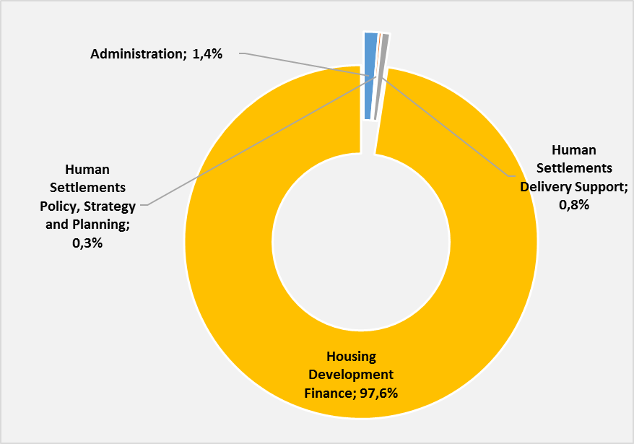

**National Treasury, 2018**

**3.1.2 Economic classification**

* The Department’s budget for compensation of employees declines from R383.3 million the previous year, to R376.9 million in 2018/19 – a real decrease of -6,0%. Indications in the ENE are that the number of posts filled would be reduced from 645 the previous year, to a total 606 in 2018/19.
* The Department is also reducing expenditure on both catering and computer services (declining in real terms with -16,02% and -9,55% respectively).
* Expenditure on consultants experience an above inflation increase – i.e. 8,75% real increase. This item grows from R128.3 million in 2017/18, to R147.2 million in 2018/19.
* Agency and support (outsourced services) triples from 869 000 to 2.4 million – i.e. 158% real growth from the previous financial year.
* Travel and subsistence, whilst showing a nominal increase from R50.9 million to R52.4 million 2018/19, in fact also declines in real terms with -2,35%.

**3.1.3 Programme 1: Administration**

Administration aims to provide strategic leadership, administrative and management support services to the Department. The Administration programme receives an allocation of R 442.7 million. This allocation reflects both a nominal (-5,81%) nominal and real (-10,72%) decrease. Expenditure across all five sub-programmes either declines or remains unchanged. The bulk of the departmental expenditure on compensation of employees (59,4%) and goods and services (52,4%) are located under this programme.

**3.1.4 Programme 2: Human Settlements Policy, Strategy and Planning**

Programme 2: Manages the development of policy, and compliance with human settlements sector delivery and intergovernmental relations frameworks, and oversees integrated human settlements strategic and planning services. Programme 2 receives an allocation of R89.8 million for the 2018/19 financial year, which is the smallest portion of the department’s budget. Its allocation reflects a decrease of -4,06% in nominal terms (and -9,06 real terms). The Human Settlements Strategy and Planning sub-programme continues to dominate expenditure with an allocation of R48.3 million for 2018/19. Expenditure declines in real terms with -14,74% from the previous year.

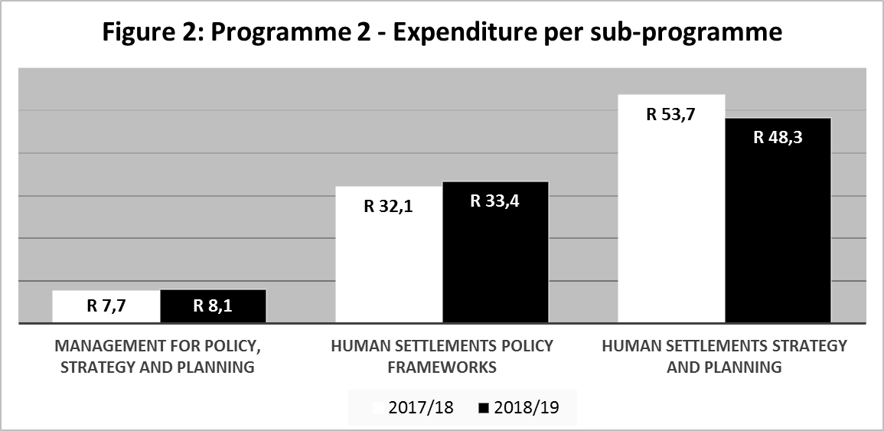

**National Treasury, 2018**

In previous financial years, the Human Settlements Strategy and Planning programme struggled to meet its performance targets, as well as experiencing underspending. The reasons for the under expenditure were:

* Failure to implement the mineworker strategy;
* Failure to develop a policy and administrative systems that support individual transactions in the affordable housing market; and
* Delay in purchasing of computer equipment due to frozen posts.

In 2017/18, this programme only achieved 63.6% of its performance targets. Some of the targets not met include:

* An approved Human Settlements Master Spatial Plan;
* About a third of title deeds backlogs was not eradicated;
* While target for hectares of land acquired was exceeded, most of it has not been
* re-zoned and thus not released for new development; and
* A draft White Paper for Human Settlements was not completed.

**3.1.5 Programme 3: Human Settlements Delivery Support**

Programme 3: Aims to support the execution, and monitor and evaluate the implementation of human settlements programmes and projects. Manage the building of capacity and skills in the sector and provide oversight of public entities.

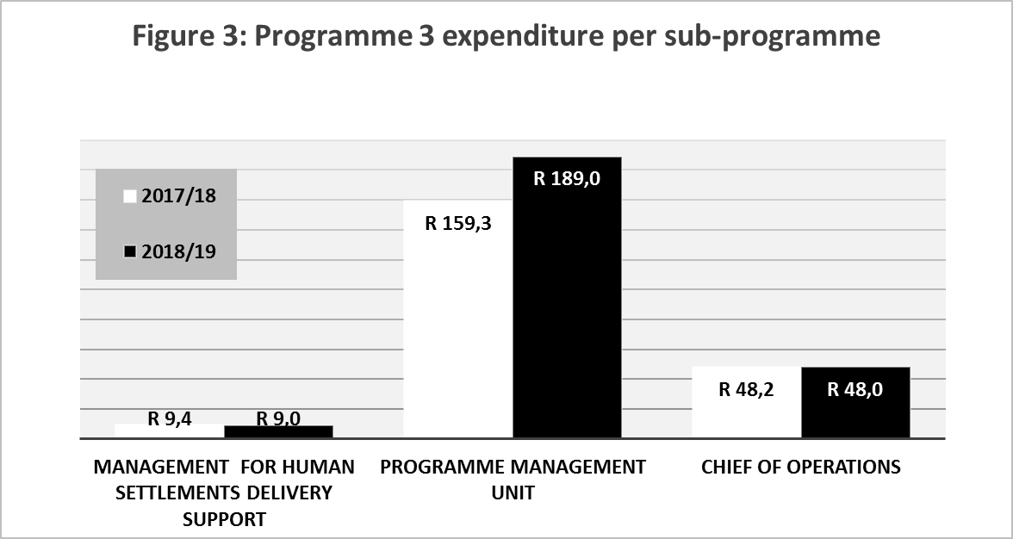

**National Treasury, 2018**

* This programme receives an allocation of R246 million, for the 2018/19 financial year, which reflects a nominal increase of 13,42% and a real increase of 7,50%. It is the only of the four departmental main programmes, which receives an above inflation increase for 2018/19.
* The Programme Management Unit sub-programme dominates expenditure with an allocation of R189 million – resulting in real growth of 12,46%.

In terms of economic classification, 66% of expenditure under this programme goes towards goods and services. Goods and services exhibits strong real growth in 2018/19, which can primarily be attributed to the significantly bigger allocation to the consultants’ item. Expenditure on consultants increase with 32,5% (real growth) from the previous year, i.e. from R79.2 million in 2017/18 to R110.7 currently.

However, this programme has been subject to consistent under-expenditure over previous financial years. For the 2015/16, the Department’s Annual Report provides the following reasons for under-expenditure:

* Delays in finalising the agreements around the Youth Brigade training with the Department of Rural Development and Land Reform meant that R7.5 million allocated to training was not transferred.
* Underspending in the National Upgrading Support Programme was reported and reasons provided include that:
* Some contracts running behind schedule due to slow responses from municipalities to approve work;
* Some service providers submitted invoices late;
* In few cases, the Department completed net draft RQFs but municipalities took long to approve these;
* Due to capacity constraints, the new capacity-building programme could not be implemented.
* Payments on the Bursary Scheme for non-employees was less than anticipated;
* The purchasing of computer equipment was delayed due to frozen positions;
* Expenditure was less than anticipated due to over estimation; and
* Expenditure on financial assets relates to approved losses approved by the loss control committee.

For 2016/17 financial year, the Department attributed its under-performance to the following:

* The delay in the upgrading of households was because the processes involved that included the adoption of upgrading plans by the council and budgeting process thereof
* Delays in delivering as a result of a number of processes that include the third quarter seasons where for almost two months’ work is stalled;
* Underperformance because of the process to reconstruct the organisation; and
* Confirming the state of readiness of projects by various stakeholders contributed to the delays and slow pace of delivery.

**3.1.6 Programme 4: Housing Development Finance**

Programme 4: It funds the delivery of all housing and human settlements programmes, and manages all matters related to improving access to housing finance and developing partnership with the financial sector.

* Programme 4 receives an allocation of R 31.5 billion, compared to R 32.6 billion previously. This reflects a real decline of -8,46%.
* The bulk of expenditure in Programme 4 is in the form of transfers, i.e. 97% of the budget is transferred to provinces and municipalities (in the form of conditional grants), as well as to the departmental entities.
* This programmes continues to be dominated by the Human Settlements development Grant (HSDG) and the Urban Settlements Development Grant (USDG). Both grant types declines in real terms from the previous year (HSDG -13,77% and USDG -5,85%).
* In 2018/19, two additional conditional grants are introduced, i.e. the Title Deeds Restoration Grant (R580.7 million) and the Emergency Housing Grant (R400 million).

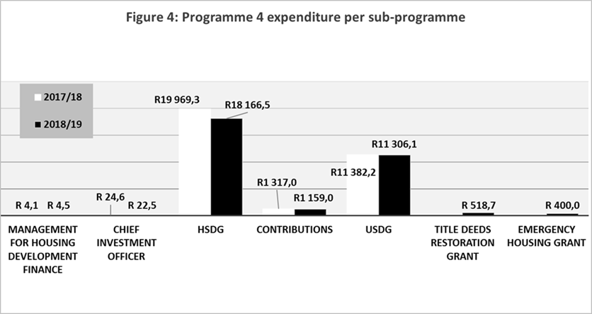

**National Treasury, 2018**

Programme 4, has consistently showed good performance over the period with an expenditure of 98.5 percent during 2015/16. However, there was underspending on the USDG in provinces such as Gauteng, Western Cape, and Limpopo. This under expenditure was attributed to the breakdown in the linkage between the funds.

**3.1.7 Relating expenditure trends to strategic outcome oriented goals**

The Department of Human Settlements is committed to the NDP’s vision of transforming human settlements and the spatial economy to create functionally integrated, balanced and vibrant urban settlements by 2030. Outcome 8 (sustainable human settlements and improved quality of household life) of government’s 2014-2019 medium-term strategic framework is aligned with this vision and guides the work of the department, as well as its commitment to improving institutional capacity and coordination across government. Over the MTEF period, the department would focus on ensuring that poor households have access to adequate housing in better living environments, and creating a functional housing market. It would invest in catalytic projects that deliver integrated communities; upgrade informal settlements; and provide affordable rental housing, outstanding title deeds to beneficiaries of state-subsidised housing, and temporary shelter to people affected by housing emergencies such as fires.

The Department has a total budget of R101.8 billion over the MTEF period, increasing at an average annual rate of 2.2 per cent, from R33.5 billion in 2017/18 to R35.8 billion in 2020/21. The below inflationary growth in the budget is due to Cabinet approved budget reductions of R3.1 billion in 2018/19, R3.8 billion in 2019/20 and R4 billion in 2020/21. Despite these reductions, the department aims to deliver 1.5 million housing opportunities by 2019, as determined by government’s 2014-2019 Medium-Term Strategic Framework.

**4. Delivery agreements for Outcome 8 for 2015/2016 (planned targets)**

Objective of Outcome 8 was to manage a comprehensive human settlements programme with multiple projects that covers extensive geographical spread aiming to improve the workings of the space economy. This would be achieved by:

* Providing poor households with adequate housing in better living environments;
* Supporting the development of functional and equitable residential property market; and,
* Improving the institutional capacity and coordination for better spatial targeting.

Housing delivery: In terms of the Outcome 8 MTSF for Human Settlements, a total number of 1. 5 million housing opportunities would be delivered over the MTSF period of five years. The 1. 5 million housing opportunities would consist of:

* 750 000 households in informal settlements upgraded;
* 563 000 individual units for subsidy market;
* 110 000 loans (70 000 FLISP plus 40 000 DFIs);
* 27 000 social housing;
* 10 000 CRU; and
* 35 000 affordable rentals.

**4.1 Other targets**

* 2 200 informal settlements would be assessed; and
* 10 000 ha of well-located land would be rezoned and released for new developments targeting poor and lower to middle income households.

**5. Allocations over MTSF by economic classification**

|  |  |  |  |  |
| --- | --- | --- | --- | --- |
|  |  | **2018 MTEF PERIOD** | | |
| **Total Allocation R`000** | **2017/18** | **2018/19** | **2019/20** | **2020/21** |
| **Departmental Operational** | **933 039** | **793 583** | **844 934** | **952 271** |
| Compensation of employees | 383 257 | 376 945 | 405 680 | 436 107 |
| Goods and services | 394 097 | 410 660 | 432 951 | 509 515 |
| Payment for Capital assets | 5 685 | 5 978 | 6 303 | 6 650 |
| **Payments for financial assets** | **150 000** | **80 000** | **50 000** | **-** |
| National Housing Finance Corporation | 100 000 | 80 000 | 50 000 | - |
| Rural Housing Loan Fund | 50 000 | - | - | - |
| **Grants and transfer payments** | **32 531 943** | **31 482 133** | **32 792 971** | **34 833 893** |
| **Grants** | **31 351 590** | **30 391 312** | **31 687 288** | **33 667 897** |
| Human Settlements Development Grant | **19 969 343** | 18 166 520 | 18 832 802 | 20 101 904 |
| Urban Settlements Development Grant | **11 382 247** | 11 306 137 | 11 880 786 | 12 534 479 |
| Municipal Emergency Housing Grant | - | 140 000 | 149 100 | 158 792 |
| Provincial Emergency Housing Grant | - | 260 000 | 276 900 | 294 899 |
| Title Deeds Restoration Grant | - | 518 655 | 547 700 | 577 823 |
| **Entities** | **1 167 031** | **1 079 034** | **1 093 236** | **1 152 864** |
| Social Housing Regulatory Authority: Operational | 46 815 | 51 980 | 55 201 | 58 237 |
| Social Housing Regulatory Authority: Institutional Investment | 20 490 | 20 132 | 21 259 | 22 428 |
| Social Housing Regulatory Authority: Restructuring Capital Grant | 851 658 | 743 640 | 738 414 | 778 527 |
| Social Housing Regulatory Authority: Regulations | 8 000 | 10 000 | 10 560 | 11 141 |
| Community Schemes Ombuds Services | 29 400 | 31 105 | 32 847 | 34 654 |
| Housing Development Agency | 210 668 | 222 177 | 234 955 | 247 878 |
| Departmental Transfers | **12 640** | **11 787** | **12 447** | **13 132** |
| Bursaries Scheme | 9 822 | 6 892 | 10 974 | 11 578 |
| UN Habitat | 1 272 | 1 346 | 1 421 | 1 499 |
| Nelson Mandela Metropolitan University | - | 3 500 | - | - |
| Transfer to Households (e.g. leave gratuity and donations to households) | 46 | 49 | 52 | 55 |
| **Total** | **33 464 300** | **32 355 716** | **33 687 905** | **35 786 164** |

**Source: Department of Human Settlements, 2018.**

**6. Grant allocation**

**6.1 Human Settlements Development Grant (HSDG) Provincial Allocations**

|  |  |  |  |  |
| --- | --- | --- | --- | --- |
|  |  | **2018 MTEF PERIOD** | | |
| **Provinces**  **R`000** | **2017/18** | **2018/19** | **2019/20** | **2020/21** |
|  |  |  |  |  |
| Eastern Cape | 2 239 316 | 1 908 439 | 1 982 512 | 2 123 601 |
| Free State | 1 193 038 | 1 072 422 | 1 111 476 | 1 185 866 |
| Gauteng | 5 528 050 | 5 046 583 | 5 236 578 | 5 598 471 |
| Kwazulu-Natal | 3 477 567 | 3 152 757 | 3 275 125 | 3 508 205 |
| Limpopo | 1 319 493 | 1 287 681 | 1 331 247 | 1 414 229 |
| Mpumalanga | 1 395 774 | 1 278 427 | 1 322 832 | 1 407 412 |
| Northern Cape | 402 668 | 474 791 | 487 930 | 512 958 |
| North West | 2 186 679 | 1 926 644 | 1 987 972 | 2 104 786 |
| Western Cape | 2 226 758 | 2 018 776 | 2 097 130 | 2 246 376 |
| **Total** | **19 969 343** | **18 166 520** | **18 832 802** | **20 101 904** |

**Source: Department of Human Settlements Strategic Plan.**

**6.2 Urban Settlements Development Grant (USDG) allocation**

|  |  |  |  |  |  |  |  |
| --- | --- | --- | --- | --- | --- | --- | --- |
|  | |  | |  | | **2018 MTEF period** | |
| **Provinces** | **Metros** | | **2017/18** | | **2018/19** | **2019/20** | **2020/21** |
| EASTERN CAPE | Buffalo City | | 768 128 | | 762 992 | 801 772 | 845 886 |
|  | Nelson Mandela | | 911 761 | | 905 664 | 951 696 | 1 004 059 |
| ***Sub Total*** |  | | ***1 679 889*** | | ***1 668 656*** | ***1 753 468*** | ***1 849 945*** |
|  |  | |  | |  |  |  |
| FREE STATE | Mangaung | | 761 307 | | 756 216 | 794 652 | 838 374 |
|  |  | |  | |  |  |  |
| GAUTENG | Ekurhuleni | | 1 985 010 | | 1 971 737 | 2 071 952 | 2 185 954 |
|  | Jo'burg | | 1 864 731 | | 1 852 262 | 1 946 406 | 2 053 499 |
|  | Tshwane | | 1 616 415 | | 1 605 607 | 1 687 214 | 1 780 046 |
| ***Sub Total*** |  | | ***5 466 156*** | | ***5 429 606*** | ***5 705 572*** | ***6 019 499*** |
|  |  | |  | |  |  |  |
| KWAZULU-NATAL | eThekwini | | 1 980 109 | | 1 966 869 | 2 066 837 | 2 180 557 |
|  |  | |  | |  |  |  |
| WESTERN CAPE | Cape Town | | 1 494 786 | | 1 484 790 | 1 560 257 | 1 646 104 |
| **Grant Total** |  | | **11 382 247** | | **11 306 137** | **11 880 786** | **12 534 479** |

**Source: Department of Human Settlements, 2018.**

**7. Summary of the MTSF targets – Provincial and Municipal Business Plans**

|  |  |  |  |
| --- | --- | --- | --- |
| **MTSF TARGET 2019** | **Planned Sites 2018/19** | **Planned Units 2018/19** | **Total Target Site & Units** |
| **UISP - HSDG** | 35 547 | 37 514 | 73 061 |
| **Individual Units** | 24 589 | 43 683 | 68 272 |
| **Social** | 0 | 0 | 0 |
| **CRU** | 0 | 1 888 | 1 888 |
| **FLISP** | 0 | 16 870 | 16 870 |
| **Total MTSF** | 60 136 | 99 955 | 160 091 |

**Source: Department of Human Settlements, 2018.**

**7.1 Summary of the MTSF Targets HSDG Business Plans Per Province**



**Source: Department of Human Settlements, 2018.**

**7.2 Free State and its Metropolitan municipality**

Mr N Mokhesi, Head of Department, introduced his delegation. He informed the Committee that Ms N Molikoe, Chief Financial Officer, assisted by Ms C Tlali, Chief Director, would present on behalf of the provincial department.

Ms Molikoe presented the financial part of the information and Ms Tlali presented the non-financial aspects.

Ms Tlali informed the Committee that the provincial department had targeted to have 6 848 sites, 5 594 units and other 36 919 by the end of financial year. The actual performance during the period of 1 April 2017 to 31 March 2018, was 4 466 sites, 3 020 units and other was at 3 374. With regards to the revitalization of mining towns, it was reported that there were 1 300 planned sites and 324 units in Matjhabeng Local Municipality. These included the incremental housing, social and rental units, and the eradication of title deeds backlog (2 497). The total budget for all the programmes was R173 735 672.

**7.3 Briefing by the Auditor-General South Africa on the Department of Human Settlements Strategic Plan, Annual Performance Plan and Budget 2018/19 findings**

Ms C Myburg, Business Executive, presented on behalf of the AGSA. She informed the Committee that the purpose of the briefing was to provide the Committee with audit insights on the interim review of the Departments’ draft annual performance plan. This would assist the Committee to add value to the oversight and with the overview of key areas of concern identified through a high-level risk assessment. She stated that the review was performed on the 2018/19 final draft APP and all findings were communicated to the Department to ensure that the APP submitted to the Committee was according to the relevant frameworks.

The Committee welcomed the presentation made by the office of the AGSA as it was an eye-opener. The presentation would assist the Committee in interrogating the presentation of Departmental APP, Strategic Plan and Budget for 2018/19 financial year. The following concern, questions and comments were raised:

* The Committee was concerned about the customised indicators were not coordinated between national and provincial departments. This presented a negative impact on the overall performance of the national department;
* The Committee was concerned about the usage of the word “support”. The Committee wanted to know what kind of support was given by the national department to provinces. For instance, what kind of support was the national department giving in the issuing of title deeds;
* The ICT challenges were constantly in the audit outcomes by the AGSA and the national department seemed not to do anything about it. Therefore, the national department would have to respond on the issue;
* That Programme 3 had never reached 80% of its target, the Committee commented that this programme is the heartbeat of the national department whilst was not doing well at all.

In response to the Committee, the AGSA reported that the national department needed monitoring of system controls of the ICT, as there was no evidence in excess controls. It was observed that there were vacancies in the unit in the previous years and that had led in the lack of monitoring. The national department and the AGSA would need to have an understanding of their work with regards to the ICT.

The Committee suggested that there should be a continuous engagement between the national department and the AGSA. This would assist in identifying challenges early. Nonetheless, the Committee was comfortable with the information given by the AGSA.

**8. Human Settlements entities annual performance plan and budget**

**8.1 Housing Development Agency (HDA)**

Mr P Moloi, Chief Executive Officer, presented the Annual Performance Plan and the Strategic Plan of the entity for the 2018/19 financial year:

* 3 000 hectares of well-located land released for human settlement development;
* 1 000 hectares released and rezoning of land;
* 5 722 sites serviced;
* 7 168 housing units provided.

Mr B Chaplog, Chief Financial Officer, presented the budget of the entity.

The Committee deliberated on the following:

* To improve on the production of land acquisition strategy for each year;
* To report on the work done in acquiring land parcels by the HDA and the Joint Coordinating Committee chaired by the Department’s Chief Operations Officer;
* Continue with capacitation of provincial departments in order to increase the number of assessments conducted with regard to informal settlements targeted for upgrading.

**8.2 Social Housing Regulatory Authority (SHRA)**

Mr R Gallocher, Chief Executive Officer, presented the Annual Performance Plan and the Strategic Plan of the entity for the 2018/19 financial year. The following were highlighted as the key for the financial year:

* 14 000 Units approved for Restructuring Capital Grant Award;
* 12 508 Social housing units delivered;
* 37 085 units under regulation;
* 95% expenditure of the Consolidated Capital Grant.

Ms A Puoane, Corporate Manager presented the budget of the entity.

The Committee deliberated on the following:

* Enhance outreach programmes;
* Explore possibility of additional delivery channel to that of intermediaries – thus there may be other options to reach out and service the market which would ensure less reliance on the use of intermediaries.

**8.3 Rural Housing Loan Fund (RHLF)**

Mr J Fakazi, Chief Executive Officer, Annual Performance Plan and the Strategic Plan of the entity. The following were highlighted as the key for the financial year:

* 53 772 housing loans disbursed
* 60% of loans provided to people earning R3,500 or less per month
* R259. 680 million disbursed to retail intermediaries
* 30% loans issued to women by 2019
* 20% of loans issued to people earning over R15 000
* 100% of clients visited for loan verification.

Mr B Gordon, Chief Financial Officer, presented the budget of the entity.

The Committee deliberated on the following:

* Enhance outreach programmes;
* Explore possibility of additional delivery channel to that of intermediaries – thus there may be other options to reach out and service the market which would ensure less reliance on the use of intermediaries.

**8.4 National Housing Finance Corporation (NHFC)**

Mr S Moraba, Chief Executive Officer, presented the Annual Performance Plan and Strategy of the entity. He informed the Committee that the entity was self-sustaining, state-owned company. It had R3.4 billion of total assets as December 2017 and R323 million of total liabilities. He highlighted the following as plans for the entity:

* 1 630 housing opportunities facilitated through disbursements;
* 826 rental housing opportunities facilitated through disbursements;
* 205 affordable housing opportunities facilitated through disbursements;
* 3 973 housing opportunities facilitated through leveraged funds;
* R782 million leveraged from the private sector.

Mr Lupondwana, Acting Chief Financial Officer presented the budget.

The Committee welcomed the presentation and wanted to know how the entity was doing its community outreach and how was it assisting communities around South Africa. A clarity was sought between the inner-city development and the inner-city focus. It was enquired from NHFC on how it was empowering the previously disadvantage communities. As a lending entity, the Committee wanted to know whom were they financing and whether the lending was transforming the lives of beneficiaries.

The Committee deliberated on the following:

* Need to unpack Section 66 of the Public Finance Management Act 1999 (No 1 of 1999) for better understanding;
* Contribution to the Transformation & Empowerment Programme including the role of partners’ contribution towards the transformation agenda;
* Need upscale marketing programmes;
* Need to expand rental housing programmes in order to accommodate students, workers etc.;
* To furnish its clients list to the Committee.

Mr Moraba’s response indicated that the entity does not have a risk capital to support the transformation programme as well as to finance the previously disadvantage communities. The Department reported that a coordinated implementation strategy on transformation would be arranged and the Committee would be briefed. The Department confirmed that the industry was still white dominated and transformation was to be prioritised.

**8.5 Estate Agency Affairs Board (EAAB)**

Mr N Sigabi, Acting Chief Executive Officer, presented the Annual Performance Plan, the Strategic Plan and the budget of the entity for the 2018/19 financial year:

* 75% of compliant registered estate agents;
* 14 million consumers reached through radio awareness campaigns;
* 10% of compliant estate agents operating in affordable housing markets;
* 1 000 youth placed with host employers;
* Fidelity Fund Net Asset Value 1.25% per annum;
* 10% increase in Estate Agencies operating in the affordable housing market -30% over MTSF period.

The Committee deliberated on the following:

* Attend to Transformation Programme while also targeting vulnerable groups for empowerment;
* Need for creative ways of making the ‘One Learner One Estate Agent’ to perform optimally;
* Resolve the IT system issue.

**8.6 National Home Builders Registration Council (NHBRC)**

Mr M Dlabantu, Chief Executive Officer, presented the Annual Performance Plan and the Strategic Plan of the entity for the 2018/19 financial year.

* 50 471 non-subsidy homes by private sector enrolled;
* 123 600 subsidy homes enrolled;
* 52 164 non-subsidy enrolled homes inspected;
* 84 455 subsidy homes enrolled inspected;
* 3 201 new homebuilder registrations approved;
* 11 297 renewals of homebuilder registrations;
* 2 000 homebuilders trained;
* 2 000 youth trained;
* 500 home inspectors trained;
* 400 Artisans trained;
* 1 800 women trained;
* 450 Military Veterans trained;
* 300 people with disabilities trained.

Mr S Abrahams, Chief Financial Officer, presented the budget of the entity.

The Committee deliberated on the following:

* Increase interaction as well as improve working relationship with municipalities in order to ensure compliance;
* Inspection must be done prior to the handing over of the house for occupation;
* Entity needs to be proactive in encouraging registration;
* Setting of measurable targets;
* Punitive measures should be put place for failure to comply;
* A long term plan to manage costs associated with outsourcing of inspections;
* Enhance internal organizational capacity in order to reduce outsourcing;
* Ensure placement of vulnerable groups and military veterans after having attended NHBRC training programmes.

**8.7 National Urban Reconstruction and Housing Agency (NURCHA)**

Mr Gqwetha, Managing Director presented the Annual Performance Plan and the Strategic Plan of the entity. The following were highlighted as the key for the financial year:

* 1 365 affordable houses built and sites serviced with NURCHA bridging finance;
* 10 120 subsidy houses built and sites serviced with NURCHA bridging finance
* 2 Infrastructure and community facility projects completed with NURCHA bridging finance;
* 37 Contractors trained through the Contractor Finance and Development Programme.

Mr Nxusani, Chief Financial Officer, presented the budget of the entity.

The Committee deliberated on the following:

* Contractor Development Programme to be expanded;
* Upscale Transformation and Empowerment Programme.

**8.8 Community Schemes Ombud Services (CSOS)**

Adv S Letele, Acting Chief Ombud, presented the Annual Performance Plan and the Strategic Plan of the entity for the 2018/19 financial year.

* 30 000 community schemes registered;
* 1 500 governance documentation quality assured;
* 70% of disputes resolved through conciliation;
* 2 Additional CSOS points of presence established.

Mr T Mabuya, Chief Financial Officer, presented the budget of the entity.

The Committee deliberated on the following:

* Enhance consumer outreach programmes and stakeholder engagement;
* Increase the entity’s footprint in all provinces;
* Forge partnerships with relevant SETAs;
* Establish targeted programmes;
* Revisit the report on the entity’s management system;
* Finalisation of the proposed collaboration with the SARS on the Management and Revenue Collection System for levy collection;
* Contribution towards the transformation agenda;
* Resolve office space requirements;
* In future to ensure full disclosure of any surplus funds whether approved or not approved by the National Treasury (including monies received from any source other than the Department);
* Address governance issues;
* Both the Department and CSOS to complete any outstanding issues.

**9. Committee deliberations and observations**

The Committee, having been briefed by the office of the Director-General South Africa Department and its entities on its strategic plans, annual performance plans and budget and provincial business plans, deliberated and made the following observations:

**9.1 Observations**

* That there was incorrect classification of financial assets in the financial statements.
* That there was availability of sufficient appropriate audit evidence regarding the report achievement on the number of title deeds eradicated.
* That the AGSA identified IT management, financial management, compliance management, and performance management as concerning performance areas.
* That there was weak user-access management control environment.
* That the Department did not have customized sector indicators to ensure consistency between performance targets and indicators reported on at national and provincial level.
* There was a general lack of approval of restructuring zones resulting in the lack of social housing projects.
* Concerns about the impact of the Consolidation of Development Finance Institutions (DFIs) on employees of affect entities;
* That there was a lack of coordination in project planning.
* That SHRA projects were mainly based in Gauteng, with minimal visibility in other provinces.
* That there were high levels of indebtedness by people seeking loans from RHLF.
* That there was a lack of visibility of NHBRC inspectors in human settlements projects.
* That there was no progress in the implementation of the One-Learner-One-Estate programme.
* That there were a lot of Estate Agents practicing illegally.

**9.2 Recommendations**

The Committee, having been briefed by the office of the Director-General South Africa, the Department and its entities on its strategic plans, annual performance plans and budget, provincial business plan, the Committee recommends that the Minister should:

* Ensure that indicators between the national and provincial departments are customized. This is critical because it has implications on the overall performance by the national department.
* Framing of targets by the Department should be clear, concise and measurable to ensure accountability. The Department must review processes on the APP to reflect SMART principles in their planning.
* Improve the IT systems because this was identified by the AGSA as a continuous challenge that could results in information leakage.
* Ensure frequent interaction between the Department and the AGSA to improve synergy of auditing processes. Top management must ensure that common understanding of auditing processes is understood by the Department employees.
* Improve planning between the spheres of government. Ensure resource optimisation in management to improve intergovernmental planning. Furthermore, provincial departments, municipalities and entities should reflect on the National Development Plan in their planning.
* Improve visibility of entities in both rural and urban settings.
* Ensure monitoring and reporting on set asides targets related to procurement awards to women, youth, military veterans and persons with disabilities.
* Fast-track the drafting of legislation that would result in the radical transformation of the human settlements sector, that would include but not limited to the Property Practitioners Bill, Housing Consumers Protection Measures Amendment Bill and Home Loans and Mortgage Disclosure Amendment Bill.
* Fast-track the consolidation of Development Finance Institutions (DFIs), the consolidation in implementation strategy must ensure empowerment of the previously disadvantaged communities.
* Ensure collaboration by the Department and its entities with the key sister-departments in providing student accommodation.
* Ensure the provision of bulk infrastructure to fast-track the provision of housing opportunities in all municipalities. This would assist in the promptness of planning and financial approvals to ensure that projects are not blocked.
* Ensure that SHRA plans and accelerate the delivery of social housing opportunities and projects in the country.
* Fast-track the approval of restructuring zones for social housing.
* Ensure that RHLF improves visibility in rural areas. In addition, the Department should ensure that the highly indebted population is considered by RHLF.
* Ensure prompt land identification and acquisition for human settlements by HDA.
* Ensure that HDA assists the Department with the implementation of mining town programmes and catalytic projects.
* Ensure that inspectors from the NHBRC are visible in all human settlements projects. Furthermore, improve the strategic capacitation of the NHBRC to improve its sustainability, efficacy and efficiency of the organisation into the future.
* Ensure that suppliers are paid within the prescribed 30 days’ period, as prescribed by the Public Finance Management Act.
* Ensure that EAAB improves the implementation of the One-Learner- One- Estate agent programme. The industry need to be more inclusive of the demographics of the country. Need to fast-track and open up for the previously disadvantaged communities across all races.
* Ensure that the illegal estate agents are rehabilitated, and meet the requirements in order to be registered in the EAAB database, and that would assist in deepening transformation of the industry.
* Ensure that all entities have a transformation agenda that would empower the previously disadvantaged community, this include women, youth, and people with disabilities.
* Ensure that CSOS conducts public awareness on its role and responsibilities.
* Ensure that CSOS fast-tracks the drafting of the Memorandum of Understanding (MOU) between the Departments of Human Settlements and Treasury.
* Fast-track the implementation of the title deeds programme in order to restore ownership and dignity to previously disadvantaged communities.

Report to be considered.