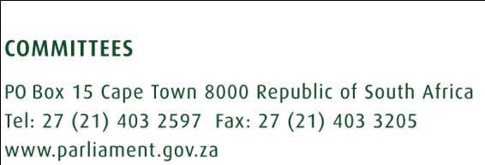

April 2018

SUMMARISED POINTS OF THE REPORT ON SEX WORKER’S SUMMIT

- The MPWC hosted the summit on sex work on 05 March 2018.
- The aim for hosting this summit was to allow all the affected critical stakeholders to respond on the report and recommendations by the South African Law reform Commission report on adult prostitution.
- The report by Law reform was released to the public domain on 27 May 2017.
- The MPWC decided to host the summit as the majority of the affected critical stakeholders had voiced their dissatisfaction about the recommendations by the Law reform Commission.
- The Law reform report recommendations are about two legislative reform options.
- The first recommended option is partial criminalisation (buyer criminalised and not the seller).
- The second option recommended is continued criminalisation with diversion programmes.
- The MPWC had planned to host the summit in October/November 2017 and had started with publicising the event, but a number of critical stakeholders pleaded for more time in order to prepare their presentations.
- An agreement was reached to host the summit in March 2018.
- In preparation for the summit, media alerts were released to inform everyone interested about the summit.
- Stakeholders had to submit their written presentations in advance before the date of the summit.
- The MPWC received 62 written submissions and 32 of them had indicated their availability for verbal representations on the day of the summit.
- On the day of the summit, 30 stakeholders were available for oral presentations.
- The presentations both written and oral revealed the following:
- Thirty seven (37) organisations and/or individuals voiced their support for full decriminalisation of sex work
- Fourteen (14) organisations and/or individuals voiced their support for continued criminalisation.
- Six (06) organisations and/or individuals communicated their choice for partial criminalisation.
- Three (03) organizations were of the view that criminalisation should be coupled with diversion programmes.
- Two (02) stakeholders did not voice any preference in relation to legal model on sex work; instead, they commented on the SALRC report and voiced concern over the poor quality of the report.

- Before presentations by stakeholders, the SALRC represented by Ms Dalene Clark presented a status update in relation to its recommendations. She reported as follows:
- The Department of Justice was busy evaluating the recommendations contained in the Project 107 report on adult prostitution.
- The Department as part of its evaluation of the Report will conduct further research, more broad public consultations and more meetings with affected stakeholders She further advised that the purpose of evaluating the report is to balance current and previous views,
- And, that the Department is planning on opening public consultations on the draft legislative proposal by the second half of year 2018.
- The steering committee had agreed that on the day of the summit, they will just engage with the stakeholders, but the steering committee will meet at a later stage and further engage on what transpired and design a way forward.
- Before hosting the summit, there were media reports about a decision to decriminalise sex work by the ANC elective conference.
- When the summit was hosted, the Conference resolutions were not yet available.
- Now the Conference resolutions are available.
- Resolution 2.28 of the social transformation reads as follows

“The calls to decriminalise Sex work must be subjected to a high level discussion and engagement with relevant multiple stakeholders, and to continue to engage society on this to determine the societal norm. Sex workers must be protected.”

Way forward
The steering committee to provide a way forward taking into consideration the following:
- The MPWC was mandated by the women’s parliament resolutions to advocate for the decriminalisation of sex work
- It was then that the MPWC publicly voiced its support for decriminalisation of sex work
- The ANC resolution of sex work as reported in the media is not depicted in the the way the resolution is actual written.

