**5. Report of the Portfolio Committee on Home Affairs on the Annual Performance Plans and Budget Vote 5 of the Department of Home Affairs Dated 24 April 2018.**

The Portfolio Committee on Home Affairs (the Committee) having met with the Department of Affairs (DHA) the Electoral Commission of South Africa (IEC) and the Government Printing Works (GPW) on their Annual Performance Plans (APPs) and budget for 2018/19, reports as follows:

1. **INTRODUCTION**

In its conducting of oversight over the DHA, IEC and GPW; the Committee met with the DHA on 20 March 2018, the IEC and GPW on 27 March 2018 to receive briefings on their APPs and budgets for the financial year 2018/19.

1. **THE DEPARTMENT OF HOME AFFAIRS**

The Vision of the DHA is to ensure a safe, secure South Africa where all its people are proud of, and value, their identity and citizenship. The mandate of the DHA is to be the custodian of identity and civic status, including citizenship; and to manage immigration securely and efficiently in the interest of economic development and national security.

The DHA has three programmes, namely Administration, Civic Services and Immigration Services. The core mandate of the DHA are Civic and Immigration Services.

The purpose of Civic Services is to ensure secure, efficient and accessible services and documents for citizens and ensure lawful documents for residents through the execution of the following core functions:

* Management of legislation and records relating to issuance of identity documents; births, marriages and deaths (BMD); passports and travel documents.
* Maintain secure, accurate and accessible systems such as the National Population Register (NPR), National Identity System (NIS) and related data.
* Affirm and regulate official identity, civic status and the acquisition and loss of citizenship.
* Provide access to secure and efficient services through enabling documents.

The core immigration mandate is to:

* Facilitate and regulate the secure movement of people through ports of entry into and out of the Republic of South Africa.
* Confirm and provide documents to foreign visitors legally residing within the Republic of South Africa.
* Enforce immigration legislation and effect deportations.
* Determine the status of asylum seekers and regulate refugee affairs.
* Contribute towards realising a positive migration trends into the Republic that enhances the skills base and support foreign direct investment.
  1. **DHA Annual Performance Plan for 2018/19 Financial Year**

A delegation from the DHA was led by the Deputy Minister of Home Affairs and the presentation was made by the Director-General (DG) of the DHA and the Chief Financial Officer (CFO).

The DG reported on the DHA contribution to Medium Term Strategic Framework (MTSF) from 2014 to 2019. He reported that a major focus of the National Development Plan (NDP) is to confront the triple challenge of poverty, inequality and unemployment by achieving higher growth rates. A priority for the DHA is to facilitate the acquisition of the critical skills needed for economic growth and to build our own skills base. The NDP draws on international experience in pointing out that the strategy will succeed if it is led by a capable state staffed by professionals; where trust is engendered by social stability, improved services and reduced corruption; and the mass of citizens feel part of the economic development plan.

The DHA could play a key role in enabling regional development by working with SADC countries to establish efficient, secure and well managed migration.

The inclusion of all citizens in democracy and development is enabled by providing them with a status and an identity, thus access to rights and services. The modernisation programme of the DHA can reduce fraud and the cost of doing business by enabling e-government and this will attract more investment.

The DG reported that the following are the priorities of the DHA for 2014 – 2019 MTSF:

* Establishment of the Border Management Authority (BMA).
* Complete the Modernisation Programme.
* Upgrade key ports of entry (6).
* Comprehensive review of Immigration Policy; and
* Improved client experience through leadership (Moetapele).

The DG reported that the BMA Bill was still with Parliament at the National Council of Provinces (NCOP). The BMA was supposed to be operational by 2017/18. This commitment has not been met. The DHA hopes that the BMA will be finalised by 2018/19.

The second commitment was the registration of 810 000 births to be captured with 30 days by 2018/19. The DHA has also planned that the National Identity System should be operational by 2019-20. The DHA will have the draft Bill on the Repositioning of Home Affairs submitted to the Minister of Home Affairs for approval in the coming year.

He reported that all 100 percent of all designated ports of entry are to be equipped with the biometric systems by 2018/19, especially those with Enhanced Movement Control System (EMCS). It was reported that South Africa has 72 ports of entry and 10 have been equipped with the full biometrics and the remaining 62 will have an interim biometric functionality rolled out by 2018/19

The DHA will ensure that the completely revised Immigration and Refugees Bills would be submitted to Parliament by end of March 2019 for approval. It was reported that the 3 DHA Premium Visa and Permit Service Centres for Corporate Account Clients and their families have been opened and 85 percent of critical skills visas are adjudicated within four weeks for applications processed within the Republic of South Africa.

The DHA Contact Centre was established in 2015-16, although the Committee indicated that it does not operate efficiently.

The DG reported that the DHA has incrementally improved in achieving its targets. In 2015-16, it achieved 81 percent of its targets and in 2016-17; 84 percent and the projection for 2017/18 is 89 percent.

He reported that there are three targets that were at risk of not being achieved; firstly; the piloting of EMCS at one port of entry since the NPR and NIS might not be linked; secondly the issuance of 3 million Smart ID Cards because the DHA is no longer opening offices on Saturdays and lastly 70 percent of misconduct would probably not be submitted to the presiding officer for consideration in time. These targets would be transferred to 2018/19 financial year.

The DG further reported that the footprint of the DHA was 412 front office, 391 health facilities that are equipped to register births and deaths as well as an agreement with financial institutions for the applications of passports and Smart ID Cards at 14 branches. The DHA mobile solutions have 16 new mobile units which would be launched on 16 May 2018 to receive applications for passports and Smart ID Cards. The DHA is represented in 30 missions abroad and there are five (5) Refugee Reception Centres with Cape Town and Port Elizabeth offices not fully operationally. The total staff compliment is approximately 10 000 with 9604 filled and funded posts. Out of the 9604 posts, there are approximately 750 Immigration Inspectorate officials.

**2.2. DHA 2018/19 Budget**

The 2018/19 budget for the DHA that follows contains a brief overview of the 2017/18 financial year as at 31 December 2017 as well as DHA priority areas for MTEF with global, continental, regional and national frameworks and concludes with some key issues for consideration by for parliamentary committees for oversight.

* + 1. **Overview of the 2017/18 Financial Year Performance**

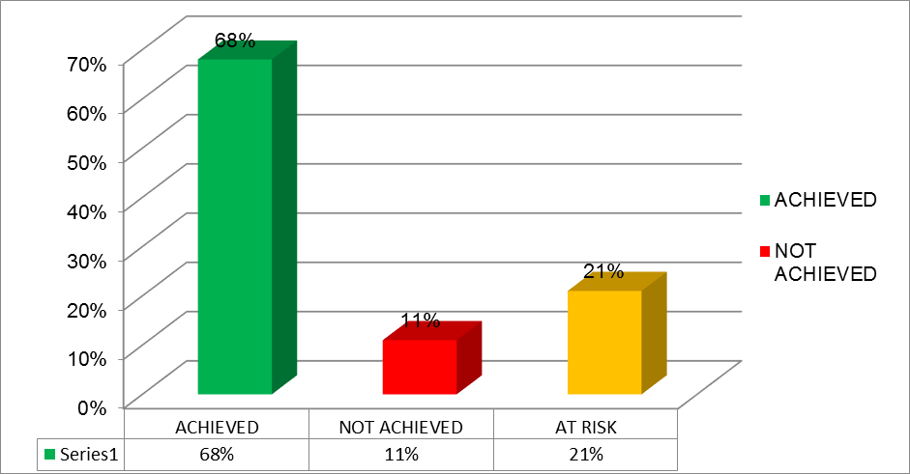The 2017/18 Annual Report of the Department, covering the full financial year ending 31 March 2018, will only be available at the end of September 2018. Therefore, this section’s focus is on DHA’s annual performance targets and financial performance as at 3rd quarter of 2017/18.

DHA’s performance from as at 31 December 2017. Source: Department of Home Affairs presentation of 3rd quarter perfomance to PC on Home Affairs (2018)

The Department had a total of 33 targets planned for the quarter 3 of 2017/18 financial year. As Figure 1 above depicts, as at 31 December 2017, DHA achieved 22 targets representing a 67 percent achievement rate, and 11 (33 percent) targets were not achieved. During its 3rd quarter performance report to the Portfolio Committee on Home Affairs (06 March 2018), DHA projected that, at the end of 2017/18 financial year, it may achieve 89 percent of the annual targets.

The DHA’s initial budget for 2017/18 financial year (ending 31 March 2018) was R7.05 billion before adjustments. However, after adjustments, the total budget for DHA was R8.3 billion. This budget includes allocations to the Electoral Commission (IEC).

The 3rd quarter expenditure report shows that at the end of 3 December 2017, the DHA had spent 71.5 percent (lower than the 77 per cent spent in the same period of 2016/17) of its available budget. DHA’s overall expenditure was R5.93 billion of the projected R5.37 billion as at 3rd quarter. This means that DHA had a variance of R607 million or 11.4 percent higher than the projected expenditure, mainly under programme 2 and 3. The overspending is mainly due to payment related to the cost of living adjustments, which were paid in December, self-financing expenditure for issuing of passports and Smart ID cards and infrastructure related expenditure for the rollout of the live capture system.

The expenditures are as follows:

**Programme 1: Administration** – programme spent R1.49 billion against the projected spending of R1.51 billion at the end of the third quarter, indicating lower than expected spending of R 11.1 million or 0.7 percent The lower spending is largely due to the “Who Am I Online” (WAIO) project where spending was not in accordance with the spending plan.

**Programme 2: Citizen Affairs** – programme spent R3.6 billion against the projected spending of R3 billion at the end of the third quarter, indicating higher than expected spending of R598.6 million or 20 percent. The higher spending is largely due to self-financing expenditure for issuing of passports and Smart ID cards and infrastructure for the rollout of the live capture system.

**Programme 3: Immigration Affairs** – programme spent R847.5 million against the projected spending of R827.3 million at the end of the third quarter, indicating higher than expected spending of R20.2 million or 2.4 percent. The higher spending is due to the deployment of staff to the Ports of Entry due to the festive season.

Spending on compensation for the third quarter is R2.4 billion against the projected spending of R2 billion, indicating higher spending of R342.5 million or 16.8 percent. This higher spending is mainly due to payments related to the cost of living adjustments which were paid in December.

Spending on goods and services for the third quarter is R2.3 billion of the projected spending of R2.1 billion, indicating higher spending of R216.6 million or 10.4 percent. This higher spending is mainly due to expenditure related to self-financing for issuing of Smart Identity (ID) cards and infrastructure for the rollout of the live capture system.

**2.2.2 DHA’s 2018/19 National, Continental and Global Policy Priorities**

The DHA medium term priorities of DHA should be aligned with the following:

* National Frameworks – NDP and MTSF.
* Regional and Continental Frameworks – African Union Agenda 2063 and the Southern African Development Community (SADC) Protocol on the Facilitation of Movement of Persons.
* Global Frameworks – Sustainable Development Goals.

Over the medium term, DHA’s focus areas include:

* Repositioning itself towards transforming into a modern, highly secure organisation and professional department within the core security system of the state.
* Establishing a border management authority.
* Reviewing the international migration policy.
* Modernising and integrating information systems.
* Improving and expanding client interface.
* Focusing on infrastructure projects.

**National Development Plan:** DHA is in the process of modernising and integrating its information system. This modernisation process seeks to improve the national identity system (NIS) which is central to the department carrying out its core functions as it enables the security and reliability of biographical and biometric identity data, and, in turn, facilitates economic transformation, prompt service delivery and security. This is in line with NDP aspirations. The NDP requires the DHA to facilitate the acquisition of the critical skills to facilitate the building of a capable state and playing a role in enabling regional development by working with SADC countries to improve the efficient, secure and managed movements of people. The plan also requires DHA to provide citizens with identity documents that give them access to rights and services, through the modernization programme, seeking to reduce fraud and the cost of doing business.

NDP also requires DHA to reduce fraud and the cost of doing business, and enabling e-government, thus attracting more domestic and international investment to fund economic restructuring and growth. A considerable progress has been made by DHA through the National Population Register (NPR), which is being used to reduce fraud on a small scale within government and private sector; but is not yet integrated, reliable, secure and comprehensive enough to serve as a platform with which modern e-government and e-commerce systems can interface.

**Medium Term Strategic Framework:** National government has fourteen outcomes, and the DHA contributes to four of these, which comprise three Strategic Outcome Orientated goals for the 2015-2020 period. These in turn translate into 10 Strategic Objectives as follow:

**Strategic Outcome Orientated goals: Home Affairs**

|  |
| --- |
| Goal 1: Secure South African citizenship & identity. |
| * 1. All eligible citizens are issued with enabling documents relating to identity and status. |
| * 1. An integrated and digitised National Identity System (NIS) that is secure and contains biometric details of every person recorded on the system. |
| * 1. All eligible citizens are issued with enabling documents relating to identity and status. |
| Goal 2: Secured & responsive immigration system. |
| 2.1. Movement of persons in and out of the country managed according to a risk-based approach. |
| 2.2. Refugees and asylum seekers are managed and documented efficiently. |
| 2.3. Enabling documents issued to foreigners efficiently and securely. |
| Goal 3: Services to citizens & other clients that are accessible & Efficient. |
| 3.1. Secure, effective, efficient and accessible service delivery to citizens and immigrants. |
| 3.2. Good governance and administration. |
| 3.3. Ethical conduct and a zero tolerance approach to crime, fraud and corruption. |
| 3.4. Collaboration with relevant stakeholders in support of enhanced service delivery and core business objectives. |

Source: Presidency (2014)

**State of the Nation Address 2018**: Although there was no specific mention made of the DHA, there are five government priorities in the SONA, which Home Affairs does and will need to contribute to. These are:

* + Encourage investment.
  + Create jobs especially for youth.
  + Infrastructure development.
  + Address corruption.
  + Improve service delivery efficiency.

**Sustainable Development Goals:** The outcome of the 2030 Sustainable Development Agenda outlining the 17 Sustainable Development Goals pays particular attention to the people, planet and prosperity. The SDGs recognises the positive contribution migration makes to inclusive growth and development and therefore call on United Nations (UN) member states to strengthen their international support and cooperation to ensure safe, orderly and regular migration with full respect for human rights and fundamental freedoms. In this regard, the South African government has embarked on a comprehensive process of re-examining the role that migration plays in its society and economy through an extensive review of the international migration policy outlook currently underway. The objective of this policy framework is to better equip South Africa to manage the challenges presented by migration and harness its opportunities for both the local communities as well as immigrants.

**African Union Agenda 2063:** At the African Union Assembly in June 2015, Members adopted Agenda 2063 as both vision and action plan for the integration of Africa. The White Paper on International Immigration Policy acknowledges at least two resolutions adopted by the Assembly, which set clear parameters for South Africa’s immigration policy, namely, the establishment of a Continental Free Trade Area (CFTA) and a continent-wide visa-free regime, including the issuing of visas on arrival at ports of entry for African citizens. As a result, visa-free entry should be the norm provided that bilateral return agreements are concluded. In fact, DHA has been issuing 10-year multiple entry visas to frequent travellers from other African countries. Where visas are still required, entry is easy as possible for bona fide travellers.

In addition, South Africa’s White Paper on International Migration Policy acknowledges at least two resolutions adopted by the Assembly, which set clear parameters for South Africa’s immigration policy, namely, the establishment of a Continental Free Trade Area (CFTA) and a continent-wide visa-free regime, including the issuing of visas on arrival at ports of entry for African citizens.

**SADC Protocol on the Facilitation of Movement of Persons:** In SADC, although lagging behind other regional economic communities on the continent, the Protocol on the Facilitation of Movement of Persons has been adopted to facilitate the free movement of people, encompassing the right to visa-free entry, residence (temporary and permanent), and establishment (income generating activities). The main challenge in this regard is to develop critical enabling conditions, such as compatible immigration policies, laws, systems and accurate population registers. In light of slow progress regionally, South Africa has unilaterally or bilaterally adopted visa-free entry for nationals from 11 SADC countries. It also offers special permits to irregular migrants from Zimbabwe and Lesotho.

South Africa supports the development objectives and aims of Agenda 2063 and the SADC Protocol on the Facilitation of Movement of Persons in the context of strengthening the African cooperation, integration and for promoting inclusive development, and peace and security. South Africa fully supports the principle of free movement on the Continent, including the need for the AU to conclude a protocol to facilitate such free movement. This is also in line with the National Development Plan, which states that South Africa needs to adopt a much more progressive migration policy. To that effect, the country recently adopted a new White Paper on International Migration, which advocates for an Afrocentric migration approach.

**2.2.3 DHA 2018/19 Budget Allocation**

Over the medium term, the spending focus of DHA would be on repositioning itself towards transforming into a modern, professional and highly secure organisation with the ability to fully execute its mandate. It also plans to focus on establishing the border management authority, reviewing international migration policy, modernising and integrating its information systems, improving and expanding client interface, and completing important infrastructure projects.

It is anticipated that the current global economic recovery provides a supportive environment for South Africa to expand trade and investment. However, domestic constraints that have reduced business confidence stand in the way of accelerated growth.

The 2018 Budget reinforces the government’s commitment to returning public finances to a sustainable path by means of adjusting expenditure. Expenditure for 2018/19 is reduced by R26.4 billion and over the 2018 and for the Medium Term Expenditure Framework (MTEF) is reduced by R85.7 billion. The baseline spending reductions in the 2018 budget is directed at large programmes, departmental administrative budgets, public entities and capital transfers to provinces and municipalities. Therefore, these budget cuts would require greater efficiency in the use of funds by the DHA. This simply means that DHA should:

* Align its non-financial performance (achievement of targets) with actual budget expenditure.
* Reduce fruitless and wasteful expenditure of R201 000 that was declared in 2016-17 financial year due to hotel bookings made but not honoured.
* Address the recurring concerns raised by the Auditor–General (AG) of South Africa such DHA’s as lack of effective oversight responsibility regarding the financial reporting and compliance with laws and regulations.

**Summary of the DHA 2018/19 budget**

As shown in the summary above, DHA’s total budget for 2018/19 is R7.915 billion. This is a decrease compared to an adjusted appropriation of R8.403 billion of 2017/18 financial year. Taking into consideration the inflation rate of 5.3 percent, the decrease in DHA’s budget is R899.6 million or 10.7 percent. In real terms, all the Department’s programmes shows a decrease in budget allocations:

* Programme 1: Administration – R520 million (or 19 percent)
* Programme 2: Citizen Affairs – R176.8 million (or 3.9 percent)
* Programme 3: Immigration Affairs – R202.8 million (or 16.6 percent)

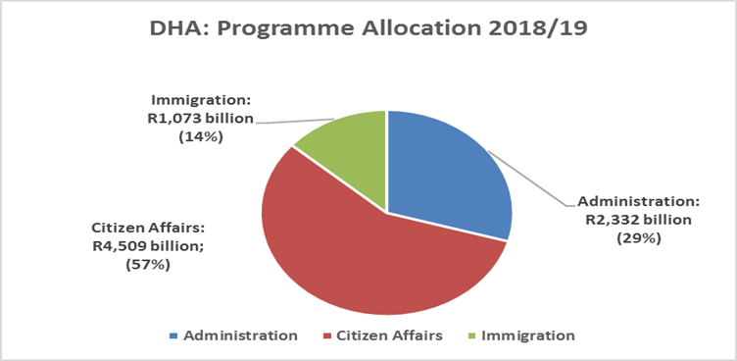

**Budget per programme and percentage share**

As indicated above, of the total budget of R7.915 billion allocated to DHA, R4.509 billion or 57 percent is allocated to Citizen Affairs programme. Administration and Immigration Affairs programmes received R2.332 billion (29 percent) and R1.073 billion (14 percent) respectively. A detailed analysis of programmes and sub-programmes expenditures is provides in the next section.

**Programme 1 Administration:** Administration programme is responsible for strategic leadership, management and support to the department and consist of 5 sub-programmes. The names of these sub-programmes are provided in Figure 3 below.

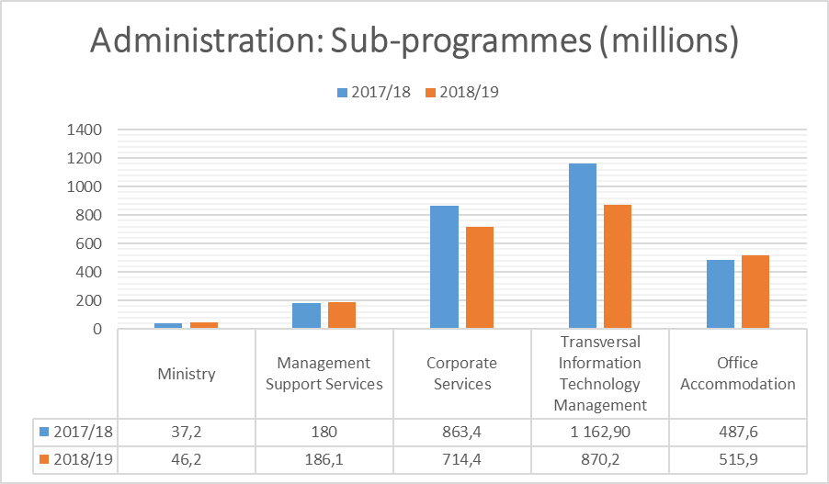**Administration Sub-programme expenditure**

As stated previously, the Administration programme’s allocation decreases by R519.9 million or 19.04 percent (taking into account the cost of inflation). The adjusted appropriation in 2017/18 was R2.731 billion, compared to R2.332 in 2018/19.

The *Transversal Information Technology Management* sub-programme continues to dominate the expenditure, but shows strong decline in expenditure from the previous year. At R870.2 million expenditure 2018/19, this sub-programme constitutes 37 percent% of expenditure under the main programme. The *Corporate Services* sub-programme with the allocation of R714.4 million constitutes 31 percent of the total budget for programme 1.

Unlike in the previous financial year, the following two sub-programmes experiences nominal and real increases growth: i.e. *Ministry* sub-programme R6.6 million real increase (17 percent) and *Office Accommodation* R1.4 million real increase (0.29 percent).

After inflation (which is calculated at 5.3 percent), the following **real** increases/ decreases are recorded per sub-programme:

* Ministry: 17 percent increase.
* Management Support Services: 2.0 percent **decrease.**
* Corporate Services: 21.7 percent **decrease.**
* Transversal Information Technology Management: 29.07percent **decrease.**
* Office Accommodation: 0.29 percent increase.

**Programme 2 Citizen Affairs:** The Citizen Affairs provide secure, efficient and accessible services and documents to citizens and lawful residents. The budget of this programme is allocated to 6 sub-programmes, namely: Citizen Affairs Management, Status Services, Identification Services, and Service Delivery to Provinces, Electoral Commission, and Represented Political Parties’ Fund.

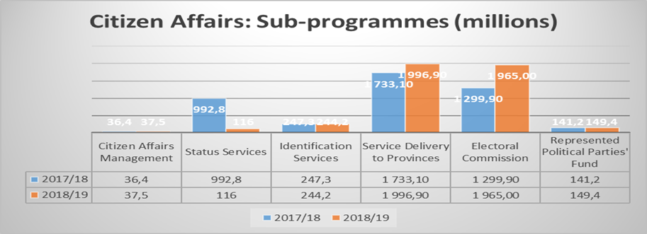**Citizen Affairs Sub-programme expenditure**

The *Citizen Affairs* programme remains the biggest of the three main programmes in the DHA, constituting 57 percent of the overall departmental expenditure. In 2017/18, this programme constituted just over half (50.6 percent) of the department expenditure. *Citizen Affairs’* allocation increases from R4.450 billion in 2017/18 to R4.509 billion in 2018/19. In real terms, expenditure declines by R176.8 million (or 3.97 percent) between 2017/18 and 2018/19.

The *Electoral Commission’s* allocation experiences significant real increases of 43.28 percent- which can be attributed to preparations towards the general elections scheduled for 2019. After inflation (5.3 percent), the following **real** increases/ decreases are recorded per sub-programme:

* Citizen Affairs Management: 2.35 percent **decrease.**
* Status Services: 88.92 percent **decrease.**
* Identification Services: 6.4 percent **decrease.**
* Services Delivery to Provinces: 9.21 percent increase.
* Electoral Commission: 43.28 percent increase.
* Represented Political Parties’ Fund: 0.29 percent increase.

The increase recorded in *Service Delivery to Provinces* sub-programme augurs well with the priority for the redevelopment and modernisation of 6 priority land ports of entry (Beitbridge, Maseru Bridge, Kopfontein Gate, Lebombo, Oshoek and Ficksburg).

The *Status Services* sub-programme continue to experiences the biggest decline in its funding, i.e. 88.92 percent (real terms). This is the sub-programme tasked with one of the main mandates of the Department. This include maintaining an accurate register of all citizens and immigrants who have acquired the right to permanent residence; registering births, deaths and marriages; providing travel and citizenship documents; providing financial assistance to citizens abroad who wish to return to South Africa but have no means of doing so; and determining and granting citizenship.

**Programme 3 Immigration Affairs:** This programme is responsible for facilitating and regulating the secure movement of people through the ports of entry into and out of South Africa. It is also responsible for determining the status of asylum seekers and regulate refugee affairs.

The budget under the programme is shared amongst 4 sub-programme as outlined below. 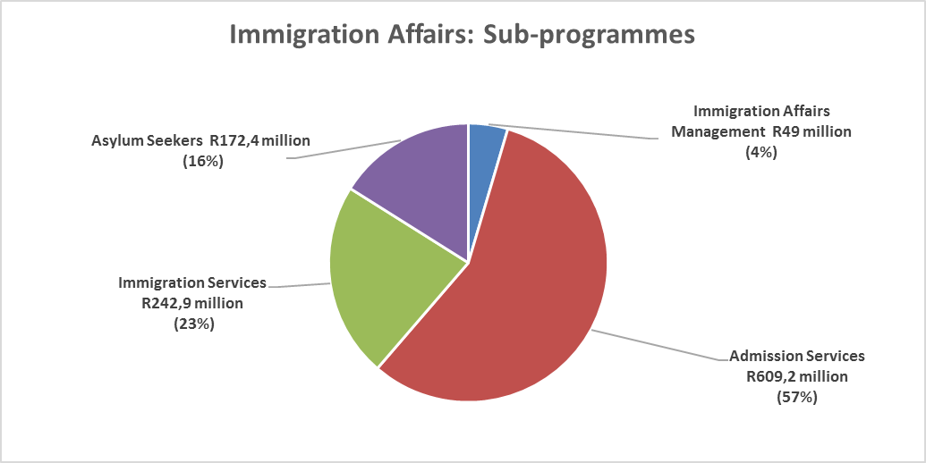

**Immigration Affair5s Sub-programme expenditure**

The *Immigration Affairs* programme is the smallest of the three main programmes in terms of budgetary size. Unlike in the previous financial year whereby the programme experienced the strongest growth both in nominal and real terms, it decreases by 16.62 per cent (real decrease) from R1.220 billion to R1.073 billion in the current year.

Of the total budget of R1.073 billion allocated to programme 3, the *Admission Services* sub-programme receives the lion’s share of R778.7 million or 64 percent. The *Immigration Affairs Management* sub-programme is allocated 4 percent of the programme budget (i.e. R48.4 million).

After inflation (5.3 percent), the following **real** increases/ decreases are recorded per sub programme:

* Immigration Affairs: 4.04 percent **decline.**
* Admission Services: 25.85 percent **decline.**
* Immigration Services: 2.23 percent **decline.**
* Asylum Seekers: 3.49 percent increase.

Asylum Seekers sub-programme is the only sub-programme that experiences increase in both nominal and real terms. The increase in *Asylum Seekers* sub-programme is commendable given the current challenges with regard to asylum seekers management in the Department. The increase in budget allocation would assist the Department in addressing those challenges.

1. **The Electoral Commission of South Africa (IEC)**

The IEC Chairperson made opening remarks and indicated that the 2019 National Elections are envisaged to take place between May and August 2019. The Political Party Funding Bill was still before Parliament and will hopefully be completed in time to prepare for the elections. The IEC will also refresh their Information Communication Technology (ICT) on both hardware and software commencing in the coming year. The five-year strategic plan will end in 2019 and hence there are long term targets that need to be completed. The IEC is not immune to fiscal constraints and is facing increasing shortfalls particularly in relation the unforeseen need to harvest addresses. There is going to be a need to appoint new Commissioners soon since Judge Makhanya’s term will end in May 2018 and Rev. Finca and Vice-Chairperson Tselane’s terms end in November 2018. Of the three, it is only one Commissioner who is eligible for an extension.

The CEO made the presentation on the APP. He reported on the recent court rulings such as the harvesting of the addresses in the voters roll by 30 June 2018 and the setting aside by the Electoral Court ruling of 23 September 2016 on the results of the Namakwa District Municipality. The IEC appealed the judgement to the Supreme Court of Appeal and the appeal was successful. The order by the Electoral Court to recount votes in Cape Metro, Bergerivier Municipality and the entire Swartland Municipality was also successfully appealed. The Pretoria High Court dismissed the appeal by the IEC vs. Abland in relation to the review of the lease of the Riverside Office Park.

The CEO also reported that the Draft Electoral Amendment Bill will be tabled in the First Quarter of 2018. The key amendments will include the electronic submission of registration of political parties and candidate lists; removing restrictions on mental health patients voting; providing for the Electoral Court to hear and determine any matter relating to the interpretation of the Constitution concerning disputes about the legitimate leadership of a party as well as voter registration enhancements to allow online registration.

He reported that the Political Party Funding Bill was due to be debated in the National Assembly in March 2018. The legalisation provides for the party funding to be managed by a separate entity to the Commission. The implementation of the legislation will be incremental due to the availability of funding.

He explained that there was an increased contestation between political parties turning to court to resolve disputes. Currently there are a number of municipalities which have coalitions which are fragile. The IEC might have to conduct a number of by-elections, especially in the KwaZulu-Natal Province.

He also reported that the IEC ICT refreshment was needed in preparation for the 2019 elections. There are 122 servers that need to be replaced during 2018. Computers, printers and laptops will also be replaced in late 2018 early 2019. Software will be upgraded from Windows 7 to Windows 10. The replacement of the equipment is pending full funding. The Registration devices (so-called zip-zip machines) need to be replaced before the 2019 Elections. It was reported that a tender for 38 000 zip-zip machines was in the final stage and delivery is expected in the first quarter of 2018/19.

The annual targets for 2018/19 and the budget of the IEC also include another registration weekend ahead of the 2019 National and Provincial Elections. The *Electoral Commission’s* allocation experiences significant real increases of 43.28 percent in 2018/19 which can be attributed to the NDP’s vision of building a capable developmental state, and an active and engaged citizenry. Accordingly, over the medium term, the commission intends focusing on preparations for the 2019 national and provincial elections, and the 2021 local government elections.

R3.1 billion is allocated over the MTEF period for the commission’s electoral operations and R808.2 million is allocated for its outreach activities. The commission plans to begin its electoral operations by conducting 2 weekends of registrations in the first half of 2018; procuring, distributing and warehousing voting registration materials; and providing logistical support for registrations.

Initially, 2017/18 was regarded as a one-year electoral cycle. However, the Constitutional Court made 2 judgments that directed the commission to obtain and record the addresses of all registered voters to ensure that they are registered in the correct voting districts before June 2018. As such, all voting stations are scheduled to open on 10 March and 11 March 2018, with about 68 000 full-time and fixed term staff deployed to record the addresses of registered voters. This activity is expected to cost R230 million. The updating of addresses on the voters roll in line with the court judgments, registration activities, and the procurement of ballot papers, ballot boxes and stationery account for estimated spending of R649 million over the MTEF period. In addition, between R450 million and R500 million is budgeted for the mentioned plans to update databases in line with electoral requirements, updating and rolling out the commission’s IT infrastructure, replacing the zip-zip machines, as well as the erection of 8 prefabricated offices housing commission staff, bringing the total number of these offices to 38 by 2020/21.

The commission has a staff complement of 1 033, which is expected to remain constant over the medium term. Spending on compensation of employees is expected to increase at an average annual rate of 15.2 per cent between 2017/18 and 2020/21, from R604.5 million to R924 million. This increase is mainly due to the appointment of approximately 6000 expansion staff on fixed term contracts over a seven-month period in 2018/19 when election-related activities are at their peak.

R890 million is allocated over the MTEF period to attract an estimated 324 850 mature and experienced electoral staff for work on election days, 114 850 of whom are also expected to be compensated for registration activities. This funding is also expected to enable the commission to improve on and increase the training it provides through the electoral operations programme.

The commission undertakes extensive civic and democracy education and communications campaigns to protect the credibility and integrity of electoral processes. Through these campaigns, the commission keeps the electorate informed and aims to attain high voter turnouts on election days. R808.2 million is set aside over the MTEF period for these campaigns. The commission derives its revenue mainly from transfer payments it receives from the DHA. The commission also generates revenue from the sale of goods and services, and interest earned from investments. The commission’s own revenue is expected to remain constant at R15 million per year over the MTEF period.

1. **The Government Printing Works (GPW)**

**4.1 Annual Performance Plan**

The Acting CEO, Ms N Moyo, made the presentation indicating the mission and vision of the GPW was still the same and that ICT is a critical element of GPW. GPW will procure eight new high tech pieces of equipment in the current financial year. The GPW was also producing the Smart ID Cards in relation to client (DHA) specifications. Government Gazettes, both digital and electronic, are also still issued timeously.

GPW was also marketing itself to most African countries, however, many countries still have contracts with their former European colonial countries. There are promising discussions with Swaziland and Zambia to produce documents. Currently, the Zambian IDs are produced by a private company based in Durban. GPW is also planning to open a store in Cape Town and Polokwane.

After the presentation by the CEO, the Committee engaged with the GPW on the following:

• The use of a private security company. GPW reported that all security officials from Fidelity Company have been vetted and where the production of Smart ID Cards is done, there are only GPW internal officials used for security purpose.

• Expanding to the African market. GPW reported that it was working with the Department of International Relations and Cooperation to further its business.

• With regard to litigation, the GPW reported that there was no litigation against it.

• In relation to the variations to the construction of Pavilion 3, GPW reported that the audit of financial had not been done because the service provider refused to provide certain information and the matter was being taken up with legal services. On the basis of the audit, criminal charges may still be laid.

**4.2 Budget**

Over the medium term, GPW intends to focus on replacing old equipment and machinery, and refurbishing its production facility. A new security printing division in Pretoria was expected to be completed by 2019/20, but due to delays in finalising the master plan, the project is still in the construction phase. The certificate of occupation for the property is scheduled in March 2018, with the project expected to be completed in 2020/21. 2 pavilions (phases) of the printing facility have been completed and once pavilion 3 is ready for use, it will provide an additional facility for the processing and dispatching of smart identity cards and passports.

Costs for refurbishing the site are projected at R1.2 billion over the MTEF period and are to be covered by the entity’s accumulated funds. As part of its equipment upgrade at a total estimated cost of R180 million in 2018/19, the entity plans to buy specialised machinery, including 2 dynamic box production machines, 2 sheet fed printing presses, a wide web printing press, 2 paper finishing machines and a narrow web printing press. Spending on goods and services will thus increase from a projected R928.7 million in 2018/19 to R1.2 billion in 2020/21.

To recruit and train personnel to use the equipment, expenditure on compensation of employees is expected to increase from R269.2 million in 2017/18 to R403.3 million in 2020/21. The entity generates its own revenue, which is expected to increase at an average annual rate of 9.9 per cent, from R1.6 billion in 2018/19 to R2.1 billion in 2020/21. The entity expects to increase revenue by expanding the production of passports and identity documents with the new equipment.

1. **Committee Observations**

5.1. **Department of Home Affairs**

* There was concern that there was no indication of the funding of the BMA, which has been processed by the Portfolio Committee on Home Affairs to establish an entity for securing of the South African borders.
* There continue to be network challenges at the DHA offices and long queues in some offices such as in the Durban area.
* The Committee appreciated the arrests of officials at the Johannesburg Central office for corruption.
* Although the issue of vacancies was explained by the DG as due to lack of funds, the Committee felt that vacant funded posts should nonetheless be filled.
* The Committee expects adherence with regards to payment of invoices within 30 days.
* The DHA does not have a sufficient monitoring with regards to matters raised by the Auditor-General in 2016/2017.
* The Matatiele office needs an upgrade to issue passports and Smart ID Cards.
* The contact centre was not sufficiently assisting the public when they phoned in.
  1. **The Electoral Commission of South Africa**
* The Committee was concerned with regards to the condonation of the irregular expenditure in relation to the lease agreement of the Riverside Office Park.
* The Committee was concerned about the voter turnout during election days for National and Provincial as well Local Government Elections.
* There was a concern in relation to the cutting of funding of other programmes to fund ICT and harvesting of addresses into the voters roll by 30 June 2018.
  1. **The Government Printing Works**
* The Committee was concerned about the use of private security in and around the production of enabling documents.
* The Government Printing Works is not penetrating enough in the African market. The Committee noted that there were discussions with Swaziland and Zambia in relation to the production of their enabling documents.
* There were variations in relation to the construction of Pavilion 3.
* It is unacceptable that financial services were not being completed because the service provider refused to provide certain information.

1. **Recommendations**

Based on the interaction between the Department of Home Affairs, the Electoral Commission and the Government Printing Works, the Committee recommends the following:

7.1. **Department of Home Affairs**

* National Treasury should consider increasing funding to the Department of Home Affairs, especially allocations for the establishment of the BMA once it is finalised. DHA should brief the Committee on the anticipated costs of the BMA as soon as possible.
* The Department of Home Affairs should move towards alternative providers if the State Information Technology Agency (SITA) continues to not address issues of downtime and queues at front offices is addressed as matter of urgency.
* The DHA should ensure the matter of corruption at its offices is addressed as matter of urgency. The officials found to be guilty of corruption should be charged criminally.
* The DHA should fill all vacant funded posts as a matter of urgency.
* The DHA should ensure that all valid invoices are paid within 30 days after receipt.
* The DHA should have a dashboard with regards to matters raised by the Auditor-General in 2016/2017
* Key rural offices in the country need an upgrade to digitally apply for passports and Smart ID Cards.
* The issue capacity at the Contact Centre should be addressed urgently.
* Reopen refugee offices in Port Elizabeth and Cape Town as per court orders.
* Prioritise roll out of fully functioning mobile offices to improve service delivery.
* Plans to address long outstanding recommendations on capacity and budget allocations to immigration services.
* Ensure the preparation of an Audit Action Plan to address all issues raised by the Auditor-General in the Annual Audit Report of the DHA.
  1. **The Electoral Commission of South Africa**
* The IEC should implement all the remedial actions of the Public Protector in relation to the lease agreement to the Riverside Office Park.
* The IEC should conduct an outreach programmes to communities regarding the importance of voting in elections.
* National Treasury should consider allocating more funding to harvesting of addresses and ICT refreshment.

**7.3. The Government Printing Works**

* The GPW should not use private security in and around the production of Smart ID Cards and ensure that all officials for both GPW and private security are vetted.
* The GPW should try to expand more to the African market and ensure that all South African departments print documents with them.
* The GPW should ensure that a financial audit is conducted to ensure that there were no financial irregularities in the construction of Pavilion 3.
* The appointment of the CEO of the GPW should be prioritised by the DHA and will be monitored by the Committee.

Report to be considered.