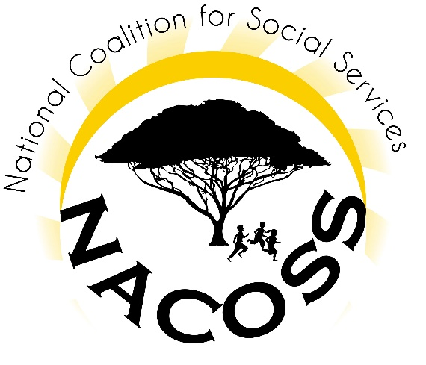
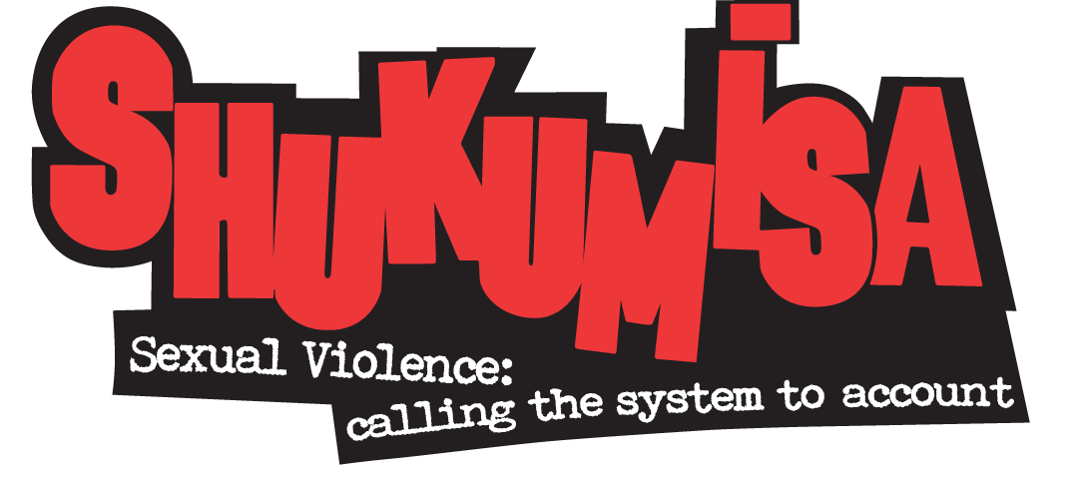

Joint Submission to the Portfolio Committee on Labour:
THE NATIONAL MINIMUM WAGE BILL [B31 – 2017]

For queries:
Lisa Vetten, Care Work Project Manager
Shukumisa Coalition / Wits City Institute
lisavetten@gmail.com / 082 822 6725
Joint Submission to the Portfolio Committee on Labour:
THE NATIONAL MINIMUM WAGE BILL [B31 – 2017]

Introduction
We thank the Portfolio Committee on Labour for this opportunity to comment on the proposed National Minimum Wage Bill. The submissions we make have been compiled on behalf of the Shukumisa Coalition, working in collaboration with the Vhembe Civil Society Network, the National Shelter Movement, the National Coalition of Social Services, the KwaZulu-Natal Welfare, Social Services and Development Forum, and the South African Federation for Mental Health. Taken together, these various groupings represent the views of over 1 500 non-profit organisations (NPO) providing post-rape and other related care, domestic violence shelter services, child protection services, residential facilities for older persons and people with disabilities, child and youth care centres, victim empowerment services and other forms of social welfare services nationally.
The organisations represented by this submission either currently receive, or have previously received, subsidies from the Department of Social Development (DSD) to support the running of their services. Thus, while noting that the Department of Health also subsidises some NPOs, our submission focuses on the DSD because we are most affected by their funding policies and practices. In the sections that follow we outline these policies and practices, the amounts paid to organisations by the DSD and then illustrate how NPOs will be affected by the introduction of a minimum wage. This background is intended to provide the Portfolio Committee with the rationale behind our recommendations.

Overview of the non-profit social welfare sector
Social welfare services in South Africa have historically been provided through partnerships between the state and the non-profit private sector (including faith-based organisations). This partnership takes concrete form in the money allocated by the DSD towards the provision of social welfare services by the non-profit sector. This financial assistance takes the form of a subsidy. It is only a partial payment of the full cost of the service because it is expected that NPOs will source the balance of their costs elsewhere. These additional sources of funding may include other government departments; donor organisations; corporate social responsibility programmes from the private business sector; trusts and foundations; and the proceeds from lotteries.

  - The DSD’s system of subsidisation
While a small number of NPOs with national offices are funded by the national office of the DSD, it is the provincial departments of social development which bear the primary responsibility for subsidising NPOs based in that province. The number of NPOs subsidised by provinces is thus far larger than the number funded by the national department. Further, because the size of the subsidy is at the discretion of the province, rather than standardised through national policy, there is considerable variation in the amounts paid to organisations both within the same province, as well as in different provinces. In virtually all cases the subsidies are inadequate to meeting the full cost of the service and have not kept pace with inflation.
Subsidies are of three sorts:
- Post subsidies cover part of the costs of a particular category of worker. In relation to social worker posts our research in progress shows these subsidies in 2016/17 to have varied between as little as R5 415/month in the North West Province, to as much as R14 536/month in the Western Cape. As a consequence, the salaries paid to NPO-employed staff with professional qualifications (such as social workers and social auxiliary workers) are below market rate, while those paid to staff without formal qualifications are even lower. For example, research on post-rape care found NPOs to receive subsidies of R1 250/month in respect of counsellors based in the Thuthuzela Care Centres and to receive subsidies of R2 500/month in respect of house mothers in domestic violence shelters.
- Programme subsidies partially fund the delivery of a service itself. To provide another example from our research, in 2016/17 a domestic violence shelter in the Free State was provided with a total of approximately R256 858 to run its shelter programme. This amount was intended to cover staff salaries, as well shelter residents’ food and other needs.
- Service delivery subsidies are usually based on the number of beneficiaries the NPO delivers a service to. The decision in National Association of Welfare Organisations and Non-Governmental Organisations and Others v MEC for Social Development, Free State and Others (1719/2010) (or “NAWONGO”) provides examples of these types of subsidy. In 2010 an amount of R4 000,00 per child per month was the accepted cost of caring for a child in a child and youth care centre. The costing of the Children’s Act by the national DSD however, set this amount higher at R6 000,00 per child per month. In relation to the two child and youth care centres managed by the Free State DSD, amounts of R5 000,00 per child per month and R6 750,00 were being expended. By contrast, subsidies for the 2011/2012 financial year to NPO child and youth care centres amounted to R2 091,00 per child per month, increased from R1 999,84 per child per month for the previous year. A NPO which could not obtain additional funding was thus forced to provide three very basic meals per day with a budget of just R11,84 per child per day, when at least R50,00 per child per day was needed. Shelters for street children and children in difficult circumstances received a subsidy of between R400,00 to R500,00 per child per month. The Free State DSD acknowledged that at least R2 000,00 per child per month was needed.

  - Court action in relation to DSD funding policies and practices
In 2010 NAWONGO launched a legal challenge in the Free State to the DSD’s funding policy and practices. The court described the amounts provided by the DSD as “substantially inadequate” and ordered the Department to develop a reasonable funding policy. According to the court the DSD’s existing funding policy (which is still in place) “fails to recognise as a fundamental principle of funding that non-profit organisations that care for children, older persons or vulnerable persons in need or provide statutory services, fulfil the obligations of [government].” As such, they cannot be funded in ways that result in inferior services.
While NPOs may have been able, at a particular point in time, to source additional funds from other sources, the first NAWONGO judgement noted that the DSD did not dispute that this supplementation had become increasingly difficult. Taking this into account, the final NAWONGO judgment approved a draft policy that provided for subsidies based on the full core costs of delivering different services if NPOs had not been able to obtain additional funds. These core costs were defined as:
the salaries of the number of each staff type necessary to provide the service, such as centre managers, child and youth care workers, social workers, nurses, kitchen cooks, administrative officers, receptionists, drivers and general assistants. Where social workers are involved in a programme, the costs of supervision of the social workers are included on the basis of a supervisor for every six social workers. These costs include employer contributions per employee in respect of unemployment insurance fund, workers’ compensation, pension fund, thirteenth cheque, medical aid fund and housing allowance.
It must be pointed out that this decision, handed down in 2014, has not yet been implemented - even in Free State. Further, while the 2018/19 Budget Vote for the DSD does contain an addition to the equitable share to allow for the implementation of the NAWONGO decision, this money will only become available in 2019/20.

- Illustrating the consequences of the minimum wage on the NPO social welfare sector
In the time available we were not able to undertake a comprehensive survey of the entire NPO social welfare sector. We thus cannot quantify the full impact on the sector of a minimum wage. Instead, we illustrate the unique and precarious position of NPOs through a selection of case studies provided by organisations currently providing social care services.
- Organisation A currently employs 13 child and youth care workers (CYCW) who earn less than the proposed national minimum wage. With the government subsidies it receives, Organisation A can only afford to pay these workers between R2 400 and R3 000 per month. Given its financial situation, there is no possibility of Organization A paying its CYCWs more. And yet, it cannot afford to retrench any of the CYCW because the Norms and Standards as they apply to Chapter 13 of the Children’s Act, which registers their service, requires a specified ratio of CYCW to be on duty for a set number of children. If Organisation A retrenches some of its CYCWs, in order to pay the remaining CYCW the minimum wage, it would be in violation of the very Act which makes provision for the service it offers. Given that children in CYCCs are wards of the state, there is a strong legal obligation to provide properly for them.
- Organisation B is part of an umbrella body, which has determined that all 32 of its affiliate organisations in one province alone will be affected. The number of workers being paid less than the minimum national wage is 330. If their salaries had to be increased in accordance with the NMW Bill, the additional cost per month would be R420 000. This would mean that they will not be able to continue with many of the projects and activities currently serving its vulnerable population groups. The umbrella organisation has in any event not been able to increase any staff salaries in the past two years.
- Organisation C has received the same subsidy of R 2 981.25 per month for its social auxiliary worker since 2005. In other words, there has been no increase in this amount for 12 years. At the request of the DSD, the organization is also administering the funds of a NPO running a daycare centre. They note that while all the staff at the centre work on a full-time basis, they receive only stipends from the DSD of R2 000 per month for each of their staff – including the centre’s director. The daycare centre has indicated that they cannot pay the minimum wage. Although they are expected to charge parents a fee, this is unrealistic, given that majority of parents are unemployed or low-income earners.
- Organisation D has 1 135 employees below the minimum wage – or 41% of its workforce. If it were to pay each employee the proposed minimum wage, it would require an additional R506 965.98 per month, and R6 083 555.76 per year. Organisation D does not have access to this amount of money and will in all likelihood have to close its facilities or retrench between 25% and 30% of its lowest-level employees who need their jobs the most.
- Organisation E assists people with mental disabilities. One of the services they provide is a youth skills development centre, or what the DSD terms a protective workshop. The DSD regards those who attend the centre as beneficiaries of the service and provides the organization with a service delivery subsidy of R200 per person per month. The Department of Labour however, considers this group of people to be employees and has indicated to Organisation E (as well as other organisations providing similar services to people with disabilities) that they expect NPOs to pay the minimum wage those who attend these programmes. This contradictory understanding of the status of people with disabilities who attend skills centres (or protective workshops) means that the organization is expected by the Department of Labour to add over 100 people to their wage bill for whom they only receive a subsidy of R200 each per month from the DSD.

- Recommendations
The NPO social welfare sector welcomes and supports the introduction of a minimum wage and will implement it where possible. However, given the funding context described above and the sector’s heavy dependence on government subsidies, paying the minimum wage will be a near impossibility for some NPOs. This will be to the detriment of both NPOs’ workers, as well as their beneficiaries. We also wish to point out that the minimum wage is thus being introduced by one section of government – the Department of Labour – at a point when it has been recognized by the courts, the DSD and National Treasury that funding to NPOs is inadequate and where no funds are immediately available to address this. As non-profit entities serving society’s most vulnerable and poor members, organisations obviously cannot address this by charging for their services. Nor can they compel donor organisations, corporate social responsibility programmes, or trusts and foundations to fund them all to the extent where they can pay the minimum wage. The National Lottery Commission’s new funding policy also does not allow for an organization to be funded for two years in a row – taking away another source of funding for many organisations.
In its 2016 report the National Minimum Wage Panel recognized that the non-profit social welfare sector faced a very particular set of challenges in funding its staff and activities. Indeed, it recognized that along with farm and forestry employees and domestic workers, staff in the welfare sector constituted a third category of vulnerable workers. In relation to the first two categories the Panel recommended a phasing-in, over time, of the minimum wage. This recommendation is reflected in the Bill. In relation to the welfare and care work sector the Panel wrote the following:
A large number of workers, mainly female workers, are employed in welfare and care work, at low wage levels. At least some of this work is undertaken on behalf of Government, and the low wages are partly a result of low levels of Government subsidy. The Panel believes that an expert group should address the challenges in this sector.
This recognition that low wages in the sector are intrinsically related to the low levels of subsidy paid by government is not acknowledged by the Bill, nor addressed by any of its provisions. An expert group has also not been convened to investigate these challenges further.
In the circumstances, we wish to make the following recommendations:
- We strongly recommend the urgent convening of the expert group recommended by the Panel. This group must include NPOs, as well as representatives of the DSD and Treasury. Amongst other things, this group must calculate the cost of increasing all DSD subsidies currently below the minimum wage to the amount proposed by the Bill and plan how this will be phased in. In addition, we recommend that a temporary exemption be applied to the sector while the expert group completes its work.
- The expert group must also resolve the different understandings of an employee held by the Department of Labour and the DSD. This differential understanding applies both to people with disabilities who attend skills development centres, as well as people the DSD classifies as volunteers. If both categories are to be defined as employees, then the subsidies paid to organisations must be adjusted accordingly.
- The proposed Minimum Wage Commission does not allow for the representation of the NPO social welfare sector. It is crucial that the Bill be amended to recognize and include this sector so that their particular work circumstances are adequately taken into account when decisions are made that affect their wages, employment and working conditions.

While the for-profit private sector also provides some social welfare services we do not discuss these here as these services are not subsidised by the DSD.
Vetten L. (2015). “It sucks/It’s a wonderful service”: Post-rape care and the micro-politics of institutions. Johannesburg: Shukumisa Campaign and ActionAid South Africa.
National Association of Welfare Organisations and Non-Governmental Organisations and Others v MEC of Social Development, Free State and Others (1719/2010) [2010] ZAFSHC 73 (5 August 2010) at 34 to 35
National Association of Welfare Organisations and Non-Governmental Organisations and Others v MEC of Social Development, Free State and Others (1719/2010) [2010] ZAFSHC 73 (5 August 2010) at 34 to 35
National Association of Welfare Organisations and Non-Governmental Organisations and Others v MEC of Social Development, Free State and Others (1719/2010) [2010] ZAFSHC 73 (5 August 2010) at 47
National Association of Welfare Organisations and Non-Governmental Organisations and Others v Member of the Executive Council for Social Development, Free State and Others (1719/2010) [2014] ZAFSHC 127 (28 August 2014) at 11.
National Minimum Wage Panel. (2016). A National Minimum Wage for South Africa: Recommendations on Policy and Implementation. Report prepared for the Deputy President of South Africa at 109.

