Climate Change & the Carbon Tax
Prof. Philip Lloyd, Energy Institute, Cape Peninsula University of Technology

Executive Summary
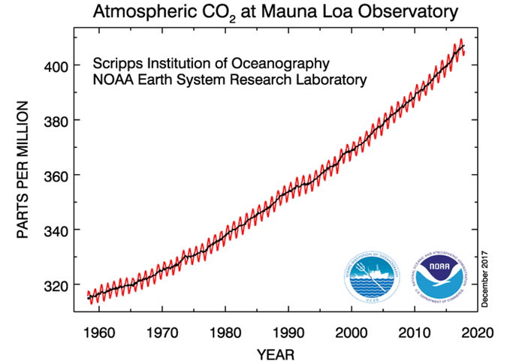
There is a general belief that “climate change” is caused by the consumption of fossil fuels, resulting in the build-up of greenhouse gases in the atmosphere. The gases trap infra-red radiation, and the earth warms. In a warmer world, storms are more frequent and more violent, floods are more severe, droughts are more extensive, and biodiversity is threatened.
The evidence underlying this belief is examined. Indeed, measurements show that the carbon dioxide in the atmosphere is growing, as shown in Fig. 1. And the composition of the carbon dioxide points clearly to its fossil origin.
Fig. 1
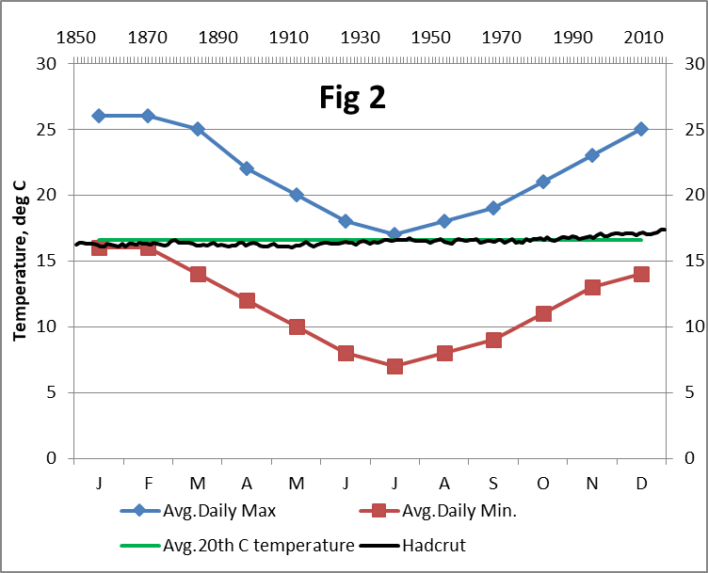
Measurements of the average global temperature show warming. However, when you compare the rise in temperature to the changes you live through every day and through all seasons, the rise is barely visible. Fig.2 shows Cape Town’s average daily maximum and minimum temperatures over the year in blue and red respectively. On the same temperature scale, the black line shows the average temperatures of the globe from 1850 to 2016, from the Hadley Climate Research Unit (“Hadcrut”). Yes, it is warming – but is this warming significant? There is evidence that it is well within the range of natural variability, and might not be caused by greenhouse gases at all.
When we come to look at the impacts of global warming, they are visible in the colder parts of the world, what is known as the “cryosphere”. The ice cover of the Arctic has been shrinking; that of Antarctica has been growing; and the net effect is neutral. Glaciers have been melting and, for instance, are revealing paths over mountain passes that were last used about 700 years ago, but have been covered by ice until this recent melt. Greenland’s ice is melting, but conditions are still colder than the conditions between 985 and 1500, when the Norse occupied the country.
Has the sea also warmed? The answer is not yet clear. One of the challenges is that the temperature drops quite steeply with depth, and the near-surface temperature profile changes between summer and winter. A second challenge is that the method of determining the sea temperature has changed dramatically over the years. It used to be measured by pulling up a bucket of water and measuring its temperature. This was found to be biased about 0.2ºC low. From the 1960’s, the temperature of the water being drawn in to cool the ship’s engines was used, but this was found to be biased about 0.6ºC high. From the 1980’s onwards, accurate electronic thermometers attached to buoys have been used. Unfortunately satellite measurements have proved misleading – they measure only the top few millimetres, which are very unrepresentative of the whole. A recent paper, deriving temperature from the solubility of rare gases, suggests the oceans have not warmed in the past 50 years. The latest IPCC estimate is shown in Fig.3. It is very uncertain, in spite of the apparent agreement of the five datasets, because of all the adjustments that have been required.
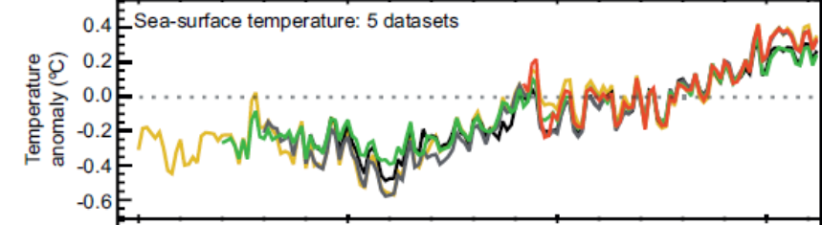
Fig. 3

Indeed, there are some strong reasons for believing that Fig 3 is wrong. There are many assertions that the sea level is increasing because the oceans are warming. The idea is that warm water is less dense than cold, so it takes up more space. If this were true, there would be a correlation between sea temperature and sea level. A typical sea level record, nearly 170 years of monthly data for the German port of Wismar, is shown in Fig.4. There is no sign of the putative warming between 1910 and 1940 shown in Fig.3, or of the similar warming between 1980 and today. Instead there has been a steady march of about 1.5mm per year. This is true for data from thousands of tide gauges around the world. Some of the gauges even show tectonic forces at work. For instance, much of Scandinavia is rising because, over the past 20 000 years, it has been relieved of the weight of several kilometers of ice. Accordingly, the Scandinavian tide gauges appear to show the sea level falling.
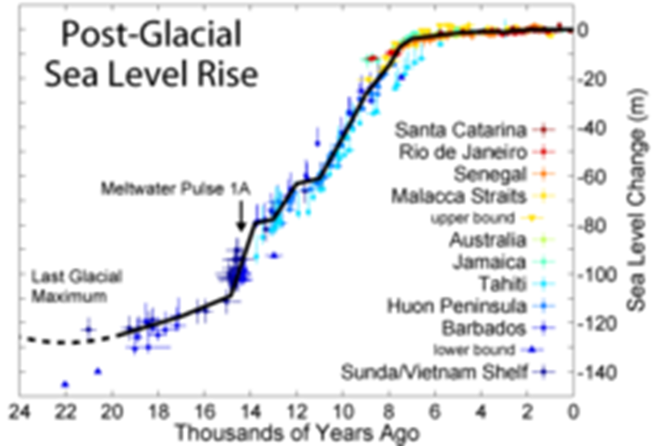
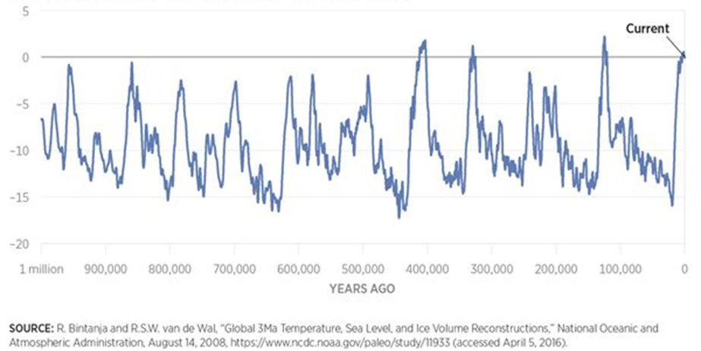
The widespread concern about climate change and sea levels appears to be unjustified. The geological record shows that sea levels were about 120m lower when the previous ice age was at its coldest, about 22 000 years ago. As the world warmed, the huge ice sheets covering North America and northern Europe melted, and the sea level rose by centimetres per year. The rise almost ceased about 8 000 years ago, as Fig.5 illustrates. While it is true that it would again rise quite rapidly if Greenland and Antarctica were to become ice-free, we can take some comfort from the fact that neither has been ice-free for over a million years, in spite of three periods when it has been significantly warmer than it is today, as shown in Fig.6.
Fig.5
Fig.6
What Fig.6 illustrates is that the global temperature has always been highly variable. One of the drivers of change has to do with the relationship between the earth and the sun, an underlying cycle called a Milankovich cycle, but it is by no means the only driver. Over the past 8 000 years, the global temperature has been reasonably stable, but one study showed that the natural variation was such that there was a 95% chance that the temperature would change by less than 2ºC over any 100-year period. The measured change over the past 100 years has been less than 1ºC (Fig.2), which is well within the range of natural variation. If there is a heating effect due to the build-up of greenhouse gases in the atmosphere, it could well be hidden in the natural variation of temperature.
One possible effect of a warmer world might be an increase in the frequency or severity or both of extreme climate events. It is a challenge to detect any such changes. An example is given of 250 years of rainfall data. If an extreme event is defined as a 1 in 20 year event, then over 250 years between 12 and 13 such events would have been expected. In fact, only 11 were observed. It would take much longer than 250 years to see whether the frequency of extreme events had changed. Finding changes in intensity is even more challenging, because the methods used to measure intensity have changed over recent decades. The Intergovernmental Panel on Climate Change has devoted a Special Report to extreme events, and few of their conclusions support the concepts that frequency or intensity are increasing, for example:
• “There is low confidence that any observed long-term increases in tropical cyclone activity are robust” Low confidence implies <33% probability.
• “There is low confidence in observed trends in small-scale phenomena such as tornadoes and hail.”
• “There is medium confidence that since the 1950s some regions of the world have experienced a trend to more intense and longer droughts, but in some regions droughts have become less frequent, less intense, or shorter.” Medium confidence implies 33-66% probability, but note, this is only for some regions of the world; for others there is less confidence.
• “There is limited to medium evidence available to assess climate-driven observed changes in the magnitude and frequency of floods. Furthermore, there is low agreement in this evidence, and thus overall low confidence at the global scale regarding even the sign of these changes.” (Emphasis added).
It can only be concluded that concerns about increasingly severe weather are exaggerated. The world has been warming for about 150 years. Neither the IPCC nor I have been able to find any data proving any increases in severity.
There are very many potential impacts. The list of putative impacts is long, and it would not be useful to attempt to address them all. However, there are several which illustrate the challenge of assessing impacts. If the impacts cannot be reliably assessed, then any costs associated with them must be indeterminate.
The first of these is the hypothesis that higher temperatures will lead to the spread of malaria. The evidence is that, if temperature plays any role, it is at best very minor. For example, “the most catastrophic epidemic on record anywhere in the world occurred in the Soviet Union in the 1920s, with a peak incidence of 13 million cases per year, and 600,000 deaths. Transmission was high in many parts of Siberia, and there were 30,000 cases and 10,000 deaths due to falciparum infection (the most deadly malaria parasite) in Archangel, close to the Arctic Circle.”
There can be “fake news” regarding climate change. South Africa was the victim of “fake news” when it banned the use of DDT for malaria control on the advice of the World Health Organisation [WHO]. The incidence of malaria rose rapidly. By 2000, there were over 65 000 cases and nearly 500 deaths. DDT control was reintroduced, and by 2005 there were less than 8 000 cases and less than 50 deaths. By 2006, WHO had reversed its earlier recommendations in the light of South Africa’s experience.
Then there is the saga of the polar bear. The reduction in Arctic sea ice was held to be the likely cause of the disappearance of the species. In 2008, the US Fish and Wildlife Service listed polar bears as threatened, based on computer models of future polar bear survival in the face of summer sea-ice loss. These models expected the global polar bear population to decline by 67% by 2050. However, even though summer sea-ice levels have remained low, the polar bear numbers have not declined as predicted, and the bears have shown a marked improvement in body condition, cub production and cub survival. In 2015, a census showed there to be over 28 500 bears in the Arctic.
In a similar vein, another putative impact is the bleaching of coral reefs. There was a fairly massive bleaching of the northern part of Australia’s Great Barrier Reef in 2016. An official Government report attributed the bleaching to climate change and excessive sea surface temperatures, but unfortunately it used satellite estimates of the temperature, and satellites detect the temperature of only the topmost millimeter. There were many measurements of deeper sea water temperatures in the bleached area and, at depths between 1m and 10m, these failed to show any abnormalities during 2014-16 compared to the prior 10 years. What had changed, however, was the sea level. El Nïno had caused a drop of approximately 0.5m in the average depth of the sea, and had exposed the corals for too long a time to the atmosphere. Climate change was not the cause of coral bleaching.
There is an extensive literature on the impacts of climate change on the loss of biodiversity. There is, however, a gap between what is claimed and what has been observed. The International Union for the Conservation of Nature maintains a Red List of species that are threatened or are extinct in the wild. Since 1600, approximately 600 species are believed to have become extinct. Humans arriving in environments such as islands during the past 500 years, and bringing predators with them, caused many such extinctions. There should be, according to evolutionary theory, natural attrition of species as well as natural development of new species. It is not known what the natural rates are, however. It is strongly suspected that human activities are impacting many species and threatening their survival, but proving that they are extinct is a very difficult process. It is known for a species not to be found for as long as 50 years after first sighting, only to suddenly re-appear and flourish. The latest IPCC Assessment Report concludes: “While recent climate change contributed to the extinction of some species of Central American amphibians (medium confidence), most recent observed terrestrial species extinctions have not been attributed to climate change (high confidence).”
A further possible impact is called “ocean acidification”. Chemically, it is a misnomer – the sea has always been slightly alkaline, and the additional carbon dioxide in the atmosphere has increased the quantity of dissolved carbon dioxide in the oceans, which has made them slightly less alkaline. The average pH has dropped from about pH8.2 to pH8.1. The chemical equilibria involved suggest that the response to increasing carbon dioxide in the atmosphere is not a linear one, and that the pH is unlikely to drop below pH8 at ten times the present atmospheric concentration of over 400ppm carbon dioxide. Again, the IPCC gives quite a reasoned view: “The fundamental chemistry of ocean acidification is well understood (robust evidence, high agreement). It has been more difficult to understand and project changes within the more complex coastal systems. Few field observations to date demonstrate biological responses attributable to anthropogenic ocean acidification, as in many places these responses are not yet outside their natural variability and may be influenced by confounding local or regional factors.”
A measurable impact is the effect of increasing carbon dioxide levels on plant growth. The phenomenon has long been recognized. For example, many European greenhouses for vegetables and flowers have used off-gases from furnaces to raise carbon dioxide levels to over 2000ppm. This has enabled them to harvest at least one additional crop each year. The Food and Agricultural Organization statistics show a rapid growth in cereal production globally during the period 2005-2014, much of which is attributed to the increased availability of carbon dioxide. NASA has shown how the planet as a whole has greened over the past 30 years.
The IPCC defines climate change as any change in climate over time, whether due to natural variability or as a result of human activity. What this review has indicated is that any change is difficult to detect; many supposed changes cannot be detected; and that it is not possible, at present, to ascribe any detectable changes to human activity.
If this is accepted, then the obverse is patently true – it is not possible to show conclusively that human activity will lead to climate change. However, what is absolutely certain is that ceasing a human activity which is suspected of causing climate change cannot have the anticipated effect of stopping climate change – natural variability will still occur, and the climate will continue to change.
In this light, South Africa’s support for the Paris Agreement does not make sense, because the Agreement calls for “holding the increase in the global average temperature to well below 2 °C above pre-industrial levels and pursuing efforts to limit the temperature increase to 1.5 °C above pre-industrial levels.” Even if the presence of excess carbon dioxide was indeed responsible for some of the warming that has been observed, and it was possible to cease all emissions, then the natural variability of the climate would still prevent the achievement of these targets.
In 2011, the South African Department of Environment Affairs produced a white paper on a National Climate Change Response. Its opening statement said:
“Climate change is already a measurable reality and along with other developing countries, South Africa is especially vulnerable to its impacts. This White Paper presents the South African Government’s vision for an effective climate change response and the long-term, just transition to a climate-resilient and lower-carbon economy and society. South Africa’s response to climate change has two objectives:
• Effectively manage inevitable climate change impacts through interventions that build and sustain South Africa’s social, economic and environmental resilience and emergency response capacity.
• Make a fair contribution to the global effort to stabilise greenhouse gas (GHG) concentrations in the atmosphere at a level that avoids dangerous anthropogenic interference with the climate system within a timeframe that enables economic, social and environmental development to proceed in a sustainable manner.”
This study has shown that almost the only measurable climate change is that of temperature; it is questionable whether South Africa is “especially vulnerable” to the small changes that have been observed. It has also shown that the climate change impacts are not quantifiable to any degree. While it is clearly necessary to develop South Africa socially, economically and environmentally, climate change cannot be a significant driver – other factors such as the supply of water, energy or health services have a far greater and quantifiable impact.
It then has to be asked what constitutes a “fair contribution” to global efforts. The aim of making a fair contribution is not unreasonable. However, it has to be asked whether any efforts are “fair” when South Africa has essentially stabilized its emissions for the whole of this century (Fig.7), and its economy has been static, while many other developing nations have increased their economies and their emissions.
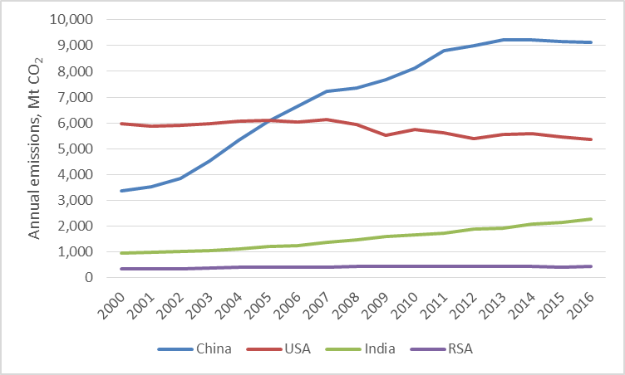
Fig.7
The extent to which any South African reduction is less than fair becomes clear when the global picture is considered. Globally, as shown in Fig.8, emissions have GROWN annually by about 300 million tonnes of carbon dioxide. South Africa’s TOTAL emission are about 425 million tonnes. Even if we were to cut our emissions by half – which in a coal-based economy such as ours is not an easy thing to do – our contribution would be swamped by next year’s growth in global emissions.
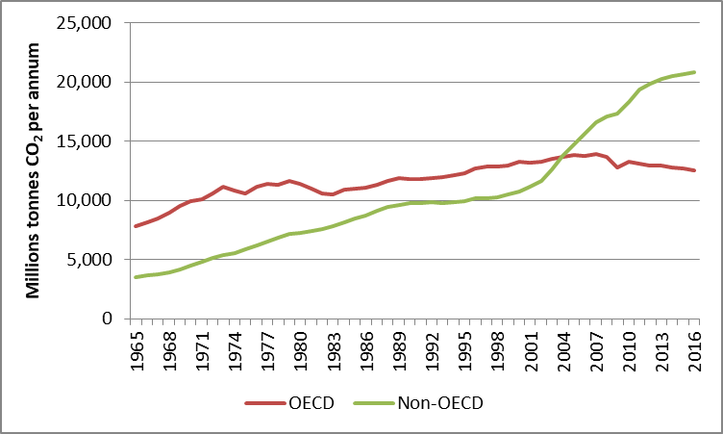
Fig.8
It is very doubtful that any contribution South Africa made would be “fair”. Indeed, it can be calculated that if we followed the peak-plateau-decline scenario of the white paper, and if the effect of increased carbon dioxide in the atmosphere were as high as predicted by the IPCC, then our efforts to follow the scenario would affect global temperatures by less than 0.003ºC by the year 2100. That is well within the error bound on the estimation of global temperatures – that is, it is immeasurable.
In this light, it has to be asked why South Africa should introduce a carbon tax. It is already a low emitter and, importantly, it has not grown its emissions as its BRICS partner nations have. It can well afford to wait to see whether other nations stop their growth in emissions. Among developing nations, there is little sign of this happening. Is South Africa to be the only one to restrict its emissions?
Furthermore, there is a strong possibility that a carbon tax will not reduce our emissions, but merely slow their growth. I know of only one jurisdiction where a carbon tax has reduced emissions, and that is British Columbia in Canada. It is a rather special case, because most of its emissions are from the transport sector. Over 80% of electrical generation is from hydropower, so that a carbon tax is essentially a fuel tax. Also the tax applied full Pigovian principles; it is accompanied by equivalent tax reductions elsewhere in the fiscus, and so is tax neutral.
Elsewhere a carbon tax has had some impact – occasionally in the wrong direction. India, for instance, introduced a significant tax on coal. As Fig.7 makes clear, it has not had a detectable impact. Europe has established a wide-ranging carbon credit scheme to encourage tax offsets. It has been so successful that the price of carbon has fallen to a few dollars per tonne, at which point it is almost valueless and the tax becomes merely punitive.
This illustrates the problem of a carbon tax in South Africa. Over 80% of our energy is fossil-fuel based. There is no way of avoiding an increase in energy prices if fossil fuel emissions are taxed, because there is no real alternative – replacing the huge investments in the fossil fuel industry with something else is just not economically possible in the time frames demanded by the National Climate Change Response.
The draft Integrated Resource Plan (IRP) 2016 proposes closing so many coal-fired plants that the demand for coal will decline by 37%. This will probably result in more than 100 000 people losing their jobs, affecting over half a million dependents. Under this scenario, by 2035 South Africa’s GDP growth will have been reduced by almost R1trillion and employment would be almost 5 million less than what could have been achieved. A revised IRP would seem to be essential. Certainly, there are economic opportunities in extending the life of the existing infrastructure.
Finally, Treasury has suggested that it might be possible to offset any tax via carbon credits. It appears to have been overlooked that there have already been some 300 attempts by South African entities to achieve carbon credits, of which about 20 have been successful for a few years before being abandoned in the face of a long-term fall in the value of carbon.
In conclusion:
- The evidence for catastrophic change due to emissions of greenhouse gases into the atmosphere is far too equivocal to form the basis for action – much of the observed climate change is natural;
- The international commitments we have made are deeply flawed and equally provide no basis for action;
- Any carbon tax is likely to damage the economy and lose jobs, because our dependence on fossil fuels is so large that it will take many years before a significant fraction of that dependency can be closed;
- Any carbon tax will therefore not have the desired effect of reducing our emissions significantly, and will certainly increase the costs of energy, so making us less competitive and reducing our ability to create jobs even further;
- A Pigovian tax such as the carbon tax is designed to correct an inefficient market outcome by being set equal to the social cost of the negative externalities. When an unquantifiable portion of the social cost arises from natural phenomena, there is no rational way to set such a tax.

