OUTA Submission on Draft Carbon Tax Bill (B - 2017)

Prepared by Ronald Chauke – Organization Undoing Tax Abuse (OUTA)
(Email: ronald.chauke@outa.co.za)

09 March 2018

TABLE OF CONTENTS
1. ACRONYMS AND ABBREVIATIONS
2. EXECUTIVE SUMMARY
3. INTRODUCTION
4. BACKGROUND AND LEGISLATIVE LANDSCAPE
5. EVOLUTION OF THE SOUTH AFRICAN LEGISLATIVE LANDSCAPE &
ENVIRONMENT
6. DESIGN FEATURES OF A CARBON TAX FOR SOUTH AFRICA TAX BASE
7. KEY OBJECTIVES
8. LITERATURE REVIEW
8.1. COUNTRIES WHERE CARBON TAX HAS BEEN IMPLEMENTED
8.2 AUSTRALIAN CASE - CARBON TAX REPEALED (CANCELLED) IN 2014
9. PROS AND CONS OF THE CARBON TAX AND CARBON BUDGET
9.1 ADVANTAGES
9.2 DISADVANTAGES
10. AIM OF THE CARBON TAX – SOUTH AFRICAN CASE
11. TRANSITIONAL MECHANISMS
12. ADMINISTRATION AND REVENUE RECYCLING (NATIONAL TREASURY,
2015)
13. EXISTING TAXES AND INCENTIVES
14. OBSERVATIONS
15. GLOBAL COMPETITIVENESS
16. OUTA’s CONCERNS/CONTENTIONS
17. REVENUE RING-FENCING
18. PROPOSED CARBON TAX IMPLEMENTATION PHASES
19. FUNDAMENTAL QUESTIONS
20. RECOMMENDATIONS
21. LIST OF REFERENCES

1. ACRONYMS AND ABBREVIATIONS
ACSA - Airports Company South Africa
AUD - Australian Dollar
BACT - Best Available Control Technology
BCA - Border Carbon Adjustment
BTA - Border Tax Adjustment
BAU - Business-as-usual
°C - Degrees Celsius
CaCO3 - Calcium Carbonate
CAD - Canadian Dollar
CAI - Chartered Accountants Ireland
CCEMF - Climate Change and Emissions Management Fund
CCERs - Chinese Certified Emissions Reductions
CCGT- Closed Cycle Gas Turbine
CCS - Carbon Capture and Storage
CDM - Clean Development Mechanism
CER - Certified Emissions Reduction
CGE - Computable General Equilibrium
CH4 - Methane
CH3OH - Methanol
CIT - Corporate Income Tax
CO2 - Carbon Dioxide
CO2-eq - Carbon Dioxide Equivalent (also CO2-e)
COP - Conference of the Parties
CSI - Cement Sustainability Initiative
CSP - Concentrating Solar Power
CWT - Complexity weighted ton
DEA - Department of Environmental Affairs
DEAT - Department of Environment Affairs and Tourism
DME - Department of Minerals and Energy
DoE - Department of Energy
€ - Euro
EDD - Economic Development Department
EEDSM - Energy Efficiency Demand-Side Management
EITI - Energy Intensive and Trade Intensive
ENCC - National Strategy for Climate Change (Estrategia Nacional de Cambio Climático)
EPC - Emissions Performance Credit
EPS - Payment for Environmental Services (El Pago de Servicios Ambientales)
EPWP - Expanded Public Works Programme
ERC - Energy Research Centre
ESCert - Energy Saving Certificate
ETS - Emissions Trading System/Scheme
EU - European Union
EU ETS - European Union Emissions Trading System
EVO - Efficiency Valuation Organisation
GDP - Gross Domestic Product
Gg - Gigagram
GHG - Greenhouse Gas
GJ - Gigajoule (109 or one thousand million joules)
IAI - International Aluminium Institute
ICAO - International Civil Aviation Organisation
IMO - International Maritime Organisation
INEP - Integrated National Electrification Programme
INR - Indian Rupee
IPAP - Industrial Policy Action Plan
IPCC - Intergovernmental Panel on Climate Change
IPMVP - International Performance Measurement and Verification Protocol
IPP - Independent Power Producer
IRP - Integrated Resource Plan
kg - Kilogram kW kilowatt (1 000 watts)
kWh - Kilowatt-hour
LTMS - Long-Term Mitigation Scenarios
MJ - Megajoule (106 or one million joules)
MRV - Measurement, Reporting and Verification
Mt - Million tons
MW - Megawatt
MWh - Megawatt-hour
N2O - Nitrous Oxide
NaCO3 - Sodium Carbonate
NAMA - Nationally Appropriate Mitigation Action
NATMAP - National Transport Master Plan
NCASI - National Council for Air and Stream Improvement Inc.
NCEF - National Clean Energy Fund
NCPC - National Cleaner Production Centre
NDP - National Development Plan
Nersa - National Energy Regulator of South Africa
NGO - Non-Governmental Organisation
NGP - New Growth Path
NH3 - Ammonia
NPC - National Planning Commission
NT - National Treasury
OCGT - Open Cycle Gas Turbine
PAT - Perform, Achieve and Trade
PFC - Perfluorocarbon
PIT - Personal Income Tax
PPA - Power Purchase Agreement
Ppm - Parts per million
PV - Photovoltaic
R&D - Research and Development
REFSO - Renewable Energy Finance and Subsidy Office
REIPP - Renewable Energy Independent Power Producer
RSA - Republic of South Africa
SACAA - South African Civil Aviation Authority
SACU - Southern African Customs Union
SANBI - South African National Biodiversity Institute
SARi - South African Renewables Initiative
SEC - Specific Energy Consumption
SEI - Stockholm Environment Institute
SWH - Solar Water Heater
t - (metric) ton
tCO2 - ton of carbon dioxide
tCO2-eq - ton of carbon dioxide equivalent (also tCO2-e) toe ton of oil equivalent
UNFCCC - United Nations Framework Convention on Climate Change
UNU - United Nations University
US$ - American dollar
VAT - Value-Added Tax
WBCSD - Word Business Council for Sustainable Development
WC/WDM - Water Conservation and Water Demand Management
WIDER - World Institute for Development Economics Research
WTO - World Trade Organisation
ZAR - South African Rand

2. EXECUTIVE SUMMARY
2.1 This document serves as the Organization Undoing Tax Abuse’s (OUTA’s) submission to National Treasury on the second Draft Carbon Tax Bill issued for public comments. The submission contains OUTA’s opinions and concerns about the envisaged introduction of a carbon tax upon the South African economy and the citizens, of which OUTA construes as an increased burden that will increase the cost of doing business and exacerbate the suppressed social and economic situation of the majority of the population/society.
2.2 As a civil society organization, OUTA understands and appreciates the need to reduce the carbon emissions and to reduce the energy intensity of our economy. However, we have some concerns based on a number of underlying and structural factors which are not explicitly outlined in the Draft Bill and the associated explanatory documentation such as:
- Timing of Implementation (Readiness cannot be ascertained)
- Emissions Baseline data has not been collected and normalised (standardised) per industry
- No substantive rationale that this will lead to behaviour change by polluters
- Quantification and costing of the administrative burden has not been unpacked (complexities not clarified)
- Diverse economic scenarios and implications have not been thoroughly modelled only a few implications were analysed
- Research data/input parameters seems incomplete
- Davis Tax Commission was not provided with comprehensive data to make proper/draw proper conclusions and recommendations
- The impact of high electricity prices since 2010 has not been factored into the carbon content equation of our sectors.
- Prevailing and forecasted economic conditions are not clearly depicted, such as possible long-overdrawn slow economic growth until 2025, etc.
- No assurance that the tax revenues raised will be ring-fenced and used like how France introduced its carbon tax, where the funds are dedicated to create green jobs as part of trade-offs, between tax imposition and promoting the renewables energy sector.
2.3 OUTA asserts that South Africa is an emerging economy and must prioritise the achievement of its objectives of economic development with the same vigour like how the developed countries used fossil fuels to propel their industrialisation. OUTA strongly supports the need for South Africa to consider the issue of introducing a carbon tax from an African context and not from a developed world’s point of view premised on its developmental agenda and timing.
2.4 It is recommended that Government must undertake a reality check by tackling head-on the existing backlogs within our developmental agenda thorny issues such as mitigating against the devastating socio-economic issues like poverty alleviation, reduction of unemployment (at 27%) and reducing the cost to do business as an intervention to promote development of small, micro and medium enterprises (SMMEs) prior to us considering implementing a sophisticated taxing system such as a carbon tax.
2.5 OUTA is aware of government concerted efforts to coordinate and develop a coherent policy framework to curb GHG emissions by 34% by 2020 and 42% by 2025 below the BAU trajectory, subject to the provision of adequate financial, technological and capacity-building support by developed countries. The question remains, is the latter financial and capacity building funding forthcoming. If so, how much has the developed countries granted to South Africa and what technologies have been developed and incentivised?

3. INTRODUCTION

3.1 OUTA is a proudly South African non-profit Civil Action Organization formed to hold those in public office accountable and is funded and supported by ordinary people who are passionate about improving the prosperity of our nation.
3.2 On Friday, 14 December 2017 National Treasury (“Treasury”) issued the Draft Carbon Tax Bill (“the second draft Bill”) for public comment. The Bill introduces carbon tax in phases with the first phase now proposed to end in 2022. The design features for the carbon tax have been revised following public consultation on the previous draft Bill. Public hearings are expected to take place after 09 March 2018, the final day to submit comments. The revised Bill is expected to be tabled before Parliament in mid-2018.
3.3 This report serves as OUTA’s submission to the National Treasury on the published Draft Carbon Tax Bill. It contains OUTA’s opinions, concerns and recommendations pertaining to the results of an initial review of existing industry and academic commentary regarding the publication of Carbon Tax consultation documents as released for public comments by the Ministry of Finance.

4. CONTEXTUAL BACKGROUND
4.1 A carbon tax is a tax imposed on releases of carbon dioxide (CO2), which is emitted largely through the combustion of fossil fuels used in electricity production; industrial, commercial, and residential heating; and transportation.
4.2 In principle, both a carbon tax and an emissions trading system (ETS) use the market to stimulate reductions in greenhouse gas (GHG) emissions. Carbon taxes work by pricing emissions directly, while ETSs operate by setting a cap on the level of emissions allowed. Firms are then allocated allowances (to be auctioned over time) which they may trade with other firms, depending on their abatement costs. Taxes provide certainty with respect to price, but no certainty with regard to emissions reductions. An ETS, however, provides certainty of the emissions reduction levels to be achieved, but not of the resulting carbon price (Carbon Tax Policy Paper 2013 – National Treasury)
4.3 In 2009, at the UNFCCC Conference of the Parties (COP) in Copenhagen, South Africa made a voluntary commitment to reduce its GHG emissions by 34% in 2020 and 42% in 2025 relative to business-as-usual (BAU). This was part of a wider commitment by government to contribute towards the global effort of mitigating anthropogenic climate change and transitioning to a lower-carbon economy.
4.4 The above commitment was reaffirmed in its Intended Nationally Determined Contribution (INDC) submission to the UNFCCC, in advance of COP 21 in Paris in 2015, which identified the intention that South African emissions should follow a ‘Peak Plateau and Decline’ (PPD) trajectory: thus, peaking in 2025 within a range of 398 to 614 MtCO2e; plateauing for approximately a decade; before beginning to decline in absolute terms, falling to between 212 to 428 MtCO2e by 2050.
4.5 Addressing the challenges of climate change through facilitating a viable and fair transition to a low-carbon economy is essential to ensure an environmentally sustainable economic development and growth path for South Africa.
4.6 Among a suite of different policies, two, in particular, have been designed with the intention of delivering a significant proportion of these emission reductions:
- A carbon tax designed by the National Treasury (NT) to provide a price signal to producers and consumers of carbon-intensive products and to create an incentive to invest in cleaner technology.
4.7 The National Development Plan (NDP) identifies 14 explicit principles. These are at a very high level of abstraction, reflecting the status of the document as one which guides South Africa’s overall development trajectory. Among the most relevant for the emissions mitigation policy are:
- Ecosystems protection. Acknowledging that human well-being is dependent on the health of the planet.
- Full cost accounting. Internalising both environmental and social costs in planning and investment decisions, recognising that the need to secure environmental assets may be weighed against the social benefits accrued from their use.
- Transformative. Addressing the structural and systemic flaws of the economy and society with strength of leadership, boldness, visionary thinking, and innovative planning.
- Delivering a managed transition. Building on existing processes and capacities to enable society to change in a structured and phased manner.
4.8 The carbon tax is expected to come into operation in 2019 at a headline rate of R120/tCO2e, although the effective tax rate will initially be lower as a result of a series of tax free allowances.
4.9 A series of carbon budgets designed by the Department of Environmental Affairs (DEA) envisaged to provide a GHG emissions allowance (in other words, a cap), against which physical emissions arising from the operations of a company during a defined time period will be tracked. In the period to 2020, the carbon budgets will not be a compliance instrument but rather will be used to increase understanding of the emissions profile of participating companies, and to establish monitoring, reporting, and verification (MRV) processes. Beyond 2020, they are intended to become compulsory.
4.10 The results of this analysis show that mitigation policy in South Africa faces something of a trilemma; resolving this trilemma requires policymakers and stakeholders to make judgements over which principles should be given greatest weight in policymaking. The carbon tax offers cost-effective abatement but limited emissions certainty (at least in the short term) and raises concerns among some business stakeholders over competitiveness concerns (notwithstanding important design features intended to address these issues); budgets offer emissions certainty but may be very cost ineffective and potentially have even more severe competitiveness issues; while an ETS - which could offer emissions certainty and cost-effective abatement, plus the opportunity to use free allowances to address competitiveness concerns— faces a number of practical challenges in South Africa, at least in the short–medium term.
4.11 The original intention of the carbon tax will be based on emissions derived from emission factors linked to the fuel inputs used. It will cover emissions from all stationary sources, including process emissions.
4.12 The key design features of the carbon tax are:
- A phased approach to the implementation of the carbon tax. The first phase (introductory) will be for five years, effective from 01 January 2019 to 31 December 2021 followed by Phase 2 of another five years, from 2022 to 2027. Follow up phases can be explored at a later stage.
- An across the board basic 60 per cent tax free threshold of actual emissions below which the tax will not be payable.
- Additional 10 per cent relief for certain sectors to allow for technical or structural limitations to reduce emissions (process emissions).
- Up to an additional 10 per cent relief for emissions intensive and trade intensive sectors, e.g. iron and steel, cement, glass, etc. to take into account the risk of carbon leakage and competitiveness concerns.
- Offsets could be used by firms to reduce their carbon tax liability up to limits of 5 or 10 per cent, depending on the sector.
- Emissions from the agricultural and waste sectors will be exempt during the first phase. This complete exemption will be reviewed during the second phase.
- The electricity sector will qualify for a tax free threshold of up to 70 per cent and some sectors will be able to qualify for a tax free threshold of up to 90 per cent during the first phase.

The Tax Rate
4.13 A carbon tax rate of R120 per ton of CO2e increasing at 10 per cent per annum will be implemented during the first phase. When the tax-free threshold and additional relief are taken into account, the effective tax rate will range between R12 and R48 per ton of CO2e (and zero for Agriculture and Waste).

Energy efficiency and technology support
4.14 The core policy mix to mitigate climate change constitutes a carbon pricing mechanism, energy efficiency and technology policies. Energy efficiency savings can be seen as one of the “low-hanging fruits” to help address concerns relating to both energy security and climate change. In the context of energy efficiency savings, the conversion of old technologies to new ones often involves a substantial amount of capital expenditure. The perceived long payback period tends to discourage businesses form making upfront investments relating to energy efficiency savings. However, major strides are being made globally as depicted in the diagrams below.

Fact Sheet - Global Investment in Energy Efficiency
4.15 The International Energy Agency (IEA) reported that global investment in energy efficiency continued to grow in 2016, increasing by 9% to $231 billion. The strongest growth rate can be attributed to China which surged by 24%, though Europe remains the largest contributor to global investment in energy efficiency.
4.16 Among end-use sectors, buildings still dominate energy efficiency investment, accounting for 58% of the world total in 2016, with most investment in that sector going to building envelopes, appliances and lighting, as depicted below.
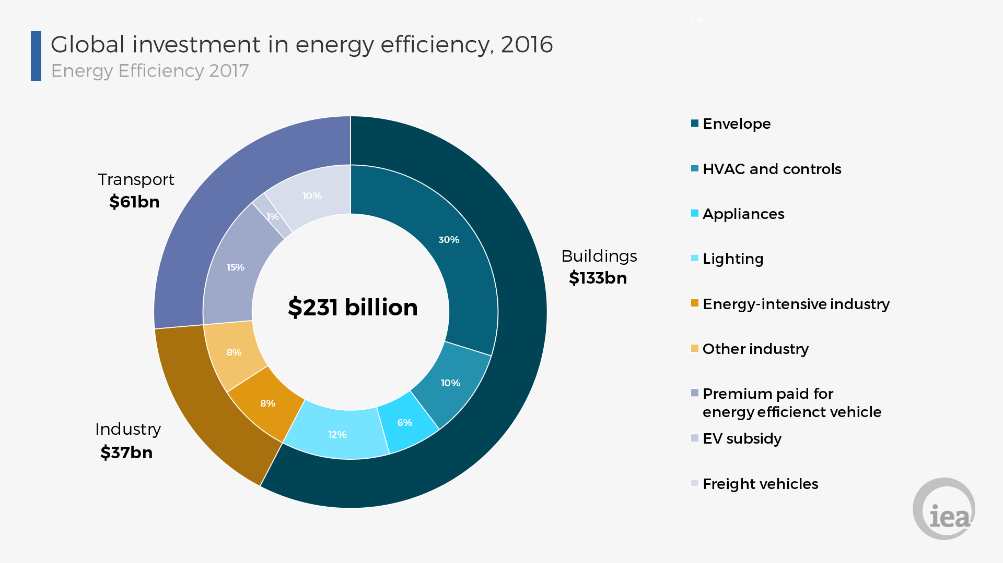
Source: IEA, Energy Efficiency 2017

4.17 As part of pursuing cleaner environment, government has introduced a support scheme for new and innovative technology via a research and development tax incentive and the carbon capture and storage (CCS) research project is already underway and in an advanced stage.

5. EVOLUTION OF THE SOUTH AFRICAN LEGISLATIVE LANDSCAPE
5.1 The 2011 National Climate Change Response White Paper provides an overarching policy framework aimed at enabling South Africa’s transition in the short, medium and long term to a low carbon economy. The policy framework provides an outline of government’s role in designing and implementing a suite of policy measures and strategies aimed at both mitigating and adapting to the impacts of climate change.
5.2 The IEA’s 2015 Carbon Disclosure Project disclosed that South Africa’s current policy-based projections estimated that emissions levels of 606 MtCO₂e will be reached in 2020 excluding Land Use, Land Use Change and Forestry (LULUCF). This is equivalent to a 75% increase in emissions from 1990 levels excluding LULUCF. For 2030, the current policy analysis suggests a further increase in emissions to 670 MtCO₂e, excluding LULUCF, representing a 93% increase in emissions compared to 1990 levels excluding the LULUCF (CPD 2016).
5.3 South Africa’s emissions have steadily increased historically. South Africa’s economy relies heavily on mining and heavy industry. Energy consumption in the industrial and buildings sectors relies largely on electricity as an energy source, which is produced with high carbon intensity using domestic coal: according to the International Energy Agency Outlook report, 93% of South Africa’s electricity is generated from coal (IEA, 2016b). Furthermore, huge quantities of coal are liquefied (converted) to produce more than 30% of South African gasoline and diesel requirements (World Coal Association, 2015). Additional emissions come from industrial-process emissions, especially steel and cement production.
5.4 The National Development Plan (NDP) outlined a 2030 vision on aimed at ensuring sustainable development, eliminating poverty and reducing inequalities. The National Climate Change Response Policy (NCCRP) of 2011 complements the 2030 vision.
5.5 In order to give effect to sector that contribute a bigger portion to the carbon content of the economy, sector plans (roadmaps) have been developed such as the Integrated Resource Plan (IRP) for electricity, the Gas Infrastructure Masterplan, Mineral Beneficiation Strategy, etc. have been developed.
5.6 South Africa through the Ministry of Finance, is contemplating to introduce a carbon tax covering fossil fuel combustion emissions, industrial processes and product use emissions, and fugitive emissions (e.g. fugitive emissions from coal mining). Under current planning horizon, the waste and land use sectors will be exempted from taxation. While the full carbon tax rate is proposed to be R120/tCO₂e (US$8/tCO₂e), after exemptions, the effective tax rate will be between R6–48/tCO₂e (US$0.4–3/tCO₂e) (World Bank, 2016). The implementation of the carbon tax has faced several setbacks and opposition from industry (Trollip & Boulle, 2017).
5.7 Originally, the 1st of January 2015 was set to be the start date, but since then, it has suffered repeated delays (The Carbon Report, 2015). The latest draft bill indicated a start date of 1 January 2017, but implementation has been yet further delayed due to the busy legislative programme of the parliament. The 2017 Budget Review states that a revised Carbon Tax Bill will be published for public consultation and tabled in parliament by mid-2017. As of October 2017, the start date of the carbon tax remains unclear (World Bank Group and Ecofys, 2017). However, in the 2018 Budget Speech, implementation date has been set for 01st January 2019.

Paris Agreement target
5.8 South Africa’s NDC, 2020 pledge and long-term target pledge are consistent with its long-term goal to constrain its emissions to follow a peak-plateau-decline (PPD) trajectory. Premised on the commitment, South Africa’s emissions are envisaged to peak between 2020 and 2025 (as targeted by the Copenhagen and NDC pledge), plateau for approximately a decade and then decline in absolute terms.
5.9 South Africa’s NDC targets are deemed as absolute emissions level in the range of 398–614 MtCO₂e including LULUCF over the period 2025–2030. Assuming LULUCF remains at the average level over 2000–2010 (-19 MtCO₂e), this NDC translates to an emissions level of between 417–633 MtCO₂e excl. LULUCF, equivalent to a 20–82% increase above 1990 levels excl. LULUCF.

2020 pledge
5.10 Under the Copenhagen Accord, South Africa committed to reduce emissions below BAU by 34% in 2020, and by 42% in 2025, including LULUCF. The emissions level (excluding LULUCF) derived from South Africa’s pledge is 417–602 MtCO₂e in 2020 and 417–633 MtCO₂e by 2025. South Africa’s Copenhagen pledge is conditional on a fair, ambitious and effective agreement in the international climate change negotiations under the Climate Change Convention and the Kyoto Protocol and the provision of support from the international community.

Long-term goal
5.11 South Africa aims to reduce GHG emissions to 212–428 MtCO₂e by 2050 (incl. LULUCF). Excluding LULUCF, this long-term target is equivalent to 231–447 MtCO₂e.

6. DESIGN FEATURES OF A CARBON TAX FOR SOUTH AFRICA TAX BASE
6.1 The 2010 Carbon Tax Discussion Paper proposes three options for implementing a comprehensive carbon price through the carbon tax, and defines the following tax bases:
- Tax applied directly to measured GHG emissions
- Fossil fuel input tax on coal, crude oil and natural gas, based on their carbon content
- Tax levied on energy outputs (electricity and transport fuels).
6.2 The best option is to impose the levy directly on the emissions of actual GHG or carbon dioxide equivalents (CO2-eq). However, such a tax on actual emissions appears to be administratively complex.
6.3 The large proportion of South Africa’s emissions pool emanates from two companies, namely Eskom and Sasol and this warrants that measures be put in place to consider effective regulation of these two entities.
6.4 The downside relates to the challenges associated with applying different instruments to different emissions in the economy. However, it may be worth considering the separate treatment of Eskom under an approach more akin to budget. There are a number of reasons why this may be valuable and/or may not be as problematic as a differential approach for other actors in the economy:
- A carbon price relies on entities making commercial decisions in response to the price incentive it creates. The current ownership structure of Eskom may mean that Eskom makes decisions.
- Option Assessment - to a wide range of factors, balancing commercial and non-commercial decisions. This may render the impact of the carbon price on its operational and investment decisions less effective than the same policy would on a privately-owned firm.
- The large capital investments made by Eskom may be subject to carbon ‘lock-in’ which would not be effectively addressed by a carbon price, but which could be tackled by a more targeted approach.
- The nature of the South African power sector means that Eskom faces limited competition (especially as renewable production is supplied under long-term fixed price contracts) and so fewer issues of competitive distortion may arise. A budget-type approach for Eskom would need to address two key issues:
6.5 Within the confines of a revised IRP, Eskom would be assigned the responsibility to reduce its own emissions through reducing the carbon intensity of electricity generation, as well as reducing transmissions and distribution losses.

7. KEY OBJECTIVES
7.1 OUTA commissioned a professional research by experts to enable civil society to have an opportunity to acquire meaningful insights about the Carbon Tax. The findings of the study are henceforth applied as the basis for the compilation of our submission to the Draft Carbon Tax Bill, with a special focus on:
- Policy Intent: What is the true intention of introducing a carbon tax?
- Is this a just or an irrational tax?
- Is this another revenue stream for the fiscus?
- Accrued Benefits: What will the payers of tax gain?
- Will this tax contribute to their bottom lines?
- Will efficiencies increase in operations?
- Economic Imperatives: How will this tax contribute to enhance economic development?
- Will the tax have a direct impact on the electricity intensity of our economic sectors?
- Will this tax serve as an enabler in our quest to maximise economic development or what’s the outlook from modelling undertaken?
- Are there thresholds (rewards for low emissions?) - If one is a carbon neutral company, are you rewarded for your behaviour?
- Behaviour change: Will this tax help in the behavioural change of society and business?
- What are the underlying assumptions and input parameters in the modelling exercise relating to possible shifts in society and industrial behaviour likely to take place when this tax is implemented?
- Are there any core drivers that will foster actual behaviour change for both individuals and business enterprises?
- Has the risk and potential for a “tax stressed” pool been factored into the equation – has the prospects for high levels of a tax avoidance or even a tax-revolt been taken into account? (Government should look at the introduction of electronic tolling (eTolls) by Sanral as a case in point in the SA context).
- Has other alternatives for possible behaviour change for organisations to lower carbon emissions (other than taxing them) been taken into account?

8. LITERATURE REVIEW
8.1 The IEA disclosed that there are several factors that are used to determine the overall CO₂ emissions level in a particular country, namely, the size of its population, its energy mix, its GDP, etc.

8.2 In 2015, according to the IEA, global CO₂ emissions from fuel combustion reached 32.3 GtCO₂, which is comparable to the 2014 level. The major countries and regions responsible for emissions were, namely: China (the People’s Republic of China and Hong Kong, China) (28%), the United States (15%), the European Union as a whole (10%), India (6%), the Russian Federation (5%), Japan (4%), Korea (2%), Canada (2%), Brazil (1%) and Mexico (1%).
8.3 IEA research disclosed that, at a global level one observes that early industrialisation was dominated by the use of solid fuel. Coal-fired power during the early stages of industrialisation at a large-scale first emerged in Europe and North America during the 1700s. It wasn’t until the late 1800s that a growth in emissions from oil and gas production started to become apparent. Another century passed before emissions from flaring and cement production began. In the present day, solid and liquid fuel dominate, although contributions from gas production are also notable. Cement and flaring at the global level remain comparably small.

Decoupling of global emissions and economic growth confirmed
(Paris) — 16 March 2016
8.4 Global energy-related carbon dioxide emissions (CO₂) – the largest source of man-made greenhouse gas emissions – stayed flat for the second year in a row, according to analysis of preliminary data by IEA during 2015, as depicted in the table below:
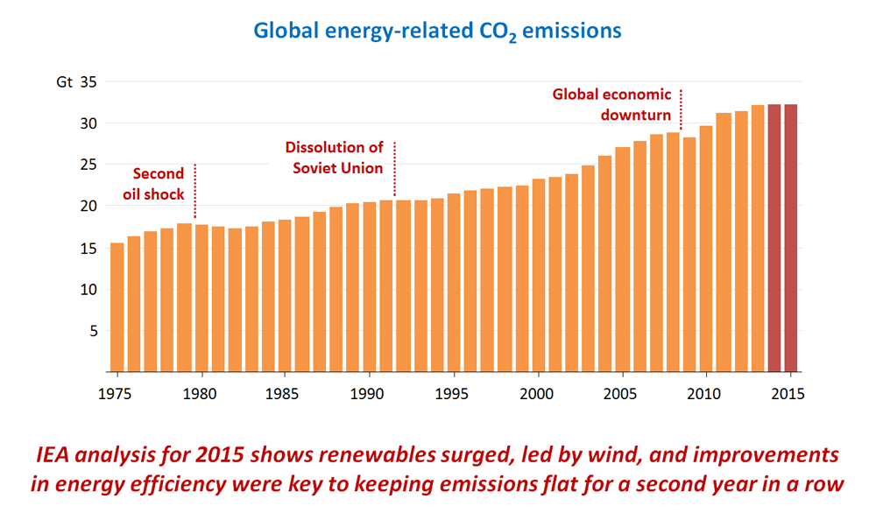
8.5 Global emissions of carbon dioxide were recorded to be at 32.1 billion tonnes in 2015, having remained essentially flat since 2013. The IEA reported that electricity generation data by renewables played a critical role, having accounted for around 90% of new electricity generation in 2015; wind alone produced more than half of new electricity generation. In parallel, the global economy continued to grow by more than 3%, offering further evidence that the link between economic growth and emissions growth is weakening.
8.6 In the more than 40 years in which the IEA has been providing information on CO₂emissions, there have been only four periods in which emissions stood still or fell compared to the previous year. Three of those – the early 1980s, 1992 and 2009 – were associated with global economic weakness. But the recent stall in emissions comes amid economic expansion: according to the International Monetary Fund, global GDP grew by 3.4% in 2014 and 3.1% in 2015.
8.7 The two largest emitters, China and the United States, both registered a decline in energy-related CO₂ in 2015. In China, emissions declined by 1.5%, as coal use dropped for the second year in a row. The economic restructuring towards less energy-intensive industries and the government’s efforts to decarbonise electricity generation pushed coal use down. In 2015, coal generated less than 70% of Chinese electricity, ten percentage points less than four years ago (in 2011). Over the same period low-carbon sources jumped from 19% to 28%, with hydro and wind accounting for most of the increase. In the United States, emissions declined by 2%, as a large switch from coal to natural gas use in electricity generation took place.
8.8 The decline observed in the two major emitters was offset by increasing emissions in most other Asian developing economies and the Middle East, and also a moderate increase in Europe.
8.9 Trends across global regions are depicted in the chart below and they vary significantly by region. Overall patterns across Europe and North America are more or less similar: early industrialisation began through solid fuel consumption, however, through time this energy mix has diversified. Today, CO₂ emissions are spread fairly equally between coal, oil and gas.
8.10 In contrast, Latin America and the Caribbean’s emissions have historically been and remain a product of liquid fuel—even in the early stages of development coal consumption was small. Asia’s energy remains dominant in solid fuel consumption, and has notably higher cement contributions relative to other regions. Africa also has more notable emissions from cement and flaring; however, its key sources of emissions are a diverse mix between solid, liquid and gas.

Each Country's Share of CO2 Emissions
8.11 The world’s countries emit vastly different amounts of heat-trapping gases into the atmosphere. The graph and table below shows data compiled by the International Energy Agency, which estimates carbon dioxide emissions from the combustion of coal, natural gas, oil and other fuels, including industrial waste and non-renewable municipal waste.
8.12 Here we list the 20 countries that emitted the most carbon dioxide in 2015 (the most recent available data).
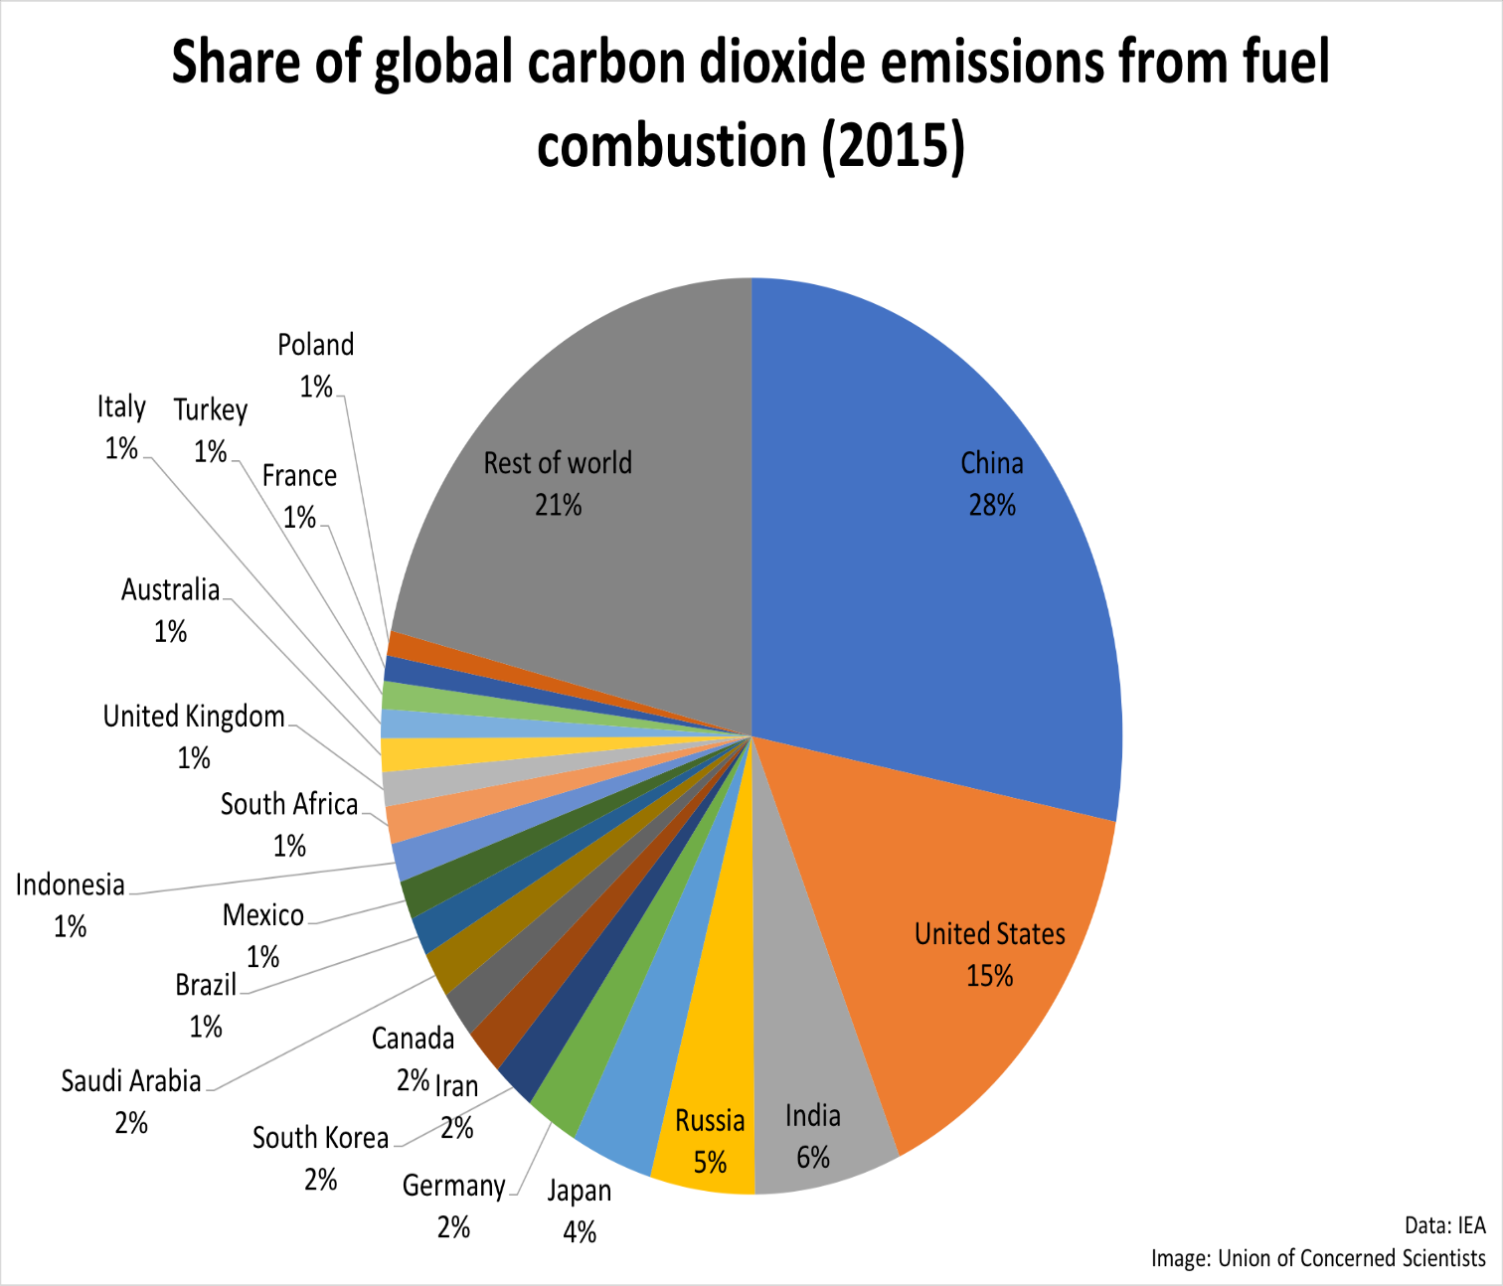

Statistics: Share of Global CO2 Emissions from Fuel Combustion per Country 2015

8.13 The interpretation of the existing statistics reveals that developed countries and major emerging economy nations lead in total carbon dioxide emissions. Developed nations typically have high carbon dioxide emissions per capita, while some developing countries lead in the growth rate of carbon dioxide emissions.

2015 total emissions country rank | Country | 2015 total carbon dioxide emissions from fuel combustion (million metric tons) | 2015 per capita carbon dioxide emissions from fuel combustion (metric tons)
1 | China | 9040.74 | 6.59
2 | United States | 4997.50 | 15.53
3 | India | 2066.01 | 1.58
4 | Russia | 1468.99 | 10.19
5 | Japan | 1141.58 | 8.99
6 | Germany | 729.77 | 8.93
7 | South Korea | 585.99 | 11.58
8 | Iran | 552.40 | 6.98
9 | Canada | 549.23 | 15.32
10 | Saudi Arabia | 531.46 | 16.85
11 | Brazil | 450.79 | 2.17
12 | Mexico | 442.31 | 3.66
13 | Indonesia | 441.91 | 1.72
14 | South Africa | 427.57 | 7.77
15 | United Kingdom | 389.75 | 5.99
16 | Australia | 380.93 | 15.83
17 | Italy | 330.75 | 5.45
18 | Turkey | 317.22 | 4.10
19 | France | 290.49 | 4.37
20 | Poland | 282.40 | 7.34

8.14 Comparative Global Emissions Overview
Estimated statistics of global anthropogenic GHG per sector, 2014

Source | Percentage %
Energy | 68%
Agriculture | 12%
Industrial process | 7%
Others | 14%

8.15 Estimated share of global anthropogenic GHG per sector during 2014

Source: World primary energy supply and CO2 emissions: shares by fuel in 2015

8.16 China saw the largest increase in single-sector emissions from 2012 to 2013 from its energy production, which increased by 365 million metric tons of carbon dioxide equivalent (MtCO2e), or 4 percent. The majority of these emissions came from an increase in electricity production, heating and transportation. However, this does represent a lower rate of increase than the historical average —China’s average annual growth rate for coal consumption from 2000 to 2013 was 8.8 percent.
8.17 On the other hand, Australia, the world’s 15th -largest emitter, saw the largest emissions decrease in a single sector, with its agricultural emissions dropping by 65 MtCO2e, or a reduction of 34.6 percent since 2012. The majority of those reductions came from a decrease in the area of burning savannah², which reduced methane (CH4) and nitrous oxide (N2O) emissions.
8.18 Statistics of World Primary Energy and Emissions contribution - 2015

Source | Percentage %
Oil | 34%
Coal | 45%
Gas | 20%
Other | 1%

8.19 World Primary Energy Supply & CO2 Emissions – 2015

Source: IEA Statistics 2017 - CO2 emissions from fuel combustion – Highlights
8.20 According to the World Resources Institute Climate Analysis Indicator Tool (WRI CAIT), South Africa’s GHG profile is dominated by emissions from the energy sector, which accounted for 84% of South Africa’s total emissions in 2012. Of this, 60% of energy emissions were due to electricity and heat, 15% to manufacturing and construction, 12% to transportation, and 12% to other energy subsectors. Agriculture is the second highest emitting sector and contributes 7% of total GHGs, of which 42% is due to enteric fermentation, 33% to manure left on pasture, and 25% to other agriculture subsectors.
8.21 Energy comprises of the following subsectors:
- Fugitive emissions
- Other fuel combustion
- Transportation
- Manufacturing/Construction
- Electricity/Heat
Contributions by sector
Source | CO2 in Metric Tonnes | Percentage
Energy | 391.77Mt | 84%
Agriculture | 30.54Mt | 7%
Industrial Processes | 21.07Mt | 5%
Waste | 19.24Mt | 4%
Land Use Change & Forestry | 1.15Mt | 0.2%
Source: World Resources Institute Climate Analysis Indicator Tool (WRI CAIT) 2012

8.22 South Africa’s GHG Emissions per Sector remains dominated by electricity generation sector as reflected in the following diagram.

Source: National Treasury Carbon Policy Paper, 2013

CO2 emissions per capita
8.23 South Africa’s CO2 emissions per capita is within the global range regardless of it being an emerging country as reflected in the table below.

Country | CO2 emissions in kt - 2015 | % CO2 emissions by country | Emission Per capita (t) 2015
World | 36,061,710 | 100% | -
China | 10,641,789 | 29.51% | 7.7
United States | 5,172,336 | 14.34% | 16.1
European Union | 3,469,671 | 9.62% | 6.9
India | 2,454,968 | 6.81% | 1.9
Russia | 1,760,895 | 4.88% | 12.3
Japan | 1,252,890 | 3.47% | 9.9
Germany | 777,905 | 2.16% | 9.6
Saudi Arabia | 505,565 | 1.40% | 16.0
Brazil | 486,229 | 1.35% | 2.3
South Africa | 417,161 | 1.16% | 7.7
United Kingdom | 398,524 | 1.11% | 6.2
Source: IEA Statistics, 2017

Fact Sheet - Global Energy Intensity

8.24 The global energy intensity is conventionally measured as the amount of primary energy demand required to produce one unit of gross domestic product (GDP), has been reported to have fallen by 1.8% during 2016.
8.25 The recorded improvement in energy intensity can be attributed to be the main reason why global energy-related greenhouse gas emissions have levelled off since 2014. The IEA disclosed that lower energy intensity has been the key driver in offsetting three-quarters of the increase in emissions due to GDP growth, with the shift to renewables and other low-emission fuels offsetting the remaining quarter as depicted in the graph below.
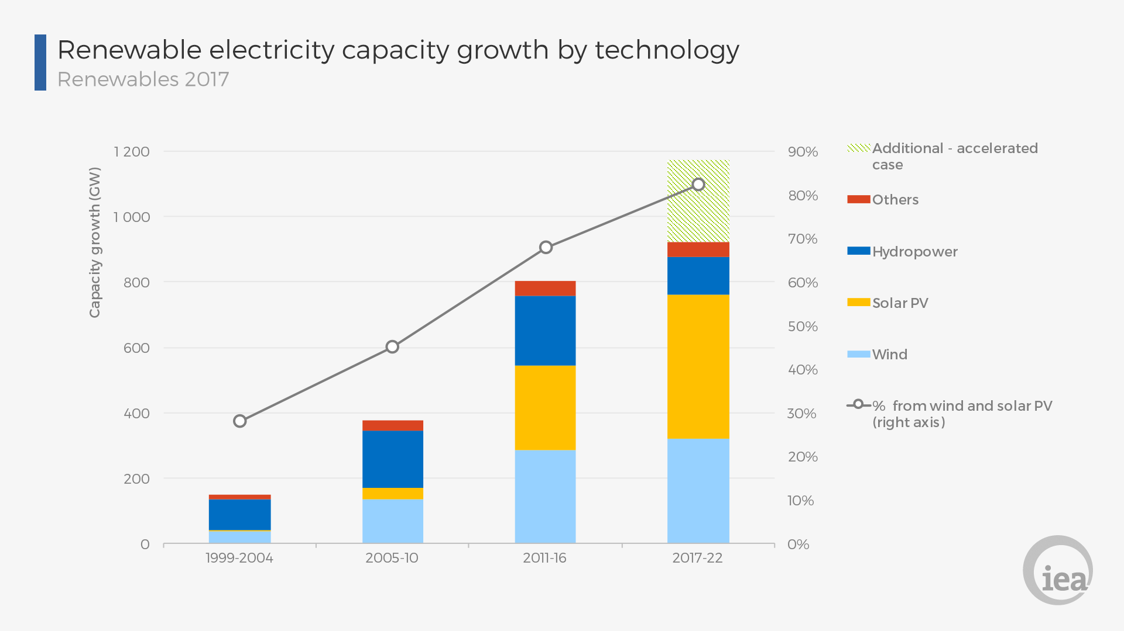
Source: IEA, Energy Efficiency 2017

Factors influencing greenhouse gas emissions – 2014-16
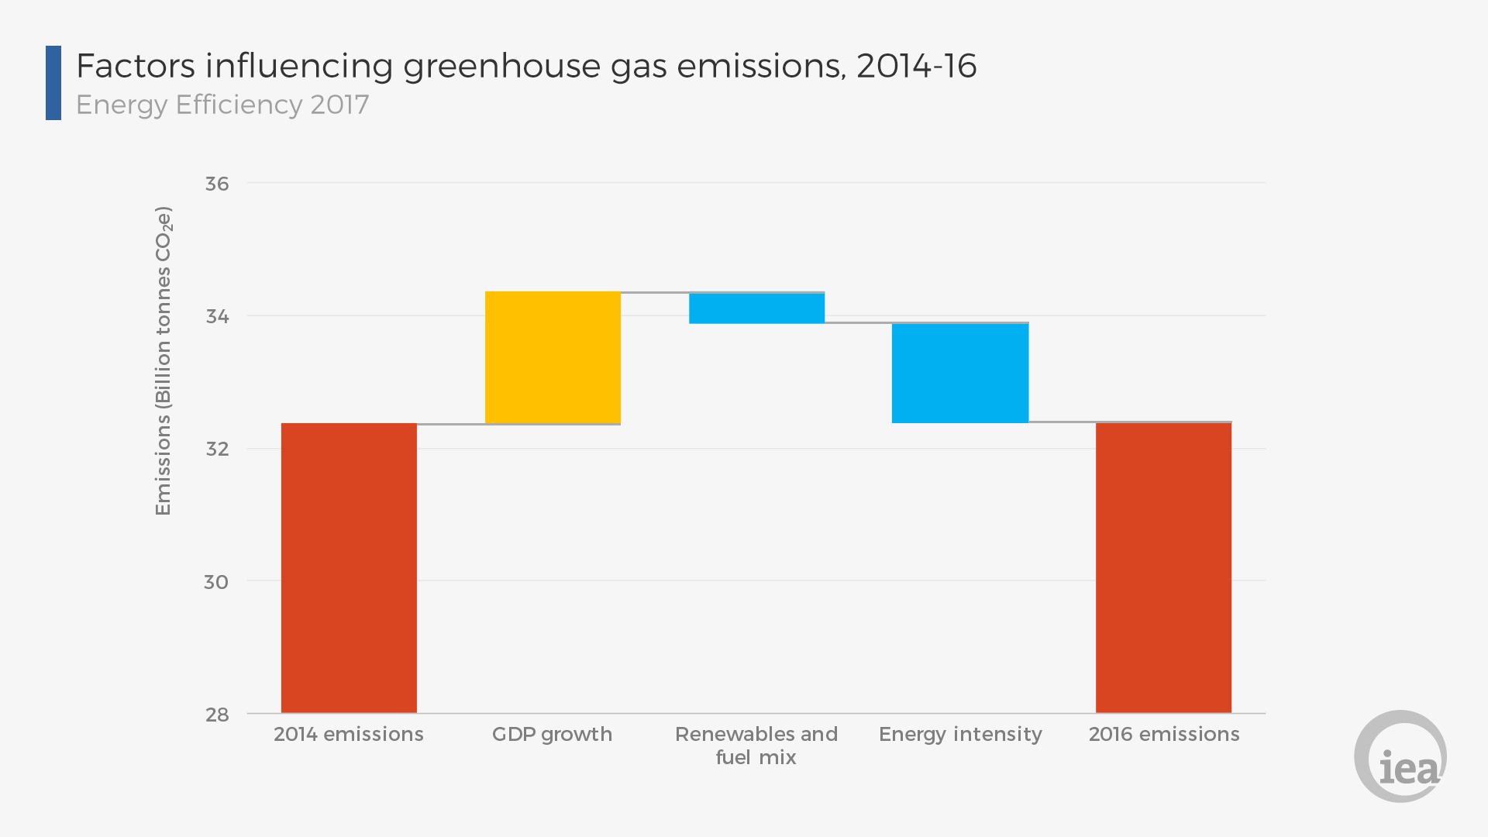
Source: IEA, Energy Efficiency 2017

9. Reflections from Interested Stakeholders
9.1 Organized Business Reflections. Key highlights of concerns from business point of view entail:
- Carbon Bill does not take into account the reality that South Africa experienced economic stagnation that resulted in a new, lower emissions trajectory than anticipated;
- The fact that electricity supply constraints have negatively impacted on the already slowed economy and have resulted in directly reduced GHG emissions
- Significant mitigation has already been achieved at significant investment price without economic and/or regulatory instruments being applied
- A carbon tax is construed to have a strong probability to increase the electricity price further, following several years of above inflation increases
- Electricity price increases, load shedding and voluntary energy efficiency initiatives have led to a structural change in electricity consumption; emissions are already below targets
- The electricity price includes renewable energy funding component
- There is limited flexibility in electricity supply: the tax is not able to reduce greenhouse gas emissions
- Policy should promote efficiency: improve incentives
- A carbon tax will reduce South Africa’s competitiveness
- Case study – for instance, Australia dropped its carbon tax for competitiveness reasons
9.2 The apparent urgency to implement the carbon tax in SA is not supported by CAIA:
- South Africa is responsible for less than 1% of global GHG emissions
- South Africa is a developing country and requires the “space” to be able to grow its economy as developed countries have had in the past
- Will investments that have been made already, and those being made/contemplated receive credit for opting for lower emission technology?
- Appears that business will need to make further financial investments to secure any available credit
- Impact assessments which need to be carried out by businesses – as well as government cannot take place in an environment of such high policy uncertainty
- Socio-economic impact(s) of the implementation of climate change policy in South Africa need to be comprehensively investigated and fully understood in the context of remaining mitigation potential and economic and social costs
- Additional tax-free component not sufficient for trade-exposed products
- South African products are under ever increasing pressure due to a loss of competitiveness. Insufficient protection for SA’s products exists;
- Border Carbon Adjustments not possible in current policy
- Additional tax-free component not sufficient for carbon offsetting
- Chamber supports the views expressed by BUSA, ITTCCC and individual member companies
- South Africa has made significantly greater progress in mitigation of national GHG emissions than anticipated in 2009
- The Chamber Of Mines (COM) is committed to support SA international commitment to lowering its GHG emissions, and the national policy to do so as reflected in the National Climate Change Response White Paper and the National Development Plan
- It is evident that the introduction of Carbon Tax would result in negative economic and social impacts to various economic sectors of the economy - especially mining
- South Africa’s emissions are tiny compared to China, India and the USA: reducing SA’s emissions will have a negligible impact on global emissions
Source: BUSA [including, Chamber of Mines, Chemicals & Allied Industries Association (CAIA), etc.]

9.3 Potential Adverse Socio-Economic Impact on the Mining Sector
- Sector faces flat to declining commodity price environment and mining companies are price takers – unable to pass on additional taxes or costs to consumers
- The mining industry is a significant contributor to GDP, a major employer, a key export industry and a key tax paying industry. The proposed Carbon Tax will undermine its competitiveness and ability to contribute to growth and transformation
- Deep level platinum and gold mines are by their nature electricity intensive for production and health and safety reasons. They are users of base-load electricity supply (constant offtake) with electricity accounting for over 20% of production costs
- Increases in input costs undermine the viability of mines, and is devastating on marginal mines, where there is limited grade flexibility. In essence, rising costs reduce the amount of gold that can be economically recovered thus sterilising ore in the ground
- Currently, 30% of the mining industry is loss-making (average across sectors)

9.4 COUNTRIES WHERE CARBON TAX HAS BEEN IMPLEMENTED
Finland
9.4.1 In 1990, Finland became the first country to implement a carbon taxation policy for the purpose of curbing its carbon emissions. The tax was designed as a component of Finland’s excise tax on fossil fuels used for transportation and heating. The policy scheme covered the utilization of all transport fuels, coal, and natural gas and included the heating, electricity generation, and transportation sectors. When the tax was first initiated, the tax rate was set as around 1.12 Euros per ton of CO2.

9.4.2 The specifics of the policy underwent several changes in the following decades. The tax rate was most recently increased in January 2016 with the intention of further encouraging the use of low carbon heating fuels and increasing the competitiveness of peat and natural gas compared to coal in the heating industry. As of 2016, the carbon tax applied on transport fuels was 66 US dollars per ton of CO2 and the tax applied on heating fuels was 62 US dollars per ton of CO2.

9.4.3 The tax was originally based only on carbon content but was subsequently changed to become a combination of a carbon and energy tax with a 60% carbon and a 40% energy component. A major reform was undertaken in 1997 when the tax rates were highly increased and the tax was changed again to become a pure carbon tax. Another major reform took place in 2011 when the carbon tax was split again into two taxes, one based on carbon content and another based on energy.

Sweden
9.4.4 The differentiation of the carbon tax across different sectors had some undesired distortionary effects on the behaviour of companies, especially between the years 1993 and 1997 when the tax difference between the fuels used in industry and the other sectors was overly high. As a result, some industries sold their by-products to the district heating companies while they themselves burned fossil fuels. This effect caused by the tax design prevented the full emissions reduction benefits of the tax from being realized.
9.4.5 As of 2016, the carbon tax rate in Sweden is applied at 137 US dollars per metric ton. This makes the Swedish carbon tax rate the highest in the world by a wide margin.

France
9.4.6 Carbon tax was launched during 2014, putting a charge on domestic consumption of energy products not covered by the EU ETS. Initially, the main fossil fuels subject to the tax were gas, heavy fuel oil, and coal. Starting from 2015, the tax was extended to cover transport fuels and heating oil. The initial tax rate was determined to be around 8 US dollars per ton of CO2 equivalent. The rate was increased to 17 US dollars (14.5 Euros) per ton CO2 equivalent in 2015 and to 25 US dollars (22 Euros) in 2016.
9.4.7 For the year 2014, the revenues collected by the tax amounted to 452 million US dollars. The revenues are intended to be used in energy transition plans with the main target of boosting employment in the green energy sector.
Japan

9.4.8 Japan is currently the only Asian country that is employing a carbon tax. ‘Japan’s Tax for Climate Change Mitigation’ became operational on 2012, covering emissions from the use of all fossil fuels based on their CO2 content. A CO2 emission factor is used for each sector to ensure that the tax rate is equal to 289 JPY or around 3 US dollars per ton of CO2 across all sectors.

Chile
9.4.9 Chile can be considered as one of the frontrunners among the developing countries in terms of taking ambitious action in the struggle against climate change. The carbon tax approved by the Chilean government is one of the centrepieces of the country’s efforts in reducing its carbon emissions. If the tax proves to be effective, it can help to demonstrate that carbon pricing policies can work in emerging economies.
9.4.10 The Chilean Parliament approved the adoption of a national carbon tax in 2014, making Chile the first South American country to tax carbon emissions. The tax will be charged on the electricity generation sector.

9.4.11 The measuring of CO2 emissions from thermal power plants is set to begin by 2017 and the tax is set to be applied on the power sector starting from 2018. The tax covers the electricity generation sector, applying to all electricity generation facilities with a capacity equal to or larger than 50 MW. The scheme doesn’t cover emissions from other prominent sectors such as industry, transport, commercial and residential sectors. The rate of is set to be 5 US dollars per ton of carbon released for the year 2018.

9.4.12 Reportedly, the tax is intended to play a central part in the country’s voluntary target of cutting its GHG emissions by 20% by the year 2020 compared to 2007 levels. The amount of the tax is liable for fluctuation depending on the exchange rate on the day of payment, since the level is calculated over US dollars. Initial studies suggest that around 50% of energy produced in the country will be taxed under the carbon taxation instrument.

Australia
9.4.13 As the country with the highest per capita GHG emissions in the world, the mitigation needs of Australia are considerable. In 2012, A carbon tax policy was implemented in the country to address this problem.
9.4.14 However, the carbon tax experiment in the country has been short lived as the tax only stayed operational for a period of two years. The tax was introduced in 2012 and was repealed in 2014, making Australia the first and only country to abolish a carbon tax.
9.4.15 The tax introduced in 2012 put a levy of 23 Australian dollars per ton of CO2 equivalent on selected fossil fuels consumed by large industrial facilities and government bodies. The tax levels were indexed to inflation and rose to 24.15 US dollars on 2013 and to 25.4 US dollars on 2014. The scheme applied to facilities that emit more than 25000 tons of CO2 equivalent on a yearly basis.

9.4.16 Transport fuels and the agricultural sector were completely left out of the coverage of the tax, however there were plans to include heavy on-road vehicles under the taxation scheme starting from 2014. In effect, the tax would only cover large electricity generators and large industrial plants in the country. Despite this, it was estimated that the carbon tax would cover around 60% of the country’s total emissions.

9.4.17 Additionally, several measures were taken to offset the impact of the tax on some sectors. The income taxes were reduced and pensions and welfare payments were slightly increased to cover the expected increases in prices. Several additional compensation mechanisms were also introduced for some affected industries. Despite the tax scheme left major parts of the country’s emissions outside of its coverage, a report by the Australian National University estimated that the policy mechanism managed to cut the carbon emissions of the country by 17 million tons in 2013. This figure marks the highest emissions reduction in the country in 24 years of records. It is reported that a large part of this reduction originated from the electricity sector.

9.4.18 In 2013, it was reported that electricity generation using the highly polluting lignite coal for nine months had fallen by 14% compared with the same period a year early. Electricity generation by using conventional coal had also fallen by 5% in the same period while electricity generated by renewable sources increased by 28%.

9.4.19 Although other factors have also played a part in this change in electricity generation, it can be argued that the employment of the carbon tax played a large role in this large change in the electricity generation mix between the two years.

9.20 The trajectory that the country’s emissions followed after the repeal of the tax clearly shows that the carbon tax was at least partially successful. As soon as the tax was abolished, the emissions caused by the electricity generation sector started to rise rapidly as a result of the increased utilization of lignite due to falling prices.

9.4.21 After its implementation, the carbon tax failed to receive widespread support from the society. The policy instrument was one of the hotly debated topics prior to the elections in 2013, with the leader of the Liberal Party Tony Abbott promising to revoke the tax if elected. After the victory of the Liberals in the election, the tax was repealed in accordance with the pre-election promise. After the repeal of the carbon tax, the government set up the Emission Reduction Fund from the consolidated revenues. It is estimated that only a third of the country’s emissions reduction target of 5% will be able to be met by the new policy tool by 2020 ((Gökşin Bavbek, 2016).

9.4.22 The governments rationale in repealing the carbon tax mainly involved the argument that the tax was hurting the livelihoods and citizens and having a negative impact on the economy and the country’s international competitiveness. It is argued that the costs of living would be significantly reduced, electricity and gas prices would decrease and economic growth would be promoted with the repeal of the tax.
9.4.23 Repealing the carbon tax and the Clean Energy Package was designed to:
- Reduce the cost of living - modelling by the Australian Treasury suggests that removing the carbon tax in 2014-15 will leave average costs of living across all households around $550 lower than they would otherwise be in 2014-15.
- Lower retail electricity by around 9 per cent and retail gas prices by around 7 per cent than they would otherwise be in 2014-15 with a $25.40 carbon tax.
- Boost Australia’s economic growth, increase jobs and enhance Australia’s international competitiveness by removing an unnecessary tax, which hurts businesses and families.
- Reduce annual ongoing compliance costs for around 370 liable entities by almost $90 million per annum.
- Remove over 1,000 pages of primary and subordinate legislation.

The repeal was intended to ensure that lower prices are passed through end users.

South Africa
9.4.24 The Government is contemplating to introduce a carbon tax that will cover all direct carbon emissions from fuel combustion and from non-energy related industrial processes, effective 01st January 2019. The scheme has been in the development and consultation phase since 2006.

9.4.25 The legal framework is in draft legislation format and the tax rate is envisioned to be around USD$8 per ton of CO2 equivalent but it is anticipated that offsets would be applied for compliance and tax exemptions starting from 60% up to a maximum of 90%. This means that the effective tax rate will actually be between 0.4 and 3 US dollars per ton for most sectors. There are also plans to increase the tax rate by 10% on an annual basis until the year 2020 (Gökşin Bavbek, 2016).

Country Overview
9.4.26 Carbon taxes can be introduced as an independent instrument or they can exist alongside other carbon pricing instrument, such as an energy tax. While the experience with direct carbon tax implementation is relatively new, such instruments are being introduced at a fast pace.
9.4.27 Introduced in 1990, Finland’s carbon tax initially applied to heat and electricity production and was later expanded to cover transportation and heating fuels. Sweden and Denmark applied a system of progressive reduction of exemptions. Ireland introduced a carbon tax in 2010 to complement the EU ETS and to capture emissions not covered by the EU ETS, by including mainly transport, waste and heat in buildings. The initial carbon tax rate, applied in 2010 and 2011, was set at €15 per tCO2 and was subsequently increased to €20 in 2012. (Source: Carbon Tax Policy Document 2013 – NT).
9.4.28 The table below provides an overview of existing national and subnational jurisdictions that have introduced a direct carbon tax.
No. | Country/  Jurisdiction | Type | Year Adopted | Overview/Coverage | Tax Rate
1. | British Columbia | Sub-national | 2008 | The carbon tax applies to the purchase or use of fuels within the province. The carbon tax is revenue neutral; all funds generated by the tax are returned to citizens through reductions in other taxes | CAD30 per tCO2e (2012)
2. | Chile | National | 2014 | Chile’s carbon tax is part of legislation enacted in 2014. The country is to start with measuring of carbon dioxide emissions from thermal power plants in 2017 and begin the tax on CO2 emissions from the power sector in 2018. | USD5 per tCO2e (2018)
3. | Costa Rica | National | 1997 | In 1997, Costa Rica enacted a tax on carbon pollution, set at 3.5 percent of the market value of fossil fuels. The revenue generated by the tax goes toward the Payment for Environmental Services (PSA) program, which offers incentives to property owners to practice sustainable development and forest conservation. | 3.5% tax on hydrocarbon fossil fuels
4. | Denmark | National | 1992 | The Danish carbon tax covers all consumption of fossil fuels (natural gas, oil, and coal), with partial exemption and refund provisions for sectors covered by the EU ETS, energy‐intensive processes, exported goods, fuels in refineries and many transport‐related activities. Fuels used for electricity production are also not taxed by the carbon tax, but instead a tax on electricity production applies. | USD31 per tCO2e (2014)
5. | Finland | National | 1990 | While originally based only on carbon content, Finland’s carbon tax was subsequently changed to a combination carbon/energy tax. It initially covered only heat and electricity production but was later expanded to cover transportation and heating fuels. | EUR35 per tCO2e (2013)
6. | France | National | 2014 | In December 2013 the French parliament approved a domestic consumption tax on energy products based on the content of CO2 on fossil fuel consumption not covered by the EU ETS. A carbon tax was introduced from April 1, 2014 on the use of gas, heavy fuel oil, and coal, increasing to €14.5/tCO2 in 2015 and €22/tCO2 in 2016. From 2015 onwards the carbon tax will be extended to transport fuels and heating oil. | EUR7 per tCO2e (2014)
7. | Iceland | National | 2010 | All importers and importers of liquid fossil fuels (gas and diesel oils, petrol, aircraft and jet fuels and fuel oils) are liable for the carbon tax regardless of whether it is for retail or personal use. A carbon tax for liquid fossil fuels is paid to the treasury, with (since 2011) the rates reflecting a carbon price equivalent to 75 percent of the current price in the EU ETS scheme. | USD10 per tCO2e (2014)
8. | Ireland | National | 2010 | The carbon tax is limited to those sectors outside of the EU ETS, as well as excluding most emissions from farming. Instead, the tax applies to petrol, heavy oil, auto‐diesel, kerosene, liquid petroleum gas (LPG), fuel oil, natural gas, coal and peat, as well as aviation gasoline. | EUR 20 per tCO2e (2013)
9. | Japan | National | 2012 | Japan’s Tax for Climate Change Mitigation covers the use of all fossil fuels such as oil, natural gas, and coal, depending on their CO2 emissions. In USD2 per tCO2e (2014) 3 Country/Jurisdiction Type Year Adopted Overview/Coverage Tax Rate particular, by using a CO2 emission factor for each sector, the tax rate per unit quantity is set so that each tax burden is equal to US$2/tCO2 (as of April 2014). | USD2 per tCO2e (2014)
10. | Mexico | National | 2012 | Mexico’s carbon tax covers fossil fuel sales and imports by manufacturers, producers, and importers. It is not a tax on the full carbon content of fuels, but rather on the additional amount of emissions that would be generated if the fossil fuel were used instead of natural gas. Natural gas therefore is not subject to the carbon tax, though it could be in the future. The tax rate is capped at 3% of the sales price of the fuel. Companies liable to pay the tax may choose to pay the carbon tax with credits from CDM projects developed in Mexico, equivalent to the value of the credits at the time of paying the tax. | Mex$ 10 ‐50 per tCO2e (2014)*  * Depending on fuel type
11. | Norway | National | 1991 | About 55 percent of Norway’s CO2 emissions are effectively taxed. Emissions not covered by a carbon tax are included in the country’s ETS, which was linked to the European ETS in 2008. | USD 4‐69 per tCO2e (2014)*  *Depending on fossil fuel type and usage
12. | South Africa | National | 2019 (Planned) | In May 2013 the South African government published a policy paper for public comment on introduction of a carbon tax. The paper proposes a fuel input tax based on the carbon content of the fuel. It was agreed that emissions factors and/or procedures are available to quantify CO2‐eq emissions with a relatively high level of accuracy for different processes and sectors. The carbon tax will cover all direct GHG emissions from both fuel combustion as well as non‐energy industrial process emissions and is expected to start in January 2016. | R120/tCO2 (Proposed tax rate for 2016)*  *Tax is proposed to increase by 10% per year until end‐ 2019
13. | Sweden | National | 1991 | Sweden’s carbon tax was predominantly introduced as part of energy sector reform, with the major taxed sectors including natural gas, gasoline, coal, light and heavy fuel oil, liquefied petroleum gas (LPG), and home heating oil. Over the years carbon tax exemptions have increased for installations under the EU ETS, with the most recent increase in exemption starting from 2014 for district heating plants participating in the EU ETS. | USD168 per tCO2e (2014)
14. | Switzerland | National | 2008 | Switzerland’s carbon tax covers all fossil fuels, unless they are used for energy. Swiss companies can be exempt from the tax if they participate in the country's ETS. | USD 68 per tCO2e (2014)
15. | United Kingdom | National | 2013 | The U.K.’s carbon price floor (CPF) is a tax on fossil fuels used to generate electricity. It came into effect in April 2013 and changed the previously existing USD15.75 per tCO2e (2014) 4 Country/Jurisdiction Type Year Adopted Overview/Coverage Tax Rate Climate Change Levy (CCL) regime, by applying carbon price support (CPS) rates of CCL to gas, solid fuels, and liquefied petroleum gas (LPG) used in electricity generation. | USD15.75 per tCO2e (2014)
Source: IEA – Carbon Disclosure Project 2017
9.4.29 Similarly, most countries treat the electricity sector emissions through stringent economic and technical regulatory mechanisms, including the Republic of Korea.
9.4.30 At the same time it was recognised that encouraging electricity consumers to improve their consumption efficiency was necessary; just less than 50 percent of emissions came from the electricity sector in 2010. (IEA, 2012) The solution adopted was to make covered firms responsible for both their direct and indirect emissions. Entities have to surrender allowances equal to the sum of their direct emissions plus their electricity consumption multiplied by the emissions intensity of electricity production. This creates incentives to reduce power consumption. However, it has also raised administrative challenges. The measurement of the emissions factor of electricity generation can be controversial, while future linking between the Korean ETS and other systems will be difficult.
9.4.31 Some experience suggests that the lack of information possessed by a regulator will lead to it setting budgets that deliver fewer emissions reductions than a cap. This, for example, was the experience in the UK under the Climate Change Agreement/Climate Change Levy regime (Martin, Preux, & Wagner, 2009).
9.4.32 On the other hand, the ability to set different budgets for different entities may allow a regulator to extract deeper emissions reductions from some entities as the stringency of the budget would only apply to that firm and would not ‘spill over’ to other entities in the economy who may have an ability to obstruct ambitious economy-wide policies. However, in turn, the different treatment of different entities could lead to concerns about equity and may, in the South African context, face legal challenges.

10. PROS AND CONS OF THE CARBON TAX
ADVANTAGES
10.1 Conventionally, it has since been accepted that the release of carbon dioxide into the atmosphere is the principal contributor to social and environmental problems, particularly global warming. It is perceived that the pollution emitted is deemed as a negative externality, which translates into a cost imposed on the entire society and not just only a section of society who is using or consuming the polluting products, such as cars.
10.2 For the countries already levying a carbon tax, they apply it to internalize such an externality, which culminates in the final price of goods incorporating the external and not just the private cost. Likewise, the “Polluter Pays Principle”, which was incorporated into International Law at the 1992 Rio Summit, asserting that those who cause environmental costs should be held accountable and be directly responsible to pay the full social cost of their polluting actions.
- It promotes the need to consider alternative resources
The imposition of a carbon tax brings with it increasing business overheads, companies are compelled to find more efficient ways to manufacture their products or deliver their services, as that will minimise the impact of the tax on their bottom line. It is construed that regardless of the tax’s downside, it has the propensity to encourage people to cycle or walk to work, promoting a healthy lifestyle.
- It fosters environmental conservation.
If properly designed, the imposition of a carbon tax propels organizations and companies that emit large amounts of carbon dioxide CO2 to reduce, if not eliminate, their emissions footprint.
- It promotes socially efficient income.
Take note that that both businesses and individuals will be paying the social cost of excess carbon dioxide through the carbon tax, which entails that they would be more socially and environmentally conscious about what uncontrolled emissions could do to businesses and mother nature. This would prompt them to switch to means of gaining income that are socially efficient.
- It helps increase revenue.
From a fiscal management point of view, a carbon tax is a quick and easy way to generate tax revenues.

Disadvantages of Carbon Tax
- It imposes expensive administration costs.
Administratively, a carbon tax is likely to be complex and expensive scheme, taking into account that the government must put in place various systems to ensure effective implementation and this would require some funds. This will foster trade- offs to source money to get the administration underway, instead of channelling the funds to the most-pressing social budget.
- It carries the risk of cost increases.
Opponents to carbon tax views it as a type of tax that will most probably increase the fossil fuel costs, which will consequently translate in increased costs in the production of goods and delivery of services.
- It promotes covert operations.
The emergence of a carbon tax is likely to make companies to explore ways and means of how to evade it, and most of them would probably engage in covert strategies and dirty tricks to exploit any loopholes in the system.
- Incentive for emissions reduction
In case a carbon tax is implemented at the right time and for the right reasons, it has the propensity to provide permanent incentives to reduce emissions by high carbon intensive entities.
- It causes a shift in production.
The introduction of a carbon tax is like to force business to migrate to areas or
regions or countries where it is not levied. This will translate into high job losses at the original company location and will also promote the issues of emissions border trading and transfer unintentionally. So, carbon tax would not exactly stop carbon dioxide production, but would only change where and how it is produced.

11. AIM OF THE CARBON TAX – SOUTH AFRICAN CASE
11.1 According to the National Treasury, the fundamental aim to introduce the carbon tax is to put to effect measures to reduce South Africa’s greenhouse gas emissions as outlined by the National Climate Change Response Policy (NCCRP) in 2011. The carbon tax aims to:
- Compel the polluter to internalise the external costs of carbon emissions, the tax aims to send price signals to change consumer behaviour and stimulate investor appetite towards low carbon options.
- Impose an initial carbon tax rate at R120 per tonne of CO2e. This is envisaged to gradually increase annual at 10% per year until 2021.
- It is envisaged that the initial tax rate will be revisited and revised before the February 2020 budget to assess carbon tax policy after 2021.
- The carbon tax is targeted to will cover only emissions that result directly from fuel combustion and gasification, and from non-energy industrial processes (Scope 1 emissions). These emissions include carbon dioxide, methane, nitrous oxide, perfluorocarbons, hydrofluorocarbons, and sulphur hexafluoride.
- Carbon tax on liquid fuels (petrol and diesel) will be imposed at source as an addition to current fuel taxes, which equates to a double tax.

12. TRANSITIONAL MECHANISMS
12.1 Government intends to provide high tax exemptions of between 60% and 95% during the period 2019 to 2022, to enable a smooth transition to a low carbon economy.
12.2 With exemptions, it means that the actual payment will range between R 6 – R 48 per tonne.
12.3 Tax exemptions include:
- Basic percentage based threshold of 60% (Fixed from 2019- 2022)
- Additional 10% for process emissions
- Additional allowance for trade exposed sectors up to 10%
- Additional allowance of up to 5% based on performance against emissions intensity benchmarks
- Carbon offsets allowance of 5-10% depending on sector.
- An addition 5% for companies participating in the carbon budget system.
- Agriculture, forestry, land use and waste sectors will not be included during the first five-year period, due to the complexity in measuring and verifying emissions from these sectors. It is anticipated that revenue recycling measures will be introduced to minimise effects on the economy – e.g.: reduction in electricity levy.

13. ADMINISTRATION AND REVENUE RECYCLING
  - The tax will be administered and collected by South African Revenue Service (SARS).
13.2 Carbon tax will be administered on a self-assessment basis – companies will have to submit 6 monthly assessments every 6 months (January – June; July – December) indicating their carbon emissions during that time.
13.3 The final tax rate, exemptions and actual date of implementation will be determined by the Minister of Finance through the annual Budget process.
  - Introduced in a phased manner, with complementary measures and revenue recycling such as:
- Reduction/removal of electricity levy.
- Credit rebate for the renewable energy premium.
- Tax incentive for energy efficient savings.
- Funding for public transport and initiatives to move freight from road to rail (Carbon Tax Policy Discussion Paper, 2015, National Treasury)

14. EXISTING TAXES AND INCENTIVES
14.1 There are already incentives that existing to assist in the promotion of emissions reduction and also aimed at enabling people to adjust their behaviour on carbon matters as listed below.
- Fuel levy on petrol and diesel (As at 01 April 2018: R3.37/litre).
- Electricity generation levy (As at 01 April 2018: R3,50/kWh)
- Energy efficiency tax incentive
- Tax exemption for revenues earned from CDM projects
- A renewable energy depreciation allowance
- A depreciation allowance for biofuels production
- Development tax initiative

15. OBSERVATIONS
15.1 Our understanding is that the Draft Bill has been developed in pursuit of South African Government’s commitment made at the Congress of Parties 2015 (COP 15), to reduce greenhouse gas emissions by 34% in 2020 and 42% in 2025.
15.2 Depending on whether the low or high level of emissions range for 2025–2030 is analysed, South Africa’s NDC is categorised as “Highly insufficient” or “2°C compatible.” We rate it “Highly insufficient” based on the upper end of the NDC range, because South Africa would reach its NDC target if its emissions in 2030 were below this limit.
15.3 The “Highly insufficient” rating indicates that South Africa’s climate commitment in 2030 is not consistent with holding warming to below 2°C, let alone limiting it to 1.5°C as required under the Paris Agreement, and is instead consistent with warming between 3°C and 4°C: if all countries were to follow South Africa’s approach, warming could reach over 3°C and up to 4°C. This means South Africa’s climate commitment is not in line with any interpretation of a “fair” approach to the former 2°C goal, let alone the Paris Agreement’s 1.5°C limit.
15.4 If the CAT were to rate South Africa’s projected emissions levels in 2030 under current policies, South Africa would also be rated “Highly insufficient.”
15.5 Subsequently, OUTA commissioned an initial research, which revealed the complexity of the draft Bill and related policies as its findings. OUTA continue to reiterate our concerns that the terminology and complexity of the regulations related to the draft Bill make it difficult for the average consumer to understand or formulate any meaningful comments, implying that it is not ‘user-friendly’.
15.6 Additional concerns regarding the nature of the systems, particularly the containment of off-sets to local projects, which are more expensive and that Global Warming is a global issue and investment into international low carbon offset projects should not be discouraged through the policy. If the price of carbon offset is cheaper elsewhere, then companies should be allowed to tap into them, however, there needs to be a small incentive to encourage investment into local projects. By encouraging international trading means that we should also encourage international companies to invest in South African projects.
15.7 The ability for the Carbon Tax to effectively change behaviour is also questionable, with the limited offset projects and the initial lower cost of the tax not significant enough to force change in the energy economy. The mere fact that Eskom has increased energy pricing over the past 7 years is in itself a behaviour changing mechanism which far exceeds what the carbon tax will do.
15.8 Another concern is the lack of quantification of the impact of implementing a carbon tax on existing employment opportunities in major sectors such as electricity generation, petroleum and mining sectors, particularly as new (and scarce) skills will be required in the “greener energy” domain.
15.9 Jargon/Terminology applied in the Draft Carbon Tax Bill is not user-friendly and makes it impractical for ordinary members of the public to compile constructive written comments as they are susceptible to misinterpret the content
15.10 The legislative process is generating high levels of uncertainty amongst affected organisations and individuals.
15.11 The hybrid nature of the system – carbon tax as well as offsets. Offsets are only local. Global warming is a global issue and off-sets in this environment should not be prescriptive in this manner, the Draft Bill does not provide the interface between these parameters.
15.12 Carbon tax is extremely complex, and for perfect implementation a country requires a perfect society and organisational structure.
15.13 OUTA experienced this level of ability and challenges in relation to managing complex systems between developed nations and South Africa on the e-Toll (electronic toll tax) system. The implementation and management of these schemes is easier to apply in countries where systems, behaviour and enforcement is well administered and managed. This appears to be easier to take place in first would countries, whilst they are a significant challenge in South Africa to ensure success. As a result, the e-toll scheme has failed to achieve 20% of users paying, even after two years of operation and with many changes to regulations and discounted offers.
  - While the Carbon Tax Policy states that R120 per tCO2e is a modest price, technical modelling suggests that these effective rates are far too low to create the incentives for behavioural change necessary to transform the country’s energy economy (ERC 2013).
  - South Africa does not yet have a matured carbon trading market, is the Draft Carbon Tax Bill contemplating that the market will grow exponentially within a short space of time, including establishing the requisite verification, auditing, measuring and reporting capabilities.

  - In the case of carbon off-set trading, there are high transaction costs in the verification and monitoring of offset projects to convince buyers that the project and reductions are credible (Newman & Conradie, 2013).

  - There is no real and convincing data on what the carbon emissions should be and consequently, what the reductions should be, which places a low credibility on the process.
15.18 The SA Carbon Tax Bill only allows for local offsets. This must be seen as a significant limitation to the bill, as global warming is a global problem, and South Africa’s contribution is only approximately 2% (PWC, 2014). The majority of emissions come from electricity production at an estimated 48% (ESKOM) because of the dependence on coal (PWC, 2014). On a per capita basis, SA’s emissions are still below most developed countries (PWC, 2014).
15.19 The scope for local offset projects is therefore greatly limited, and will be ineffective in a global context, which poses the question, what is the real purpose and potential impact of the introduction of the Carbon Tax in South Africa. It will also be more expensive to off-set only on SA based projects, which are few and will be highly priced. Businesses will feel compromised if they are not allowed to off-set and trade in carbon off-sets on the international stage.
15.20 SA is one of the first developing countries to implement a Carbon Tax of any significance (PWC, 2014), and the first in Africa. This will result in a decrease in South Africa’s competitiveness due to the fact that South Africa is still a developing country and dependent on an economy driven by primary industries which are de facto carbon dense industries (e.g. energy production). South Africa will not be able to compete with other markets such as China and Brazil if carbon tax contributes to additional economical burdens.
  - According to the 5th National GHG Inventory (2000-2012) South Africa’s emissions profile:
- GHG emissions decreased slightly from 531 Mt CO₂e in 2010 to 518.7 Mt CO₂e in 2012
- Current national emissions profile falls well within the PPD target trajectory range as depicted in the table below:

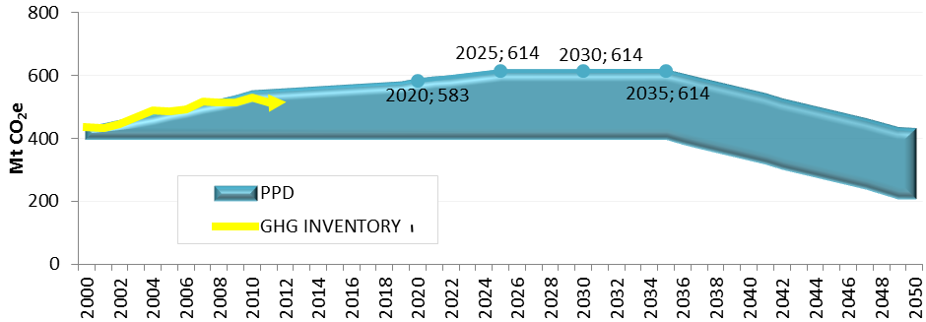
Source: DEA, 2015

- The Figure above shows South Africa’s GHG inventory trajectory compared to the PPD trajectory and the mitigation NDC target of the country.
- By 2012 an implied carbon budget of 96 MtCO₂e between the GHG inventory levels and the upper limit of the PPD and NDC targets can be observed from the figure.
- This means that between 2012 and 2025 the country’s emissions should not grow faster than 7.4 MtCO₂e per year on average if the PPD and NDC targets for 2025 are to be achieved.
- With an estimated 2016 economic growth of 0.4% year-on-year and a projected 2017 economic growth of no more than 1.0% year-on-year, an average emissions growth rate of 7.4 MtCO₂e per year does not seem likely (Quantec 2017).
15.22 According to the Davis Tax Committee, “in South Africa, a number of structural, technical and practical challenges hinder a smooth transition to a low-carbon economy. Furthermore, any approach to such a transition needs also to recognise the necessity for South Africa to address critical socio-economic issues. Nonetheless, in the NDP, the opinion has been expressed that ‘South Africa can manage to transition to a low-carbon economy at a pace consistent with government’s public pledges, without harming jobs or competitiveness’ (National Planning Commission, 2011).
15.23 A shift to less carbon-intensive goods, processes and services will most likely require significant reductions in the consumption of carbon intensive products, i.e. cement, steel and aluminium and/or that their production processes become significantly less carbon intensive. In South Africa, these industries are important to the economy as well as to the infrastructure building programme already underway. Any climate change mitigation policies which would be implemented need to ensure that these industries can take appropriate and feasible long-term decisions. The question remains – is this practical under the current economic climate and foreseeable future?
15.24 Shortcoming – The modelling done by the National Treasury suggested that there would be only a small negative impact on economic growth if the carbon tax is coupled with revenue recycling. The most positive impacts for the recycling of revenue would emanate from directing carbon tax proceeds towards new productive investments in the respective sectors.
15.25 Furthermore, the model did not address the timing of employment losses relative to employment gains and hence, the transitional costs of adjustment were not modelled. The modelling was unable to quantify the value of the benefits of emissions reductions although the level of these reductions was estimated. National Treasury has argued that the results over-estimate the costs of a carbon tax and under-estimate the benefits from the lower levels of emissions (National Treasury, 2013).
15.26 Another consideration which requires further discussion is the possible effect of the proposed carbon tax on municipal revenues. This tax will increase the operating cost associated with the provision of free basic electricity which will impact not only on Eskom, as a provider of these services, but also on municipalities which perform the distribution and reticulation. Additional funds may need to be channelled to municipalities through the local government equitable share grants to cover this. Furthermore, many municipalities use surpluses from electricity sales to cross subsidize other services. Increasing costs may reduce electricity related surpluses to the extent that municipalities are unable to raise tariffs and also negatively affect municipal sustainability and the grants system.
15.27 Government has developed a strategy for the local beneficiation of South African minerals (Department of Mineral Resources, 2011). Iron and steel, aluminium and other metal producing industries have high carbon intensities. An unintended consequence of a carbon tax could be to drive beneficiation offshore with harmful effects on currency flows and the exchange rate. It is also possible that this carbon shifting may even increase net global CO2 emissions.
  - Carbon tax is extremely complex, and for perfect implementation a country requires a perfect society and organisational structure.

  - OUTA experienced this level of ability and challenges in relation to managing complex systems between developed nations and South Africa on the e-Toll (electronic toll tax) system. The implementation and management of these schemes is easier to apply in countries where systems, behaviour and enforcement is well administered and managed. This appears to be easier to take place in first would countries, whilst they are a significant challenge in South Africa to ensure success. As a result, the e-toll scheme has failed to achieve 20% of users paying, even after two years of operation and with many changes to regulations and discounted offers.

  - While the Carbon Tax Policy states that R120 per tCO2e is a modest price, technical modelling suggests that these effective rates are far too low to create the incentives for behavioural change necessary to transform the country’s energy economy (ERC 2013).

  - Because carbon credits are essentially an invisible commodity, relying on information between buyers and sellers, there are a number of indirect costs of verification, auditing, measuring, reporting and managing, that need to be considered.

  - The SA Carbon Tax Bill only allows for local offsets. This must be seen as a significant limitation to the bill, as global warming is a global problem, and South Africa’s contribution is only approximately 2% (PWC, 2014). The majority of emissions come from electricity production at an estimated 48% (ESKOM) because of the dependence on coal (PWC, 2014).
  - On a per capita basis, SA’s emissions are still below most developed countries (PWC, 2014). The scope for local offset projects is therefore greatly limited, and will be ineffective in a global context, which poses the question, what is the real purpose and potential impact of the introduction of the Carbon Tax in South Africa. It will also be more expensive to off-set only on SA based projects, which are few and will be highly priced. Businesses will feel compromised if they are not allowed to off-set and trade in carbon off-sets on the international stage.

  - SA is one of the first developing countries to implement a carbon tax of any significance (PWC, 2014), and the first in Africa. This will result in a decrease in South Africa’s competitiveness due to the fact that South Africa is still a developing country and dependent on an economy driven by primary industries which are de facto carbon dense industries (e.g. energy production). South Africa will not be able to compete with other markets such as China and Brazil if carbon tax contributes to additional economical burdens.

  - OUTA is of the view that there is no harmonisation of the legislative framework from an environmental management and carbon pricing points of view, given that, the Department of Environmental Affairs (DEA) was supposed to provide National Treasury with the readiness assurance for the introduction of a carbon tax and the Department of Energy (DoE), was supposed to provide outcomes of its own studies on the impact of the possible imposition of a carbon tax on the final energy prices (including electricity, petroleum and gas price adjustments) from a sector and end users’ points of view

16. GLOBAL COMPETITIVENESS
16.1 South Africa is currently ranked as number 61 out of 137 countries in 2018 compared to number 47 in 2017.
16.2 South Africa (61st) remains one of the most competitive countries in sub-Saharan Africa, and among the region’s most innovative (39th)—but it drops 14 positions in the overall rankings this year. South Africa’s economy is nearly at a standstill, with GDP growth forecast at just 1.0 percent in 2017 and 1.2 percent in 2018 - hit by persistently low international demand for its commodities, while its unemployment rate is currently estimated above 25 percent and rising.
16.3 Political uncertainty in 2017 has decreased the confidence of South African business leaders: although still relatively good in the African context, the country’s institutional environment (76th), financial markets (44th), and goods market efficiency (54th) are all rated as weaker than last year, also partially due to a structural break in the Executive Opinion Survey sample (Global Competitiveness Report 2017–2018).

17. OUTA’s CONCERNS/CONTENTIONS
17.1 The are key concerns OUTA is raising, entailing the terminology and complexity of the regulations related to the Draft Carbon Tax Bill. This makes it difficult for the average consumer to understand/interpret or comment on.
17.2 The nature of the systems, particularly the containment of off-sets to local projects, are more expensive and that Global Warming is a global issue and investment into international low carbon offset projects should not be discouraged through the policy.
17.3 If the price of carbon offset is cheaper elsewhere, then companies should be allowed to tap into them, however, there needs to be a small incentive to encourage investment into local projects. By encouraging international trading means that we should also encourage international companies to invest in South African projects.
17.4 A major flaw in the policy is that it doesn’t recognize the ability for an organization to become carbon neutral through the carbon trading and off-set mechanisms, by exempting such organizations from having to pay a carbon tax. Full carbon neutrality in line with UNFCCC should be recognized by zero carbon taxation, otherwise, the incentive to invest in projects which have a direct benefit to global warming will not be encouraged as the carbon tax become a double taxation and counter-productive to the process.
17.5 In addition, the absence of ring fencing strategies for the tax will result in organizations labeling the CT as an additional tax burden and revenue generator to make up budget deficits encountered by the National Treasury. This policy must not discount this and we reflect on the issue of trust in our submission.
17.6 The ability for the Carbon Tax to effectively change behaviour is also questionable, with the limited offset projects and the initial lower cost of the tax not significant enough to force change in the energy economy. The mere fact that Eskom has increased energy pricing over the past 7 years is in itself a behaviour changing mechanism which far exceeds what the carbon tax will do.
17.7 Phase 1 of the Bill is envisaged to be implemented from 2019 until 2021. However implementation of standards, measurements of data and cost implications are still unclear. Local monitoring and evaluation standards have not yet been developed. The bill and relevant commentary also offer no information of post 2020 strategy and cost implications.
17.8 Other concerns discussed in this document include the impact on employment in major sectors such as electricity generation and mining activities, particularly as new (and scarce) skills will be required in the “greener energy” domain. The cost to company of alternative energies is also discussed. The current economic and political climate must also be considered.

17.9 The timing of the implementation of this tax is questionable, as SA is currently experiencing an economic downturn, and is at risk to be downgraded to “junk status” in international credit worthiness. In addition to the economic challenges, the political climate is currently unstable, with mass economic based strike and protest action across the country, and general distrust in government and increasing forms of tax revolt already seen in the e-tolls in Gauteng.
  - It seems there will be implications on other areas that need to be investigated, such as the revenue recycling and re-distribution effects that the carbon tax is likely to have on shifting expenditure between sectors, such as building industry, transport and education. These implications must also be considered since most of these industries are local industries, if prices increase due to carbon tax, this will affect the cost of building houses and schools, the transport of such goods (bricks and cement) and ultimately the implications on service delivery by Government to the people and the economy.
17.11 Cumulative impact of other levies (environmental) and taxes (electricity) must be considered. Concerns that this is a “double tax” and will become a tax burden on both consumers and organisations.
  - There are serious concerns that the Carbon Tax will merely be a Pigouvian Tax, in that its application within a market /industry activity, will become a cost that will be pushed on down to the consumer. In this respect, the cost is not really born by the person or organisation on whom the tax was imposed in the first place and this generates negative externalities.
  - In the same vain, what are the implications if the industries who contribute the most to the GHG emissions are state owned. Does the merely get paid for by the tax payer?

  - If Carbon Tax is higher in South Africa within a specific industry, to that applied by competitor countries, and if CT causes the process of accumulating costs within primary resources (employment and industrial costs) to be higher than importing them, then members of organisations such as SAISI (South Africa Iron and Steel Institute) might become compelled to rather import their manufactured products as opposed to manufacturing these here. This will have a dire impact on employment levels and poverty within the development of SA primary industries. As we know, South Africa is still very reliable on carbon intensive industries and products.
17.15 We believe this will have the impact on companies relocating elsewhere because of the non-competitive electricity costs of other countries.
  - Econometrix is a credible economic impact assessment organisations, who has calculated that Carbon Tax will slow GDP growth by 0.4% a year. This equals 6.5% by 2030, or R350bn in GDP decline. In terms of jobs, this could be as much as 1.4 million jobs. This must surely be included as a concern for the tax not to proceed.

  - Indirect costs to companies have not yet been details or sufficiently investigated, such as:-
  - The cost of carbon audits and tax returns
  - The complexity of the system may require carbon emission and accounting experts – higher HR cost.
17.18 According to our analysis, South Africa reaches the higher end of its emission reduction targets in 2020 and 2025 under the current policy projections. However, as emissions are still projected to keep rising post-2025, whereas the NDC pledge requires a flattening of emissions, South Africa would not achieve its proposed target by 2030. The CAT’s projection for South Africa’s emissions trajectory under its implemented policies in 2020 and 2030 are expected to increase by 75% and 93%, respectively, on 1990 levels excluding LUCF.
17.19 The significant reduction in projected emission levels compared to last year’s analysis is primarily due to downward adjustment of assumptions on economic growth rates until 2030 in the external scenario used (see ‘Assumptions’ for more details). If South Africa were to experience stronger economic growth rates leading up to 2030, emissions levels in its current policy trajectory are likely to increase.
17.20 Tracking the transition to a Lower Carbon Economy
- Energy sector remains the single largest contributor to the country’s total GHG emissions (81.7% in 2012)
- Renewable energy contribution to the national energy mix increased significantly from 2000 to 2012, however, the overall carbon intensity of the national energy system remained fairly constant.

Source: DEA, 2015

- Significant mitigation between 2000 & 2014 - emissions reductions estimated at 779.4 Mt CO₂e - energy efficiency measures responsible for 82% to 85% or reductions

Source: DEA, 2015

Climate Change Mitigation Targets and Plans
17.21 South Africa’s Intended Nationally Determined Contribution (INDC) defines its GHG mitigation target according to its “peak, plateau and decline” (PPD) emissions trajectory. According to this plan, emissions will peak between 2020 and 2025, plateau for approximately a decade, then decline in absolute terms, ranging between 398 and 614 MtCO2e between 2025 and 2030. South Africa considers this PPD range to be an equitable contribution to the global mitigation effort, given the country’s current and historical emissions and its national circumstances.

Practical example of the impact of Carbon Tax in RSA economy as per the PWC Study on the proposed tax

17.22 A carbon tax of R100/ton will increase the cost of a kWh of electricity supplied by Eskom by approximately 10c. The increased price would represent a 15% increase in the price of electricity over and above the average price of 65.85c/kWh approved by NERSA for the period 1 April 2012 to 31 March 2013 and would therefore have serious inflationary implications.

17.23 The increased cost of electricity will undermine the competitiveness of South Africa’s economy relative to other countries, particularly those that do not put a price on carbon emissions. The increased cost of electricity would have a severe impact on the competitiveness of the mining and manufacturing industries. A carbon tax levied on steel producers would also have a significant impact on the international competitiveness of this industry, which uses significant amounts of coal in its processes.

17.24 Levying a carbon tax on the likes of Eskom will have no impact on South Africa’s energy mix and the additional cost will simply be passed on to consumers in the form of higher tariffs (PWC,2014).

18. REVENUE RING-FENCING
18.1 National Treasury has asserted its position of not ring-fencing revenues in the national revenue fund (NRF). In the absence of assurance on ring-fencing carbon tax revenues, it translates into mixed perceptions (including misconceptions) that the principal aim for the introduction of a carbon tax is solely for revenue generation instead of greenhouse gas emissions reduction in mitigation against climate change. The latter culminates in a ‘trust deficit’ about the real intent of introducing a carbon tax. OUTA is surprise by National Treasury not drawing lessons from France, which ensures that money from carbon tax is used specifically to create green jobs.

19. PROPOSED CARBON TAX IMPLEMENTATION PHASES
19.1 It is envisaged that Phase 1 of the carbon tax will be implemented from 2019 until 2021. However, implementation of standards, measurements of data and cost implications remains unclear. Local monitoring and evaluation standards have not yet been developed. The draft Carbon Tax Bill and relevant commentary provide no information of post 2021 strategy and the associated cost trajectory.
19.2 The timing of the implementation of this tax is questionable, as South Africa is currently experiencing a prolonged economic downturn, and is already on downgraded to “junk status” in international credit worthiness. In addition to the economic challenges, the political climate is currently unstable, with mass economic based strike and protest action across the country, and general distrust in government and increasing forms of tax revolt already seen in the e-tolls in Gauteng.

20. FUNDAMENTAL QUESTIONS
- Intent: What is the true intention of implementing the carbon tax?
- Is this a just or an irrational tax?
- Is this another revenue stream for Treasury?
- What benefits will the organisations that are expected to be directly affected and paying this tax derive?
i) Economic imperative of the tax – Cost-benefit analysis for both consumers and businesses – are there outcomes of such studies? If so, please make them available;
ii) Are there thresholds (rewards for low emissions?) - If one entity is carbon neutral, will it be duly rewarded?
- What are the underlying assumptions about society and behaviour that are driving the implementation of this tax?
  - Will this tax actually change behaviour?
  - What are the chances of organisations changing their behaviour?

21. RECOMMENDATIONS
- OUTA strongly recommends that the proposed Carbon Tax MUST NOT be implemented in the current economic conditions, however, South Africa must first be on course to sustainable economic recovery and the socio-economic challenges be under control, prior to the introduction of the carbon tax.
- OUTA recommends that government must first get its house in order by providing sustainable economic solutions to meet the day-to-day needs of the economically active citizens by creating an enabling environment for investors to inject the most required foreign direct investments, which in turn will enable people to find meaningful employment and the economy be on a positive strong growth trajectory prior to introducing a carbon tax.
- The carbon tax is at this point in time contrary to the socio-economic objectives of SA and will unfortunately increase the cost of doing business.
- The levels of readiness have not been reached from both tax collection and comprehensive emission data banking, hence, the timing remain ill-conceived if it is executed in urgency. National Treasury cannot with absolute certainty assure the public that SARS, Department of Environmental Affairs and organized business are ready both administratively and technically to meet the compliance requirements to start reporting on carbon tax.
- South Africa is suffering from poor economic growth, (in the bottom 2 in Sub-Saharan countries as per IMF forecasting). South Africa is currently being faced with excessive imports and insufficient exports which is negatively affecting the GDP. This also contributes to a large current account deficient. However, STATSA recently reported that the latest gross domestic product (GDP) results provide some cautious cheer. The South African economy grew by 1,3% in 2017, exceeding National Treasury’s expectation of 1,0% growth announced during the National Budget Speech in February 2018. We are far from effectively addressing the scourge of unemployment and low economic growth.
- Specific note should be given to South Africa’s ranking on the Global Competitiveness Index. All of the aforementioned must to be taken into account prior to imposing a Carbon Tax on a society which is already over-burdened with tax (tax-fatigue), considering the recent 1% VAT hike announced in the 2018 Budget Speech.
- National Treasury must take cognisance of the fact that its contemplated imposition of a carbon tax effective on the 01st January 2019 is unfortunately going to over-burden business and the population – this is due to the tendency of entities that are sources of a major part of pollution likely to pass their carbon tax obligations through to end users by aggregating the associated increased costs into the final price, regardless of being regulated, and this could force business to be more creative in designing ways and means to avoid tax or inflate their pricing of end products.
- OUTA fully concurs with the Davis Tax Committee’s input, in that Phase 1 of carbon tax which asserted that South Africa is not ready for this type of tax and should proceed with monitoring and evaluation process to ensure that business and Government understands the ability for:
- optimal data accumulation and reporting mechanisms;
- the creation of sound and accurate models and;
- ensuring the readiness of entities to align their processes from medium to long term strategies. No charging should take place during this period.
- OUTA recommends that the municipal fiscal framework must be reviewed prior to the implementation of a carbon tax due to the probable negative impact it will have on municipal revenues as municipalities use electricity related surpluses to support and cross-subsidise operating costs, further impacting on service delivery.
- OUTA recommends that National Treasury should continue to model the various scenarios and assign other national institutions, viz. DEA, DoE, SARS, Eskom to undertake impact analysis’ studies to ensure that the final models are based on latest updated data.
- In terms of the above…how does Government assure that the real polluter pays, because, current practice dictates that corporations (polluters) factor the impact of the administered prices into the final price consumers ultimately pays, i.e. pass-through these costs unto end-users. OUTA suggest that a mechanism has to be developed to ease the burden of increased prices on the already over-taxed customers.
- Given the reality of the current economic climate and development levels in the country, OUTA strongly recommends that the proposed Carbon Tax be scrapped or put on hold indefinitely until the socio-economic crisis is address and South Africa is on a new economic development trajectory and levels of unemployment and poverty are drastically reduced.

22. CONCLUSION
- If South Africa introduces a carbon tax it will be the first developing country to introduce such a tax, do we really have to do this at the current economic climate? OUTA construes any attempt to impose this tax burden as a move that will put South Africa at a significant competitive disadvantage relative its competitors. It is envisaged that such a move would also make South Africa behave like it is economically well-positioned better than many developed countries, most notably the United States. “Not a wise move.”
- Government must conduct a state of readiness assessment subsequent to a comprehensive due diligence on each key players’ role and capabilities such as SARS, Department of Environmental Affairs, large pullers (i.e. Eskom & Sasol) and a further consultation process that provides all interested and affected parties to engage in the final phase of preparations must be initiated.
- Comprehensive modelling still need to be undertaken to ensure that all options are factored into the final scenarios and better rational choices are made.
- Implementation/imposition of a carbon tax should only be introduced once the economy is growing at more than 3 to 4%+ per annum, for minimum of three consecutive years - prior to that, it should be put on hold.
- Government must engage its partners including civil society to design and determine the most appropriate intervention to reduce the carbon intensity of our economy and this should be aligned to foreign direct investments and job creation taking into account the reality that South Africa remains the key supplier of electricity to its SADC counterparts.
- The cost of administration through the required measurement, audit and controls appears to be excessive and only affordable to larger organisations.
- OUTA is of the view that Government should take a cue from countries like Australia who decided to repeal the carbon tax subsequent to realising that it is increasing the cost to do business and increase the burden on its population.

23. LIST OF REFERENCES

- https://unfccc.int/files/press/backgrounders/application/pdf/fact_sheet_the_kyoto_protocol.pdf accessed on 01.02.2018
- https://www.iea.org/publications/freepublications/publication/CO2EmissionsfromFuelCombustionHighlights2017.pdf accessed on 01.02.2018
- South Africa’s electricity is generated from coal (IEA, 2016), accessed from http://www.iea.org/ciab/South_Africa_Role_Coal_Energy_Security.pdf on 29.01.2018
- https://futureofworking.com/8-advantages-and-disadvantages-of-the-carbon-tax/
- International Energy Agency – Global Energy Outlook, 2012
- EDAM Energy and Climate Change Climate Action Paper Series 2016/4 - Carbon Taxation Policy Case Studies - October 2016 - Gökşin Bavbek, Research Assistant, EDAM, accessed from http://edam.org.tr/wpontent/uploads/2016/10/EDAM_CarbonTax Cases_October2016.pdf on 09.02.2018
- Bengt Johansson, ‘Economic Instruments in Practice 1: Carbon Tax in Sweden’, Swedish Environmental Protection Agency, pp. 7-8, accessed from https://www.oecd.org/sti/inno/2108273.pdf on 02.03.2018
- Sumner, Jenny, Bird, Lori and Smith, Hillary, ‘Carbon Taxes: A Review of Experience and Policy Design Considerations’(2013), National Renewable Energy Laboratory, p. 11
- Carl, Jeremy and Fedor, David, ‘Tracking global carbon revenues: A survey of carbon taxes versus cap-and-trade in the real world’(2016), Energy Policy, Volume 96, pp. 50-51
- World Bank Group and Ecofys, ‘Carbon Pricing Watch 2016, An advance brief from the State and Trends of Carbon Pricing 2016 report, to be released late 2016’ (2016), p. 626
- National Climate Change Response Policy (NCCRP) in 2011, accessed from
- The Guardian, 17.5.2016, ‘France sets carbon price floor’, accessed from https://www.theguardian.com/environment/2016/may/17/france-sets-carbon-price-floor on 19.02.2018
- Ministry of the Environment, The Government of Japan, accessed from https://www.env.go.jp/en/policy/tax/env-tax/20121001a_dct.pdf on 03.03.2018
- Reuters, 27.9.2014, ‘Chile becomes the first South American country to tax carbon’, accessed from http://uk.reuters.com/article/carbon-chile-tax-idUKL6N0R - R4V720140927 on 18.02.2018
- Department of National Treasury Republic of South Africa, ‘Carbon Tax Policy Paper’ (2013), p. 12
- The Guardian, 17.8.2016, ‘Carbon tax is gone: Repeal bills pass the Senate’, accessed from http://www.theguardian.com.au/story/2423819/carbon-tax-is-gone-repeal-bills-pass-the-senate/?cs=8 on 03.03.2018
- Government of Australia, accessed from http://www.cleanenergyregulator.gov.au/Infohub/CPM/About-the-mechanism on 05.03.2018
- Australian Government, ‘Emissions Reduction Fund White Paper’(2014), accessed from https://www.environment.gov.au/system/files/resources/1f98a924-5946-404c-9510-440304280f1/files/emissions-reduction-fund-white-paper_0.pdf on 07.03.2018
- Government of Australia, Ministry of Environment, accessed from https://www.environment.gov.au/climate-change/repealing-carbon-tax on 02.03.2018
- The Sydney Morning Herald, 13.7.2014, ‘Fall in Greenhouse Gas Emissions Largest in 24 Years’, accessed from http://www.smh.com.au/environment/climate-change/fall-in-greenhouse-gas-emissions-biggest-in-24-years-20140613-zs7be.html on 02.03.2018
- Government of Australia, accessed from http://www.cleanenergyregulator.gov.au/Infohub/CPM/About-the-mechanism on 27.02.2018
- Reuters, 27.9.2014, ‘Chile becomes the first South American country to tax carbon’, accessed from http://uk.reuters.com/article/carbon-chile-tax-idUKL6N0R-R4V720140927 on 26.2.2018
- World Bank Group and Ecofys, ‘State and Trends of Carbon Pricing’ (2015), pp. 42-43
- World Bank, ‘Background Note: Putting a Price on Carbon with a Tax‘, pp. 272-273, accessed from http://www.worldbank.org/content/dam/Worldbank/document/Climate/background-note_carbon-tax.pdf on 02.03.2018
- National GHG Inventory (2000-2012) South Africa’s emissions profile
- National Development Plan, accessed from file:///C:/Users/RONALD~1/AppData/Local/Temp/NPC%2520National%2520Development%2520Plan%2520Vision%25202030%2520-lo-res.pdf on 01.02.2018
- Department of Mineral Resources, South Africa’s Beneficiation Strategy 2011, accessed from http://www.dmr.gov.za/publications/finish/162-beneficiation-strategy-june-2011/617beneficiation-strategy-june-2011-/0.html/ on 29.01.2018
- Carbon Tax- Advantages and Disadvantages, Tejvan Pettinger November 28, 2016
- https://www.economicshelp.org/wp-content/uploads/2012/11/tax-on-negative-externality-1.jpg, accessed 05.03.2018
- https://www.iea.org/statistics/topics/CO2emissions/ accessed on 06.02.2018
- http://www.iea.org/publications/freepublications/publication/key-world-energy-statistics.html accessed on 07.02.2018
- World Coal Association, 2015 - accessed from https://www.worldcoal.org/coal-facts-2015, on 19.02.2018
- National Climate Change Response Policy (NCCRP 2011) – accessed from https://www.environment.gov.za/sites/default/files/legislations/national_climatechange_response_whitepaper.pdf on 03.02.2018
- Integrated Resource Plan (IRP2010), accessed from http://www.energy.gov.za/IRP/irp%20files/IRP2010_2030_Final_Report_20110325.pdf on 17.02.2018
- World Bank, 2016 State and Trends of Carbon Pricing, accessed from http://documents.worldbank.org/curated/en/598811476464765822/pdf/109157-REVISED-PUBLIC-wb-report-2016-complete-161214-cc2015-screen.pdf on 18.02.2018
- World Bank Group and Ecofys, 2017 – accessed on http://documents.worldbank.org/curated/en/468881509601753549/State-and-trends-of-carbon-pricing-2017 ..15.02.2018
- https://openknowledge.worldbank.org/handle/10986/28510 accessed on 03.02.2018
- https://www.ucsusa.org/global-warming/science-and-impacts/science/each-countrys-share-of-co2.html#.WqDOb-exXIU
- http://energyatlas.iea.org/#!/tellmap/1378539487 accessed on 08.02.2018
- https://ourworldindata.org/co2-and-other-greenhouse-gas-emissions accessed on 03.03.2018
- http://www.ee.co.za/article/thabametsi-coal-plant-given-go-ahead-despite-staggering-climate-impacts.html accessed on 09.02.2018
- https://ourworldindata.org/co2-and-other-greenhouse-gas-emissions accessed on 01.02.2018
- http://www.iea.org/publications/insights/insightpublications/managinginteractionscarbonpricing_final.pdf, accessed on 03.02.2018
- https://www.iea.org/publications/scenariosandprojections/ accessed on 12.02.2018
- https://www.pwc.co.za/en/assets/pdf/cop17-the-case-against-introducing-a-carbon-tax-in-sa.pdf, accessed on 16.02.2018
- https://www.environment.gov.za/sites/default/files/reports/themeD_lowercarbon_economy.pdf, accessed on 08.02.2018
- https://unfccc.int/files/essential_background/convention/application/pdf/english_paris_agreement.pdf, accessed on 03.02.2018
- CDP South Africa Climate Change 2016, accessed from
- http://www.nbi.org.za/wp-content/uploads/2016/10/CDP-Climate-Change-2016-Executive-Summary.pdf accessed on 11.02.2018
- Carbon Disclosure Project 2017, accessed from https://www.cdp.net/en/scores-2017 on 17.02.2018
- The Global Competitiveness Report 2017–2018, accessed from http://www3.weforum.org/docs/GCR2016-2017/05FullReport/TheGlobalCompetitivenessReport2016-2017_FINAL.pdf on 13.02.2018
- CEP Discussion Paper No 917 - March 2009, The Impacts of the Climate Change Levy on Business: Evidence from Microdata Ralf Martin, Laure B. de Preux and Ulrich J. Wagner, accessed from http://eprints.lse.ac.uk/28592/1/dp0917.pdf on 01.02.2018
- https://www.pwc.co.za/en/assets/pdf/cop17-the-case-against-introducing-a-carbon-tax-in-sa.pdf on 19.02.2018

- http://www.wri.org/blog/2017/04/interactive-chart-explains-worlds-top-10-emitters-and-how-theyve-changed, accessed on 28.02.2018

