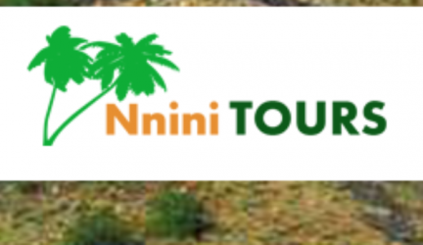 |  |  | 566 Zone 10  Sebokeng  1983  Cell:0824250775  Email:info@nninitours.co.za  Web:nninitours.co.za
PARLIAMENT OF SOUTH
120 PLEIN STREET
CAPE TOWN CITY
CAPE TOWN
8000

MAAA0474398  VENDOR NO: 1100138423 |  |  | 09 February 2018

Thank you Multi Party Womens Caucus for holding a summit to hear stakeholders for their inputs and responses to the South African Law Reform Commisions Report 107.I Nnini Rebecca Khambule don’t like the law to allow adult prostitution to be allowed in our lovely country.We have little girls who will be forced to leave their studies to do prostitution.
Our country is over populated with these people who are coming from other countries.If this law is allowed everybody from other country will be running to South Africa to do the dirty work.PLEASE PLEASE don’t allow that law

Hoping my concern is heard.

FROM: Nnini Rebecca Khambule

N.B. I WILL BE AVAILABLE FOR ORAL SUBMISSION

