The Chairperson
Mr Mandla Isaac Rayi
Select Committee on Economic and Business Development
Parliament
Cape Town

17 November 2017

Attention: Ms Noziphiwo Dinizulu
ndinizulu@parliament.gov.za

Dear Chairperson,
CALL FOR PUBLIC COMMENTS: ADMINISTRATIVE ADJUDICATION OF ROAD TRAFFIC OFFENCES AMENDMENT BILL [B 38B – 2015]
OUTA is a proudly South African non-profit civil action organisation, comprising of and supported by people who are passionate about holding government to account and improving the prosperity of South Africa.
As an organisation and on behalf of our supporters have an interest in legislation regarding road safety, road traffic offences and transport matters in general.
Please accept our written comments on the Administrative Adjudication of Road Traffic Offences Amendment Bill [B 38B – 2015].
We also request your consideration in affording us the opportunity to make an oral submission to clarify and expand on our written comments.
We trust that you will consider our request kindly.
Yours sincerely
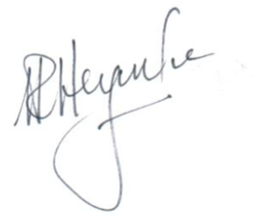

________________________
Rudie Heyneke
OUTA Portfolio Manager: Transport

