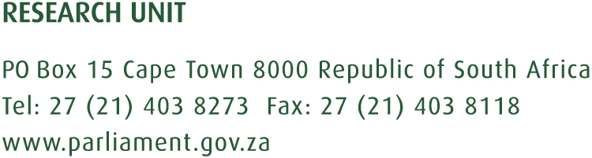

22 November 2017

ANALYSIS OF THE ANNUAL REPORT OF THE OFFICE OF TAX OMBUD (2016/17)
- Introduction
The Office of the Tax Ombud (OTO) was established in terms of section 14 and 15 of the Tax Administration Act, 28 of 2011. The OTO formally began operation in October 2013. The mandate of the OTO is to review and address any complaint by a taxpayer regarding a service matter or procedural or administrative matters arising from the application of the provision of Act. Furthermore, OPO is to review at the request of Minister emerging issues related to a service matter or the application, procedural or administrative provisions of the Act.
- Highlights of 2016/17

- Legislative amendments included:
  - Changing the term of office of the Tax Ombud from three to five years,
  - OTO powers (with approval from the Finance Minister) to initiate investigations into any systemic and emerging issues persistent.
    - One of the major issues dealt with in this financial year was delays in tax refund payments by SARS.
  - Powers to appoint the staff of the Office without consulting the SARS Commissioner.
  - Budget to be determined by the Finance Minister instead of the SARS
- Record tax payer complaints
  - This is evident from the increasing number of complaints the Office is receiving, rising from 2 133 in 2015/16 to 3 454 complaints in 2016/17

- Outcome of Performance Information
The OPO’s performance against its strategic objectives are reported below:
Table 1: Performance Information by Programme:
Programme | Achievements | Challenges | Comments
Programme 1: Office of the CEO | - Achieved 2 of 4  - Strategic Plan and Performance Plan  - 6 bi-monthly and 4 quarterly reports | - Budgetary constraints  - Research and development of concept document not completed.  - Governance frameworks outstanding | It seems like this government institution is finding it increasingly difficult to fulfil their mandate because of budgetary constraints.
Programme 2 : Operations | - Achieved 0 of 2 | - High volumes of complaints received and no staff growth
Programme 3: Communication and Outreach | - Achieved 2 of 2  - Communication and education outreach  - Collaborations with key stakeholders |  | Investigation of complaints about delays in tax refund payments by SARS generated significant media attention.
Programme 4: Legal Programme | - Achieved 1 of 1  - Legal matters referred to legal services completed within standard turnaround times. |  | Can OPO elaborate on the plans in place to give effect to further legislative amendments?
Programme 5: Office Enablement | - Achieved 4 of 5  - Training programmes  - Health risk assessment and awareness reports | - Budgetary constraints – HR capability plan was not finalised

- Financial Performance Analysis
For the period under review, revenue in the form of transfer from SARS was R30.9 million. The total expenditure including commitments amounted to R29.7 million, resulting in a surplus of R1.2 million. Personnel expenditure remains the main cost driver, and represents 80% of the total expenditure for the 2016/17 financial year.

References

Office of the Tax Ombud Annual Report 2016/17

