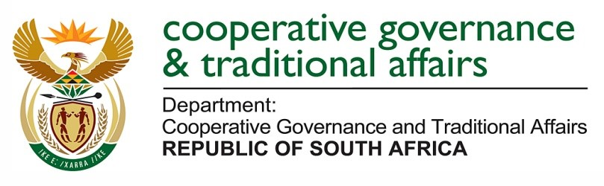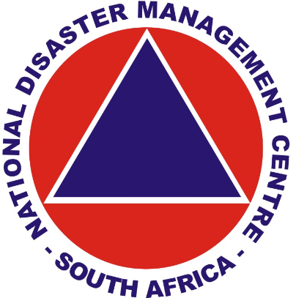

REPORT TO THE PORTFOLIO COMMITTEE ON THE ACTIVITIES FOR THE PAST FINANCIAL YEAR 2016/17 – ASSISTANCE ON ALL DISASTER, EXPENDITURE ON THE RELIEF, ETC. BY THE NATIONAL DISASTER MANAGEMENT CENTRE

PURPOSE
To brief the Portfolio Committee on the National Disaster Management Centres activities for the past financial year 2016/17 – assistance on all disaster, expenditure on the relief, etc.

SUMMARY
The NDMC, in terms of Section 24(1) of the Disaster Management Act, 2002, (DM Act) must submit a report annually to the Minister of Cooperative Governance and Traditional Affairs who, in terms of Section 24(2) must submit the report to Parliament. The 2016/17 NDMC Annual report, in compliance with the DM Act provides,
- A foreword by the Minister
- A strategic overview by the Head: NDMC
- General Information about the NDMC in Chapter 1
- An overview of the activities of the NDMC in Chapter 2
- An overview of the Monitoring and Evaluation results in Chapter 3
- An overview of States of Disasters Classified and Declared in Chapter 4
- An overview of Disaster Management Implementation in Chapter 5
- An overview of Disaster Management Plans (DMP) submitted to the NDMC in Chapter 6
- An overview of National Coordination in Chapter 7

The report is presented in three parts.
- Part 1 deals with the NDMC 2016/17 Annual Report.
- Part 2 provides information on the submission of the NDMC 2016/17 Annual Report to Parliament, and
- Part 3 provides information on the distribution of the NDMC 2016/17 Annual Report to provincial and municipal disaster management centres.

PART 1: NDMC 2016/17 ANNUAL REPORT
1.1 Legislative obligation
Section 24 of the DM Act enjoins the NDMC to submit a report to the Minister. The NDMC has fulfilled this legislative obligation.
Section 24: Reporting
[Heading substituted by s. 10 (a) of Act 16 of 2015 (wef 1 May 2016).]
(1) The National Centre must submit a report annually to the Minister on-
(a) its activities during the year;
(b) the results of its monitoring of prevention and mitigation initiatives;
(c) disasters that occurred during the year in each province;
(d) the classification, magnitude and severity of these disasters;
(e) the effects they had;
(f) particular problems that were experienced-
(i) in dealing with these disasters; and
(ii) generally in implementing this Act and the national disaster management framework;
(g) the way in which these problems were addressed and any recommendations the National Centre wishes to make in this regard;
(h) progress with the preparation and regular updating in terms of sections 25, 38, 39, 52 and 53 of disaster management plans and strategies by organs of state involved in disaster management; and
(i) an evaluation of the implementation of such plans and strategies.
(2) ….

1.2 Overview of the foreword by the Minister
The foreword by the Minister of Cooperative Governance and Traditional Affairs highlights the,
- concerns of government regarding the impact of the ongoing drought on the social, environmental and economic sectors of our country and the SADC region and calls for stakeholders to work together to mitigate the effects of the drought.
- need for strong and robust institutions to drive the disaster management agenda to be advanced through the establishment of the ICDM.
- need for continuity in leadership as a key to component of any government programme and welcomes the incoming Head of the NDMC, Dr M Tau with effect from 1 January 2017.

1.3 Overview by the Head: NDMC
The overview by the Head: NDMC presents the high level strategic achievements for the year under review which include,
- Emphasising that the responsibility for disaster funding lies primarily with an organ of state responsible for the maintenance of such infrastructure.
- The development and adoption of two guidelines on the “Minimum Infrastructure Requirements of a DMC” and the “Development and Structure of a Disaster Management Plan”.
- An overview of the celebrating the United Nations International Day for Disaster Reduction.
- The ongoing coordination of the response to drought.
- The collaboration and coordination with international stakeholders.

1.4 Overview of Chapter 1: General Information
Chapter one provides general information about the NDMC by unpacking the,
- Overview and objective of the branch;
- Legislative and other mandates;
- Strategic overview;
- 2016/17 strategic objective;
- 2016/17 branch objectives;
- Organisational structure;
- Expenditure trends; and
- International engagements undertaken.

1.5 Overview of Chapter 2: Activities of the NDMC
Chapter two provides details of the activities of the NDMC undertaken by the,
1.5.1 Chief Directorate: Legislation and Policy Management which develops disaster management and fire services policies, legislative frameworks and guidelines derived from the DMA, the NDMF, and the FBSA. It also provides support to stakeholders on the implementation of the policies and frameworks across the sectors and spheres of government.
  - Directorate: Policy Development and Regulatory Frameworks
    - Supported the implementation of the Disaster Management Amendment Act by conducting 26 workshops with stakeholders.
    - Developed two guidelines.
    - Provided secretariat services to disaster management institutional structures.
    - Supported other NDMC projects and disaster management stakeholders.
    - Performed compliance management.
  - Directorate: Fire Services
    - Enhanced the fire services regulatory framework by preparing the draft white paper on fire services and the second draft Bill on fire services.
    - Contributed to the professionalisation of the fire services through participation in the development of municipal staff regulations.
    - Support the implementation of the National Fire Safety prevention Strategy through capacity assessments and support in 27 municipalities.
    - Supported the establishment of Urban Search and Rescue institutional arrangements and the assessment of current capacity.
    - Hosted various national fire services institutional structures.

1.5.2 Chief Directorate: Disaster Risk Reduction, Capacity Building and Intervention develops and implements disaster management operational systems and coordinates disaster management capacity building and strategic research across the three spheres of government.
- Directorate: Disaster Risk and Reduction and Planning.
  - Facilitated the development of disaster management plans.
  - Supported and responded to disasters.
  - Supported the preparation efforts to be ready for Cyclone Dineo.
  - Developed and administered the respective disaster grant guidelines and frameworks.
- Directorate: Disaster Risk Management, Education, Training, Awareness and Research
  - Developed the Disaster Risk Reduction School Toolkit to ensure the integration of Disaster Risk Reduction into the schooling system.
  - Developed a Disaster Risk Reduction capacity-building programme for Local Government Stakeholders.
  - Promoted career development through the Bursary Programme.
  - Facilitated the commemoration of the 2016 International Day for Disaster Reduction (IDDR)

1.5.3 Chief Directorate: Integrated Provincial Disaster Management Support, Monitoring and Evaluation Systems develops and implements an integrated system to monitor and evaluate the effectiveness and performance of disaster management and fire services in the country.
- Directorate: Disaster Management Monitoring and Evaluation
  - Supported the PDMCs to implement the disaster management monitoring and evaluation (M&E) framework.
  - Overseen the submission of quarterly M&E reports.
  - Overseen the maintenance of a central database for declared states of disasters.
  - Developed a concept note for the future evaluation of disaster management.
  - Reported on the outcome 10 delivery agreement 2014 – 2019.

1.5.4 Chief Directorate: Information Technology, Intelligence and Information Management Systems guides the development of a comprehensive information management and communication system and establishes integrated communication links with all disaster management role players.
- Directorate: Early Warnings and Capability Management Systems
  - Improved the disaster early warning systems.
  - Improved the indicative risk and vulnerability profile.
  - Improved the geographic information system.
- Directorate: Intelligence and Information Management
  - Facilitated the training and roll out of the eConvenor system.
  - Revamped the NDMC website.
  - Implemented the Veeam availability suite.

1.6 Overview of Chapter 3: M&E Results
An assessment tool was developed to assess compliance of national sector departments with the DM Act. Five sector departments were assessed and the outcome of the assessment is set out below.
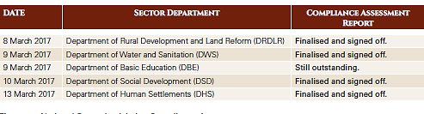

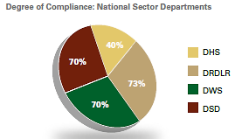

The annual reports of three PDMCs submitted to the NDMC in terms of Section 36 of the DM Act were assessed for compliance. The results of the assessment show that annual reports submitted to the NDMC do not fully comply with the legislative prescripts.

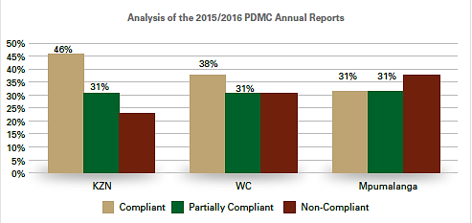

The functionality of disaster management institutional structures was analysed and the results are presented below. The consistent participation of sector departments, government agencies and other stakeholders in disaster management institutional structures remains challenging.

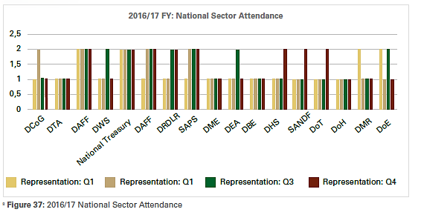

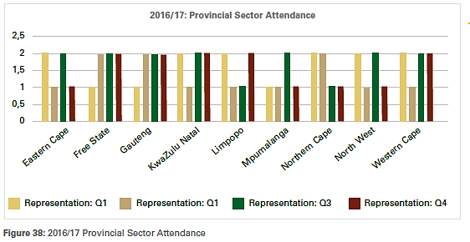

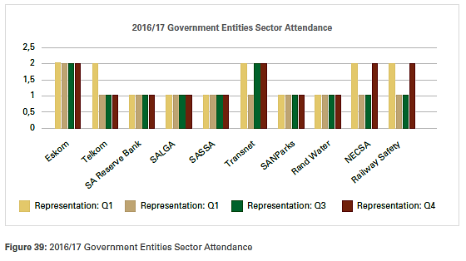

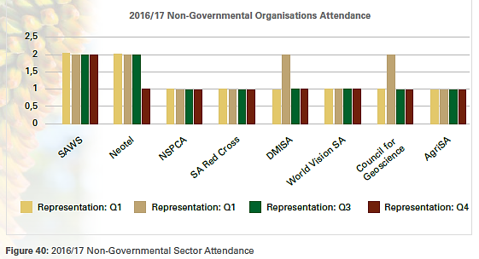

1.7 Overview of Chapter 4: Disasters
Various disasters were experienced during 2016/17 with drought being predominant. The NDMC continued with the coordination of drought response measures as drought conditions persisted in some parts of the country. The National Joint Drought Coordinating Committee (NJDCC) was operational with the participation of key sector departments, state entities and PDMCs. The frequency of the meetings was scaled down to once a month later in the year. The focus for the committee was on:
- Technical support to provinces and municipalities in addressing drought and water-related challenges.
- Reprioritisation of available resources from existing programmes in sector departments, municipalities and provincial governments.
- Collaboration and integration of response measures by all spheres of government to maximise resources and avoid duplication.
- Involvement and contributions by private sector and Non Governmental Organisations (NGOs) to assist affected communities.
- Stringent measures for water management to ensure conservation of the available resources.

Gradual improvements in the drought conditions in some parts of the country, this was backed-up by the reports from South African Weather Service (SAWS), indicating that El Nino conditions are weakening and returning to a neutral state. The NJDCC encouraged the sector departments to ensure proper planning during the financial year, particularly the alignment of project funding to the needs on the ground to address drought challenges experienced by communities. Civil society organisations also contributed extensively to support water-stressed communities with the focus on sustainable intervention measures such as the drilling and equipping of boreholes.

Implementation of intervention measures during the period of reporting was done in two phases, i.e. Phase 1 on the reprioritisation of resources by the organs of state through the existing programmes as well as well Phase 2 on financial contribution from Disaster Grants within the DCoG. The details are as follows:

- Phase 1
- Reprioritization of resources from existing programmes in all Spheres of Government;
- Contributions by Private Sector and NGOs;
- Technical Support to provinces and municipalities;
- Water Use Management and Conservation Measures;
- Contribution by Private Sector; and
- Monitoring of conditions on the ground.

The agriculture and water sectors indicated that their resources were depleted and therefore requested additional resources since the conditions had not improved, the focus therefore shifted to Phase 2.
- Phase 2
The Department of Water and Sanitation (DWS) as well as the Department of Agriculture, Forestry and Fisheries (DAFF) submitted funding requests to the DCoG to assist the affected communities. The following amounts were approved by National Treasury in September 2016 for drought intervention measures:
  - An amount of R212 million for the provision of livestock feed within the agriculture sector; and
  - An amount of R341 million for the water sector for a mobile desalination plant (KZN) and water tankering in affected provinces.

The details for the funding allocations are as follows:
NAME OF SECTOR | Division of Revenue Act | Purpose
 | R 000 000
Department of Water and Sanitation
Eastern Cape | 8.6 | Water tankering and storage
Free State | 42.2 | Water tankering and storage
KwaZulu-Natal | 290.7 | Desalination plant
Total | 341

NAME OF SECTOR | Division of Revenue Act | Purpose
 | R 000 000
Department of Agriculture Forestry and Fisheries
Eastern Cape | 29 | Livestock feed
Free State | 31 | Livestock feed
KwaZulu-Natal | 23 | Livestock feed
Limpopo | 28 | Livestock feed
Northern Cape | 25 | Livestock feed
Mpumalanga | 26 | Livestock feed
North West | 38 | Livestock feed
Western Cape | 12 | Livestock feed
Total | 212

Grant Allocation during 2016/17 by the DORA (2017)
NAME | AMOUNT
Municipal Disaster Grant | R269m
Provincial Disaster Grant | R111m
Municipal Disaster Recovery Grant | R140m

Expenditure of the disaster grants for 2016/17
Out of R269m, R118m was allocated to the Merafong City Local Municipality to address the sinkhole formations occurrences, which caused damage to critical infrastructure within the municipality. The municipality declared a state of local disaster. The municipality has spent the funding to repair emergency funding and had a balance of R265 688.00.

MUNICIPAL DISASTER GRANT
NAME OF MUNICIPALITY | Division of Revenue Act | Actual transfer | Funds withheld | Amount received | Amount Spent
MUNICIPAL DISASTER GRANT
GAUTENG
GT484 Merafong City Local Municipality | 118 075 | 118 075 |  | 118 075 | 117 809
Total | 118 075 | 118 075 |  | 118 075 | 117 809

The Municipal Disaster Recovery Grant

NAME OF MUNICIPALITY | Division of Revenue Act  ‘000 | Actual transfer ‘000 | Amount received ‘000 | Amount spent ‘000
Municipal Disaster Recovery Grant
KWAZULU - NATAL
KZN212 Vulamehlo – demarcation funds transferred to Umdoni | 30 000 | 30 000 | 30 000 | Still awaiting reports
KZN213 Umzumbe | 10 000 | 10 000 | 10 000 | Still awaiting reports
KZN238 Emnambithi – demarcation funds transferred to Alfred Duma | 50 000 | 50 000 | 50 000 | Still awaiting reports
MPUMALANGA
MP324 Nkomazi | 20 000 | 20 000 | 20 000 | R20 000 spent however waiting for closeout reports
WESTERN CAPE
WC042 Hessequa | 30 000 | 30 000 | 30 000 | R30 000 spent however waiting for closeout reports
Total | 140 000 | 140 000 | 140 000

The Provincial Disaster Grant
No expenditure incurred due to the reprioritisation process by organs of state mainly during the drought. The NDMC facilitated funding from the National Treasury through the budget adjustment process for the following organs of state that is the DWS and DAFF. An amount of R553 million was allocated to the two sectors as follows: DWS was allocated R341 million and DAFF received R212 million.

NAME OF SECTOR | Division of Revenue Act | Purpose | Amount Spent
 | R'000
Department of Water and Sanitation
Eastern Cape | 8.6 | Water tankering and storage | Fully spent
Free State | 42.2 | Water tankering and storage | Fully spent
KwaZulu-Natal | 290.7 | Desalination plant | Fully spent
Total | R341 |  | R341 spent
Department of Agriculture Forestry and Fisheries
Eastern Cape | 29 | Livestock feed | 29
Free State | 31 | Livestock feed | 31
KwaZulu-Natal | 23 | Livestock feed | 23
Limpopo | 28 | Livestock feed | 28
Northern Cape | 25 | Livestock feed | 25
Mpumalanga | 26 | Livestock feed | 26
North West | 38 | Livestock feed | 38
Western Cape | 12 | Livestock feed | 12
Total | R212 |  | R212

1.8 Overview of Chapter 5: Disaster Management Implementation
Chapter five reflects on some legislative compliance issues and challenges faced by organs of state across the spheres of government in implementing the disaster management legislation which includes details of the,
- Annual reports received from PDMC’s, MDMC’s, national organs of state and other entities, and provincial organs of state.
- Functionality of the Disaster Management Advisory Forums.
- Disaster risk reduction, capacity building and intervention by stakeholders.
- Capacity building initiatives.

1.9 Overview of Chapter 6: DMP
Chapter six provides a list of the disaster management plans submitted to the NDMC and work performed by the task team on disaster management planning

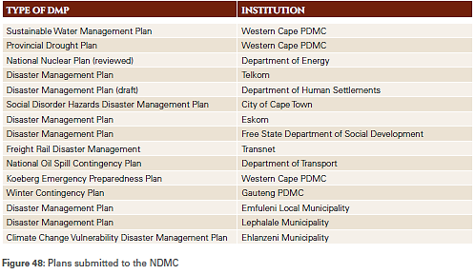

1.10 Overview of Chapter 7: National Coordination
Chapter seven reflects on the national coordination of disaster management across the three spheres of government which includes details of the,
- Structure of National Disaster Management Coordination.
- Intergovernmental Committee on Disaster Management.
- National Disaster Management Advisory Forum.
- National Joint Drought Coordination Committee.
- Participation in Intergovernmental and other Coordinating Structures.

PART 2: SUBMISSION OF THE NDMC 2016/17ANNUAL REPORT TO PARLIAMENT
2.1 Legislative obligation
Section 24(2) of the DM Act enjoins the Minister to submit the NDMC Annual Report to Parliament. The Minister has fulfilled this legislative obligation.

PART 3: DISTRIBUTION OF THE NDMC 2016/17 ANNUAL REPORT TO PROVINCIAL AND MUNICIPAL DISASTER MANAGEMENT CENTRES
3.1 Legislative obligation
Section 24(3) of the DM Act enjoins the NDMC to share the NDMC Annual Report with each provincial and municipal disaster management centre. The NDMC has fulfilled this legislative obligation.

