DCOG MUNICIPALREVENUE MANAGEMENT:

  - REPORT TO THE PORTFOLIO COMMITTEE OCTOBER 2017

DCOG REVENUE MANAGEMENT:
BACKGROUND:
In order to deliver the services effectively municipalities rely on two sources of revenue; the transfers from national government which include the local government equitable share and other conditional grants as well as municipal own revenue which comprises of the municipal property rates taxes and charges for producing water, electricity, refuse removal, sanitation and other services.
Section 229 of the constitution of the Republic of South Africa requires municipalities to raise rates and impose surcharges on fees for services provided, section 154 places and obligation on both national and provincial government to support and strengthen the capacity of municipalities to manage their own affairs to perform their functions. Municipalities are required to provide services such as water, electricity, refuse removal and other trading services. In the execution of these functions, credit control and debt management become the central part of their sustainability.
The ability of municipalities to maintain adequate levels of revenue is constrained as a result of non- payment by municipal consumer debtors which poses serious threats to the municipal sustainability and service delivery. Revenue protection and effective revenue management are therefore crucial to enhance the potential of revenue collection and reduce municipal consumer debt municipalities.
Escalating municipal debt is a major threat to the financial sustainability of municipalities, particularly those that render limited services. Past experiences have shown that the situation has been compounded by a number of variables; some within the control of the municipalities and others being outside their control. Limitations on accurate and reliable information, interpersonal relationships are but some of the areas that require attention.
The department embarks in a number of municipal governance programmes that are aimed identifying areas of risk in local government finances so that appropriate policy responses can be developed and implemented. The work of the department also identifies those municipalities that are in financial distress so that processes can be initiated to determine the full extent of their financial problems and whether a municipality requires support and what that support should be, or if an intervention is required in a municipality due to a crisis in its finances.
There are numbers of indicators commonly used to measure the financial health of a municipality and these includes the following amongst others:
- Reliance on national and provincial government transfers and this is used to determine the level at which municipalities are able generate own funds to finance revenue generating assets and to enhance and sustain revenue generating streams.
- Persistence of negative cash balances which identifies whether cash shortages/bank overdrafts pose a “chronic” problem for the municipality.
- Cash as a percentage of operating expenditure to determine cost coverage; i.e. does the municipality have adequate cash available to meet its operating expenditure requirements?
- Debtors as a percentage of own revenue which examines municipalities' revenue management capabilities.
- Year on year growth in debtors; i.e. the municipality exercising fiscal effort in collecting outstanding debt. To what extent is financial distress the result of poor debtor management?
- Debt impairment as a percentage of billable revenue is a complementary measure of the cost to a municipality of providing for non-collection/writing off of billable revenue.
In order to fully appreciate municipal revenue protection; it is important to understand the extent of work that goes into effective revenue management. This entails a number of activities which each contribute to what we term the revenue cycle. These activities include the following as aligned to the 5 pillars of our Back to Basics Programme:
Under Pillar 1 which is putting people and their concerns first municipalities need to ensure that there is proper
- Indigent management and
- Customer care.
Under Pillar 2 which is supporting the delivery of quality service delivery they need to ensure that there are seamless interphases with the service departments because if people are to pay for these services, they need to be of quality standard and those who receive the service must all form part of the revenue pot of the municipality.
Under Pillars 3 and 5 which is Good Governance as well as building institutional resilience and administrative capacity there must be clearly defined legal & institutional arrangements. These include the structures of Council; the human resource capacity, the reporting ability, the internal controls, the Internal Audit and decision making.
Under Pillar 4 which is Sound financial management the following need to be in place and effectively maintained:
- The policy environment which include properly constituted by-laws.
- Property valuations and the Municipal Property Rates Act prescripts.
- Meter installations, meter management and meter readings.
- Data management – property data, meters and consumer data.
- Accurate and timely billing.
- Payment and receipt management.
- Credit control, debt management and collection.
- Cash and liquidity management.
These are the basics that contribute towards revenue protection and revenue management.

CURRENT REVENUE MANAGEMENT PROJECTS:
- SIMPLIFIED REVENUE PLAN PROJECT
PROJECT BACKGROUND
DCoG has identified a strategic intervention aimed at enhancing the municipal revenue management and debt collection system in local government. The development and implementation of municipal-specific revenue plans was identified and is currently being rolled out in 30 selected municipalities; 8 of which are in the Free State Province. The nominated municipalities were identified for the project through the Back to Basics (B2B) programme and by assessing the level of outstanding debt in municipalities.
OUTPUTS IN PHASES
- Implementation planning and conducting an “As Is’’ assessment
Data was extracted and analysed in each allocated municipality as per the final replicable model.
An “as-is” assessment of the revenue value chain in a specific municipality was conducted.
2. Development of an improvement plan (municipal-specific simplified revenue plan)
This phase was informed by the findings of the assessment above.
The activities included in the plan were mapped against corrective measures as well as a project plan for the implementation.
The findings and corrective measures were presented to the key stakeholders in the municipality and the DCoG steering committee.
3. Implementation of the municipal-specific simplified revenue plan
This phase is the actual implementation of the corrective measures identified in the previous phase according to the project plan.
The progress that clearly identifies the outputs for each stage in the plan is reported on a monthly basis to the Municipal Manger, Chief Financial Officer, and Revenue Manager or MANCO.
CURRENT STATUS:
The “AS IS” assessment was concluded in all municipalities.
We have developed a municipal specific revenue management plan for each of the municipalities.
An analysis of all the business processes and revenue related data has been conducted in all municipalities.
All revenue policies and revenue procedure manuals were reviewed to enable revenue protection, efficient revenue management and debt collection.
The debtors’ master files are currently being reconciled to the valuation rolls and billing system to ensure accuracy and validity of billing data.
Implementation of the municipal specific revenue management plans is currently underway.

REVENUE MANAGEMENT AND ENHANCEMENT VALUE CHAIN
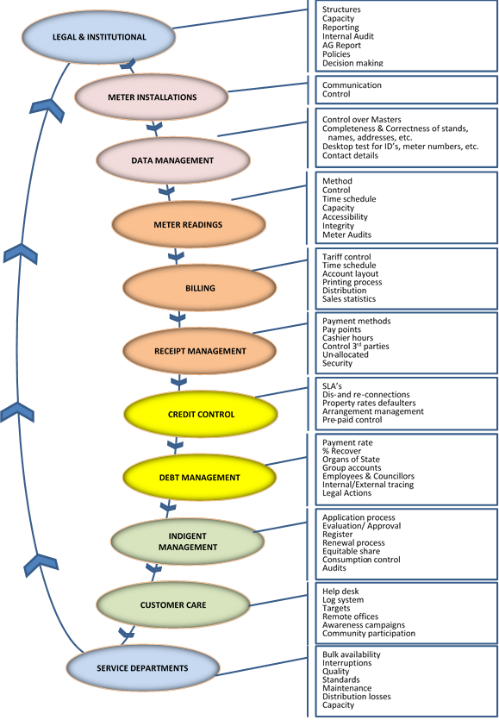
SIMPLIFIED REVENUE PLAN MUNICIPALITIES
 | Municipality | Province
1 | Amathole | Eastern Cape
2 | O.R. Tambo | Eastern Cape
3 | King Sabata Dalindyebo | Eastern Cape
4 | Dihlabeng | Free State
5 | Maluti-A-Phofong | Free State
6 | Masilonyana | Free State
7 | Nala | Free State
8 | Ngwathe | Free State
9 | NKETOANA LOCAL MUNICIPALITY | Free State
10 | MAFUBE MUNICIPALITY | Free State
11 | PHUMELELA MUNICIPALITY | Free State
12 | Lesedi | Gauteng
13 | Merafong | Gauteng
14 | uThukela | Kwa-Zulu Natal
15 | ULUNDI LOCAL MUNICIPALITY | Kwa-Zulu Natal
16 | Mopani | Limpopo
17 | Ba-Phalaborwa | Limpopo
18 | THABAZIMBI LOCAL MUNICIPALITY | Limpopo
19 | MOOKGOPHONG LOCAL MUNICIPALITY | Limpopo
20 | Albert Luthuli | Mpumalanga
21 | Dipaleseng | Mpumalanga
22 | Lekwa | Mpumalanga
23 | Msukaligwa | Mpumalanga
24 | THABA CHWEU LOCAL MUNICIPALITY | Mpumalanga
25 | Victor Khanye | Mpumalanga
26 | DITSOBOTLA LOCAL MUNICIPALITY | North West
27 | Moses Kotane | North West
28 | NALEDI LOCAL MUNICIPALITY | North West
29 | Sol Plaatje | Northern Cape
30 | Drakenstein | Western Cape

- Development and maintenance of a spatially enabled, integrated property and consumer database for municipalities:
The project focus is on municipal data integrity; to provide municipalities with a platform to access up to date data that has been integrated with both private and national government data sets that are relevant to municipalities but not currently accessible to them centrally.
This project is a medium term (2016/17 – 2019/20) aimed at creating a municipal centralised municipal data repository that contains information:
• All properties countrywide verified with Surveyor General, Deeds Registry and Municipal Valuation rolls.
• All municipal consumers countrywide (ID’s verified with Department of Home affairs and companies with the Company Registry)
• All addresses which will assist for election purposes.
• All people receiving free basic services (verified with all municipalities, SASSA and the Department of Human Settlements)
• All meters – Water and Electricity – verified with GPS coordinates.
The Pilot project municipalities:
Mangaung
Sol Plaatjie
Dikgatlong
Phokwane
Magareng

