4. SELECT COMMITTEE ON SOCIAL SERVICES JOINT STUDY TOUR
(with the SELECT COMMITTEE ON EDUCATION AND RECREATION)
to INDONESIA, SINGAPORE AND MALAYSIA

10-21 July 2017

Table of Contents
LIST OF ACRONYMS 2
1. INTRODUCTION 5
1.1. Indonesia 5
1.2. Singapore 6
1.3. Malaysia 6
1.4. Mode of Interactions during the Study Tour 7
2. OVERVIEW OF INDONESIA 8
2.1. Demographics of Indonesia 8
2.2. Parliament’s Commission V 9
2.3. Water Services 10
2.4. Universal Access to Adequate Sanitation 11
2.5. Universal Access to Drinking Water 12
2.6. Issues Emanating from the Deliberations 13
3. OVERVIEW OF SINGAPORE 15
3.1. Demographics of Singapore 15
3.2. Health Services 15
3.2.1 Healthcare 2020 17
3.2.2 Beyond Healthcare 2020 18
3.2.3 Healthy Living Masterplan 18
3.3. Site Visit: Ng Teng Fong General Hospital 18
3.4. Water Services 20
3.4.1 Key Strategies 20
3.4.2 NEWater Initiative 21
4. OVERVIEW OF MALAYSIA 22
4.1. Demographics of Malaysia 22
4.2. Health Services 22
4.2.1 Universal Health 23
4.2.2 Refocusing Health Coverage 23
5. CONCLUSION 24

LIST OF ACRONYMS

AHS Alexandra Health System
EHA Eastern Health Alliance
EMS Emergency Medical Services
GDP Gross Domestic Product
HDI Human Development Index
ICT Information and Communication Technology
JHS Jurong Health Services
MoH Ministry of Health
NCD Non-communicable disease
NHG National Healthcare Group
NHI National Health Insurance
NRF National Research Foundation
NUHS National University Health System
PHC Primary Health Care
PUB Public Utilities Board
PPP Public-Private Partnership
SHS Singapore Health Services
UHC Universal Health Coverage
WHO World Health Organization

PARLIAMENTARY DELEGATION

- Ms LC Dlamini – Chairperson: Select Committee on Social Services
2. Mrs LL Zwane – Chairperson: Select Committee on Education and Recreation
3. Ms TK Mampuru – Committee Whip
4. Mrs TG Mpambo-Sibhukwana
5. Ms PC Samka
6. Mr C Hattingh
7. Mr M Khawula
8. Ms L Moshodi
9. Ms D Ngwenya

PARLIAMENTARY OFFICIALS

- Ms Marcelle Williams – Committee Secretary
- Ms Thabile Ketye – Content Advisor

INTRODUCTION

The Select Committee on Social Services undertook its first Study Tour in the Fifth Parliament (in line with its Annual Performance Plan and Strategic Plan) to three countries, namely: Indonesia, Singapore and Malaysia. The Study Tour took place from 10 to 19 July 2017.

The aims of the study tour were to explore, understand and learn from the Singapore and Malaysia health care systems and the Indonesia and Singapore water and sanitation systems. This report therefore reflects learning from the health care, water and sanitation systems of the visited countries.

The report is structured and/or divided into four parts. The first part of the report is the introduction to the report. The subsequent parts of the report provide information on the lessons from each country. Below is a brief background on the areas that the Committee focused on in each country.

Indonesia

The Committee focused on the provision of water and sanitation services in Indonesia’s informal settlements.

In recent years, the Indonesian government identified the lack of access to adequate water and sanitation services as a key challenge to be addressed. The Indonesian government has placed specific emphasis not only on urban settlements, but informal settlements and rural areas. It has since embarked on a number of projects and programmes to address this issue. For example, in 2010 the Settlement Sanitation Development programme was launched to provide access to adequate sanitation to 80% of urban households by 2014. At the time the programme was estimated to cost US$5.5 billion. The programme was aimed at developing waste water services in 226 cities, build sanitary landfills which would serve 240 urban areas and stop inundations in strategic urban locations, covering around 22 500 hectares.

Prior to that, in 2008, the Indonesian government had embarked on the National Strategy for Community-Based Total Sanitation. The purpose of the programme was to introduce more effective water treatment methods in 10 000 villages by 2012.

It was due to this background that the Committee identified Indonesia to be part of the Study Tour. It was important for the Committee to learn what programmes the Indonesian government is undertaking to provide adequate access to water and sanitation services in informal settlements, as this is one of the priorities for South Africa.

Singapore

The focus of the Committee was on Singapore’s water and health systems.

Singapore has a successful Universal Health Coverage (UHC) system that it has been implementing for years. The South African government is in the process of phasing-in the National Health Insurance (NHI), which is about providing UHC. Further, Singapore's medical facilities are among the finest in the world. The South African government is implementing an Ideal Clinic initiative which seeks to provide world class healthcare facilities.

In terms of water services, Singapore has long recognised the vital role the provision of a sustainable water supply plays in its future prosperity.

It is within this background that the Committee felt it would benefit in performing a well-informed oversight in the roll-out of NHI in South Africa.

Malaysia

There are a number of similarities between the Malaysian and South African healthcare systems. Over the past few decades, the Malaysian government has successfully implemented UHC, better known as the NHI in South Africa.

The socio-economic development in Malaysia, over the few decades, has brought about significant improvement in the general health status of the population partly due to sustained investment into social infrastructure such as schools and health facilities. The country’s public healthcare system has gradually improved and provides comprehensive care at minimal fees to the country’s citizens.

Due to healthcare reforms in the country, Malaysia can claim to have achieved UHC - the ultimate health system goal of the World Health Organisation (WHO).

It was due to this background that the Committee identified Malaysia to be part of the Study Tour.

Mode of Interactions during the Study Tour

The mode of information sharing was largely through PowerPoint presentations followed by discussions. Members of Parliament were given opportunity to ask questions to explore and probe on issues raised in the presentations. In some instances, books were made available to learn more about topics of interest to the delegation. Thus, the Information presented in this report stems from those interactions.

OVERVIEW OF INDONESIA

Demographics of Indonesia

Indonesia has a population of 256 million, with 34 provinces, 17 000 islands, and 516 regencies or districts. Its urban population comprises of 54% of the total population. Please see the map of Indonesia below.

Map of Indonesia
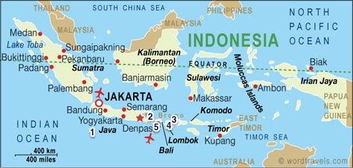

The country has an expansive pyramid population, with almost 60% of its population aged less than 30 years. The national coverage of the slum area is 38 431 hectares (ha). The national coverage of safe drinking water is 71.6%. The national coverage of safe sanitation is 64%.

The poverty rate is at 11.2%. The life expectancy is 71 years. The gross domestic product (GDP) is US$ 3,605 with an economic growth of 5%, and a population growth of 1.1%. Its human development index (HDI) ranking is 112 of 186 countries.

There are only two seasons in Indonesia – dry and wet/rainy.

Parliament’s Commission V

The Committee held a meeting with its Indonesian counterpart, Commission V. Commission V is a “committee” that oversees the following departments in Indonesia:
- Public Works and Housing
- Transportation
- Climatology
- Underdeveloped Regions

The Commission comprises of 52 Members. Its mandate includes the following:
- Processing and passing laws.
- Monitoring and evaluating programmes that are being implemented by the Executive.

In relation to its mandate, Commission V prepared and passed Law 1 in 2011. Law 1 speaks to housing (and the alleviation of slums) in Indonesia. This Law entails three components, namely:
- Restoration: The focus was repairing ad rebuilding existing settlements into decent and sustainable settlements.
- Building renovation: The focus was on establishing a better quality of settlements to address the security and safety needs of communities.
- Resettlement: The focus is on relocating communities from existing (disaster prone) locations that many not be rebuilt in accordance with the spatial plan.

It has also drafted a law on infrastructure which was being debated at the time of the visit. It is envisaged that a water resource management law will be processed and passed in future.

The Indonesian motto is: Humility in diversity.

Water Services

The Committee met with the Ministry of Public Works and Housing. The Ministry is responsible for overseeing water services under its Human Settlements Directorate.

The Indonesian government believes in strong public-private partnerships (PPPs). The Ministry of Public Works and Housing gives the opportunity to propose creative and innovate ways of alleviating slums to the local government, academia, experts and communities.

In terms of policy, the Indonesian government has committed itself to the National Medium Term Development Plan for 2015–2019. This Plan entails the ambitious target of eradicating slums and achieving universal access to safe water and sanitation by 2019. The programme is called “100-0-19”. This basically means that there will be 100% (universal) access to safe drinking water, and a complete eradication of slums by 2019.

More specifically, the National Medium Term Development Plan for 2015-2019 states that:
- Universal access to safe drinking water will be achieved through the development of water supply systems at regional, city, district and neighbourhood levels; in both rural and urban areas.
- Urban slum area eradication will be achieved through slum upgrading efforts in the 38 431 ha area, and through a community empowerment programme in 7 683 sub-districts.
- Universal access to adequate sanitation will be achieved through meeting the basic domestic waste water, solid waste and drainage system needs in urban and rural areas.
- Improved building security and safety; and enhancement and maintenance of harmony will be achieved through the following:
  - Development and monitoring of state-owned buildings;
  - Development of regulations on, and implementing green building;
  - Establishment of local building codes.

In line with these targets, the Indonesian government has launched sectoral platforms of service delivery in urban and rural water, sanitation and slum upgrading and has established the National Slum Upgrading Programme as a national platform for collaboration between governments, the private sector, communities and multi-lateral donors. A proposed loan to the amount of US$216.5 million is under consideration by the World Bank for the National Slum Upgrading Project.

Universal Access to Adequate Sanitation

The Indonesian government has initiated a community-based sanitation project (SANIMAS) in partnership with communities. SANIMAS is a communal wastewater infrastructure development project which entails the installation of communal wastewater treatment, and the installation of a combination (with Mandi Cuci Kakus++) of wastewater treatment for low income societies that either do not have wastewater infrastructure or have it but it is not yet feasible; and house connections for locations with non-optimal house connections.

The project is underpinned on the following principles:
- SANIMAS must respond to the needs of the communities.
- The community members are entirely responsible for decision-making.
- Communities must define, plan, build and manage their systems.
- The government must facilitate community group initiatives.

It is envisaged that the project will:
- Improve public health status through stimulus development of decent sanitation facilities, especially for low income people in dense and sanitation-prone areas in urban region;
- Increase public awareness regarding sanitation infrastructure and facilities; and
- Improve the utilisation of sanitation facilities that have been built.

The project funding sources are as follows:
- National budget: This covers the physical development (building materials, workers’ wages) costs; training, operations and salary of community facilitators; and non-physical cost of construction assistant.
- Provincial and regency/city budget: This entails the replication of community-based infrastructure development, including the cost of empowerment; and the co-financing fund for the project pre-construction activities in line with local government policy.
- Community fund: This funding from the community is done as proof of the sincerity of the community. The contribution may be in cash or in kind (local labour and materials).

Universal Access to Drinking Water

Indonesia has experienced water supply challenges. In 2015, access to safe water had reached 71% of the total population in Indonesia. About 29% (77 million people) remain without access to safe water.

The Indonesian government envisages improving access to drinking water by at least 6% annually. The total funding investment required to achieve this is US$19.53 billion (or 253,850 Rupiah). This funding would come from different sources which include the central government budget allocation, PPP (including commercial borrowing), local government budget, and the water utility budget.

The strategies towards 100% access to safe water are shown in the table below.

IMPLEMENTATION STRATEGY | TARGET
Construction of water supply systems (WSS) | -Provide support for the construction of WSS for regional, urban and special regions.
Assistance of provincial government/local government | -Provide assistance for local government in strengthening institutions and improving financial capacity.  -Provide technical assistance in:  - Preparing norms, standards and guidelines.  - Monitoring water supply development.  - Supporting emergency response programmes.  - Providing programme assistance for water utilities.
Community participation | -Provide support for construction of water supply system through community-based programme.  -Provide assistance in preparing community work plans.

Issues Emanating from the Deliberations

Indonesia has no significant water supply problems. There is adequate water for consumption and sanitation.

Indonesia has its own regional water treatment facility, which entails the development of an environmental drainage system. In Indonesia there are three pipe water delivery systems, namely the regional pipe water delivery system, urban pipe water delivery system, and the community-based delivery system in special zones. At the time of the visit, it was reported that it is at 71% of its 100% target for 2019.

There is no bucket system or open latrines in the urban area. Many households have access to underwater tables or well points.

The government sets the tariffs for water services. The local water utility companies collect the tariffs. In addition, local water utility companies are delegated to provide water reticulation services. The Ministry is also responsible for constructing dams and ensuring that there is water.

An on-line procurement system is utilised. This ensures more transparency and accountability and leaves no room for fraudulent activities.

The Public Works Directorate is responsible for irrigation systems, dam infrastructure, and roads. The Ministry of Health is responsible for the water quality and management of related water illnesses. The Ministry of Public Works and Housing works closely with the Ministry of Health on the community programmes related to sanitation.

Public housing is built by both the national and local governments. About US$15 to 20 million is provided by the Indonesian government to assist in the provision of public housing. The Ministry of Housing puts a ceiling on how much can be spent. In the main, contractors are outsourced for construction. The local government works with local contractors/consultants. There is one Director-General (DG) for Construction Development. The responsibility of the DG is to improve the skills of local contractors/consultants.

The national housing programme provides about 1 million houses per year. Assistance may be in the form of grants or rental. A subsidy is paid by government towards housing. In addition, the interest rate is kept at a minimum (about 5%). In addition, government also assists through bank loans and house deposits. The resident can then pay for the house over 20 years.

The Public Service Agency is responsible for marketing and lobbying. The central or local government is responsible for the maintenance of government houses.

OVERVIEW OF SINGAPORE

Demographics of Singapore

The population size in Singapore is 5.6 million. The land size is 719.2 kilometres. Its population density is 7.8 per kilometre square. Please refer below for the map of Singapore.

Map of Singapore
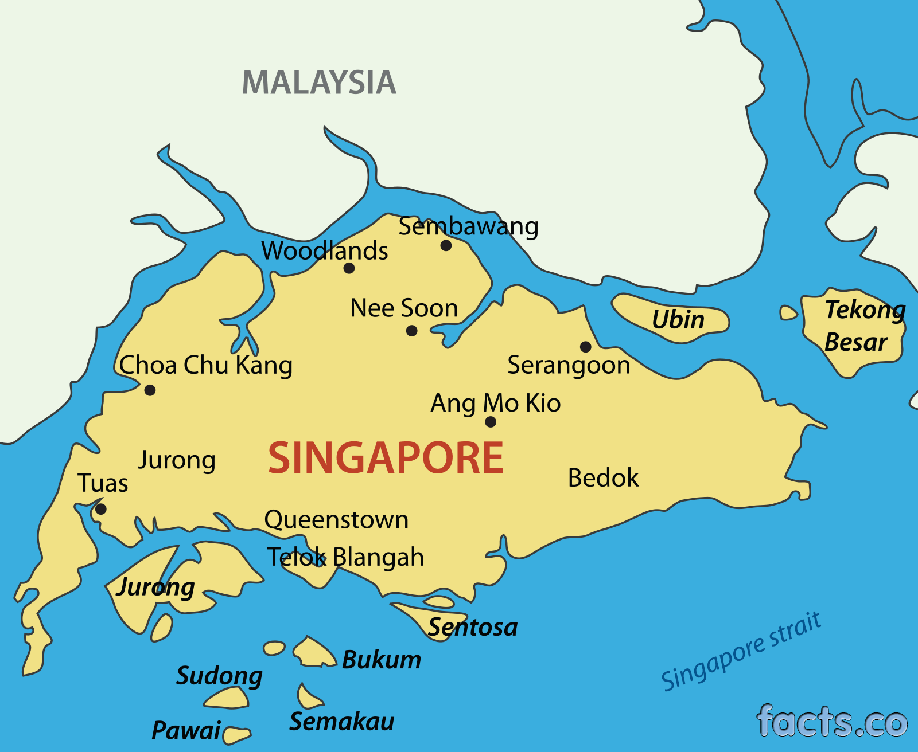

The life expectancy is 82.7 (84.9 for Females and 80.4 for Males).

Health Services

The Committee met with the Ministry of Health (MoH). The meeting was followed by a site visit to one of the new public health facilities in Singapore.

The responsibilities of the Ministry of Health entail the following:
- Being a regulator – introducing legislation
- Systems design and governance. This includes performance management.
- Service planning. This includes preventing and controlling infectious and non-communicable diseases; infrastructure planning; emergency service (EMS) response; and ensuring there are skilled and adequate human resources.
- Healthcare financing. This includes subsidised healthcare services and, 3Ms.

The structure of the Ministry of Health (MoH) is shown below.
STATUTORY BOARDS | PROFESSIONAL BOARDS | MOH HOLDINGS
Health Promotion | Medical Council | Agencies
 | Nursing Council
 | Pharmacy Council | Public Health (PH) Clusters
 | Dental Council
Health Services Authority | Medical Practitioners Council
 | Allied Health Council | - 6 health systems
 | Optometrist Council

Singapore has one of the most efficient health care systems in the world. However this was not always the case. Before 1985, the system was highly bureaucratic – government owned and operated all public health sector hospitals. From 1985, government embarked on corporisation, where hospitals became subsidiaries under the Health Corporation of Singapore, now known as MoH Holdings.

The objectives of corporisation was to allow the following:
- More room for market forces to operate.
- Improved corporate discipline and cost-consciousness.
- Flexibility and responsiveness to needs.

In 2001, two clusters of healthcare existed in Singapore. Between 2010 and 2017, a process of re-clustering was introduced and implemented. This led to six regional healthcare systems, namely: Alexandra Health System (AHS), National Healthcare Group (NHG), Eastern Health Alliance (EHA), Singapore Health Services (SHS), National University Health System (NUHS) and Jurong Health Services (JHS). Each of these was allocated a region, in line with the growing population and demographic needs.

The Ministry is currently in the process (or planning phase) of reorganising and integrating the healthcare system, into three clusters. The clusters will be: West NUHS (which will merge NUHS and JHS, Central NHG (which will merge NHG and AHS), and East SHS (which will merge SHS and EHA). The purpose of reorganising the systems is to provide a fuller range of assets, capabilities, networks and services across different care settings, including ensuring a strong PHC system. Further, it will enable more effective and efficient provision of healthcare services.

The public healthcare system in Singapore can be defined in three broad categories. These are discussed below.

3.2.1 Healthcare 2020

The MoH has embarked on a new strategy called “Healthcare 2020”. The focus of this strategy is on improving accessibility, quality and affordability of public healthcare in Singapore.

The vision is to improve accessibility by expanding capacity in facilities; improve quality by leveraging on technology, by empowering citizens, enabling providers (through the use of personal digital assistants to follow-up on patients), and having a national electronic healthcare record system’ improve affordability through an enhanced NHI scheme.

The NHI scheme known as Medishield Life covers all citizens automatically from birth, covers patients for life, and provides better protection (that is, it pays more – patients pay less). Previously, very old patients were excluded.

The Singapore government subsidises a part of the premium for those who are poor or cannot pay. However, all patients are expected to make a contribution towards the scheme.

3.2.2 Beyond Healthcare 2020

This initiative is about making positive shifts to ensure better healthcare for Singaporeans.

- Beyond hospital to community
  - Transforming PHC services.
  - Developing aged care in the community.
  - Integrating care across the continuum.
- Beyond quality to care
  - Ensuring appropriate care and treatments.
  - Making healthcare delivery more productive. Being innovative.
  - Tapping on the private sector, especially in PHC sector.
- Beyond healthcare to health
  - Ageing actively – ensuring seniors stay engaged and active.
  - Moving upstream to health – declaring a war on diabetes.
- “ACE” unit based at the MoH
  - Using technologies.
  - Ensuring value for money without compromising on quality.

3.2.3 Healthy Living Masterplan

In 2014, the MoH launched the “healthy living” masterplan. This entailed introducing more healthy food options in schools and workplaces, as well as introduction of gyms.

In 2016, the MoH launched the “war on diabetes” programme. The programmes focuses in prevention, screening management of the disease, public education and stakeholder engagement.

Site Visit: Ng Teng Fong General Hospital

The delegation visited Ng Teng Fong General Hospital, which is part of Jurong Health (JHS). It is the first hospital to be twinned with a community healthcare centre – the 400-bed Jurong Community Hospital. It is integrated into the community. The train station is nearby. There are shopping centres in the surrounds. Thus there are three buildings which have been integrated and comprise of two healthcare facilities.

The facility was built in response to the rapid growth in the population (it serves over 1 million patients), rapid ageing of the population, and the increasing burden of chronic diseases.

The facility, which took six years to build comprises of 3 towers. Tower A, which is the General Hospital Clinics has eight levels. Tower B which is the General Hospital Wards has sixteen levels and 700 beds. Tower C which is the Community Hospital has twelve levels and 400 beds.

The facility Clinic (Tower A) offers a satellite pharmacy on almost every floor. It has a modular design to manage patient flow. To optimise infection control and ensure a patient-centred approach to healthcare, there is natural ventilation in the wards. Further, the wards are designed in such a way that there is a window for each patient. Patient beds are diagonally to ensure privacy and dignity.

Jurong Hospital offers post-acute and rehabilitation services. It has a mobility park with a bus and train. These were included to ensure that patients can acclimatise to using public transport post-treatment.

The facility is focused on ensuring a hassle-free experience for its patients. This is done through using less paper, and more electronic systems. For example, the in-patient pharmacy has an automated barcode system. About 976 medical devices were integrated into the system at the time of the visit. The kitchen uses the cook-chill technology used in airplanes. Further, there is an electronic self-registration system, to curb long queues and waiting times. The system provides a detailed account of where the patient needs to go and when. At the end of the visit, the payment for all services is consolidated in one bill, and the patient can settle it at the last service point/ward they visit.

The staff compliment for the integrated facility is 4 500. To address nurse and doctor shortages, it is looking into having “nurse extenders”.

Water Services

Singapore’s Ministry of Environment and Water Resources (MEWR) has overarching responsibility for water related affairs. However, the country’s national water agency, the Public Utilities Board (PUB), indicates it is afforded a high degree of autonomy in designing policy and spearheading initiatives aimed at ensuring an efficient, adequate and sustainable supply of water in Singapore. Be that as it may, it is said that due to the country’s small land mass and limited water storage facilities, Singapore has historically been forced to rely on imported water from Malaysia, despite its relatively high and regular rainfall. Singapore’s water agreements with Malaysia date back to 1927, and have a source of strategic tension between the two countries.

It is argued that there has been a clear political intent and wide spread public support for ensuring national water security and establishing a diversified, clean, safe and sustainable water supply that is sufficient to meet the country’s growing demand for water going forward.

3.4.1 Key Strategies

Singapore has four sources of water, namely: desalinated water, NEWater, imported water and water from the local catchment areas.

Water management in Singapore can be characterised into the following key strategies:
- Collection of every drop of water.
- Reuse of water, endlessly.
- Desalination of sea water. To help meet 30% of water needs, there are two desalination plants which are operational currently. One plant is expected in 2017. One plant is planned for 2020.

There is a three-pronged water strategy to manage the water demand. These are:
- Pricing. Potable water through tariffs and water conservation tax. Used water through a waterborne fee and sanitary fee.
- Voluntary.
- Mandatory.

3.4.2 NEWater Initiative

The first masterplan for NEWater was drawn up in 1972. The pilot plant was built in 1974. Singapore has five NEWater plants: Bedok in 2003, Kranji in 2003, Ulu Pandan in 2007, Changi in 2010. Three of these are run by the private sector.

The production process entails microfiltration, reverse osmosis and ultraviolet disinfection. PUB tracks the water at system level. Once the water is in the loop, then about 50% of it recycled. When the water reservoirs are full, some of the water is released into the sea because there is a challenge of storage space. Singapore has a lot of waterways but do not have large rivers.

During the reverse osmosis phase, heavy metals and materials are removed from the water.

The National Research Foundation (NRF) has put aside S$670 million, since 2006. Payment is made in three traches. The first one was made in 2011. The second one was made in 2016. The last one is expected in 2030.

OVERVIEW OF MALAYSIA

Demographics of Malaysia

Malaysia has a population of about 30.5 million, with 13 States and 3 Federal Territories. The national language is Bahasa.

Map of Malaysia
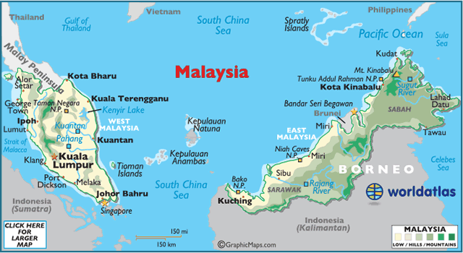

The life expectancy is 74.8 years.

Health Services

The total allocation to public health from the national budget is 8.6%. The total expenditure on health as a percentage of GDP is 4.5%. Of this, the total expenditure on health is 52.4%

The public healthcare system is divided into Secondary Health (hospitals) and Primary Health (clinics and community clinics). The public healthcare system comprises of 143 hospitals, 1 061 clinics, 1 808 community clinics and 6 flying doctor services.

4.2.1 Universal Health

Malaysia achieved independence in 1957. Universal health coverage was achieved in the 1980s, through general taxation, government revenue, social security, MoH and the local authority.

The PHC services were developed over time. Currently there are approximately 2 869 health clinics, which include the rural health teams and (about 203) mobile clinic teams. The aim is to decongest hospitals, and to improve the provision of effective health.

The Malaysian health system, through universal health coverage, is pro-poor. Patients pay 1 Malaysian Ringgit for consultation.

4.2.2 Refocusing Health Coverage

The Malaysian health system focuses on the following pillars:
- Infrastructure development.
- Human resources. This entails ensuring that healthcare providers do not work in silos, to improve access to healthcare.
- Operations or business process reengineering. This entails the establishment of urban transformation centres – implementing a multi-sectoral approach and offering one-stop centres. Further, this entails increasing access to ICT.
- Prevention of NCDs and strengthening population health. This entails refocusing for early detection, and improving communication skills. This also entails community empowerment through government agencies, to raise awareness and translating knowledge into practice.

CONCLUSION

The Select Committee on Social Services found the engagements experience by means of the Study Tour very enlightening. South Africa has similar policies and plans, however implementation seems to be a challenge, especially with the economic climate.

Water management, appreciation and saving mechanisms are important to ensure that South Africa supplies clean water to its citizens for various uses. Water responsibility and education on saving water is a theme that ran through all engagements that the Committee had. South Africa can start implementing these mechanisms at primary school level as part of the curriculum programme like, Life Skills. Children learn from an early age to appreciate and save water which is a necessity.

Both Singapore and Malaysia have great universal health coverage models. The concept of universal health coverage would alleviate many issues around providing much needed medical care to the population of South Africa. Singapore and Malaysia have proven that it can be done, and it works well in both countries. However, although it is envisioned by the South African Department of Health, it is health system that requires huge investment.

Overall, the Committee applauds the initiatives taken by these countries in trying to create a better life for all their citizens. The strategies implemented by the various countries can be achieved in South Africa, granted the right skills, planning and monitoring are put in place, in line with the required financial resources.

