3. REPORT OF THE SELECT COMMITTEE ON SOCIAL SERVICES ON AN OVERSIGHT VISIT TO THE SOL PLAATJE LOCAL MUNICIPALITY IN THE NORTHERN CAPE PROVINCE 14-18 AUGUST 2017

TABLE OF CONTENTS

1. INTRODUCTION 3
2. STRATEGIC FOCUS OF OVERSIGHT VISIT 3
2.1 Health 4
2.2 Human Settlements 4
2.3 Water and Sanitation 5
2.4 Social Development 5
3. FINDINGS, CHALLENGES & RECOMMENDATIONS: VISITED SITES 6
2.1 Kimberly Hospital 6
2.1.1 Findings 6
2.1.2 Challenges 8
2.1.3 Recommendations and Issues for follow-up 8
2.2 Galeshewe Community Health Centre/ Day Hospital 8
2.2.1 Findings 8
2.2.2 Challenges 9
2.2.3 Recommendations and Issues for follow-up 9
2.3 Military Veteran Housing and the revitalisation of mining towns, Lerato Park village 9
2.3.1 Findings 10
2.3.2 Challenges 10
2.3.3 Recommendations and Issues for follow-up 11
2.4 Lerato Place of Safety 11
2.4.1 Findings 11
2.4.2 Challenges 12
2.4.3 Recommendation and Issue for follow-up 13
2.5 Water and Sanitation 13
2.5.1 Findings 13
2.5.2 Challenges 15
2.5.3 Recommendation and Issue for follow-up 16
4. CONCLUSION 16

PARLIAMENTARY DELEGATION

- Ms LC Dlamini – Chairperson: Select Committee on Social Services
2. Mrs LL Zwane
3. Ms TK Mampuru – Whip
4. Mrs TG Mpambo-Sibhukwana
5. Ms PC Samka
6. Mr C Hattingh
7. Mr M Khawula
8. Ms D Ngwenya
9. Mr D Stock

PARLIAMENTARY OFFICIALS

- Ms Marcelle Williams – Committee Secretary
- Ms Thabile Ketye – Content Advisor
- Ms Zukiswa France – Committee Assistant
- Mr Mkhululi Molo – Committee Researcher
- Ms Jeanie Le Roux – Committee Researcher

INTRODUCTION

The Select Committee on Social Services (hereinafter, the Committee) conducted an oversight visit to the Northern Cape Province. The oversight visit took place during the week of 14 – 18 August 2017. The decision to conduct an oversight trip at Northern Cape followed a decision taken during the National Council of Province’s (NCOP) Strategic Planning session held on 1-2 September 2014 and Annual Planning Session held on 28 February-1 March 2017.

In line with the National Development Plan (NDP), Medium Term Strategic Framework (MTSF), priorities of the Fifth term of Parliament, and the mandate of the Committee, the oversight undertaken in Northern Cape focused on five key portfolios: Health, Water and Sanitation, Human Settlements and Social Development. This was done by visiting specific projects and programmes implemented by the above-stated Departments. In Northern Cape, the Committee visited the Sol Plaatje Local Municipality.

Key focus area per Department was identified. The Committee thus conducted oversight on Health services offered at Kimberley Hospital and Galeshewe Community Health Centre/ Day Hospital. In terms of Human Settlements the Committee focused on the Lerato Park military veteran’s project. In terms of Water and Sanitation the Committee focused on bulk water supply. Lastly, the Lerato Place of Safety was visited as an area relating to Social Development.

This report provides an overview of the areas the oversight focused on - highlights the findings from the sites that were visited, and reported challenges. Based on these, recommendations and issues for follow-up have been identified and made.

STRATEGIC FOCUS OF OVERSIGHT VISIT

The NDP serves as a premise to the Committee’s plan and programme of implementation as it highlights the importance of reaching a minimum standard of living for all South Africans by 2030. A key mechanism of realising this is through a holistic multi-pronged approach.

Health

A long and healthy life for all South Africans is Outcome/Priority 2 in the MTSF and NDP. Some of the targets geared at improving the health of the South African population include:

- Raising life expectancy to at least 70 years.
- Ensuring that the generation of under-20 year olds is largely free from HIV.
- Significantly reduce the burden of disease.
- Achieving an infant mortality rate of less than 20 deaths per 1 000 live births, and an under-5 mortality rate of less than 30 per 1 000.
- Construction of 213 clinics and community health centres, 43 hospitals; and refurbishment of over 870 health facilities in 11 national health insurance (NHI) pilot districts.
- Doubling of the number of people on ARTs from the present 2.4 million to a projected 5.1 million.
- Intensifying TB screening and treatment programmes for vulnerable groups, including 150 000 inmates of correctional services facilities, 500 000 mineworkers and an estimated 600 000 people living in mining communities.
- Vaccination of all girls in Grade 4 against the human papilloma virus, to significantly reduce their risk of acquiring cervical cancer in future.

For the purposes of this aspect of the oversight visit, the Committee visited the Kimberley Hospital and Galeshewe Community Health Centre/ Day Hospital. The focus visiting these two sites was on the availability of medicines, emergency medical services, infrastructure, human resources and Ideal Clinics status.

Human Settlements

Human settlements as defined in the NDP and other strategic policy documents, refers to a provision of not only houses but elements that will ensure people live in a community with all the basic amenities. A lot of infrastructure comes into play in relation to provision of human settlements. These include but are not limited to planning, building and provision of water and electricity. This also has its complexities because planning takes place at the local level; building of houses is a provincial level responsibility; and provision of water, sanitation and electricity is split between the departments responsible for bulk services and reticulation. Due to this the Committee met with all the respective role-players and stakeholders.

For the purposes of this aspect of the oversight visit, the Committee focused on the Lerato Park military veteran’s project.

Water and Sanitation

According to the NDP water is a strategic resource for critical socio-economic development. Further, it is acknowledged that South Africa is a water scarce country hence greater attention should be paid to water management and use. Moreover, it is acknowledged that water supply and sanitation services are vital for community health, development, cohesion and continued economic activity. It is within this context that the Committee focused on this sector during its oversight.

For the purposes of this aspect of the oversight visit, the Committee was briefed by the Provincial Manager of the Department of Water and Sanitation on bulk water supply.

Social Development

To implement the commitment in the NDP to realise a comprehensive, responsive and sustainable social protection system, the MTSF contains actions intended to:
- Improve efficiency in the delivery of social protection services;
- Address the exclusions by identifying and reaching those who are entitled to the existing benefits of social protection;
- Reduce the administrative bottlenecks that prevent people from accessing benefits; and
- Develop an enabling environment and create conditions for social partners such as the NGO sector to contribute to social protection.

The key targets that the MTSF seeks to achieve include:
- Ensuring that by 2024, an essential age- and developmentally stage-appropriate package of quality early childhood development (ECD) services is available and accessible to all young children and their caregivers.
- Universal access (at least 95% of eligible people) to social assistance benefits by 2019, notably the child support grant, disability grant and old age pension.

For the purposes of this aspect of the oversight visit, the Committee visited the Lerato Place of Safety. The focus was on the following:
- Management and operations of the facilities.
- Overview and assessment of the services offered.

FINDINGS, CHALLENGES & RECOMMENDATIONS: VISITED SITES

The Committee received briefings from the role-players and stakeholders in the form of PowerPoint presentations prior to undertaking site visits. The briefings were followed by discussions where the Members of Parliament (MPs) asked questions to explore and probe on issues raised (during the presentations), and during the site visits.

Information presented in this report therefore comes from the information collected from presentations, discussions and observations.

Kimberly Hospital

Findings
The Committee was taken to view the Kimberly Hospital and found that it is the only tertiary hospital in province (T1), the Regional hospital for eastern half of the province and a District hospital for Sol Plaatje district.

It comprises of the following:
- 671 operational beds
- 25,278 per annum inpatient admissions
- 168,195 per annum outpatients and emergency attendances
- 3,868 per annum births
- 72% bed utilisation rate
- 6.8 days average length of stay

The total budget allocated is R935 million. Of this amount, R635 million is for compensation of employees, R271 million is for goods and services, and R29 million for capital equipment.

The clinical staff complement is as follows:
- 486 Nurses (however there are 98 vacancies)
- 27 Specialists
- 168 Medical officers (including 60 community service/ trainee doctors)
- 60 Medical Interns

The delegation visited the maternity ward, radiology and intensive care units (ICUs). At the maternity ward it was reported that the facility has the best Kangaroo Mother Care and Milk Bank.

The Kangaroo Mother Care and Milk Bank is a 9 bedded unit which provides babies with warmth and nutrition by continuous skin to skin contact on a mother’s chest. In addition, child feeding is done on demand; sleep schedules are synchronised; there is temperature, heart rate and respiration regulation; there is quicker breastfeeding/initiation of breastfeeding. The delegation was informed that this unit enables bonding between mother and baby; increases growth rate; stabilizes the blood sugar levels of babies; and provides infants in need with donated safe pasteurized breast milk. In turn, this improves chances of survival as all the new moms are informed about the benefits of breastfeeding.

The Radiology unit comprises of a Picture Archiving and Communication System (PACS). The PACS stores digital images on a hard drive, which can be viewed on computers anywhere on the network. It has six general electric digital x-ray units: which produces 80,000 images per annum. In addition, it has a Lodox system (which is a full-body digital x-ray imaging device) that is used at the Emergency Centre. The Lodox system produces 380 full body and spinal scans. The Specialised Radiology unit has 65 slice computed tomography (CT) scanner, which produces ±10,000 images per annum; a magnetic resonance imaging (MRI) scanner, which produces ±1,700 scans per annum; and a Mammography unit, which produces ±4,000 examinations per annum.

The ICU has two Intensive Care Unit (ICU) sections, namely the Paediatrics and Adult units. The Paediatrics ICU has six specialist beds. It is for critically ill patients that need close observation and, post-operative patients that needs to recover fully. The Adult ICU has ten specialist beds. It is the Intensivist’s or critical care Physician’s decision to admit patients into the unit.

Challenges

The delegation was informed and observed the following key challenges:
- Ageing infrastructure. This includes sewage pipes, leaking rooves, lifts/elevators, lights, security, fire detection, heating, ventilation, and air conditioning (HVAC).
- Clinical staff shortages. This entails theatre capacity (orthopaedics, general and specialist surgery) obstetrics and gynaecology, neurosurgery, oncology, 72-hour mental health, critical care, renal dialysis. The provincial Department indicated that through a recent recruitment process, Specialist and General Nurses, Specialist Doctors, Medical Officer posts were filled. In addition, there are 60 Community Service Medical Officers.
- There are budgetary constraints, which lead to supply chain delays. The delegation was informed that the provincial Department is under administration form the province.

Recommendations and Issues for follow-up

The Committee recommended to the provincial Department of Health that the following takes place in the 2017/18 to 2019/20 financial years:
- The MRI machine should be replaced.
- An additional orthopaedic theatre should be opened.
- The old mental health unit should be replaced with new 20 beds unit.
- Six high care beds should be opened.
- A feasibility study prior to procuring radiotherapy equipment (linear accelerators and bunkers) should be undertaken.

Galeshewe Community Health Centre/ Day Hospital

Findings

The Committee was taken to view the Galeshewe Community Health Centre and found that it is a 24-hour facility. It is not fully functional. It offers an array of services. That is, maternity, paediatrics, x-ray unit, dentistry and pharmacy, physiotherapy and speech therapy. It is the only community health centre (CHC) in the Sol Plaatje district that assists border provinces as well. The pharmacy works well as it supplies other pharmacies in the district.

Challenges

The main challenges reported are:
- The CHC operates with nine doctors, of which four are community service (trainee) doctors that require supervision.
- Approximately 350 patients are seen per day. Thus, there is a high demand for services.
- The dental unit does not have essential equipment. The dental chair is not functional – it needs to be replaced. A suction machine and an air compressor are needed. Due to this, only extractions are performed.

Recommendations and Issues for follow-up

- The facility management staff should conduct a survey to assess various patient needs.
- The national Department of Health should assist with equipping the dental unit.
- The provincial Department of Health should recruit an additional Radiographer.

Military Veteran Housing and the revitalisation of mining towns, Lerato Park village

The Committee was briefed by the Department of Co-operative Governance, Human Settlements and Traditional Affairs (Coghsta). The delegation was informed that in terms of the revitalisation of mining towns national programme, the following Municipalities were named for interventions:
- Gamagara Local Municipality (located in Kathu)
- Ga-Segonyana Local Municipality (located in Kuruman)
- Tsantsabane Local Municipality (located in Postmasburg)

According to the Department of Coghsta, distressed mining towns are characterised by a widespread growth of informal settlements, distressed, stagnant and declining property markets with no major investment or renewal of infrastructure and general deterioration of public infrastructure. In addition, they are characterised by outward migration driven by a lower labour demand and weakening of the local economy, deterioration and vandalism of public infrastructure. Furthermore, community unrest and broken trust, labour concerns (job losses and loss of income) also contribute negatively.

It was reported that at the time of visit there were land acquisitions in progress. The Department had commissioned dolomitic investigations. From this process, detailed planning has begun for the upgrading of the promised land in Kuruman and 300 ventilation improved pit (VIP) toilets. The Department further reported that a dolomitic investigation is also underway for Tlhakalatlou informal settlement in Danielskuil.

In relation to the issuing of title deeds, the Department that the backlog was 24,865 at inception (of the project), during 2014. In 2016/17 there was a backlog of 3,222. The target for 2017/2018 is 9,500 properties and, 872 properties are to be registered in the first quarter of 2017/18. Figures for Lerato Park were not provided, however it was indicated that the issuing of title deeds would be underway.

Findings

The houses at Lerato Park are built with quality face brick but are incomplete. However, residents moved in - keys were handed over. The residents the delegation spoke with indicated that they had not yet received title deeds.

The houses the delegation viewed have two bedrooms. However, the delegation felt the second bedroom was too small. There are no stoves in the houses and some finishes need work.

Challenges

The following challenged were identified and noted:
- The houses are built on tribal land.
- At times the approved beneficiary is not occupying the house, but an illegal person.
- Regular deeds update on the national housing register is not done.
- Turnaround time at Vryburg deeds office needs to be improved
- Top funding for Military veterans has not been received, as the programme is being funded from the Human Settlements Development Grant (HSDG).
- Not all municipalities have erven available for the implementation of the military veterans programme.
- Very few municipalities have responded positively to the request for them to allocate land to the mv for formalization and servicing.

Recommendations and Issues for follow-up

- The title deeds should be transferred to the Kimberley deeds office by the Department of Coghsta.
- All the relevant departments should contribute to a fund in assisting the military veterans to get (proper) housing.
- The Department of Military Veterans should look at possible job opportunities for the Veterans, as they are unable to maintain their livelihood.
- A meeting should be held with the Minister of Human Settlements to address the size of the houses (number of the bedrooms, 3 bedroom instead of 2 bedroom), as it per the specification that was initially agreed upon.

Lerato Place of Safety

The Centre has been operational since 1991. It has been servicing boys and girls that are awaiting trial, and children in need of care and protection (including toddlers and children living with disabilities).

This is the only place of safety in the province. The Centre caters for 65 boys and girls and is divided into 3 sections:
- junior boys (aged 8-13 years),
- girls section (aged 9-17 years), and
- senior boys (ages 14-17 years).

There are 41 children at the internal school: Mimosa Primary. There are 19 children registered at mainstream schools, one is in Matric and one in a Technical and Vocational Education and Training (TVET) College. There are four children at a special school (3 boys and 1 girl).

Findings

The Committee was informed that the Centre has the following staff compliment an operational manager, two social workers, a professional nurse, team leader’s drivers, cleaners, grounds men, administration clerks and child and youth care workers. Admissions are done only when the relevant documentation is presented, providing for the immediate basic needs of children. A development assessment is done within 48 hours and a 5 day structured orientation programme for new intakes is completed. Registration of children at schools is also then done. Various developmental programmes are offered as well as recreational programmes, therapeutic and awareness programmes.

Programmes are monitored by the District and Provincial office. The Centre has a good relationship with SAPS, Correctional Services, faith-based organisations, NGO’s, corporate departments and various government departments. During February 2017, the children embarked on protest action against the centre. The Head of Department (HoD) intervened and the following concessions were made:
- Fixing of the electricity cable as the lights were not working properly.
- Improved allocation of toiletries, mattresses, door locks, tables and chairs, laundry and meals.
- Approval of vacant posts were signed by the HoD and MEC.

Challenges

The following challenges were noted by the delegation:
- There is limited movement for the children in terms of space.
- Children that are awaiting trial were not separated from other children.
- There are no structured and accredited programmes being attended by the youth care workers.
- There are staff shortages in the youth care unit.
- There are infrastructural challenges as the building is old and does not comply to the norms and standards of youth centres.
- There is insufficient office space for staff.
- At the time of the visit, the geyser was broken and there was no hot water. There were broken windows, it appeared that the children were not receiving adequate blankets to keep warm, and the floor tiles were chipped at the children’s dormitories. This means that the children are sleeping in very cold rooms and are exposed to harsh living conditions.

Recommendation and Issue for follow-up

- The Committee recommended that the Department try and find creative ways to assist the Centre in terms of staff requirements, vocational and accredited training for staff.
- Compliance to norms and standards of youth centres should be adhered to as awaiting trial children ought to be kept at a separate facility. The Department should follow-up on this.
- The national Department of Social Development should request National Treasury to allocate more funds so that the Centre can receive assistance with repairing the structural issues.
- The Provincial Department Managers should meet with Centre Management staff to resolve household issues.

Water and Sanitation

The Committee received a presentation by the Department of Water and sanitation.

Findings

The Department highlighted to the delegation that Northern Cape is a vast province, which covers a third of South Africa’s surface area. Most services are rendered from Kimberley resulting in long travel distances and response times. The province is viewed as an “unattractive” province for professionals which contributes to high staff turnover. There are language barriers, for example, the western region is largely Afrikaans speaking. The Northern Cape has 26 Local Municipalities and 5 District Municipalities. All the municipalities are designated Water Service Authorities.

This is reflected in the figure below.
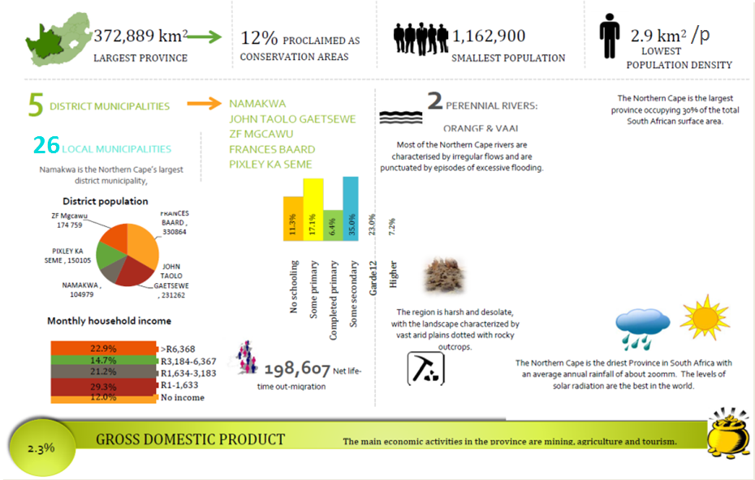

Trends in use of bucket toilets in South Africa: 2004 to 2014

The figure below shows the usage of bucket toilet system in South Africa. Although the consumer units that were using bucket toilets had decreased by 16%, it was still a high number at 84 065. 78% of these consumer units were located in two provinces, Eastern Cape and Free State. At Municipal level, 35% of the consumer units using bucket toilet was in Nelson Mandela Municipality.
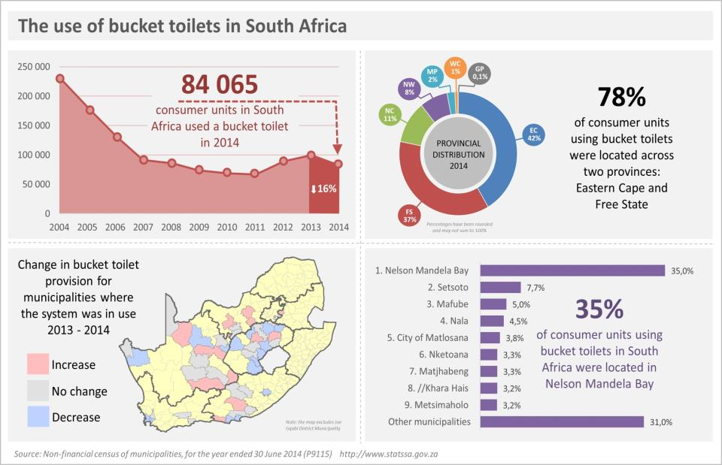

The cost of the sanitation and water infrastructure needs for Northern Cape are reflected in the two tables below.
SANITATION |  |  |  | SANITATION TOTAL
DM | INTERNAL BULK | REGIONAL BULK | RETICULATION
Frances Baard | 692 998 787.29 | 653 163 604.00 | 40 943 442.00 | 1 387 105 833.29
John Taolo Gaetsewe | 63 638 441.00 | 1 486 988 606.24 | 61 659 365.00 | 1 612 286 412.24
Namakwa | 332 524 611.00 | 143 703 704.00 | 100 363 922.00 | 576 592 237.00
Pixley Ka Seme | 326 406 521.00 | 242 808 691.00 | 351 425 229.00 | 920 640 441.00
ZF Mgcawu | 335 881 868.00 | 443 683 137.00 | 65 540 487.00 | 845 105 492.00
Grand Total | 1 751 450 228.29 | 2 970 347 742.24 | 619 932 445.00 | 5 341 730 415.53

DM | WATER |  |  | WATER TOTAL | GRAND TOTAL
 | Internal Bulk | Regional Bulk | Reticulation
Frances Baard | 414 182 634.56 | 18 300 643 854.00 | 798 713 140.00 | 19 513 539 628.56 | 20 900 645 461.85
John Taolo Gaetsewe | 1 771 737 876.82 | 1 837 062 018.00 | 307 255 779.34 | 3 916 055 674.16 | 5 528 342 086.40
Namakwa | 802 203 723.05 | 1 158 161 400.00 | 87 964 552.09 | 2 048 329 675.14 | 2 624 921 912.14
Pixley Ka Seme | 454 130 195.00 | 1 053 461 285.00 | 130 138 102.00 | 1 637 729 582.00 | 2 558 370 023.00
ZF Mgcawu | 878 619 707.41 | 2 164 305 775.22 | 105 075 920.59 | 3 148 001 403.22 | 3 993 106 895.22
Grand Total | 4 320 874 136.84 | 24 513 634 332.22 | 1 429 147 494.02 | 30 263 655 963.08 | 35 605 386 378.61

Challenges

The key challenges identified are as follows:
- Strengthening institutional capacity at the Department of Water and Sanitation and Water Service Authorities. The Department’s areas of concern include water use authorization, validation and verification, infrastructure, local government support, planning and regulation.
- Improve intergovernmental relations – synergy between/alignment of government programmes
- Water monitoring programmes – long term trends informing water use and management
- Mainstreaming water planning - planning upfront for water requirements – Northern Cape Planning Commission.
- Diversifying the water mix – desalination, re-use, artificial recharge.
- Water sector climate change response strategy – appropriate technology, water security, climate change resilient infrastructure.
- Promoting water conservation and demand management –reduction of leaks, metering.
- Water allocation reform and equity – from who sits round the table to allocation of water use entitlements, equity in water and sanitation services between urban and rural areas.
- Promoting and maintaining water quality – mine water management,.
- Changing water use behavior - nurturing attitudinal and behavioral changes towards the value of water – community engagement, participation and ownership
- Water infrastructure – integrated provincial infrastructure plan – role of private sector - Northern Cape Infrastructure Fund – rural water supply programme
- Refurbishment (infrastructure recapitalization) and operation and maintenance of water infrastructure.
- Financial sustainability relating to – water tariffs, social considerations, improving financial management, etc.
- Confirmation of co-funding by the City of Mbombela Local Municipality for Northern Nsikazi amounting to R101m is still outstanding.

Recommendation and Issue for follow-up

The Committee recommended that the bucket eradication programme be relooked.

CONCLUSION

The Committee undertook oversight on the Departments of Health, Human Settlements, Water and Sanitation and Social Development.

The sites were visited with various stakeholders and role-players, provincial and national Departmental officials. This proved to be a fruitful exercise as it enabled the stakeholders and role-players to see and understand progress made in relation to the projects.

The Committee deliberated and concluded that in the main, the following are crucial in strengthening the projects visited:
- Funding issues to be taken up with National Treasury- Northern Cape is a vast Province however the funds allocated to various portfolios are unable to cater to the needs of the Province.
- The importance of taking into account policy implications during the planning phase of projects.
- The need for strengthened inter-governmental relations and thus better coordinated collaboration.
- Comprehensive monitoring and reporting of progress.
- Continuous monitoring of the Lerato Place of Safety, and communication between the Department and centre management.

Following this undertaking, the Select Committee on Social Services will (continue to) undertake oversight on the identified projects.

Report to be considered

National Planning Commission (2012).
MTSF 2014-2019.

