**SUBMISSIONS**

**TO PARLIAMENTARY AD HOC COMMITTEE CONDUCTING INVESTIGATIONS INTO THE SABC BOARD**

**BY THE STAFF OF SABC**

**EMPLOYED AS INDEPENDENT CONTRACTOR/S**

17TH JANUARY 2017.

**PREAMBLE**

1.

**WHEREAS**

* 1. Dr. Ben Ngubane, during his appearance before the aforesaid Committee invited it to “interview the staff at the SABC”;
  2. Dr. Ben Ngubane’s evidence regarding the information supplied with regard to the contractual and employment obligations of the “staff at the SABC”, was unchallenged;
  3. The aforesaid evidence was given by Dr. Ben Ngubane, in relation specifically to the employment contractual affairs of the “staff” which, with the utmost respect, contained factual inaccuracies, as referred to herein;
  4. Accordingly, the undersigned, **do not agree** with the evidence presented by Dr. Ben Ngubane, in the following respects:  
     1. Mr. Motsoeneng helped establish trust between the Union and staff;
     2. By eliminating Labour Brokers, staff have received protection;
     3. As a result of the intervention by Mr. Motsoeneng, “staff at the SABC” were now “fully covered by all the benefits”

**NOW WHEREFORE**

* 1. The “staff at the SABC”, the undersigned, comprising of the persons employed for the SABC as independent contractors, do NOT agree with these presented facts as contained in the evidence of Dr. Ben Ngubane.
  2. Consequently the undersigned, wish to afford themselves of this opportunity to present this memorandum to the Honourable Committee members, in the hope that it clarifies the inaccuracies referred to in the testimony of Dr. Ben Ngubani, with the intention of assisting the Committee in their decisions regarding the affairs of the SABC and any recommendations they may make for the attention of any future Board.

**BACKGROUND TO THE EMPLOYMENT OF THE “STAFF AT SABC”**

* 1. The periods of employment of the undersigned “staff” for the SABC varies from 30 (thirty) years to 1 (one) year;
  2. The ages of the staff range from 28 years to 58 years;
  3. The undersigned persons occupy in various regions throughout the Country and in a variety of positions at the SABC, such as announcers, cameramen, video editors, bulletin writing, producers, sports reporters, desk writers, news and current affairs announcers etc., covering all the official languages;
  4. The group comprises of people of all races of both female and male. By far the greater majority of the group members are sole supporters of families between 2 and 12 persons;
  5. All of the members of the group have always been employed on contracts of “limited duration”, irrespective of the length of time employed at the SABC.
  6. These contracts were initially “fixed term” contracts, for fixed periods which were typically renewed annually or every two or three years. Typically these were generally identified as being linked to labour brokers, which was not the case.
  7. These contracts did not afford staff security of tenure of employment nor pension or Medical Aid benefits, hence protection afforded to employees under the Labour Relations Act, Basic Conditions of Employment Act and Workmen’s Compensation was never provided. This meant that, irrespective of the duration of the contract, the undersigned were never entitled to any benefits in respect of:  
     1. Paid sick, maternity and holiday leave, fair labour practises nor Union affiliation and protection.
  8. As a result of pressure from civil society and various Unions which decried the so called “fixed term” contracts, amendments were brought to the Labour Relations Act by way of Section 198.
  9. As a result of this amendment, in summary, subject for certain exceptions, which need not be dealt with within the auspices of these submissions, “fixed term” (temporary employment service) contracts could only be for an initial period of 3 months. Thereafter, any renewal of the contract, is deemed, in terms of the Amendment, became a contract of employment on a permanent basis.

**CURRENT FACTUAL MATRIX (in reply to the submissions made by Dr. Ben Ngubane)**

* 1. The undersigned have all, since their commencement at the SABC, individually and collectively approached management, to be provided with employment contracts in order that they could enjoy:  
     1. security of tenure;
     2. the benefits of paid annual holiday leave, sick leave and maternity leave;
     3. the protection of Workmen’s Compensation;
     4. membership to a pension fund and medical aid;
     5. Rights of affiliation to Union for collective bargaining;
     6. payment of subsistence and travel allowance before the cost is incurred;
  2. All attempts over the many years to rectify the above situation have NEVER been resolved to date. We challenge the SABC Board or management or Mr. Ngubane.
  3. The undersigned were promised new contracts. As a result the aforesaid “fixed term” contracts were replaced by carefully crafted contracts entitled “Memorandum of Agreement” or “Contract of Services” between the SABC and the staff member as INDEPENDENT CONTACTOR/S.
  4. In effect, the contracts were the same, except for the title of the undersigned, as “independent contractor/s”. A copy of such typical contract is annexed hereto, as evidence, marked **“A”**.
  5. These contracts have been for limited periods of time (e.g. 1, 2 or 3 years), earning an hourly rate, and in some instances, presented for immediate signature, there and then on the last day. The staff signed these contracts in some cases under duress, under the threat of having no contract and consequently, no employment. These contracts have always been, and continue to be unilateral without the option of negotiation of any terms thereof.
  6. The allegation by Dr. Ben Ngubane, that staff were pleased with the improvements in conditions of employment or that as a result of the intervention by Mr Motsoeneng, staff were all now, covered by the benefits, could be no further from the truth, nor reality.
  7. The effect of the Contracts which the undersigned have signed, means:  
     1. The tax rate deduction is 25%, for independent contractors, as opposed to the average of 18%, applied on a sliding scale dependent on remuneration.
     2. There is no entitlement or payment for holidays, sick leave or maternity leave. Recently one of the undersigned gave birth to a child, and had to return to work 2 weeks thereafter, or face the prospect of no income for her and her child. The staff collected money amongst themselves to afford the affected person to stay at home a little longer!
     3. No medical aid nor pension fund;
     4. The undersigned, had to assume all liability for themselves if injured at work i.e. no Workmen’s Compensation entitlement.
     5. Any entitlement to subsistence and travel allowance when work is required to be conducted away from home, must by funded by the undersigned up front as re-imbursement is only effected at the end of the month. All other employees who have an employment contract, that is that are permanently employed receive such expenses before the expense is incurred.
     6. No bonuses or entitlement thereto.
     7. Promises by management specifically Mr. Motsoeneng, of “sweeteners”, once-off payments to staff, such as sums of R10, 000.00 for specific events requiring exceptional work load, e.g. World Cup or late President Mandela’s funeral, never materialized.
  8. The undersigned have documented over the years, their dissatisfaction with the contracts in respect of:  
     1. Being devoid of any benefits as contained in the Labour Relations Act, and Basic Conditions of Employment Act.
     2. As a result Mr. Motsoeneng made a commitment during at least two meetings, to rectify the situation by converting the Independent Contractor Agreements to normal Employment Contracts.
  9. Regrettably these promises never materialised. What did materialise was Mr. Motsoeneng receiving a 63% salary increase but some of the undersigned receive in terms of their contracts, as little as, R 60.00 and R 147.00 per hour! Some of these employees have the same scholastic qualifications as Mr. Motsoeneng!

**CONCLUSION**

* 1. It is **not true** that the Board and Mr Motsoeneng have ensured that “staff are fully covered by all benefits”
  2. It is a travesty of injustice that the SABC, which as a state owned enterprise, should be protecting its employees, but instead it is the very organization that has deliberately, robbed its employees of the benefits and rights contained in the Labour Law.
  3. It is a well-known fact that the current Labour Legislation in our Country is one of the most advanced in the world, but the irony is that, the organisation which is owned by the State does not follow it by taking care of its employees, many of whom are reaching retirement age, without any financial security.
  4. For these reasons alone, it is our submission that the Board has totally failed in the performance of its functions and in proper governance as it has only acted in the interests of its own members. It has failed to act in the interests of those who have loyally dedicated themselves for the benefit of the Country by making it possible to bring the news into every citizen’s home, irrespective of their financial status.

**SIGNED BY THE STAFF AT THE SABC AS SET OUT HERETO.**

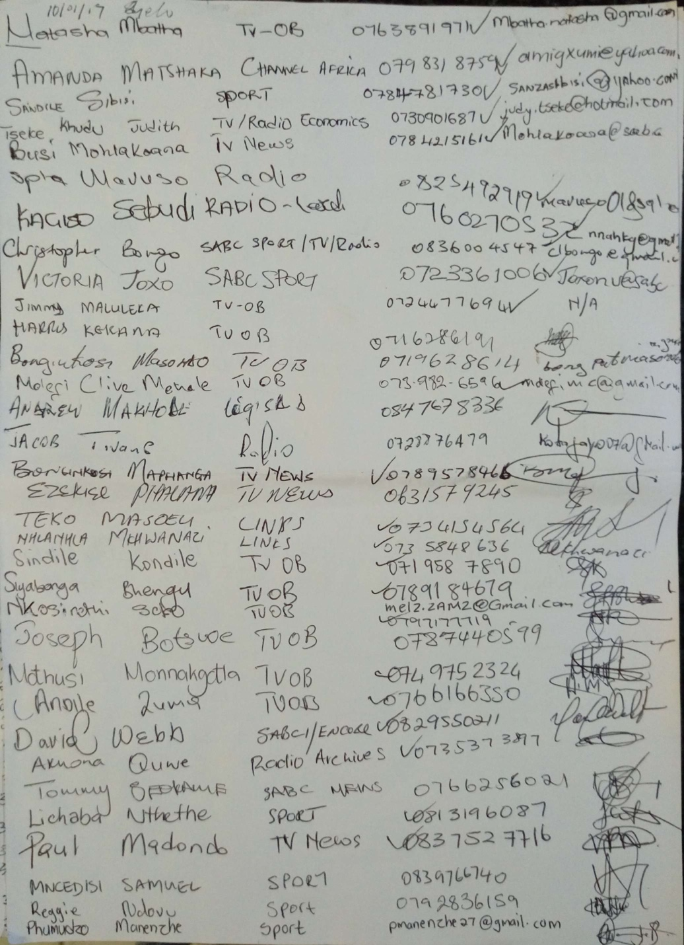

cid:FE7F5C0E-F88B-48EE-8BCE-4402A7ADDCBB

