**MANDATE FOR BUDGET 2018**

Final: 24 August 2017

# **CONTENTS**

1. Introduction
2. Objectives of the Mandate Paper
3. The National Development Plan (NDP): Targets and levers
4. Socio-economic and fiscal context and the current challenge
5. Process for prioritisation and the Mandate Paper
6. Proposals from the previous Budget
7. Key priorities for the 2018 Budget under the NDP Strategic Levers
8. Mandate Paper 2018 Budget Priorities
9. Summary of Priorities for 2018/19
10. Conclusion

**A INTRODUCTION**

In 2016, Cabinet identified the need to strengthen the alignment of the South African Budget, the Medium-Term Strategic Framework (MTSF) and the National Development Plan (NDP), and for budget prioritisation to focus on the last 24 months of the current administration. The Department of Planning, Monitoring and Evaluation (DPME) and the National Treasury (NT) were instructed to develop a Mandate Paper to guide the budget process for 2018, to ensure a focused implementation of Government’s plans.

**B OBJECTIVES OF THE MANDATE PAPER**

Government plans are implemented at different levels across the three spheres of Government (national, provincial and local) and across a large number of public entities and State-owned Companies. The Mandate Paper aims to guide all spheres of Government and all Government entities to refine plans and develop budget proposals. The Mandate Paper therefore has to consider the specific functions and strengths of these institutions as well as the various pressures they face.

The Mandate Paper’s objective is to establish the strategic framework for decision-making on budget priorities that are required to advance the goals of the National Development Plan (NDP). It seeks to establish a systematic basis for making strategic choices among competing priorities and limited resources, in order to better optimise the budget as a key lever for driving the NDP.

The Mandate Paper further sets out a broad set of prioritisation criteria which should guide the consideration of budget proposals for 2018/2019. It does not indicate specific funding allocations, which is part of the budget process led by National Treasury, but makes recommendations on the priorities which will focus the Budget on the achievement of the goals of the NDP.

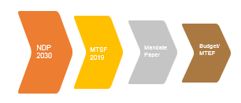

The Mandate Paper does not supplant other Government plans such as the NDP, nor is it about ad hoc priorities. It is not a comprehensive policy analysis tool and agenda which are dealt with by the MTSF recommendation for the balance of the term of Office. In fact, its point of departure is South Africa’s development goals and objectives as embodied in the NDP. It seeks to reinforce initiatives that have the greatest growth and transformative impact in terms of the NDP goals and targets and that must be prioritised in the budget and in decision-making. In this regard, the Mandate Paper is firmly focused on the outcomes spelt out in the NDP and the MTSF, of a decent life for all South Africans, the eradication of poverty and the reduction of unemployment and inequality.

In this way the Mandate Paper seeks to tighten the alignment between the budget and implementation plans of all National, Provincial and Local Government departments, public entities and State Owned Companies.

The prioritisation process led by DPME will take place prior to National Treasury’s budget or Medium-Term Expenditure Committee (MTEC) process and is led by the DPME. The Mandate Paper as approved by Cabinet therefore sets specific priorities aligned with the NDP in the existing socio-economic context in order to guide the detailed allocation of funding by National Treasury, and in this way ensure that the budget better advances national developmental goals.

The practice of strategically framing and priority setting for budget allocation is prevalent in many countries, particularly countries that have adopted and are implementing National Development Plans (NDPs). The practice in other countries has a clear legal and institutional basis with varying levels of maturity. Common elements of NDPs and Budget Prioritisation Frameworks include:

* Firm commitment within and outside government to the long-term development vision and priorities for the country, a clear strategy to advance the vision and key performance targets.
* Alignment between the priority setting process and the Budget process
* Recognition that development needs often outstrip the availability of resources.
* Alignment between priority setting and the budget process often involves trade-offs and is informed by the specific socio-economic context.
* Transparent and formal consultations, including public participation
* Legal and operational enforceability of decisions and resource allocations by the political executive.

South Africa had a number of the above elements in place, with the exception of a strong alignment between the priority setting process and the Budget process. The Mandate Paper process seeks to overcome this gap. The South African Mandate Paper process will however, need to be reinforced and formalised institutionally and legally through practice notes and directives. This will be addressed in proposals for legislation by DPME to clarify and institutionalise South Africa’s planning system. Consultations within and outside Government are planned on this in the coming months.

Moreover, in order to be an effective guide to planning and budgeting at national, provincial and local spheres, it is envisaged that in the next financial year the process for developing the Mandate Paper will have to be brought earlier in the annual planning cycle. The proposal is for the Mandate Paper to be finalised by April 30th of every year to guide the preparation of budgets in the May to July process.

Therefore, the Mandate Paper has a three-fold purpose:

1. Improve the alignment between the budget and the NDP and;
2. Serve as a framework for resource-allocation decisions in the context of rising budgetary demands, weak economic and revenue growth, as well as a commitment to fiscal consolidation.
3. Guide all spheres of Government and all Government entities to refine plans and develop budget proposals.

The outline of this Mandate Paper therefore:

* spells out the priorities and targets of the NDP.
* summarises the current economic, social and fiscal context for planning and the budget.
* outlines out the process and criteria for prioritisation, and of reprioritisation for Budget 2018 particularly in the context of fiscal constraints;
* reviews the priorities in Government spending of Budget 2017; and
* identifies the key national priorities and mandates for the 2018 Budget.

**C THE NATIONAL DEVELOPMENT PLAN: TARGETS AND LEVERS**

The NDP was adopted in 2012 and sets out a vision and framework for pursuing radical social and economic transformation. It sets the key South African priorities which is to ***eradicate poverty*** by 2030 and to substantially ***reduce unemployment and inequality***. As indicated in Figure 1, the NDP targets zero per cent poverty in 2030 and reduced unemployment and inequality. The figure also provides the interpolated, implicit targets for 2015. The NDP sees significant ***employment growth*** (reducing unemployment from 25 per cent in 2010 to 6 per cent in 2030) and **economic growth** (average growth of 5.4 per cent per year between 2012 and 2030) as the key means of achieving these targets.

Figure 1: Transformation targets in the NDP

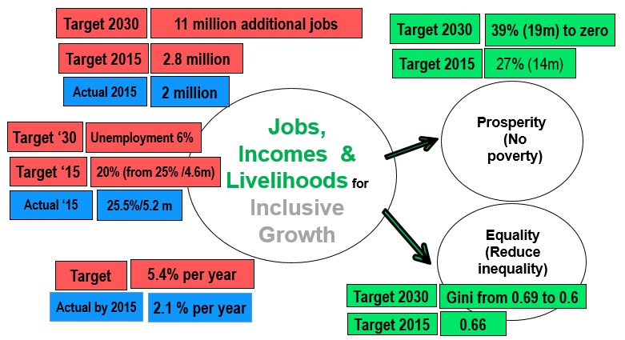

The NDP aims to mobilise South Africans around a common strategy built on 3 broad pillars or levers (as shown in figure 2), namely:

* + Building a stronger and more inclusive economy for faster employment and income growth;
  + Enhancing the capacities of South Africans through providing social services including quality education, skills development, health and social protection; and
  + Building the capability of the state to play a leading role in South Africa’s economic, social and political development.

These pillars are designed to support economic growth and incomes through generating jobs and livelihoods. The impact of this will be increased prosperity and a reduction in inequality.

In order for Government to be effective in progressively bringing about socio-economic transformation, it is critical that it be focused and consistent in decisions about where and how much to invest (e.g. skills, infrastructure, science and technology and beneficiation) and which capacities to build (planning and coordination systems) in line with the long-term trajectory of the NDP.

Increased investment in science, technology and innovation is critical to ensure the competitiveness of the South African economy and our ability to raise living standards sustainably. Following on the digital revolution, a range of new technologies such as big data, the Internet of Things, artificial intelligence and genome mapping, components of what is being referred to as the Fourth Industrial Revolution, are sweeping the world. South Africa has to be part of this revolution, advancing and harnessing these technologies to improve living standards.

The Mandate Paper is intended to assist in linking such short to medium-term decisions to long-term outcomes.

Figure 2: Pillars of the NDP: Main levers to grow jobs, livelihoods and the economy in order to reduce poverty and inequality

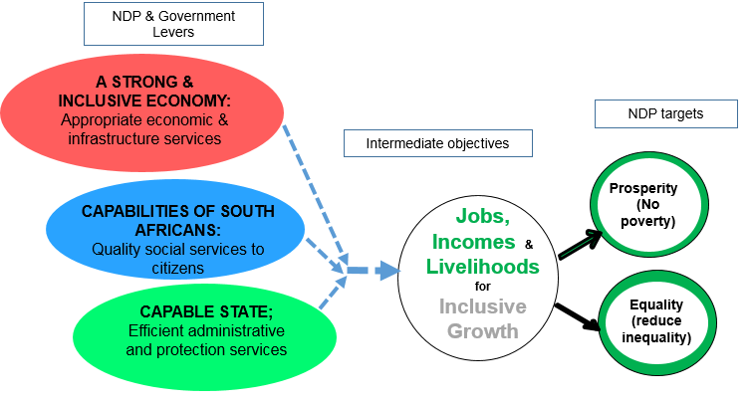

# **D THE SOCIO-ECONOMIC AND FISCAL CONTEXT**

After recovering somewhat from the recession of 2008, the South African economy has seen a progressive worsening of economic growth. The economy shrunk by about 1.5 per cent in 2008 and achieved positive growth rates of around 3 per cent 2009 and 2010. However, from 2011 onward growth decelerated (Figure 3) by 1 per cent per year to almost 0 per cent in 2015. In 2016 the economy shrunk further, this time by just more than 1 per cent. These low and negative growth rates translate into declining average incomes for South Africans, impacting most severely on those at the lower end of the income distribution.

The economic slowdown has been accompanied by lower levels of employment creation and increasing inequality. The graph below illustrates how growth has slowed, in contrast to the NDP targets of 5.4 per cent per year for GDP and 2.9 per cent for employment creation by 2030.

Figure 3: Economic and employment growth rates compared to National Development Plan targets (2000 to 2016)

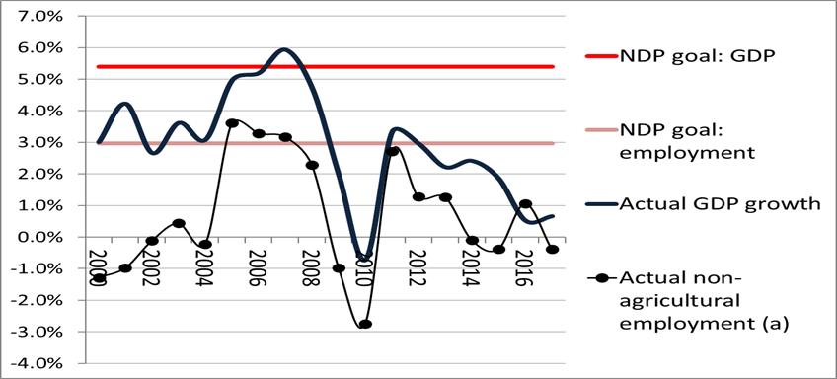

Sources: Stats SA and South African Reserve Bank

If the current trends continue, it is unlikely that South Africa will achieve the NDP goals progress and transformational targets set out. The current economic crisis underscores the need to develop more effective strategies for dealing with economic challenges. Furthermore, it requires a prioritisation framework to ensure Government priorities are appropriately aimed at urgently turning this dire situation around.

This situation is being referred to by commentators as a “low growth trap” for South Africa and impedes the economy’s ability to curb unemployment and inequality. It could also become “a vicious circle of falling growth and rising debt.” (IMF, 2016).

The growth slowdown can be related to both global and domestic factors. The global economic slowdown, downturn of the commodity cycle, and slowdown of economic growth in China, have reduced the demand and prices of South African exports. In addition to these international trends, slow rates of socio-economic transformation have resulted in growing protests in poor areas and at higher education institutions in South Africa. The political environment, increasing evidence of corruption and a governance crisis at prominent State-Owned Companies (SOCs) have also negatively influenced levels of trust between business, government, and citizens.

There has been a sharp fall in investor confidence, reflected in the 5 per cent fall in private investment in the year to the first quarter of 2017, the second largest fall in private investment since 1994. (surpassed only in 2009 at the height of the global financial crisis). SOCs also saw declining investment, in part because of constraints on their income and borrowing.

The declining rate of growth has impacted dramatically on the national fiscus. Low growth together with rising costs (especially wage costs) and expenditure pressures have led to an inability to reduce the national deficit much below the 4.6 per cent of GDP mark. The substantial annual deficits saw the country’s debt to GDP ratio increase from below 30 per cent in 2009 to 45.4 per cent in 2016 and government debt cost absorbing 10 per cent of the national budget as shown below.

Figure 4: Recent growth and weakening of the Government fiscal situation



Source: South African Reserve Bank

Increasing debt costs in combination with slowing revenue growth has made it necessary to reduce medium-term allocations of government departments and provinces and to increase taxation in the last two fiscal years (2016/17 and 2017/18) in order to stay within the agreed fiscal framework.

While overall government expenditure growth has remained positive in real terms, some departments have seen cuts to their budgets and to the purchasing power of their allocations due to remuneration growth above inflation. Over the three years (as shown in Table 1) between 2016/17 and 2019/20 general government expenditure (including debt service cost) is expected to increase by just less than 2 per cent per year (1.2 per cent excluding debt service cost). The Agriculture, Rural Development and Land Reform and General Public Services groups are projected to decline in real terms (by 1.1 per cent and 3.3 per cent per annum respectively).

Table 1: Real growth and projected real growth in real general government spending 2013/14 to 2016/17 and 2016/17 to 2019/20, by function group



Source: Own calculations from National Treasury Budget data

# **E PRIORITISATION CRITERIA AND THE MANDATE PAPER**

The context and challenges for planning processes and 2018 Budget are therefore clear: “**accelerate growth and socio-economic** **transformation”**. This has to happen in the context of very slow real budget growth and with a number of expenditure items accelerating faster than inflation, importantly the wage bill but also debt service cost which is under further pressure from credit rating downgrades.

Given insufficient economic growth and socio-economic transformation, a tight alignment of the NDP and the Budget is required. This means ensuring that priorities in the plan are adequately funded, funds are reallocated from non-core and non-performing programmes and that the funding is used appropriately for more urgent interventions.

The South African government will in 2017/18 spend approximately R1.5 trillion (about a third of GDP) of which nearly a third is on goods and services. The Budget Mandate process is therefore a very important element of implementing government plans, re-examining focus and previous budget allocations and reprioritisation to ensure socio-economic transformation.

The purpose of the Mandate Paper is to function as a **shorter-term instrument of national planning, building on the NDP and the MTSF,** to refine objectives and approaches given the prevailing socio-economic context and ensuring that resource strategies (budgets) are aligned with the NDP. Such mandating entails taking stock against various criteria.

**Prioritisation** **Criteria** and decisions about how much to spend used in this Mandate Paper include:

1. Inefficiencies and opportunities for savings;

2. Key policy and implementation blockages where critical decisions have to be made;

3. Enhancing the transformative impact of spending; and

4. Priority areas for spending including cost pressures and catalytic projects.

These are discussed below.

**Effectiveness and efficiency of spending and potential savings and reallocations**

The South African general government revenues totalled slightly more than 30 per cent of GDP in 2010 as shown Figure 5. The diagram shows that while the South African government’s role in the economy as measured by government revenue as a proportion of gross domestic product (GDP) is below that of Brazil (at 45 per cent) it exceeds the average of around 24 per cent for a range of developing countries. The South African government revenue to GDP ratio in 2010 was similar to that of Bolivia and Argentina but higher than in countries like Russia, Chile, Sri Lanka and Mexico.

**Figure 5: Government revenue as proportion of GDP, group of middle income countries, circa 2010**

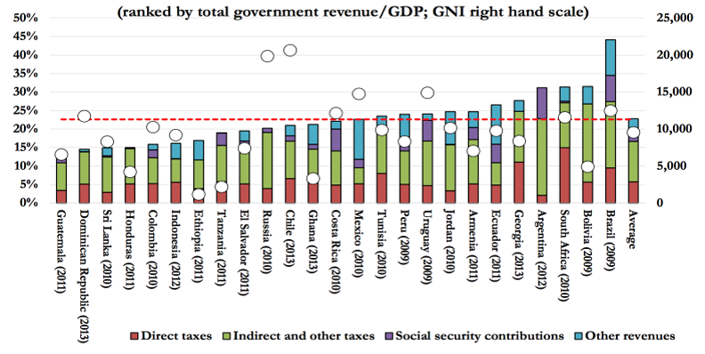

Source: UNU-Wider from Lusting 2017

In addition to identifying areas where more spending is required the budget process must assess whether current spending is efficient and effective, especially in the context of slow growth and constrained funding. If current spending is ineffective or inefficient, changes can be made to delivery to increase output and impact, or funds could be reallocated to other areas with higher returns or better use. Whether society is getting value for money is therefore a key concern of this prioritisation process.

Over time, to generate savings, it will be necessary to take a more systematic approach to different types of inefficiencies and how they can be dealt with. Three broad “types” of inefficiencies can be identified, namely fragmentation, overlap and duplications; operational inefficiencies; and corruption.

* ***Fragmentation, overlap and duplication***. This is when more than one Government agency is involved in delivery of the same service or activity, or where responsibility for a specific area is spread among a number of departments or units.
* ***Multiplicity of funding systems.*** Wherever there are existing multiple funding, grants, and transfers and government programmes, the aim must to consolidate, integrate and streamline into single funding programmes. Targets in this regard are municipal infrastructure funding, scholarships, student financial aid and bursary and the funding of training.
* ***Inefficient operations, inappropriate service delivery models, or inappropriate policy balance.*** Inefficient operations can exist where a department’s production process for certain outputs (e.g. textbook delivery or employment incentives or labour market regulation) are not well-understood so that time or resources (both of civil servants and of citizens) such as labour may be wasted. In this regard, rapid development in information and communication technology has made it much easier to monitor processes with greater ease and provide management information to assess and improve efficiency.
* ***Inappropriate service delivery models or programmes*** where designs are flawed can be found in many aspects of government business. One example is where government itself undertakes parts of service delivery which could be more efficiently undertaken by other institutions. If service delivery models are not appropriate, advantages and capacities of various services providers and quality may suffer or costs will be too high. Related to inappropriate service delivery models, quality and cost will also suffer if there is “policy imbalance”, such as where there is too much expenditure on the inappropriate and expensive levels of delivery (e.g. curative rather than preventative care).
* ***Corruption***, where state resources for certain services are diverted towards private use rather than public good. Corruption generally increases the cost of government service delivery or obstructs it with the result that citizens do not receive much needed services or value for money, and levels of trust in government decrease. Over time it, therefore, undermines the public finance system and government service delivery. Corruption must therefore be rooted out as far as possible both through law enforcement and a “Whole of Government and Societal Approach”.

**Enhancing the transformative impact of Government spending**

In the 2017 Budget, the Minister of Finance estimated that in 2017/18 government will spend about R500 billion (a third of the budget) on acquiring infrastructure and operational inputs (goods and services). This underlines the importance of public procurement as a strategy for “developing local industries, broadening economic participation and creating work opportunities”.

The concern, however, is that more than 20 years after democracy, not only do apartheid patterns persist but current public spending locks the bulk of South Africans out of participating fully in the economy and society. A typical trend seems to be a bias towards subsidising large corporates with less attention being paid to informal and small suppliers or steps to change the apartheid structure of the South African economy. While the 2017 Budget announced further measures to strengthen procurement from smaller suppliers, stronger efforts as well as monitoring and support will be required to eliminate ‘fronting’, reduce market dominance and promote localisation.

Empowerment of the youth, women and protection of children must be mainstreamed in all government programmes.

**Spending Priorities**

The fourth area of prioritisation is to identify and rank programmes and projects where additional spending is a high priority. Such priorities may develop because of too low spending in areas which will support growth into the future, and where delivery frameworks are at an advanced stage of finalisation (early childhood development, youth unemployment, economic infrastructure), or areas of service delivery where cost increases or previous spending cuts will lead to lower access to services or lower quality. At a time when the budget is not growing in real terms and some cost trends are absorbing larger parts of the funding (government debt cost and wage pressures) priority spending areas have to be funded out of cuts in other areas of spending.

**Key policy decisions and policy certainty in specific areas.**

In a number of sectors government spending is therefore not the primary issue compared to government policy and regulation in creating certainty and to reduce risk for investment. Uncertainty about funding mechanisms and distribution of costs will not only retard investment but also leave room for the shifting of large costs, sometimes emergency costs, onto the government Budget.

The prioritisation process therefore draws attention to those areas where spending by government is not necessarily the missing element to open up opportunities and promote inclusive growth, but where quick policy decisions, removal of policy uncertainty and implementable projects are necessary to unlock further opportunities for government and private investment, and in turn economic growth, job creation and poverty alleviation.

**Broad NDP Levers for prioritisation**

Approaching prioritisation as outlined above provides government with three broad levers to push forward transformation and break the threatening low-growth trap, namely, economic services, social services and administrative services (which includes the critical safety and security functions). For each of these three levers the questions being asked are:

* What are the areas where efficiency can be improved and savings generated?
* What are the critical outstanding policy issues?
* How can the transformative impact of spending be enhanced? and
* What are the new priority areas of spending? (See Figure 6 for an overview)

**Figure 6: The three broad levers of the NDP and elements of prioritisation to apply to each of them**

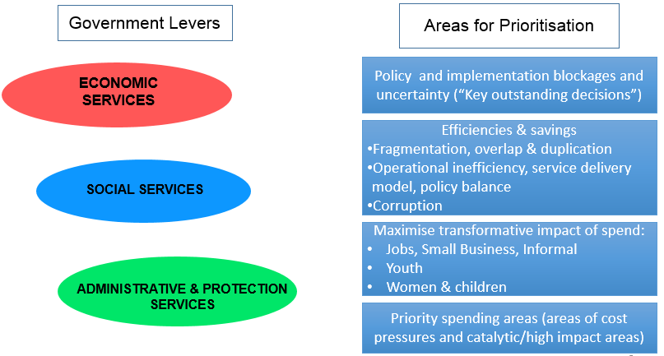

**F PROPOSALS FROM THE PREVIOUS BUDGET**

**Efficiency and savings identified for the 2017 Budget**

The prioritisation and budget processes were confronted with many spending pressures and priorities from departments, but no clear proposals or cases could be made where significant savings could be derived as a result of inefficiencies and duplication of services. It was concluded that an across-the board cut of departments within the broad principles of prioritisation should be adopted. In addition, it was pointed out that savings could be made by postponing capital projects where operational funding is at any rate not yet secured, and investigate transfers to government entities with significant surpluses.

It was noted that procurement reform to increase efficiency and reduce corruption should continue.

Generally, it was believed that room exists for greater cooperation and removing duplication in government. For example, it was noted that capacity-building in government could be rationalised including support to local governments from national and provincial. Better coordination and rationalisation in the agricultural sector (especially small farmer support) and small-business support were also identified as areas of significant duplication.

**Key policy decisions and policy uncertainty**

The 2016 Mandate Paper identified the priorities as a number of areas where delays in decisions or uncertainties are believed to have impacted on economic activity and the growth potential of the economy. A number of these areas were again highlighted by the President in his State of the Nation speech in February 2017. The list included:

* The Minerals and Petroleum Regulation and Development Act (MPRDA) Amendment Bill.
* The NEDLAC agreement on a minimum wage, strike balloting, compulsory advisory arbitration and a code of good practice on collective bargaining and industrial action.
* The finalisation of the Integrated Energy Plan (IEP) and Integrated Resource Plan (IRP). The IEP and IRP must provide certainty on energy mix as well as a clear electricity pricing path.
* Expediting broadband rollout; which is dependent on finalizing the approach for digital TV.
* Strengthening competition in agricultural inputs (notably fertilizers). SA charges on average 78 per cent more for fertilisers compared to USA.
* Asserting the importance of maintenance and rehabilitation of municipal infrastructure. Municipal assets valued at current replacement cost of R1.26 trillion face a risk according to the National Treasury.
* Considering the strategic importance of State-Owned Companies in promoting economic growth and transformation, and the concern about governance of these SOCs.

Other than the minimum wage, these matters are yet to be fully resolved and will thus feature in the current mandate paper.

**Priorities identified for the previous Budget**

While a large number of spending issues were identified for the 2017 Budget, it was realised that the tight fiscal environment would not allow for substantial spending increases beyond the baseline. In this context a three-pronged approach was proposed:

* Strengthen support for skills development through additional spending on post-school training and skills development as a key driver of the economy and to promote stability in this key sector.
* Generally social service budgets continued to grow at rates higher than inflation and the general principle was to maintain real levels of spend on the poor (with sufficient funding in the baseline for inflation-related grant increases, and education and health growing by slightly more than inflation).
* Maintain infrastructure spend in real terms, particularly municipal infrastructure. More generally, the focus should be on the efficiency and effectiveness of spending.

**Approach and allocations of the previous Budget**

The final proposals on areas for prioritisation and their funding in Budget 2017 are summarised in Table 2 (savings in order to deal with revenue slowdown and priorities) and Table 3 (areas where allocations were increased above the baseline). Cuts to MTEF baselines affected the national, provincial and local spheres as well as public entities and were used primarily to increase the allocation to post-school education and training.

The result was that while the overall budget still grew in real terms (by about 1.2 per cent per year excluding debt service cost), some function areas saw real declines over the MTEF, namely Agriculture, Rural Development and Land Reform, Defence, Public Order and Policing and General Public Services. Transfers to households (mostly social grants) continued to grow in real terms (by about 1.8 per cent per year) over the MTEF while government spending on buildings and other capital assets remained constant in real terms.

Table 2: Baseline reductions by sphere of government, Budget 2017/18



Table 3: Allocation of baseline reductions, Budget 2017/18



# **G KEY PRIORITIES FOR THE 2018 BUDGET UNDER THE NDP STRATEGIC LEVERS**

**Internal reprioritisation**

Given the declines in economic growth and government revenue growth, the 2018/19 Budget will not have funds available to increase spending above the baseline. As in Budget 2017, general cuts may have to be administered to departmental baselines in order to fund unexpected and emergency spending. It is clear that internal reprioritisation within government clusters and government departments is needed to drive key NDP and MTSF targets. In other words, departments will have to reduce and eliminate non-core, non-performing programmes, particularly those not in line with NDP goals.

All departments will need to ensure that NDP priority actions identified through the midterm review of the Medium-Term Strategic Framework are appropriately resourced and implemented through an internal reprioritisation process of redirecting resources and capacities away from non-core and non-performing programmes to the priority actions. All non-core and non-performing programmes must be reviewed.

In reprioritisation there are a number of potential areas to focus on:

* 1. Cutting non-core (i.e. not aligned to NDP) and non-performing programmes (relative to MTSF targets and indicators). DPME monitoring evaluation findings and National Treasury expenditure reviews will be part of the instruments used.
  2. Limiting the use of consultants by capping this expenditure item. This should target the use of goods and services budget for consultants to do work for which departments and entities have employed in-house capacity. This could later extend to assessment of the use of consultants in large capital projects.
  3. Strict limits on contingency liabilities and litigation costs (through a mechanism with the Department of Justice and Constitutional Development to determine cases to be defended or resolved through arbitration)
  4. Optimise state procurement by setting pricing parameters and centralise procurement of major items, as well as improve capacity for contract management and compliance with procurement regulations. The initiatives of the Chief Procurement Officer (OCP) in this regard, including the compiling of price reference lists, need to come into effect.
  5. Improve returns and value for money on state infrastructure projects (e.g., combat collusion and strengthen project and contract management capacity to prevent cost escalations due to delays). This will require systematic collaboration between the OCP and the Competition Commission, building on the recent success of the Commission in this area.
  6. Insist on good governance in SOC and public entities and penalise governance lapses by withholding transfers and/or guarantees. Particular attention should be given to SOCs and public entities where such lapses are endemic.

Efficiencies and savings must also be explored in general administration budgets through one stop shop investment centres, shared services and intergovernmental coordination.

Relevant Government Departments, SOCs and Public must also maximise revenue-generating opportunities and alternative funding sources.

**Growing and transforming the economy**

For the economy to grow government must provide policy and regulatory certainty, direct state investment to support economic growth and play a critical role in transforming the economy. The key mechanisms through which Government supports the building of the economy are ensuring workers have skills (through the post-school education and training system and the skills development system), providing appropriate infrastructure and effective regulation (e.g. through industrial relations or competition law enforcement) and by providing incentives or subsidies to promote economic activities and investment.

These instruments of economic policy (skills development, infrastructure investment, regulation and incentives/subsidisation) are also highlighted in the NDP as important to reduce the cost of doing business and improve the competitiveness of the economy. Following on this, government adopted the Nine-Point Plan in 2015 as a more detailed framework for driving economic transformation.

The Nine-Point Plan identifies certain cross-cutting input areas that need to be managed effectively to ensure the competitiveness of businesses, some key enablers and a number of targeted sectors or job drivers.The **cross-cutting areas** are information and communication technology (including the acceleration of Connect), transport infrastructure, science and technology for innovation, and water infrastructure and services. Boosting the role of state-owned companies in a number of these areas is also a priority. The **central enablers** are resolving the energy challenge, managing workplace conflict and scaling up private sector investment.

The focus sectors in the Nine-Point Plan are agriculture and the agro-processing value chain, effective implementation of a high-impact Industrial Policy Action Plan (IPAP), mineral beneficiation, unlocking the potential of small and medium enterprises, specifically in townships and rural areas, and growing the oceans economy.

Programmes and projects aligned with the Nine-Point Plan continue to be rolled out, boosting investment and production. One example is the May 2017 launch of the **IPAP** 2016/17-2017/18 which confirms government support to lock in private sector investment in a range of sectors, including clothing, textiles and footwear; business process services; film; agro-processing; metal fabrication including capital and rail transport equipment; green industries; automotive; chemicals, cosmetics, plastics and pharmaceutical; beneficiation; upstream oil and gas and boatbuilding.

South Africa needs to strengthen local procurement by finalising the Procurement Bill as well as ensuring local suppliers can expand capacity through enforcement of product designations and local procurement requirements. This will require more effective systems of verification and monitoring of compliance. Localisation programmes such as the solar water heater programme must be prioritised for SMMEs and youth employment.

More broadly, to improve the ease of investment, the dti reported progress with reducing regulatory and process barriers and strengthening inter-governmental coordination through new One-Stop Investment Centres.

The mobilisation of finance (including through the Industrial Development Corporation), the oversight of competition policy, and using settlements with competition offenders to boost key policies such as localisation and driving the Strategic Infrastructure Projects remain very important.

Infrastructure investments open up economic opportunities and foster the competitiveness of both large and small businesses, while ensuring service delivery to our citizens. The key investments in network infrastructure such as energy and water must therefore continue, but other critical areas such as rural access roads, township infrastructure, as well as hospitals and schools should also receive attention. Maintenance of infrastructure, particularly local government infrastructure, is critical.

Land restitution and land reform remains a foundation for reversing past injustices and giving wider access to economic opportunities. In this context, it is important for backlog land restitution to be funded and finalised (as instructed by the Constitutional Court), and for land restitution to be accelerated. Farmer support programmes should be consolidated and strengthened, and the shift of function and finance for post-restitution farm support be transferred to the DAFF. Initiatives emerging from Operation Phakisa on Agriculture, Land Reform and Rural Development seeking to attract investment to transform and revitalise agriculture value chains must be implemented.

Government is therefore acting over a wide range of sectors and with a multitude of tools to transform and grow the South African economy. The key imperative is to stay on course and strengthen the implementation and impact of these initiatives, including fostering greater cohesion (for example between elements of the Nine-Point Plan). The Minister of Finance in July 2017 also detailed actions and specific timelines for resolving key issues related to private sector participation in the economy, governance of SOCs and concluding important policy processes. Given significant overlap and duplication in the governance of the economy, mechanisms should be found to enhance coordination in economic policy making where mandates are spread over a range of departments. A rationalisation of functions is recommended.

In this regard, the Presidency should establish a high-level and authoritative group of political leaders (DPME, NT, the dti and EDD) to sequence and coordinate the implementation of the proposed economic policy package, including all engagements with business, labour and other key stakeholders. This centre should monitor progress on implementation of the package against outcomes as well as internal goals, and where necessary address blockages or reforms. In addition, it should ensure that regulatory changes around the economy are based on consistent and realistic analyses of their likely costs and benefits, risks and sustainability.

A significant risk in the economic sphere is the continuing governance problems at SOCs which create fiscal pressures but also lower the impact of these entities on the country’s economy. The budgetary and growth implications of failing to resolve governance issues at SOCs will be substantial and therefore urgent interventions are required, and no reprioritised funds should be allocated to these companies.

Integrated high-return economic activities should be supported that are currently not perceived to be government priorities but promote the national interest through investment and export opportunities in the SADC region and the African continent. Current and new economic programmes that open up economic growth opportunities for South Africa must be pursued vigorously in line with our international relations policy.

The Post-School Education and Training (PSET) system, consisting of higher education (or universities), technical and vocational education, community education and skills development is critical in supplying necessary skills to the economy and society. In recent years the sector has seen significant expansion, accommodating about 1.1 million full-time equivalent students by 2014. However, in 2014 the sector accommodated only about 15 per cent of South Africans between 18 and 24 years of age, too small to serve the needs of South African youth and to fire up the economy.

The rapid expansion in the PSET sector together with significant cost pressures resulting mostly from the competition to secure high-level staff has put the sector under significant pressure. This has been exacerbated by pressure from students who are struggling to cope with the rising costs at universities, also because of gaps and inefficiencies in Government’s National Student Financial Aid Scheme. There are demands to change the current financing model by reducing the private fee contribution to the PSET system. Even without this, the sector requires increased funding for expansion, quality improvement and stability which will have to be accommodated to safeguard the country’s development prospects.

Technical and Vocational Education and Training has a crucial role in skilling our young people and ensuring their socio-economic advancement. In TVET we have to ensure that the right policies, including a demand-driven curriculum, are in place and improve efficiencies. The Department of Higher Education and Training has implemented a range of actions to improve the quality and efficiency of the sector, including greater oversight to improve governance, resolve problems in certification as well as expanding training and industry opportunities for TVET educators. These efforts must be sustained.

In the 2017 Mandate Paper a number of decisions and policy impasses were identified for urgent resolution to open up opportunities for investment and job creation in the economy. These included progress with regard to the Mineral and Petroleum Resource Development Bill; the national minimum wage and measures to stabilise labour relations; finalisation of the Integrated Energy Plan and the Integrated Resource Plans; and processes which underlie the roll-of broadband, which is dependent on finalising the approach for digital TV (encryption or non-encryption). While agreement has been reached with regard to the minimum wage in NEDLAC it is now imperative to move to implementation. While there has been some progress in other areas, a number of these matters have not been finally resolved and the lack of certainty delays investment.

**Developing human capabilities**

Sustained economic growth and improvement in living standards require South Africans (1) with cognitive and non-cognitive abilities that enable them to be skilled further and play a productive role in the economy, (2) with good health as a result of good nutrition and basic conditions and services (health, housing, sanitation, water) and (3) with solid social protection against the major risks of a modern society, including grants and social insurance. Hence, the social services provided by government (including early childhood development, basic education, health and social protection) play a key role for improving the lives of South Africans and providing the basis for a strong economy.

There has been significant progress over the last two decades in the provision of social services. International standardised tests as well as the senior certificate examination shows that the quality of our education is improving. Although the improvement is from a low base, in recent years the pace of improvement rivals the best international performers. In the health sector South Africa has seen a dramatic turnaround in life expectancy due to a massive anti-retroviral programme and HIV/AIDS and TB prevention initiatives. Although poverty remains unacceptably high, the country has also significantly reduced the poverty rate among adults and children, mostly through the rollout of cash support for poor children and the elderly.

In the social services area, the priority should be to maintain the course of the last decade and continue to improve the efficiency and quality of services in order to continue to support skills, protect health and reduce vulnerability. The focus on further strengthening basic services should be maintained. In basic education this means avoiding further cuts to provincial education budgets as this will lead to further reduction in teacher numbers. The Department of Basic Education should focus on further strengthening accountability systems and learning from the range of initiatives implemented in recent years (ANA, LURITS, Funza Lushaka, workbooks, etc.). Curriculum stability should be an important priority, as also set out in the NDP. While there is a continuing need to modernise our education system and focus on skills for the future, the resource requirements of the “three-stream” curriculum envisaged by the Department of Basic Education should be considered.

The quality of early learning should be improved through increasing the provision of trained ECD practitioners and finalising the development of the ECD curriculum. This is an important priority because evidence suggests that unless investments are made at an early age, and appropriate stimuli is received it is almost impossible for children to reach their ultimate potential. The R1.3 billion conditional grant must be maintained for training and hiring of ECD practitioners. However, what is required is the integration of ECD between DoH, DSD and DBE, the resolution of outstanding issues and decisions such as the first1000 -days, and establishing implementation plans and systems.

The South African youth defined as citizens aged 15 to 34 total around 20 million people and more than one-third of the population (36.5% in 2015). Slowing overall population growth has led to a growing youth population which holds the promise of a demographic dividend, resulting from lowering dependency rates and potential for more rapid increases in living standards. This demographic dividend is, however, dependent on the appropriate skilling of young people and their productive inclusion in the economy. Currently young South Africans make up approximately 70% of the unemployed and young people not in employment, education or training (NEETs) remain around 30% of those aged 15 to 34. This situation entails risks of major social and political instability in the country and needs to be turned around.

In health, following the approval by Cabinet of the White Paper on National Health Insurance in June 2017, focus should be on phased implementation. In 2018/19, priority focus will be on:

1. Improving access to a common set of maternal health and ante-natal services;
2. Expanding the integrated school health programmes, including provision of spectacles and hearing aids;
3. Improving services for people with disabilities, the elderly and mentally ill patients, including provision of wheelchairs and other assistive devices.

The Primary Health Care (PHC) platform of service delivery should be strengthened as the backbone of successful implementation of NHI. Community Health Workers (CHWs) are game changers in community-based services. The health sector should finalise the policy on Community Health Workers and mobilise resources for expanding the CHW component of PHC, to enhance health promotion and disease prevention. Routine maintenance of the health system includes ensuring continuous availability of lifelong antiretroviral therapy (ART) for the 3.7 million people already receiving treatment, and those who will be newly initiated on ART.

The key focus in Social Development should be on removing the current uncertainty around the grant payment system and developing a credible plan to strengthen welfare services (the Department of Social Development is currently developing a White Paper on Developmental Social Welfare Services).

**Capable state – priority actions and funding needs**

A capable state, among other attributes, refers to a state with the capacity to implement its policies and commitments with regard to service delivery, financing and regulation. Two key components of a capable state are: general public services which provide services to citizens directly, and security services (consisting of defence and departments in the integrated justice cluster, namely, Police, Justice and Correctional Services). Efficient government administration keeps down the cost of living for citizens and an efficient policing and justice system allow people to “feel and be safe” and enhance people’s opportunities, activities and standards of living.

As is argued in the Justice cluster’s “Integrated Operational Plan to Fight Crime”, the high levels of violent crime, in particular gender-based violence, as well as corruption at all levels of society are frustrating our moral compass, leading to a degrading of social cohesion and the social contract between people and government. In light of this, the implementation of the Integrated Operational Plan to Fight Crime should be given top priority, as well as corruption and economic crimes. In addition, a clear framework for ethical conduct in the public sector should be developed and improper conduct and behaviour should be speedily investigated and stringently acted upon and should include sufficient deterrents.

Improved operational and information systems will help fight crime and corruption but also government efficiency generally. Ongoing technological change is driving down the cost of effective administrative, information and monitoring systems. A bedrock of such administrative systems is an effective identity system for citizens and visitors. It is therefore critical to ensure that the population register of the Department of Home Affairs and the electronic and card Identification system include all citizens and be of the highest integrity. Obstacles to a more rapid rollout must be investigated and a comprehensive integrated approach developed about how this system can be integrated with other government programmes and systems.

Many departments are making progress with their information systems such as is the case with Basic Education and their School Administration and Management System and Learner Unit Record and Tracking System. There are potentially huge opportunities in terms of efficiency gains and improving services to the public by integrating the ID system and other systems offering individual services such as driving licencing, social grants and housing subsidies. It is proposed that these opportunities be investigated and a viable plan for the progressive integration of the systems be developed for implementation over the medium-term. The aim should be for the unique identity number one receives at birth to be used to track and ensure receipt of all social protection goods and public services provided by government but also link it to the criminal justice system to root out criminals.

While the Home Affairs identification system must form the information infrastructure for Government service delivery, physical service delivery must be extended and made more accessible through cooperation between departments. This can be further enhanced through the utilisation of the extensive infrastructure of the South African Post Office. This will extend the reach of government service delivery, ensure integration and improve cost-efficiency.

In addition to building service delivery improvement it is also necessary for Government to systematically inform citizens of progress in implementing the electoral mandate. The Government Communication and Information Services should be adequately capacitated and resourced in order to effectively communicate on an ongoing basis to citizens about Government programmes and to ensure that the impact of Government based on real objective conditions inform policy decisions in Government.

2018 Budget indicates that the government wage bill as a share of the budget and personnel headcounts have stabilised, but that the 2015 wage agreement has led to substantial fiscal pressure and the crowding-out of infrastructure, and goods and services. Containing headcounts therefore remain critical in a number of departments and fiscal considerations will have to receive due consideration in the next round of wage negotiations, due to start in 2017, which have the potential to be a budget pressure.

The preceding analysis points to extensive interventions from government to support the economy and significant progress in social services which lay the foundation for a strong economy and vibrant society. The launch of further initiatives in the absence of results from current interventions should be discouraged.

# **H. MANDATE PAPER 2018 BUDGET PRIORITIES**

This section outlines the budget priorities to accelerate the implementation of the NDP flowing from the mid-term review of the MTSF and deliberations of Cabinet Lekgotla. A number of areas identified for prioritisation speak directly to the needs for broad-based socio-economic transformation as well as empowering of women and youth and protection of children. The development of youth, women, people living with disability and children should be prioritised and mainstreamed in all government programmes.

The Cabinet Lekgotla of 1-3 August 2017 considered a list of priorities based on Government’s mid-term review of the MTSF. The priorities below are the integration of the original and deliberations at the Lekgotla, including further work by the Cluster Coordinating Directors-General. The Cabinet Lekgotla deliberations emphasized consideration of the final priorities approved must:

* Advance the implementation of the NDP;
* Advance the electoral mandate;
* Have a positive impact on jobs, youth, women, children and people living with disabilities;
* Have a positive impact on transformation and empowerment, specifically on small and medium enterprises. Cooperatives, townships, rural economies and black business; and
* Have concise clear priorities which are implementable.

The Cluster Co-ordinating Directors General met and deliberated on the various Cabinet Lekgotla requirements, discussed the various urgent interventions and opportunities for integration required in their sectors. The proposed priorities span seven areas for the 2018 Budget as follows:

1. **Job Creation and development of Small Business Development**

A failure to make an impact on levels of unemployment, and high levels of youth unemployment specifically, continues to drive high levels of poverty and social dissatisfaction.

In relation to job creation, specific programmes to be prioritised are the implementation of the 30% set-aside for smaller contractors as part of bigger Government contracts and incentivising localisation of manufacturing (specifically in the food, information technology, automotive components, furniture and agro-processing sectors). For 2015 StatsSA found that small businesses made up just less than 30 per cent of the total private sector turnover of about R2.1 trillion. Small businesses, however, made up nearly 50 per cent of turnover in business services. 36 per cent in trade and around a third of turnover in both construction and personal services. In manufacturing the share, however is only 18 per cent and a mere 4 per cent in mining.

In addition to creating jobs through small businesses, there will be a focus on finalising the harmonisation and integration of the frameworks for community-based workers in various sectors with an improved focus on integrated community development via Community Development Workers, Social Workers, Community Development Practitioners and Community Health Workers.

1. **Youth Development**

In terms of youth development, the priorities focus on business opportunities for youth in the internet services area (aiming to establish 96 youth owned internet service providers) and capacitating such enterprises, also through the rollout of broadband and fibre optic infrastructure including SA Connect. Youth initiatives in the tourism and hospitality industry will also be supported through massive capacity building. Government will upscale currently successful labour intensive programmes (including the Community Worker Programme, the Expanded Public Works Programmes and various initiatives in the manufacturing and agricultural sector) and continue to focus on the expansion of internships and learnerships and producing an increased number of artisans.

1. **Maintain real infrastructure spend including maintenance of existing infrastructure**

Two priority areas, infrastructure expansion and land reform, smallholder farmers and agricultural development, relate to Government’s economic cluster and are important for enhancing growth but also inclusion and transformation. Infrastructure expansion will focus on the revitalisation of Local Industrial Parks, township technology and innovation hubs and the expansion of agri-parks. Rural roads, broadband infrastructure and water infrastructure are critical as is the maintenance of infrastructure (including local government infrastructure).

1. **Land Reform and agriculture development**

Government will fast-track the settlement of restitution claims and accelerate land redistribution for smallholder farmer development. The Comprehensive Farmer Support Package will also be implemented. There will be a specific focus on transforming the wildlife economy. Off-take agreements for SMMEs & cooperatives will be pushed and their market access for plant and animal exports expanded.

1. **Comprehensive Social Security, Education and Skills**

Comprehensive social security includes social assistance, social insurance (of which National Health Insurance is a component) and social inclusion. Comprehensive Social Security together with education and skills are critical for the capabilities of South Africans, enabling participation in the economy and society. Important priorities in this area are the phased implementation of National Health Insurance, continued implementation of the HIV/Aids and TB Plan and the expansion of Early Childhood Development in an integrated fashion with cooperation between health (First 1000 days programme), social and learning interventions. Different pathways to skills and employment (higher education, technical and vocational education, technical high schools, schools of skills and focus schools) must be in place and there must be free education for the poor. Student accommodation must be expanded.

1. **Integrated Plan to Fight Crime**

Crime and violence continues to impact hugely on cost of business and quality of life in South Africa. Implementing the Integrated Plan to Fight Crime is therefore a sixth priority. Specific areas that need attention are gender-based, service delivery protest-related and taxi violence, as well as universal access to integrated criminal justice system. Fighting corruption and economic crimes is critical. Three priority systems which underlie crime and corruption fighting and which therefore need support are the integrated national identification system being rolled out by the Department of Home Affairs, finalising the Border Management Authority and adequate deployment of South African National Defence Force companies to protect South African borders, and the integrated vetting strategy where critical positions need to be filled.

1. **Regional integration and development**

A final priority is advancing the South African national interest through participating, in and hosting key regional and international organisations such as the Southern African Development Community (SADC, which South Africa is chairing in 2018) the organisation of Brazil, Russia, India, China and South Africa (BRICS) and the Indian Ocean Rim Association (IORA).

# **I. SUMMARY OF PRIORITIES FOR 2018/19**

1. Job Creation and Small Business Development
2. Youth Development
3. Infrastructure expansion and maintenance
4. Land reform, smallholder farmer and agriculture development
5. Comprehensive social security, education and skills
6. Integrated plan to fight crime
7. Advancing the national interest in SADC, African Continent, BRICS and Indian Ocean Rim Association

# **J. CONCLUSION**

This document outlines the function of the Mandate Paper, its context and approach. It then discusses the economic context and the development goals and context of the three NDP levers to guide prioritisation for 2018 budget. It identifies cases where additional spending is not required (key decisions and areas for efficiency and savings) and criteria for reprioritisation to release funds for more urgent interventions. It reflects on the 2017 Mandate Paper and budget and comments on progress and then specifically proposes seven priorities for 2018 Budget. These spending priorities result from both cost pressures and the identification of areas which could serve as strong catalysts for growth and transformation.

The Mandate Paper was submitted to Cabinet on 16 August 2017 and approved in order to guide the MTEC and MINCOMBUD processes for Budget 2018.

**END**