HIGHLEVEL COMMITMENTS AND RECOMMENDATIONS MADE DURING THE NCOP VISITS TO ALFRED NZO DISTRICT MUNICIPALITY AND BUFALLO CITY METROPOLITAN MUNICIPALITY IN NOVEMBER 2016
SEPTEMBER 2017
DEPARTMENT OF SOCIAL DEVELOPMENT
NO | COMMITMENT RECOMMENDATIONS | PROGRESS
 | Most of the ECDs visited have serious infrastructure problems and the National DBE will look at ways at how they can be provided with the necessary infrastructure. | -The Eastern Cape Department has set aside an amount of R8m for infrastructure renovations for the financial year 2016/17. The renovations were planned to take place in all Districts.  In Alfred Nzo, 06 ECD Centres were planned for renovations. 05 ECD Centres have been completed and inspected by the Department of Roads Public Works. 01 ECD Centre is still under renovations. Delays were due to service provider that was nominated and declined on the last hour, and the Department had to re-advertise.  - BCM planned to renovate 05 ECD Centres and 04 of them have been completed. 01 ECD Centre is almost complete and the Department of Roads Public Works will conduct a site visit on the 06th October 2017. Delays were due to the poor workmanship by constructor which resulted in the demolishing of the centre.  The National Department of Social Development has put a budget of R12m for ECD Centre renovations during the financial year 2017/18. The Provincial Department is in a process of appointing 02 Project managers and a Quantity Surveyor and an administrator.
 | Provision of adequate funding for ECD centre | The Department is funding 1727 ECD Centres for the current financial year from the voted funds and 833 ECD Centres from conditional grant. These ECD Centres are still funded for 209 days as opposed to 264 days which is a National norm. The subsidy is R15 per child per day.  Special Day Care Centres are already paid R17 per child per day for 264 days.
 | The Provincial Department of Social Development (DSD) should ensure that social workers, psychologists and other qualified professionals monitor learners with special needs across all schools in an effort to ensure that these learners are placed in appropriate facilities of learning. | 735 children with special needs access ECD services in 28 Special Day Care Centres. Social Workers from the Department of Social Development conduct monitoring in all Special Day Care Centres.
 | The Provincial Department of Social Development must ensure that principals, teachers and school governing body members are properly trained to ensure efficient and sustainable ECDs. | The Department of Education is rolling out a training of ECD Practitioners on National Curriculum Framework (NCF) 0-4 years. It has also outsourced training to National Development Agency (NDA) to train teachers and school governing body members
 | To develop basic management skills of ECD centres, especially in areas like financial management, general administration and record keeping. | The National Development Agency is conducting training of NPO’s on Basic Management skills.  The Department is in the process of finalising Service Level Agreement (SLA) with NDA for the training of 174 ECD Practitioners on NQF level 4.
 | The Department of Social Development to ensure that there is a review of the policy in respect of the number of children who should be funded | The Department is subsidising children who are in dire need (poor), and prioritizing children from disadvantaged areas. A means test is used as a tool to track the children who qualify for the subsidy.
 | The Provincial Department of Social Development to improve on the management of the interface between the Province and District through the decentralisation of some of its functions to the District | CD: ISS (North & South)
 | Plan to curb the drug abuse problem in schools | See attached hereto the Plan as Annexure A

ANNEXURE 1: KEY SERVICE DELIVERY CHALLENGES PER SITE

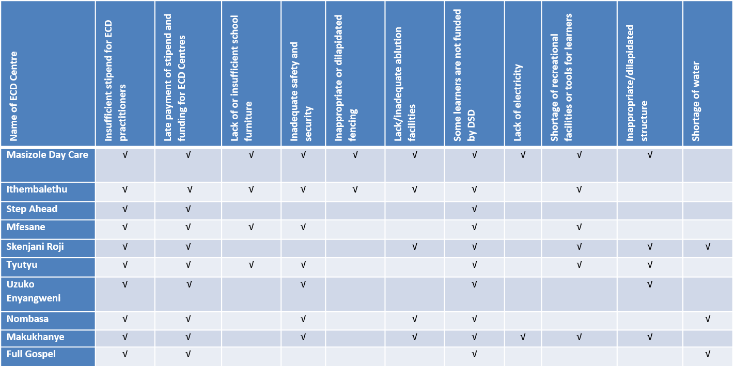
A. ECD CENTRES

B. SCHOOLS
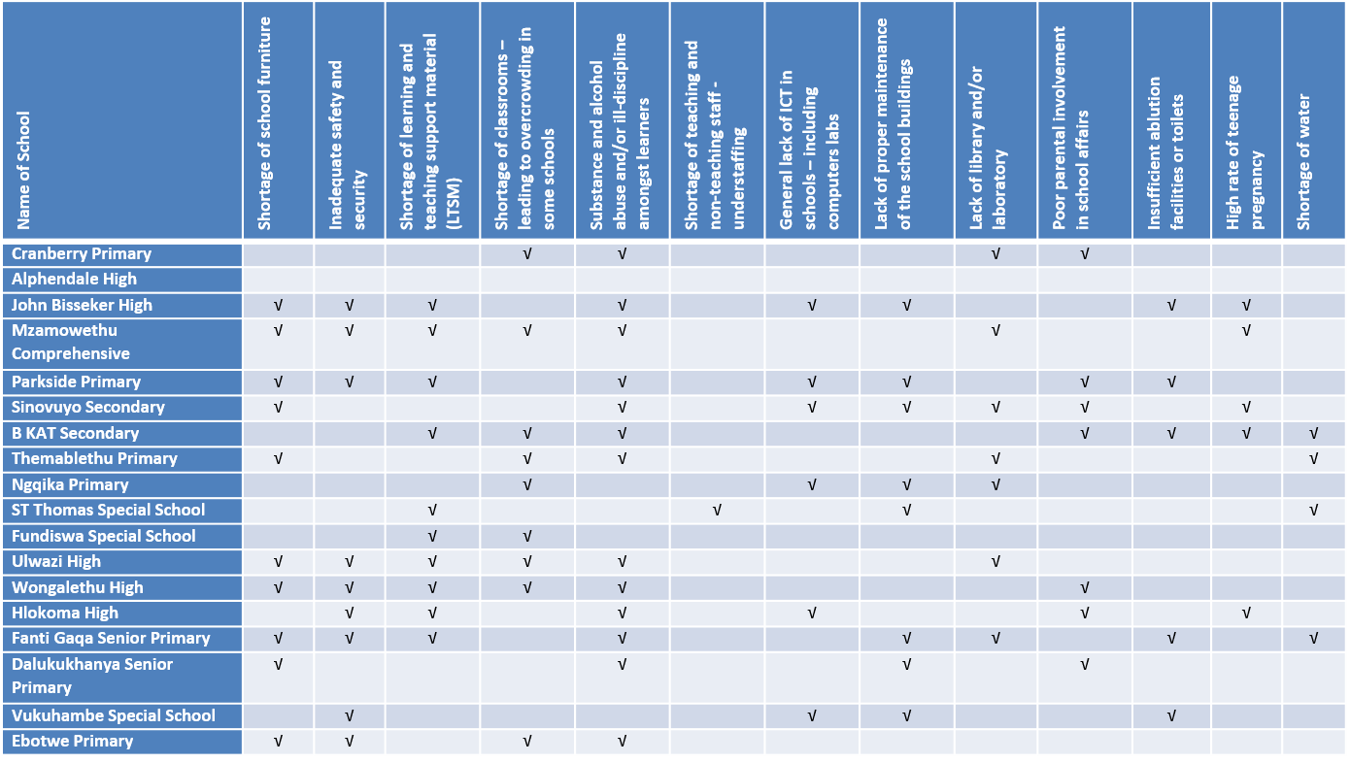

C. INSTITUTIONS OF HIGHER LEARNING
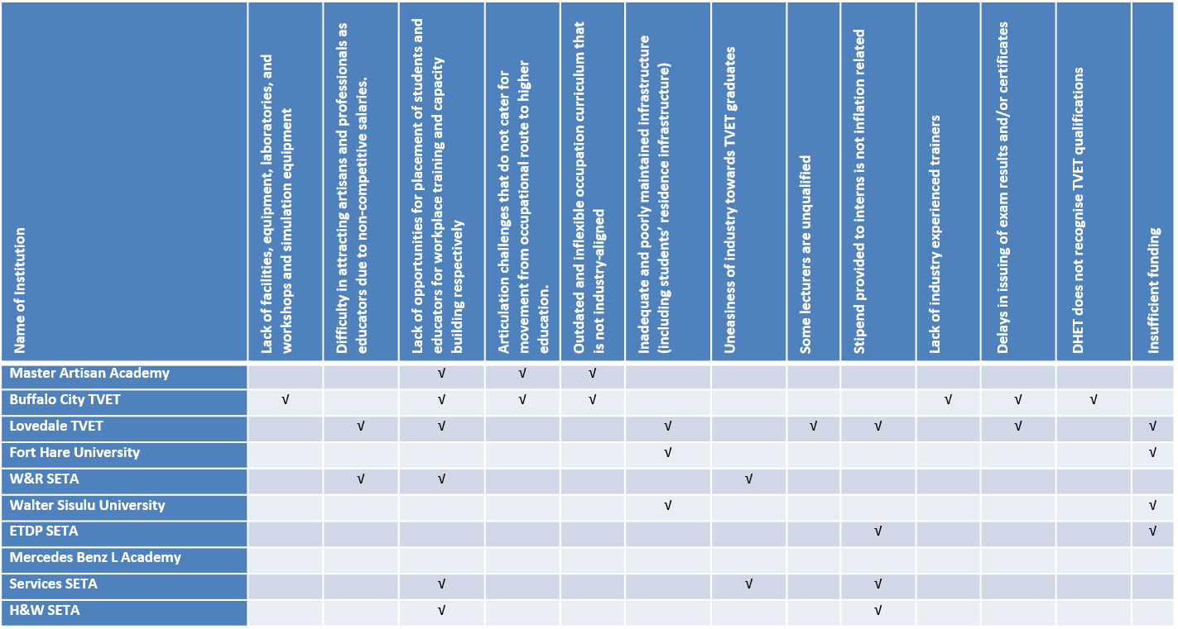

D. PUBLIC LIBRARIES
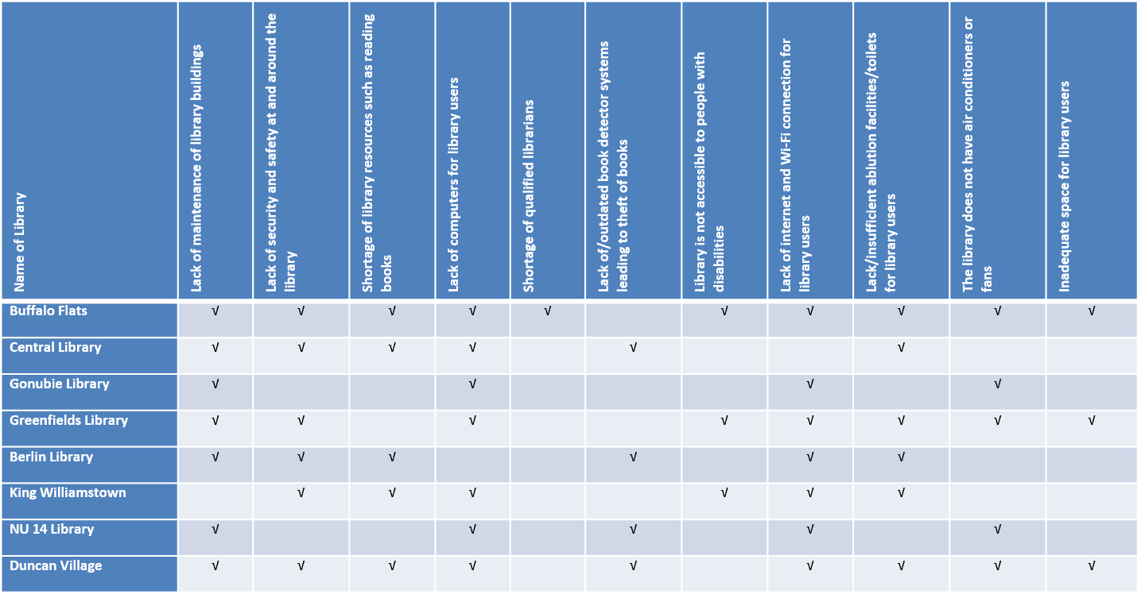

E. LOCAL ECONOMIC DEVELOPMENT PROJECTS
