ANNUAL REPORT2016/17
PRESENTATION TO THE PORTFOLIO COMMITTEE
ON TELECOMMUNICATIONS & POSTAL SERVICES
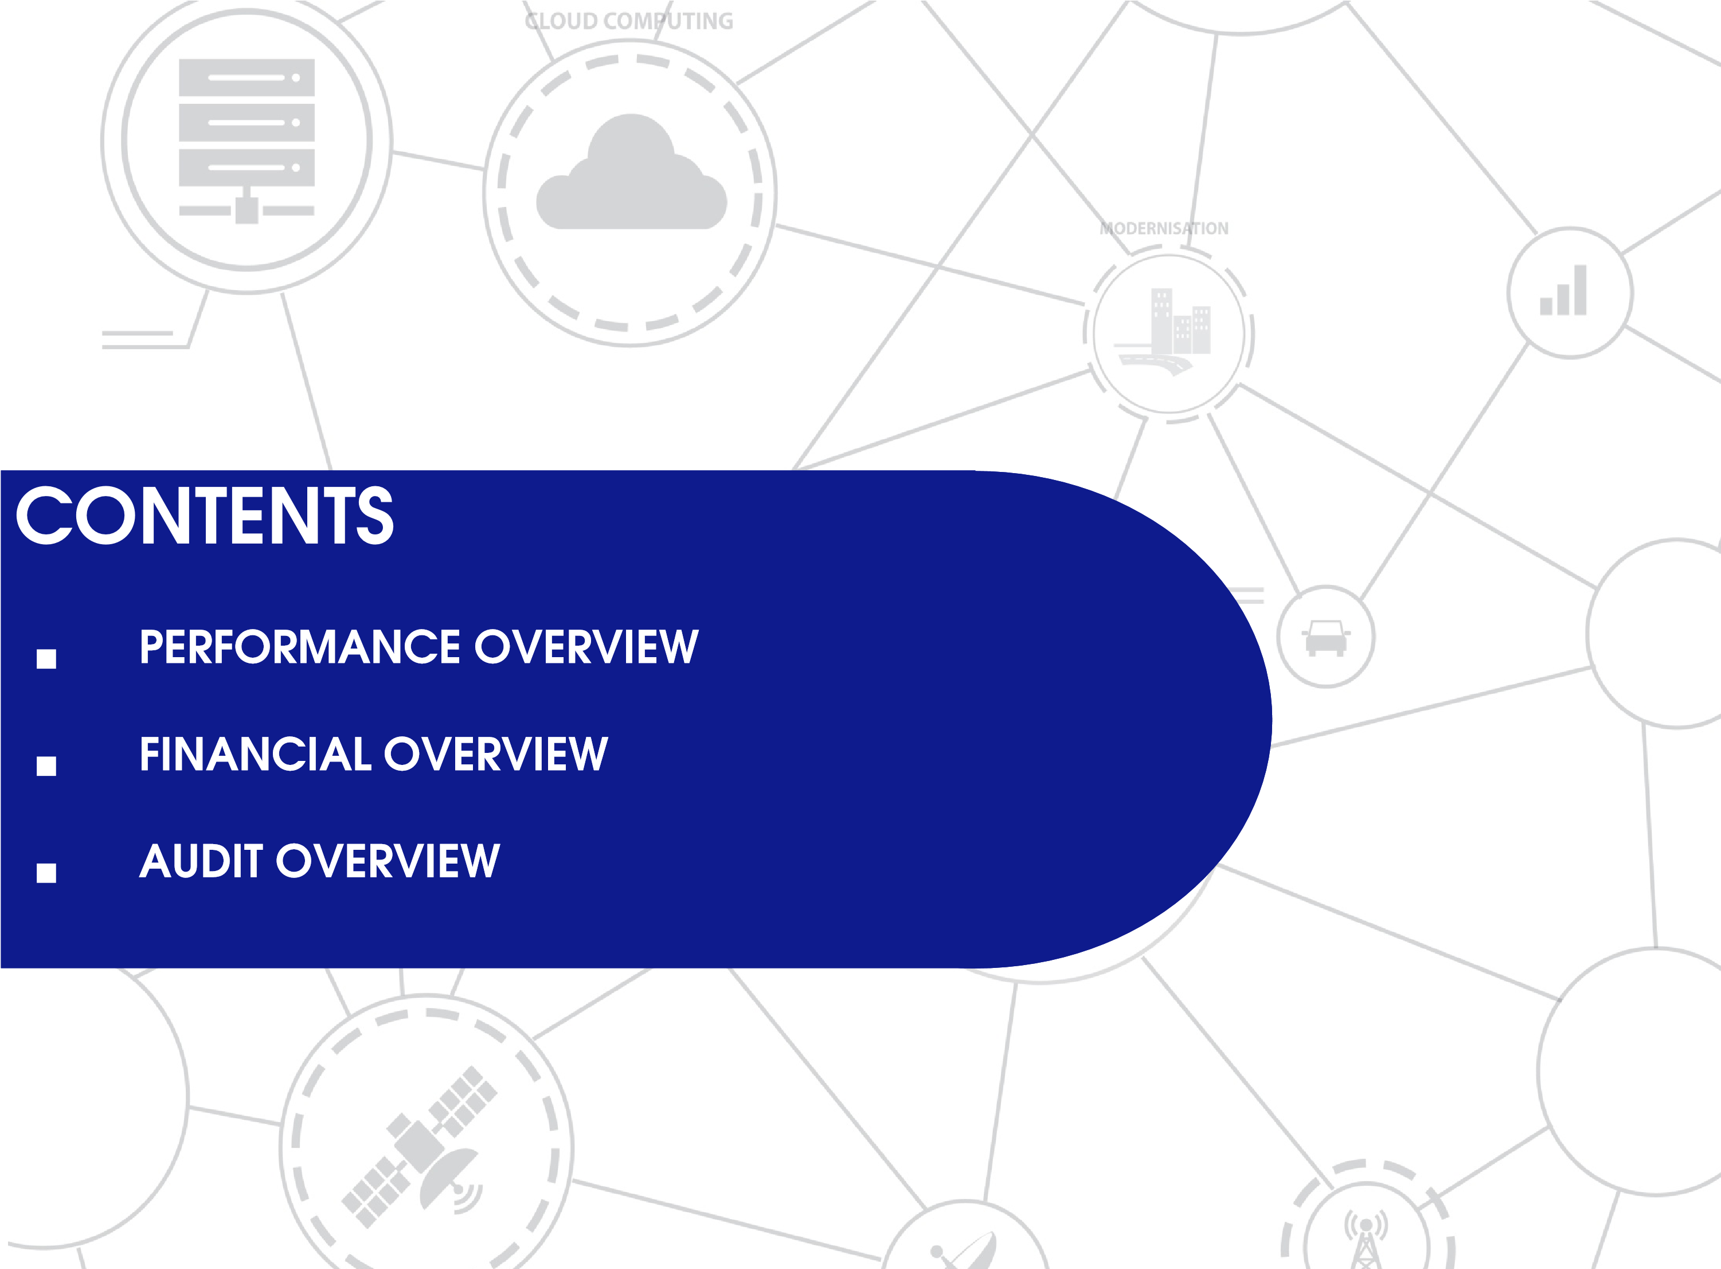
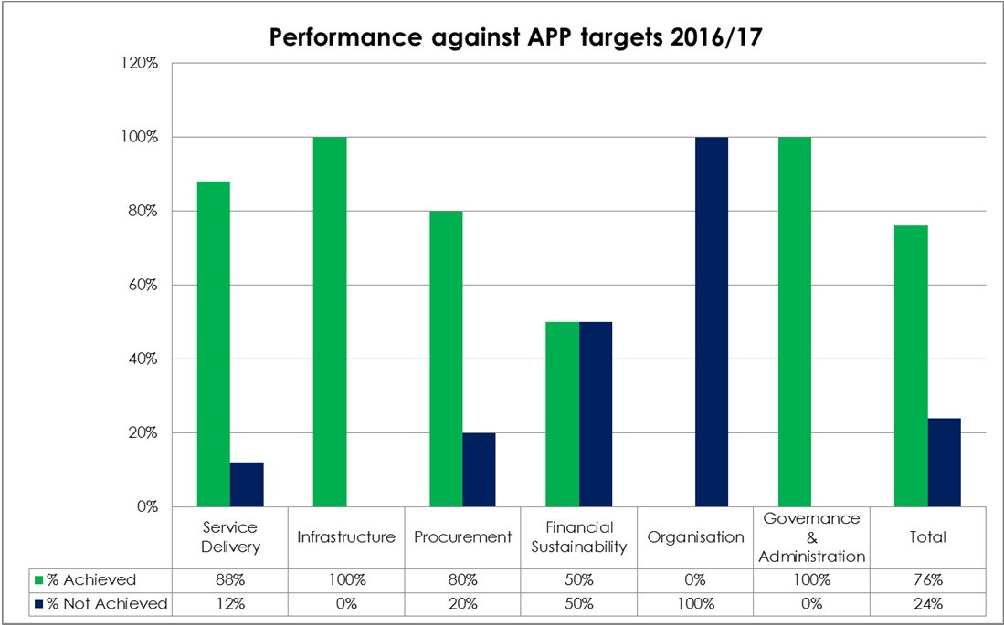
SITA achieved 76% of its planned annual performance plan targets.
The Agency had 25 targets and has achieved 19 targets with an over achievement on 10 targets.
None achievement is mainly within the internal key performance indicators and is due to delays in the execution of plans and stricter controls over the spending on capital expenditure amongst others.
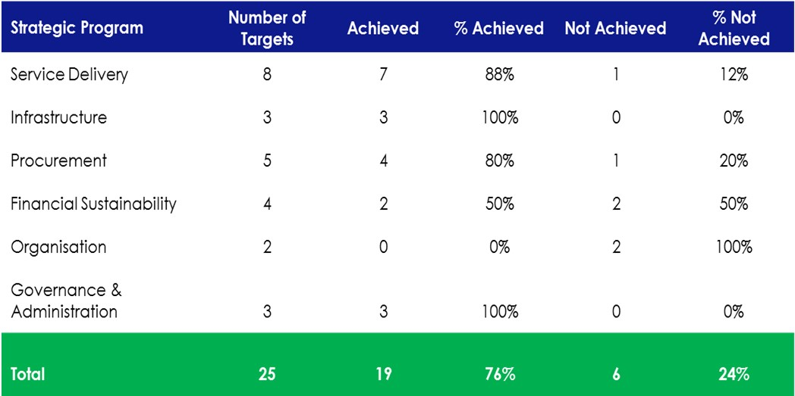
In order to improve performance the Agency has adopted a new business model which seeks to address the long standing service delivery challenges and current internal inefficiencies.
SITA will implement a customer service improvement strategy with new energy, focus and attention to detail .
The full implementation of the gCommerce platform will significantly improve procurement turnaround times.
SITA will invest and nurture Black Qualifying Small Enterprises (QSE’s) / Exempted Micro Enterprise (EME’s) and individuals with entrepreneurial abilities to transform these into independent and sustainable businesses.

SITA’s overall financial health has slightly improved, the Agency made a surplus of R245m compared to the deficit of R207.9m in the previous financial year. This was a result of much tighter controls on expenditure.
The Agency received an unqualified audit opinion on both the financial statements and the predetermined objectives.
The establishment of the loss control committee has resulted in a more focused approach in identifying irregular expenditure. (Consequence management has been implemented and forensic audit investigations were conducted in extreme and worst case scenarios).
A comprehensive investigation into alleged fraudulent activities within the HR department was concluded . Individuals involved were either dismissed or resigned including the executive head of HCM.
The actions taken to root out corrupt activities with the HCM department is a starting point and is a welcomed step in ensuring that SITA has the necessary personnel with ethical morals that will ensure the entity further delivers in terms of the mandate.
SITA in collaboration with National Treasury renegotiated the existing Microsoft contract which will result in significant savings of over R1.3 billion over the next three years to the national fiscus on the government-wide software and services contract.
SITA responded to government’s national e-strategy through the SITA e-government programme delivering e-government services in line with its strategic intent. The Agency implemented 28 eservices for various Government core services.
As part of its transformation journey, the Agency in 2016/17 continued with its modernisation programme and successfully rolled out the Government Private Cloud Programme to government, a virtual hosting environment for cost-efficiency.
SITA in collaboration with the Western Cape Government (WCG) Broadband Project has connected 1 037 schools of which 382 are in the rural areas.
The Agency managed to reduce the National Certificates (Vocational) backlog from 33 2 97 to 3 046.
SITA continues to drive the transformation agenda through SMME development, a total of 15 SMME’s graduated from the SITA enterprise development programme.
SITA launched a gCommerce platform i.e. an automated online buying system to speed up the procurement process and lessen the risks associated with manual manipulation. Currently the platform provides clients the ability to procure computers, computer peripherals and consumables through the SITA transversal contract.
SITA conducted a customer satisfaction survey and a Customer Satisfaction Index (CSI) of 49% was achieved which is an increase of 14% from the FY2012/13 CSI of 35%.
SITA achieved its gender target for females, where the actual performance was 46.3% against a target of 45.2%.
The Agency hosted the first SITA Hackathon, encouraging a culture of innovation and creativity to develop solutions destined to solve service delivery challenges and transform and promote a functional society..
A total of 219 interns were engaged during the financial year 2015/2016. Of these numbers, 79 interns were absorbed in various fixed term contractor positions.
As part of implementation of the CSR strategy, SITA has donated ICT hardware to 36 schools throughout the country. This initiative will bring the learners and their communities a step closer to participating in the digital world.

PROGRAMME PERFORMANCE:
SERVICE DELIVERY
The purpose of this programme is to provide high quality IT services to enable government to deliver efficient and convenient services to citizens through the use of ICT and to optimise the provision of SITA’s IT infrastructure services in order to increase availability, flexibility, scalability, predictability and security.
Strategic Objectives |  | Performance Indicator | Actual  Achievement  2015/16 | Planned  Target  2016/17 | Actual  Achievement  2016/17 | Deviation from  Planned Target  2016/17 | Reasons for Variance
 | C1: Enhance efficiency of government business processes | M5: No. of eGovernment  services  implemented | 24 e-Services developed for  2015/16 | 20 e-services implemented | Achieved 8  28 e-Services |  | Additional services were developed to meet identified clients‘ needs
 | C2: Improve  security of  government data  assets | M6: Level of maturity of ICT security  M7: % compliance of SITA NKP Act with  SAPS evaluation | 45%of security ICT controls, plan implemented  - | Implementation of the following security controls: 1. End Protection  2. Threat  Management  >90% compliance of  SITA NKP with  SAPS | Achieved None  System controls |  | N/A  N/A
 |  |  |  |  | have been implemented  Achieved  91% | None
 |  | M8: % of | - | >90% compliance Achieved  to personnel 92.07% clearance requirements |  | None | N/A
 |  | personnel security clearance requirements
PROGRAMME PERFORMANCE:ORGANIZATIONAL PERFORMANCE:

SERVICE DELIVERYService Delivery
The purpose of this programme is to provide high quality IT services to enable government to deliver efficient and convenient services to citizens through the use of ICT and to optimise the provision of SITA’s IT infrastructure services in order to increase availability, flexibility, scalability, predictability and security.
Strategic Objectives |  | Performance Indicator | Actual  Achievement  2015/16 | Planned Target 2016/17 | Actual  Achievement  2016/17 | Deviation from  Planned Target  2016/17 | Reasons for Variance
 | C3: Transform SITA into customercentric organisation | M9: Customer -  satisfaction level |  | 60% customer  satisfaction level | Not achieved  49% | -11% | Customer relationships have improved.  However, customers are still not satisfied with the level of service they receive.
 |  | M10: % 96% level  performance Performance against measured against |  | 95% level  Performance against measured contracted SLA metrics | Achieved  95.6% | 0.6% | There is consistent monitoring and escalations to responsible individuals through the weekly Service Level Management (SLM)  Committee meetings.
 |  | contracted SLA metrics | measured contracted SLA metrics
 | C4: Achieve growth in government market share | M11: % increase in government market share | - | 10% Increase government market share (increase on  2014/2015) | Achieved  10.8% | 0.8% | Improved customer relationships & improved value proposition through our transformation programs.
 |  | M12: % retention of services provided to customer | - | 90% retention of | Achieved | 7.68% | Constant monitoring of service levels & tracking service performance through SLA & BA meetings.
 |  |  |  | services provided 97.68% to customer
8
PROGRAMME PERFORMANCE:ORGANIZATIONAL PERFORMANCE:

INFRASTRUCTUREInfrastructure
The purpose of this programme is to optimise the provision of SITA’s IT infrastructure services in order increase availability, flexibility, scalability, predictability and security.
Strategic Objectives |  | Performance Indicator | Actual  Achievement  2015/16 | Planned  Target  2016/17 | Actual  Achievement  2016/17 | Deviation from  Planned Target  2016/17 | Reasons for Variance
 | C5: Consolidate and modernise data centres | M13: No. of data centres modernised |  | 3 SITA owned Achieved 0.244% data centres 99.993% stabilized to a) Centurion:  99.749% 99.98 %  availability b) Beta: 100% electrically and c) Numerus: 100% mechanically |  |  | Due to data centre stabilisation
 |  | M14: No. of storage and server infrastructures refreshed |  | Infrastructure and Achieved None modernisation 100% plan developed Board approved and approved in January 2017  by Board by March 2017 |  |  | N/A
 | C6: Improvement of ICT infrastructure: disaster recovery | M15: Number -  of disaster recovery sites established |  | 2 disaster Achieved None  recovery sites 2  established |  |  | N/A

PROGRAMME PERFORMANCE: PROCUREMENT
The purpose of this programme is to address all issues relating to delayed procurement turnaround times, operational inefficiencies, removing customer pain points, cost ineffectiveness and transforming the procurement function.
Strategic Objectives |  | Performance Indicator | Actual  Achievement  2015/16 | Planned  Target  2016/17 | Actual Deviation from  Achievement Planned Target  2016/17 2016/17 |  | Reasons for Variance
 | C7: Improve procurement operational efficiency to enable service delivery | M16: % of 55% of tender tender awards awards completed completed  within the within the  targeted targeted  turnaround time turnaround time |  | 65% of tender Not achieved -31%  awards 34% (132/393)  completed  within the targeted turnaround time |  | Late designing and implementing of effective operating model that assists  in the efficient utilisation of  resources and improvement on turnaround times
 |  | M17: Develop and roll-out of the  Government e-  Procurement | - | Implementation Achieved None |  | N/A
 |  |  |  | and roll-out of  Government  Transversal eProcurement portal at SITA and National  Treasury in the  OCPO | The transversal  e-Portal was implemented and 4 transversal contracts were loaded
 | C8: Drive ICT costeffectiveness through  Economies of  Scale | M18: % actual savings on acquisition of ICT goods and services with  major OEMs/  OSMs | 24% actual savings on | 10% actual savings on | Achieved 15%  25% | Due to negotiated discounts with service providers.
acquisition of ICT acquisition of
goods and ICT goods and services with services with
major major
OEMs/OSM OEMs/OSM

ORGANIZATIONAL PERFORMANCE: PROGRAMME PERFORMANCE: Procurement PROCUREMENT
The purpose of this programme is to address all issues relating to delayed procurement turnaround times, operational inefficiencies, removing customer pain points, cost ineffectiveness and transforming the procurement function.
Strategic Objectives |  | Performance Indicator | Actual  Achievement  2015/16 | Planned Target 2016/17 | Actual  Achievement  2016/17 | Deviation from  Planned Target  2016/17 | Reasons for Variance
 | C9: Drive  economic transformation  agenda | M19: % of ICT 11% of ICT acquisition spend acquisition |  | 15% of ICT Achieved acquisition 20.03% spend through |  | 5.03% | Due to managed and monitored SMME spend from list of accredited suppliers.
 |  | through SMME  entities | spend through SMME entities
 |  |  |  | SMME entities
 |  | M20: Number of SMME entities completed SITA enterprise development | - | 10 SMME  entities  completed SITA ED  program | Achieved  15 | 5 | - Positive response from SMMEs  - Well-coordinated training programme
 |  | (ED) programmes

PROGRAMME PERFORMANCE: FINANCIAL SUSTAINABILITY
The purpose of this programme is to ensure an effective and efficient financial management and ensure financial growth and sustainability.
Strategic Objectives | Performance Indicator | Actual  Achieveme nt 2015/16 | Planned  Target  2016/17 | Actual  Achievement  2016/17 | Deviation from  Planned Target  2016/17 | Reasons for Variance

F1: Achieve M1:% EBIT - 2% EBIT Achieved 0.75 %
sound financial 2.75 %
management
M2: % liquidity 2.3:1 1.2:1 Achieved 1.2 ratio 2.4:1

ORGANIZATIONAL PERFORMANCE
M3: % gross margin | - | 20% Gross  Margin | Not achieved  18.5% | -1.5%
M4:% expenditure against approved Capex budget | 95.8% | 90% expenditur e against approved Capex | Not achieved  65% | -25%
Strict cost containment measures and improved contract negotiations that yielded positive results; a positive EBIT variance was achieved.
Cost containment measures, vigorous contract negotiations and capital expenditure budgets not utilized fully resulted in a

variance as this impacted directly to higher current assets and lower current liabilities than anticipated.
Service revenue targets with high gross margin rates were not achieved.
Due to various tender delays and stricter controls over the spending on capital expenditure to ensure that the full asset life cycles and return on investment are considered, capital expenditure was lower than budgeted.
ORGANIZATIONAL PERFORMANCE:PROGRAMME PERFORMANCE:

OrganisationORGANISATION
The purpose of this programme is to build and maintain organisational capability to enable SITA to achieve its strategic imperatives.
Strategic Objectives |  | Performance Indicator | Actual  Achievement  2015/16 |  | Planned Target 2016/17 | Actual  Achievement  2016/17 | Deviation from  Planned Target  2016/17 | Reasons for Variance
 | L1: Build a healthy and highperforming organisation | M24: % 10% improvement Drive and |  |  |  | Not achieved  48% | -32% | Delays in finalising the HPO plan and late implementation of HPO dimensions affected the achievement of the target.
 |  | improvement in in HPO baseline HPO baseline and HPO  and HPO institutionalisation  institutionalisation |  | implement 80% of the 13 HPO Dimensions as per the HPO improvement plan
 |  | M25: % of critical positions with minimum cover  ratio of 1:2 |  | 20% of critical positions with  minimum cover  ratio |  | Not achieved  13% of talent pool has been achieved | -7% | Due to delays in finalising the succession pool implementation process.

ORGANIZATIONAL PERFORMANCE: PROGRAMME PERFORMANCE:

Governance and AdministrationGOVERNANCE & ADMINISTRATION
The purpose of this programme is to provide leadership, strategic management, governance, risk and resource management in line with government’s accepted norms and standards.
Strategic Objectives |  | Performance Indicator |  | Actual  Achievement  2015/16 | Planned Target 2016/17 | Actual  Achievement  2016/17 | Deviation from  Planned Target  2016/17 | Reasons for Variance
 | P1: Establish effective governance practice | M21: Number of -  material AuditorGeneral findings on finances, predetermined objectives and compliance to laws and regulations |  |  | 0 material Auditor Achieved  general findings on finances, predetermined objectives |  | None | N/A
 |  | M22: Maturity level Maturity level 4 of of risk management risk management implementation implementation |  |  | Maturity level 4 of Achieved risk management CEB level 4 implementation achievement |  | None | N/A
 | P2: Proactive approach to procurement compliance | M23: Number of 0 findings on |  |  | 0 findings on Achieved |  | None | N/A
 |  | findings in the procurement fraud procurement fraud external audit with and corruption as and corruption as respect to fraud per External Audit per External Audit
including fraud and and corruption in report report
corruption procurement
process-related activities
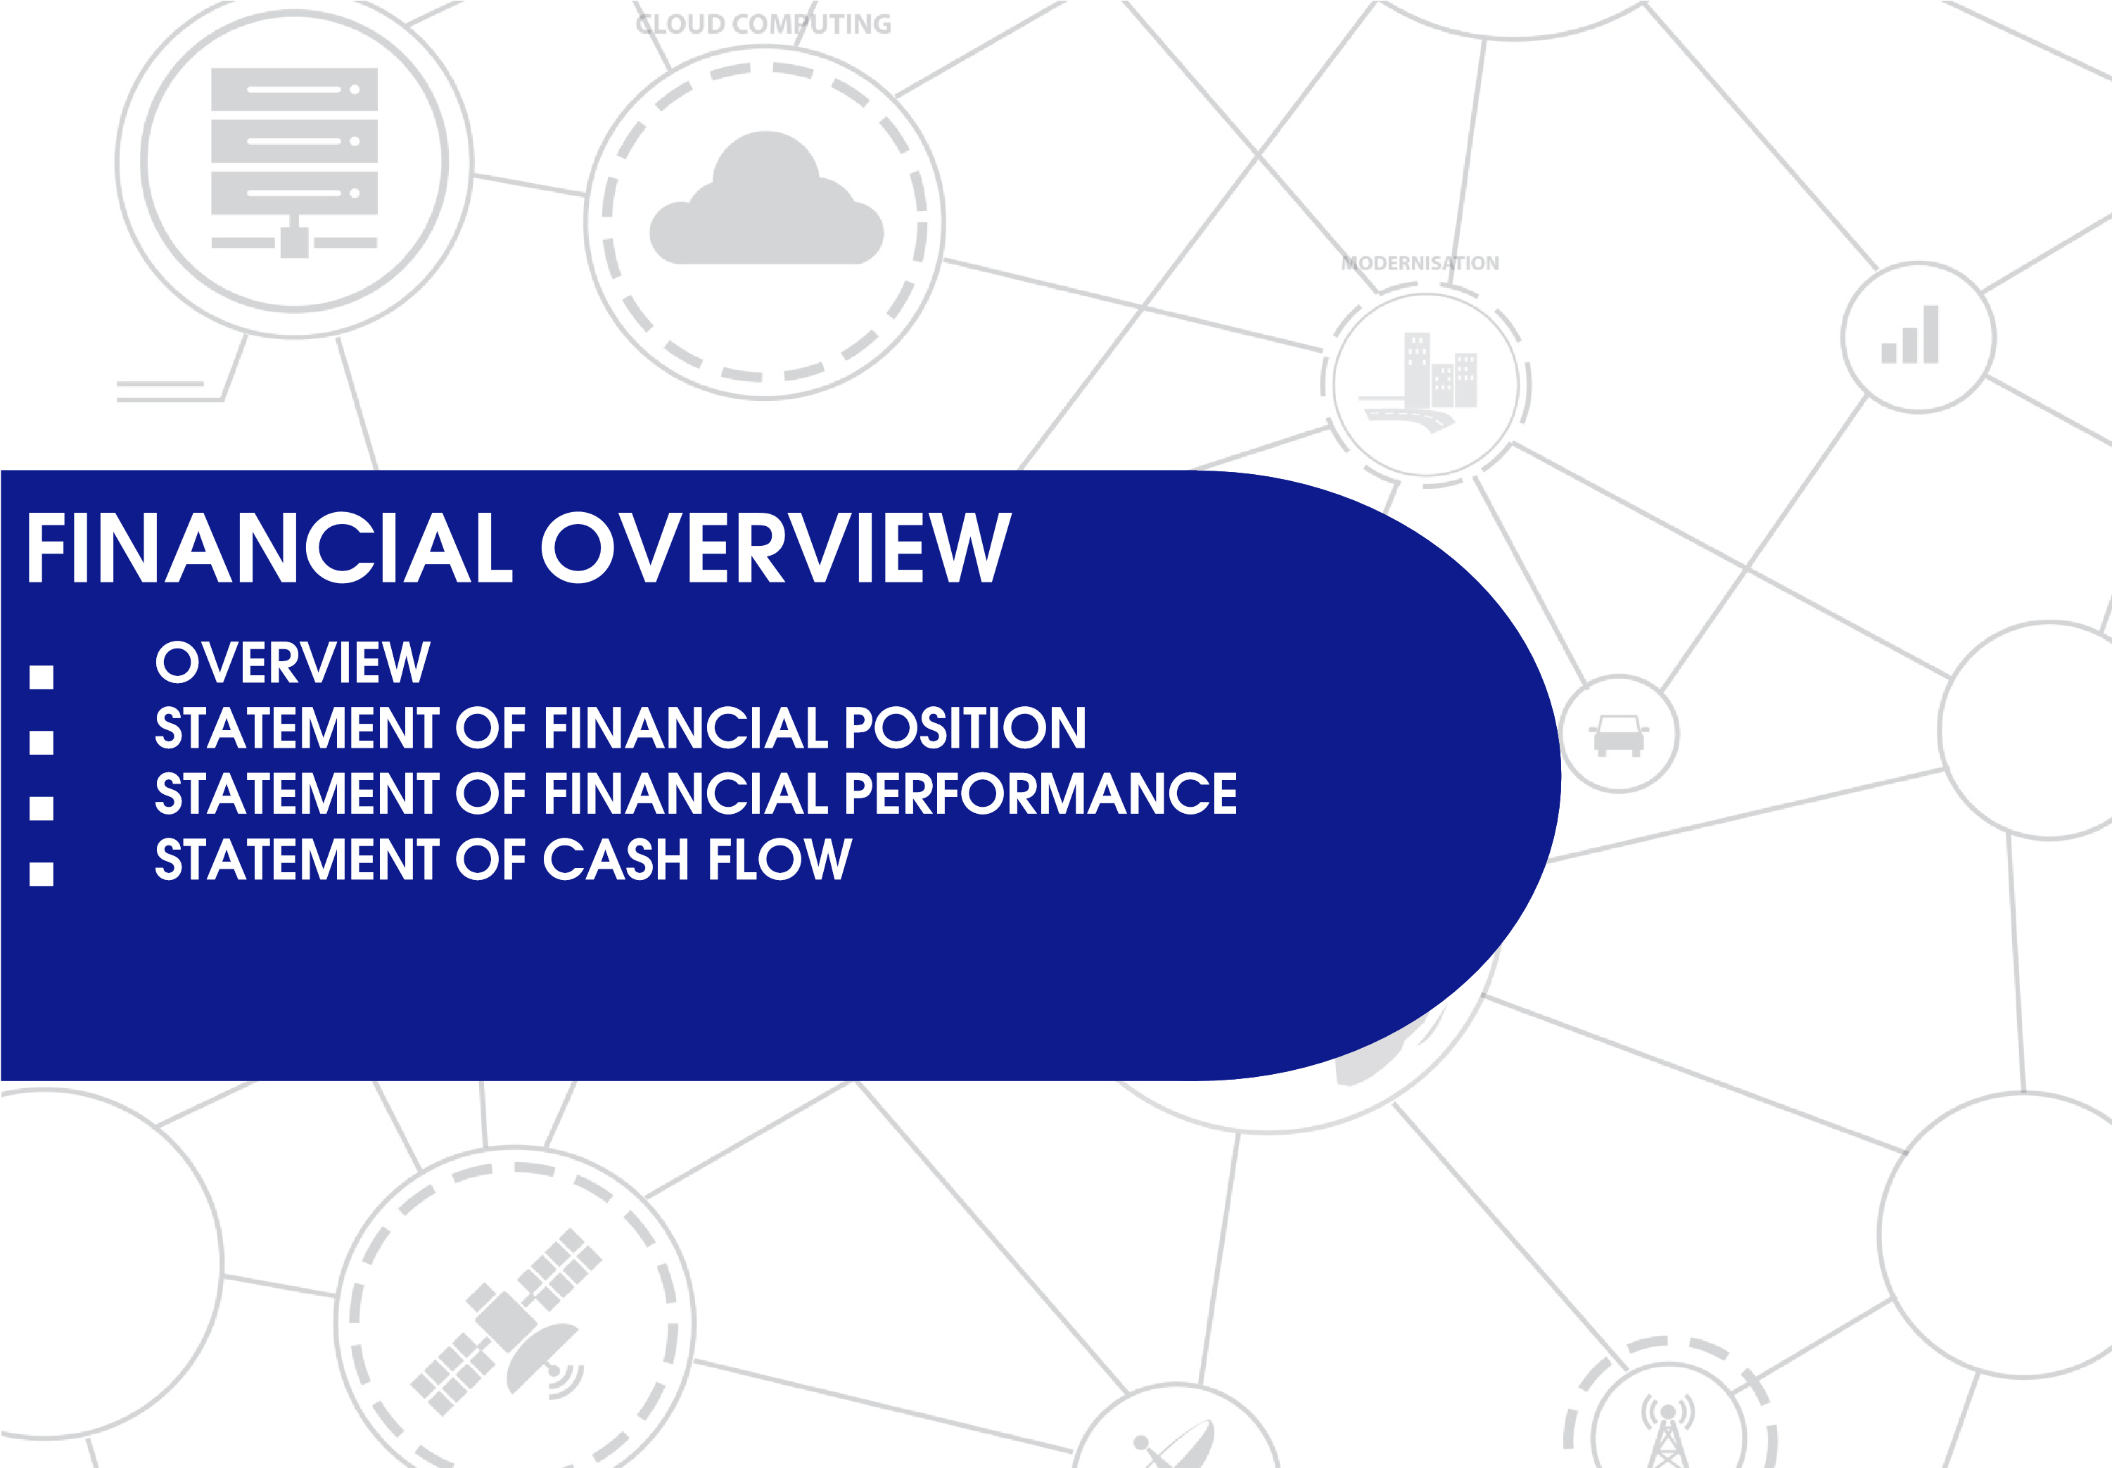
FINANCIAL OVERVIEW
The revenue for the year of R5.681bn is R714.6m (11.2%) below the budget of
R6.395bn.
The actual service revenue performance for the year was below the budget by R607.3m, while the agency revenue below budget by R107.3m
The expected gross margin on services was R1.157bn and represented a margin of 24% on services revenue. The actual gross margin was R990.4m or 23.6% of revenue. This left a gross margin shortfall on services revenue for the year of R167.1m
The expected gross margin on agency related sales was R64.9m or 4% of revenue. The actual margin for the year on agencies was R28.5m or 1.9% of agency revenue. This was a negative variance of R36.4m of the budget.
The actual gross surplus was R1.019bn which is R203.5m below the budgeted gross margin of R1.222bn.
The under performance at a gross surplus level was a combination in respect of an underachievement of labour based revenue and business opportunities that did not materialise as planned.
16

STATEMENT OF FINANCIAL POSITION
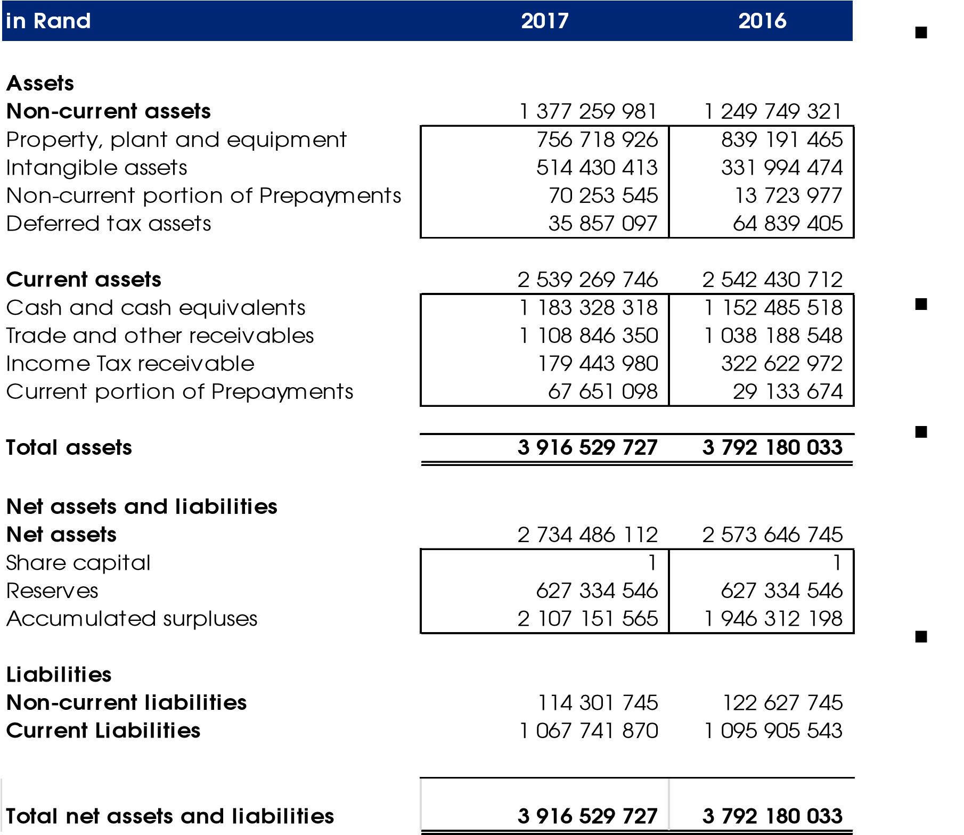
Property, plant and equipment/
intangible assets
Represents the infrastructure assets of the Agency. The increase is due to capital expenditure incurred to replace and expand the asset base.
Cash and cash equivalent
Detailed explanation is provided on the cash flow statement.
Trade and other receivable
This represents the amount owed to the Agency by departments. The agency is working with DPTS and National Treasury to collect the debts.
Income tax receivable
Amount due to the Agency from
SARS. The amount for 2016 was received in 2017.

17
17

STATEMENT OF FINANCIAL PERFORMANCE
In Rand | 2017 | 2016
Revenue | 5 680 792 621 | 5 458 602 601
Cost of sales  Gross surplus | (4 661 882 237) | (4 710 313 016)
 | 1 018 910 384 | 748 289 585
Other income | 38 344 632 | 57 419 222
Operating expenses  Surplus/(Deficit) from operating activities | (954 839 206) | (1 139 152 306)
 | 102 415 810 | (333 443 499)
Finance income | 192 272 892 | 169 474 785
Finance expenses  Surplus/(Deficit) before income tax | (49 677 626) | (43 986 595)
 | 245 011 076 | (207 955 309)
Income tax expense  Surplus/(Deficit) for the year attributable to shareholder | (84 171 709) | 50 686 382
 | 160 839 367 | (157 268 927)
18
18

ANNUAL PERFORMANCE PLAN BUDGET VS ACTUAL

In Rand ACTUAL AS PER ADJUSTMENT STATEMENT OF FOR FINANCIAL NOTIONAL PERFORMANCE INTEREST
Revenue 5 680 792 621 88 424 604
- Agency revenue 1 483 252 455 23 087 625
- Services revenue 4 197 540 166 65 336 979
Cost of sales -4 661 882 237 -39 809 174
- Agency cost of sales 1 454 738 381 - Services cost of sales 3 207 143 856 39 809 174
Gross surplus 1 018 910 384 48 615 430
- Agency gross surplus 28 514 074 23 087 625
- Services gross surplus 990 396 310 25 527 805
Other income 38 344 632 -
Operating expenses -954 839 206 8 738 599
Surplus before income tax 102 415 810 57 354 029
Net Finance income 142 595 266 -41 707 111
Surplus before income tax 245 011 076 15 646 918
Income tax -84 171 709 Surplus for the year attributable to shareholder 160 839 367 15 646 918 ACTUAL EXCL. BUDGET VARIANCE

NOTIONAL INTEREST (B) % (A) (A-B)/B
5 769 217 225 6 395 449 003 -9.79%
1 506 340 080 1 590 594 254
4 262 877 145 4 804 854 749
-4 701 691 411 -5 173 077 004 9.11%
1 454 738 381 1 525 704 906 3 246 953 030 3 647 372 098 1 067 525 814 1 222 371 999
51 601 699 64 889 348
1 015 924 115 1 157 482 651
38 344 632 21 369 997 79.43%
-946 100 607 -1 155 538 332 18.12%
159 769 839 88 203 664
100 888 155 47 175 337 113.86%
260 657 994 135 379 001 92.54%
-84 171 709 -37 906 120 122.05%
176 486 285 97 472 881 81.06%
19

STATEMENT OF FINANCIAL PERFORMANCE– COST PERFORMANCE AGAINST BUDGET ANALYSIS
Decrease) in
(
costs
Decrease) in
(
labour costs
Decrease) in
(
agency COS
(
Decrease) in
service delivery
COS
Increase in loss
on disposal of
assets
(
Decrease) in
depreciation
costs
Difference Actual vs APP
(711 893 890)
(82 989 410)
(70 966 525)
(345 842 417)
5
(63 516 153)
900 751
(800 000 000)
(700 000 000)
(600 000 000)
(500 000 000)
(400 000 000)
(300 000 000)
(200 000 000)
(100 000 000)
0
100 000 000
The Actual costs were below budget by R711.9million. The reason for the variance is a combination in respect of underachievement of labour based revenue and business opportunities that did not materialise as.
20

STATEMENT OF FINANCIAL PERFORMANCE– COST PERFORMANCE AGAINST BUDGET ANALYSIS- HR
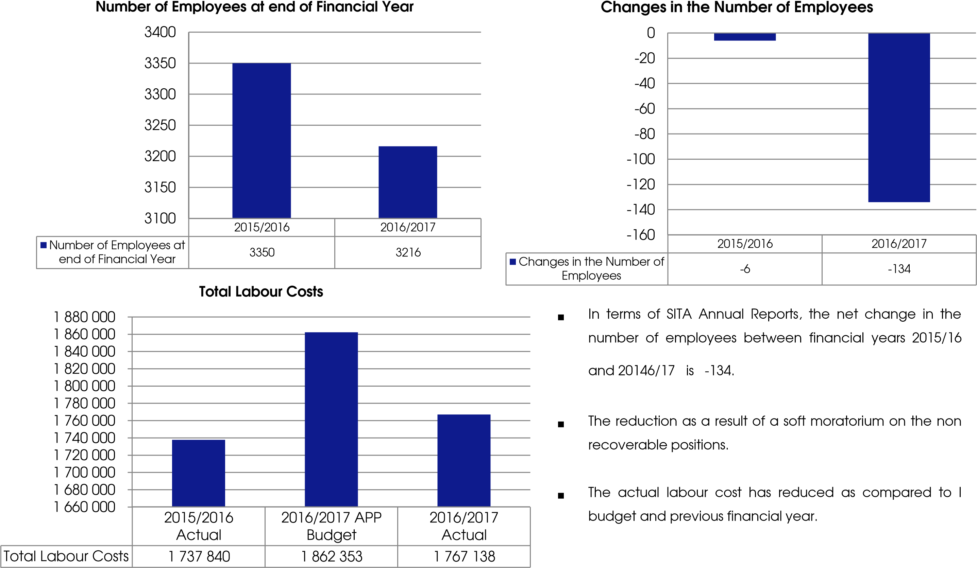
21

STATEMENT OF FINANCIAL PERFORMANCE– MARGIN ANALYSIS
Agency Margin
Service Margin
Difference Actual vs APP
)
36 375 274
(
(
167 086 342
)
APP Budget
4
%
24
%
Actual
2
%
24
%
(180 000 000)
(160 000 000)
(140 000 000)
(120 000 000)
(100 000 000)
(80 000 000)
(60 000 000)
(40 000 000)
(20 000 000)
0
20 000 000
The annual performance is a reflection of the management of the Agency’s ability to adapt to changing environments and re-focussing resources to deliver on its mandate within the constraints of an evolving environment.

22
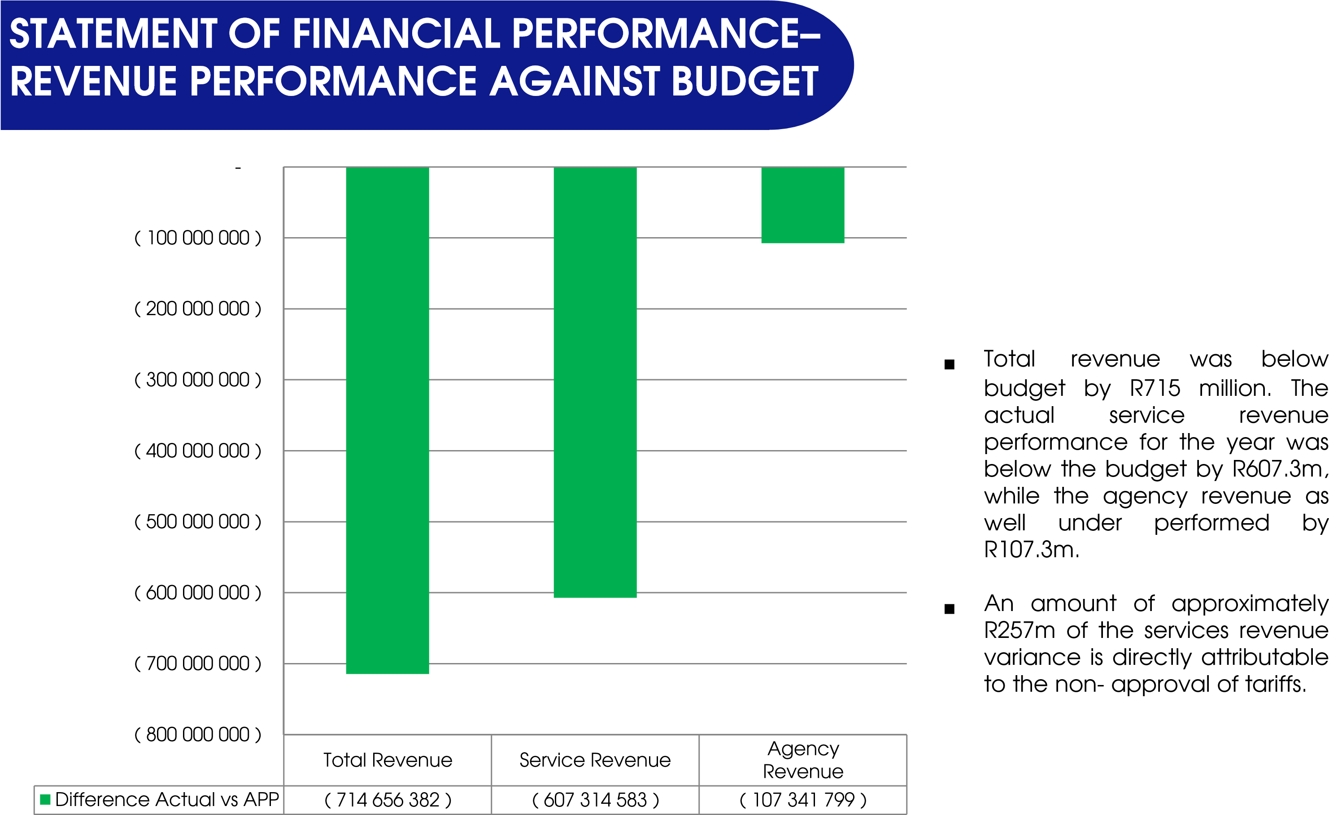
23

STATEMENT OF CASH FLOW
in Rand | 2017 | 2016
Cash flows from operating activities  Receipts  - Sale of goods and services  - Finance income received  - Income tax receipt  Payments  - Payment to suppliers and employees  - Finance costs paid  - Income tax paid  Net Cash flows from operating activities | 6 390 210 507 | 5 513 729 864
 | 6 235 144 690  62 615 731  92 450 086 | 5 445 164 099  68 565 765  -
 | (6 155 473 458) | (5 389 527 253)
 | (6 154 985 588)  (487 870)  - | (5 290 365 858)  (5 947 054)  (93 214 341)
 | 234 737 049 | 124 202 611
Cash flows from investing activities  Purchase of property, plant and equipment  Purchase of intangible assetsProceeds from the sale of property, plant and equipment  Net Cash flows from investing activities  Cash flows from financing activities  Net Cash flows from financing activities  Increase/(Decrease) in cash and cash equivalents  Cash and cash equivalents at beginning of year  Cash and cash equivalents at end of year | (32 837 502)  (171 056 747)  - | (309 621 490)  (201 794 610)  294 371
 | (203 894 249)  -  30 842 800  1 152 485 518 | (511 121 729)  -  (386 919 118)  1 539 404 636
 | 1 183 328 318 | 1 152 485 518
SITA is not generating enough cash from operations to fund capital expenditure
Cash reserves are depleted to fund urgent capital expenditure
procurement
SITA is developing a finance strategy which will deal with this conundrum
24

STATEMENT OF CASH FLOWFREE CASHFLOW
 | In Rands | fy2013 | fy2014 | fy2015 | fy2016 | fy2017
 | Net income | 399,115,806 | 45,421,364 | 144,289,136 | (157,268,927) | 160,839,368
Add: | Finance expenses | 4,311,214 | 816,400 | 10,197,483 | 7,219,821 | 49,677,626
Less: | Finance income | (52,343,619) | (56,920,624) | (53,690,169) | (54,469,804) | (138,436,482)
Add: | Depreciation | 74,085,193 | 21,110,286 | 48,589,082 | 74,469,620 | 95,806,395
Less: | Capital expenditures | (216,067,864) | (355,975,204) | (250,904,318) | (511,121,731) | (203,894,249)
Less: | Working capital investment | 0 | 142,146,383 | (28,387,958) | 403,055,381 | 5,840,093
 | Free cash flow | 209,100,729 | (203,401,395) | (129,906,744) | (238,115,641) | (30,167,250)
Free cashflow represents the cash that a company is able to generate after spending the required funds to maintain and/or expand its asset base.
(300 000 000)
(250 000 000)
(200 000 000)
(150 000 000)
(100 000 000)
(50 000 000)
0
50 000 000
100 000 000
150 000 000
200 000 000
250 000 000
fy2013
fy2014
fy2015
fy2016
fy2017
Free cash flow
SITA over the years has been producing negative free cashflow due to low cash generated from operations. This resulted in the Agency utilizing its cash reserves to fund the business operations,
This is evident when looking at the bank balance which has been depleting year on year

25
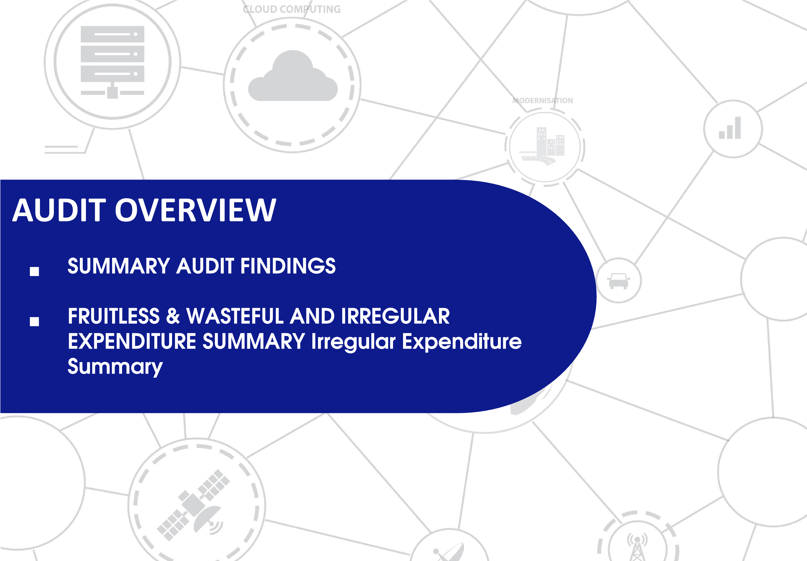

SUMMARY AUDIT FINDINGS
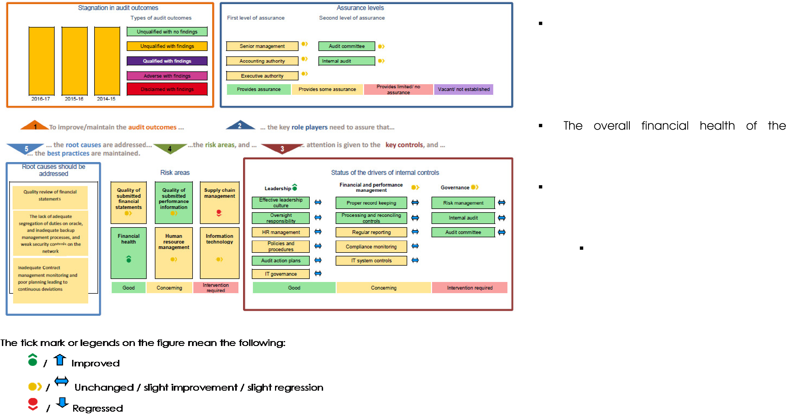
The Agency received an unqualified audit opinion on both the financial statements and the predetermined objectives.
overall financial health of the
organisation has improved.
There are issues relating to noncompliance to legislation noted in the audit report, namely:
The Agency has incurred irregular expenditure and fruitless and wasteful expenditure amounting to R450 million and R0.4 million respectively.
27

UNCONDONED UNATHORISED, IRREGULAR, FRUITLESSS AND WASTEFUL EXPENDITURE
500.0
400.0
300.0
200.0
100.0
-
 | Opening Amount | Prior year adjustments | Current Year Cases | Condonement /  Write-off | Closing Amount awaiting  condonement/write  -off
2014/15 | 67.3 | 0.2 | 22.5 | 22.8 | 67.2
2015/16 | 67.2 | 6.7 | 64.7 | - | 125.2
2016/17 | 125.2 | - | 450.4 | 9.5 | 566.0
600.0 Year on year comparison
R'm
28

UNCONDONED UNATHORISED, IRREGULAR, FRUITLESSS AND WASTEFUL EXPENDITURE
Incurred in current and prior years
Irregular expenditure
Fruitless and wasteful
expenditure
Total
Incurred in current year
86 662
410
87 072
Incurred in prior years
363 324
363 324
0
Total
449 986
450 396
410
0
50 000
100 000
150 000
200 000
250 000
300 000
350 000
400 000
450 000
500 000
R'000
29

UNCONDONED UNATHORISED, IRREGULAR, FRUITLESSS AND WASTEFUL EXPENDITURE
Number of cases incurred in _{SITA} has Improved its system of 2017 financial year internal control resulting in a better identification of irregular expenditure.
Less than or
equal to R1mil
Greater than
R1mil but less
than or equal
to R10 mil
Greater than
R10 mil
Total
Number of cases
2
5
3
10
0
2
4
6
8
10
12
Management has initiated a number of formal investigations relating to irregular expenditure and fruitless and wasteful expenditure. Majority of the cases were still under investigation at year end.
As a result no disciplinary cases were concluded during the year.
Appropriate action will be taken as soon as the investigations have been finalised.

THANK YOU!

