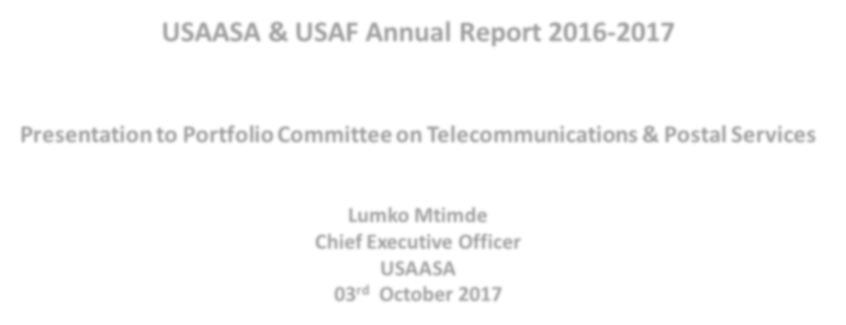
USAASA & USAF Annual Report
2016
-
2017

Presentation to Portfolio Committee on Telecommunications & Postal Services
Lumko Mtimde
Chief Executive Officer
USAASA
03
rd
October 2017
1
#
InternetForAll
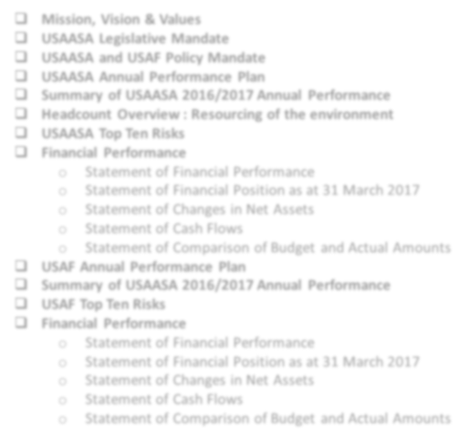
2
Table of Contents
❑
Mission, Vision & Values
❑
USAASA Legislative Mandate
❑
USAASA and USAF Policy Mandate
❑
USAASA Annual Performance Plan
❑
Summary of USAASA 2016/2017 Annual Performance
❑
Headcount Overview : Resourcing of the environment
❑
USAASA Top Ten Risks
❑
Financial Performance
o
Statement of Financial Performance
o
Statement of Financial Position as at 31 March 2017
o
Statement of Changes in Net Assets
o
Statement of Cash Flows
o
Statement of Comparison of Budget and Actual Amounts
❑
USAF Annual Performance Plan
❑
Summary of USAASA 2016/2017 Annual Performance
❑
USAF Top Ten Risks
❑
Financial Performance
o
Statement of Financial Performance
o
Statement of Financial Position as at 31 March 2017
o
Statement of Changes in Net Assets
o
Statement of Cash Flows
o
Statement of Comparison of Budget and Actual Amounts
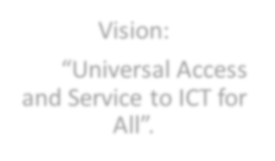
•
To facilitate the rollout of adequate Information and Communication
Technology (ICT) infrastructure to enable universal access to under
-
serviced areas in South Africa.
•
To facilitate ICT service to under
-
serviced areas and thereby
contributing to the reduction of poverty and unemployment in South
Africa.
•
To promote and pursue the goal of Universal Access and Services and
contribute to the sharing and preservation of information in order to
build South Africa’s sustainable knowledge society.
Mission
:
•
Batho Pele
–
We believe in providing excellent, efficient and effective
service to all customers and stakeholders.
•
Integrity
–
We uphold high standards of trust; condemn bribery and
corruption; and uphold honesty and respect in all interactions with
stakeholders.
•
Accountability
–
We foster employee ownership and responsibility in
ensuring quality service.
•
Innovatio
n
–
We support employee creativity in delivering all our
services.
•
Transparency
–
We encourage openness in all our activities.
•
Teamwork
–
We strive to create a harmonious work environment,
where all employees and contributors are respected.
Values
:
3
Vision:
“Universal Access
and Service to ICT for
All”.
Vision, Mission & Values
USAASA Legislative Mandate
In line with the NDP, USAASA through USAF projects provides broadband infrastructure and ICT connectivity in the underserved
SAConnect Provides guidance on building an access or core network, coordinates building programmes for efficiency, and
promote universal access through efficient spectrum allocation, and focuses on driving uptake and usage through the provision of affordable services and devices, using the government as an anchor tenant for the core network
SIP 15 USAASA always ensures the alignment of the USAF projects to the SIP 15 goal of “ 100% access to digital ICTs to all
South Africans by 2020 as a driver of new economic opportunities and digital equity”

USAASA Mandate
- strive to promote the goal of universal access and universal service;
- foster the adoption and use of new methods of attaining universal access and universal service
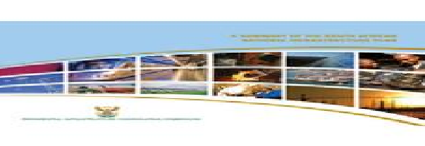
- conduct research into and keep abreast of developments in the Republic and elsewhere on information communication technology, electronic communications services and electronic communications facilities
- manage the Universal Service and Access Fund (USAF) in accordance with the provisions of the Act

USAF Mandate
- Provide connectivity to primary health facilities, educational institutions and needy communities
- Provide incentives to network licensees to construct operate and maintain networks in under-serviced areas.
- Access to digital broadcasting services
South Africa Connect Policy Target
Broadband access in Mbps user By 2020
experience 90% at 5Mbps
50% at 100Mbp
MTSFOutcome 9 Point Plan
Outcome 1 Quality basic education Applicable to broadband
roll-out.
Outcome 2 A long and healthy life for
all
  - Nr 7. Unlocking potential
Outcome 3 Decent employment of SMME’s; Cooperatives; through inclusive townships and rural economic growth enterprises
  - Nr 8. Reform & boosting
Outcome 4 Skilled and capable
of the role of SOE’s ICT or workforce to support an
broadband infrastructure inclusive growth path
rollout
Outcome 5 An efficient, competitive and responsive economic infrastructure network
International Measurements
WEF Ranking = 47 (2016) ITU Ranking
World Economic Forum Global South Africa has moved from
Competitive Index ranks South Africa as position 86 to 88 in the 4 the 47th most completive economy of International Telecommunication

Legislative Mandate & Policy Mandate

 The Constitution
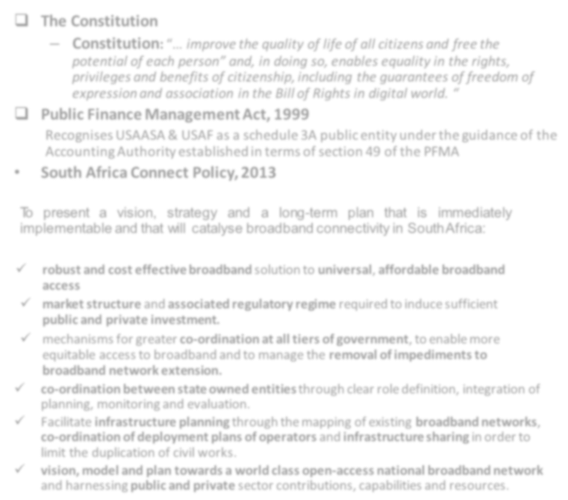
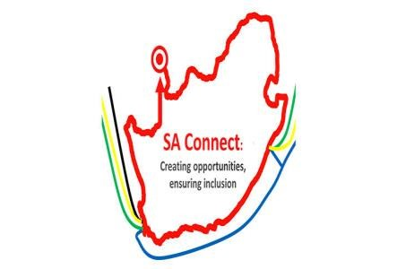
– Constitution: “… improve the quality of life of all citizens and free the potential of each person” and, in doing so, enables equality in the rights, privileges and benefits of citizenship, including the guarantees of freedom of expression and association in the Bill of Rights in digital world. “

 Public Finance Management Act, 1999
Recognises USAASA & USAF as a schedule 3A public entity under the guidance of the
Accounting Authority established in terms of section 49 of the PFMA

• South Africa Connect Policy, 2013
To present a vision, strategy and a long-term plan that is immediately implementable and that will catalyse broadband connectivity in SouthAfrica:
- robust and cost effective broadband solution to universal, affordable broadband access
- market structure and associated regulatory regime required to induce sufficient public and private investment.
- mechanisms for greater co-ordination at all tiers of government, to enable more equitable access to broadband and to manage the removal of impediments to broadband network extension.
- co-ordination between state owned entities through clear role definition, integration of planning, monitoring and evaluation.
- Facilitate infrastructure planning through the mapping of existing broadband networks, co-ordination of deployment plans of operators and infrastructure sharing in order to limit the duplication of civil works.
- vision, model and plan towards a world class open-access national broadband network 5 and harnessing public and private sector contributions, capabilities and resources.

Policy Mandate
- National Development Plan (NDP):
The ICT sector by 2030 will underpin the development of a dynamic and connected information society and a vibrant knowledge economy that is more inclusive and prosperous. A seamlessinformation infrastructure will…
- New Growth Path:
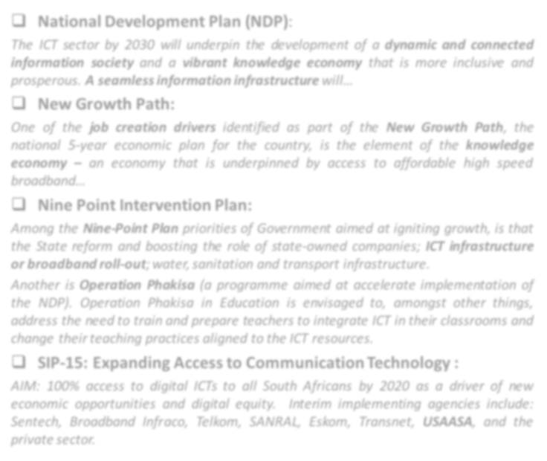
One of the job creation drivers identified as part of the New Growth Path, the national 5-year economic plan for the country, is the element of the knowledge economy – an economy that is underpinned by access to affordable high speed broadband…
- Nine Point Intervention Plan:
Among the Nine-Point Plan priorities of Government aimed at igniting growth, is that the State reform and boosting the role of state-owned companies; ICT infrastructure or broadband roll-out;water,sanitation and transport infrastructure.
Another is Operation Phakisa (a programme aimed at accelerate implementation of the NDP). Operation Phakisa in Education is envisaged to, amongst other things, address the need to train and prepare teachers to integrate ICT in their classrooms and change theirteaching practices aligned to the ICT resources.
- SIP-15: Expanding Access to Communication Technology :
AIM: 100% access to digital ICTs to all South Africans by 2020 as a driver of new economic opportunities and digital equity. Interim implementing agencies include: Sentech, Broadband Infraco, Telkom, SANRAL, Eskom, Transnet, USAASA, and the
private sector. ₆

Strategic
Goals
Strategic
Objectives
KPIs
Annual
Target
2016/2017
Actual
Achievement
Achieved
/
Not
Achieved
Variance Explanation
SG 1:
Centre
of Excellence
on Universal
Service and
Access in
South Africa
Optimise
organisational
efficiency
by
2021
to
support
the
project
delivery
of
Universal
Service
and
Access
Fund
▪
Human
capital
training
and
development
programmes
aligned
to
organisational
strategy
Implement
the
organisational
Work
Skills
Plan
WSP
(
)
Target
was
not
fully
achieved
as
planned
although
the
WSP
was
approved
by
the
Board
.
Not
achieved
The
training
plan
as
per
the
Board
approved
WSP
was
not
fully
achieved
largely
due
to
poor
planning
▪
Optimally
functional
Human
Resources
policies
and
systems
aligned
to
organisational
strategy
Review
and
implement
functional
human
resources
policies
Target
was
not
fully
achieved
and
only
one
out
of
the
four
planned
target
was
planned
Not
achieved
The
outstanding
3
policies
were
not
approved
by
Board
largely
due
to
poor
planning
▪
Optimally
functional Human
Resources policies
and systems
aligned to
organisational
strategy
Develop
and
implement a
Human
Resources
Service Level
Agreement (SLA)
The
monitoring
and
reporting
on
Human
Resources
SLA
took
place
as
planned
Achieved
The
target was fully
achieved as planned
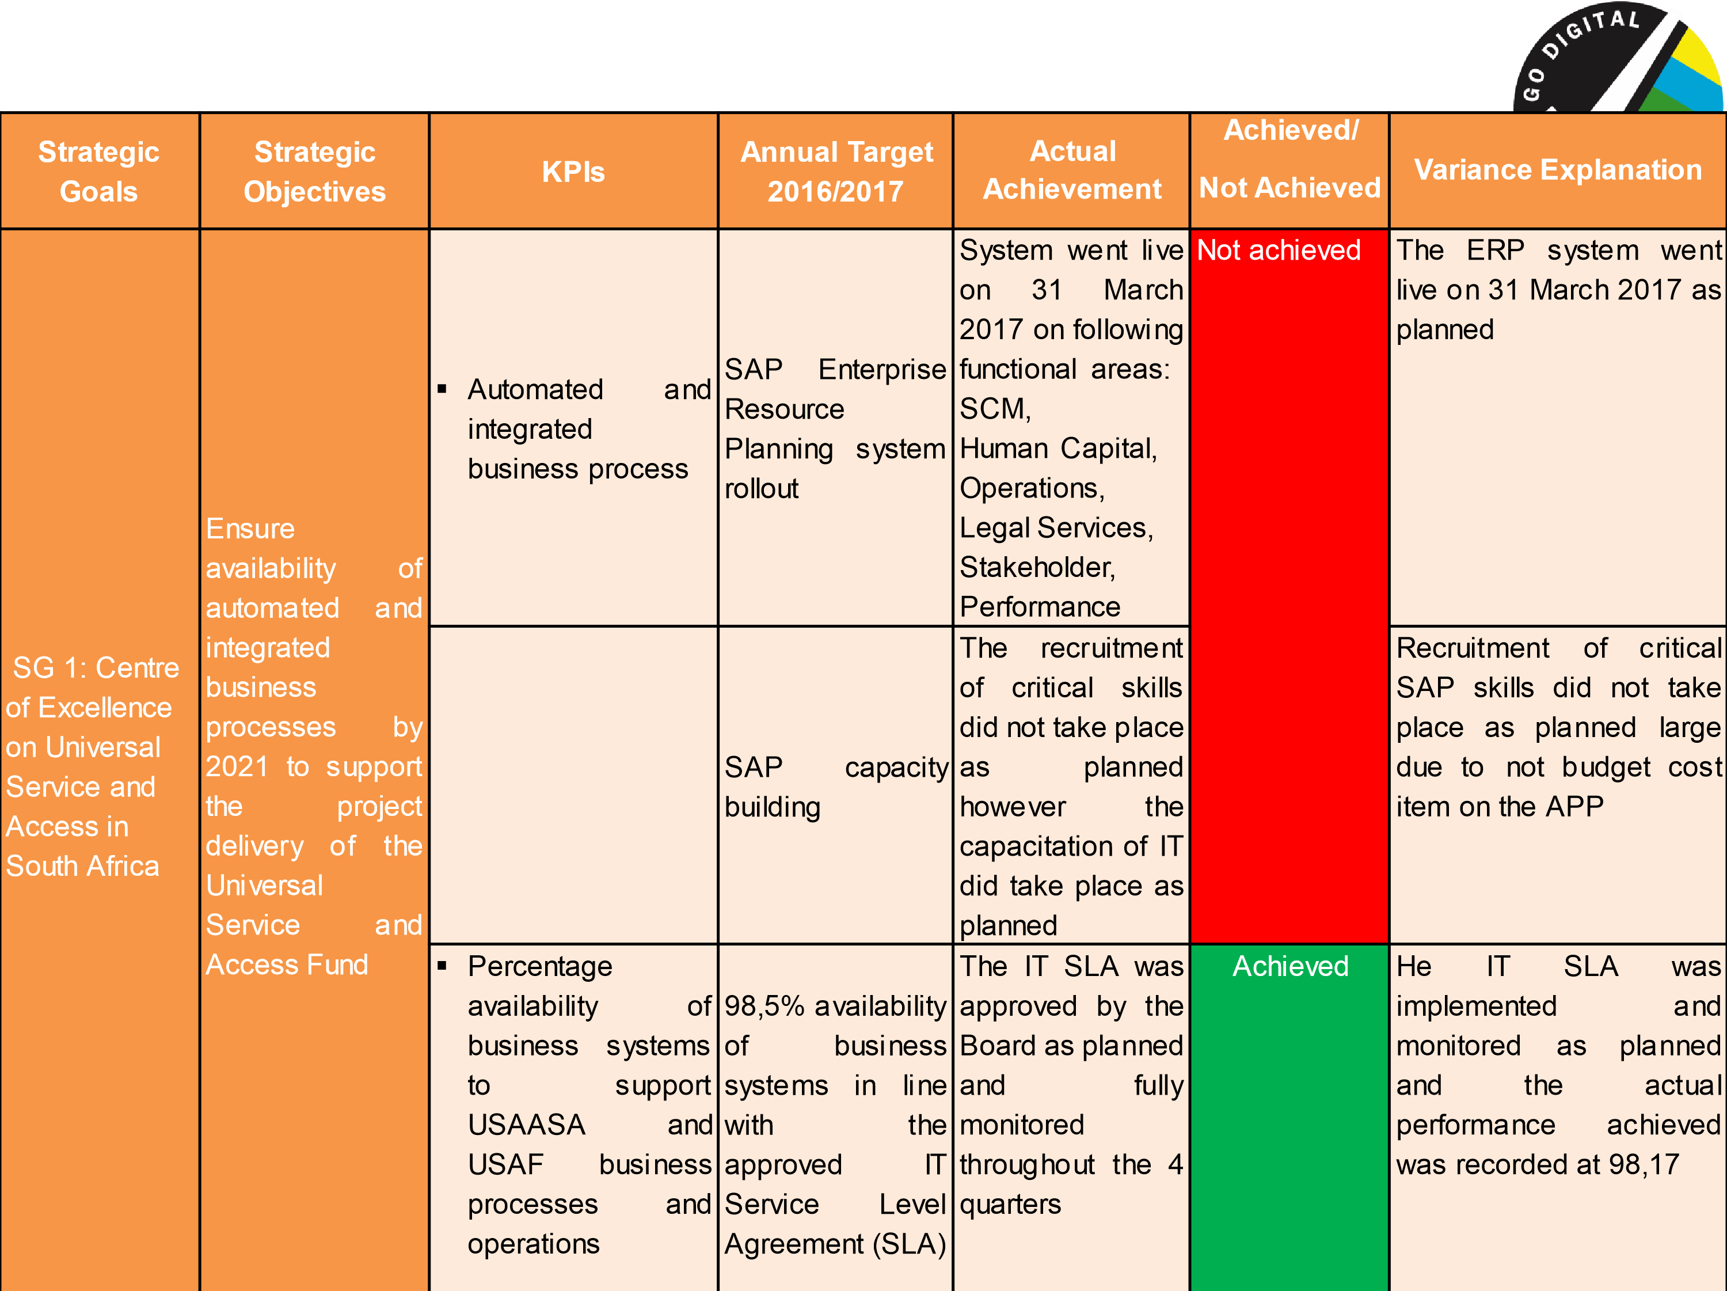
Strategic
Goals
Strategic
Objectives
KPIs
Annual
Target
2016/2017
Actual
Achievement
Achieved
/
Not
Achieved
Variance Explanation
SG 1:
Centre
of Excellence
on Universal
Service and
Access in
South Africa
Provide
legally
sound
services
to
the
Agency
by
2021
to
support
the
project
delivery
of
the
Universal
Service
Fund
▪
Number
of
days
for
providing
legal
services
in
accordance
with
relevant
legislation
and
policy
Ensure
sound
legal
services
are
provided
to
the
Agency
The
target
was
fully
achieved
Achieved
The
monitoring
of
the
written
legal
opinions
and/or
advice
provided
within
7
working
days
and
the
drafting
of
contracts
within
21
working
days
did
take
place
as
planned
USAASA
established
as
a
centre
of
excellence
for
Universal
Access
and
Universal
Service
market
information,
knowledge
and
expertise
by
2021
▪
Information
on
impact
of
the
provision
of
universal
access
and
universal
service
Monitor
and
evaluate
the
impact
of
universal
access
and
universal
service
provision
on
access
gaps
and
disseminate
the
findings
The
target
was
fully
achieved
Achieved
A
consolidated
impact
assessment
report
for
6
identified
underserviced
areas
was
developed
and
presented
to
key
stakeholders
as
planned
.
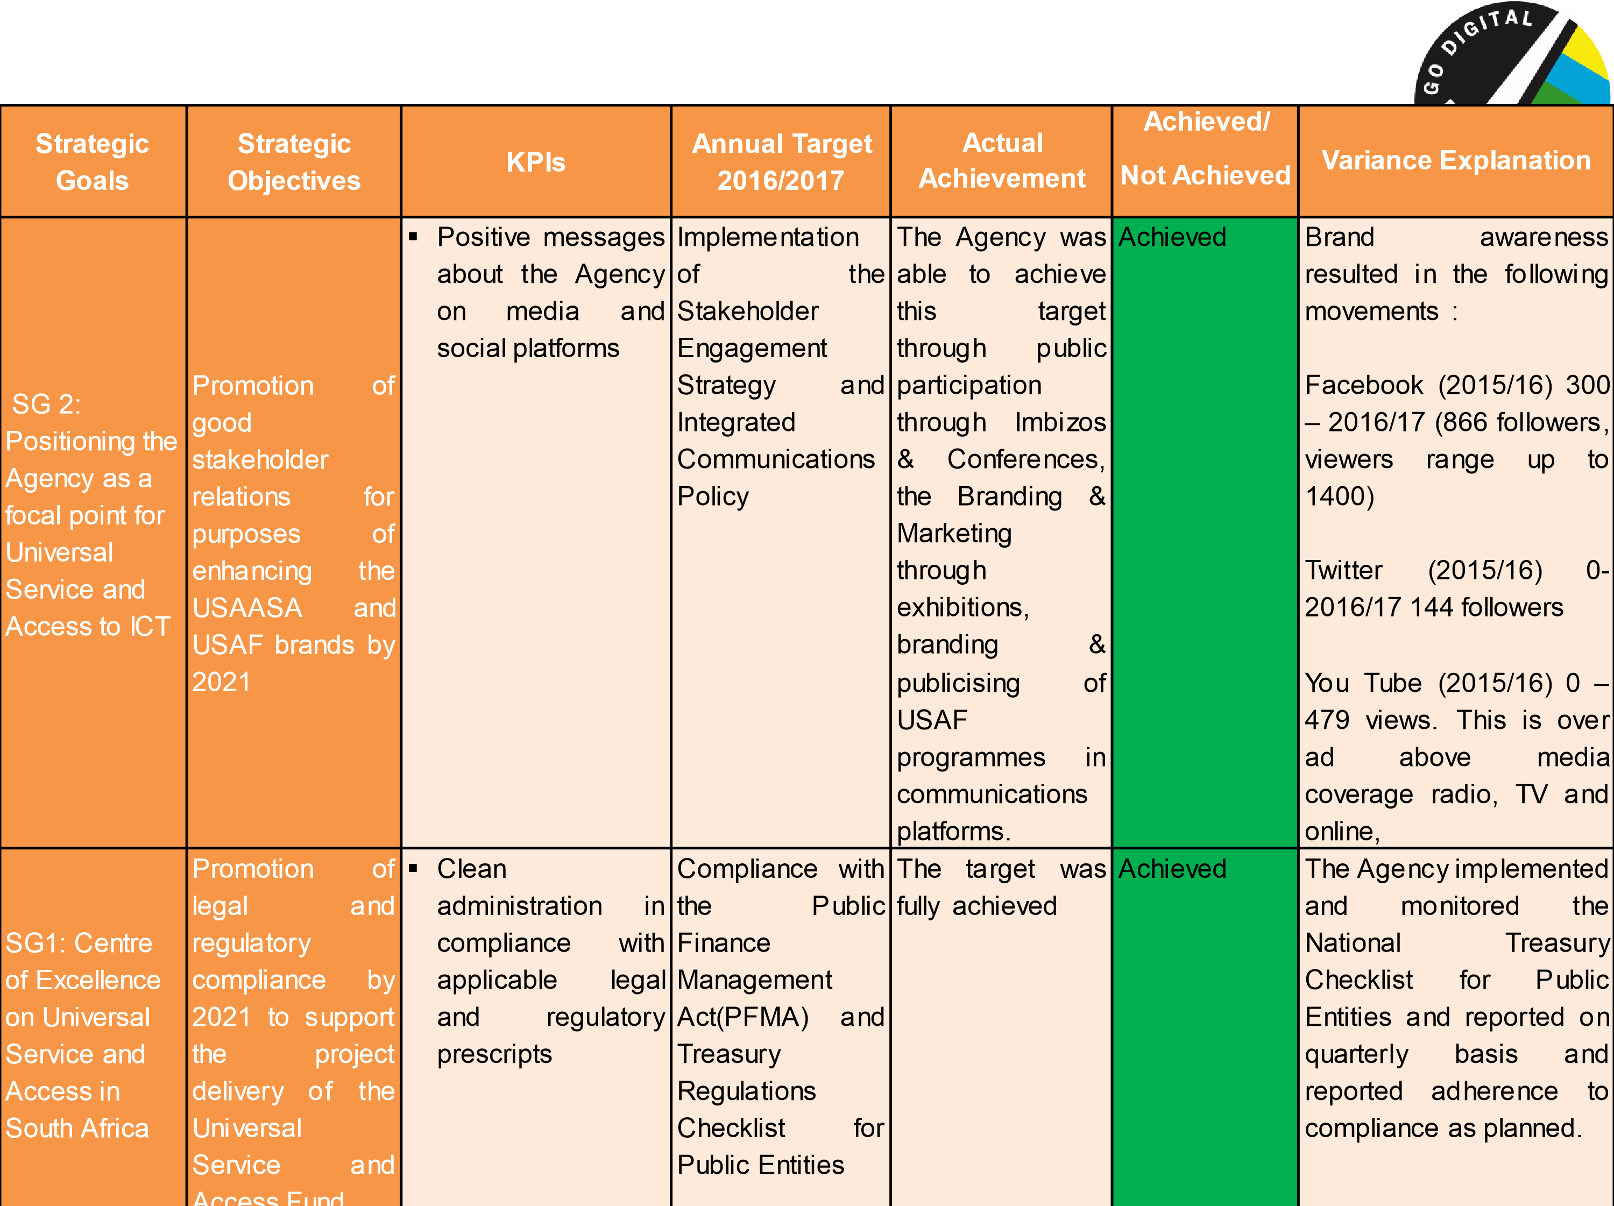

Summary of USAASA 2016-2017 Annual Performance
The graph below depicts the Agency’s achieved annual targets against the planned annual targets in the 2016-2017 approved Annual Performance Plan.
- Six (6) of the nine (9) planned targets were achieved, amounting to 67% of the total planned targets,
- and three (3) of the nine (9) planned targets were not achieved, resulting to 33% of the total annual planned targets
33
%
Not
Achieved
67
%
Achieved

Headcount Overview : Resourcing of the environment
Human Capital | Fillingof key positions | Vacant positions during the financialyear
At the closing of the financial year, USAASA employees complement compromised of 50 permanent staff | The following key positions were filled during the financial year:  o Chief Executive Officer o Chief Financial Officer o Senior Manager : Finance o Company Secretary | - Executive : Performance Management – Resigned o Executive : Operations – Resigned o Company Secretary – Resigned  - Senior Manager : Broadcasting & USAF – Resigned o Senior Manager : BDM – Resigned o Travel Management Officer – Resigned o Registry Officer – Resigned
An internship programme in both Finance & IT comprising of 4 interns was completed during the year under review
There are 13 funded vacancies in the staff establishment
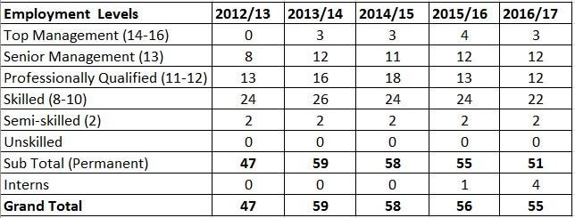
USAASA Staff Complement
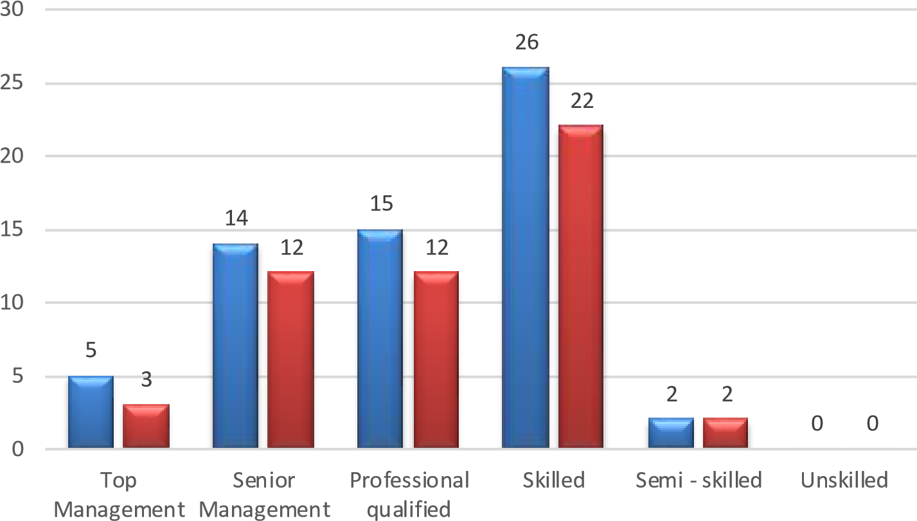
No of approved posts Actual appoinment
Risk Description [2017/18 Quarter Two] | Risk Description [2016/17 FY]
Low organisational performance and risk culture leading to inadequate and/ or slow response in addressing performance, audit and risk recommendations aimed at improving internal controls systems and eliminating governance risks | Negative stakeholder perceptions about the Agency
Inability to effectively recover should a disaster occur | Inability to effectively recover should a disaster occur
Lack of an ongoing SAP support in line with the IT service level agreement and SAP skills to support the ERP | Inability to implement the ERP system in a timely manner
Inability to produce Quarter One USAASA and USAF financial statements and subsequent months due to system related issues. | Failure to produce GRAP compliant financial statements resulting in an undesirable audit opinion
Lack of adequate technical skills | Inability to deliver on the USAF mandate
Potential litigation brought against the Agency/ Fund | Negative stakeholder perceptions about the Agency
Strategic goals, strategic objectives, key performance indicators and targets inconsistent with the "SMART" criteria | Strategic goals, strategic objectives, key performance indicators and targets inconsistent with the "SMART" criteria
Going concern – development of the Digital Development Fund Bill | Inability of the Agency to continue operating in its current form for the foreseeable future
Lack of an up-to-date adequate Organisational policy manual | Lack of review of the standard operating guidelines (Fund manual)
Failure to derive value from OD process deliverables | Failure to derive value from OD process deliverables

USAASA Top Strategic Risks
Slide 13

Statement of Financial Performance | Note(s) |  | 2017  R’000 | 2016  R’000
Revenue
Government grants & subsidies  Interest received –investment Other income |  | 26 | 69,045  10,642 27 | 262,429  8,605  267
Total revenue |  |  | 79,714 | 271,301
Expenditure  Employee related costs  Depreciation and amortisation  Finance costs  Lease rentals on operating lease  Repairs and maintenance  General Expenses |  | 12  27  13 | (41,839)  (3,100)  -  (4,600)  (188) (97,510) | (38,165)  (3,227)  (84)  (4,842)  (201) (32,745)
Total expenditure |  |  | (147,237) | (79,264)
Operating (deficit) surplus  Loss on disposal of assets and liabilities |  | 14 3 | (67,523) (20) | 192,037  (14)
(Deficit) surplus for the year |  |  | (67,543) | 192,023
The comparative figures have been adjusted accordingly to reflect correction of prior period errors.
Statement of Financial Position as at 31 March 2017 | Note(s) |  | 2017 R’000 | 2016 R’000
Assets
Non-Current Assets  Property, plant and equipment  Intangible assets |  | 3  4 | 5,112  39,892  45,004 | 4,236 25,297  29,533
Current Assets  Inventories  Loans and receivables  Cash and cash equivalents |  | 5  6  7 | 28  1,496  104,543  106,067 | 145  735  208,483  209,363
Total Assets |  |  | 151,071 | 238,896
Liabilities  Non-CurrentLiabilities  Finance lease obligation |  | 8 | 8 | 152
Current Liabilities  Finance lease obligation  Trade and other payables  Provisions  Total Liabilities  Net Assets |  | 8  9  10 | 207  12,090  1,950  14,247 14,255  136,816 | 203  15,740 18,441 34,384  34,536  204,360
Accumulated surplus |  |  | 136,816 | 204,360
The comparative figures have been adjusted accordingly to reflect correction of prior period errors.
Statement of Changes in Net Assets
Accumulated Surplus
R’000
Total net Assets
R’000
Balance at 01 April 2015
Changes in net assets
Surplus for the year
12,337
192,023
12,337
192,023
Total Changes
192,023
192,023
Opening balance as previously reported
Adjustments
Correction of errors
203,651

708
203,651
708
Balance at 01 April 2016 as restated*
Changes in net assets
Surplus for the year
204,359
(
67,543)
204,359
(
67,543)
Total changes
(67,543)
(67,543)
Balance at 31 March 2017
136,816
136,816
Note(s)
Statement of Cash Flows
Note(s)
2017

R’000
2016

R’000
Cash flow from operating activities
Cash receipts from government
Cash paid to suppliers and employees
69,045
(164,899)
262,429
(49,641)
Cash generated from operations (excl. interest)
Interest income
Finance costs
15
(95,854)
10,642
-
212,788
8,605
(84)
Net cash from operating activities
(85,212)
221,309
Cash flows from investing activities
Acquisition of property, plant and equipment
Proceeds from disposal of property, plant and equipment
Purchase of other intangible assets
3
3
4
(3,682)
-
(14,906)
(900)
9
(24,937)
Net cash from investing activities
(18,588)
(25,828)
Cash
flow
from
financing
activities
Finance
lease
payments
(140)
224
Net cash from financing activities
(140)
224
Total cash movement for the year
Cash and cash equivalents at the beginning of the year
(103,940)
208,483
195,705
12,778
Cash and cash equivalents at the end of the year
7
104,543
208,483

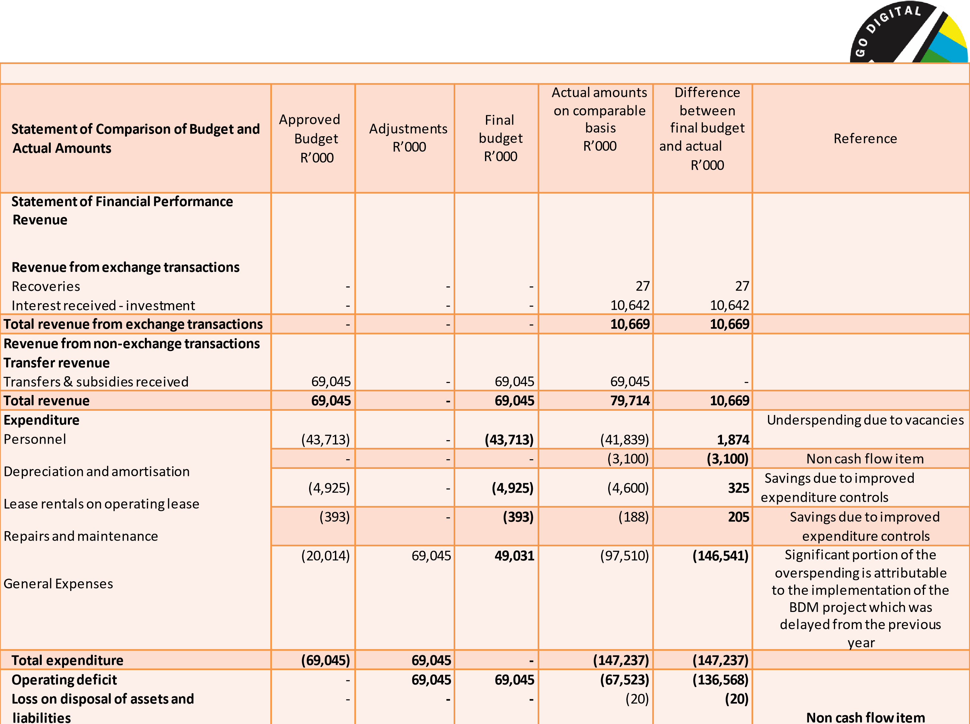
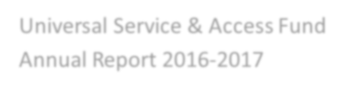
Universal Service & Access Fund
Annual Report 2016
-
2017

Achieved/Not
Strategic Strategic Variance
KPIs Annual Target Actual Performance Achieved Goals Objectives Explanation
The backhaul towers and KPI was achieved as
SG 1: Current base stations have been a result of effective
under-
Two under-serviced local constructed at King Sabata engagement with
serviced areas Accessible
Accessible municipality broadband Dalindyebo and Mhlontlo relevant
connected broadband broadband projects initiated and Local Municipalities as Achieved stakeholders.
through network network coverage completed in OR Tambo planned
affordable, coverage in in identified District Municipality in the
available, identified underserviced Eastern Cape The accessible WiFi access
sustainable underserviced
areas points in primarily health
and areas
facilities and public
qualitative schools were installed and
broadband operational as planned
SG 2: Number of The planned target of 258 Not Achieved The KPI was not Innovative ICT Facilitate the existing sites was not fully achieved largely due offerings that broadband broadband achieved. Only 68 sites to poor planning respond to connectivity of network Maintain broadband were connected for the and execution
the needs of educational connections network connectivity in financial year. leading to failure to
education, institutions, maintained in 127 schools, 93 clinics and conclude the primary primary educational 38 traditional ICT centres Service Level
health care healthcare institutions, in compliance with Section Agreements for and facilities and primary 88 of the Electronic connectivity at the
government government healthcare Communications Act, 2005 deployed sites
institutions in institutions by facilities and within schedule. underserviced 2021 traditional ICT areas centres
20

USAF Performance against corporate KPIs
USAF
Performance against corporate KPIs
21
Strategic
Goals
Strategic
Objectives
KPIs
Annual Target
Actual
Performance
Achieved/Not
Achieved
Variance
Explanation
SG
3:
Digital
access to TV
provided to
million
5.2
needy
households
To
fund digital
television access
equipment for
qualifying TV
–
owning needy
households by
2021

Number
of
Set
-
Top
-
Boxes
&
antennas
procured
and
installed
for
qualifying
needy
TV
-
owning
households
460 Set
58
-
Top
-
Boxes
& antennas procured
and installed for
qualifying needy TV
–
owning households
The target was not fully
achieved as planned. Only
43
272 set
-
top
-
boxes and
antennas out of the 58 460
planned were installed as at
the end of the financial
year.
Not
Achieved
The
Agency
did
not
complete
58
460
planned
set
-
top
-
boxes
owing
to
legal
challenges
and
also
the
installations
were
only
confined
to
Square
Kilometre
Array
and
boarder
lines
areas
.
A
total
of
35
393
installations
were
recorded
in
Q
1
(
2017
/
18
)
The STB registration phase has been activated in the remaining Provinces [KZN (Total Province), Eastern Cape (Total Province)
, W
estern Cape
and Gauteng) on
1
August 2017 (Official launch: 1 Sept
2017).
A total of 343, 651 TV owning qualifying households has been registered today 31 August 2017

Summary of USAF 2016-2017 Annual Performance
The graph below depicts the Fund’s achieved annual performance against the planned annual targets in the 20162017 approved Annual Performance Plan.
- One (1) of the three (3) planned targets was achieved, being 33% of the total planned targets, and
- two (2) of the three (3) planned targets were not achieved, being 67% of the total planned annual targets.
33
%
Achieved
67
%
Not
Achieved
Risk Description [2017/18 Quarter Two] | Risk Description [2016/17 FY]
Limitation of participation in the digital economy brought about by a lack of elements such as adequate access, digital literacy, awareness, integration and support | Inability to influence policy and strategy in South Africa, leading to lack of innovation and creation of new ICT solutions that anticipate and meet beneficiaries' increasing demands
Inadequate availability of funding to facilitate the rapid deployment of broadband infrastructure in identified underserviced areas | Inadequate availability of funding to facilitate the rollout of integrated broadband infrastructure in identified under-serviced areas
Duplication of effort and inefficient utilisation of limited resources | Lack of an integrated or a shared approach by key players in the ICTs sector towards the achievement of service-related goals to enhance universal service and access
Inadequate sign-off and monitoring and evaluation leading to a poor verification of the electronic communication infrastructure | Inadequate verification of reported performance outcomes to ensure reported performance matches actual performance
Low availability of Set Top Boxes and related accessories | Low uptake and usage of the digital broadcast services
BDM Stock holding for periods longer than anticipated may result in a loss of stock through events such as Fire, theft, etc. Stock counts have revealed that most of SAPO’s warehouses and branches fire hydrants/extinguishers have passed their service dates. The loss may even be greater than the insured value of stock | Potential litigation in the BDM Project
Inaccurate costs in relation to broadband projects | Non-compliance with contractual obligations by way of ensuring that project expenditure obligations by the service provider(s) are adhered to.
Underutilisation of the infrastructure and the end user devices | Underutilisation of the infrastructure and the end user devices
Lack of segregation of duties between project planning, implementation and verification | Lack of segregation of duties between project planning, implementation and verification
Lack of or poor quality research and evaluation outputs | Lack of or poor quality research and evaluation outputs

USAF Top Strategic Risks
Slide 23
The comparative figures have been adjusted accordingly to reflect correction of prior period errors.
Transfers and subsidies
Finance income
Other income
20
644,540
108,696
-
233,540
98
,440
12
Total revenue
753,236
331,992
Expenditure
Project Expenses
Audit Fees
Administrative Expenses
2
3
5
(94,951)
(1,497)
(21)
(65,658)
(1,077)
(3)
Total expenditure
(96,469)
(66,738)
Operating surplus/deficit
Surplus before taxation
Taxation
Surplus for the year
-
656,767
-
656,767
-
265,254
-
265,254
Statement
of Financial Performance
Revenue
Note(s)
2017
R’000
2016
R’000

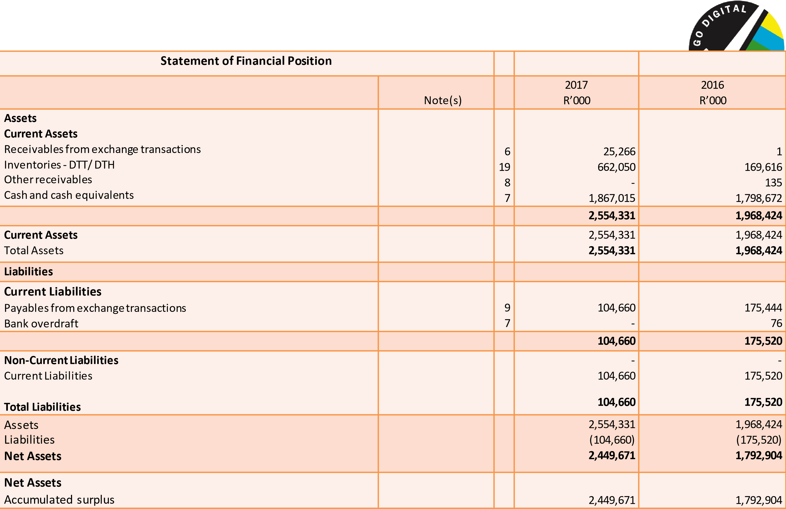
The comparative figures have been adjusted accordingly to reflect correction of prior period errors.
The comparative figures have been adjusted accordingly to reflect correction of prior period errors.
Statement
of Changes in Net Assets
Accumulated
surplus
R’000
Total
net assets
R’000
Balance at 01 April 2015
Changes in net assets
Surplus
for the
period
Transfer
of income surplus to
Nationa
l
Revenue
Fund
1,578,595
270,558

(
50,942)
1,578,595

270,558
(50,942)
Total revenue
219,616
219,616
Adjustments
Prior year adjustments (Refer to note 17 )
(5,307)
(5,307)
Balance at 01 April 2016
Changes in net assets
Surplus for the period
1,792,904
656,767
1,792,904
656,767
Total changes
656,767
656,767
Balance at 31 March 2017
2,449,671
2,449,671
The comparative figures have been adjusted accordingly to reflect correction of prior period errors.
Statement
of Cash Flows
Note(s)
2017

R’000
2016
R’000
Cash flows from operating activities
Receipts
Grants
644,540
233,540
Payments
Suppliers
(684,952)
(130,968)
Total receipts
Total
payments
Net cash flows from operating activities
10
644,540
(684,952)

(40,412)
233,540
(130,968)

102,572
Cash flows from investing activities
Interest Income
108,696
98,440
Cash flows from financing activities
Repayment of inter
-
entity loan
135
(161)
Net cash from financing activities
135
(161)
Net
increase/(decrease)
in
cash
and
cash
equivalents
Cash
at
the
beginning
of
the
period
68,419
1,798,596
200,851
1,597,745
Net increase in cash and cash equivalents
7
1,867,015
1,798,596
