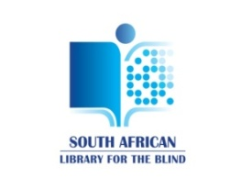

28 June 2017

Ms Joanmariae L. Fubbs
Chairperson: Portfolio Committee on Trade and Industry

COPYRIGHT AMENDMENT BILL [B13-2017]: THE SOUTH AFRICAN LIBRARY FOR THE BLIND SUBMISSION AND REQUEST TO THE PORTFOLIO COMMITTEE ON TRADE AND INDUSTRY

Dear Ms Fubbs

The South African Library for the Blind is the only Library for the blind in South Africa and on the African Continent. The mandate of the Library is regulated by the South African Library for the Blind Act 91 of 1998. The nature of our work, i.e. to produce accessible reading material and to make it available to blind and visually impaired people across South Africa is influenced by the provisions of the Copyright Legislation. It is therefore with great appreciation that the Library would like to submit the attached document to the Portfolio Committee for consideration.

In addition to the written submission the South African Library would also like the opportunity to present its case during the Public Hearings scheduled for the end of August 2017. You are humbly requested to consider this request favourably.

Your kind consideration of the above submission and request will be appreciated.

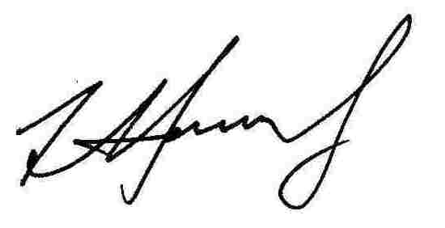
………………………………………………..
Francois Hendrikz
DIRECTOR: SA LIBRARY FOR THE BLIND

Legal Deposit Committee

28 June 2017

Ms Joanmariae L. Fubbs
Chairperson: Portfolio Committee on Trade and Industry

For attention: Mr. A. Hermans
ahermans@parliament.gov.za

COPYRIGHT AMENDMENT BILL [B13-2017] SUBMISSION FROM THE SOUTH AFRICAN LIBRARY FOR THE BLIND

Introduction

The mandate, role and function of the South African Library for the Blind (SALB) is regulated by the South African Library for the Blind Act 91 of 1998. The Library was established in 1919 and have since then rendered library and information services to all blind and visually impaired South Africans. The Library is in Grahamstown in the Eastern Cape.

SALB role and function

The affairs of the SALB is governed by a Board that is appointed every three years by the Minister of Arts & Culture. The Board reports to Parliament annually. The SALB represents 6,450 registered blind and visually impaired members. The SALB is recognised in Schedule 3A of the Public Finance Management Act (Act 1 of 1999) as a national public entity. The SALB Act mandate the Library to
- Produce documents in special mediums such as braille and audio formats for use by its members;
- Develop standards to produce such documents;
- Research production methods and technology in the appropriate fields; and
- Acquire and disseminate the technology required by people with print disabilities to read.

Because the SALB serves a very particular constituency it is
- socially committed to strive, by its own efforts and in cooperation with others, for the removal, as far as possible, of access barriers to information; and
- to provide a quality service to meet, as fully as practicable, the information and reading needs of al South African who are blind or print handicapped.
The role and function of the SALB is aligned to various national and international governance and policy documents such as but not limited to:
- The National Development Plan 2030 providing a long-term perspective of a better South Africa for all South Africans;
- Medium Term Strategic Framework 2014-2019 targeting an efficient, effective and development oriented public service;
- The United Nations Convention of the Right of Persons with Disabilities as well as the White Paper on the Rights of People with Disabilities that was published by the Department of Social Development in 2016; and
- The Marrakesh Treaty to Facilitate Access to Published Works for Persons who are Blind, Visually Impaired, or otherwise Print Disabled
In addition to the above he Minister of Arts and Culture (together with Ministers from 12 other African countries) signed the Cape Town Declaration in August 2014, which noted the need for the improvement of library services for the blind and people with sight impairment as well as other forms of impairment. The amendment of the South African Copyright Legislation is therefore seen to be a positive response to the Treaty and the Declaration. However, until the Marrakesh Treaty is ratified by the South African Government, allowing reciprocal cross-border sharing of accessible reading material, these provisions in the Bill may not be fully effective. The SALB recommends ratification as soon as possible.

Finally, the SALB is a key role-player to promote access to reading material and information for blind people in South Africa and in doing so responds to the human rights of blind people in support of one of the National Government’s priorities which is Social Cohesion.

SALB and Copyright
The South African Government participated in the Diplomatic Conference in 2013 in Marrakesh, Morocco where the Marrakesh Treaty to Facilitate Access to Published Works for Person who are Blind, Visually Impaired, or Otherwise Print Disabled was accepted by member countries of the World Intellectual Property Organisation. This was the result of more than 31 years of negotiations by the World Blind Union and related parties to address the challenges faced by blind and visually impaired people to access information and reading material in various formats. The Treaty gives the Department of Trade and Industry a blue print to be included in the amendment of the South African Copyright Legislation. It is noted with appreciation that the most salient provisions of the Treaty are incorporated in the Copyright Amendment Bill.
The Copyright Act No.98 of 1978 makes no provision for exceptions or limitation to allow blind and visually impaired people reasonable and equitable access to reading material. The SALB produces on average 500 titles in audio and braille as well as some newspapers and magazines per annum. The fact that the current Copyright Act makes no provision for exceptions and limitations the SALB must send individual requests to copy right owners requesting permission to convert print copies into accessible formats. This is a huge administrative burden and cost and results in long delays before production could commence. The implication is that books can only be made available to blind people 6 months to a year after its first publication. The SALB is therefore pleased to note that the Copyright Amendment Bill contains provisions that will address this as well as other challenges.
Because of the Bill’s alignment to the Marrakesh Treaty the SALB would like to propose one recommendation to be incorporated in the Bill.

SALB RECOMMENDATION

- Term ‘Author’ vs ‘Rightsowner’
In many sections of the Bill, including those relevant to people with disabilities, the word ‘’author’’ is used instead of rights-owner. In most instances, authors assign their rights to third parties, e.g. editors, publishers, etc.

Recommendation:
Where reference is made to author instead of rights-owner, it should read as follows: ‘rights-owner’, or ‘rights-owner and/or author, as the case may be’.

The positive consideration of the above recommendation would be appreciated.

………………………………………………..
Francois Hendrikz
DIRECTOR:SA LIBRARY FOR THE BLIND

https://www.ifla.org/files/assets/wlic/2015/documents/cape-town-declaration-of-ministers.pdf

