ANNEXURE A
STATEMENT OF INTENT

TO restore the dignity and integrity of the institution of royalty in South Africa and TO PROMOTE UNITY IN DIVERSITY AND MOVE SOUTH AFRICA FORWARD FOR AN INCLUSIVE PROSPEROUS FUTURE

28 May-02 June 2017

We, the delegates, at this Indaba gathered at Birchwood Conference Centre, Gauteng Province, from 28 May to 02 June 2017, focusing on restoring the dignity of the Traditional Leadership in South Africa to promote unity in diversity in pursuit of moving South Africa forward for an inclusive and prosperous future.
A

CKNOWLEDGING the significant role of royal leadership, accountability and reconnecting with communities as the fulcrum to achieve radical socio-economic transformation in rural areas;
R

ECOGNISING that the South African indigenous people consist of a diversity of cultural communities, that are recognized by our Constitution according to customary law; and that democratic governance and the values of an open and democratic society must be promoted;
I

NSPIRED by the leadership, support and guidance provided by the President of the Republic of South Africa and his Cabinet, Kings, Royal Highnesses, Houses of Traditional leaders under the leadership of the National House of Traditional Leaders, the Congress of Traditional Leaders of South Africa, National Khoi-San Council, Moral Regeneration Movement, South African Local Government Association, Academia, State Institutions Supporting Democracy (Chapter 9 Institutions), and other State Owned Enterprises to move South Africa forward.

WE AFFIRM our resolve to strongly condemn the recent spate of violence and abuse against our women and children; we commit to upholding African family values for the protection of our women, children and our communities as well as their dignity and integrity.

RECOGNIZE that the conference seeks to establish institutional mechanisms and create a platform for dialogue between the institution of traditional leadership, government and other stakeholders towards:
  - harmonization of relationships between the institution of traditional leadership, government, communities and other sectors.
  - Promotion of Nation building and Social Cohesion in the context of Ubuntu.
  - Resolution of challenges around cultural practices that violate legislative rights of individuals and communities; and
  - Strengthening the role of traditional leaders in radical economic development and land matters.

FURTHER RECOGNIZE that the outcome of this Indaba is an Action Plan for implementation of the resolutions.

DECLARE our commitment to:

- LAND OWNERSHIP, TENURE RIGHTS AND ECONOMIC DEVELOPMENT

  - Reverse the legacy of apartheid that ensured the permanent loss of land of indigenous populations;
  - Government transferring 13% of land to traditional authorities within a six months and where there is no legislation, such legislation be enacted within 2 years period;
  - Government undertake land Summit to discuss the transformation of 87% of land parcel. The Expropriation Bill must cover the 87% of land;
  - Effect moratorium on the acquisition of land by foreign nationals;
  - The undertaking of land audit across the country for purposes of ascertaining the amount of land that rightfully belongs to the institution of traditional leadership;
  - Utilize our land for socio-economic development, support and enabling the capacitation of rural communities;
  - Recognize rural-urban interdependency and the need for a more comprehensive, integrated approach to urban and rural development;
  - Ensure implementation of land tenure reforms, and land redistribution within a developmental approach;
  - The use of legal processes by Government, in consultation with traditional councils and communities, to transfer land and register titles of all communal land that it currently holds in trust for the traditional communities;
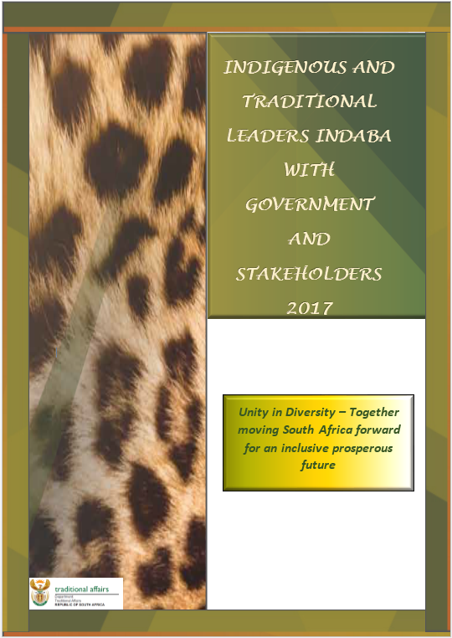
  - To suspend SPLUMA as it undermines the authority of the Traditional Leadership in their areas of jurisdiction and that the President of the Republic of South Africa issue a proclamation to this effect without delay;
  - Establishment of a Land Commission as a Chapter 9 Institution;
  - Hold regular report-back meetings with our communities to keep them abreast on land issues;
  - Expand socio-economic opportunities and activities towards the creation of economically and self-sustainable traditional communities.
  - Develop a model for radical socio-economic transformation once necessary research has been undertaken. The model will be tabled to the institution for further engagement and adoption.

- NATION BUILDING AND SOCIAL COHESION

  - Accelerate the statutory recognition and participation of Traditional Khoi and San leaders in Government programmes;
  - Promote nation-building, harmony and peace amongst our people in their diverse forms;
  - Promote the principles of co-operative governance in our interactions with all spheres of government and organs of state;
  - Harmonize relationships between the Institution of Traditional Leadership, Government, communities and other sectors;
  - Foster continuous engagement between Executive Authorities in all spheres of government and Traditional Leadership Structures;
  - Strengthen the participation of Traditional Leaders in Municipal Councils and other Governance Structures;
  - Eliminate cultural practices that violate legislative rights of individuals especially women and children, and communities;
  - Promote an Efficient, Effective and Fair Dispute Resolution System, and a fair system of administration of justice as envisaged in applicable legislation;
  - Promote freedom, human dignity and the achievement of equality and non-sexism; and
  - Establish Regional and Continental Relations through the National House of Traditional Leaders.

- INSTITUTIONAL CAPACITY AND SUPPORT

  - Ensure that the dignity of Traditional Leaders is restored through the provision of equitable support;
  - Promote ethical, accountable and committed leadership;
  - Ensure that Traditional Leadership Structures advise Government, and participate in a process to strengthen the legislative framework;
  - Constant engagement with the Remuneration Commission for Public Office Bearers to review the remuneration structure and to enable Traditional Leaders to effectively perform their functions;
  - Establish Pension and Medical Scheme suitable for Traditional Leaders as Public Office Bearers;
  - Make budgetary provision for the training of Traditional Leaders and Royal Families as well as for the benefits of spouses and widows of Traditional Leaders;
  - Integrate the Induction Program for Traditional Leaders and Municipal Councilors; and
  - Ensure that Government makes available the requisite funding for infrastructure development for Traditional Structures.

- CONSTITUTIONAL AND LEGISLATIVE MANDATE

  - Reconstitute the structures of Traditional leadership;
  - Ensure the establishment of Ministry for Traditional Affairs;
  - Review the legislative status of Royal Families;
  - Ensure that the National Department of Traditional Affairs gives effect to uniform implementation of the legislative frameworks by provincial governments;
  - Ensure further engagement on policy-making processes regarding the Traditional Courts Bill; and
  - Ensure that Government commissions the compilation of African Customary law.

We, the delegates at this inaugural Indigenous and Traditional Leaders’ Indaba with Government and Stakeholders:

Hereby adopt this declaration in the firm belief that this indaba defines the necessary roadmap towards the restoration of the Institution of Traditional Leadership, we commit and continue to serve our people, act in the best interest of the traditional communities, foster good working relations with organs of state, and reinforce the integrity of the Institution of Traditional Leadership within a system of democratic governance; and

Embrace the call for “Unity in Diversity” to move South Africa forward for an inclusive prosperous future.

