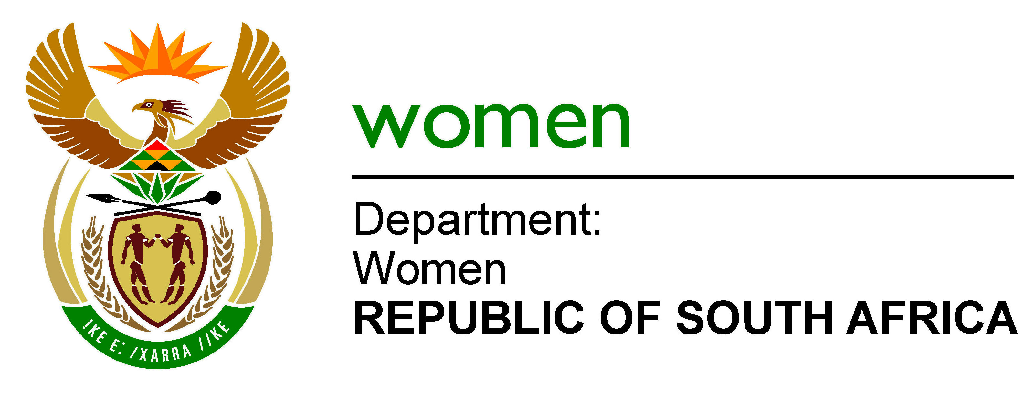

NARRATIVE REPORT ON OUTSTANDING RESPONSES TO ISSUES RAISED ON THE PORTFOLIO COMMITTEE MEETING HELD ON 7 MARCH 2017

- SANITARY DIGNITY POLICY FRAMEWORK PROJECT
PC QUESTION: DoW to give a report that elaborates on how the sanitary pads are delivered, where, when and by whom. Are clinics considered for this, and which ones?
.
DoW co-ordinates the Sanitary Dignity Policy Framework Project Task Team, consisting of DoW, DoH, DSD, DBE, DHET, NT, StatsSA, the dti, and DSBD, to develop a policy framework for the provision of sanitary pads to indigent women and girls in quintile 1-3 schools, young women supported in their higher education by NSFAS and women in the care of state institutions. The Minister will report back to Parliament by the end of June..

- POTENTIAL FOR WOMEN TO BENEFIT FROM AGRIPARKS
PC QUESTION: An update on the matter of Agri Parks, e.g who owns the land, what type of farming, what is the impact, Are the plans area specific, the role of the DTI and details of economic empowerment?

In terms of the Agri-parks model, the smallholder farmers are the major beneficiaries. Women will benefit in terms of employment and ownership under the Agri-Parks initiative. It is recommended that the PC obtain the information pertaining to updates on the issues related to Agriparks directly from the implementing departments viz. the Department of Rural Development and Land Reform and the Department of Agriculture, Forestry and Fisheries who are best placed to provide this.

- STOKVELS
PC QUESTION: How is the department assisting women with their stokvels in order to grow their inputs?

Stokvels are voluntary and private associations of individuals. There has been no policy development in relation to the regulation of stokvels. They are not regulated in law or policy. Moreover, stokvels are not restricted to women. Therefore fall outside of the mandate of government departments. It is not within the mandate of the Department of Women.

- NATIONAL DIALOGUES
PC QUESTION: What is the impact of the National Dialogues?
The Limpopo dialogues summary report is attached.

- CSW
The CSW61 report is attached.

- DoW STAKEHOLDER INVOLVEMENT
DoW holds consultation workshops with National and Provincial departments, civil society organisations and Inter-Governmental agencies when preparing for all its major events like National Women’s Month, CSW, 16Days of Activism, and National Dialogues.

The consultation in preparation for and on the report on CSW61 has been addressed in the CSW 61 report and reflects a solid process of involving government and non-government stakeholders in the work around CSW. Having finalised the current task of the Report on CSW61, we have committed to convening the stakeholders to focus on the implementation of Agreed Conclusions from CSW61.

The Department is also in the process of formalising a number of partnerships around specific programmes of its work .

- NATIONAL POLICY FRAMEWORK ON WOMEN’S EMPOWERMENT AND GENDER EQUALITY
The National Policy Framework on Women’s Empowerment and Gender Equality and the Strategic Framework on Gender Equality in the Public Service have not been repealed and so still provide the framework within which government and the Department of Women operate. However, in certain respects the frameworks are time-bound (for example in relation to coordinating mechanisms since the Cluster system of government and IGR frameworks have changed since 2000) and in certain respects the manner in which the frameworks have been implemented has been inconsistent across government, and in some instances does not reflect the intention of the framework. The major weakness of the implementation has been that GFPs are often HR equity personnel, events managers and at a too junior level. This poses challenges for the Department as often the GFPs do not have the technical knowledge nor seniority that allows them access to strategic decision making in their departments to drive the mainstreaming of socio-economic empowerment of women in the core delivery of the department.

As already reported to the PC, DoW is working on correcting the mis-interpretation of the role and functions of the Gender Focal Points, and the role of Directors-General and Heads of Departments. DoW has made recommendations on a new accountability mechanism for HoDs, functions, competencies, and location of GFPs, and proposing that all Directors-General have mainstreaming of the socio-economic empowerment of women and the promotion of gender equality as a Government Priority Area in their performance agreements. The matter has been consulted through the cluster; the Minister will be engaging her counter-part the Minister for Public Service and Administration to bring her up to speed; and then it will be tabled to Cabinet. Dow and DPSA will be working together on the implementation process across government.

- GIRLS AND STEM
We have an MOU with Techno-girl Trust. Through this partnership we aim to grow the impact of Technogirl programme to enhance the education programme, in which together Technogirl, together with DoW DBE, UNICEF and SITA identifies girls in grades 9-12 in STEM fields and facilitates their job shadowing programme during the school holidays. The programme also supports the girls to register for Higher Education Institutions and ensures they are supported. In order to ensure a comprehensive programme the department through this partnership is engaging with the private sector to facilitate the placement of young girls / Techno-Girl Alumni in internships or learnership. This is to mitigate the disproportionate representation in STEM fields between male and females despite more young women being qualified in the STEM fields. Children from poor background are selected.

- IMPROVING DEPARTMENTS PLANNING AND DELIVERY
PC QUESTON: DoW previously had 32 targets and now are 29, How many have changed or are discarded and what are the financial implications and effected on delivery?

In the 2016/17 APP, the Department had 32 targets overall, with 3 Key Performance Indicators (KPI) & their targets under Programme 3 Sub-programme: Research and Policy. These 3 KPIs were collapsed and replaced with 1 KPI & its target as an outcome of the Mid-Year Performance Review in October 2016, as a result the targets for the second half of the year were 29 instead of the initial 32. In the Mid-Term Performance Review the Department, under the leadership of the Minister, reflected on the extent to which with limited capacity that the Department has, we were able to deliver on the Presidential Directive in relation to the monitoring of the empowerment of women through the work of the Economic and Infrastructure Departments in the Nine Point Plan. This new area of work was recognised as not receiving sufficient attention.

These three targets:
- Research Analytical Report on the social impact of poverty and inequality on the lives of women in the country developed
- Research coordinating mechanism for the implementation of the research strategy established
- Policy Analysis paper on benefits to women of government programmes as related to the Nine-Point Plan developed
Were collapsed into the following target:
- Number of Desk top Research and analytical reports on the Social impact of the Nine-Point Plan on women’s socio-economic empowerment and gender equality developed.

The errata or revised APP or Strategic Plan was approved by the Executing Authority. According to the Framework for Managing Programme Performance Information “A Strategic Plan may be changed during the five-year period that it covers. However, such changes should be limited to revisions related to significant policy shifts or changes in the service-delivery environment. The relevant institution does this by issuing an amendment to the existing plan, which may be published as an annexure to the Annual Performance Plan, or by issuing a revised Strategic Plan.

In the situation whereby the amendments done from the 3rd quarter like in the department the delivery of Q1 & 2 will be reflected in the Annual Report.

The Strategic Management Unit ensures that all outstanding targets from the previous quarters (1&2) are reported upon until finalised and continues to monitor reporting on performance information on a quarterly basis.

- DOW STAFFING MATTERS
PC QUESTON: IKM who is now responsible for it as the CD is not with the department?

In the Mid-Year Performance Review, it was determined that the role of the IKM function and the area of work identified for IKM in the previous APPs was not appropriate to the Department at this stage. The IKM post was therefore restructured. Given the underfunding of the compensation of employees in 2016/17 and 2017/18, the funding was used to strengthen the capacity in STEE Branch. The focus of knowledge management going forward will focus on an information communication function to build the Department’s ability to share information within the gender sector.
.
The 2017/18 year will entail a detailed Organisational and HR Planning process given the increased allocation of Compensation of Employees funding in 2018/19 onwards and so the structural and budget allocation changes will be addressed during the organisational and HR planning and the National Treasury programme structure amendments in 2017/18 FY.

- PC QUESTON: When will a CFO be appointed?
From the time that the CFO transferred to Department of Energy, the Department has had an Acting CFO. The position was advertised, but the Department has determined that a finance and supply change management turn around programme must be completed before the appointment of a permanent CFO takes place. We have currently employed a finance expert on a contract from January until the end of August 2017 to support the Acting CFO in this turn-around strategy. This process is focusing on ensuring that appropriate systems are in place; that backlog issues such as suspense accounts, asset management, irregular expenditure investigations; that the closing of the financial year and the management of the audit process are finalised. The appointment of a permanent CFO will be initiated to ensure that a CFO is appointed by the latest the 31 August 2017.

- MPAT
MPAT comparison report is attached.

