|  |
| --- |
| NEW NEF LOGO |
| Submission to the  **Parliament of the Republic of South Africa,**  **STANDING COMMITTEE ON FINANCE** |
| **COMMENTS ON THE TRANSFORMATION OF THE**  **FINANCIAL SECTOR** |
| Ms Philisiwe Mthethwa,  Chief Executive Officer  National Empowerment Fund  Monday, March 13, 2017 |

**Contents**

|  |  |
| --- | --- |
| Topic | Page |
| 1. Introduction | 3 |
| 1. About the NEF | 4 |
| 1. Journey of South Africa’s transformation | 4 |
| 1. Summary B-BBEE performance of JSE listed financial services companies | 7 |
| 1. Comparison of the Codes and the Financial Sector Codes | 13 |
| 1. Rationale for the establishment of a Black owned bank | 14 |
| 1. Proposed improvements to the Revised 2016 FSC | 19 |
| 1. Conclusion | 27 |

1. **Introduction**

# **Background**

In February 2017 the Hon. Yunus Ismail Carrim, MP and Chairperson of the Standing Committee on Finance, as well as the Hon. Joan Fubbs, MP and Chairperson of the Portfolio Committee on Trade and Industry, issued the following public invitation:

*“The Standing Committee on Finance (SCOF) hereby invites members of the public, interested and affected parties and stakeholders to make comments on the transformation of the Financial Sector. This will include a focus on its deracialisation; high level of monopoly; progress on implementation of the Financial Sector Charter and other related matters.”*

# **Purpose of this submission**

The purpose of this submission by the National Empowerment Fund (NEF) is in response to the invitation by the Parliament of the Republic of South Africa through the Standing Committee on Finance for written or oral submissions at public hearings that will be held in March 2017 on the transformation of the financial sector. Through this submission the NEF seeks to provide the following:

* A perspective on the transformation journey of the financial sector;
* An analysis of ownership of financial services companies listed on the Johannesburg Stock Exchange (JSE) in terms of Broad-Based Black Economic Empowerment (B-BBEE) performance;
* Comparison of the Draft Amended Financial Sector Code (Draft Amended FSC) against the Amended Codes of Good Practice (the Codes) and the 2012 FSC;
* Proposed NEF improvements to the Draft Amended FSC; and
* Opportunities for further transformation in the financial services sector such as the establishment of a directly owned Black bank.

In particular, the NEF wishes to see improvements in the following key areas:

* Targeted Investment
  + Transformational Infrastructure
  + Black SME Financing
  + Black agricultural financing
  + Affordable housing
* BEE Transaction Financing and risk capital to support economic growth through Black industrialisation;
* Monitoring and Evaluation (M&E); and
* Transformative competition.

1. **About the NEF**

Established by the National Empowerment Fund Act No. 105 of 1998, the NEF is a driver and a thought-leader in promoting and facilitating black economic participation through the provision of financial and non-financial support to black businesses, as well as by promoting a culture of savings and investment among black people.

As the only Development Finance Institution (DFI) that is exclusively mandated to grow black economic participation in South Africa, the NEF makes this submission inspired by the recognition of the historic imperative for a just, progressive and enabling policy regime that will help the financial sector to accelerate transformation and to bridge the economic divide.

Among its many milestones the NEF has approved 839 transactions worth more than R8.5 billion for black-owned and managed businesses across the country, since its capitalisation by Government to the tune of R2.4 billion between 2005 and 2010. Through its funding activities the NEF has supported in excess of 89 000 jobs countrywide, and has implemented programmes to provide investor education, business-planning, entrepreneurship training, incubation and mentorship support for the benefit of black communities and entrepreneurs countrywide.

As an early proponent of efforts to support the emergence of black industrialists, the NEF has developed over 20 strategic and industrial projects in partnership with local and international partners across sectors identified in both the Industrial Policy Action Plan and the National Development Plan, spanning Renewable Energy, Mineral Beneficiation, Agro-processing, Information and Communication Technology, Infrastructure and Tourism. The projects are valued in excess R20 billion and have the potential to support a further 86 500 jobs.

1. **Journey of South Africa’s transformation**

It could be argued that transformation in South Africa began as early as 1990 with the unbanning of political movements and between 1990 and 1994, the extensive apartheid laws were repealed and finally in 1994, a democratically elected Government was put into power by the will of the people.

However, the deep economic divide across colour lines was too obvious to ignore and true transformation still need to be addressed. Black people in this country still live with too many of the reminders of apartheid policies, match box houses, poor infrastructure in the townships, lack of access to decent education and job opportunities, systematic exclusions from participating in the mainstream of the economy to name but a few.

# **Financial Sector Charter timeline**

In January 2004, the Financial Sector Charter came into effect as a transformation policy based on the terms of the Broad-based Black Economic Empowerment (B-BBEE) Act (53 of 2003).

This was formed as a voluntary agreement by all National Economic Development and Labour Council (NEDLAC) members in 2002. NEDLAC is a multilateral social dialogue forum which brings together government, business, labour and the community members to promote social and economic integration and access to the financial services sector. Figure 1 depicts the FSC implementation timeline:

Figure 1: FSC Charter timeline

* The Financial Sector Charter (FSC) came into effect in January 2004 and was the first voluntary BEE Charter that represented commitment from an entire sector of the economy to transform the financial services industry in line with the B-BBEE Act with the primary objective of reducing inequalities across the economy.
* As indicated above, the Codes of Good Practice on B-BBEE were gazetted in 2007, four years after the act had been gazetted. The Codes were gazetted under section 9(1) of the B-BBEE Act and this gave the codes a superior legal status to that of the charters gazetted under section 12.
* From 2007 to 2011, the Charter constituencies were engaged in discussion to align the FSC to the Codes with the aim of gazetting the FSC under section 9 of the Act to have the same legal status as the Codes.
* In December 2011 phase 1 of the draft sector code was gazetted for public comment. In November 2012 a Financial Sector Code was gazetted under section 9 (1) of the Act.

# **Key objectives in respect of the financial sector code**

The financial sector code measures transformation in respect of the pillars of the generic codes, being, ownership, management control, skills development, enterprise and supplier development and socio-economic development. In addition to these pillars, the FSC also introduced two pillars, empowerment financing and access to financial services.

The focus of these two pillars is on making financial services accessible to the previously unbanked and underserved, as well as empowering the previously disenfranchised through the provision of affordable housing, financing of black SMMEs and rural entrepreneurs through agricultural financing, and investing in various forms of transformational infrastructure to create the necessary platform to grow the economy on an equitable basis.

In 2003 the Black Economic Empowerment (BEE) Strategy document was drafted to provide clarity and certainty about Government’s approach to BEE. It represented a call to action for all sectors of South Africa to take active steps to contribute towards the process of BEE implementation.

In 2007, The Codes of Good Practice on B-BBEE (“The Codes”) were gazetted. They were addressing the broader aspects of BEE, being:

1. Ownership;
2. Management;
3. Employment equity;
4. Skills development;
5. Preferential procurement;
6. Enterprise development; and
7. Socio-economic development.

It is through these Codes that the Transformation targets were clarified and therefore, companies could be measured on their commitments on transformation on an equitable basis. Whereas, the Financial Sector Charter (the Charter) came into effect in January 2004 as a result of a voluntary offer to develop an industry transformation charter by the financial sector.

* As indicated in Figure 1, the Codes were gazetted in 2007, four years after the Black Economic Empowerment Act (BEE Act) had been gazetted. The Codes were gazetted under the BEE Act they have a superior legal status to that of the charters. From 2007 to 2011, the Charter constituencies were engaged in discussion to align the Charter to the Codes with the aim of gazetting the Charter under section 9 of the BEE Act to have the same legal status as the Codes.
* In December 2011 phase 1 of the draft sector code was gazetted for public comment.
* In November 2012 a Financial Sector Code was gazetted under section 9 (1) of the Act.

# **Key objectives in respect of the Charter**

The financial sector Charter measures transformation in respect of the pillars of the generic codes, being, ownership, management control, skills development, enterprise and supplier development and socio-economic development. In addition to these pillars, the FSC also introduced two pillars, empowerment financing and access to financial services.

The focus of these two pillars is to make financial services accessible to the previously unbanked and underserved, as well as empowering the previously disenfranchised through the provision of affordable housing, financing of black SMMEs and rural entrepreneurs through agricultural financing, and investing in various forms of transformational infrastructure to create the necessary platform to grow the economy on an equitable basis.

1. **Summary B-BBEE performance of JSE listed financial services companies**

It appears that the achievements of the sector are a far cry from the targets set by the 2012 FSC and further undermine the efforts and aspirations of the Codes, as evidenced by the following:

# **Ownership**

A sample analysis of the top 17 financial services companies by market capitalisation as listed on the JSE shows underperformance against the set 2012 FSC target of 10%. The findings of the analysis indicate that the black ownership achieved is 6.0% as extensively highlighted in Table 1. Furthermore, the methodology of computing the ownership target is based on 2010 baseline market capitalisation as per the 2012 FSC. It would be instructive to use current market capitalisation data on an ongoing basis as this would provide accurate and up to date figures.

# **Empowerment financing**

Claims by the majority of the financial institutions indicate that they have complied with the empowerment financing element. However, the claims cannot be validated due to poor reporting and the absence of effective monitoring. Furthermore, there are four (4) sub-elements to empowerment financing being:

* transformational infrastructure;
* black SME financing;
* black agricultural financing; and
* affordable housing.

Financial services companies would earn twelve (12) points in respect of the R48 billion target set for the industry in empowerment financing. However, financial institutions have enjoyed the liberty of cherry picking their preferred sub-element of empowerment financing to the detriment of others e.g. most financial institutions are more likely to utilise Government-backed securities and financial instruments in fulfilment of empowerment financing. In fifteen (15) years, the R48 billion baseline target set in 2002 has neither been adjusted for inflation nor to meet the considerable needs of empowerment financing.

# **Access to financial services**

The 2012 FSC set a target of R32 billion regarding access to funding. However, this amount is also based on the 2002 baseline and doesn’t cater inflationary increases, population and economic growth. Furthermore, the amount has not been adjusted to cater for the growth in assets held by the respective participants.

# **Shortfalls of the traditional B-BBEE funding structures**

In 1993, one of the first Black Economic Empowerment (BEE) transactions was concluded when Sanlam sold Metropolitan Life to a black-owned consortium that led to the establishment of New Africa Investments Limited (NAIL). This signaled the wave of BEE transactions which typically focused on ownership by black people and some limited level of control through non-executive directorships by black people. Below is a synopsis of the typical BEE deals of the past:

* The majority of transactions were done at the peak of the economy and concluded on the basis of high valuations that obviously increased the repayment amounts.
* Many of the transactions entered into between 1990 and 1998 were highly geared (over indebted) such that the real beneficiaries of these transactions were the financial institutions that funded them.
* There was high reliance on value realisation from share price increases and not the cash flows of acquired companies. The global financial crisis of 1998 proved to be too much of a challenge to this model of equity structuring as black shareholders found themselves in a precarious position as they held more debt in these structures than the value of equity realised when global markets crashed.
* The shares in the hands of black people that had been held as security (guarantees) for the debt raised from the funders depreciated due to adverse market movements, resulting in capital calls to maintain the adequate assets (collateral to maintain the level of security required). Black people historically do not have access to capital and therefore they would not be able to financially respond to the capital call requirements, leading to the dilution of the acquired shares in the transactions.

Figure 2 and Figure 3 depict the typical scenarios where black shareholders entered into a transaction in the early days of BEE where deals would be under water (where value of debt raised is higher than the value of the shares purchased) for long periods but the companies would recognise BEE points even though the BEE shareholder did not realise any form of value:

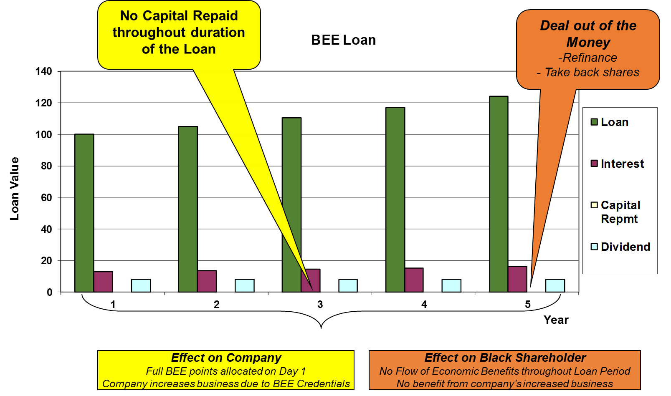

Figure 2: Early BEE deal structures

The requirements of the codes in respect of ownership and in particular the requirement to measure the proportion of the debt free portion of equity in the hands of black people allowed for alternative funding mechanisms to be employed so that black shareholders could derive value during the life of the transaction. This saw a move from share appreciation to cashflows driven structures.

The black shareholder’s ability to service the debt linked to their shares relied on receiving dividends for the shares purchased and this therefore meant that they were at the mercy of the dividend policies of the companies.

The ring-fencing of the debt to Special Purpose Vehicles (SPVs) when funding shares purchased by black shareholders was a clear misalignment to the original intent of BEE. Where the target company is not financially exposed to the debt raised for the acquisition of the black shareholder’s portion of equity, they are less likely to have dividend policies that allow the repayment of acquisition debt at a quicker pace. The introduction of the concept of net value (debt free portion of equity in the hands of black people) in the 2007 codes addressed to some extent this misalignment as full points on the ownership scorecard could not be allocated where the debt remained unpaid.

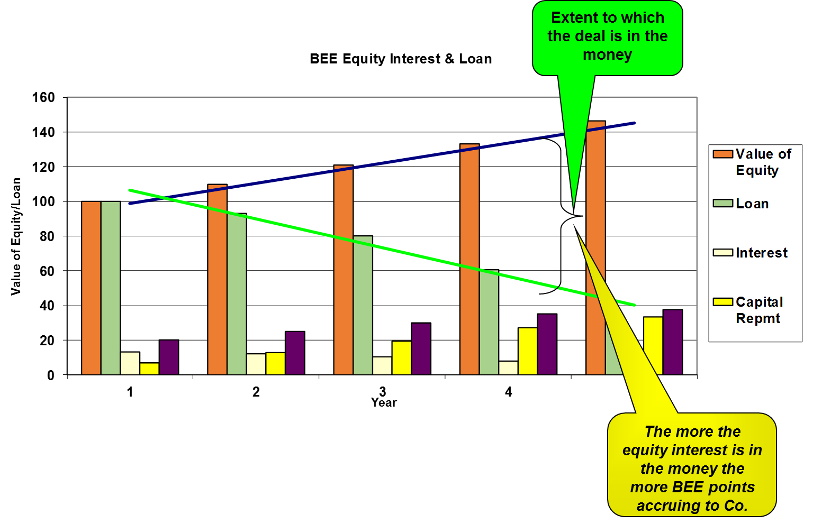

Figure 3: Effect of B-BBEE Codes provisions

# **Analysis of transformation of the JSE-listed financial sector companies**

The Most Empowered Companies Survey published annually since 2004 has shown some level of transformation on the basis of verified scorecards of companies listed on the JSE. Since 2009, these companies have been consistently featuring in the top 10 of these results with one or more of the banks being ranked in the top 3 consistently. This can be attributed to the application by companies in this sector of the FSC 2012.

However, it is important to note that these companies have and/or would have performed poorly against the Codes, because the Codes have higher targets than the 2012 FSC. The focus of this report in respect of transformation in the financial sector is based on data relating to JSE listed companies for which such data was readily available. In 2015, the Financial Sector Charter Council commissioned a report to assess the B-BBEE ownership positionof large firms in the financial sector, an extract of the updated (as at 31 December 2016) outcome of this study by Intellidex (Pty) Ltd as depicted in Table 1.

Table 1: Top 17 FSC Ranked Companies by Market Capitalisation (updated as at 31 Dec 2016



Concluded refers to transactions where the vesting period has been fulfilled and the black shareholders are no longer bound by lock-ins

* The market capitalisation, as at 31 December 2016, of the 17 financial services companies identified above totals R1, 6 trillion. The values of transactions in these companies, live and concluded, were measured in the study to be approximately R98 billion in total.
* This equates to approximately 6.03% of the market capitalisation at 31 Dec 2016 of value of transactions concluded to date in the sector for BEE purposes
* The FSC code allows for equity enhancements including investments made by institutional investors using public funds (mandated investments), exclusion of foreign operations, modified flow through adjustments, etc. These enhancements lead to the recognition of higher black ownership than the actual equity held.
* At least half of these transactions were concluded on behalf of strategic partners with the balance shared between staff schemes and community schemes.
* From the data gathered, FirstRand and Sanlam had the largest value of transactions concluded on behalf of communities (totalling R21 billion) and these transactions were both concluded in 2014.
* The question remains whether or not there has been any real value realised by the communities for whom these deals were structured. The majority of these shares in respect of these community structures are housed in trusts which may result in value leakage in respect of the accrual of benefits to the ultimate beneficiaries as there are costs associated with the running of these trusts.
* The staff schemes are for the benefit of employees, this may include management and directors in some instances and may be perpetuating inequality where the benefits are weighted favourably towards higher earning employees vs. lower skilled workers and lower income earners.

In the 2016 calendar year, no new transactions were entered into in this sector, with the majority of transactions entered into in 2005 that have since concluded with typical 10-year lock-in periods that have expired. This means that those companies that do not have active transactions may be benefitting from the Once Empowered Always Empowered (continuing consequences) principle.

The 2016 Most Empowered Companies’ survey released by Empowerdex, revealed those financial institutions which must fulfil the requirements for empowerment financing are by and large scoring full points. Contributions to this pillar of the financial sector code are geared towards transformational infrastructure, mostly financing projects that support economic development in the country.

1. The aggregation of the score allows for the financial institutions to opt for those products that are perceived lower risk and reduces the likelihood for funding of rural entrepreneurs, new industries and black SMMEs in general. In order to see real impact in this area of the scorecard, it would be necessary to split out the target of R 48 billion amongst the different sub-pillars and allocate a higher target for Black SME Financing and black agricultural financing, for example 60% of the target.
2. The draft FSC has set aside R32 billion for transaction financing and risk capital support for the black industrialisation programme. This fund are still loans that needs to be repaid back with an interest.

It is difficult to conclusively quantify the proportion of funding raised by the financial ‘institutions towards each of the four (4) empowerment financing sub-pillars and a full research study would need to be conducted to provide this granular level of data.

Although the codes went a long way in addressing the need for transformation, the slow pace of change remained a challenge as more and more of the population remained disgruntled at being left out of the transformative process.

Section 1 (c) of the BEE Act was gazetted with its objectives clearly outlined to facilitate broad-based black economic empowerment by:

1. promoting economic transformation in order to enable meaningful participation of black people in the economy;
2. achieving a substantial change in the racial composition of ownership and management structures and in the skilled occupations of existing and new enterprises;
3. increasing the extent to which communities, workers, cooperatives and other collective enterprises own and manage existing and new enterprises and increasing their access to economic activities, infrastructure and skills training
4. increasing the extent to which black women own and manage existing and new enterprises, and increasing their access to economic activities, infrastructure and skills training;
5. promoting investment programmes that lead to broad-based and meaningful participation in the economy by black people in order to achieve sustainable development and general prosperity;
6. empowering rural and local communities by enabling access to economic activities. land, infrastructure, ownership and skills; and
7. promoting access to finance for black economic empowerment.
8. **Comparison of the Codes and the Financial Sector Codes**

Within four years of the pronouncement of the BEE Act, the Codes of Good Practice on Broad-Based Black Economic Empowerment were gazetted and introduced the measurement criteria of the focus areas of the Act. Figure 1 summarises the pillars of the codes in terms of the codes of good practice as gazetted in 2007.

Figure 4: Pillars of the Codes of Good Practice on B-BBEE

# **Analysis of the revised FSC**

When comparing the Revised 2016 FSC against the Codes as well as the 2012 FSC, it is evident that the Revised 2016 FSC codes undermine both the Codes and the 2012 FSC as highlighted below:

1. **Ownership**

A fundamental deficiency of the charter is the lower 10% target for direct ownership in the financial sector, which compares unfavourably with the 25% target in the Generic BEE Codes. The draft FSC code allows companies to use indirect ownership to meet the 25% ownership target. This is not allowed under the BEE Codes. Indirect ownership occurs where an institution or other investor owns shares in a company on behalf of beneficiaries and there may not be direct participation by the beneficiaries in the voting rights.

A fundamental deficiency of the charter is the lower 10% target for direct ownership in the financial sector, which compares unfavourably with the 25% target in the Generic BEE Codes. The draft FSC code allows companies to use indirect ownership to meet the 25% ownership target. This is not allowed under the BEE Codes. Indirect ownership occurs where an institution or other investor owns shares in a company on behalf of beneficiaries and there may not be direct participation by the beneficiaries in the voting rights.

1. **Empowerment financing**

The R48 billion target for Empowerment Financing is based on the 2002 baseline and has not been reviewed nor has it been adjusted to cater inflationary increases, population and economic growth. Furthermore, the amount has not been adjusted to cater for the growth in assets held by the respective participants.

The FSC allows for financial services companies to earn up higher points for pillars of the codes that relate specifically to the industry, i.e. empowerment financing and access to financial services (both discussed later in this document). The empowerment financing scorecard applicable to banks and life assurers is as follows:

Table 2: FSC Empowerment financing targets

|  |  |  |  |
| --- | --- | --- | --- |
| **Measurement Criteria** | **Weighting Points** | **Banks Target** | **Long-term insurers target** |
| **Targeted Investment**   1. Transformational Infrastructure 2. Black SME Financing 3. Black agricultural financing 4. Affordable housing | 12 points | R 48 billion | R 27 billion |
| **BEE Transaction Financing and risk capital to support economic growth through black industrialisation** | 3 points | R 32 billion | R 15 billion |
| Total | 15 points |  |  |

* the banking and long term insurers’ commitment to targeted investments of R48 billion and R27 billion – under the empowerment financing indicator - is too low in an industry that had assets of R4.8 trillion in September 2016. Commissioner Ntuli rightly asks whether there is a need for such an indicator given that such empowerment financing is an “ordinary business activity” of banks “If lending is to be recognised it must be at seriously preferential rates or conditions for black people,” she said in her presentation. Empowerment Financing is currently measured in terms of a financial institution’s aggregate contributions towards the following:
* Transformational Infrastructure
* Black SME Financing
* Black agricultural financing
* Affordable housing
* There are currently 12 points allocated towards targeted investments, and most financial institutions are most likely to utilise the government bonds, which are low risk instruments. From the data collected, the majority of the financial institutions have achieved the 12 points in respect of R 48 billion target set for the industry.
* The aggregation of the score allows for the financial institutions to opt for those products that are perceived lower risk and reduces the likelihood for funding of rural entrepreneurs, new industries and black SMMEs in general. In order to see real impact in this area of the scorecard, it would be necessary to split out a much higher target amongst the different sub-pillars and also allocate a higher target for Black SME Financing and black agricultural financing, for example 60% of the target. Therefore, we have serious reservations about this indicator.
* It is difficult to conclusively quantify the proportion of funding raised by the financial institutions towards each of the four empowerment financing sub-pillars and a full research study would need to be conducted to provide this granular level of data.
* Despite these contributions, the support provided to black SMMEs by funding institutions seems to fall through the cracks and not enough support is provided to this sector of the economy by financial institutions as well as Development Finance Institutes (DFIs).

1. **Access to financial services**

The 2012 FSC set a target of R32 billion regarding access to funding. However, this amount is also based on the 2002 baseline and doesn’t cater inflationary increases, population and economic growth. Furthermore, the amount has not been adjusted to cater for the growth in assets held by the respective participants.

The problems that can be highlighted with the current FSC codes (2012 Gazette) can be summarised as follows:

* Some of the calculation methodology is not in compliance with the codes. E.g. the measurement of the management control pillar requires the use of the economically active population targets which principle seems to be have left out of the draft FSC. This is critical given the low representation by Black people, in particular Africans, in middle and senior management
* Exempted Micro Enterprises and Qualifying Small Enterprises which have met the qualifying criteria as enterprise or supplier development beneficiaries are recognised as beneficiaries even after they have exceeded the turnover threshold for qualifying as valid beneficiaries in the draft FSC – this impedes the introduction of more beneficiaries as financial institutions continue to recognise “non-qualifying” beneficiaries long after they have ceased to qualify.
* The target for Targeted Investments for financial institutions per the 2008 FSC BEE Performance Reporting Guidance Notes was R122.5 billion and this remains unchanged 14 years later.
* As part of the radical economic transformation programme, there should be alignment to the codes by restricting the period in which financial institutions and all other sectors can claim continuing consequences as part of ownership. Currently, the claim under ownership is restricted to the number of years that the BEE shareholder was in place. This could for example, be restricted to a maximum of two (2) years to give the measured entity time to find another black shareholder. Failure to find such a black shareholder could result in penalties for the measured entities.
* The current FSC code allows recognition of ownership on the basis of the 2010 valuation of the measured entities. This gives the financial institutions an advantage over other sectors as the ownership percentages will be favourable for the financial sector while companies in other sectors are required to apply the most current valuation and are therefore disadvantaged when compared to financial services companies.

# **Once Empowered Always Empowered principle conundrum**

The Chamber of Mines has approached the High Court for a declaratory order to provide guidance on the principles applicable to the assessment of the ownership pillar of the mining sector, particularly in response to the consequences of deals concluded in the earlier phases of BEE. The Department of Minerals and Resources (“DMR”) was in agreement with the approach of seeking court resolution.

The application was brought about due to concerns that the DMR intended to exclude empowerment ownership transactions post-2004, which was when the Mining Charter pursuant to the Mineral and Petroleum Resources Development Act (MPRDA) was introduced, where historically disadvantaged South Africans (“HDSA”) have sold their participation.

The Chamber is of the view that excluding such transactions would be prejudicial to mining companies and would undermine the sustainability of the sector. Post 2004, many mining companies entered into transactions that afforded historically disadvantaged South Africans the opportunity to acquire equity on terms that were beneficial to such parties. In many instances these shareholders sold their shares at a later point in time resulting in a dilution of the shareholding held previously by HDSAs in the mining companies.

The Chamber argues that the ability of the HDSA shareholders to sell their equity constitutes a meaningful ownership and meets the objectives set out in MPRDA and the Mining Charter. The Chamber further says that requiring mining companies to enter into new transactions, which would also be on beneficial term, and to do so retrospectively – would be unfair.

The Chamber is further of the view that the consequence of the DMR’s approach would be to cause indefinite lock-ins and that this would be contrary to the objectives of the MPRDA. The Chamber considers that, for as long as the HDSA shareholders are able to freely dispose of their shares, the fluctuation of HDSA ownership in mining companies is inevitable.

This matter is yet to be finalised. The decision will be a game changer as the implications are hugely significant across all sectors of South Africa, and the financial services sector will not be immune to this. A ruling in favour of “once empowered, always empowered” principle will constitute a reference point for companies operating under different sectors.

Issues of transfer pricing have not been investigated at length, e.g. some mining companies have dual listings or they set up other companies offshore and they would sell the commodity at cost and realise the profits at offshore companies when they sell offshore at real prices. As a result of this the mining companies in South Africa would have lower profits and thus would be unable to pay dividends. Some companies would initiate BEE transactions at their subsidiary level while the holding company continues charging management fees that divert benefits (profits) and leaving the BEE parties at subsidiary divided high and dry, while not being able to service the debt that was used to finance the acquired shares.

The BEE Commissioner, in the 2nd Edition of their newsletter, drew a distinction between the concept of “once empowered always empowered” and the continuing recognition principle. The main difference being that the Generic Codes provide guidelines on how to measure this recognition, including limiting the amount of years it can recognised for, limiting the points on the scorecard to 40% of total ownership points, and that the value created for black participants is taken into account when assessing the applicable percentage and points derived from the sale of shares by a black participant. These principles are contained in the FSC sector code.

1. **Rationale for the establishment of a Black owned bank**

It is evident that the Sector is unable and to a large extent, has not been able to meet the needs of the majority of the people. This therefore warrants for a radical shift on how Black people supported by Government should lead in the establishment of an alternative offering by establishing a directly Black owned bank.

Such a bank would require initial capital of approximately R306 million for the acquisition of a banking license, IT infrastructure and systems, reserve requirements, a branch network and working capital, among others.

This capital would be raised from both the Government and the black public at large across all provinces. This will be a fully-fledged bank with licenses to receive cash reserve deposits, make loans and offer products and services to municipalities, Government departments, SOEs, the private sector, organised labour, NGOs and CBOs and the general public.

The bank will encompass both commercial/retail banking functions and investment banking solutions to offer various products and services that are affordable, fit for purpose, tailored to client needs, user friendly and accessible. The investment bank would operate as a quasi-development and investment bank for advancing a developmental mandate.

**Shareholders and source of initial capital**

The R150 million initial capital will come from Government for subscription of 49% equity in the bank and the black public would subscribe for 51% for total capital of R156 million. In the past we have witnessed the successes of BEE schemes and Initial Public Offerings such as the NEF Asonge Share Scheme and many other JSE listed BEE schemes that were oversubscribed, indicating the availability of excess capital and a desire from the black public to subscribe to shares in a black bank.

**Additional deposits would be raised as follows**

As an expression of its commitment to the quest for inclusive growth, we believe that Government should redirect a minimum 30% of its deposits to capitalise the establishment of the Black Bank.

The bank would take deposits from the public and as well as from the national, provincial and local Government departments and SOCs, and generate meaningful revenue from services offered. For example the Government and public enterprises collectively had deposits of R279 billion in the banks at the end of September 2016.

If the Government allocates 30% of these funds as a start, this would be equivalent of R83.7 billion, which would provide adequate liquidity to the Black Bank for lending activities. The capital raised would unlock the growth of black businesses, given historical and continuing constraints by black business i to access capital from commercial banks.

**Services offered:**

* Manage municipal accounts, which includes the payment of rates and taxes as well as water and electricity, for a fee,
* Handle state services such as the payment of social grants and payment of traffic fines,
* Black business financing,
* Insurance,
* Savings and investments,
* Payments of salaries and wages,
* Black agricultural financing and
* Affordable housing

**The role of the NEF in establishing a Black Bank**

As a patriotic corporate citizen and a catalyst in development finance, the is ready to play a quasi-investment-banking role to the Black Bank To date the NEF has demonstrated its capabilities by approving over 839 transactions worth more than R8.5 billion for black-owned and managed businesses across the country, since its capitalisation by Government to the tune of R3 billion between 2005 and 2010. Further, the NEF’s achievements in developing greenfield projects into a pipeline of 20 bankable industrial projects with potential value of R20 billion, the NEF is a worthy and willing partner to help initiate the establishment of the Black Bank.

1. **Improvement areas based on FSC results**

As demonstrated in earlier sections of this submission, the FSC has been ineffective in transforming the financial services sector in order to bring about the meaningful and sustainable economic empowerment of black people in South Africa. Below are the improvement recommendations suggested for the Draft Amended FSC:

# **Segregate and improve thresholds for the 4 elements for target investments**

The 12 points under targeted investment should be allocated evenly between the four elements being:

* Transformational Infrastructure
* Black SME Financing
* Black agricultural financing
* Affordable housing

This will serve to deter the financial institutions from preferential selection of one the above elements and still get the benefits of the full 12 points.

# **Increase funding for targeted investments and black industrialisation**

The banking sector’s commitment to targeted investments of R48 billion and R32 billion of black industrialist funding is too low in an industry that had assets of R4.8 trillion in September 2016. Indicatively, the Codes target minimum direct black equity of 25% and therefore the banks must set a target to at least R1.2 trillion for BEE transaction financing (transformational infrastructure, black SME financing, black agricultural financing, affordable housing and black industrialist funding).

# **Improve target for access to financial services**

The sector must improve the provision of banking and insurance services to Black people. This requires the development of affordable products and services.

# **Conformity to Enterprise and Supplier Development (ESD)**

In addition to the two sector specific pillars, enterprise development which is applicable to companies across the economy is also a requirement for financial services companies and it aims at fostering and developing new and existing black companies through improving the levels of assistance provided to such companies/suppliers in the economy.

Examples of enterprise development include:

* skills transfer,
* secondment of staff,
* infrastructure support,
* providing financial, technical and administrative support and assistance for the establishment and growth of black companies or suppliers

In the financial services sector this includes broking agencies and/or enterprises through which the sector sells its products and services.

In addition, where appropriate, financial institutions will refer business opportunities to, and procure from, black owned financial institutions as an avenue to assist black SMMEs.

These requirements are the “business of financial services” and are not necessarily transformative in nature. The financial services companies are in the business of providing funding, insurance products as well as savings and investment products. Therefore the targets set for transformation in the FSC code do not extend their mandate past their core business offering. It is therefore recommended that the sector invest and partner with DFIs and other government institutions in the implementation of ESD programmes and/or co-investment in business supported by such public sector entities.

# **Allocation of additional points for ESD compliance**

Allocation of additional points for compliance with ESD targets will be beneficial to the sector because ESD is one of the major economic growth drivers. The sector should also pursue punitive measures for non-compliance by reducing the overall score by one level.

# **Socio-Economic Development (SED)**

The sector should aggressively implement its SED programmes and in instances that, there are bottlenecks, then it should pursue partnerships with the public sector. It is also important for mandatory reporting to establishment the impact of SED by the sector.

# **Apply appropriate funding mechanisms**

The current instruments available in the financial system of the country do not adequately address the requirements of the black entrepreneur. Effectively, an ecosystem designed and built with the unique challenges of these entrepreneurs would need to be created.

# **Increased partnership with DFIs**

Despite the contributions and the support provided to black business by funding institutions there seems to be a shortfall in the required support provided to this sector of the economy by financial institutions. Development Finance Institutes (DFIs) offer alternate funding options for these black businesses however they cannot carry the load alone as their available capital is limited. Examples of values of assets in the DFI sector are:

1. According to the South African Reserve Bank, at 30 September 2016 the Public Investment Corporation (PIC) had assets of R1.9 trillion. This included direct and indirect investments in ordinary shares of R962 billion. This was equivalent to 7.2% of the JSE’s market capitalization. The PIC also finances almost 20% of Government debt.
2. According to National Treasury’s 2017 Budget Review, DFIs in the country had assets of R254 billion. This was equivalent to about 5.3% of total banking assets:

* At the end of March 2016, the Industrial Development Corporation (IDC) had assets of R121 billion,
* At the end of March 2016, the Development Bank of Southern Africa (DBSA) had total assets of R82 billion
* At the end of March 2016, the Land Bank had total assets of R41 billion, and
* At the end of March 2016, the NEF had assets of R5.3 billion
* At the end of March 2016, the combined total assets of other DFIs was R3.9 billion.

1. The Government and public enterprises had deposits of R279 billion in the banks at the end of September 2016, which was equivalent to about 8.2% of total bank deposits.

The above figures provide an overview of the size of the sector that should be transformed. Overall, they show that the Government is an important but rather small player in the banking industry. However Government still remains a meaningful player in the sector:

1. However, Government has a meaningful presence in the long-term savings sector. In 2013, public sector pension funds, SOCs and municipalities accounted for about 45% of all retirement funds, while 25% of the country’s total investment and savings industry, and was worth R6.5 trillion.
2. In reference to the 17 listed financial services companies analysed herein, the PIC has invested approximately R153 billion, equivalent to 9.3% of their market capitalisation in addition to this, the PIC holds equity interests in at least 16 of these companies.

There have been calls for more financial institutions built specifically for the needs of black entrepreneurial business, which are shunned because of their high risk profile (in the traditional sense) by the formal banking sector.

This would be the space where, in a more formal economy, DFIs, venture capitalists, angel funders and seed funders would find themselves. However, this market is quite small in South Africa and leaves black entrepreneurs in the cold as the formal banking sector is found to be unwilling to expose themselves to this perceived high risk. Figure 5 depicts the position that black entrepreneurs will mostly find themselves in South Africa.

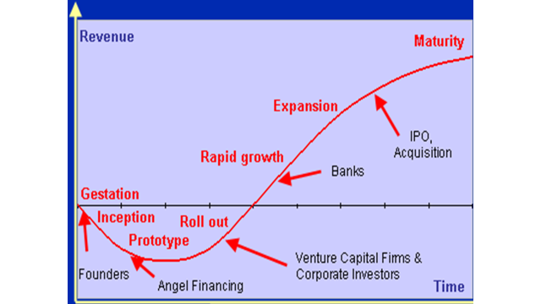

Figure 5: Entrepreneur business lifecycle

Black business hardly makes it above the graph, as many remain in the inception, prototype and roll out stages of the curve, with very few making it to rapid growth stages and above.

# **Prevention of value leakage**

Value leakage in the financial system should be prevented such as transfer pricing which is tantamount to fronting as it undermines the objectives of transformation. The real value accruing to black people is diluted when this practice is employed in transaction structuring and implementation.

# **Monitoring and Evaluation of the Sector**

This sector is poorly monitored and evaluated as the 2013 Review Report of the FSC Council states only 70 out of 1423 financial institutions to whom the FSC Code is applicable responded to the call to submit annual results to the councils, this resulted in a mere 4.92% response rate. This poor submission and reporting demonstrates the lack of support for the transformation of the sector and warrants mandatory reporting and imposition of penalties for delinquent behaviour. The benefits of M&E for the sector are as follows:

1. Collection of continuous correct data;
2. Ability to compare progress and identify bottlenecks early;
3. Identification of uncooperative and delinquent organisations;
4. Accurate reporting.

The B-BBEE Commissioner as well as various relevant regulatory bodies such as the South African Reserve Bank (SARB), the Banking Supervision Department, National Credit Regulator (NCR), Financial Service Board (FSB), and the JSE will need to increase their monitoring and evaluation in order to report on progress in this sector.

# **Preferential Procurement as an anchor to Transformation**

If the argument were to be placed that the country’s net measurable procurement spend is R1 trillion as an example, the codes would require that at least 40% of that is spent with black owned business and 12% with black woman owned business. This translates to approximately R400 billion and R120 billion for black and black woman owned businesses respectively. There is currently not enough funding available in the DFI space to fund procurement to black owned business.Table 2 is an illustration of the spend requirements for the R1 trillion South African market:

Table 3: Illustration of impact of required spend in South Africa

|  |  |  |
| --- | --- | --- |
| **BEE Scorecard Requirement** | **Targeted %** | **Targeted Spend** |
| EME Suppliers | 15% | R150 billion |
| QSE Suppliers | 15% | R150 billion |
| Black Owned Suppliers | 40% | R400 billion |
| Black Women Owned Suppliers | 12% | R120 billion |

This would mean that as a minimum, up to R400 billion of work granted to companies to across the economy should be delivered by black business. A significant portion of this would need to be funded for working capital, transitional loans, debtor/invoice factoring, capital raising amongst others. All these relate to financial support, other forms of support include non-monetary support such as management development skills transfer, back office support, use of facilities at discounted rates, etc.

Use procurement as a catalyst for transformation. Government must make it mandatory for private and public sector entities to fulfil national transformation objectives by implementing the preferential procurement requirements of the amended codes.

Ownership funding models and targets must fulfil the set targets per the codes, i.e. (25%+1 vote for voting rights and 25% economic interest in the hands of black people).

# **Establishment of a directly owned Black bank**

Increase competition by establishing a directly black owned bank in order to foster competition in the sector, de-concentrate the sector and encourage the creation of a diversity of institutions that respond to consumer needs and national priorities. This will require the development of a vision of the future structure of the industry. Examples include the German “three pillar” banking system. According to Behr and Schmidt (2015) the German system which has:

* Private commercial banks with a market share of 39% in 2014. This pillar includes big banks – household names such as Deutsche Bank and Commerzbank – and a considerable number of smaller regional banks,
* Savings Banks with a market share of 28%. These banks – national and regional - have Government involvement,
* Cooperative Banks with a market share of 14%, and
* Other banks with a market share of 20%. Since these banks are so diverse, there are not referred to as a fourth pillar. They include mortgage and other special purpose banks.

1. **Conclusion**

It is evident that the FSC has short comings in terms of reforming the sector, it has proven to be a blunt tool in driving transformation, employment and radical change in the sector. The NDP is premised on economic growth and this instrument of transformation fails to deliver on the growth objectives of the nation and redistribution of wealth.

Transformation has remained a voluntary process in this country, even as the financial services sector raised its hand to be the first of the sectors in the economy to develop a framework for transformation, the process was not mandatory and was thus driven by the procurement process

The greatest challenge facing black entrepreneurs in South Africa is access to market. Although many incubation support programmes exist, offering office space and training, this does not seem to translate to more business for the entrepreneurs, while their clients are able to claim their full Enterprise Development points. It is not one more excel training course that is required, but rather:

* access to business opportunities,
* capital to fund these business opportunities,
* Technical support

There is reason to support the idea of mandated to an institution owned and controlled by black people with a sole intention and focus to develop and provide financing without strictly being required to abide by the solvency requirements of Basel III (not a bank). This institution should be a hybrid between a formal bank and a DFI with clearly articulated developmental mandate. The intention of this entity would be to facilitate a strategic partnership through which Government can enable market access and funding opportunities for black entrepreneurs.

**END**

