ANNEXURE 1

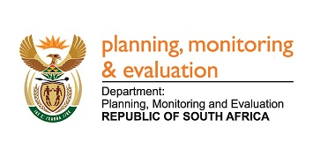

**FRONTLINE SERVICE DELIVERY MONITORING: ANNUAL FINDINGS REPORT**

**2015/16:**

**Table of Abbreviations**

CHC Community Health Centres

DLTC Driver’s License Testing Centres

DPME Department of Planning, Monitoring and Evaluation

FSD Frontline Service Delivery

FSDM Frontline Service Delivery Monitoring

HA Home Affairs

KPA Key Performance Areas

M&E Monitoring and Evaluation

MCCC Municipal Customer Care Centres

MPAT Management Performance Assessment Tool

MTLP Maintenance Turnaround Lean Project

OTP Office of the Premier

SAPS South African Police Service

SARS South African Revenue Service

SASSA South African Social Security Agency

**Table of Contents**

[1 INTRODUCTION 4](#_Toc457417175)

[1.1 Background 4](#_Toc457417176)

[1.2 Types of Facilities and Key Performance Areas Monitored 5](#_Toc457417177)

[PART A 6](#_Toc457417178)

[2 IMPROVEMENTS MONITORING RESULTS 6](#_Toc457417179)

[2.1 Approach and Methodology 6](#_Toc457417180)

[2.2 Improvements Monitoring: Overall Outcome 7](#_Toc457417181)

[2.3 Improvements Monitoring Results 9](#_Toc457417182)

[2.3.1 DLTCs (15 Facilities) 9](#_Toc457417183)

[2.3.2 Schools (28 Facilities) 12](#_Toc457417184)

[2.3.3 Health Facilities (15 Facilities) 16](#_Toc457417185)

[2.3.4 Home Affairs Offices (9 Facilities) 20](#_Toc457417186)

[2.3.5 Magistrate Courts (12 Facilities) 22](#_Toc457417187)

[2.3.6 MCCCs (7 Facilities) 24](#_Toc457417188)

[2.3.7 Police Stations (11 Facilities) 25](#_Toc457417189)

[2.3.8 SASSA Offices (23 Facilities) 27](#_Toc457417190)

[2.4 Photographic Evidence relating to Improvements Monitoring 31](#_Toc457417191)

[2.5 Improvements Monitoring: List of Facilities to be Monitored for Improvements in 2016/2017 34](#_Toc457417192)

[2.6 Improvements Monitoring: Way Forward 35](#_Toc457417193)

[PART B 35](#_Toc457417194)

[3 BASELINE MONITORING FINDINGS 35](#_Toc457417195)

[3.1 Number and Types of Facilities Monitored since 2011/2012 to 2015/2016 35](#_Toc457417196)

[3.2 Baseline Monitoring Overview for 2015/2016 in Provinces (n=107 Facilities) 36](#_Toc457417197)

[3.3 Baseline Monitoring Overview for 2015/2016 for Sectors (n=107 Facilities) 36](#_Toc457417198)

[3.4 Facility-level overview per sector/type of facilities assessed 37](#_Toc457417199)

[3.5 Baseline Monitoring Findings in Pictures 46](#_Toc457417200)

[PART C 48](#_Toc457417201)

[4 LESSONS 48](#_Toc457417202)

[5 RECOMMENDATIONS 51](#_Toc457417203)

[6 WAY FORWARD 52](#_Toc457417204)

# INTRODUCTION

## Background

The Frontline Service Delivery Monitoring Programme (FSDM) gives effect to the priorities set out in Outcome 12 of building “an efficient, effective and development oriented public service and an empowered, fair and inclusive citizenship”. This asks of government departments to make concerted efforts to improve the quality of and access to public services. The FSDM programme is a collaboration between the Department of Planning, Monitoring and Evaluation (DPME) and Offices of the Premier (OTP) and it initiated its activities in June 2011. The programme uses unannounced monitoring visits to ***assess the quality of service delivery in frontline services facilities***, using structured questionnaires to guide interviews with citizens and staff, as well as observations by monitors. The questionnaires assess the quality of services against eight key performance areas.

The FSDM programme response to a number of weaknesses in M&E in government, in particular “problems are not treated as an opportunity for learning and improvement” and “M&E is regarded as the job of the M&E unit and not all managers”. Hence the FSDM initiative is aimed at strengthening the M&E practices of field-level managers and their supporting decision makers in head offices, encouraging them to (i) value regular on-site monitoring as an source of evidence for decision making (ii) use the evidence for quick and decisive decision making as well as for systemic changes.

The objectives of these monitoring visits are to demonstrate to sector departments the value of on-site monitoring as a tool to verify the impact of service delivery improvement programmes; to demonstrate the value of obtaining the views of citizens during monitoring; to highlight successes and failures at service facility-level and to support departments to use the findings for performance improvements.

## Types of Facilities and Key Performance Areas (KPA) Monitored

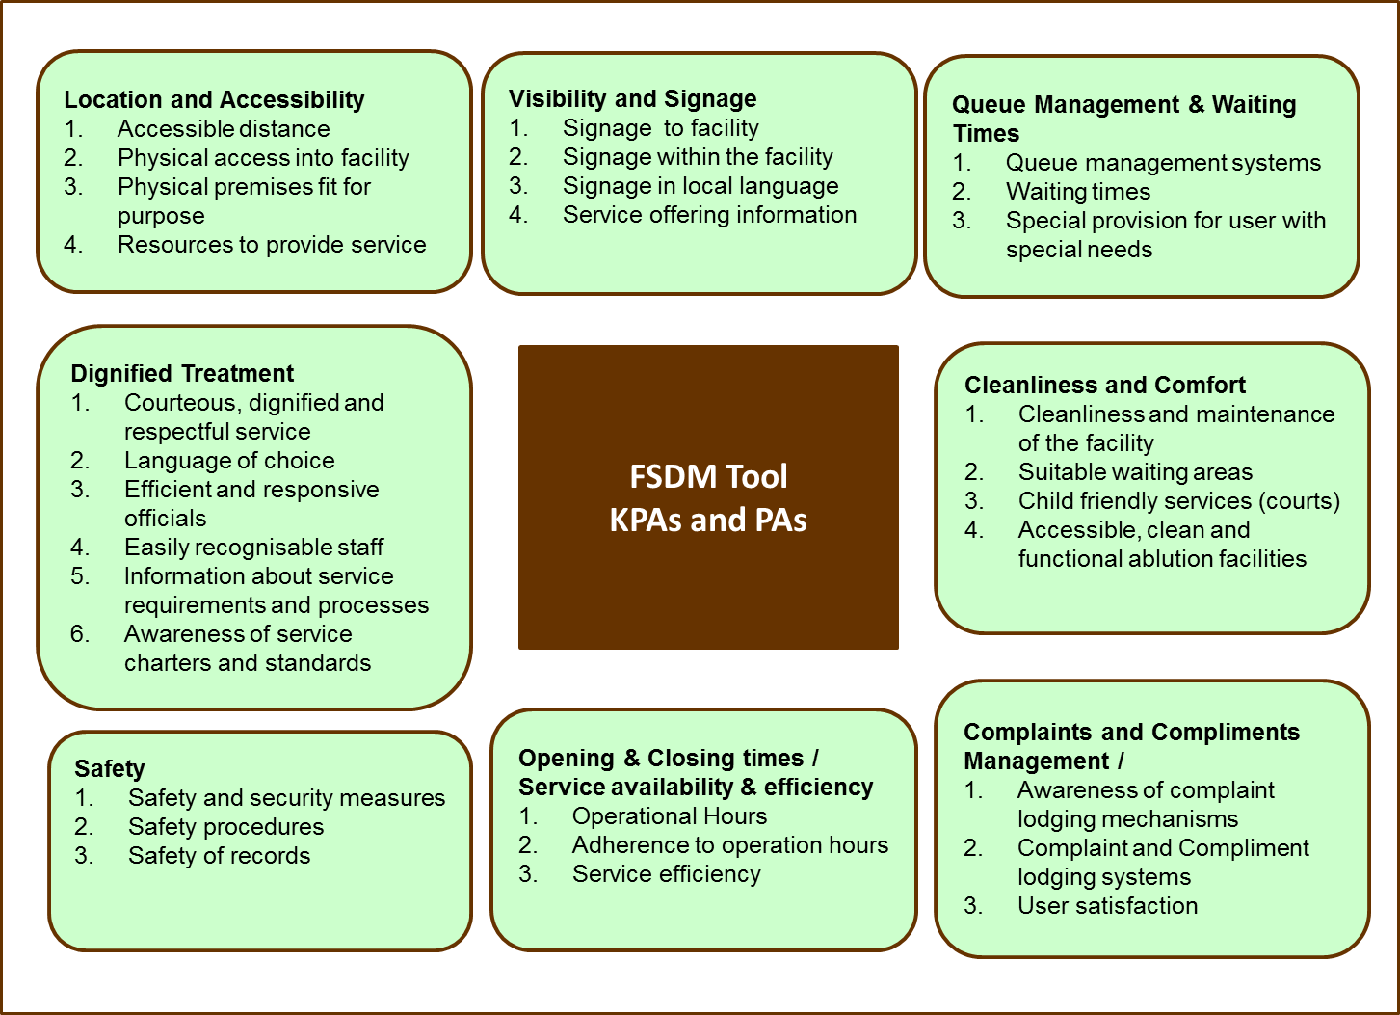

KPA: Key Performance Area = Location and Accessibility

PA: Performance Area = Accessible distance

# PART A

# IMPROVEMENTS MONITORING RESULTS

## Approach and Methodology

The FSDM programme conducts targeted improvements monitoring – the selected sample of facilities is monitored every year to track improvements, with a methodology that attempts to combine problem-solving facilitation and then monitoring of results.

Within the FSDM programme, the Improvements Monitoring approach consists of three activities:

* Firstly, the DPME informs the national department (head office) senior management that a facility has been selected for improvements monitoring because of poor scores. The intention is for senior management to create an enabling and supportive environment in which facility-level managers can address the identified challenges.
* Secondly: a meeting is held at facility-level (facilitated by DPME and OoP) to obtain progress with agreed improvements. The intention with this meeting is to facilitate actioning of findings and to facilitate problem solving between the different role players.
* Thirdly: The unannounced monitoring of improvements are conducted, applying the same scoring questionnaire tool used for the first assessment. A new score card is produced for the facility which reflects a longitudinal view of the scores, for each KPA, over time.
* The trends are based on the score comparison of the current year of monitoring against the previous.

A new score card is produced for the facility which reflects a longitudinal view of the scores, for each KPA, over time.

## Improvements Monitoring: Overall Outcome



A total of 785 facilities have been assessed since 2011, of which 120 were selected for improvement monitoring in 2015/16.

Of the 120 facilities reassessed for improvement monitoring, **60%** of showed improvement, 38% of the facilities have regressed and 2% facilities status remains the same.

In year 5 of frontline monitoring, **60%** (72) facilities that have been selected for improvement monitoring have improved, 38% (46) of the facilities have regressed and 2% (2) facilities status remains the same. This is an outcome measure of improvement within facilities, little control can be enforced by the DPME however the facilitation of improvement has resulted in 72 facilities improving or keeping their improvement status.

It is important that monitoring actually leads to improvements in service delivery. The FSDM improvement monitoring is such an approach that seeks to facilitate improvements in identified facilities. In certain facilities there are bigger root-causes to the slow turn around in the improvement of the facilities; this includes budgetary issues, turnover of facility management, weaknesses in operations efficiencies by facility management and the support from region/districts/province and national departments or challenges at facilities.

Since the inception of the programme, one of the biggest hindrances is the actioning of the monitoring findings by responsible individuals. In many cases the reasons for not acting on the findings are not clear. An assumption can be made that one such reason is the punitive culture that was pre-dominant within the country and the public service. It can be noted in facilities that if punitive measures are not enforced, very little is done by the responsible officials. The FSDM is not advocating for punitive measure to be utilised, but a cultural change of self-management and ownership by responsible individuals, including some level of consequence management.

Colour legend in the below tables: (*i) Red (poor)= 1.00 - 1.49 (ii) Amber (fair) = 1.50 – 2.49 (iii) Yellow (good) = 2.5 – 3.49 (iv) Green (very good) = 3.50 – 4.00*

## Improvements Monitoring Results

### DLTCs (15 Facilities)







### Schools (28 Facilities)









### Health Facilities (15 Facilities)





### Home Affairs Offices (9 Facilities)





### Magistrate Courts (12 Facilities)





### MCCCs (7 Facilities)



### Police Stations (11 Facilities)





**2.3.8 SASSA Offices (23 Facilities)**

### SASSA Offices (23 Facilities)









## Photographic Evidence relating to Improvements Monitoring

**Good findings**

|  |  |
| --- | --- |
| **Figure : Classrooms at Mathibela High School, 2013** | **Figure : New classrooms at Mathibela High School, 2015** |
| ***M:\8. Frontline Service Delivery Monitoring\4.7 Work In Progress\FSDM Photo Library\Mpumalanga\Mathibela High School\2013-14\IMG_1919 - Copy.JPG*** |  |
| Improvement in the state of classrooms at Mathibela High School: classroom block in 2013 (Figure 4, left) and new classroom, block in 2015 (Figure 5, right) | |

|  |  |
| --- | --- |
| **Figure : Complaints box and procedures at Wesfleur Hospital, 2014** | **Figure : Complaints box and procedures at Wesfleur Hospital, 2015** |
|  |  |
| Improvement in complaints management system: Labelling of box and display of procedurea at Weslfeur Hospital in 2014 (Figure 4, left) and 2015 (Figure 5, right) | |

|  |  |
| --- | --- |
| **Figure 4: Clean, resourced ablutions at Winburg Magistrate Court, 2013** | **Figure 5: Clean, resourced ablutions at Winburg Magistrate Court, 2015** |
|  |  |
| Maintenance of good practices: clean resourced ablution facilities at Winburg Magistrate Court in 2013 (Figure , left) and 2015 (Figure , right) | |

**Poor findings**

|  |  |
| --- | --- |
| **Figure : Broken furniture at Etwatwa Police Station, 2014** | **Figure : Broken furniture at Etwatwa Police Station, 2015** |
|  |  |
| Non-implementation of recommendations: broken chairs in the waiting area at Etwatwa SAPS in 2014 (Figure , left) and 2015 (Figure , right) | |

|  |  |
| --- | --- |
| **Figure : Toilet for persons with disablities at Umtata Magistrate Court, 2014** | **Figure : Toilet for persons with disablities at Umtata Magistrate Court, 2015** |
|  |  |
| Toilets for persons with disabilities used as storage space at the Umtata Magistrate Court: 2014 (Figure , left) and 2015 (Figure , right) | |

|  |  |
| --- | --- |
| **Figure : Broken, dirty learner toilet at Polokong Combined School, 2014** | **Figure : Broken, dirty learner toilet at Polokong Combined School, 2015** |
|  |  |
| Non maintenance of learner toilets: Broken toilet in 2014 (Figure 2, left) and 2015 (Figure 3, right) | |

## Improvements Monitoring: List of Facilities to be monitored for Improvements in 2016/2017



## Improvements Monitoring: Way Forward

Improvement monitoring will continue for the 100 facilities selected. In 2016/17 the improvement monitoring rescoring approach will be replaced by the improvement verification approach which is central to physical verifying of the progress recorded against the improvement plan action items during the improvement meeting. What is critical is to find an approach that will be beneficial in driving sustained improvements in facilities for the quality of service delivery that the citizens deserve.

# PART B

# BASELINE MONITORING FINDINGS

## Number and Types of Facilities Monitored since 2011/2012 to 2015/2016

Since the inception of the FSDM programme in June 2011, 785 facilities have been monitored, these are facilities that have passes the internal quality assurance. 63 DLTCs, 148 Schools, 185 Health Facilities, 70 Home Affairs offices, 65 Courts, 67 MCCCs, 97 Police Stations, 90 SASSA facilities. Although this sample size of 785 represents a small percentage of the total number of facilities in the country, departments are encouraged to increase their on-site monitoring presence so as to deepen their understanding of frontline facilities service delivery conditions. In 2015/16, 107 facilities were assessed in all nine provinces.



## Baseline Monitoring Overview for 2015/2016 in Provinces (n=107 Facilities)

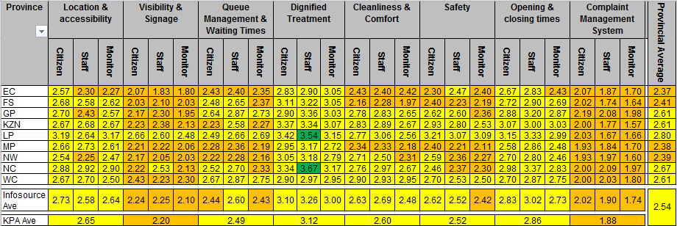

Fair to good average scores/rating are being recorded in all provinces, this is an improved finding since the inception of the programme. It should be noted that average rating are not a true reflection of individual facilities performance but a summarised descriptive of what it happening in each province. There is still consistency in the fair average rating for Complaint Management and Visibility and Signage Key Performance Areas, hence attention is required for the overall improvements to be realised.

## Baseline Monitoring Overview for 2015/2016 for Sectors (n=107 Facilities)

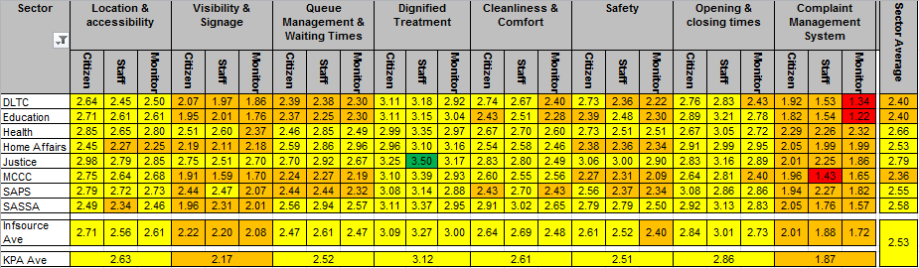

Fair to good average scores/rating are being recorded in all Sectors, this is an improved finding since the inception of the programme. It should be noted that average rating are not a true reflection of individual facilities performance but a summarised descriptive of what it happening in each Sector. There is still consistency in the fair average rating for Complaint Management and Visibility and Signage Key Performance Areas that requires attention for overall improvements to be realised.

## Facility-level overview per sector/type of facilities assessed

**3.4.1 DLTCs (11 Facilities)**

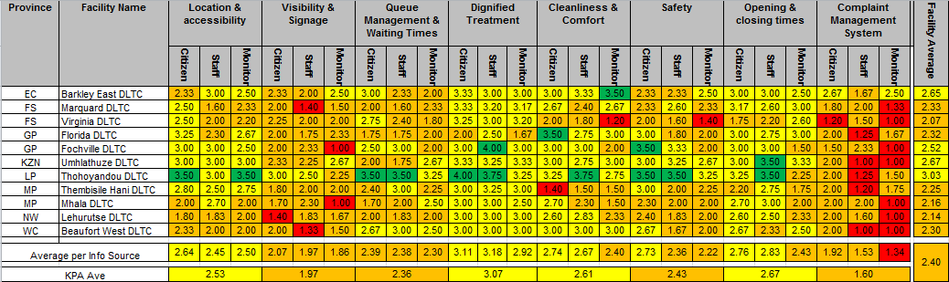

In general, the sector’s average in terms of scores for the baseline assessments reflect ‘fair’ performance, with the lowest KPAs being Complaints Management (1.60), and Visibility and Signage (1.97). Location and Accessibility was scored lower as well, highlighting challenges in terms of access to persons with disabilities (2.0). Safety also is a concern, scoring an average of 2.43. Thohoyandou DTLC recorded the compliance rating of 3.

**3.4.2 Education Facilities (20 Facilities)**

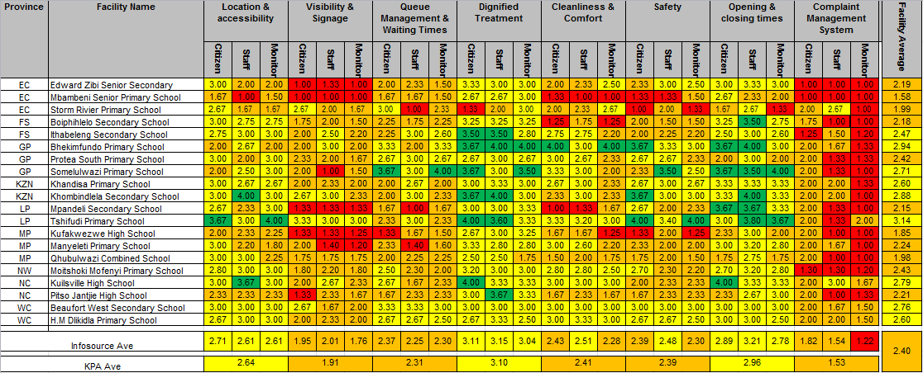

Complaints management in schools scored rather low (1.53), with several schools having scored poorly. Visibility and Signage is also major concern (1.97). Cleanliness as well as safety also requires intervention, as the learner’s well-being is put at risk. Overall, the sector received ‘average’ scores of 2.40

**3.4.3 Health Facilities (27 Facilities)**

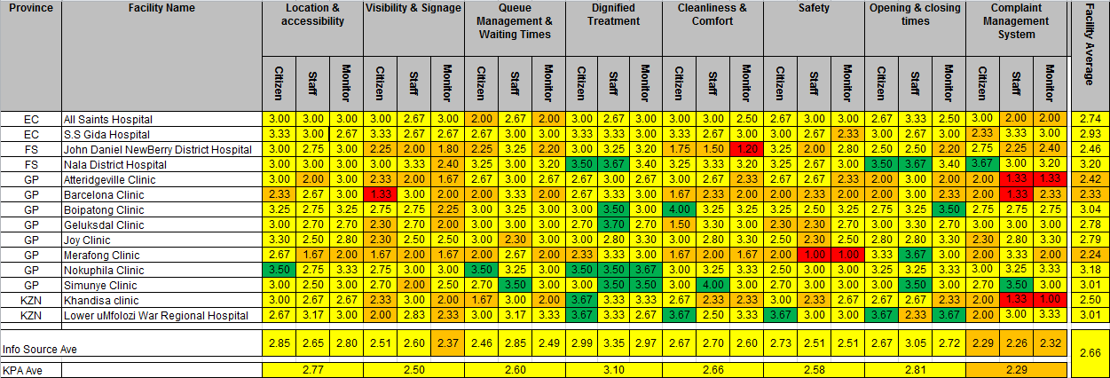

**Health Facilities (27 Facilities) (continued)**

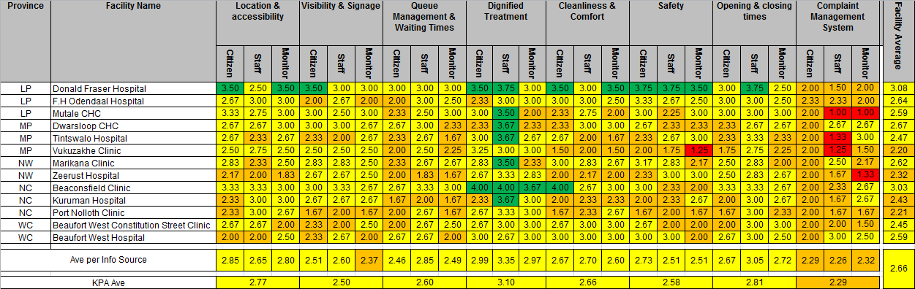

Overall, this is a well-performing sector. Only complaints management received average scores of ‘fair’ (2.29). However, the cleanliness in several facilities needs to be improved, as does some aspects of signage (especially internal signage to accommodate various language groups)

**3.4.4 Home Affairs Offices (8 Facilities)**

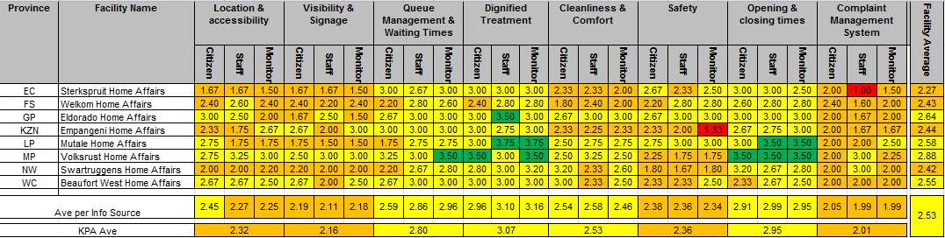

Complaints management, as well as Visibility and Signage, received lower scores in this sector when compared to others (2.01 and 2.16 respectively). Safety was highlighted as a concern in some facilities, as was cleanliness (especially in terms of maintenance of the offices). In general, the sector received scores of ‘good’ in half of the Key Performance Areas assessed.

**3.4.5 Magistrate Courts (8 Facilities)**

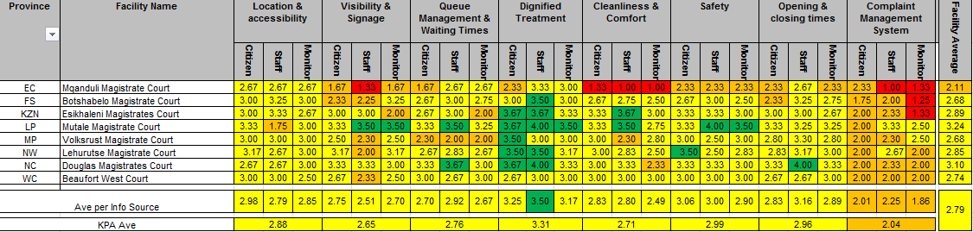

In general, this is a well-performing sector, with only Complaints Management receiving average score of ‘fair’. Mqanduli Magistrate Court has several issues to be addressed, especially in terms of maintenance and the cleanliness of the court. This sector is close to achieving the desires scored of three (3), indicating compliant service delivery.

**3.4.6 MCCCs (8 Facilities)**

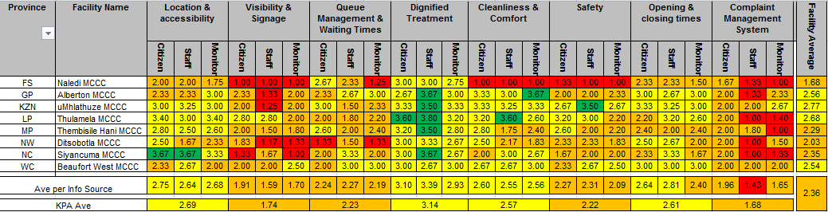

Several challenges are faced in this sector, as is reflected in the lower scores achieved in Complaints Management (1.68), Visibility and Signage (1.74), Safety (2.22) and Queue Management (2.23). Only dignified treatment received the desired average rating of higher than three (3.14)

**3.4.7 Police Stations (12 Facilities)**

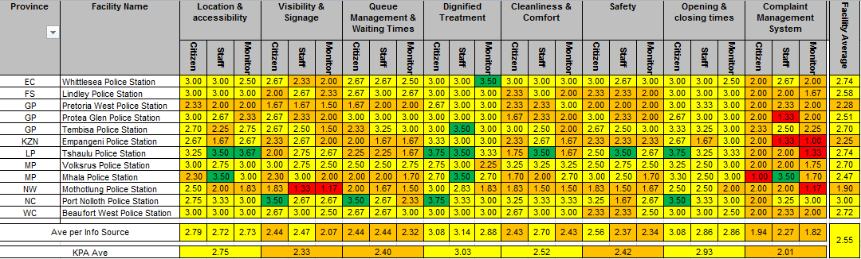

With an average score of 2.55, the SAPS sector still has some challenges to address. Complaints management was scored the lowest, at 2.01, followed by Visibility and Signage (2.33). Safety was raised as a concern at several stations as well, especially in terms of staff members not feeling safe.

**3.4.8 SASSA Offices (13 Facilities)**

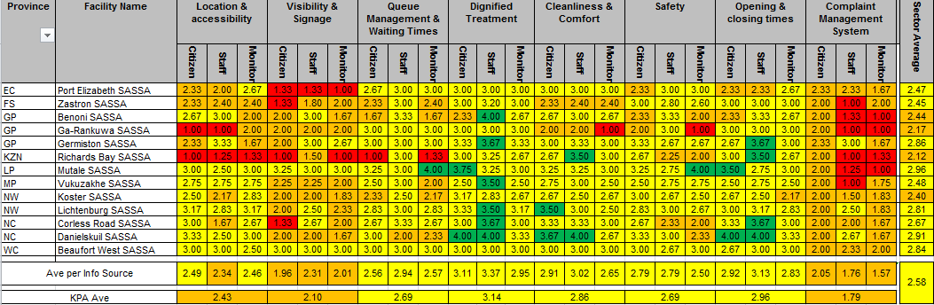

This sector has different challenges as compared to other sectors due to the type of clientele it services. With an average score of 2.58 the sector is performing better. In terms of complaints management, the absence of management processes contributes to the lower scores. The accessibility to persons with disabilities has also been raised as an issue at some offices, as has the absence of sufficient signage.

## Baseline Monitoring Findings in Pictures

**Good Findings**

|  |  |
| --- | --- |
| **Figure : Provision of drinking water at Mutale SASSA, 2015** | **Figure : Provision of drinking water at Danielskuil SASSA, 2015** |
|  |  |
| Provision of drinking water in SASSA Offices: Mutale SASSA (Figure , left) and Danielskuil SASSA (Figure , right). | |

|  |  |
| --- | --- |
| **Figure : Ablutions for persons with disabilities at Barkley East DLTC, 2015** | **Figure : Ablutions for persons with disabilities at Barkley East DLTC, 2015** |
|  |  |
| Good practices found at Barkley East DLTC: Clean, maintained (Figure , right) and well identified (Figure , left) ablutions for persons with disabilities | |

|  |  |
| --- | --- |
| **Figure : Internal directional signage at Benoni DLTC, 2015** | **Figure : Display of of operational hours at Benoni DLTC, 2015** |
|  |  |
| Good provision of information to users: display of directional signage inside the facility (Figure, rigth) abnd display of opening and closing times (Figure , left) | |

**Poor Findings**

|  |  |
| --- | --- |
| **Figure : Broken windows in classroom at Mpandeli Secondary School, 2015** | **Figure : Broken, filthy learner toilet at Mpandeli Secondary School, 2015** |
|  |  |
| Lack of maintenance at Mpandeli Secondary School: Windows in learner classroom (Figure , left) and a dirty, broken leraner toilet (Figure , right) | |

|  |  |
| --- | --- |
| **Figure : Pile of floor tiles in Mqanduli Magistrate Court, 2015** | **Figure : Unlabled suggestion box on floor at Mqanduli Magistrate Court, 2015** |
|  |  |
| Wooden floor tiles in a pile in the waiting area of Mqanduli Magistrate Court (Figure , left) and an unlabled suggestion box on the floor at the same court (Figure , right) | |

|  |  |
| --- | --- |
| **Figure : Damaged ceiling in office at Toekomsrus MCCC, 2015** | **Figure : Damaged ceiling in office at Toekomsrus MCCC, 2015** |
|  |  |
| Collapsing ceilings in various offices at the Toekomsrus MCCC in 2015: (Figure , left) and and (Figure , right) | |

# PART C

# LESSONS

* Some of the improvement monitoring meetings and rescoring indicated that facilities did not fully implement their activities not only because of budgetary constraints, but due to lack of commitment by facility management.
* DTLC facilities are still facing the challenges on the infrastructure where maintenance is not taken into consideration and this is prevalent in government owned buildings. This in turn affects the overall operations of a facility thereby impacting on the quality of service delivery.
* The presence of relevant decision makers during feedback meetings is important in shaping the improvement plans that are smart and aligned to sector improvement initiatives. Their presence is also beneficial when dealing with issues such as infrastructure, centralized procurement, and centralized personnel recruitment which the facilities could not improve on.
* Sector engagements during feedback and improvement monitoring meetings assist facilities to learn from each other, and this approach make it possible for other facility managers to learn ways of improving the level of service provision for their own facilities.
* Another positive shift is noted from the National Department of Transport in regulating the DLTCs, Vehicle Testing Stations (VTSs) and Registering Authorities (RAs) by setting minimum standard and requirements for service delivery which aims to standardise the operational practices at these centres through service delivery charters which are still in a draft form.
* Cleanliness, particularly in learner ablutions at schools, needs to be improved across most schools.
* Complaints management remains a sector-wide challenge, with all facilities scored either ‘poor’ or ‘fair’ in terms of this area; the biggest challenges with complaint management are central to the procedure followed to manage complaints and provision of complaints infrastructures in schools. It should be noted that the National
* Continuous monitoring by DPME and OTP is not sufficient to sustain improvements at some facilities, as is evident from the regressions recorded in 2015/16 improvement monitoring at several facilities;
* Misalignment of planning, budgeting and service delivery improvements continues to be a constraint in addressing infrastructure and maintenance of facilities (buildings) challenges, which consequently affect the upgrading of ablutions and security measures at most facilities.
* External road signage and identification of staff members by nametags requires attention to improve the status of visibility and signage.
* Lack of accountability and poor operations management from some facility managers is evident in the current state of facilities regarding general management of cleaners, adherence to operational hours and enforcement of minimum safety and security measures.
* The Justice Sector has good practices in terms of security, especially in terms of access control, as is evidenced by the presence of metal detectors and x-ray machines in most facilities monitored.
* Most magistrate court facilities monitored have shown consistent improvements in the scores, emphasising the importance and support required from facility management in the implementation of the improvement plans. This is supported by the number of facilities removed from the improvements monitoring list;
* The persistent improvements by the Justice department can be ascribed to managerial commitment. All of the facilities monitored have shown sustained improvements, which indicate dedication from the Department of Justice and Constitutional Development and Health;
* Some renovations and repairs are hindered by some facilities being housed in Heritage Buildings;
* The Ideal Clinic project addresses most of the indicators in terms of service delivery as assessed by the FSDM Programme. For instance, the Ya Rona Clinic and Mohlakeng Clinic in Gauteng, most of the recommendations made in terms of cleanliness, accessibility and signage were addressed as part of the Ideal Clinic Programme.
* The implementation of the front office toolkit in Home Affairs has contributed to some improvements noted which includes standard display of amended operational hours, service costs and management contact details.
* The reflection of the FSDM baseline assessments indicates a positive shift on the perception of the users on the quality of frontline services in the Home Affairs sector as compared to initial stages of the programme from both the baseline and improvement scores.
* Dependency on the landlord for daily routine maintenance is a challenge that needs to be addressed going forward when new service level agreements are entered into to enforce obligations towards this responsibility. This is a matter that has to be driven by the Department of Public Works.
* Application processes are shortened immensely where officials are trained as Commissioners of Oath at SASSA. According to both citizens and officials this intervention has gone a long way in curbing repeat visits. However, in some facilities where officials were ready to carry out this duty, required resources (stamps and ink) were not available.
* Well-intentioned mechanisms for amplifying citizen voice such as suggestion boxes may implicitly serve as instruments of exclusion. For citizens who cannot read or write, these do not avail them. The language used in communicating with citizens was also brought into sharp relief. The lack of provision for sign language implies that deaf citizens would have to be accompanied by a family member to the service office.
* Although the legal status of pension committee is unresolved, they still operate at varied levels at some SASSA facilities. This precarious status is a source of much frustration and confusion around roles and functions. The structure in its current format is not positioned to monitor and hold SASSA to account; it does not have the earmarks of a governance and participatory mechanism.

# RECOMMENDATIONS

## Feedback on the 2015-16 recommendations

|  |  |  |
| --- | --- | --- |
| Year | Recommendation | Progress |
| 2014-2015 | Going forward, departments and provinces are encouraged to ensure that their commitment to frontline performance is reflected in their plans, their budgets and their public communications. | In most sector departments assessed through FSDM the work of frontline is link to other service delivery initiatives and monitoring programmes. It is not explicitly displayed in their plan. DOJCD: The infrastructure plan has taken into consideration the magistrate courts. Programme 2 within DOJCD APP has made provision for the frontline issues such as resolving of magistrate district boundaries and access to justice services. DHA: through the secure, effective, efficient and accessible service delivery to citizens and migrant’s strategic objective are training nominated staff on leadership and management programme. The facilities identified by frontline are also part to the infrastructure plan. COGTA: APP under Local Government Support and Intervention Management. SAPS APP have under strategic management the Frontline monitoring programme. The facilities have been selected to improve frontline standards. |
| Line Departments who are responsible for frontline facilities must invest in developing operations management competencies at junior, middle and senior management levels and resourcing change projects | Home affairs have initiated Moetapele initiative as part of the operations efficiencies. COGTA is currently implementing the Back to Basic programme. Department of Justice continues to train is staff on operation efficiencies through Justice College. SAPS conducting change management programme for management through UNISA. SASSA has re-engineered its operations processes and provision for staff to be trained on customer care has been made |
|  | The assessment framework will be made available to all departments and provinces to enable them to assess the state of their Complaint handling against the 8 KPAs. | The standards framework has been published on the DPME website and distributed to all FSDM and Hotline Local, Provincial and National stakeholders |
|  | The DPME will finalise the “Quality of Service Delivery Assessment Framework” and will make it available for use by all departments to update their standards-setting | The standards framework has been published on the DPME website and distributed to all FSDM provincial and National stakeholders |

## 2015-16 Recommendations

It is recommended that:

* The districts and provinces supports facilities in the implementation of the improvements plans, particularly where the facility’s competency is limited; this includes areas such as building and infrastructure maintenance, centralised procurement, and centralised personnel recruitment. Accountability by facility managers to act on the FSDM findings should be strengthened through self-monitoring by district/regional managers throughout the provinces.
* Frontline service delivery monitoring be elevated to a strategic level for accountability by sector departments. This could be achieved by incorporating responsibilities for frontline monitoring into the performance agreements of senior officials in the sector departments
* Managers as well as decision makers to consistently act on the FSDM findings to improve the quality of services delivered at facility level. This requires close monitoring and working together between DPME, national departments, provinces and municipalities to drive improvements.
* Sector department responsible for facilities should assist the facilities to action the monitoring findings. There is a slow pace when it comes to the implementation of the improvement plans which leads to frustrations in terms of general quality of service delivery in facilities.
* OTP and the Sector departments regularly monitor the facilities that are not revisited by DPME in order to instil the culture of self-monitoring.
* Service Providers in facilities should be consistently monitored and held accountable by sector departments as per the lease/contract agreements.
* The implementation of Service Delivery Improvement Programmes put in place by National Sector Departments should be monitored and reported on in support of the National Development Plan in improving the quality of public service and to strengthen accountability at facilities. An example being the frontline toolkit at Home Affairs.

# WAY FORWARD

The implementation of the programme will continue for the 90 baselines facilities, 100 improvement monitoring facilities as well as the 20 unscheduled monitoring visits during the 2016/17 financial year. 2016/17 will see the FSDM programme monitoring facilities using the revised frontline standards as approved by the FSDM Steering Committee. A new verification approach will also be introduced to facilitate the actioning of findings. We will continue to track progress of all the other facilities that are not part of the improvement monitoring given their good status.