March 2, 2017
ANNEXURE 2
CITIZEN-BASED MONITORING IMPLEMENTATION REPORT
Figure 1: Community Survey in Kopanong, Free State

Introduction
This report presents an overview of the implementation of the Department of Planning, Monitoring and Evaluation’s (DPME), Citizen-Based Monitoring (CBM) programme, including details on the completion of a two-year national pilot project, as well as activities that have followed this phase.

Background
The Framework for Strengthening Citizen-Government Partnerships for Monitoring Frontline Service Delivery was approved by Cabinet in August 2013 and provided a road map for advancing citizen-based monitoring, tasking DPME to take the lead as policy custodian and champion.
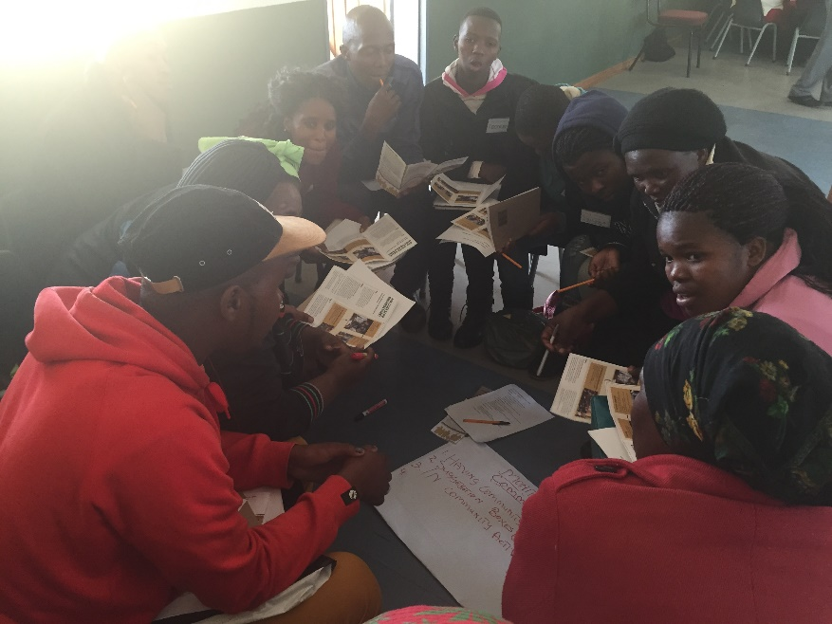
As a way to building capacity and knowledge, DPME embarked on a two-year action learning process with key service delivery departments. This national citizen-based monitoring pilot was completed in September 2015 and was implemented in three waves that reached all nine provinces. The pilot involved 34 government facilities - nine police stations, eight SASSA (South African Social Security Agency) local offices, eight health facilities, and eight Department of Social Development (DSD) service points providing services in nine communities. In addition, Offices of the Premier played a key role, leading the participation of provincial and local government stakeholders in the process. The pilot trained 366 community members to undertake surveying in their communities. A total of 25 982 citizens were interviewed and 1 191 staff interviews were conducted. The pilot also interacted with 278 NPOs and three community radio stations.
Figure 2: Community surveyors being trained in Elundini, Eastern Cape

THE CITIZEN-BASED MONITORING METHOD
The pilot focused on policing, health, SASSA and social welfare services in specific communities, in order to develop a generic method and tools for bringing citizens and communities into the monitoring of government services. The method that was developed over the two-year pilot involves three steps, each implemented using participatory approaches aimed at progressively building ownership of the process. The diagramme on the following page describes the three step generic model, which can be adapted to various services and conditions.
In each of the 34 facilities that participated in the feedback from citizens and staff was used as the basis for dialogues between community members, councillors and sector department officials to understand the root causes of service delivery challenges. These dialogues were used to develop local commitment charters to address problem areas.
A toolkit for implementing citizen-based monitoring is available from DPME’s website.
Figure 3: The three step CBM model
At a systemic level the findings of the pilot have been taken up with various sector departments and feed into DPME’s frontline monitoring reporting.

DPME’s role following the pilot
An implementation evaluation of the pilot was conducted and concluded that the CBM pilot has successfully tested and evolved an inclusive, credible approach and methodology for CBM across four services. The action learning approach proved highly effective for developing the CBM method, allowing for flexibility and responsiveness in the tools and methods developed. The participatory planning method used to turn feedback into actions is producing innovative solutions and partnerships and moves the participants from a compliance-driven mind-set to a solution-seeking paradigm.
Following the pilot and based on the recommendations of the evaluation, DPME is now focused on playing a supporting role to sector departments to use citizen-based monitoring to improve service delivery. This involves working directly with departments to adapt and implement the citizen-based monitoring method developed through the pilot, as well as to assist departments to utilise the monitoring work done by civil society and community organisations.
The figure 2 sets out the key strategic areas of DPME’s five-year CBM strategy.

Figure 4: DPME's CBM strategy

CBM take up in government
Based on the work done through the CBM pilot, the South African Police Service (SAPS) has rolled out the CBM method in nine new pilot stations, with the aim being to build capacity and knowledge to expand in 2017/18. This process is supported by DPME. A similar approach to the CBM pilot has been followed, with reviews taking place after each implementation in order to evolve version of the method that is fit for purpose for the SAPS environment. This adoption of the iterative listening approach in the highly hierarchical policing environment is significant and could unlock innovation and new capacities for problem solving.
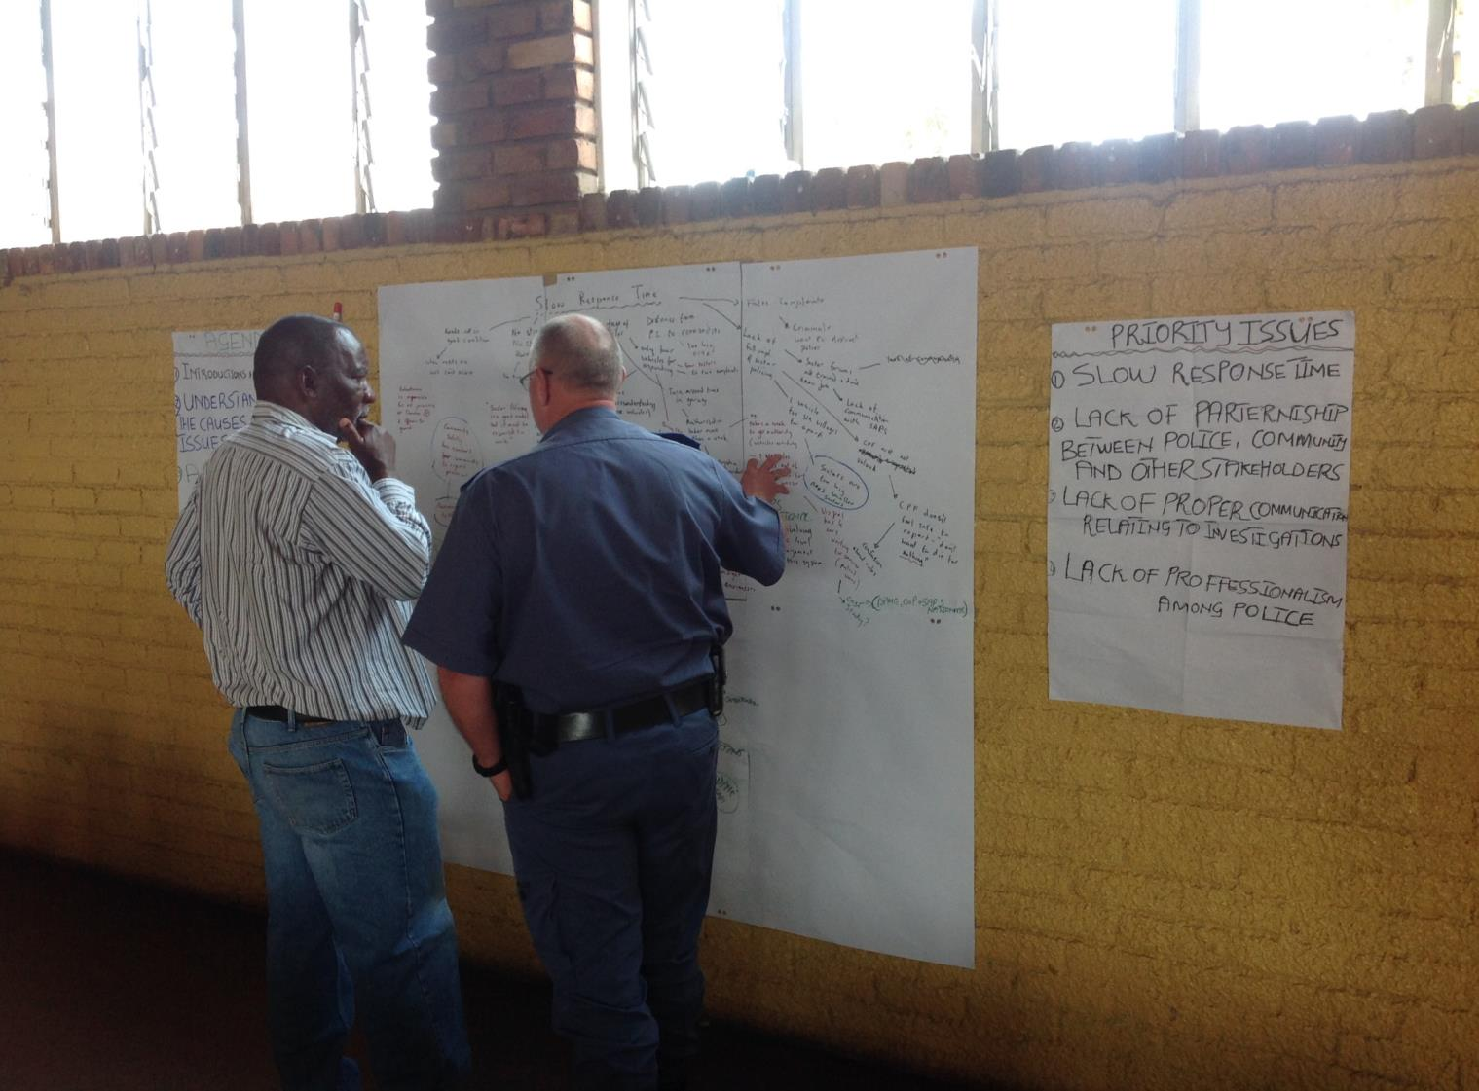
The CBM work has identified a number of systemic challenges facing SAPS through its focus on the specific experiences of frontline managers, staff and the communities they serve. These included turn-around time in vehicle maintenance, allocations of resources for police stations that serviced areas with large informal settlements, inadequate and the unintended negative consequences of targets set at by the national office for arrests for drug possession and other indicators. The root cause analysis method allowed police and community members to unpack what was driving certain behaviours and provided insights on what kind of improvements were likely to have positive impacts. The deliberative spaces created through the citizen-based monitoring process were largely alien to the police culture, where obedience and respect are valued above problem-solving and feedback.
Figure 5: CPF Chair and Station Commander review root cause analysis at Kabokweni Police Station
The CBM team is currently taking the three step CBM method to the local government space, with an experimental approach to the development of an integrated development plan (IDP). At the request of the Northern Cape Office of the Premier and the Umsobomvu Local Government, DPME’s CBM team has designed a three-month consultative process, starting with a survey of each household to determine local priorities. This will be used as the basis for deliberation and negotiation within the municipality and with provincial and national departments. The aim is to empower local government (in particular ward councilors and ward committees) as frontline champions of community development priorities, rather than end-of the-line recipients of technocratic processes determined outside their sphere of influence. If successful this participatory approach will create the required awareness and understanding between communities and their elected representatives to overcome the tendency for fracture at this fragile level, and build stronger accountability mechanisms for delivery on commitments and plans. The training of over 100 community volunteers and councilors was completed in January 2017, with the councilors electing to be part of the survey team, so as to have direct experience of this process. The survey was completed in February and at the time of writing the feedback was being analyzed to be used as the based for deliberations with multiple stakeholders on IDP priorities.

Advancing CBM through partnerships With civil society
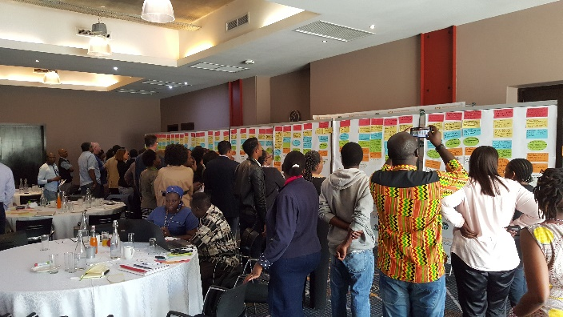
In addition to the support to implementing the CBM method with government stakeholders, the CBM programme has been active in supporting knowledge sharing and partnerships around citizen-based monitoring with non-governmental actors. The Open Government Partnership (OGP) (led by Deputy Minister for Public Service and Administration) has provided a useful platform for this focus area. South Africa’s Third Country Action Plan includes a commitment on citizen-based monitoring. In support of this DPME organised a workshop in September 2016 under the theme ‘’ Advancing Citizen-Based Monitoring’’ which attracted the participation of government departments (National Treasury, Department of Public Service and Administration, SASSA, SAPS, & Department of Cooperative Governance (DCOG), the South African Local Government Association (Salga) civil society and community-based organisations. Discussions ranged from the DPME’s strategy for institutionalising CBM in government, the role technology can play in supporting the CBM effort, to opportunities for collaboration between government and community organisations. The conceptualisation and planning of workshop was a collective effort of the DPME and the following civil society organisations: Black Sash, Isandla Institute, Code4SA and Making All Voices Count.
Figure 6: Advancing CBM Workshop
The workshop unlocked considerable energy and ideas between different stakeholders to take a number of collaborations forward. These include a citizen-based monitoring project with SAPS and the Sustainable Livelihoods Foundation, collaboration on an accountability and information platform, inclusion of citizen-based monitoring tools and approaches as part of the induction of new local government councillors. DPME has subsequently had an engagement with Salga and DCOG to look at how best to revitalise existing local participation mechanisms through CBM. There were also discussions between local media organisations on how to reinforce the work of citizen journalists in gauging the ‘pulse and mood’ of community relating to service delivery.

RESPONDING TO ISSUES RAISED BY CBM PROCESSES
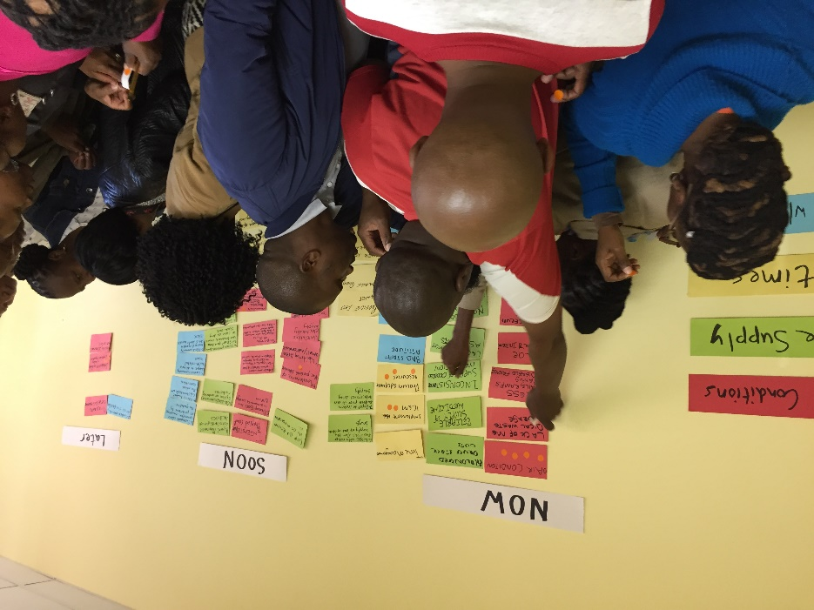
The DPME team is supporting various interventions that are responding to issues raised during citizen-based monitoring exercises. While these may be narrowly focused on a particular issue and community, the problems that these interventions are trying to solve have their roots in larger systemic challenges. As such these projects have the potential to provide useful learning for addressing challenges at a system level. For example following from the citizen-based monitoring of several clinics in Kabokweni outside Nelspruit, DPME has collaborated with Mpumalanga Office of the Premier and the Department of Health (DoH) to implement CBM commitments to prepare ground for the achievement of Ideal Clinic status, in 11 primary health facilities. The project is using a participatory approach to address the root causes of problems with medicine supply, infrastructure, maintenance and relationships with communities. These root causes include lack of delegations to frontline managers, transparency and accountability in the budget and supply chain processes. Insights from pilot pointed to the lack of frontline managers in budget making and planning. It is anticipated that the learning from this collaborative initiative, which also include the Department of Public Works, National & Provincial Treasury, can be shared and reproduced in other parts of the health sector.
Figure 7: Health workers from Kabokweni clinics vote on top issues to address service delivery challenges
Other projects focused on issues such as planning rural infrastructure, creating channels for feedback from frontline managers around unintended consequences aim to use an iterative approach to building problem solving capacity based on addressing real-life challenges encountered by officials and communities.

Each municipality is required by law to develop an integrated development plan at the beginning of each five-year local government term. This process is supposed to be deeply consultative, however in practice the IDP has been criticised as being a tokenist exercise that is often outsourced to consultants.
The mayor stated the difficulty in getting provincial and national departments, who are responsibility for delivering key services such as health, education, grants etc., to participate meaningfully in the IDP process.
Local councillors are targeted for government failures outside their area of control.

