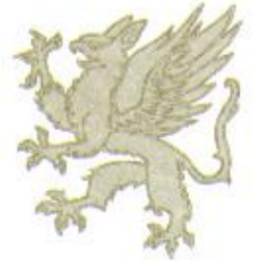
Griffons Rugby
Unie

Union

Tel: 057-352 6482 · Fax: 057- 357 1117 · Posbus /P.O. Box 631, WELKOM 9460
____________________________________________________________________________

GRIFFONS RUGBY UNION REPORT 2016

DEMOGRAPHICS

- The Union is situated in the Free State Province.
- Consist of three of the five districts, namely Lejweleputswa District in which the Griffons Rugby Union is and then we have the Fezile Dabi District (Kroonstad) and Thabo Mofutsanyane District (Bethlehem).
- The Union includes inter alia the following towns in the North; Parys, Sasolburg, South Ficksburg, East Vrede and West Hoopstad.
GOVERNANCE

- The Amateur structure consists of seven members namely; The President Mr. Randall September, Deputy President Wellington Hanisi, four Vice Presidents namely Japie Van Wyk, Chris Frans, Wynie van der Berg and Isaac Nyumbu with a 60% black majority.
- The Executive Committee members are democratically elected by the Union Committee, which elected a portion of the Executive at the Annual General meeting. Black members’ positions are entrenched in the constitution to safe guard transformation to erase the imbalances of the past.
- The Union is 100% shareholder in Griffons Rugby Union Pty (Ltd) and consists of five board members. The board members are three union directors and two independent directors, with a 60% black majority.
TRANSFORMATION

- The Griffons Rugby Union is one of the well transformed Unions in SARU.
- The Head Coach of the Senior Professional and the under 20 coach are both of previous disadvantaged communities.
- In both professional teams are players that are well integrated and also players of colour.
- Players of colour are playing on merit and are the best in their positions.
- In our associations and committees black people are well represented.
- Our women rugby teams are well represented by players and management of players accommodating players from Lindley, Marquard and Paul Roux.
- The development of Griffons is managed by Elliot Mtsewu, with an office in Thabong to make it to the people.
- All structures of development and transformation report directly to the President who liaise with all the stakeholders be it local or provincial government.
- The Union runs programmes in Matjhabeng and Dithlabeng Municipalities in the townships of Thabong, Bronville, Kutlwanong, Meloding and Butlakong.
- Employing 22 unemployed youth in different townships with the SARU programmes of Vuka and GIR that involve learners.
- In club rugby we have black clubs playing in the leagues in the North and clubs playing in the east.
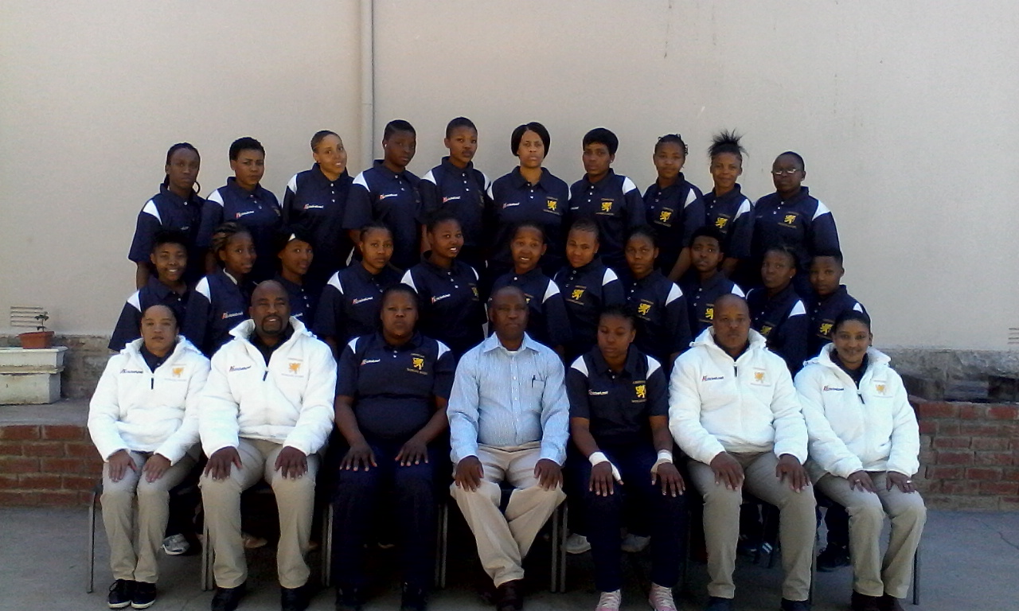

FINANCIAL POSITION OF THE UNION

- Griffons Rugby Union is one of only four SARU unions that are financially sound and still create opportunity for underprivileged youth.
- Providing opportunities for the black business people from the townships totally of the overall budget.
We are seen as a small union but are only spend on what we have and still make a saving and put quality teams on the field.

HIGHS AND LOWS OF THE UNION
- The low point in our union is the performance of our women’s rugby teams, but we are busy addressing the problem with SARU officials.
- Low point, the absence of females on the Executive and Board, busy addressing this.
- High point winning the SARU under 20 competition against Boland that has a SARU academy.
- High point, winning the SARU first division against the Leopards in Potchestroom

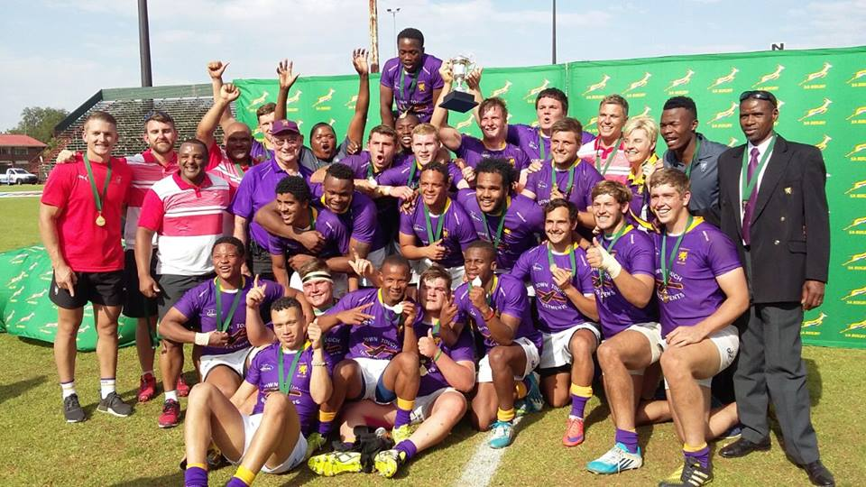

GRIFFONS UNDER 20 TEAM 2016
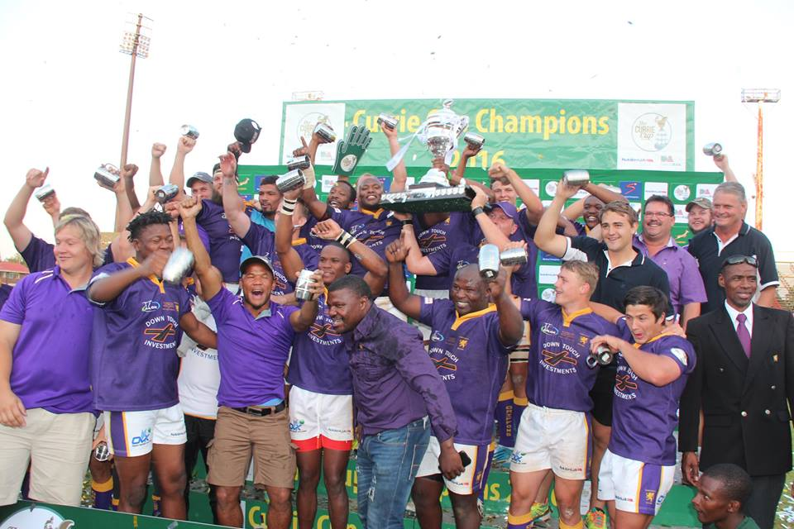

GRIFFONS SENIOR TEAM 2016

CONCLUSION
- As a union we put our people first and always try to perform to the best of our ability and never underestimate our capabilities.
- We belief transformation is from the top downwards and if you are not prepared to transform than you are not in Rugby for the people of South Africa, irrespective of colour, but for yourself.

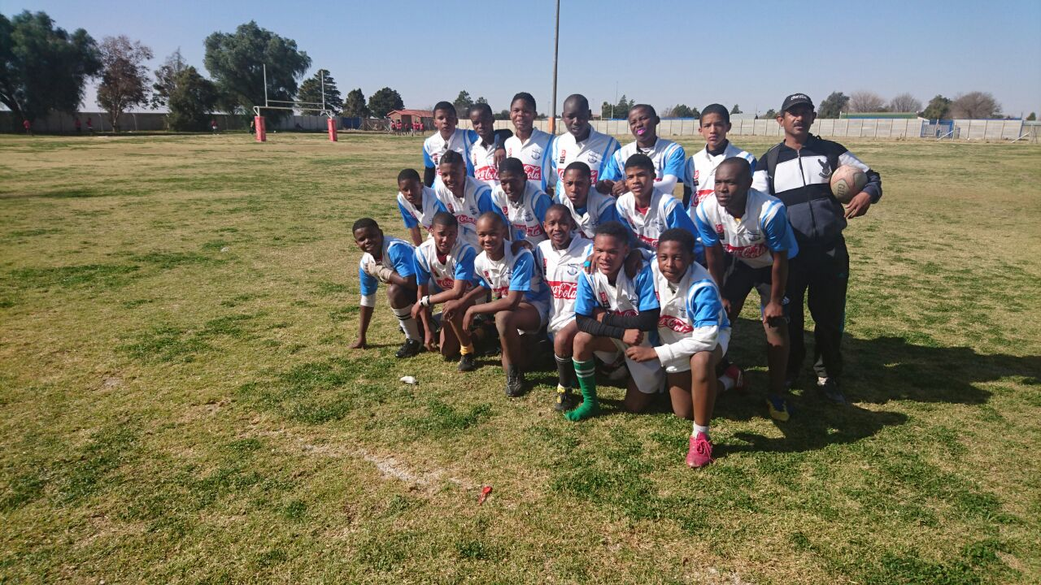

RANDALL SEPTEMBER
PRESIDENT GRIFFONS RUGBY UNION.

