WORKING ON FIRE OVERVIEW OF EXPENDITURE AND KEY DELIVERABLES FOR THE FINANCIAL YEARS 2013/14 TO 2016/17 (MID-TERM)
- INTRODUCTION
Key data was extracted from the key performance indicator (KPI) reports of the Working on Fire Programmes (WoFire) for the financial years under review. The 2013/14 financial year data is applicable to the previous contract with the then Department of Water Affairs, WP9191. The figures for the other three financial years are based on data under the current contract as entered into by Department of Environmental Affairs (DEA) on 1 April 2014.
As the request from the Portfolio Committee on the Environment on the 18th October 2016 focused on financial information, more particular on expenditure and funding sources some emphasis was placed on these indicators. Presenting financial figures without a geographical and operational context would not present a thorough overview to the programme though. Data for some key operational indicators where therefore also extracted. These included, training, number of fires attended to, estimated hectares of fire attended to, hectares of manual fuel load reduction, hectares of burnt fire belts, hectares of prescribed burning and high level employment figures.
- GEOGRAPHICAL OVERVIEW
Most of South Africa’s biologically diverse ecosystems are fire adapted and in fact depend on fire to regenerate and survive (Figure 1) (Forsyth et al. 2010; Le Maitre et al. 2014).
Figure 1: Untransformed fire-prone vegetation, forest plantations, degraded vegetation and wetlands in South Africa. (Van den berg et al. 2008; Forsyth et al. 2010)
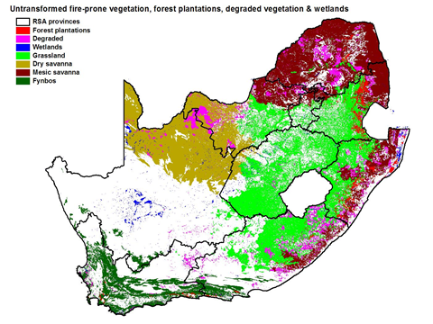

Figure 2 below shows distribution of Working on Fire (WoF) bases during the 2015/16 financial year.

Figure 2: Most recent distribution of WoF (including high altitude invasive alien plant clearing teams) bases.
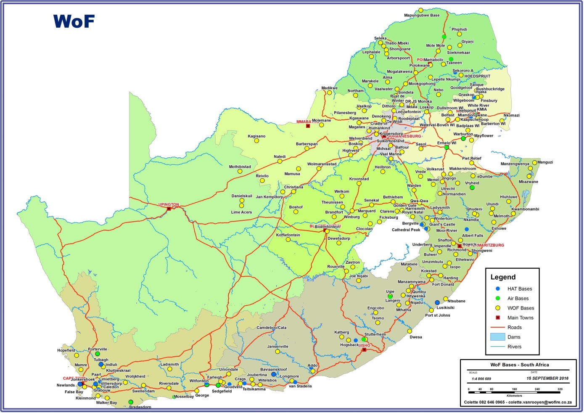

From the map it is clear that teams are being deployed within the fire prone biomes of the country. In large parts of the Northern Cape (the Great Karroo) no teams are based. Figure 1 clearly illustrates why no teams are needed there as the vegetation in these areas is not fire prone. Over the last number of years there was a gradual shift in the placement of teams towards resource poor areas. This does come with additional costs to the programme as generally there are fewer funding partners in these areas. Figure 3 shows the impact sphere of the programme. Assuming a 100km radius for resources deployed the map shows what part of the country is covered by the programme. This does not mean that teams cannot be deployed outside these areas. It’s not uncommon for teams to be deployed outside the 100 km radius. During disaster fires teams from Cape Town can and are being deployed in Limpopo or any other part of the country and vice versa.

Figure 3: The area of the country covered by WoF bases assuming a 100km radius around the base.
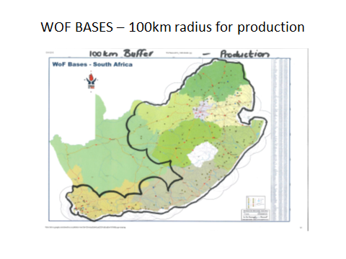

Historically the deployment of well-equipped veld and forest fire management resources were largely focused around the commercial forestry areas of the country. During the 1970’s and 80’s some resources were also placed in the mountain catchment areas and state forests declared under the Mountain Catchment Areas Act of 1970 and the Forest Act. Limited support was given to agricultural and especially communal areas though. With the launch of WoF this all changed to the point where the country’s fire prone areas are well covered by resources. The bulk of the land covered by WoF is now agricultural, including communal areas and commercial forestry land as can be seen in figure 3. As the Department of Agriculture Forestry and Fisheries is a key partner the support for state forest plantations are also shown as a separate category in the pie chart of figure 4. Supporting agricultural areas means that the programme makes a significant contribution to maintain the ecological integrity of fire prone biomes while securing the livelihoods of people involved in the agricultural sector but also the overall food security of the country. Of particular importance to Department of Environmental affairs is the extent of protected and communal areas being supported by the programme.
The institutional partners in the agricultural land category are Fire Protection Associations and local authorities in support of DAFF and DCOG. The national distribution of the deployment of fire fighters expressed as person days worked is shown in figure 4 below. It must be noted that the country has effectively two fire seasons. In the summer rainfall areas the highest fire danger indices recorded are during the winter months, while in the Western Cape which has a Mediterranean climate and therefore gets its rain during winter the fire season is during the hot summer months of the year. The highest team densities occur in KwaZulu-Natal and Gauteng where the programme has a number of very strong partners.
Figure 3: Distribution of resources per partner category.
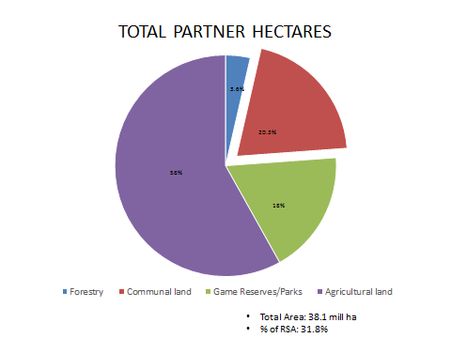

Historically the forestry areas were favoured but over the years the emphasis has gradually shifted to agricultural areas especially resource poor areas. Currently the most resources have been deployed in KwaZulu-Natal. The allocations need to be measured in terms of the extent of fire prone areas of the province being considered.
Figure 4: The provincial distribution of WoF resources using person days of employment as a proxy for resources deployed.

- FINANCIAL INDICATORS AND HIGH LEVEL PERFORMANCE INDICATORS
Table 1 shows the WoF income from different sources. As can be seen the bulk of the resources is still funded by the EPWP.
Table 1: Expenditure per programme income streams since 2013/14. The last column shows the 2016/17 up to the end of September 2016.
Sources of funding | 2013/14 | 2014/15 | 2015/16 | 2016/17  Forecast | 2016/17  YTD
A. DEA Baseline and Wage Incentive | R 420 055 719 | 513 201 748 | R 556 803 876 | R 558 870 873 | R 354 735 063
Gauteng Projects | R 7 000 001 | R 7 210 000 | R 7 100 000 | R 7 606 680 | R -
Medupi Project | R - | R 6 880 432 | R 779 959 | R 2 114 139 | R -
Sasol Project and eThekwini Projects | R - | R 8 234 575 | R 4 934 938 | R 8 676 812 | R 4 338 406
B. Sub-total partners and participating  departments | R 7 000 001 | R 22 325 007 | R 12 814 897 | R 18 397 630 | R 4 338 406
Aviation Revenue | R - | R - | R - | R 56 456 999 | R 26 116 233
Recoupments | R - | R 3 830 272 | R 6 410 936 | R 1 418 108 | R 1 181 757
Interest Received | R - | R 2 780 856 | R 4 246 128 | R 2 595 347 | R 2 162 789
Service Rendered Revenue | R - | R 13 651 187 | R 8 751 798 | R 9 810 155 | R 4 081 736
Employee Tax Incentive | R - | R 10 360 625 | R 15 614 730 | R 7 962 830 | R 6 635 692
Other Income | R - | R 32 798 | R 309 088 | R 2 839 309 | R 1 585 784
C. Sub-total Additional Third Party  Revenue | R - | R 30 655 738 | R 35 332 680 | R 81 082 749 | R 41 763 991
Canada 1 | R - | R - | R 6 653 273 | R - | R -
Indonesia | R - | R - | R 5 467 970 | R - | R -
Canada 2 | R - | R - | R - | R 24 560 357 | R 24 560 357
D. Sub-total foreign deployments | R - | R - | R 12 121 243 | R 24 560 357 | R 24 560 357
Total WoF funding | R 427 055 720 | R 566 182 493 | R 617 072 696 | R 682 911 609 | R 425 397 817

Notes explaining table 1:
- These amounts represent total funding received through DEA allocation.

- The amounts included as contributions from partners and participating departments consist of multi-year projects as listed.

- Additional aviation standby and flying hours were not paid or recorded as third party revenue in WoF records for the years preceding 2016/17, but directly to the contracted service provider.
  - These contracts were subsequently amended to enable recording and receipt of these contributions in the WoF Accounting records.
  - During extended fire suppression operations, the South African Air Force could also assist with aerial suppression, depending on budget and crew resource availability. The Air Force assistance is activated through the Disaster Management System. Activation is only done when insufficient private sector resources are available.
  - Recoupments consist of recoupment of costs from third parties like kilometres travelled and rations provided during production and suppression activities.
  - Interest received consists of interest earned on the dedicated project bank - and investment accounts on surplus project funds invested.
  - Services rendered consist of revenue earned from third parties on the provision of services like prescribed burning, suppression etc.
  - Employee Tax Incentive is an incentive earned on employing young and less experienced work seekers.
  - Other income consists of non-recurring items like insurance receipts etc.

- Foreign deployment income consists of all additional revenue generated through these deployments.
All surpluses generated though the above additional sources of revenue are utilised in the WoF Programme for additional capacity like training and person days. As can clearly be seen in Fig 7 for the years 2014/15 – 2016/17, actual person days are consistently higher than planned as a result of the additional revenue generated.
Annexure A shows the steps that the Department has taken so far to ensure collaboration between South Africa and Canada can be optimized in the future.
Figure 5 below shows the 3rd party resources against the DEA WoF contributions between 2013/14 and 2016/17.
Figure 5: Analysis of funding sources

Figure 6 shows the %’s of total expenditure per high level expense category funded by the DEA EPWP WoF programme. Direct employment cost includes the wages of fire fighters, the salaries of management staff in the programme and other employment related costs such as Unemployment Insurance Fund, Workmen Compensation and pre-employment and compliance medical examination for workers. Indirect employee costs, those costs that are needed to keep the teams operational, include personal protective equipment, operational equipment, training and transport.
Figure 6: Expense analysis per Expense Category

Note that the last column in figure 6 represents the expenditure to the end of September. Indirect employment costs such as personal protective clothing and equipment are generally bought early in the financial year. This explains why the management fee during September 2016 stood at 10.1%. A maximum of 96% is a condition of the agreement. The Department will therefore ensure that no more than 9.6% is being paid out to the implementing agent.
The programme expenditure versus funding drawn down since the beginning of the 2016/17 financial year is shown in table 2 below. As can be seen the 1st quarter drawdown was 40% of the total amount allocated to the programme by DEA to ensure a seamless transition between financial years and allow for upfront expenditure that needs to be done by the programme during the 1st quarter, for example personal protective, and operational equipment with annual life spans.
The 2nd quarter drawdown was 25% of the total budget. While there was an 8% surplus at the end of the 1st quarter, the 2nd quarter drawdown was 6% less than the amount spent leaving only 2% unspent at the end of quarter 2. It should be noted that the 8% surplus at the end of the 1st quarter is equivalent to an average month’s turnover.

Table 2: Working on Fire Expenditure versus Drawdowns September 2016/17
 | Q1 YTD Actual | Q2 YTD Actual | YTD Sept 2016
Wages | R 51 672 301 | R 48 096 395 | R 99 768 696
Salaries (WoF Management) | R 23 143 191 | R 30 606 057 | R 53 749 247
Other employment related costs | R 8 632 637 | R 5 654 348 | R 14 286 985
Direct Employee Cost | R 83 448 128 | R 84 356 800 | R 167 804 928
PPE & PPC | R 12 847 014 | R 15 593 906 | R 28 440 920
Training | R 17 023 560 | R 17 885 591 | R 34 909 151
Transport | R 12 201 983 | R 11 982 830 | R 24 184 812
Indirect Employee Cost | R 42 072 557 | R 45 462 326 | R 87 534 884
Operational Variable Costs | R 20 084 806 | R 8 949 325 | R 29 034 131
Research | R 356 259 | R 220 676 | R 576 935
Media, Communication & Marketing | R 372 466 | R 2 882 780 | R 3 255 246
IT | R 218 989 | R 3 021 225 | R 3 240 214
FPA's | R 1 569 398 | R 2 096 974 | R 3 666 372
Other Overhead Cost | R 22 601 917 | R 17 170 981 | R 39 772 899
Aviation | R 11 875 000 | R 11 875 000 | R 23 750 000
Management Fee | R 21 460 642 | R 14 411 711 | R 35 872 352
Total expenditure | R 181 458 244 | R 173 276 818 | R 354 735 063
Amount Paid | R 223 548 349 | R 139 717 718 | R 363 266 067
Variance | R 42 090 105 | -R 33 559 100 | R 8 531 005
Variance | 8% | -6% | 2%

The fact that the bulk of the resources deployed by WoF are funded by the EPWP does not mean that other institutions do not allocate resources to integrated veld and forest fire management. In a recent project on reducing disaster risks from wildland fire hazards associated with climate change in South Africa focusing on the Cape Floristic Region funded by the Global Environment Facility (GEF) it became clear that other stakeholders do contribute to veld and forest fire management as well.
A survey done by the project showed that in the Western Cape around 55% of resources deployed towards integrated veld and forest fire management was being funded by WoF. Land users through Fire Protection Associations (FPA) & individual commitments contributed 36%, local authorities 6.5%, provincial government, 1% and National government agencies 1.5%. The resources deployed by the provincial conservation agency are included under land users. It must be noted that this is not necessarily the case in other parts of the country. In resource poor areas like the former homelands contribution profile will be different to the Western Cape. These resource poor communities will be more dependent on the contribution of government to protect their livelihoods against wildfires but also to support them to implement sustainable grazing regimes by implementing prescribed block burning and fire break programmes.
Table 2: Contribution by sectors per integrated veld and forest fire management activity
Contributors | Proportional Contribution per sector
Land Users
Fire Protection Association (FPA) Costs | 7.0%
FPA Aerial Support Costs | 3.0%
Forest Fire Detection | 3.0%
Forestry Costs | 23.0%
Agricultural Costs | 0.0%
Working on Fire
WoF Ground Operations | 23.0%
WoF Aerial Support | 3.0%
WoF Other | 29.0%
Local Authorities
District Municipalities | 6.0%
Metropolitan Municipalities | 0.5%
Provincial Government | 1.0%
National Government (SANParks, National Disaster Management Centre, DAFF) | 1.5%
Total | 100.0%

- HIGH LEVEL OPERATIONAL INDICATORS
Some high level indicators will be presented below showing the national scale of the socio-economic and natural resource management impact of the WoF programme.
  - Socio-Economic deliverables
    - Employment
Figure 7 shows the employment created by the programme since 2013/14. As can be seen during the 2015/16 financial year the number of person days came down. This was due to a misinterpretation between EPWP and DEA about what qualifies as a person day. Historically, when a fire fighter worked overtime the latter was added and reported as additional person days of employment. The EPWP system however only allows for a 40 hour work week and the programme stopped reporting these person days. The cost of these so-called overtime person days were also relatively low as there are effectively no additional costs with regards to additional management, equipment, personal protective equipment etc. It is predicted that the employment in 2016/17 will come down marginally again due to budget cuts in all the DEA Environmental Programmes. If expressed as full time employment (230 working days per year) the person days shown in figure 7 represents 5 696 person years of employment during 2013/14, 6 757 during 2015/16, 6 069 during 2015/16 and it is predicted that the programme can create 5 652 during 2016/17.
Figure 7: No of person days of employment created between 2013/14 and September 2016/17

As can be expected, the costs per person day are going up in line with inflation but have gone up more significantly during the 2015/16 financial year due to the “disqualification” of the overtime person days which was a significant proportion during 2014/15. The impact can also be seen in figure 8 below. Like in the above cases the high upfront annual costs is having an impact on the midterm person day costs.
Figure 8: Costs per person day for the respective financial years.

    - Training
Figure 9 shows the training days during the period under review. Notable from the training is that WoF consistently offers a significant number of accredited training days every year.
Figure 9: Training days given to fire fighters in WoF between 2013/14 and 2016/17

  - Operational Deliverables
Figure 10 shows the number of fires attended to by WoF during the period under review. One cannot not be blamed for questioning why the number of fires attended to during 2015/16 was lower than 2014/15 as it was a very dry year. On the surface it could be expected that dry years should have more fires than wet years. This is not necessarily true in general though. Long term ecological research has shown that the years with the biggest and most severe fires are associated with at least two years of above average rainfall during the wet season. This leads to a build-up in grass fuels in both the savannah and grassland biomes. The herbivores on the land are then unable to graze it down so that the biomass loads are too low to sustain a fire. Should it be able to sustain the fire it is a relatively low intensity fire due to the lower than normal grass fuel loads. This does not necessarily apply across the country though. In the fynbos areas in the Western & Eastern Cape this will not be true. Fynbos generally has fire intervals between 8 and 45 years with an average of between 12 to 15 years. Therefore no matter what, during a dry hot year one would expect a higher number and more intense fires in the fynbos. In the grasslands though, the current drought would have had an effect on available fuel in the landscape due to higher levels of utilization by stock and wildlife which could be one of the major contributors to a reduction in the number of call outs. The 2016/17 financial years is an even drier year in the summer rainfall regions. The number of fires attended to up to the end of September is not even ½ of 2015/16. It could however change dramatically during the Western Cape & western parts of the Eastern Cape fire season.
Figure 10: Number of fires attended to by WoF between 2013/14 and 2016/17

The last two years could therefore be described as relatively mild fire seasons. Figure 11 shows the estimated area of the fires WoF attended to during the period.
Figure 11: Estimated Hectares of fire that WoF attended to

The number of fires and the estimated area attended to confirms that 2014/15 was a particularly bad year for wild fires. Figure 12 shows the average size of the fires based on figures 11 & 12 above.
Figure 12: Average size per fire as shown in figures 11 & 12.

During these periods the focus should be on ensuring a sustainable veld age distribution. The making of fire breaks, fuel load reduction and prescribed burning are always important to achieve the goal of maintaining a sustainable veld age distribution. Figure 13 shows the hectares of fire breaks burnt during the respective years. These are planned fires and are aimed at ensuring that big enough breaks in the vegetation are being created to minimize the risk of catastrophic wild fires.
Figure 13: Fire breaks made during the period 2013/14 to September 2016.
Up to September 2016 a substantial area of fire breaks have already been burnt. This should contribute to the ability of land users to contain wildfires during the next fire season. Fire breaks go hand in hand with the manual reduction of fuel loads around infrastructure like fences around parks and built up areas and includes the clearing of dense stands of invasive alien plants. Figure 14 shows the areas treated by the programme with regards to manual fuel load reduction. During 2013/14 the Department started putting a greater emphasis on prescribed burning and fuel load reduction. The 2013/14 planned figures show that the managers were over ambitious with what they can achieve.
Figure 14: Hectares manually cleared to reduce fuel loads and minimizing the risk of damage to infrastructure.

The final high level indicator that is of specific importance to DEA is the areas of prescribed burning, figure 15. These areas are all burnt for ecological reasons, either to improve the veld age distribution or fire was used as a tool in the clearing of invasive alien plants. Climatic conditions and a greater emphasis on prescribed burning have led to a significant over performance during 2015/16. Not too much should be read in it for future planning though as prescribed burning is very weather dependent.
Figure 15: Hectares of Prescribed Burning for ecological reasons.

Figure 12 - 15 shows that over the last four years the programme has become more proactive in ensuring sustainable fire management regimes.
- CONCLUSIONS
As can be seen from the above, significant strides have been made by WoF in the fight against unwanted wild fires in South Africa. WoF covers nearly all naturally fire prone areas of the country and is making significant contributions to the successful implementation of the National Veld and Forest Fire Act of the DAFF. In the process more than 5 000 young people are being given employment and training opportunities every year with more than 30% of them women, higher than any other fire management programme in the world.
Highlighted by the overview is that, should WoF disappear from the greater South African landscape, veld and forest fire management in rural areas might well collapse with serious livelihood, food security and biodiversity implications. If it is assumed that the findings of the GEF project is a reasonably accurate estimate of resource allocations in the Western Cape, one of the richer provinces in the country, the programme contributes as much as 55% of all resources towards integrated veld and forest fire management. In resource poor areas this % is expected to be much higher.
While there will always be room for improvement the overview shows that progress has been made to ensure that WoF resources are being deployed optimally. In the early years of the programme substantial emphasis was placed on fire suppression in partnership with established partners in especially the forestry and environmental sectors. As the programme grew however capacity has been developed gradually in resource poor areas. Figure 2 is evidence that the footprint of the programme has improved substantially. The % of direct costs of employment (employee wages/salaries and staff benefits) have consistently been above 50% for the period under review.
The unlocking of 3rd party resources is also growing but can still be improved. To optimize the latter though, DEA and its partners, DAFF, DWS, DCOG, DRDLR and conservation agencies need to create an enabling environment for the programme to unlock further 3rd party resources. The institutional arrangements to unlock 3rd party resources therefore need to be looked at over the next five years during the “so called” exit strategy for the programme. Governance can also still improve as long term institutional arrangements are developed.
The next four and a half years is crucial for veld and forest fire management in the long term. By the end of the current agreement the new institutional arrangements must be of such a nature that the gains that have been made by the programme to date is not lost and that it can be increased in the future.

End
27 October 2016

ANNEXURE A: SOUTH AFRICA CANADA RELATIONS

  - The Relations between South Africa and Canada were formalised in 2003 with the signing of the Joint Declaration of Intent to strengthen relations between South Africa and Canada. This led to the establishment of Annual Consultations between the two countries that are held at a Senior Officials level.

  - Currently, there is no formal cooperation with Canada in the environmental sector but in 2015 a request was received for the deployment of Fire-fighters. Following the July 2015 deployment, the Department of Environmental Affairs (DEA) attempted to remedy this situation by looking at the possibility of establishing formal cooperation with Canada on Environmental issues.

  - As an initial step in this process, DEA participated in the 10th Annual Consultations which took place in Ottawa, Canada in December 2015.

  - The Department participated in bilateral working group meetings with the Canadian Forest Service, which focused largely on how to grow the sector in terms of integrated veld and fire management (wildland fire management), responsible forestry, natural resource economics, environmental impacts and eoxyribonucleic acid (DNA) barcoding, where the possibility of cooperation in these areas was discussed.

  - It was envisaged that the outcome of these discussions would be formalised in terms of official cooperation in the broader environmental sector. However, Working on Fire (WoF) received a formal request to assist with wildland fire suppression efforts in Canada in May 2016 before this process could be completed.

  - On 03 June 2016, the internal meeting was held in the Department to assess the interest of various Branches in cooperating with Canada. Emanating from this meeting, the broad areas identified for cooperation with Canada entail natural resources management, climate change, sustainable development, compliance and enforcement, waste management, environmental management tools and systems and biodiversity.

  - Following this a meeting was held with DIRCO on 13 July 2016 to provide feedback on the progress on the internal DEA discussion and the proposed areas of cooperation which includes natural resources management, climate change, sustainable development and biodiversity amongst others Subsequently a meeting was held with colleagues from the Canadian High Commission on 25 July 2016 in which they undertook to consult internally within in the Canadian Government and revert regarding the proposals.

  - At a follow up meeting held in October 2016, the Canadians informed the SA government that since the change of government policies, particularly in the Environment sector, they have been receiving a number of requests for cooperation on environmental issues. They are thus internally still working on a strategy before they will be able to provide feedback.

  - Pending this feedback, a first draft of an Agreement will be drafted and negotiations will commence between the Parties with the aim of finalising the Agreement by the next Annual Consultations which is likely to be scheduled for April 2017.

