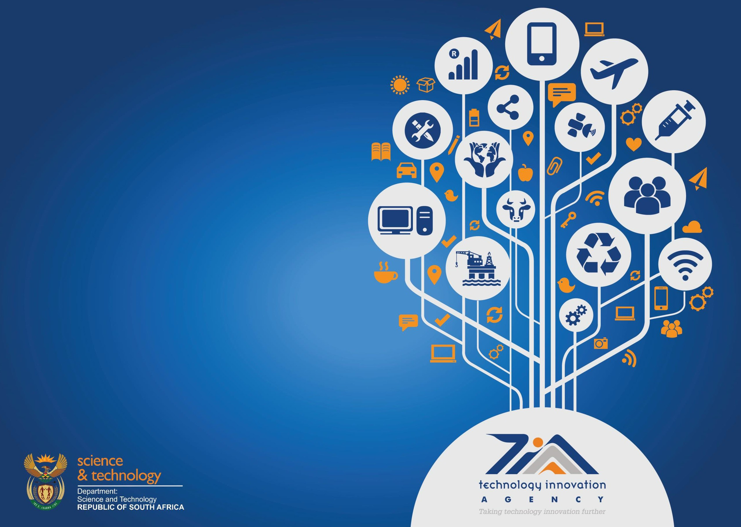Annual Report 2015/2016
Presentation to the Parliamentary
Portfolio Committee on Science &
Technology
19 October 2016

Outline

1. Overview

2. Achieving National Development
Programme (NDP) goals

3. Innovation Enabling & Support

4. Operational Performance

5. Financial Performance and Governance

Annual Report 2015/2016 2

‘Innovation is the primary
driver of technological growth
and drives higher living
standards…. and brings about
economic growth, we propose a
larger, more effective
innovation system, closely
aligned with firms’

Annual Report 2015/2016 3

Vision & Mission

VISION
• To be a world-class leading technology
innovation agency that stimulates and supports
technological innovation to improve the quality of life for all South Africans
MISSION
• To facilitate the translation of South Africa’s
knowledge resource into sustainable socio-
economic opportunities

Annual Report 2015/2016 4

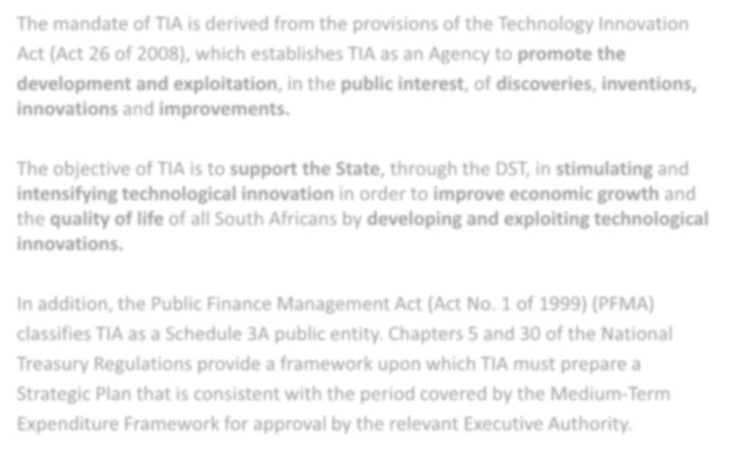OUR MANDATE

The mandate of TIA is derived from the provisions of the Technology Innovation
Act (Act 26 of 2008), which establishes TIA as an Agency to promote the development and exploitation, in the public interest, of discoveries, inventions, innovations and improvements.

The objective of TIA is to support the State, through the DST, in stimulating and intensifying technological innovation in order to improve economic growth and the quality of life of all South Africans by developing and exploiting technological innovations.

In addition, the Public Finance Management Act (Act No. 1 of 1999) (PFMA) classifies TIA as a Schedule 3A public entity. Chapters 5 and 30 of the National Treasury Regulations provide a framework upon which TIA must prepare a Strategic Plan that is consistent with the period covered by the Medium-Term Expenditure Framework for approval by the relevant Executive Authority.

Annual Report 2015/2016 5

Delivering on our
5-Year Plan

Strategic impact

• Contribution towards an innovation economy

• Stimulating and intensifying technology innovation resulting in a vibrant eco-system

• Socio-economic impact of technology innovations

• Growth in the number of skilled jobs

• Increasing revenues e.g. taxes, improved trade balance

• Increase in knowledge intensity of businesses and
industries

Annual Report 2015/2016 6

HR Improvements

Policy Review

All critical HR policies have been reviewed in support of establishing a high performance culture, developing employees that are innovative, creative and accountable

Preventative Employee Relations

Adopted a Preventative Employee Relations approach ensuring employees receive the required support pro-active from HR in balancing their intellectual, emotional, spiritual and physical health

Annual Report 2015/2016 7

HR Improvements

Employee Engagement Survey

• Overall score including transformation and values rating increased from
43% in FY14/5 to 57% in FY15/16

Harmonisation

• Detailed benchmark was done comparing remuneration and employee benefits against 3 industries (National, NSI and Science and Technology)
• The outcome resulted in:
• All employees below the 25th percentile have been adjusted
• One additional leave day was added to the benefits
• Long service leave was added to the employee benefits

Annual Report 2015/2016 8

TIA Board

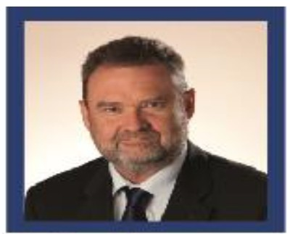Ms Khungeka Njobe
Chairperson
Ms Helen Brown
Chairperson: HR and
Remunerations
Dr Steve Lennon
Chairperson: Aucflt
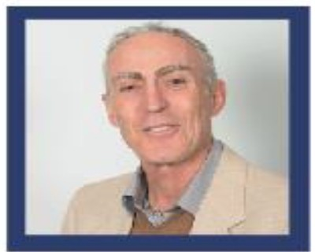and Risk

Dr Petro Terblanche Chairperson: Investment andRnance
Adv Motlatjo Prof David Ellis Kaplan
Josephine Ralefatane Board Member
Board Member

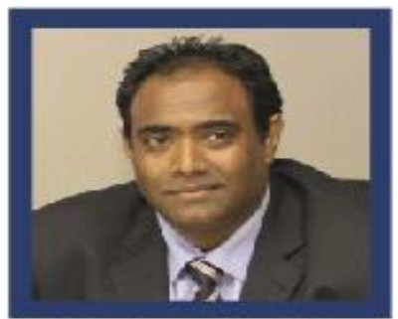

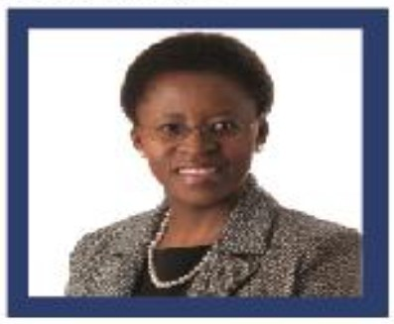Prof Diane Hildebrandt Ms Rosetta Xaba
Board Member Board Member

Annual Report 2015/2016
Mr Barlow Manila/
Chief Executive Officer

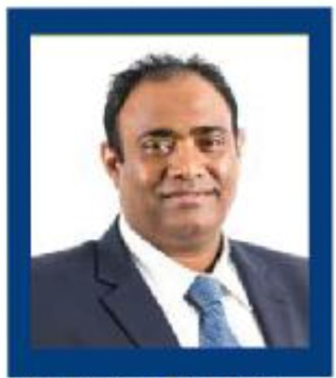TIA Executives

Mr Barlow Manila/
Chief Executive Officer

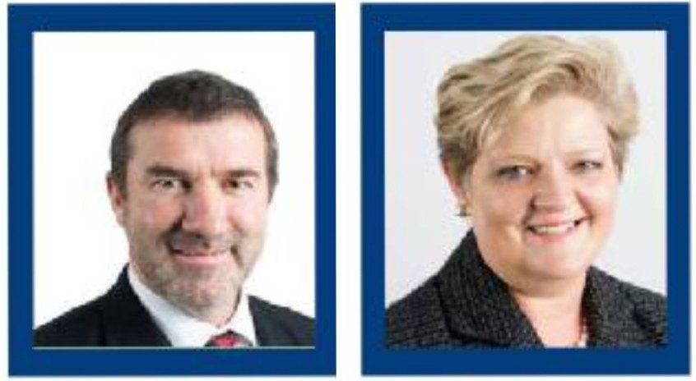

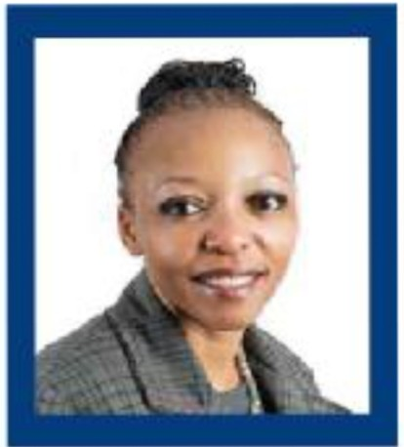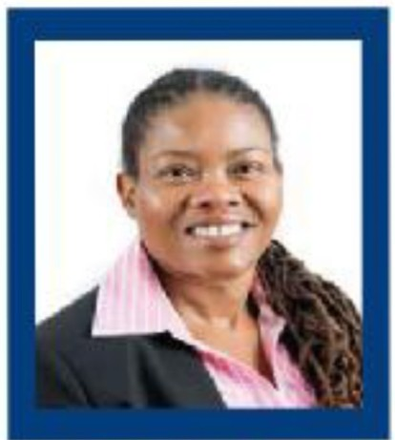Mr Werner vand der Ms Femke Pienaar Dr Sibongile Gumbi
Merwe Executive People Systems Executive Innovation
Chief Financial Officer and Facilities Enabling and Support

Annual Report 2015/2016
Ms Pontsho Maruping Executive Innovation Funding Pre-Commercialisation and Support

Taking Technology Innovation Further
Supporting the NDP

Annual Report 2015/2016 11

Government outcome/ NDP
Alignment

Outcome 2: A long and healthy life for all South Africans
Outcome 4: Decent employment through inclusive economic growth

Outcome 5: Skilled and capable workforce to support an
inclusive growth path
Outcome 7: Vibrant, equitable and sustainable rural communities with food security for all

Outcome 10: Protect and enhance our environmental assets and
natural resources
Outcome 11: Create a better South Africa and contribute to a better Africa and a better world

Annual Report 2015/2016 12

FibreLux (Pty) Ltd

Innovation : FiberLux device is a portable, user-friendly, affordable and accurate fibre

diameter meter for on-farm measurement of wool, mohair and other animal fibre fineness. Investment: R6.77 million (R4.84 million for technology development and
R1.93 million for commercialisation). The product is being manufactured and sold by the

company.

Highlights: Identified as a technology that could be part of a special programme targeted at technology diffusion to small-scale farmers in the Eastern Cape as a tool to create income by operating the FibreLux units in the shearing communities. The DST has endorsed the project and will be committing funds for the purchase of 30 units, which will
be deployed to the youths, as part of the project execution.

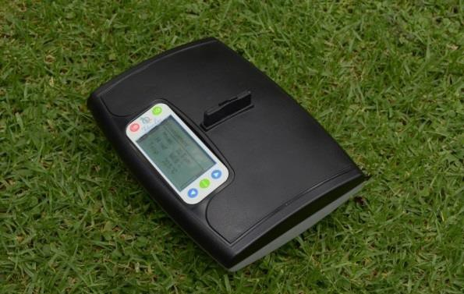

Annual Report 2015/2016
OUTCOME 7: Vibrant, equitable and sustainable rural communities with food security for a1ll3.

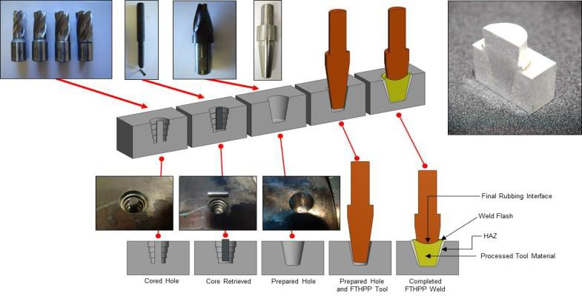Weldcore

Innovation: Innovation for preventative maintenance of large infrastructure. From proof

of concept to full demonstration through collaboration and the investment of R32 million from Eskom, the THRIP and TIA over a 12-year period. The technology will be used to improve the maintenance of the electrical infrastructure of Eskom and other SOEs such as Sasol and Transnet.
Highlights: A spin-off company, Mantacor (Pty) Ltd, in partnership with the Nelson Mandela Metropolitan University, was created to take the Weldcore® products and processes to the market. NMMU has provided start-up funding to the amount of
R1 million to get the company operational. Weldcore also received an investment of some
R30 million including TIA funds and this has facilitated over R1 billion in deferred expenditure .

Annual Report 2015/2016 14

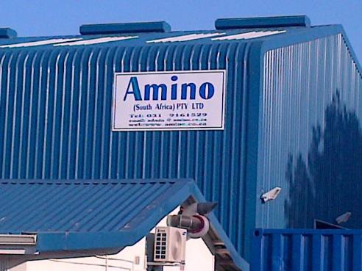Amino South Africa (Pty) Ltd

A start-up company in the Industrial Biotechnology Sector based in KZN

Innovation Technology: Production of amino acids from vegetable raw materials .

Highlights: Bioprocessing Platform provided infrastructure and analytical services for validation of processes and analysing raw materials prior to construction of the production plant. In 2015 Amino SA secured an FDI investment of Euro 1 million for the
establishment of the production facility in Kwa-Zulu Natal leading to job creation.

Annual Report 2015/2016 15

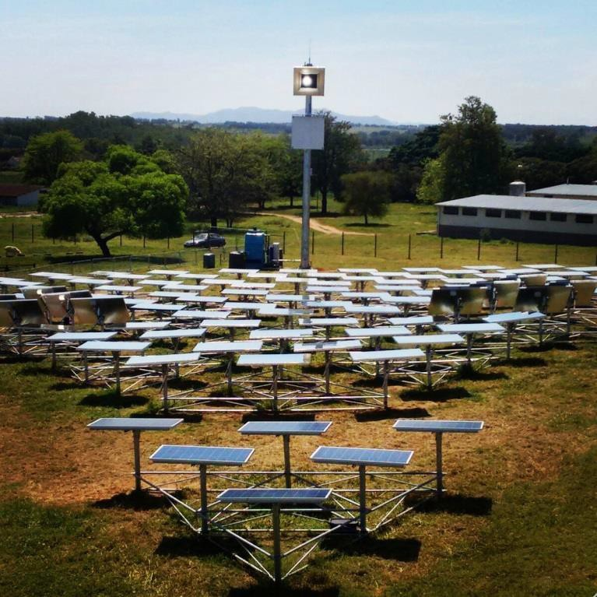Helio100

Innovation: A Concentrated Solar Power (CSP) project to develop a low-cost

heliostat with high optical accuracy. A heliostat is a slightly curved mirror which tracks the sun during the day and focuses the sun’s radiation on the receiver on top of a tower, thereby converting optical energy to thermal energy.
Investment: TIA R15.4million and DST R2million

Highlights: The project has maintained a local component supply of more than
90% and manufacturing and installation is done by local semi-skilled labour. MoU for supply to Israel signed with AORA.

OUTCOME 10: Protect and enhance our environmental assets and
natural resources

Annual Report 2015/2016 16

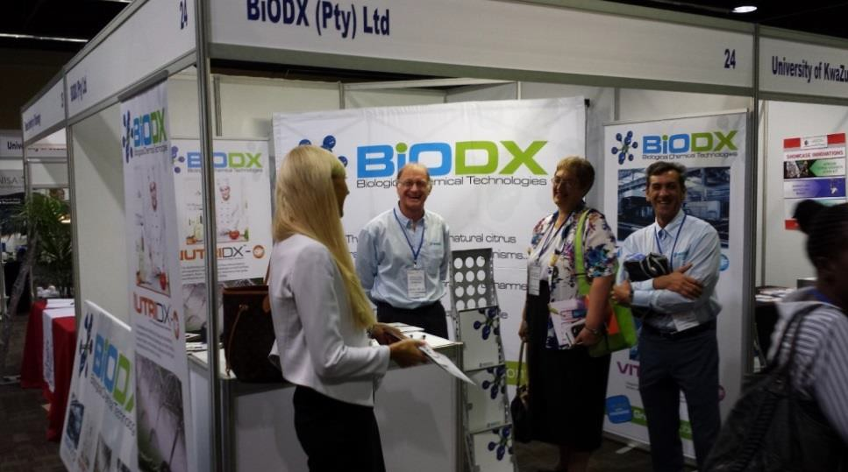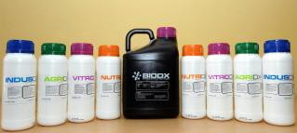BiODX (Pty) Ltd

Innovation Technology: New and environmentally sustainable biocide products for

cosmetic and industrial application

Highlights: Completed and presented a field trial at the Lethabo power station. Eskom cooling water trials, BIODX products are currently tested in water purification applications at the Tutuka power station’s effluent plant. Additional R3.5m illion TIA funding to configure and formulate the product to meet the requirements of A&L Biologicals, Sappi SA, Westerblend, Tongaat-Hulett Sugar, Tongaat-Hulett Starch, Cavalier
Foods and Electricite De France (EDF). BiODX also received an additional R43.5million IDC

funding to scale up its DecontA manufacturing process, as well as to construct a

manufacturing plant for commercial production of DecontA.

OUTCOME 2: A long and healthy life.

Annual Report 2015/2016 17

Innovation Enabling & Support

Annual Report 2015/2016 18

Technology Platforms
Supporting the Bio economy Strategy

63 Students supported and 34 Internships placed at
Technology Platforms

1 international patent expansion for acid mine drainage remediation

Total client project support by Platforms (prototypes and patents) grows from 70 to 102 in 2015/16

26 Technologies and services developed and/or
improved due to Platform support

R59.1 million Co-funding raised of which R37 million was FDI
Outcome 4: Decent employment through inclusive economic growth

Annual Report 2015/2016 19

Technology Stations
Supporting SMMEs

110 SMEs secured contracts from TSP support
103 Interns in the * SETIIP with industry partners

*Science Engineering and Technology Internship Programme

At least 4821 testing, quality assurance, analytical services and engineering support provided to enterprises

235 Products
& Prototypes
completed
3 Technology Stations received certifications 7 accreditations in quality management systems such
as ISO
9001:2015 Outcome 4: Decent
employment through inclusive economic growth

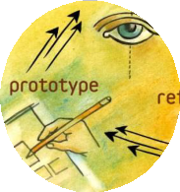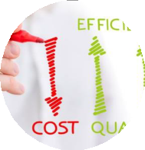

Annual Report 2015/2016 20

Global Cleantech
Supporting SMMEs

Programme Highlights
Khaya Power

• Applications increase from 68 to 102 in
2015/16
• 60 Ground-breaking innovative solutions unearthed
• Khaya Power (e.kasi.energy) wins 1st place at Global Cleantech Competition in San Francisco
• Developed a micro- gasifier stove with an electrically driven fan, which is smoke-free and burns biomass efficiently for households in poor communities with inadequate,
unreliable or no access to grid-power

OUTCOME 10: Protect and enhance our environmental assets and
natural resources

Annual Report 2015/2016 21

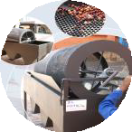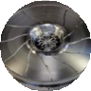Seeding Ideas (R47.4million)

Fund adds 101 new projects to its portfolio of 275 projects

Number of participating Universities grow from 17 to 20 in
FY15/16

50 Projects completed

5 New patents registered

5 Previously Disadvantaged Institutions continue to lag
behind

HEI’s: 27 Innovation outputs: market reports, prototypes

HEI Seed Fund: 275 Applications approved
Regional Seed Fund (RSF) – 89 SMMEs funded

Annual Report 2015/2016 22

Innovation Skills Development

136 Interns placed in partnership with NRF and EWSETA to projects in energy efficiency, fibre optics, etc.

10 Masters Candidates placed and completed training with Oxford ISIS Enterprise
Commercialisatio n Specialist
SA VentureLeaders take 3 of 5 finalist spots at the Zurich Google Pitchfest where 13 SA entrepreneurs competed with Swiss counterparts

2nd Round of UK Newton Fund benefits 16 candidates, 56% Black and 56% Women

177 candidates benefit from innovation management training with the Stanford University Global Institute for Leadership Development

Outcome 5: A skilled and capable workforce

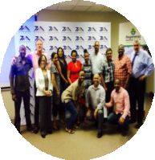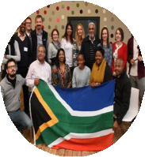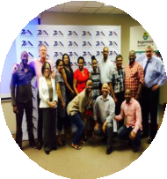

Annual Report 2015/2016 23

Youth Development

From 14 to
31 Business
enterprises
developed

1 PCT, 4 provisional patents

From 17 to
24 Fully
functional
prototypes
completed

From 40 to
34 Projects
currently at
Tech
Stations for
prototyping

57
Applications
approved
for funding
9 Youth Technology Innovation Programme (YTIP) calls for
proposals to date

OUR MANDATE: Innovation in the public interest

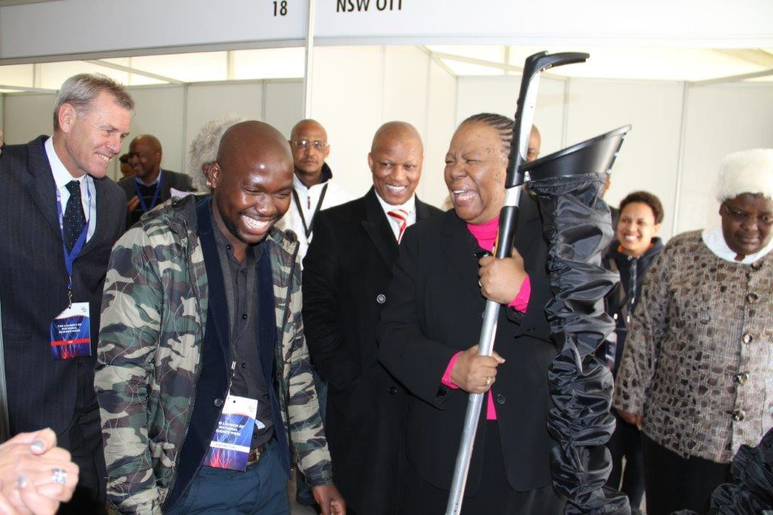

Annual Report 2015/2016 24

Thought leadership & Stakeholder
Engagements/ Partnerships

Annual Report 2015/2016 25

Thought Leadership & Partnerships

▪ The role of Venture Capital in technology venture
creation

▪ Advanced Manufacturing Technology road-map

▪ Technology Stations Programme impact assessment
model with NACI

▪ Partnerships with SEDA and ATNS

Annual Report 2015/2016 26

Supporting the African Agenda

Key partnership activities agreed for implementation include:

a) Institutional Capacity Development through knowledge exchanges on Intellectual Property management; technology and commercialization and M&E

b) Collaborative technology development initiatives from joint research
projects undertaken with the NRF

a) Market access opportunities for the technical services provided by the
Technology Stations

b) Technical Cooperation on replication of the Technology Stations business
model in various African partners

Annual Report 2015/2016 27

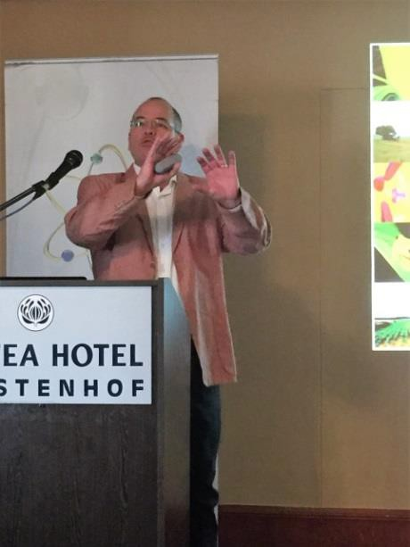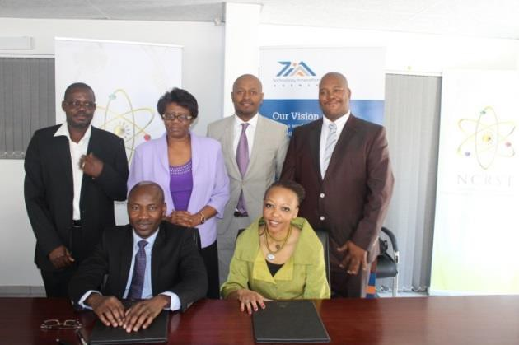
Supporting the African Agenda

TIA engaged 4 African countries in 2015/16:
Tanzania ₒ Angola ₒ Namibia

MoU with Namibia’s Commission on Research Science and Technology (NCRST)

• Joint review of research projects for technology development
• Knowledge exchange on commercialization and
Intellectual Property (IP) management
• Establishment technology station, start-ups and
incubation services
• Training on Technology Management for
government institutions

Dr Hennie Groenewald, the Executive Manager of Biosafety South Africa presented on “Public awareness of GMOs from a South African perspective: Risk analysis as a basis for sound decision making,” to share regulatory
best-practice and contribute to Namibia's implementation of GMO regulations

Annual Report 2015/2016 28

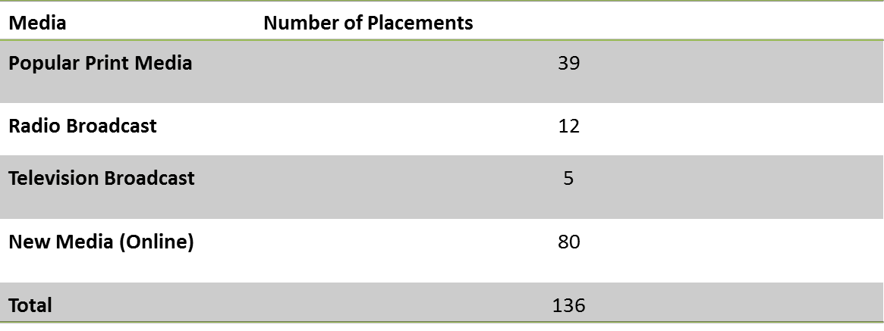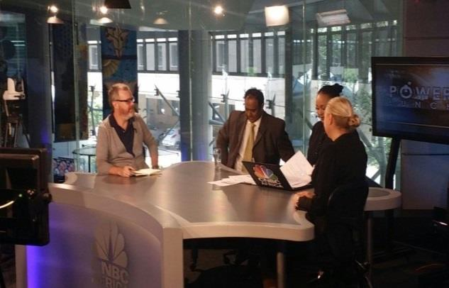Media Engagement

• TIA has emerged from common-place bad publicity arising from its past poor performance and the restructuring process
• Increasing positive reports about TIA, its projects, programmes and activities
• A total of 136 positive stories with Advertising Value Equivalent (AVE) of
R7 531 761
• Programmes on skills development, Technology Stations and the Seed
Fund have attracted most attention
• Nil negative reports for the year

Annual Report 2015/2016 29

Voice Of The Stakeholder
“Customer Centricity – Our Reason for success
or failure”

Annual Report 2015/2016 30

Overall satisfaction

The provision of great service and support is typically the biggest driver of satisfaction amongst satisfied stakeholders of the TIA. Also contributing to satisfaction, according to Support Institutions are the staff and leadership of the TIA. Turnaround times and a lack of communication appear to be key drivers of dissatisfaction

Drivers of satisfaction Drivers of dissatisfaction

Innovators, Researcher, SMMEs Support Institutions
Innovators, Researcher, SMMEs Support Institutions

Great service & support

29%
43%
Unsatisfied with service in general
24%

21%

Satisfied with service received in general

Good Communication

Friendly & helpful staff and leadership

12%

12%
20%

19%

29%

25%

Delays & Long turnaround time

Unresponsive / Poor communication

Incompetent Staff & Leadership

13%

9%

11%

17%
24%

21%

n=299
4% Great improvement
3%

n=299
5% Room for improvement

30%

SOURCE: Genex Insights 2016

31

Conclusion & Recommendations (I)

The overall satisfaction rating of 5.7 out of 10, is low. Notably, this score is influenced negatively by those who have been denied funding, however even amongst those who have been successful in their applications, the score remains fairly low at 6.1 out of 10. Evidence suggests that the TIA should target a score of 7.5

For the most part, stakeholders agree that the TIA is governed by good leadership principals and strategies, however there is a breakdown in the execution and implementation of this strategy which leads to poor service delivery. However considerable change in organisational staffing is apparent. and pockets of improvements were starting to emerge.

Recommendations

1 Turnaround times – Improvement of operational turn-around times

2 Communication and feedback - Providing regular communication & feedback

3 Adequate notice for submission of further information to avoid delays in processing applications

SOURCE: Genex Insights 2016

32

Business Performance

Annual Report 2015/2016 33

Year On Year Performance

Audit Outcome

3rd Party

Funding

SMMEs Assisted

Knowledge Innovation Products

Youth Projects

Seed Fund
Projects

Funds Disbursed

2013/14

Unqualified

R74.4m

1904
----
27

43

70

R374m

2014/15

Clean Audit

R200m

2188

38

37

145

R373m

2015/16

Clean Audit

R97m

2197
----
76

52

275

R379m

Annual Report 2015/2016

Overall Business Performance

Overall KPI performance

SO 1: To provide customer-centric technology development, funding and support

SO 2: To provide and enabling environment for technology innovation in collaboration with other role players

SO 3: To develop an effective and efficient internal environment to successfully execute the strategy
93%

100%

100%

80%

Annual Report 2015/2016 35

Performance Highlights

R97 million attracted to TIA’s portfolio from 3rd parties
2197 SME’s receiving support from Tech Stations and the Institute for Advanced Tooling

76 Knowledge innovation products supported
27 Technologies reaching demonstration

8 Knowledge innovation products receiving follow- on funding

9 Technologies taken up by the market

Annual Report 2015/2016 36

Financial Performance And
Governance

Annual Report 2015/2016 37

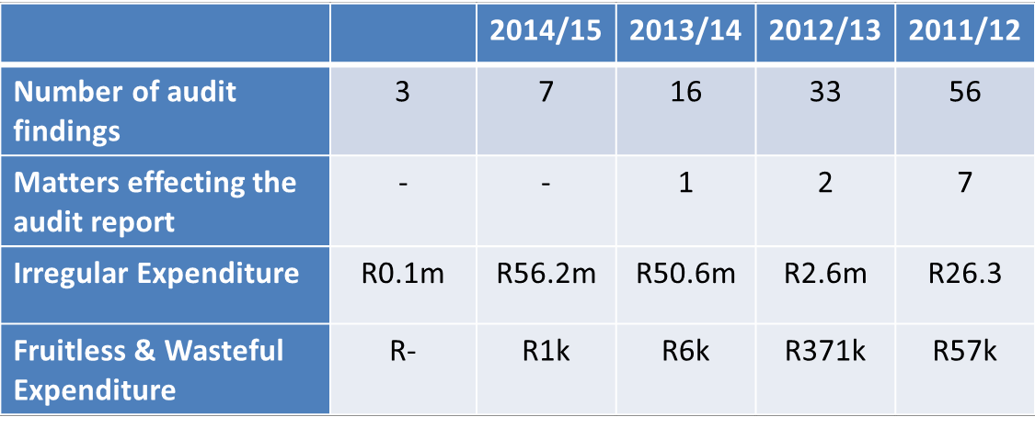2015/16 Audit Results

• Unqualified audit opinion, clean audit
• Findings 3 (2014/15: 7)
• Increased focus on internal audit findings (Included in
Performance management contracts and disciplinary action
taken)

Annual Report 2015/2016 38

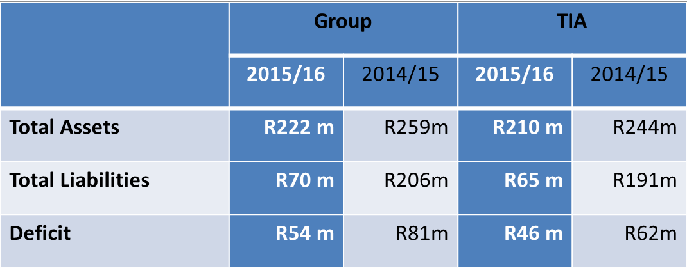TIA Group Results

Consolidated results include:

• 6 Subsidiaries (Control and > 50%
shareholding)

• 28 Associates (Less than 50% and > 20%)

• One minor investment of R 26 million

Annual Report 2015/2016 39

MTEF And DST Contracted (R'OOO)

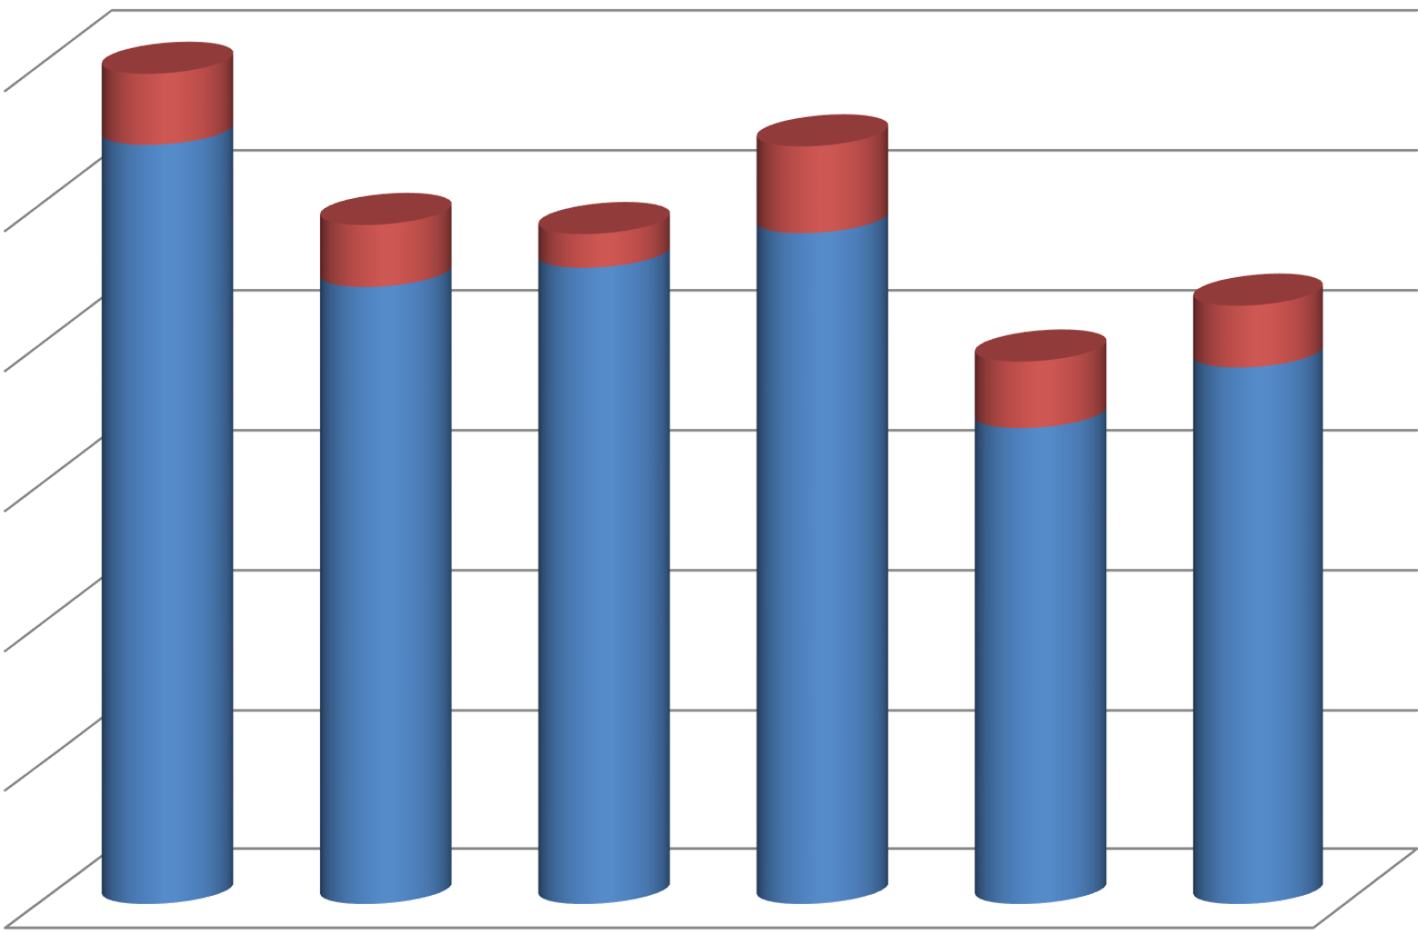600,000

500,000

400,000

300,000

200,000

100,000

2010/11 2011/12 2012/13 2013/14 2014/15 2015/16

•Parliamentary grant •Specific contracted

Annual Report 2015/2016

90,000

80,000

70,000

60,000

50,000

40,000

30,000

20,000

10,000
Other Income (R'OOO)

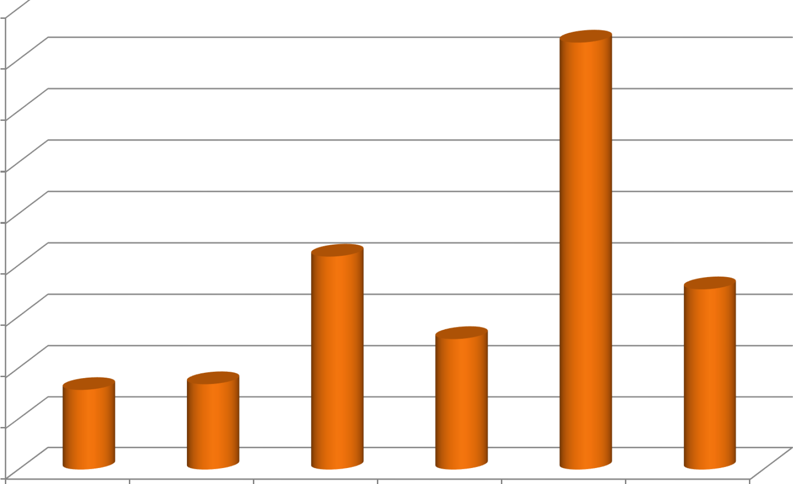
2010/11 2011/12 2012/13 2013/14 2014/15 2015/16

Annual Report 2015/2016

600,000

500,000

400,000

300,000

200,000

100,000
Project Funding (R'OOO)

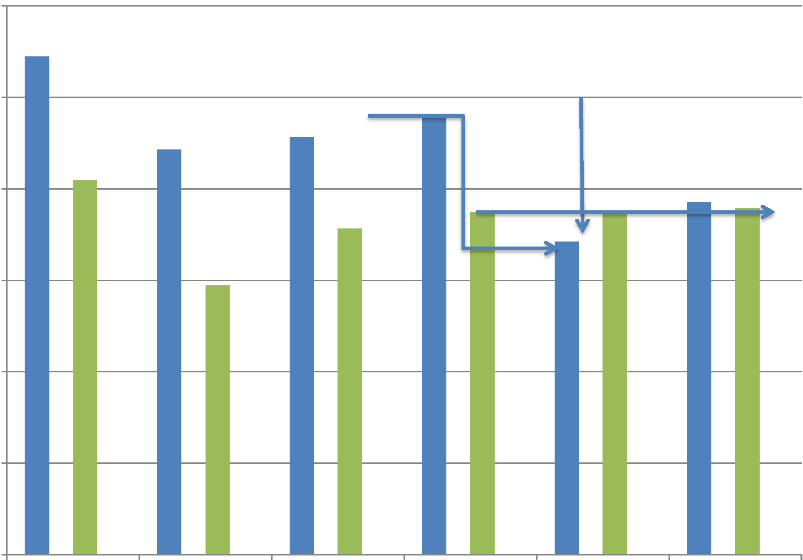2010/11 2011/12
2012/13 2013/14 2014/15

Annual Report 2015/2016
2015/16

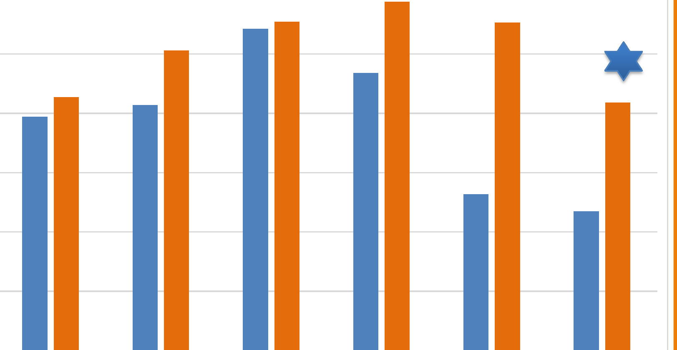

140,000

120,000

100,000

80,000

60,000

40,000

20,000
Admin and Employee Costs

2010/11 2011/12 2012/13 2013/14 2014/15 2015/16

•Administrative expenditure •Employee related expenditure

Annual Report 2015/2016

Efficiency Ratio

40%

38%

38%

38%

36%
36%

34%

32%

30%
30%

29%

26%

24%

22%

20%

2010/11 2011/12 2012/13 2013/14 2014/15 2015/16

Activity-based costing reveals and efficiency ratio of 14%
Annual Report 2015/2016 44

Surplus/(Deficit)

30,000

20,000

10,000

-
2011/12
-10,000

-20,000

2012/13
2013/14

2014/15

2015/16

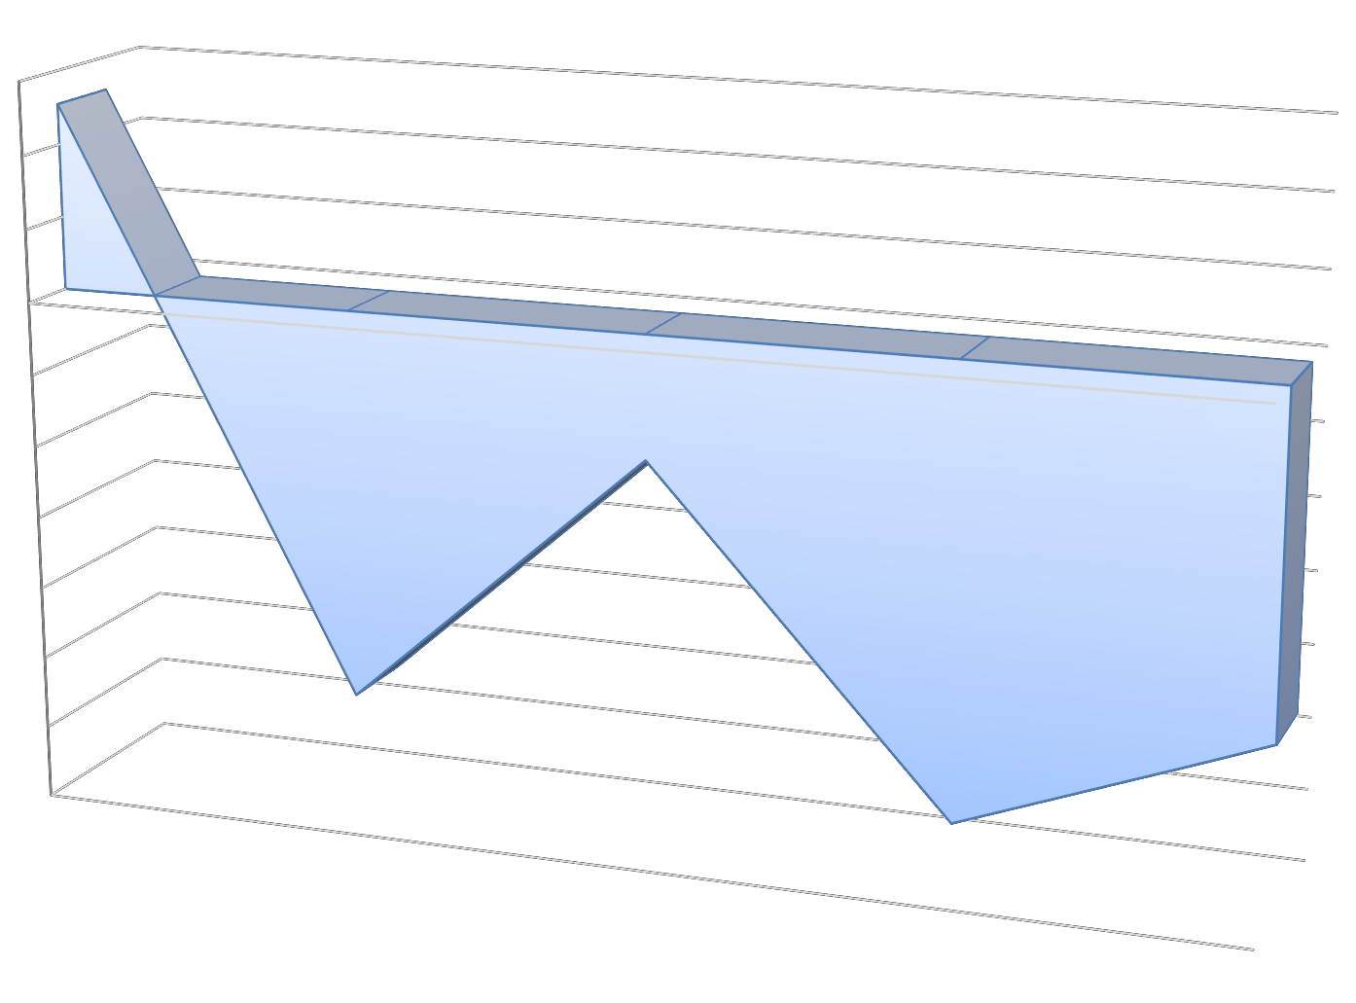
-30,000

-40,000

-50,000

-60,000

-70,000

Annual Report 2015/2016 45

Economic Impact Assessment

Grand Total
Production (Rm) | 8 383,8
GDP (Rm) | 4 096,3
Employment (Number) | 14 022
Income (Rm) | 1 968,2
Taxes (Rm) | 171,8
Production Multiplier | 2,87
Beneficiaries (Number) | 3 651
Estimated Leveraged Funds  (Rm) | 372,3
Successful Investments  Revenue (Rm) | 5 953,7
Royalty Amount Received (Rm) | 18,9

Annual Report 2015/2016 46

Strategy Development Process

Annual Report 2015/2016 47

High Performance Values

“T”

Teamwork

Promoting teamwork internally within TIA and within the greater NSI
“I”

Impact

Responding fully and effectively to the TIA mandate so as to positively impact on the economy as well as in the lives of our people
“A”

Accountability

Accountability both in terms of meeting expectations as well as ensuring optimal governance and compliance standards

Annual Report 2015/2016 48

Strategic Evolution Phase 1 - FY17/20

Performance
Analysis

Calibration of Organisational and Individual
Key Performance Indicators

Intelligence
gathering Tracking and evaluation for the progression
of ideas within the NSI

Impact
Analysis

Measurement of socio-economic return
generated from operations

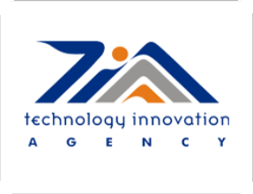

Enhance
Internal
Capacity Develop competency framework, adopt staff
retention policy and stimulate a high
performance culture
Annual Report 2015/2016 49

FY2017/18 Operational Impetus

Scale

Increase the scope of technology development interventions by leveraging on synergistic relationships within the
Teamwork
NSI in a bid to
optimise
resources and
achieve a
broader
impact in
addressing
the triple
threat
challenge
Pace

Improve the speed and agility in responding to articulated and unarticulated needs of our customers in supporting technology development to enable ideas to progress
Impact
along the value chain.

Space

Deepening our commitment to be more accommodative and
Accountability

transparent when engaging with innovators, stakeholders
and suppliers

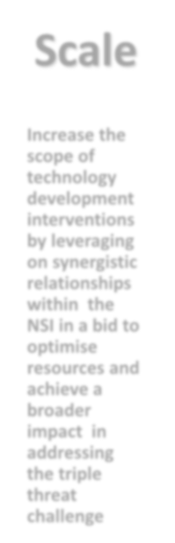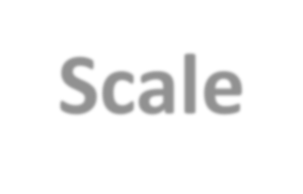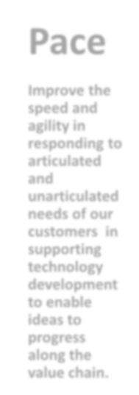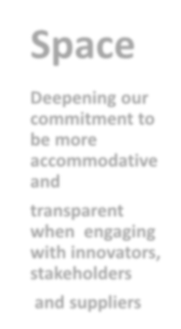

Annual Report 2015/2016 50

Targeted Interventions

SUMMARY OF
IMPROVEMENTS
4 Month turnaround time for investment process
– application to approval (from 18 months)

7 days turnaround time for contracting of investments (from 3 moths)

3 days turnaround time for vendor payments
(from 90 days)

Organisational and Individual Performance calibration and alignment exercise completed.

Ongoing business system and process integration

Review and improvement to current funding instruments

Annual Report 2015/2016 51

Focus Areas Over The MTEF Cycle
FY17/18 – FY19/20

Shareholder

- 10 year White Paper on
Science and Technology

- R&D led Innovation

- Technology Localisation
Programme

- Sector Innovation Fund

Stakeholder

- Creation of a Glass Pipeline

- Customer Experience
Journey Mapping

- Stakeholder Charter

- Inter-Governmental Relations ( Hub and Spoke model)

- International partnerships

Technology Landscape

- 4th Industrial Revolution

- Rapid Funding Instruments

- Future of Growth: Technology Driven and Human Centred.

Annual Report 2015/2016 52

Thank You

Siyabonga

Dankie

Annual Report 2015/2016 53

