Presentation to
Parliamentary
Portfolio Committee
on Science and
Technology

20 October 2016

ANNUAL REPORT 2015-2016

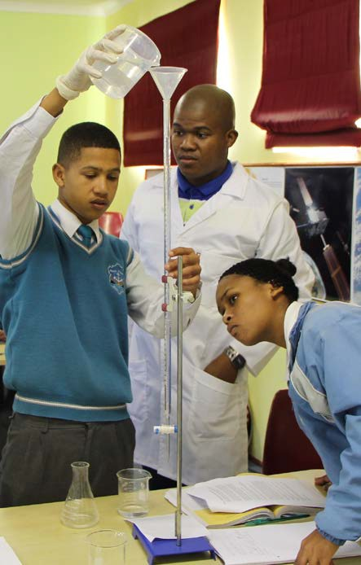

PART 1: Overview and Governance PART 2: Impact of space on our lives PART 3: Entity Performance
PART 4: Financial Performance

Mandate 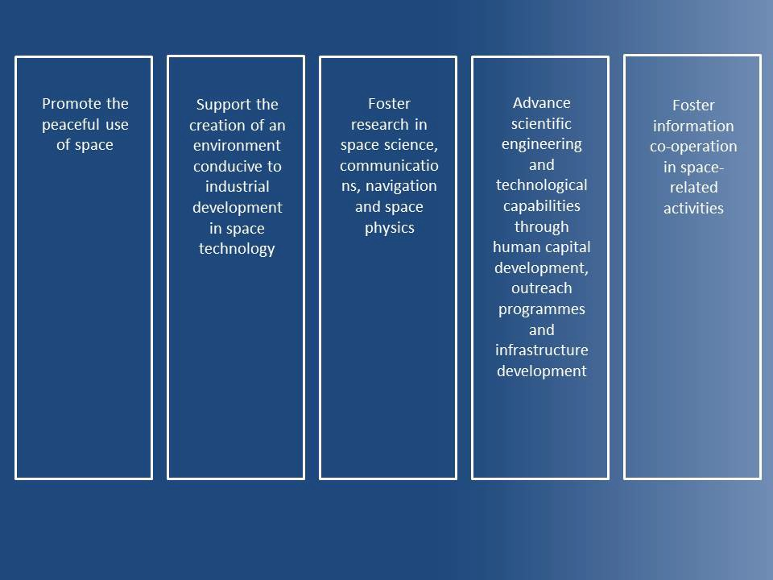

Mission

We will achieve our vision by leading and inspiring the South African space community to create a better future.

I

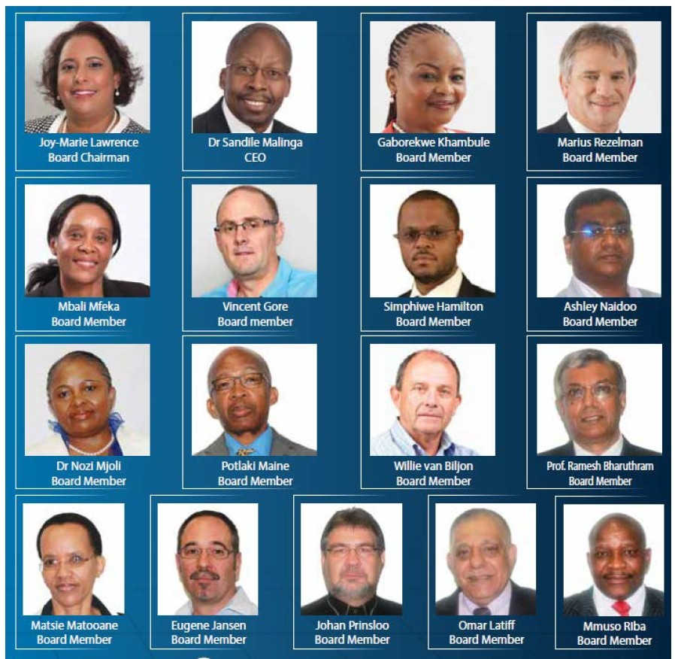science
& technology
Department:
Science andTechnology
REPUBLIC OF SOUTH AFRICA 3

Percentage

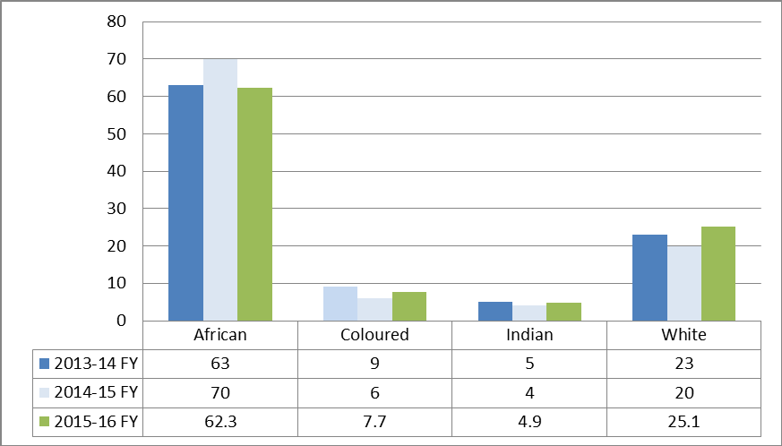

• Permanent Employees: 160
• Temporary Employees: 23
• Grand Total: 183
4

African
Coloured

100
80
60
40
20
0
 |  | Male | Female
 | •2013-14 | 7 | 6
 | • 2014-15 | 6 | 8
 | •2015-16 | 6 | 7

100
80
60
40
20
0

Male Female

• 2013-14 69 41
• 2014-15 74 41
• 2015-16 69 43

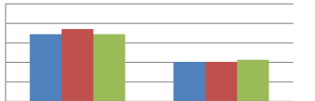White
Indian
80
60
40
20
0
 |  | Male | Female
 | • 2013-14 | 7 | 2
 | • 2014-15 | 6 | 2
 | • 2015-16 | 7 | 2

100

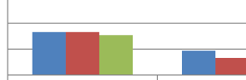100
80
60
40
20
0

• 2013-14 33 19
•2014-15 33 13
•2015-16 31 16

Iscience
& technology
Department:
Science and Technology
REPUBLIC OF SOUTH AFRICA 5

Corporate Support Programme
Board, ERM, Audit, Finance, SCM, PM&E, Stakeholder Management, ICT, Communications,
Facilities

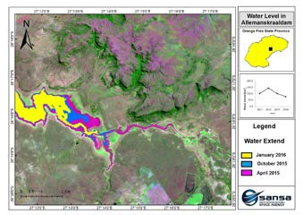Earth Observation
Programme

• Image acquisition
• Image distribution
• Value-added
services
• Value-added
products
Space Science
Programme
• Geo-space
observations
• Space physics
• Space weather
• EM
technologies
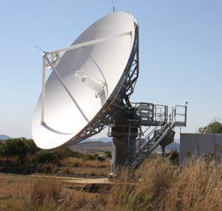

Space Operations
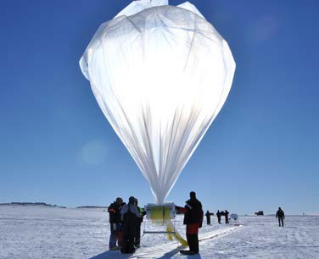Programme
• Launch support
• In-orbit testing
• Emergency
support
• Carrier
monitoring
6
• Hosting

Satellite Engineering
Programme
• Satellite
development
• Industry
development
• Technology
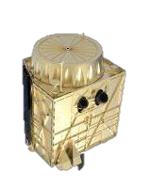development

science
& technology
7 Ar.!T a
Department:
Science and Technology
REPUBLIC OF SOUTH AFRICA
ACE AGENCY

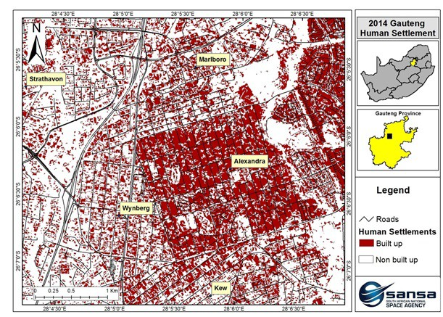
Improving Human Settlements

Addressing the urban housing challenges

Department of Human Settlements aims to eradicate the countries housing backlog and SANSA is providing satellite data through the Human Settlement Layers for South Africa to enable DHS to meet their goals.

• Data assists municipal decision-makers to plan and manage human settlements in urban areas
• Tool supports spatial planning and development policies for human settlements aligned to NDP, SPLUMA, etc

Contribution to

NDP
Outcome 8 & 9 of MTSF
Alleviation of poverty & inequality

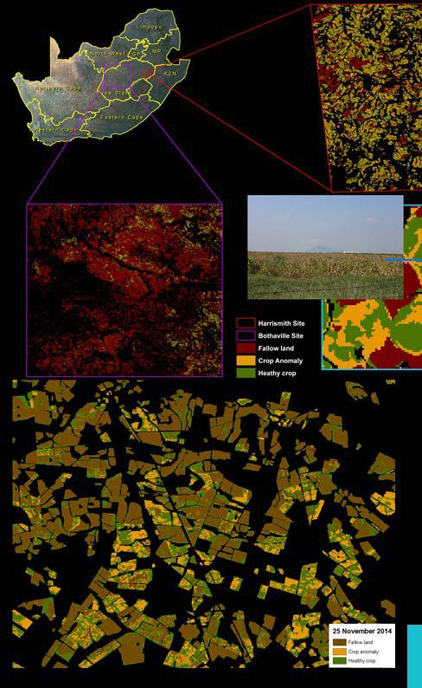
Enhancing Food Security

Monitoring and managing our food security

Department of Agriculture identified various food security challenges experienced by local farmers.

• SANSA produced biophysical variables under the Crop Watch for South Africa (CW4SA) project. This contributes near real- time information on field and crop conditions to farmers to manage crop health and yield as well as the land.

• A Drought Observatory was developed to provide a vegetation change visualisation tool

Contribution to

Outcome 7 of MTSF Alleviation of poverty, inequality & unemployment

Improving Water Management

Monitoring and managing our water resources

Department of Water and Sanitation uses satellite data from
SANSA to:
• regulate and monitor water usage in compliance with National
Water Act.
• Authorise and licence water use for irrigation and,
• Assess the status of small water bodies at municipal level

SANSA also provided Rand Water with products to monitor algal bloom as well as critical dam level information in Free State during the drought

Contribution to

Outcome 2 of MTSF Point 8 of Nine-Point Plan Alleviation of poverty & inequality

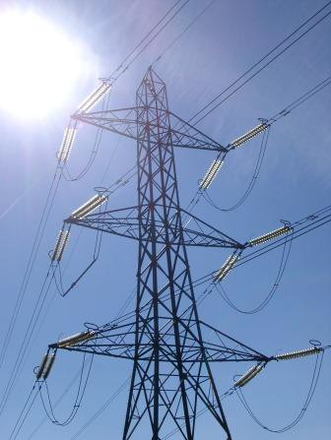
Ensuring Energy Security

Protecting the National Power Grid

SANSA ‘s products and services supports government’s energy solutions and the Agency contributes through the following:

• SANSA and Eskom have a MoU to protect the national power grid from potentially harmful space weather activity.
• MODIS data is supplied to CSIR AFIS on fire episodes that could impact on powerlines
• At Koeberg Power Station ,SANSA measures Geomagnetically Induced Currents (GICs), which could cause damage to power transformers and IPS instability
• SANSA researchers have developed a GIC proxy, based on solar wind measurements, to improve GIC prediction and thus mitigating devastating impacts on the power grid.

Contribution to
Point 1 of the Nine-point Plan Addressing inequality through access to energy

Ensuring National Security and Safety

Monitoring Land, Air and Marine Security

• Aligned with Operation Phakisa, an SBAS application was investigated for the maritime domain.
• SANSA developed a space weather information display system for the Maritime Control Centre at the Institute for Maritime Technology. This is to assist the South African Navy set communication paths for vessels at sea
• Provided the defence force with satellite imagery for defence intelligence
• Electric and magnetic signature management for the navy through IMT
• Space weather services for the SANDF for HF communication

Contribution to

Operation Phakisa
Point 8 of Nine-point Plan

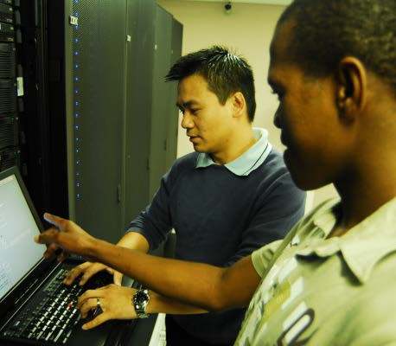
Creating Knowledge

• Understanding the space environment including the neutral atmosphere, ionosphere, magnetosphere, plasmasphere.

• Space weather applications for defence and aviation in line with ICAO recommendations to provide all passenger planes with space weather forecasts by 2017.

• Extensive maintenance and expansion of the geophysical research infrastructure platform including the installation of the Optical Space Research (OSR) laboratory in Sutherlands in partnership with DLR.

• High publication record in high-impact scientific journals.

Contribution to

NDP – Knowledge & skills Addressing inequality through skills development & knowledge

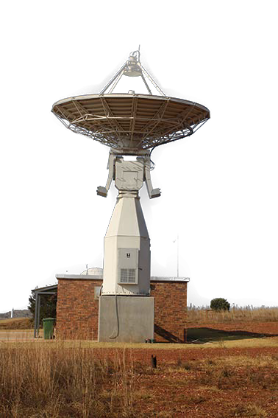
Technology, Innovation & Space Operations

• Magnetic ground support and signature management for the
Air-force and the Navy

• SANSA, in partnership with Avanti Communications has undertaken the SBAS-Africa navigation project which utilises satellite-based augmentation to improve aviation safety, precision farming, maritime security.

• SANSA installed an antenna for data collection for Spire, monitoring station for a Japanese company, monitoring station for Norway’s KSAT and new antenna system as part of the CNES CORMORAN project.

• Provided 25 transfer-orbit support services; 3 in-orbit tests; 3 drift supports; 1 launch support services; and earth station verification assistance.

• These activities contributed to global communication, navigation and science

Contribution to
Operation Phakisa
Point 8 of Nine-point Plan

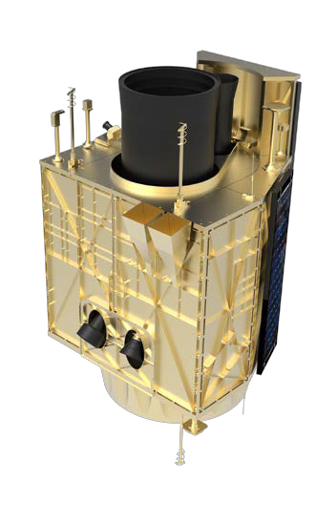
Satellite development

• Full optics procured together with the engineering sensor models

• Completed the power distribution units, on-board computer for satellite control, horn antenna prototypes for the X-band transmitter.

• Prototype reaction wheel developed

• Review of the preliminary designs of the satellite major components including magnetic sub-system interface

• Developed a detailed EO-Sat1 Implementation Approach, Funding Strategy and more accurate Full Lifecycle Costing

Contribution to
Africa’s space agenda African Resource Management Constellation (ARMC)

Performance against targets - Goal 1 ,2 & 3

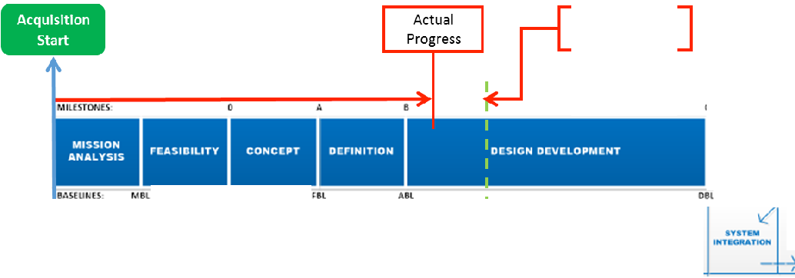 2014 2015 2016 2017 2018 2019 2020 2021

15 months behind schedule
FM Estimate
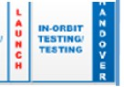Beginning 2020

0

FABRICATION I.
QUALIFICATION

COMM ISSIONI NG

UL PSL OSl

MISStoN NEi:D
..A&.V IS
IVITIM COHCI:,.TI IVAt..UAT'10N

CONCEP'f OEMONJ.TitAllOM &
YAUD.-noH NGtNI.....NO MANUfACTURINO Ot"."VILO NT
fVe'Kt-'
OUI\L .tcATKHI TU TIHG
LAUHCH
Pin-ORAnON' COMM...aiOft

I

science
& technology
Department:
Science andTechnology
REPUBLIC OF SOUTH AFRICA 16

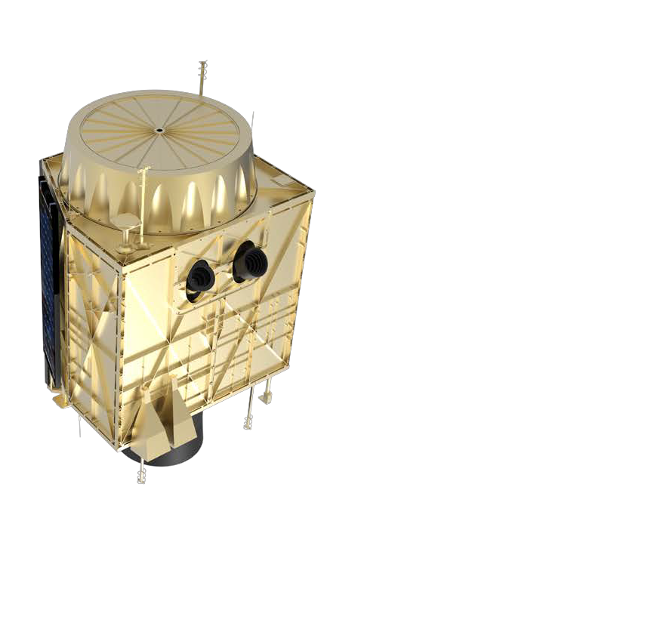
Industry development

• 53 jobs directly supported by the satellite programme with a
R94 million total outsourced to industry.

• A number of SMMEs have benefitted from the programme including the following
• Astrofica Technologies (100% Black owned; 50% Black
Woman Owned)
• Group 6 Technology & Infrastructure (75% Black
Owned)
• Luvhone Engineering & Consulting (100% Black Woman
Owned)
• Connecta (100% Black Woman Owned)

Contribution to

Points 7 of Nine-point Plan

17

Satellite Programme Funding Received - 2015/16

300

250

c 200
·e 150
a: 100

50

2012/13
2013/14 2014/15 2015/16
Total

•Satellite Development
16 49 70 91 227

•Incentive and Facilities Upgrade
28 30 58

Total Funds Received
16 77
70 122 285

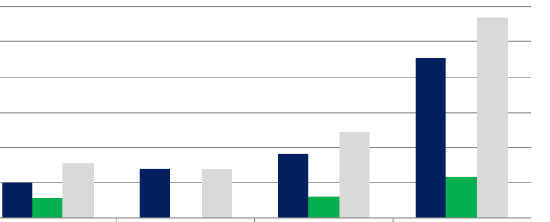Iscience
& technology
Department:
Science andTechnology
REPUBLIC OF SOUTH AFRICA 18

2J0
Contractor Expenditure - 2015/16

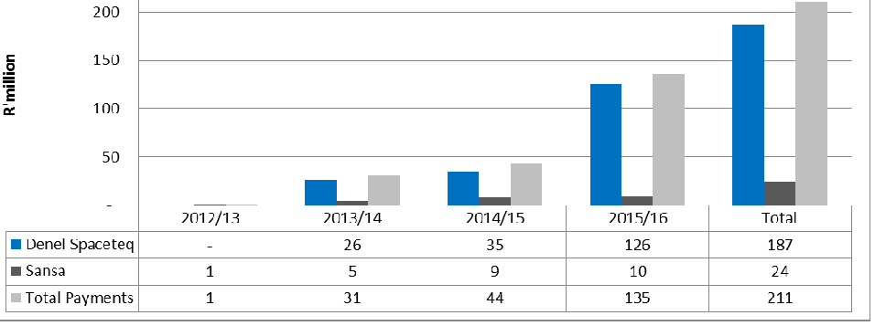Programme Expenditure - 2015/16

250

200

150
·e

-
2012/13 2013/14

I I .. IlL

c.: 100

0 ---
2014/15 2015/16 Total

•Sdlellile Segment 1
14 38 101 154

•Incentive Offer 2. 2. 14 24
• /\IT Facilities Upgrade 12 - 20 32
•Bursaries 0 0 0 1
•Total Programme Payments 1 31 44 13J 211

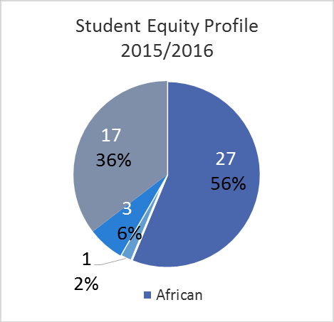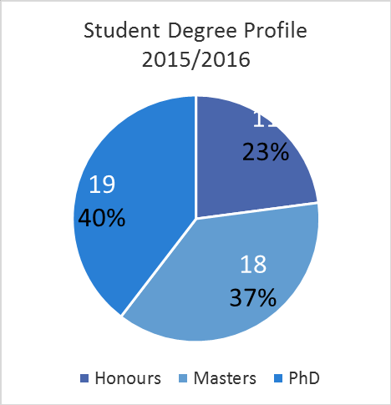Space Knowledge

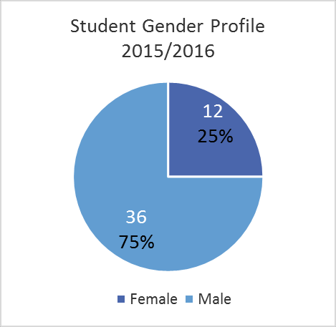
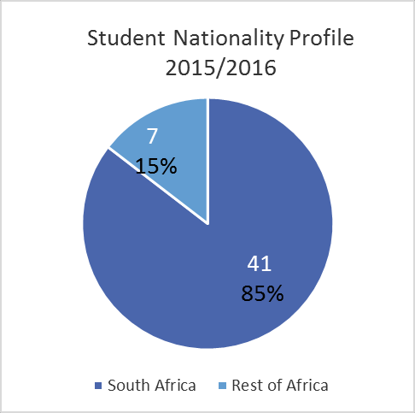

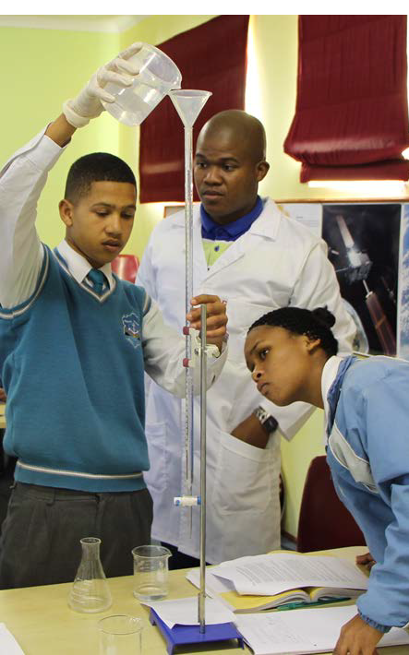
Promoting Science

• Directly engaged 15 347 learners in all nine provinces

• Supported the Women in Physics in South Africa (WiPiSA) – 24 female students from the University of Cape Town

• Annual School Holiday Programme

• SANSA Science Center activities

• Participation is Science Festivals and exhibits

Contribution to
Increased interest & uptake of science, engineering & technology

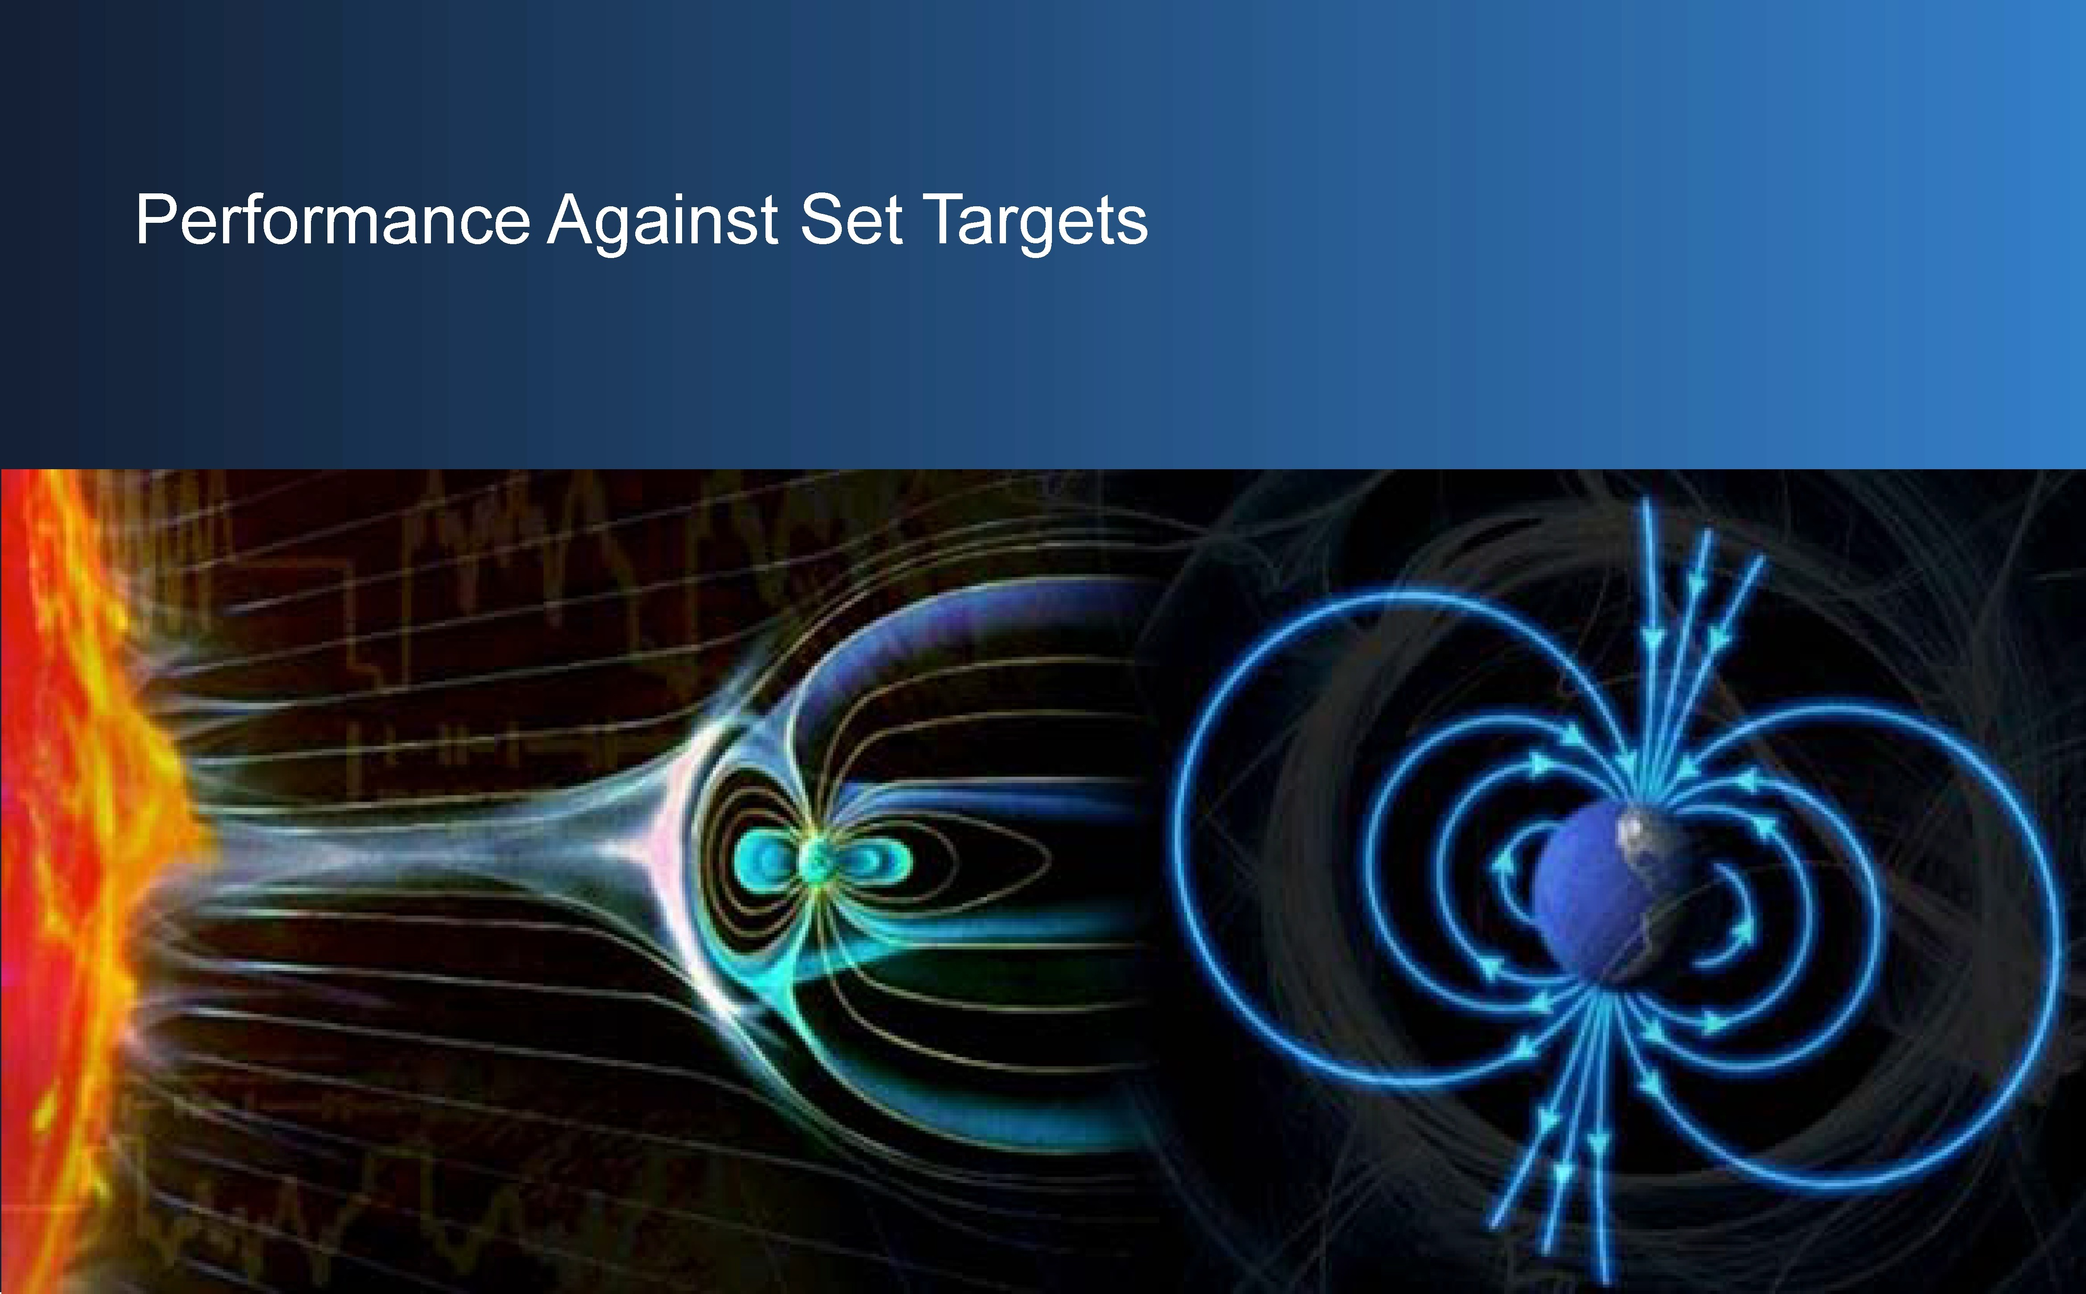

science
& technology
Department:
Science and Technology
REPUBLIC OF SOUTH AFRICA 22

.r.!T a
AcE AGENCY

Clean audit – three financial years in a row

KPI Annual
Target

Annual Actual

Goal 1

Address South Africa’s challenges through space services and products
T1.1. Four high-impact
national products and 4 4
applications

T1.2. Two government
policy support tools 2 2

Goal 2
Lead high-impact collaborative R&D on a national scale

T2.1 Achieve a research
productivity score of 750

750 1992

Goal 3

Develop national human capacity and ensure transformation
T3.1 Directly engage 8
000 young people 8000 18769

T3.2 Support 40
students
40 53

23

KPI Annual
Target

Annual Actual

Enhance the competitiveness of the South

T4.1.1 Successful satellite pass monitoring rate for earth observation
Actual 42686
Total 42833
97% 99.7%

Goal 4

African s pace industry
T4.1.2 Total income generated from space
operations activities

T4.1.3 Total amount of space operations
R58.3
million

R10.176
R77 million

money invested in other SANSA
programmes
million R20 million

T4.2.1 The number of direct jobs supported externally through SANSA programme contracting

40 53

T4.2.2 The progress status on the EO-Sat1
Goal 4 Enhance the competitiveness of the South development project
African s pace industry

25% 21%

T4.2.3 The total contract expenditure to
SMEs for core space projects
R2.4 million

R7.8 million

T4.2.4: The total contract expenditure out- sourced to the broad space related
industry for core space projects

R50 million R98.1 million

KPI Annual
Target

Annual Actual

Goal 5 Develop active global partnerships

T4.1 Global partnerships contribute an equivalent of 5% to the space programme revenue
Actual R 4 241 704.81
Total R 1 004 746 272

5% 2%

T6.1.1 Total SANSA income R223 million

R238 million

T6.1.2 Estimated annual monetised impact
R105 million

R299.6 million

Goal 6
Ensure the growth and sustainability of
SANSA
T6.1.3 SANSA’s public value awareness 50% 93%

T6.2 NSP implementation status of 30% 30% 52%

T7.1.1 Four initiatives that enhance
organisational performance 4 4

Goal 7 Transform SANSA into a high performance T7.1.2. Proportional (%) representation of
132

Agency
permanent staff from designated groups
in the top two management levels( Managers, senior manager)
65%
185

71%

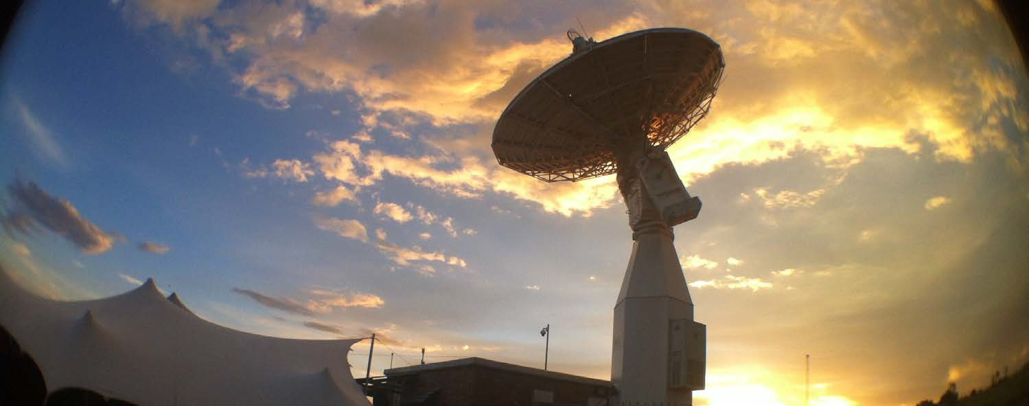

Statement of Financial Position

2016
R
2015
R

ASSETS

Current Assets 199397 438 145997762
cash andcash fqlivalents 178458539 123228549
Receivablesfrom ExchangeTransactions 18046991 17 443498
Receivablesfrom Non-fxdlangeTransactions 6.2 2540088 2«17214
Recetvallleheld on behaJriPrilcipal 18 2583090
lrwentory 351820 335411

Non-Current Assets 279597014 19288102
Propelty,Plant andEqupment 2578815881 164831024 1
lnoogible A5sets 9 21 715426 _ 28050Ml8

Total Assets 478994452 338879194

LIABILITIES

Current Liabilities 15555401] 125 425823
TradeandOlher Payables hom ExchangeTra nsactiOm 10 38281160 25195017
Proiisions 11 6961610 6160602
liabilty heldon behaJof Pmc: 18 lla!J483
ComrrittedCorditional Grant 12 82 335930 89146354
Currer< IU!ion -tongTerm Liabirty 13 5 891830 4588815
Currenr «UonciFinanceLease 14 102992
OperatingLeaseLiabiiy 14,1 232043

Non-Current Liabilities 5891799 91n6lo
Non -CurrentIUtion-toogTerrn Liability 13 58917991 9177630 1

Total Llabdltles 161445812 134603453

science NET ASSETS 317548640 204275 741
A<:currulatedSurpkJs 15 317 5486401 204 275741 1
& technology
a,
Department: Total Net Assets 317548640 204275 741
Science andTechnology

REPUBLIC OF SOUTH AFRICA 27
I
ACE AGENCY

600
Net Asset Value - 2015/16

500

400

300
R'million

200

100

-
 | 2015/16 | 2014/15 | Movement | % Movement
Total Assets | 479 | 339 | 140 | 41%
Total Liabilities | 161 | 135 | 27 | 20%
NET ASSETS | 318 | 204 | 113 | 55%

600

500

400
R' million

300

200

100

-

-100
Total Assets - 2015/16

2015/
16
2014/
15
Move ment
%
Move ment
%
Total
2016
%
Total
2015

Current Assets 199 146 53 37% 42% 43% Property, Plant and Equipment 258 165 93 56% 54% 49% Intangible Assets 22 28 -6 -23% 5% 8% Total Assets 479 339 140 41% 100% 100%

Key Projects/Assets Satellite dev - R146m SPOT Terminal - R22m

180
160
140
120
100
R' million
80
60
40
20
-
-20
Total Liabilities - 2015/16

2015/16 2014/15 Movement % Movement

% Total 2016 % Total 2015

Current Liabilities 156 125 30 24% 96% 93% Non-Current Liabilities 6 9 -3 -36% 4% 7% Total Liabilities 161 135 27 20% 100% 100%

Statement of Financial Performance

REVENUE
Revenue fromNon-exchangeTransa<tlons
Transfersand SLtlsidies Received

Revenue fromExchangeTransactlons

lntetest Income Rendeli:lg c:iServices Othet lncome
Net Gains/lossesonIOreignexchange transaarons

TotalRevenue

EXPENDITURE
Employee Related Costs Board Member Remuneration Depreciation andArrortisation Impairmentof Intellectual Property RepairsandMaintenance FinanceCosts
Oatl Licencefees GrantsandSubsidies Paid Antenna lnfliiStruCtUie Services Training Expenses GeneralEl<pEflSeS
Net Losses on IOreigr exchange transactionS
Loss on Disposal c:iPropertyP, lant andEquipment

TotalExpenditure
2016 2015

R R

17 232441074 163585 721

16 8394522 5579000

30 96828618 67681 755

19 9398(8 668054
28 2179815

338604032 239694425

20 96046176 93019880

21 914 270 650119

22 25097187 22902663

22 1440000

8355117 7 586042

23 10202 49680

31 31406738 26729023

24 3622 398 2672002

25 4146811 1102997

26 1mro2 I 578863

27 47378832 50160312

28 5470529

29 1149071 149771

225331133 208041 352

Iscience

SURPWSFOR THE YEAR'

113272899 31653073

& technology
Department:
Science andTechnology
REPUBLIC OF SOUTH AFRICA
E!. a
31 ACE AGENCY

Revenue and Transfers received - 2015/16

450

400

350

300
R' milliom

250

200

150

100

50

–
2011/12 2012/13 2013/14 2014/15 2015/16 % Total
Parliamentary Grant 104 106 112 118 124 32% Ring Fenced Transfers 28 28 69 70 154 39% Self generated revenue 68 82 81 82 112 29% Total revenue and transfers received 200 216 262 271 391 100%

300
Transfers - 2015/16

250

200

150
R' million

100

50

–

(50)
 | 2011/12 | 2012/13 | 2013/14 | 2014/15 | 2015/16 | % Total
Parliamentary Grant | 104 | 106 | 112 | 118 | 124 | 32%
% Growth |  | 2% | 6% | 6% | 5%
Ring Fenced Transfers | 28 | 28 | 69 | 70 | 154 | 39%
Total Transfers | 132 | 134 | 181 | 188 | 278 | 71%
% Growth |  | 0% | 144% | 1% | 120%

120
Contract Revenue - 2015/16

100

80

60
R' million

40

20

–

(20)
 | 2011/12 | 2012/13 | 2013/14 | 2014/15 | 2015/16 | % Total
Foreign Contracts | 38 | 45 | 52 | 39 | 67 | 17%
Local Contracts | 19 | 27 | 19 | 31 | 30 | 7%
Research Grants | 7 | 4 | 4 | 4 | 6 | 2%
Contract Revenue | 63 | 76 | 76 | 74 | 103 | 26%
% Growth |  | 21% | -1% | -2% | 39%
Interest and Other income | 5 | 6 | 6 | 8 | 9 | 2%
% Growth |  | 27% | -1% | 44% | 11%

400

350

300

250
R'000

200

150

100

50

-
 | 2011/12 | 2012/13 | 2013/14 | 2014/15 | 2015/16 | % Total
Compensation of Employees | 56 | 63 | 76 | 94 | 97 | 29%
Goods and Services | 99 | 114 | 123 | 114 | 128 | 38%
Payments for Capital Assets | 11 | 32 | 47 | 87 | 114 | 34%
Total Expenditure | 167 | 209 | 246 | 296 | 339 | 100%

Expenditure by Economic Classification - 2015/16

400
Expenditure by Programme - 2015/16

350

300

250
R' million

200

150

100

50

-
 | 2011/12 | 2012/13 | 2013/14 | 2014/15 | 2015/16 | % Total
Corporate Support | 41 | 38 | 37 | 44 | 40 | 12%
Earth Observation | 47 | 57 | 56 | 97 | 85 | 25%
Space Operation | 30 | 58 | 86 | 74 | 68 | 20%
Space Science | 34 | 38 | 39 | 36 | 41 | 12%
Space Engineering | 15 | 18 | 28 | 44 | 105 | 31%
Total Programme Expenditure | 167 | 209 | 246 | 296 | 339 | 100%

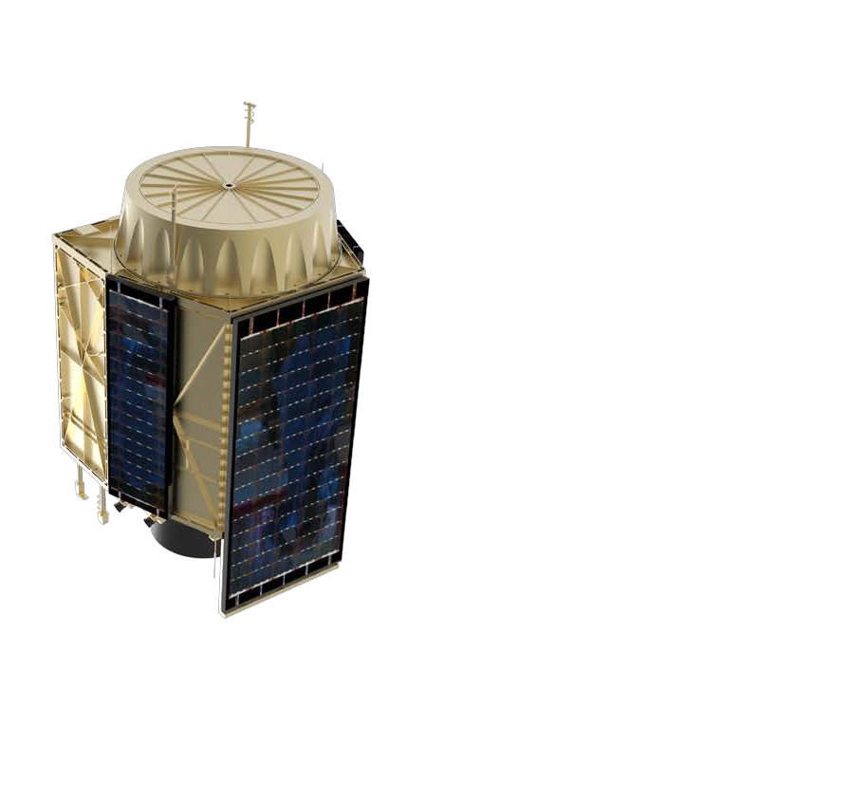
Key Issues

• Progress on the EO-Sat1 Programme

• Funding for the EO-Sat1 Programme

• Progress on the Institutional Development Plan

• SANSA Base funding

• Progress on CEO Appointment

Acronyms
MTSF | Medium Term Strategic Framework
MoU | Memorandum of Undertsanding
NDP | National Development Plan
NSP | National Space Programme
OSR | Optical Space Research
PM&E | Performance Monitoring and Evaluation
SANDF | South African National Defence Force
SCM | Supply Chain Management
SPLUMA | Spatial Planning and Land Use Management Act

CW4SA | Crop Watch 4 South Africa
DHS | Department of Human Settlements
DLR | German Space Agency
EM | Electro Magnetic
ERM | Enterprise Risk Management
GIC | Geomagnetically Induced Currents
HF | High Frequency
ICAO | International Civil Aviation Organisation
ICT | Information Communication Technology
IMT | Institute of Maritime Technology

37

