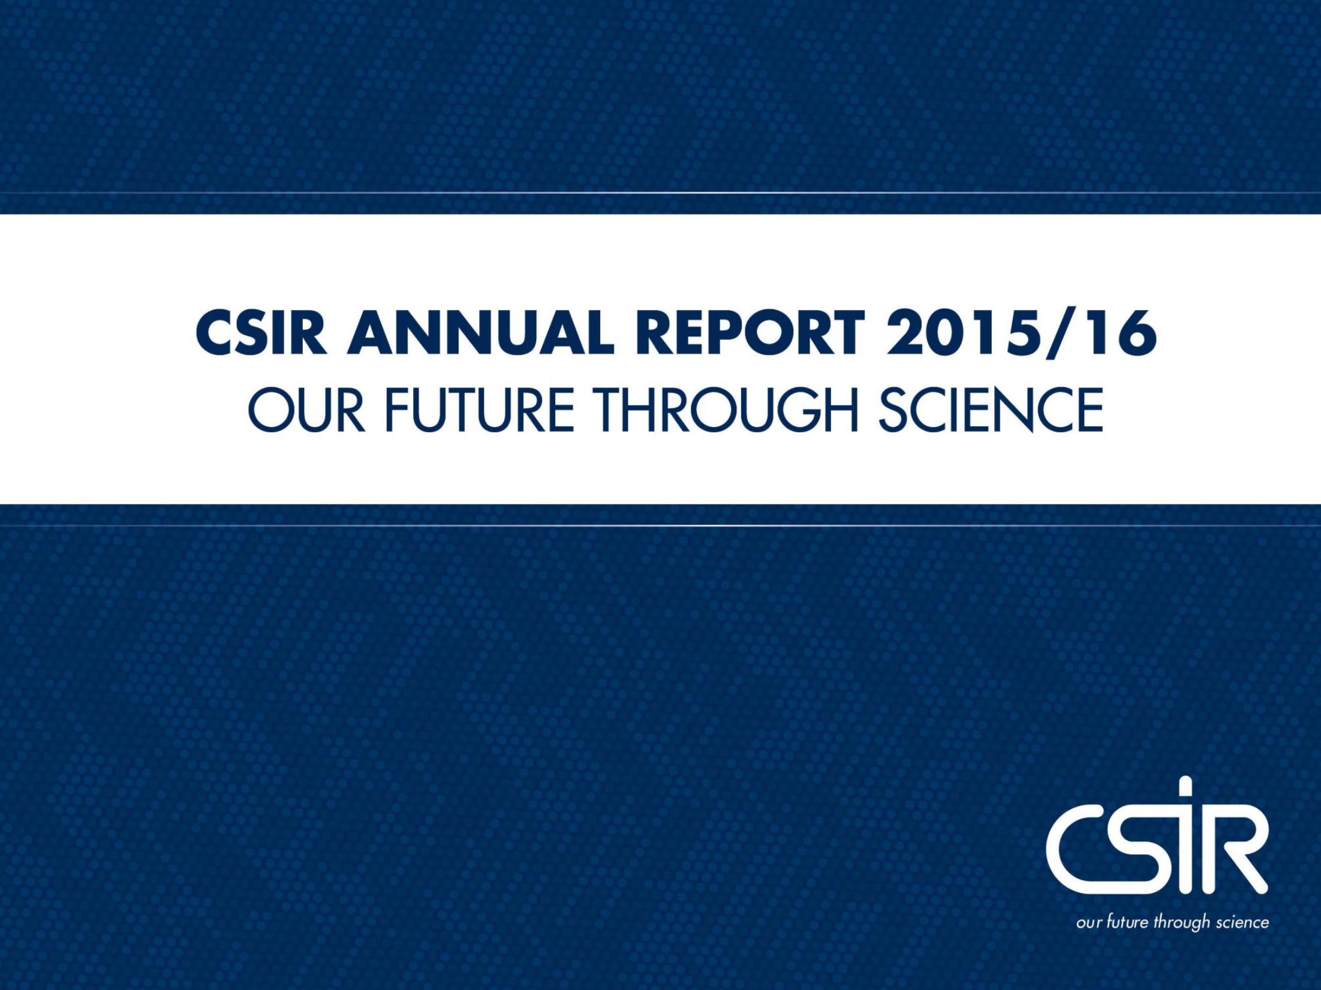

Presentation to the parliament portfolio committee
on science and technology

20 October 2016

Contents

ABOUT US

1. CSIR Overview
• National context
• Strategic context objectives
• CSIR at a glance

2. Key performance indicators
• Scientific and technical
• Learning and growth
• Financial and governance

3. Research, development and implementation in response to national priorities

2

Our response to the triple challenge of
poverty, inequality and unemployment

ABOUT US

• Our imperative is to identify key determinants of poverty, inequality and unemployment and draw the link between our research work and addressing these determining factors.

• The key issues that we seek to address through various interventions are:
- The economy and employment
- Building a capable state
- Economic and social infrastructure
- Transforming human settlements
- The transition to a low-carbon economy
- Building safer communities
- Improving health

3

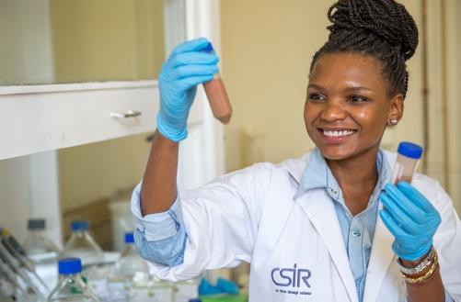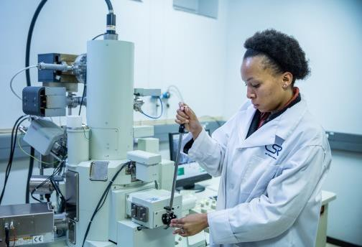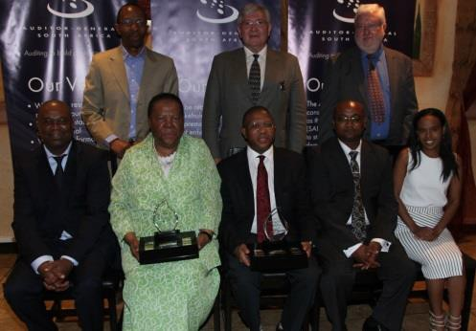CSIR strategic objectives

ABOUT US

Conduct high-quality and relevant research and technological innovation to foster industrial and scientific development

Build and transform human capital

Maintain financial sustainability and good governance

CSIR at a glance

ABOUT US

• The CSIR is a science council, classified as
a national government business enterprise

In numbers:

Pretoria

71yrs

2 685 345
Johannesburg

Durban

1945 - 2016 Total staff

SET base with PhD

Cape Town

Stellenbosch Port Elizabeth

516 R2.7 bn 1 969

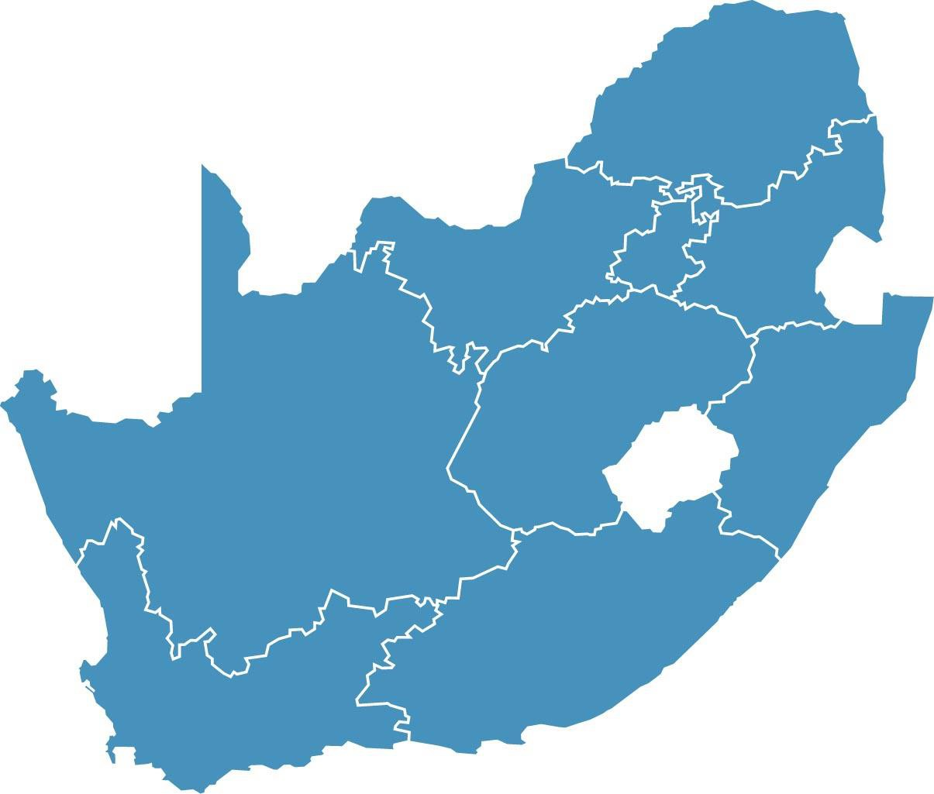

5
Publication equivalents

5
Total operating income
Total in SET base

KEY
PERFORMANCE INDICATORS

Key performance indicators at a glance

Scientific
OUR PERFORMANCE

Strategic objective Key performance indicator 2015/16 Target 2015/16 Actual

Publication equivalents ≥ 490 516

Journal articles ≥ 300 340

and technical
Perform relevant research and development

New technology demonstrators ≥ 30 50

New patents granted ≥ 15 20

Contract R&D income ≥ R1 786 m R1 967 m

Royalty and licence income ≥ R7.4 m R5.2 m

Learning

Strategic objective Key performance indicator 2015/16 Target 2015/16 Actual

Total size of SET base 1 850 1 969

and growth

Build and transform human capital

% of black South Africans in SET base ≥ 57 59

% of female South Africans in SET base ≥ 34 35

% of SET base with Doctorates ≥ 18 18

Strategic objective Key performance indicator 2015/16 Target 2015/16 Actual

Investment in property, plant and equipment
≥ R113 m R308 m

Financial
and

Maintain financial
sustainability and

Total income ≥ R2 450 m R2 697 m

Net profit ≥ R54 m R59.2 m

governance
good governance

B-BBEE rating Level 2 contributor

Level 2 contributor

7 Disabling injury frequency rate < 0.3 0.11

OUR PERFORMANCE

The CSIR has met or exceeded the annual targets for five of the six indicators in
this category.R2.15 bn

Key performance indicator | 2014/15  Actual | 2015/16
 |  | Target | Actual
Publication equivalents | 502 | ≥ 490 | 516
Journal articles | 311 | ≥ 300 | 340
New technology demonstrators | 45 | ≥ 30 | 50
New patents granted | 18 | ≥ 15 | 20
Contract R&D income | R1 679 m | ≥ R1 786 m | R1 967 m
Royalty and licence income | R8.7 m | ≥ R7.4 m | R5.2 m

Trend in journal articles
Trend in cumulative patents

Trend in cumulative patents

Trend in royalty
Trend in contract R&D income

Trend in royalty and licence income

Learning and growth

OUR PERFORMANCE

The CSIR has met or exceeded the annual targets for all seven indicators in this category.R2.15 bn

Indicator | 2014/15  Actual | 2015/16
 |  | Target | Actual
Total size of SET base | 1 869 | 1 850 | 1 969
Number of black South Africans in SET base | 1 042 | 1 050 | 1 164
% of SET base who are black South Africans | 55.8 | ≥ 57 | 59
No. of female South Africans in SET base | 628 | 630 | 692
% of SET base who are female South Africans | 33.6 | ≥ 34 | 35
No. of SET base with doctorates | 335 | 330 | 345
% of SET base with doctorates | 17.9 | ≥ 18 | 18

Trend in SET staff
Trend in doctorates

OUR PERFORMANCE

The CSIR has met or exceeded its target for all five indicators in this category.R2.15 bn

Indicator | 2014/15 Actual | 2015/2016
 |  | Target | Actual
Investment in property, plant  and equipment | R209.7 m | ≥ R113 m | R308 m
Total income | R2 385 m | ≥ R2 450 m | R2 697 m
Net profit | R52.4 m | ≥ R54 m | R59.2 m
B-BBEE Rating | Level 2  contributor | Level 2  contributor | Level 2  contributor
Disabling injury frequency rate | 0.04 | < 0.3 | 0.11

Trend in income streams
Trend in income streams
Investment in PPE

RESEARCH
PROJECT HIGHLIGHTS

Research, development and implementation

12
in response to national priorities

OUR WORK

• The key issues that we seek to address through various interventions are:

- The economy and employment
- Building a capable state
- Economic and social infrastructure
- Transforming human settlements
- The transition to a low-carbon economy
- Building safer communities
- Improving health

Economy and employment

Challenge
OUR WORK

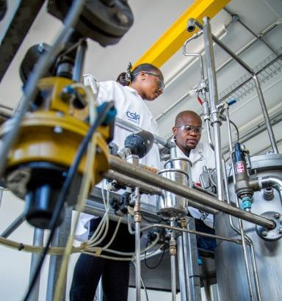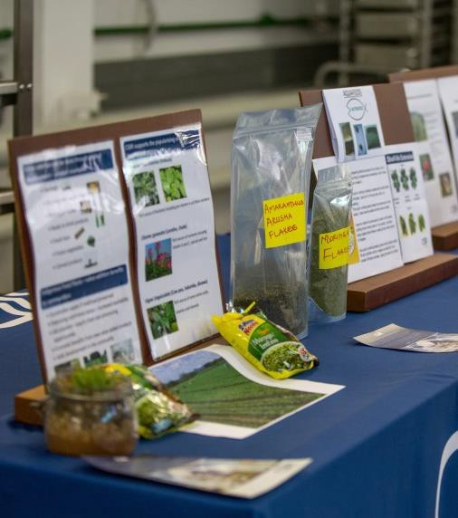• South Africa has an underdeveloped biomanufacturing industry and conversion of biosciences R&D into commercialised products and technologies is extremely limited

Research and development
• The Biomanufacturing Industry Development Centre (BIDC) was established to provide the skills and infrastructure to both industry and SMMEs in the sector in order to translate R&D into market- ready products and services

Outcome
• The BIDC has supported 19 enterprises (10 black women- owned), 16 owned by black entrepreneurs,
• Transferred 44 market-ready products to SMMEs
• 125 permanent jobs created in industry, SMMEs and value chains
• 180 temporary jobs created in SMMEs and value chains
• 181 beneficiaries trained through workshops
• 73 interns trained in BIDC vocational learning programme

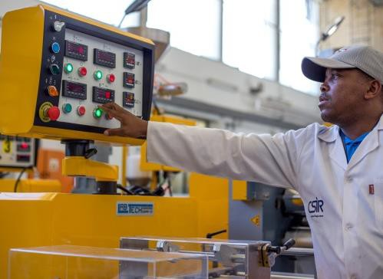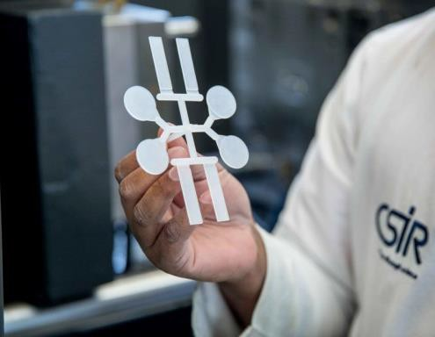Economy and employment

OUR WORK

Challenge
• Producing nanomaterials on an industrial scale to make the
SA industry more competitive

Research and development
• Research into the development of nanocomposites that can be used in the plastics, cosmetics and paint industries
• Researchers have modified nanoclay minerals by attaching various chemicals to their surfaces, which helps to integrate them with polymers and other substrates

Outcome
• Launched the DST-CSIR National Centre for Nano-structured Materials to enable research organisations and private sector enterprises to produce and test nanomaterials on an
industrial scale
• Partnerships with Greenfields and Amka on artificial turf and
homecare products
14

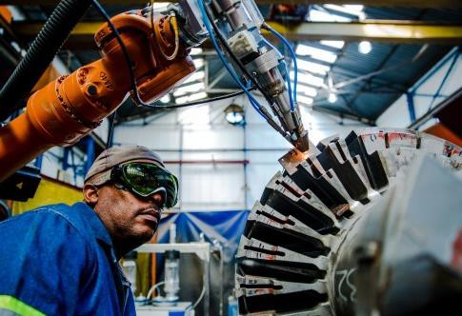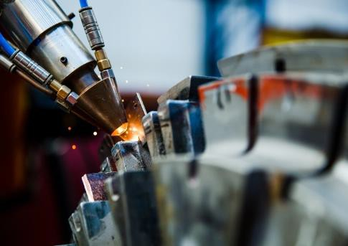Economy and employment

OUR WORK

Challenge
• Aging infrastructure and high cost of refurbishment
• Extending the life of industrial infrastructure

Research and development
• Used laser cladding technology to support local industries in servicing their high-value components thus extending their lifetime

Outcome
• Technology successfully used with Eskom to extend service life of Koeberg water tanks
• Technology saved the South African industry maintenance costs by at least 55%

15

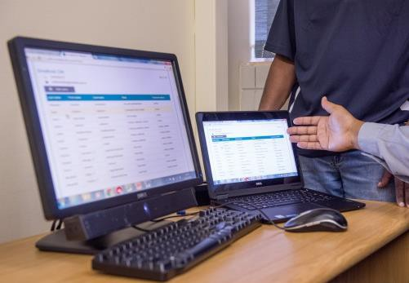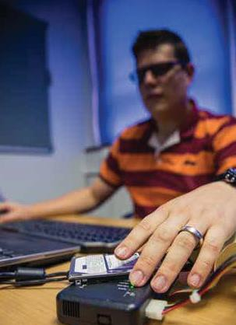Building a capable state

OUR WORK

Challenge
• Efficient service delivery in municipalities

Research and development
• Designed and developed web-based technology to help municipalities improve their turnaround times on service delivery complaints
• The system was piloted in the Amathole District Municipality in the Eastern Cape

Challenge
• Poor network security systems in municipalities

Technology intervention
• CSIR cyber security experts supported a municipality that had experienced an information network security breach
• Team conducted a penetration test (ethical hacking) to identify
several vulnerabilities in the municipality’s cyber infrastructure
• This helped the municipality to improve its network security
16

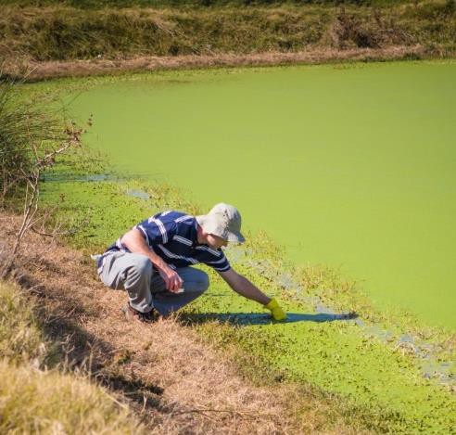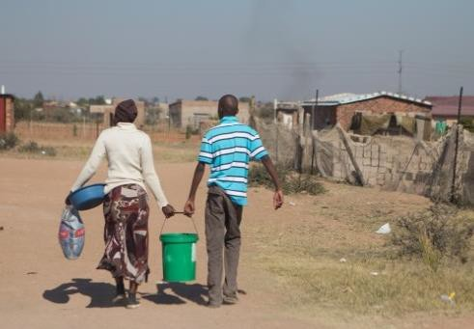Economic and social infrastructure

OUR WORK

Challenge
• Building new and conserving natural infrastructure for a
water-secure future

Research and development
• Installed an algae-based wastewater treatment project at
Motetema in the Sekhukhune District Municipality in Limpopo
• The treatment uses a specific community of algal species,
which have been isolated and cultured in the laboratory
• They create unfavourable conditions for pathogens and E. coli bacteria by increasing the pH level of the water

Outcome
• CSIR researchers are training pond operators on maintenance guidelines
• The success of this test case will lead to implementation in other municipalities

17

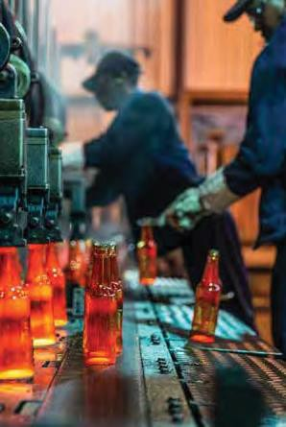Transitioning to a low-carbon economy

OUR WORK

Challenge
• Efficient energy use to improve industry competitiveness

Technology intervention
• Since 2010, the National Cleaner Production Centre, South Africa - hosted at the CSIR on behalf of the dti has saved companies R1.54 billion through the
implementation of the Industrial Energy Efficiency Project

• In 2015/16, the NCPC-SA assisted companies to achieve R75 million in resource savings and identified R232 million in potential savings through resource efficiency and cleaner production assessments

18

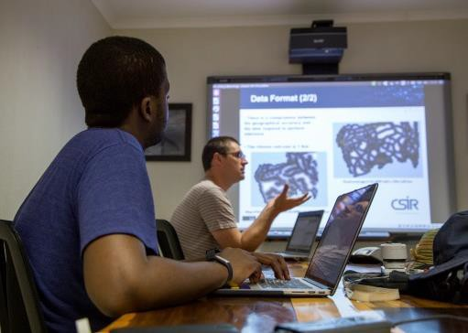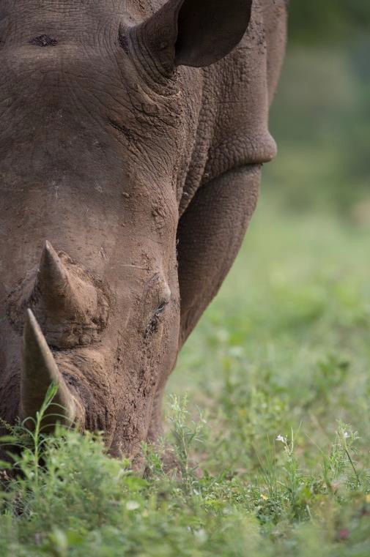Building safer communities

OUR WORK

Challenge
• Rhino poaching and associated crimes continue to be a challenge for
South Africa

Research and development
• A predictive modelling tool recently deployed to assist rangers in the Kruger National Park and other nature reserves to focus their resources on the areas where incursions were most likely to take place
• Other counter Rhino poaching initiatives include:
• Surveillance Systems (advanced day and night sensor and tracking systems; human movement, border crossing and the origin of gunshots.)
• Solutions for secure communication and intelligence sharing
• Systems integration, technical support and database development
• Reaction Ranger capability (weapon systems, training; canine
support requirements)
• Ranger Mobility (e.g. all terrain vehicles)
• Behavioural science research on impact of combat stress on
19 rangers

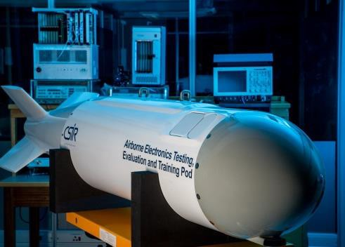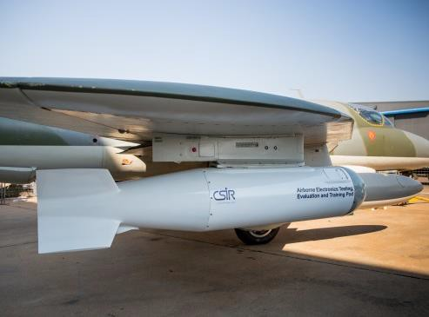Building safer communities

OUR WORK

Challenge
• Gap available in flight systems test performance
• Building and maintaining national capabilities in radar and electronic warfare

Research and development
• Developed a multipurpose electronics pod that evaluates and tests radar and electronic warfare systems in flight
• The modular payload can be reconfigured for various
research, test, evaluation and training scenarios

Outcome
• System has been deployed and results are encouraging

20

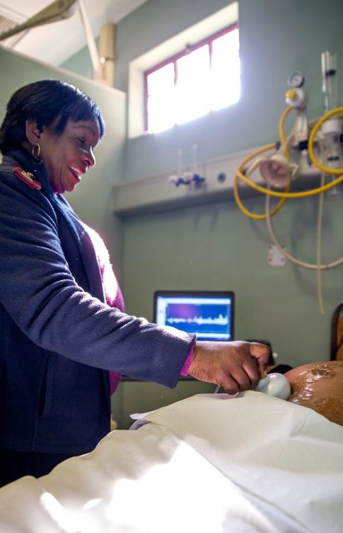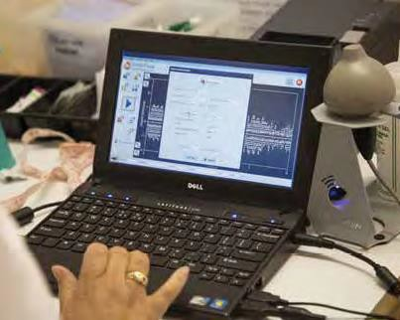Improving health

OUR WORK

Challenge
• Improving access to specialist obstetric care to improve foetal health

Research and development: Umbiflow
• An ultrasound device used in clinics to determine foetal health
• Device capable of detecting foetuses at risk of death during pregnancy
• A field trial was conducted in Kraaifontein, in the
Western Cape and in Tshwane district.

Outcome
• First six months revealed that perinatal mortality rate for women who had access to Umbiflow testing was 11.3 per 1 000 deliveries, compared to 20 per 1 000
21 deliveries

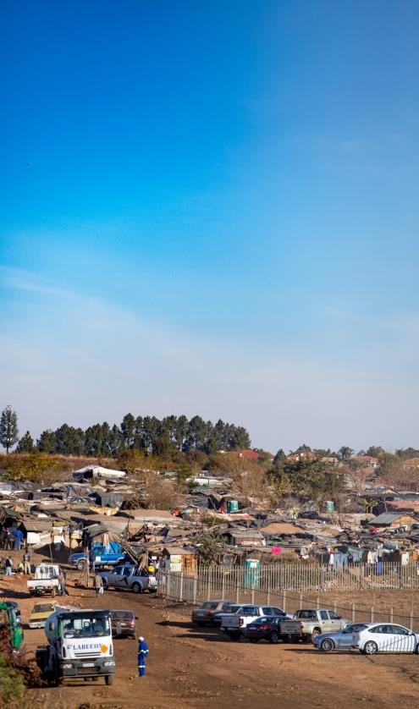Transforming human settlements

OUR WORK

Challenge
• Modelling housing demand

Research and development
• Developed a housing demand model in partnership with the Palmer Development Group
• The model combines a range of data and assumptions to
predict changing demographic patterns

Outcome
• The CSIR is training officials from the Gauteng Provincial Government in the use of the housing demand model as a decision-making tool
• The same model can be applied in other metros

22

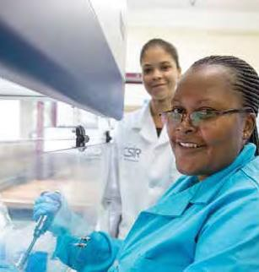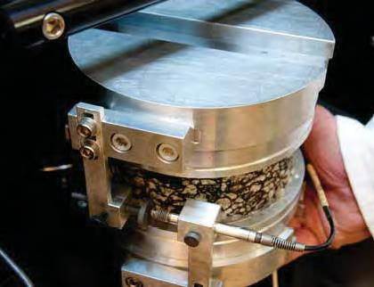African research, development and implementation

OUR WORK

Challenge: Livestock disease
Research and development
• Developed diagnostic instruments that test for infectious diseases, such as foot-and-mouth disease and brucellosis,
• Diagnostic instruments supply real-time results to enable
immediate decision-making around containment strategies

Challenge: Renewable energy
Research and development
• Leading a project to support the development and integration of renewable energy resources in power systems in the SADC region

Challenge: Road infrastructure
Research and development
• CSIR engineers helped Tanzania’s road authorities in developing new asphalt guidelines to counter high incidents of premature pavement failures
23

THANK YOU

Trend in journal articles

OUR PERFORMANCE

Trend in journal articles

400
Actual = 340

350

300
Number of journal articles

250

200

150

100

50

0
06/07 07/08 08/09 09/10 10/11 11/12 12/13 13/14 14/15 15/16

25 Back

Trend of cumulative patents awarded

OUR PERFORMANCE

Cumulative patents

300

Target = ≥216

250
Number of patents

200

150

100

50

0
2005/06 2006/07 2007/08 2008/09 2009/10 2010/11 2011/12 2012/13 2013/14 2014/15 2015/16 2019/20

26 Back

Trend in contract R&D income

OUR PERFORMANCE

Contract R&D income

2500

Actual = 1 967

2000

1500

1000

500

0
06/07 07/08 08/09 09/10 10/11 11/12 12/13 13/14 14/15 15/16

27 Back

Trend in royalty and licence income

OUR PERFORMANCE

Royalty and licence income (Rm)

25

20

15
Royalty & Licence income (Rm)

10 Actual = R5.2 m

5

0
06/07 07/08 08/09 09/10 10/11 11/12 12/13 13/14 14/15 15/16

28

Back

Trend in SET staff numbers

OUR PERFORMANCE

Trend in SET staff numbers

Actual = 1 969

2000

1900

1800

1700

1600
Number of SET staff

1500

1400

1300

1200

1100

1000

29

06/07 07/08 08/09 09/10 10/11 11/12 12/13 13/14 14/15 15/16

Back

Trend in number of doctorates

OUR PERFORMANCE

Trend in number of doctorates

400
Actual = 345

350
Number of staff with doctorates

300

250

200

150

100

50

0
06/07 07/08 08/09 09/10 10/11 11/12 12/13 13/14 14/15 15/16
30

Back

Trend in CSIR income streams

OUR PERFORMANCE

Trend in income streams

3 000 000

2 500 000

2 000 000

1 500 000

1 000 000
Royalty Income

SA Public Sector

SA Private & International Sector

Parliamentary Grant

500 000

-
Ba
06/07 07/08 08/09 09/10 10/11 11/12 12/13 13/14 14/15 15/16

31

Back

Trend in investment in property, plant and equipment

OUR PERFORMANCE

Investment in PPE (Rm)

350
Actual = R308 m

300
Investment in PPE (Rm)

250

200

150

100

50

0
06/07 07/08 08/09 09/10 10/11 11/12 12/13 13/14 14/15 15/16

32

Back

