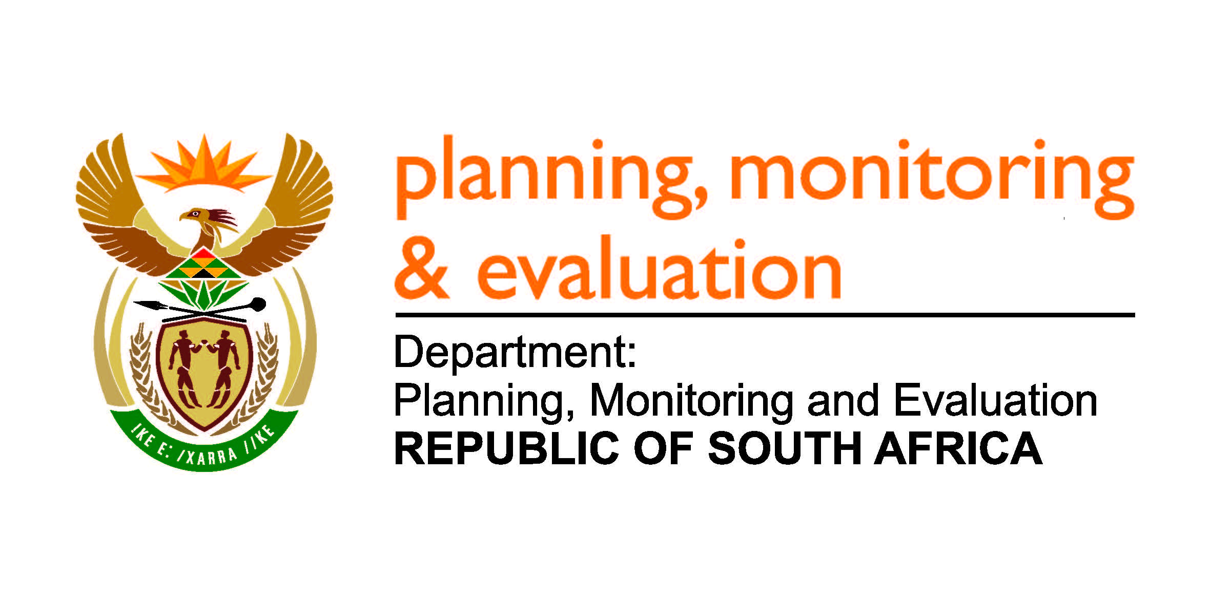

SOCIO-ECONOMIC IMPACT ASSESSMENT SYSTEM (SEIAS)
FINAL IMPACT ASSESSMENT TEMPLATE (PHASE 2)
JULY 2016

The Final Impact Assessment [Insert the Name of the Policy/Bill/Regulations/Other]
The Final Impact Assessment provides a more detailed assessment of the ultimately policy/legislative/ regulations/ other proposal. In addition, it identifies (a) mechanisms for monitoring, evaluation and modification as required; and (b) a system for managing appeals that could emerge around the implementation process.
- The problem Statement/ Theory of Change

  - Give summary of the proposal, identifying the problem to be addressed and the root (causes) of the problem that will be addressed by the new rule.
    - Summary of the proposal (Summary Background of the proposed policy/bill/ regulations/ other)
    - Problem/s and root causes that the proposal is trying to address
Identified Problem | Root causes
  - Describe the intended outcomes of the proposal

  - Describe the groups that will benefit from the proposal, and the groups that will face the cost. These groups could be described by their role in the economy or in society. As a minimum, consider if there will be specific benefits or costs for the poorest households (earning R 7000 a month or less); for black people, youth or women; for small and emerging enterprise; and /or for rural development. Add more rows if required

Groups that will benefit | How will they benefit?

Groups that will bear the cost or lose | How will they incur the costs or lose?

  - Describe the behaviour that must be changed, main mechanisms to achieve the necessary changes. These mechanisms may include modifications in decision making process systems; changes in procedures; educational work; sanctions; and or incentives. Also identify groups inside or outside government whose behaviour will have to change to implement the proposal. Add more rows if required.

Groups inside Government | Behaviour that must be changed (Current Behaviour) | Main mechanism to achieve the necessary changes

Groups outside Government | Behaviour that must be changed (Current Behaviour) | Main mechanism to achieve the necessary changes

  - Report on consultations on the proposal with the affected government agencies, business and other groupings. What do they see as the main benefits, costs and risks? Do they support or oppose the proposal? What amendments do they propose? And have these amendments been incorporated in your proposal?

Table on consultations:
Affected Stakeholders | What do they see as main benefits, costs and risks? | Do they support or oppose the proposal? | What amendments do they propose? | Have these amendments been incorporated in your proposal?
- Government Departments and Agencies (Name them)
- Business (Name them)
- Organised Labour
- Civil Society
- The Public
- Other groupings (Name them)

  - Describe possible disputes arising out of the implementation of the proposal, and system for settling and appealing them. How onerous will it likely be for members of the public to lodge a complaint and how burdensome and expeditious is the proposed dispute-settlement procedure?

- Impact Assessment

  - Describe the costs and benefits of implementing the proposal to the groups identified in point 1.5 above, using the following chart. Add more rows if required

Group | Implementation Costs | Costs of changing behaviour | Costs/Benefits from achieving desired outcome | Comments

  - Describe the changes required in budgets and staffing in government in order to implement the proposal. Identify where additional resources would be required for implementation. It is assumed that existing staff are fully employed and cannot simply absorb extra work without relinquishing other tasks.
  - Describe how the proposal minimises implementation and compliance costs.
It minimises the wage bill and provides efficient services delivery. It removes the challenges for non-compliance that existed.

- Managing Risk

  - Describe the main risks to the achievement of the desired ends of the policy/bill/regulations/other and/ or to the national priorities (aims) that could arise from adoption of the proposal. Also describe the measures taken to manage the identified risks. Add more rows if necessary.

Identified Risk | Mitigation Measures

  - Describe the mechanisms included in your proposal for monitoring implementation, evaluating the outcomes, and modifying the implementation process if required. Estimate the minimum amount of time it would take from the start of the implementation process to identify a major problem and remedy it.

- Summary

  - Summarise the impact of the proposal on the main national priorities
National Priority | Impact
- Social Cohesion
- Security (Safety, Financial, Food, Energy and etc.)
- Economic Growth
- Economic Inclusion (Job Creation and Equality)
- Environmental Sustainability

  - Identify the social and economic groups that would benefit most and that would bear the most cost. Add more rows if required.

Main Beneficiaries | Main Cost bearers

  - In conclusion, summarise what should be done to reduce the costs, maximise the benefits, and mitigate the risks associated with the policy/bill/regulations/other. Note supplementary measures (such as educational campaigns or provision of financing) as well as amendments to the draft itself, if appropriate. Add more lines if required.

  - Please identify areas where additional research would improve understanding of the costs, benefits and/ or risks of the policy/bill/regulations/other

For the purpose of building SEIAS body of knowledge please complete the following:
Name of Official/s
Designation
Unit
Contact Details
Email address

