Science and Technology Portfolio

PC briefing note

Purpose of the presentation
Annually oversight committees set aside time to focus on assessing the performance of departments. On completion of the process, portfolio committees are required to develop department-specific budgetary review and recommendations reports (BRRR), which express the committee`s view on the department’s budget for recommendation to the National Treasury ahead of the following year`s budget period.
Our role as the AGSA is to reflect on the audit work performed to assist the portfolio committee in its oversight role of assessing the departments’ performance, taking into consideration the objective of the committee to produce a BRRR.

CONTENTS
1. Introduction 4
2. Audit opinion history 6
3. Key focus areas 7
4. Other matters of interest 8
5. Drivers of internal control 9
6. Other AGSA reports 10
7. Combined assurance on risk management in the public sector 11
8. Minister’s commitments and progress on these commitments 14
9. Proposed commitments for the Portfolio committee 15
10. Key root causes and recommendations 15
11. Best practice to maintain audit outcomes 15
12. Entities included in portfolio not audited by AGSA 16

Introduction

Reputation promise of the Auditor-General of South Africa
The Auditor-General of South Africa has a constitutional mandate and, as the supreme audit institution of South Africa, exists to strengthen our country’s democracy by enabling oversight, accountability and governance in the public sector through auditing, thereby building public confidence.

Purpose of document
The purpose of this briefing document is for the Auditor-General of South Africa (AGSA) to provide an overview of the audit outcomes and other findings of the Department of Science and Technology and its entities for the 2015-16 financial year.

Overview
Legislative mandate

Science and Technology Laws Amendment Act, (Act No. 7 of 2014), the Scientific Research Council Act, 1988 (Act No. 46 of 1988), the National Research Foundation Act, 1998 (Act No. 23 of 1998), the Academy of Science of South Africa Act,2001 (Act No. 67 of 2001), the Natural Scientific Professions Act, 2003 (Act No. 27 of 2003), the Human Sciences Research Council Act, 2008 (Act No. 17 of 2008), the Technology Innovation Agency Act,2008 (Act No. 26 of 2008), and the South African National Space Agency Act, 2008 (Act No. 36 of 2008).

The portfolio consists of:
- Department of Science and Technology (DST)
- Three public entities audited by the AGSA:
  - Human Sciences Research Council (HSRC)
  - National Research Foundation (NRF)
  - Council for Scientific and Industrial Research (CSIR)

- Three entities not audited by the AGSA in terms of section 4(3) of Public Audit Act:
  - Technology Innovation Agency (TIA) – audited by Ngubane and Company/Johannesburg Incorporated
  - South African National Space Agency (SANSA) – audited by SizweNtsalubaGobodo
  - Academy of Science for South Africa (ASSAF) – audited by SizweNtsalubaGobodo

Aim of the vote
To develop, coordinate and manage a National System of Innovation that will bring about maximum human capital, sustainable economic growth and improved quality of life for all.

Vision
To create a prosperous society that derives enduring and equitable benefits from science and technology.

1.4 Organisational structure

Audit opinion history
Clean audit opinion: Financially unqualified opinion with no findings on PDO and compliance
Financially unqualified opinion with findings on PDO and compliance
Qualified audit opinion (with findings)
Disclaimed/adverse audit opinion
DEPARTMENT/ENTITY HAD FINDINGS (in the related matter)

Improved
Unchanged
Regressed

DESCRIPTION | Movement | 15-16 | 14-15 | 13-14
Audit opinions
• Department of Science and Technology
• National Research Foundation
• Council for Scientific and Industrial Research
• Human Sciences Research Council
• Council for the African Institute of South Africa | N/A | Closed | Closed
OTHER MATTERS
Predetermined objectives
• Department of Science and Technology
• National Research Foundation
• Council for Scientific and Industrial Research
• Human Sciences Research Council
• Council for the African Institute of South Africa | N/A | Closed | Closed
Compliance with legislation
• Department of Science and Technology
• National Research Foundation
• Council for Scientific and Industrial Research
• Human Sciences Research Council
• Council for the African Institute of South Africa | N/A | Closed | Closed

- The portfolio’s overall outcomes have regressed in 2015-16 due to the Department of Science and Technology (DST) moving from an unqualified audit opinion with no other findings to an unqualified audit opinion with findings on compliance with legislation. The National Research Foundation (NRF), the Council for Scientific and Industrial Research (CSIR) and the Human Sciences Research Council (HSRC) retained their unqualified audit opinion with no other findings.
- The entire portfolio has consistently submitted quality annual financial statements timeously and no material adjustments were made to any of the submitted financial statements.
- It should be noted that Council for the African Institute of South Africa (AISA) was incorporated into the HSRC with effect from 1 April 2014 and operates as a programme under the HSRC.

Key focus areas

Predetermined objectives
Department/ entity | Finding | Common root cause | Recommendation
Department of Science and Technology | - We identified material misstatements in the annual performance report submitted for auditing.  - Management subsequently corrected these misstatements thus avoiding any material findings in the audit report. | - Lack of appropriate systems to collect, collate, verify and store information by the programmes to ensure compliance with chapter 5 of the National Treasury Framework for managing performance information (FMPPI) | - Management should Implement appropriate systems to collect, collate, verify and store information by the programmes to ensure compliance with chapter 5 of the National Treasury Framework for managing performance information (FMPPI  - Management should enhance review and monitoring controls to ensure that misstatements are prevented or detected and corrected timely before reporting on the annual performance report.
National Research Foundation | - We identified material misstatements in the annual performance report submitted for auditing.  - Management subsequently corrected these misstatements thus avoiding any material findings in the audit report.
Council for Scientific and Industrial Research | None
Human Sciences Research Council | None

Compliance with legislation
Department/ entity | Finding | Common root cause | Recommendation
Department of Science and Technology | Contractual obligations and money owed by the department were not settled within 30 days, as required by section 38(1) (f) of PFMA and Treasury Regulation 8.2.3. | Ineffective review and monitoring of compliance with laws and regulations by senior management. | Ensure basic financial disciplines and daily/monthly processing and reconciling of transactions are occurring and payments are made in a timely manner.
National Research Foundation | None | None | None
Council for Scientific and Industrial Research Group | None | None | None
Human Sciences Research Council | None | None | None

Financial health
Department/entity | Finding | Root cause | Recommendation
The financial health of the portfolio remain good with the exception of DST being unable to settle its creditors timely resulting in a significant increase in its accruals and payables compared to the previous years.

Other matters of interest

Unauthorised, irregular and fruitless and wasteful expenditure
- Unauthorised expenditure: Expenditure not in accordance with the budget vote
- The portfolio did not incur any unauthorised expenditure.

- Irregular expenditure: Expenditure incurred in contravention of key legislation
Department/ Entity |  | Irregular expenditure
 |  | Movement | Amount  R  2015/16 | Amount  R  2014/15 | Root cause | Recommendation
1 | Department of Science and Technology |  | 1 088 000 | 1 920 000 | This was due to lack of review and monitoring of compliance with legislations surrounding supply chain management. | Management to adequately provide oversight responsibility on compliance and related internal controls.  Officials should be held accountable for non-compliance with legislation and irregular expenditure should be tracked, with proactive preventative measures being implemented.
2 | National Research Foundation |  | R6 569 000 | R22 065 000 | Management did not adequately provide oversight responsibility on compliance and related internal controls as the Supply Chain Management legislations and policies were not always complied with at some of the facilities. | Management to adequately provide oversight responsibility on compliance and related internal controls.  Officials should be held accountable for non-compliance with legislation and irregular expenditure should be tracked, with proactive preventative measures being implemented.
3 | Council for Scientific and Industrial Research |  | - | 117 000 | Not applicable | Not applicable
4 | Human Sciences Research Council |  | R3 968 000 | R241 000 | This was due to emergency procurement necessitated by stringent project timelines which resulted in the impracticability of competitive sourcing of service providers. | Management to ensure that the necessary approvals and processes are followed for cases of emergency.  Officials should be held accountable for non-compliance with legislation and irregular expenditure should be tracked, with proactive preventative measures being implemented.
 | TOTAL |  | R11 625 000 | R24 343 000 | The portfolio incurred R12million of irregular expenditure as a result of non-compliance with supply chain management regulations, of which 35% was identified by the auditees. There was an overall decrease in irregular expenditure by 52% from the previous year.

- Fruitless and wasteful expenditure: Expenditure that should not have been incurred (incurred in vain that could have been avoided and no value for money received)
Department/ Entity |  | Fruitless and Wasteful expenditure
 |  | Movement | Amount  R  2015/16 | Amount  R  2014/15 | Root cause | Recommendation
1 | Department of Science and Technology |  | 62 000 | - | Negligence of staff members thus relating largely to traffic fines issued to staff members on hired vehicles, flights missed and failure to utilise booked hotel rooms. | Management should ensure that adequate controls are implemented and action is taken against staff contributing to the fruitless and wasteful expenditure.
2 | National Research Foundation |  | 44 000 | 14 000
3 | Human Sciences Research Council |  | 182 000 | 67 000
4 | Council for Scientific and Industrial Research |  | - | - | Not applicable | Not applicable

Drivers of internal control
Drivers of internal control
Auditee | Leadership | Financial and performance management | Governance
Department of Science and Technology
National Research Foundation
Council for Scientific and Industrial Research
Human Sciences Research Council

STATUS LEGEND

Good
In progress
Intervention required

- Management to provide attention to key controls by:
  - Implementing controls at DST to ensure that invoices received are processed and captured timely on the system for payment.
  - Management should enhance review and monitoring controls to ensure that misstatements are prevented or detected and corrected timely before reporting on the annual performance report.
  - Preparing monthly/interim AFS with full disclosures in an effort to reduce the risk of misstatements at year end and DST, NRF and HSRC.
  - Providing adequate oversight on the compliance and related internal controls surrounding to ensure preventative measures are being implemented.

Other AGSA reports

Audit related services and special audits
- As requested by the National Research Foundation, an engagement was conducted during the year under review on grants received and related expenditure for various contracts/ programmes of the Research and Innovation Support and Advancement (RISA). The audit certificates covered the period 01 April 2015 to 31 March 2016.
- At the request of the National Research Foundation, we audited financial statements of Technology and Human Resources for Industry Programme (THRIP) in terms of International Standards on Auditing 805 (ISA 805). THRIP programme form part of the financial statements of National Research Foundation. The amount relating to the THRIP is received as a transfer payment from Department of Trade and Industry.

Investigation
The National Research Foundation appointed a private firm to conduct a forensic investigation into allegations of fraud perpetrated by external syndicate. The investigation is currently still in progress.

Combined assurance on risk management in the public sector
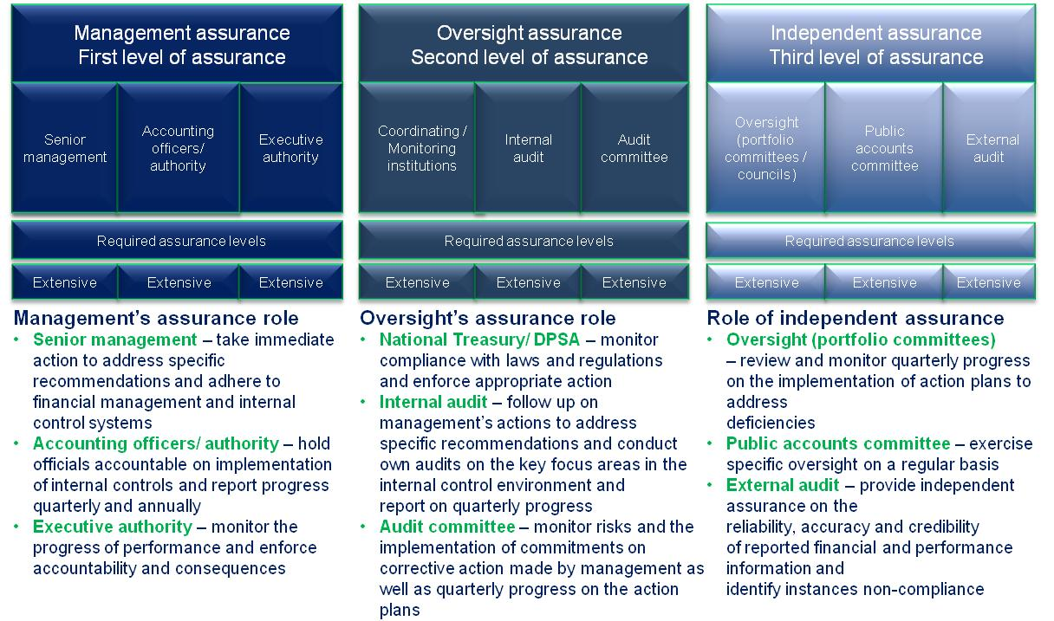

 | Assurance levels
Department & Entities |  | Senior management | Accounting officer/authority | Executive authority | Internal audit | Audit committee | Portfolio committee | Comments
Department of Science and Technology |  |  |  |  |  |  |  | Senior management provided some assurance as insufficient review and monitoring of compliance with legislation regarding payments within 30 days and lack of review and monitoring of controls to ensure that misstatements are prevented or detected and corrected timely before reporting on the annual performance report submitted for audit on 31 May 2016.
National Research Foundation |  |  |  |  |  |  |  | Senior management provided some assurance as there was lack of review and monitoring of controls to ensure that misstatements are prevented or detected and corrected timely before reporting on the annual performance report submitted for audit on 31 May 2016.
Council for Scientific and Industrial Research |  |  |  |  |  |  |  | Assurance provided.
Human Sciences Research Council |  |  |  |  |  |  |  | Assurance provided.
Overall Assessment |  |  |  |  |  |  |  | The minister, accounting officer, accounting authorities, audit committees and internal audit provided the necessary assurance which contributed towards the sustained key internal controls, particularly those relating to leadership, financial and performance management and governance. Overall senior management also provided the necessary assurance with the exception of the senior management at DST and NRF only providing some assurance in the area of compliance with legislation and performance information.  The Portfolio committee performed in terms of it’s legislative oversight requirements and it robustly engages the department and the entities on their role and mandate.

Assessment of the Portfolio committee
The following criteria were used to evaluate the level of assurance for the Portfolio Committee:
- Oversight role in terms of robust budget vote process, review of the annual report including the audit report, quarterly reporting;
- Follow up on progress made by the entities to address poor audit outcomes;
- Recommendations made in relation to key audit matters; and
- Follow up on key matters reported in the committee’s prior year BRRR report.
- The Portfolio committee performed in terms of it’s legislative oversight requirements and it robustly engages the department and the entities on their role and mandate.

STATUS LEGEND
Provides assurance
Provides some / limited assurance
Provides no assurance
Not applicable

Minister’s commitments and progress on these commitments

The following are commitments made by the minister and their progress:
Focus area | Commitment | Due Date | Status
Action plan to address internal and external audit findings (2014-15) | - The minister will require a detailed plan addressing the audit findings, and quarterly updates on the progress and implementation of the plan.  - The minister will address the ASSAF matters reported in discussions with the chairperson of the ASSAF board to ensure that a turnaround strategy is implemented.  - The DST will provide necessary support to its public entities to ensure compliance with its mandate and PFMA. | March 2016
Action plan to address internal and external audit findings (2015-16) | - Minister to be provided an update on a quarterly basis on the implementation of the audit action plans that are based on the audit findings, root causes and recommendations reported by the AGSA, internal audit, audit committees and other governance structures. The update should provide details of issues finalised, in progress and not yet implemented. | March 2017 | Proposed new commitment

STATUS LEGEND
Commitment has been implemented
Commitment in progress
Commitment has not been implemented

Proposed commitments for the Portfolio committee
The following recommended commitments to be actioned by the committee:
- Obtain feedback on implementation of action plans to address audit weaknesses identified.
- The committee will exercise oversight during its quarterly reviews with regards to compliance and performance reporting to ensure achievement of objectives.

Key root causes and recommendations
Root cause | Recommendation
Slow responses by management | - Regular monitoring of the action plans to ensure that the identified deficiencies are addressed to avoid repeat findings and continued non-compliance.  - Although internal control processes exist, it must be consistently monitored and adhered to by all employees.  - Regular assessments of the status of internal controls, especially regarding financial statement preparation and implementation of action plans, must be undertaken by management to address deficiencies as and when they arise.  - Officials should be held accountable for non-compliance with legislation.
Ineffective review and monitoring of compliance with legislation

Best practice to maintain audit outcomes
To improve and sustain the audit outcomes in the portfolio, senior management should implement and sustain key internal controls and focus on the following:

- Implement audit action plans that are based on the audit findings, root causes and recommendations.
- Ensure basic financial disciplines and monthly processing and reconciling of transactions.
- Continue to regularly prepare credible financial and performance reports.
- Officials should be held accountable for non-compliance with legislation and irregular expenditure should be tracked, with proactive preventative measures being implemented.

The portfolio remains largely on track and is moving in the right direction. The leadership and senior management must ensure that the effective leadership which is based on a culture of honesty, ethical business practice and good governance is maintained to ensure good audit outcomes.

Entities included in the portfolio not audited by the Auditor-General of South Africa (section 4(3) audit entities)
AUDIT OPINIONS |  |  |  |  | 15/16 | 14/15 | 13/14
- Technology Innovation Agency (TIA)
- South African National Space Agency (SANSA)
- Academy of Science of South Africa (ASSAF)
PREDETERMINED OBJECTIVES |  |  |  |  | 15/16 | 14/15 | 13/14
- Technology Innovation Agency
- South African National Space Agency
- Academy of Science of South Africa |  |  |  |  | N/A | N/A | N/A
COMPLIANCE WITH LAWS AND REGULATIONS |  |  |  |  | 15/16 | 14/15 | 13/14
- Technology Innovation Agency
- South African National Space Agency
- Academy of Science of South Africa |  |  |  |  |  |  | N/A
 |  |  | AUDIT OPINION LEGEND
 |  |  |  | CLEAN AUDIT OPINION: No findings on PDO and Compliance
 |  |  |  | UNQUALIFIED with findings on PDO and Compliance
 |  |  |  | QUALIFIED AUDIT OPINION (with/without findings)
 |  |  |  | DISCLAIMER/ADVERSE AUDIT OPINION
 |  |  |  | DEPARTMENT/ENTITY HAD FINDINGS (in the related matter)

Comments relating to section 4(3) entities
- TIA and SANSA retained there status of unqualified audit opinion with no findings.
- ASSAf still had non compliance findings relating to section 2 (2) of the ASSAf Act which requires ASSAf to comply with the provisions of the PFMA. Predetermined objectives is not applicable since the entity is not listed in the PFMA.

