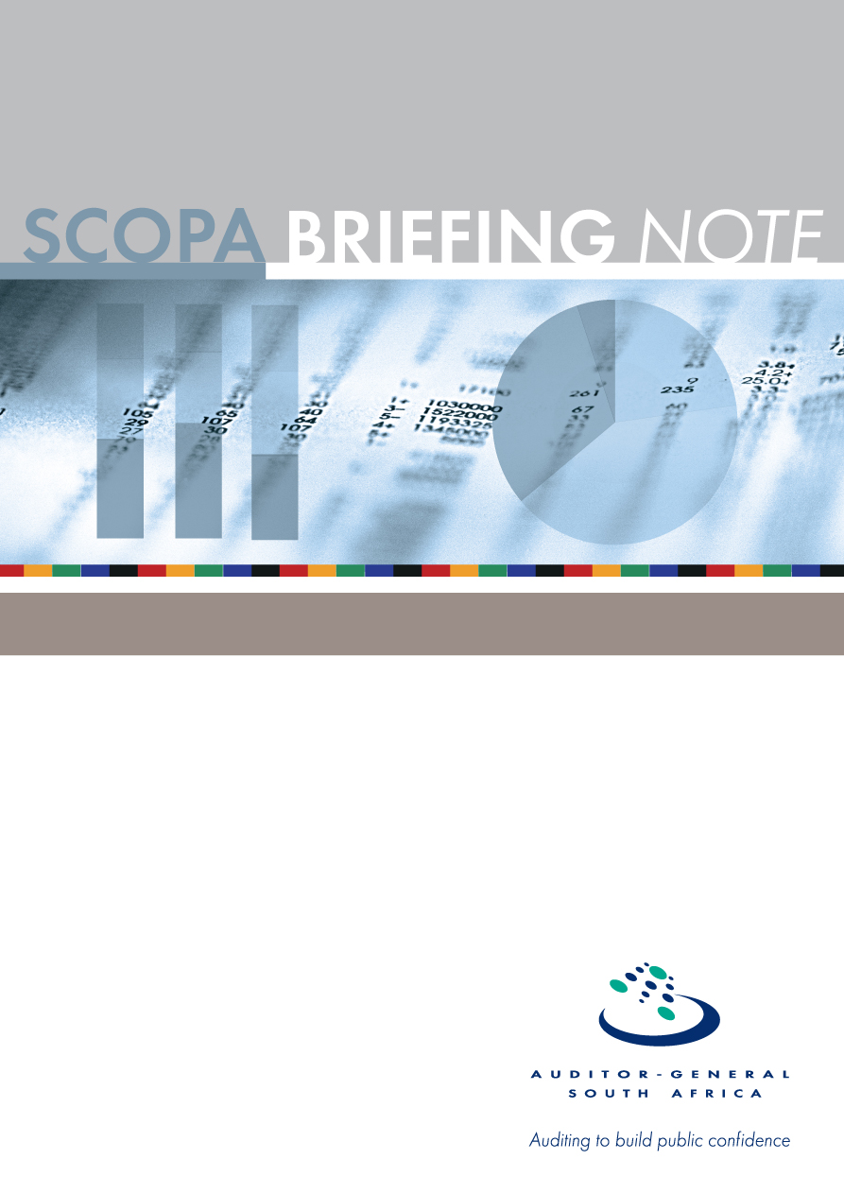
Portfolio:
Justice and Constitutional Development
October 2016

PC

PFMA audit outcomes of the 2015-16 financial year

CONTENTS
1. Introduction 3
2. Audit opinion history 4
3. Assurance providers 7
4. Drivers of internal control 9

- Introduction
1.1 Reputation promise of the Auditor-General of South Africa
The Auditor-General has a constitutional mandate and, as the Supreme Audit Institution (SAI) of South Africa, it exists to strengthen our country’s democracy by enabling oversight, accountability and governance in the public sector through auditing, thereby building public confidence.
1.2 Purpose of document
The purpose of this briefing document is for the Auditor-General of South Africa (AGSA) to provide an overview of the audit outcomes and other findings in respect of the Office of the Chief Justice for the 2015/16 financial year
1.3 Role of the AGSA in the BRRR process
- Our role as the AGSA is to reflect on the audit work performed to assist the portfolio committee in its oversight role in assessing the performance of the entities taking into consideration the objective of the committee to produce a BRRR.
- To provide the portfolio committee with applicable information and guidance on the Justice and Constitutional Development portfolio’s 2015-16 audit outcomes so that they, the committee, can ensure effective oversight.
- To enable oversight to focus on areas that will lead to good governance.
1.3 Funding
Office of the Chief Justice | Budget  R ‘000 | Actual Expenditure  R ‘000 | Over / underspending  R ‘000 | Variance  %
Programme 1: Administration | 97 787 | 88 836 | 8 951 | 9%
Programme 2: Judicial Support and Court Administration | 651 566 | 648 208 | 3 358 | 0,5%
Programme 3: Judicial Education and Research | 34 026 | 30 642 | 3 384 | 10%
Statutory Appropriation | 873 748 | 887 682 | (13 934) | 1,6%
Total | 1 657 127 | 1 655 368 | 1 759 | 0,1%

Regardless of which programme it related to, the following areas of main expenditure were noted:
Main areas of expenditure | Budget  R ‘000 | Actual Expenditure  R ‘000 | Over / underspending  R ‘000 | Variance  %
Compensation of employees | 1 302 465 | 1 303 706 | (1 241) | 0,09%
Goods and services | 202 473 | 197 512 | 4 961 | 2,5%
Transfers and subsidies | 53 655 | 56 214 | (2 559) | 4,5%

- Overall audit outcome history (New department)

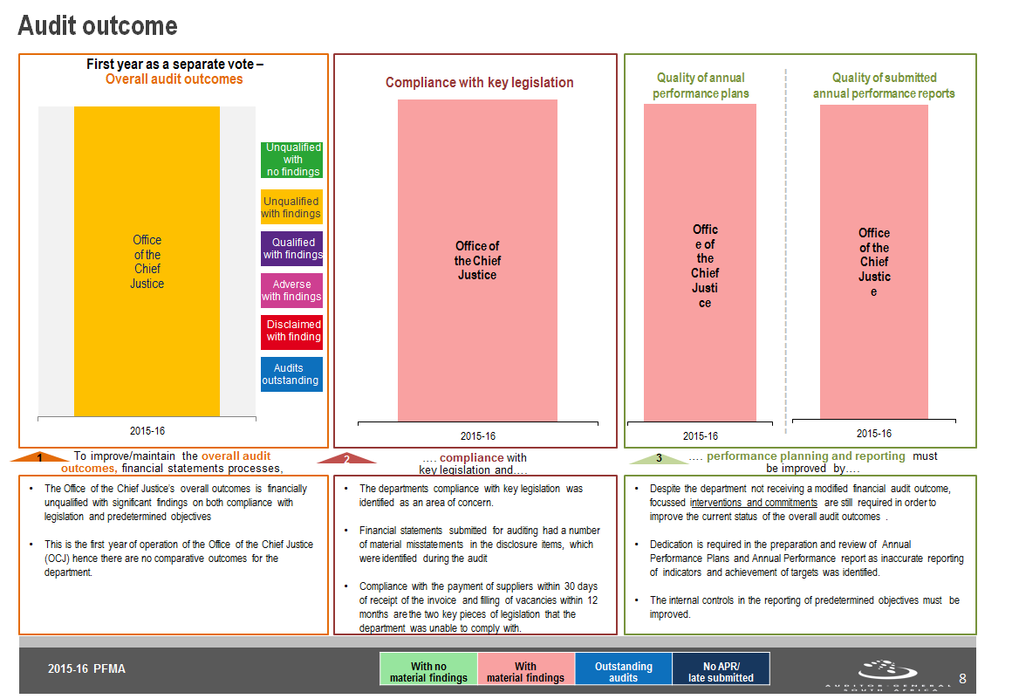

  - Financial management
Department | Finding | Root cause | Recommendation
Office of the Chief Justice | The financial statements submitted for auditing were not prepared in accordance with the prescribed financial reporting framework as required by section 40(1) (b) of the Public Finance Management Act. Material misstatements of disclosure items identified by the auditors in the submitted financial statements were subsequently corrected, resulting in the financial statements receiving an unqualified audit opinion. | Inadequate review of financial statements and supporting documents by management. | - Management should implement systems to ensure that financial statements are accurate and complete.  - The financial statements should be adequately reviewed by management prior to submission for auditing.  - The financial statements prepared should be adequately supported by substantiating evidence to corroborate validity, accuracy and completeness thereof.  - Financial statements which are submitted must be the final set approved by the leadership and supported as referred to above.

  - Performance management
Department/Entity | Finding | Root cause | Recommendation
Office of the Chief Justice | The department received material findings on the usefulness of the reported performance information because they were a newly established department and did not clearly define the support role provided to the judiciary and executive. As a result important indicators were not well defined. The reported performance information was not reliable when compared to the source information because of the exclusion of some court files from the reported performance information. | Inadequate reviews of the performance information register to ensure that all cases are included.in the performance report | - Management should ensure that registers for court performance information are adequately reviewed and courts performance information is completely reported on.  - Management should embark on training sessions to ensure that all the employees are aware of the reporting requirements of the performance indicator

  - Compliance with legislation (including supply chain management)
Department/Entity | Finding | Root cause | Recommendation
Office of the Chief Justice | - Contractual obligations and money owed by the department were not always settled within 30 days or an agreed period, as required by section 38(1)(f) of the PFMA and Treasury Regulation (TR) 8.2.3. | Inadequate monitoring of compliance with legislation by management. | - Management should ensure compliance with all applicable legislation by implementing the policies, procedures, circulars and checklists in place at the department.  - Tracking registers should be introduced to track processing of invoices from date of receipt until date of payment in order to understand and investigate reasons for delays in payment.

  - Human resource management and consequence management
Department/Entity | Finding | Root cause | Recommendation
Office of the Chief Justice | Funded vacant posts were not filled within 12 months as required by the Public Service Regulation 1/VII/C.1A.2. | Management did not implement effective HR management and monitor compliance with laws and regulations. | The accounting officers should provide feedback to the executive authority on the progress made in filling of key vacancies at key management level on a quarterly basis.

  - Financial Health
Department/Entity | Finding | Root cause | Recommendation
Office of the Chief Justice | No concerns with regard to the financial health of the department , department realised a surplus and the net cash flow was positive | Regular engagements with the National Treasury and regular reviews of financial position by management and the audit committee. | Not applicable

  - Information technology (control environment)
Department/Entity | Finding | Root cause | Recommendation
Office of the Chief Justice | Management did not implement adequate security management controls to prevent unauthorised access to the network and information systems that generate the information used to prepare the financial statements | inadequate planning for the movement from the Department of Justice to the OCJ | - Security and configuration standards should be developed, approved, implemented consistently, and monitored for compliance (for firewalls, operating systems and databases).

- Assurance providers

Senior management
Senior management provides some assurance. Management did not have sufficient monitoring controls to ensure adherence to the National Treasury framework for strategic plans and annual performance plans; and the Framework for Managing Programme Performance Information. In addition management did not have adequate policies and procedures to guide the operations of the Department, resulting in instances of non-compliance with the PFMA, as detailed under the findings on compliance with legislation section of this report.
Accounting officer
The accounting officer provided some assurance. This is based on the number and nature of findings identified in the current year.
Executive authority
Minister assessment remained as providing some assurance as findings on non-compliance are still being reported.
Internal audit
Legislation in South Africa requires the establishment and roles and responsibilities of internal audit units. Internal audit units form part of the internal control and governance structures of the department and play an important role in its monitoring activities. Internal audit provides an independent assessment of the department’s governance, risk management and internal control processes.
The internal audit unit of a department must prepare a risk-based audit plan and internal audit programme for each financial year. It must advise the accounting officer and report to the audit committee on implementing the internal audit plan and matters relating to internal audit; internal controls; accounting procedures and practices; risk and risk management; performance management; loss control and compliance with the PFMA. The internal audit unit must also perform such other duties as may be assigned by the accounting officer. The internal audit unit has executed its planned activities for the year under review.
Audit committee
The audit committee is an independent advisory body to the department and the management and staff of the department on matters relating to internal financial control and internal audits; risk management; accounting policies; the adequacy, reliability and accuracy of financial reporting and information; performance management; effective governance; PFMA, Treasury Regulations and any other applicable legislation; performance evaluation; and any other issues.
The audit committee adequately fulfilled their responsibilities for the current audit cycle.

- Drivers of internal controls

