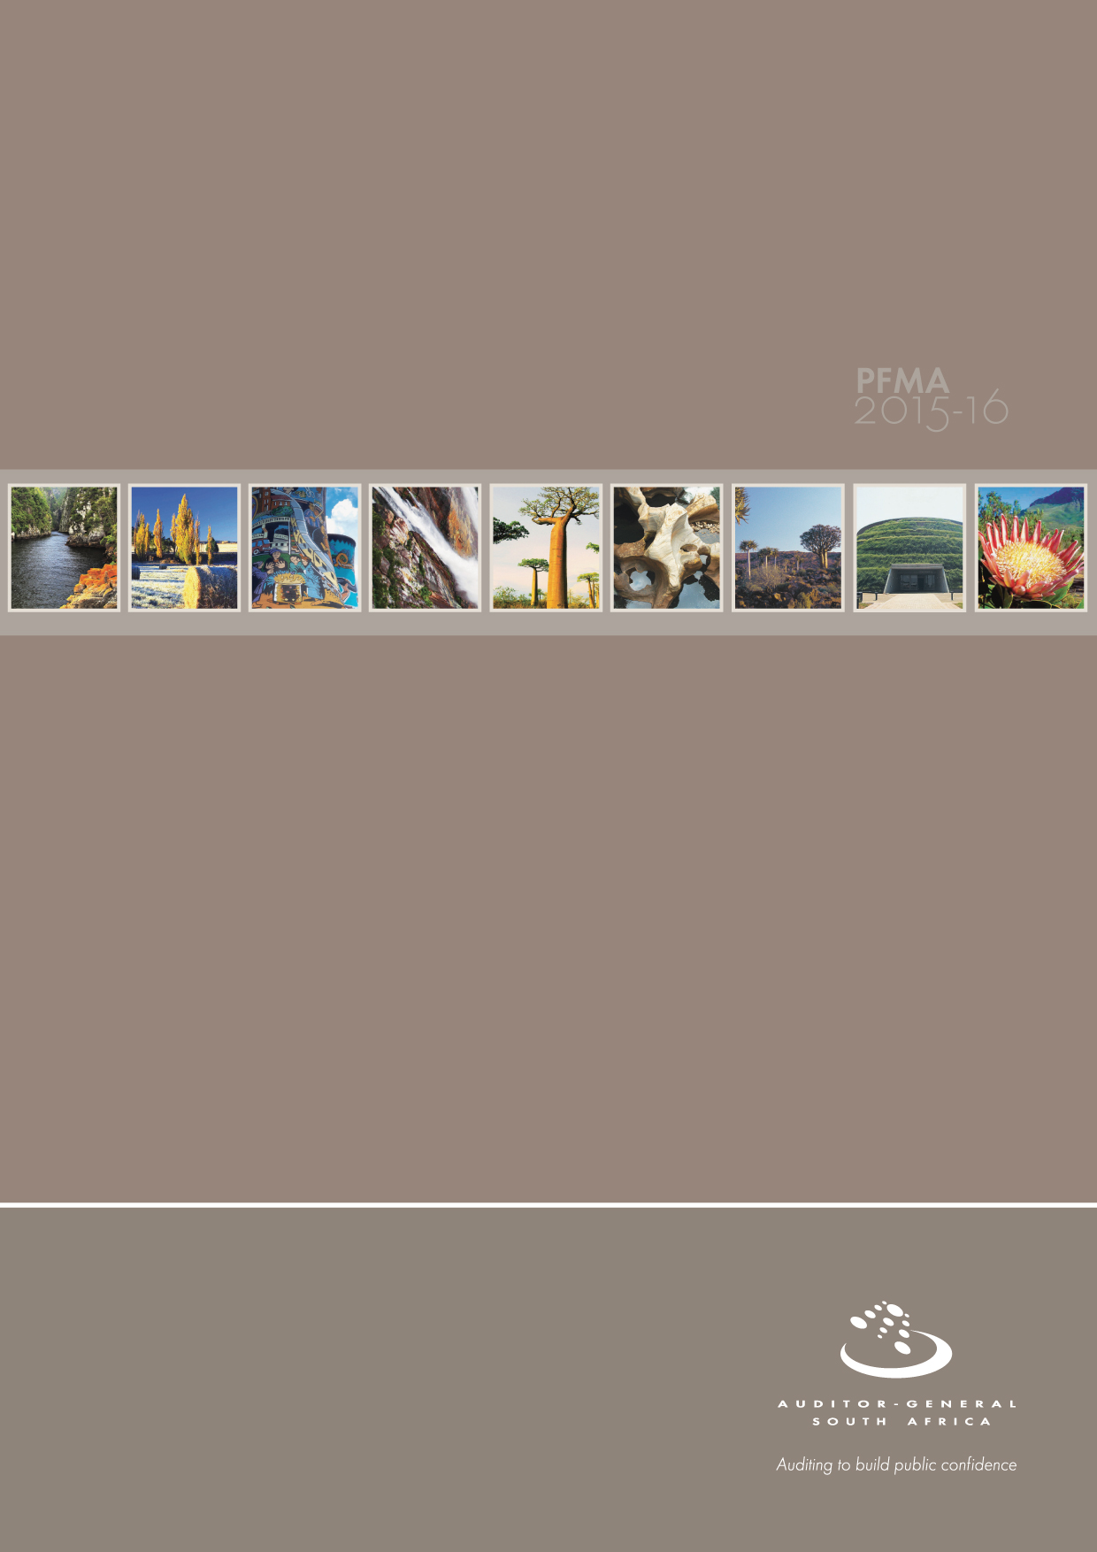
Arts and Culture portfolio

PC briefing note

Purpose of the presentation
Annually oversight committees set aside time to focus on assessing the performance of departments. On completion of the process, portfolio committees are required to develop department-specific budgetary review and recommendations reports (BRRR), which express the committee`s view on the department’s budget for recommendation to the National Treasury ahead of the following year`s budget period.
Our role as the AGSA is to reflect on the audit work performed to assist the portfolio committee in its oversight role of assessing the departments’ performance, taking into consideration the objective of the committee to produce a BRRR.

CONTENTS
1. Introduction 4-6
2. Audit opinion history 7-13
3. Key focus areas 14-30
4. Other matters of interest 31-32
5. Drivers of internal control 33-34
6. Other AGSA reports 34-35
7. Combined assurance on risk management in the public sector 36
8. Minister’s commitments and progress on these commitments 37
9. Assessment of portfolio 37-38

Introduction

Reputation promise of the Auditor-General of South Africa
The Auditor-General of South Africa has a constitutional mandate and, as the supreme audit institution of South Africa, exists to strengthen our country’s democracy by enabling oversight, accountability and governance in the public sector through auditing, thereby building public confidence.

Purpose of document
The purpose of this briefing document is for the Auditor-General of South Africa (AGSA) to provide an overview of the audit outcomes and other findings of the Department of Arts and Culture and its entities for the 2015-16 financial year.

Role of the AGSA in the BRRR process
Our role as the AGSA is to reflect on the audit work performed to assist the portfolio committee in its oversight role in assessing the performance of the entities taking into consideration the objective of the committee to produce a BRRR.
To provide the portfolio committee with applicable information and guidance on the Economic Development portfolio’s 2015-16 audit outcomes so that they, the committee, can ensure effective oversight.
To enable oversight to focus on areas that will lead to good governance.

Overview
The Department of Arts and Culture (DAC) derives its mandate from the Constitution. Section 16(1) states:
Everyone has the right to freedom of expression, which includes a) freedom of press and other media; b) freedom to receive or impart information or ideas; c) freedom of artistic creativity; and d) academic freedom and freedom of scientific research.
Section 30 states:
Everyone has the right to use language and to participate in the cultural life of their choice, but no one exercising these rights may do so in manners inconsistent with any provision of the Bill of Rights.
Section 32(1) states:
Everyone has the right of access to - (a) any information held by the state; and (b) any information that is held by another person and that is required for the exercise or protection of any rights.
The department is responsible for access to information, the development, protection, preservation and promotion of the arts, culture and heritage, increased economic development and empowerment, linguistic diversity, social cohesion and democracy in line with its constitutional mandate.
The department is responsible for 26 entities that were established to enable the department to deliver on its mandate. The entities are Artscape, Die Afrikaanse Taalmuseum, Ditsong Museums of South Africa, Freedom Park, the Iziko Museums of South Africa, the KwaZulu-Natal Museum, the Luthuli Museum, the Market Theatre Foundation, the Msunduzi/Voortrekker Museum, the National Arts Council of South Africa, the National Film and Video Foundation of South Africa, the National Heritage Council of South Africa, the National Library of South Africa, the National Museum, the Nelson Mandela National Museum (Mthatha), the Pan South African Language Board, the Performing Arts Centre of the Free State, the Robben Island Museum (Cape Town), the South African Library for the Blind (Grahamstown), the South African Heritage Resources Agency, the South African State Theatre, the National English Literary Museum (Grahamstown), the Playhouse Company, the War Museum of the Boer Republics, the William Humphreys Art Gallery and the Windybrow Theatre.
The Pan South African Language Board reports directly to parliament.

Aim of the vote
The aim of the department is to promote access to information, and to develop, protect, preserve and promote the arts, culture and heritage, linguistic diversity, social cohesion and democracy.

Vision
An arts, culture and heritage sector that contributes significantly to social cohesion, nation building and economic empowerment.

Mission
To ensure a supportive and enabling environment for the growth and development of the sector by:
- developing, protecting, preserving and promoting South African arts, culture and heritage
- providing access to information
- promoting the official languages of South Africa and enhancing the linguistic diversity of the country
- Facilitating social cohesion and inclusivity.

Strategic goals
The strategic goals of the department are:
- enhanced access by citizens and public institutions to accurate, reliable and timely information in their language of choice
- enhanced capacity of the sector and equitable and sustainable development, protection and preservation of the arts, culture and heritage
- increased contribution by the arts, culture and heritage sector to job creation, skills development, entrepreneurship and inclusive growth
- entrenched linguistic diversity in a manner that facilitates equitable cultural expression by citizens and communities
- advanced social cohesion and deepened democracy, resulting in enhanced national identity, pride and participation in civic life by citizens and communities
- enhanced alignment of public sector art, culture and heritage institutions around a shared vision, common mandate and strong governance and accountability.

Organisational structure

Audit opinion history
Clean audit opinion: Financially unqualified opinion with no findings on PDO and compliance
Financially unqualified opinion with findings on PDO and compliance
Qualified audit opinion (with findings)
Disclaimed/adverse audit opinion

DESCRIPTION | Movement | 15-16 | 14-15 | 13-14
Audit opinions
Department of Arts and Culture
Artscape
Die Afrikaanse Taalmuseum
Ditsong Museums of South Africa
Freedom Park
Iziko Museums of South Africa
KwaZulu-Natal Museum
Luthuli Museum
Market Theatre Foundation
Msunduzi/Voortrekker Museum
National Arts Council of South Africa
National Film and Video Foundation of South Africa
National Heritage Council of South Africa
National Library of South Africa
National Museum
Nelson Mandela National Museum (Mthatha)
Pan South African Language Board
Robben Island Museum
South African Library for the Blind
South African Heritage Resources Agency
The South African State Theatre
National English Literary Museum (Grahamstown)
The Playhouse Company
War Museum of the Boer Republics
William Humphreys Art Gallery
Windybrow Theatre
Qualification issues
Department of Arts and Culture
- Commitments
- Irregular expenditure
Ditsong Museums of South Africa
- Property, plant and equipment
- Heritage assets
- Receivables from exchange transactions
- Irregular expenditure
- Trade and other receivables
- Administrative and operating expenditure
Iziko Museums of South Africa
- Heritage assets
KwaZulu-Natal Museum
- Heritage assets
Msunduzi (Voortrekker) Museum
- Property, plant and equipment
- Heritage assets
National Arts Council
- Payables
- Receivables
National Library of South Africa
- Post-retirement medical aid liability
- Deferred income
- Property, plant and equipment
- Heritage assets
- Irregular expenditure
Nelson Mandela National Museum
- Unspent conditional grant
- Staff costs
- Payables from non-exchange transactions
- Irregular expenditure
- Heritage assets
PanSALB
- Irregular expenditure
- Finance lease obligation
- Fruitless and wasteful expenditure
- Property, plant and equipment
- Other operating and administrative expenditure
- Staff costs
- Contingent assets
- Consolidation
- Payables from exchange transactions
- Contingent liabilities
- Related parties
- Cash flow statement
State Theatre
- Property, plant and equipment
- Aggregate immaterial uncorrected misstatements
- Expenditure
- Payables from exchange transactions
- Trade debtors
- Cash and cash equivalents
- Irregular expenditure
- Fruitless and wasteful expenditure
- Commitments
National English Literary Museum
- Provision for post-retirement pension fund
- Property, plant and equipment
- Irregular expenditure
- Contingent liabilities
- Heritage assets
National Museum
- Heritage assets
War Museum of the Boer
- Heritage assets
William Humphrey Art Gallery
- Heritage assets
Windybrow Theatre
- Comparison of budgeted amounts and actual amounts
- Irregular expenditure
OTHER MATTERS
Predetermined objectives
- Arts and Culture
- Die Afrikaanse Taalmuseum
- Ditsong Museums of South Africa
- Msunduzi/Voortrekker Museum
- National Heritage Council of South Africa
- National Library of South Africa
- Nelson Mandela National Museum (Mthatha)
- Pan South African Language Board
- Performing Arts Centre of the Free State
- South African Heritage Resources Agency
- The South African State Theatre
- William Humphreys Art Gallery
- Windybrow Theatre
Compliance with legislation
- Arts and Culture
- Artscape
- Die Afrikaanse Taalmuseum
- Ditsong Museums of South Africa
- Freedom Park
- Iziko Museums of South Africa
- KwaZulu-Natal Museum
- Luthuli Museum
- Market Theatre Foundation
- Msunduzi/Voortrekker Museum
- National Arts Council of South Africa
- National Heritage Council of South Africa
- National Library of South Africa
- National Museum
- Nelson Mandela National Museum (Mthatha)
- Pan South African Language Board
- Performing Arts Centre of the Free State
- South African Library for the Blind (Grahamstown)
- South African Heritage Resources Agency
- The South African State Theatre
- National English Literary Museum (Grahamstown)
- War Museum of the Boer Republics
- William Humphreys Art Gallery
- Windybrow Theatre

The overall audit outcomes of the Arts and Culture portfolio regressed over the three years from 2013-14 to 2015-16. The major contribution to this regression has been GRAP 103, Heritage assets which was effective from 2014-15 and affected 38% of the entities in the portfolio in 2015-16 (2014-15: 30%). Eight auditees regressed, four improved and fifteen were unchanged.
The following analysis summarises the movement:
- Ditsong Museum of South Africa regressed from a qualified to an adverse audit opinion and The South African State Theatre regressed from an unqualified opinion with findings to a disclaimer of audit opinion. PanSALB improved from a disclaimed to a qualified audit opinion.
- Iziko Museum, KwaZulu-Natal Museum and War Museum of the Boer Republics regressed from unqualified opinions with no findings to a qualified audit opinion. National Museum, Performing Arts Centre of Free State and William Humprey Art Gallery regressed from unqualified opinions with findings to qualified audit opinions.
Of the 13 auditees who had financially qualified opinions in the portfolio, 10 auditees’ opinions were qualified on heritage assets.
The entities are faced with the following challenges:
- Different measurement techniques and experts
- There was no clear guidance from the Accounting Standards Board and National Treasury
- Entities were unable to prove impracticability to comply with the measurement criteria
- Some entities did not have adequate documentation and controls to account for all heritage assets.

Significant emphasis of matters

Department/entity | Emphasis of matter raised
Arts and culture | Restatement of corresponding figures in the current year
Die Afrikaanse Taalmuseum | Restatement of corresponding figures in the current year
Ditsong Museums of South Africa | - Restatement of corresponding figures in the current year  - Going concern – due to a liability created by the post-employment medical aid subsidy and accumulated deficit of R8,8 million
Iziko Museums of South Africa | Restatement of corresponding figures in the current year
Msunduzi Museum | Restatement of corresponding figures in the current year
National Heritage Council | Contingency - the entity is challenging the outcome of the Commission for Conciliation Mediation and Arbitration to reinstate the dismissed employees with back pay at labour court
National Arts Council of South Africa | Restatement of corresponding figures in the current year
National Library of South Africa | Restatement of corresponding figures in the current year
Nelson Mandela National Museum | - Restatement of corresponding figures in the current year  - Underspending of conditional grants  - Irregular expenditure accumulated over a number of years not recovered, written off or condoned
Pan South African Language Board | - Restatement of corresponding figures in the current year  - Contingency - the institution is a defendant in a labour lawsuit, the matter is with the Commission for Conciliation, Mediation and Arbitration (CCMA) and labour court; the settlement is estimated to be R18,2 million
Performing Arts Centre of the Free State | - Financial viability - the entity incurred net loss of R1,7 million  - Restatement of corresponding figures in the current year
Robben Island Museum | Restatement of corresponding figures in the current year
South Africa Library for the Blind | - Restatement of corresponding figures in the current year  - Irregular expenditure incurred as a result of non-compliance with procurement requirements
South African Heritage Resources Agency | Restatement of corresponding figures in the current year
William Humphreys Art Gallery | Irregular expenditure incurred as a result of non-compliance with procurement requirements
Windybrow Theatre | - Restatement of corresponding figures in the current year  - Significant uncertainties – the entity was a defendant in a lawsuit with the service provider for breach of contract  - The entity was a defendant in a lawsuit with the former chief executive officer and the chief financial officer for potential overpayments to suppliers for building costs that were incurred at the entity’s premises

Comments on additional AGSA interactions to help improve financial outcomes
Department/entity | Additional interaction/ service (for example, workshops, etc.) | Impact/outcome
All entities within the Arts and Culture portfolio that have to comply with GRAP 103 | Meeting between the National Treasury and the Auditor-General of South Africa was held and the Office of the Accountant General promised to provide guidance on compliance with GRAP 103 to the entities  This was not followed through by the Office of the Accountant General and resulted in 10 auditees receiving a qualified audit opinion | Regression in the audit outcomes.
Department of Arts and Culture | The draft 2015-16 annual performance plan (APP) was reviewed during the 2014-15 audit cycle for usefulness by the AGSA and findings communicated in time to management. Management subsequently made the corrections as recommended by the AGSA | The department did not have usefulness finding on AOPO for the previous two financial years.

Key focus areas

Predetermined objectives
Department/ entity | Finding | Common root cause | Recommendation
Department of Arts and Culture | Arts and culture promotion and development (programme 3)  Adequate and reliable corroborating evidence could not be provided for the reported achievements against planned targets of the important indicator – number of work opportunities created across all MGE work streams and cultural development programmes  Heritage preservation and promotion (programme 4)  Adequate and reliable corroborating evidence could not be provided for the reported achievements against planned targets for the following important indicators:  - Number of hand flags distributed  - Number of schools receiving preamble of the constitution  - Number of schools receiving booklets and posters of the national symbols and orders(in all languages)  - Number of library materials provided | - Lack of adequate controls to ensure that the reported information is valid and adequately supported  - Lack of adequate review to ensure that the planned and reported indicators and targets are consistent  - Instability or vacancies in key positions or key officials lacking competencies  - Inadequate consequences for poor performance and transgressions | - The accounting authorities and accounting officer should implement adequate controls to ensure that:  - entities have processes that ensure adequate and reliable supporting evidence for the reported performance information is easily retrievable  - the annual performance plan is reviewed against the plan and, if any changes are made, that these have been approved by the executive authority  - Entities should request the AGSA to perform SMART criteria assessment of the annual performance report for the next financial year before it is approved by the executive authority
Ditsong Museums of South Africa | Business development (programme 2)  Usefulness  Reasons for variances between planned targets and actual achievements reported in the annual performance report were not provided as required by the National Treasury Guide for the preparation of annual report  A total of 100% of the reported objectives, 25% of the indicators and 36% of the targets were not consistent with those in the approved annual performance plan.  A total of 36% of the targets were not specific and 27% were not measurable  Reliability  We were unable to obtain the information and explanations we considered necessary to satisfy ourselves as to the reliability of the reported performance information  Public engagement (programme 3)  Usefulness  Reasons for variances between planned targets and actual achievements reported in the annual performance report were not provided as required by the National Treasury Guide for the preparation of annual report  A total of 100% of the reported objectives and 22,2% of the targets were not consistent with those in the approved annual performance plan
National Library of South Africa | Business development (programme 2)  Reliability  Adequate and reliable corroborating evidence could not be provided for the reported achievements against planned targets of the following important indicators:  - Number of damaged books repaired  - Number of volumes bound.
National Heritage Council | Heritage promotion (programme 2)  Usefulness  A total of 31% (> 20%) of the indicators were not specific and well defined
Performing Arts Centre of the Free State | Business development (programme 2)  Usefulness  No reason for variances between planned and actual achievements reported in the annual performance report were given for 100% (>20%) of the targets as required by the National Treasury’s Guide for the preparation of the annual report  Reliability  Significantly important targets were not reliable when compared to the source information and evidence provided  Public engagement (programme 3)  Usefulness  No reason for variances between planned and actual achievements reported in the annual performance report were given for 100% (>20%) of the targets as required by the National Treasury’s Guide for the preparation of the annual report  Reliability  Significantly important targets were not reliable when compared to the source information and evidence provided
The South African State Theatre | Administration (programme 1)  Usefulness  A total of 45% of the indicators were not verifiable  Reliability  Adequate and reliable corroborating evidence could not be provided for 45% of the reported achievement against planned targets

Compliance with legislation
Department/ entity | Finding | Common root cause | Recommendation
Department of Arts and Culture | Annual financial statements  The financial statements submitted for auditing were not prepared fully in accordance with the prescribed financial reporting framework and supported by full and proper records as required by section 40(1)(a) and (b) of the PFMA  Procurement and contract management  - Invitations for competitive bids were not always advertised for a minimum period  - Sufficient appropriate audit evidence could not be provided that contracts and quotations had been awarded to suppliers whose tax matters had been declared by Sars  - Quotations were awarded to bidders based on preference points that were not allocated in accordance with the requirements of the Preferential Procurement Policy Framework Act and its regulations  - Quotations were awarded to bidders based on points given for criteria that were not stipulated in the original invitation for quotations  - Contracts and quotations were awarded to suppliers who had not submitted a declaration on whether they were employed by the state  Expenditure management  - Payments to suppliers were not made within 30 days  - The accounting authority did not take steps to prevent irregular expenditure as required by the PFMA  - Effective steps were not taken to prevent irregular and fruitless and wasteful expenditure as required by the PFMA | - Slow response in improving key controls and addressing risk areas  - Instability or vacancies in key positions or key officials lacking competencies  - Inadequate consequences for poor performance and transgressions | The accounting authority and the accounting officer should ensure that the entities and the department do the following:  - Identify the causes of slow response by management to improving the control environment  - Investigate and take disciplinary steps against non-performance and non-compliance with the prescribed legislation including those related to SCM  .
Die Afrikaanse Taalmuseum | Annual financial statements  The financial statements submitted for auditing were not prepared fully in accordance with the prescribed financial reporting framework and supported by full and proper records as required by section 55(1)(a) and (b) of the PFMA .
Ditsong Museums of South Africa | Annual financial statements  The financial statements submitted for auditing were not prepared fully in accordance with the prescribed financial reporting framework and supported by full and proper records as required by section 55(1)(a) and (b) of the PFMA.  Procurement  - Goods and services below R500 000 were procured without obtaining the required number of quotations  - Contracts were awarded to bidders who had not declared their past SCM practices (fraud)  - Contracts were extended without the approval of the delegated official  - Quotations were awarded to bidders based on preference points that were not allocated in accordance with the requirements of the Preferential Procurement Policy Framework Act and its regulations  - Measures for combating the abuse of the SCM system were not implemented  Expenditure management  Effective steps were not taken to prevent irregular and fruitless and wasteful expenditure as required by the PFMA  Revenue management  Effective and appropriate steps were not taken to collect all revenue due to the public entity  Consequence management  Disciplinary steps were not taken against officials who made and permitted irregular expenditure
Iziko Museums | Annual financial statements  The financial statements submitted for auditing were not prepared fully in accordance with the prescribed financial reporting framework and supported by full and proper records as required by section 55(1)(a) and (b) of the PFMA
KZN Museum | Annual financial statements  The financial statements submitted for auditing were not prepared fully in accordance with the prescribed financial reporting framework and supported by full and proper records as required by section 55(1)(a) and (b) of the PFMA.
Market Theatre Foundation | Expenditure management  The accounting authority did not take steps to prevent irregular expenditure as required by the PFMA.
Msunduzi/ Voortrekker Museum | Annual financial statements  The financial statements submitted for auditing were not prepared fully in accordance with the prescribed financial reporting framework and supported by full and proper records as required by section 55(1)(a) and (b) of the PFMA  Expenditure management  The accounting authority did not take steps to prevent irregular expenditure as required by the PFMA  Procurement  Goods and services below R500 000 were procured without obtaining the required number of quotations
National Library of South Africa | Annual financial statements  The financial statements submitted for auditing were not prepared fully in accordance with the prescribed financial reporting framework and supported by full and proper records as required by section 55(1)(a) and (b) of the PFMA  Expenditure management  The accounting authority did not take steps to prevent irregular expenditure as required by the PFMA  Procurement  - Goods and services below R500 000 were procured without obtaining the required number of quotations  - Quotations were awarded to bidders that did not score the highest points in the evaluation process  Consequence management  Disciplinary steps were not taken against officials who made and permitted irregular expenditure
National English Literary Museum | Annual financial statements  The financial statements submitted for auditing were not prepared fully in accordance with the prescribed financial reporting framework and supported by full and proper records as required by section 55(1)(a) and (b) of the PFMA  Expenditure management  The accounting authority did not take steps to prevent irregular expenditure as required by the PFMA  Consequence management  Disciplinary steps were not taken against officials who made and permitted irregular expenditure
National Museum | Annual financial statements  The financial statements submitted for auditing were not prepared fully in accordance with the prescribed financial reporting framework and supported by full and proper records as required by section 55(1)(a) and (b) of the PFMA
Nelson Mandela Museum | Annual financial statements  The financial statements submitted for auditing were not prepared fully in accordance with the prescribed financial reporting framework and supported by full and proper records as required by section 55(1)(a) and (b) of the PFMA  Expenditure management  The accounting authority did not take steps to prevent irregular expenditure as required by the PFMA  Procurement  Contracts and quotations were awarded to suppliers who had not submitted a declaration on whether they were employed by the state
Pan South African Language Board | The minister did not appoint the Board for the financial year as required section 5 of the PanSALB Act.  Annual financial statements  The financial statements submitted for auditing were not prepared fully in accordance with the prescribed financial reporting framework and supported by full and proper records as required by section 40(1)(a) and (b) of the PFMA  Strategic and performance management  - A strategic plan for the 2015-2019 was not prepared by PanSALB as required by treasury regulation 5.1.1  - Quarterly reports were not prepared and submitted to the executive authority as required by treasury regulation 5.3.1  - Performance against predetermined objectives was not reported as required by section 40(3)(a) of the PFMA  - Effective and transparent systems of risk management and internal control with respect to performance information and management was not in place as required by section 38(1)(a)(i) of the PFMA  Expenditure management  - Effective steps were not taken to prevent irregular and fruitless and wasteful expenditure as required by the PFMA  - Effective controls were not in place for payment approval and processing  Procurement  - Goods and services below R500 000 were procured without obtaining the required number of quotations  - Contracts were awarded to bidders who had not declared their past SCM practices (fraud)  - Contracts were extended without the approval of the delegated official  - IT related goods and services classified as mandatory were not procured through SITA
Performing Arts Centre of the Free State | Annual financial statements  The financial statements submitted for auditing were not prepared fully in accordance with the prescribed financial reporting framework and supported by full and proper records as required by section 55(1)(a) and (b) of the PFMA  Expenditure management  Effective steps were not taken to prevent irregular and fruitless and wasteful expenditure as required by the PFMA  Procurement  - Goods and services below R500 000 were procured without obtaining the required number of quotations  - Sufficient appropriate audit evidence could not be provided that contracts and quotations had been awarded to suppliers whose tax matters had been declared by Sars  - Contracts and quotations were awarded to suppliers who had not submitted a declaration on whether they were employed by the state
South Africa Library for the Blind | The financial statements submitted for auditing were not prepared fully in accordance with the prescribed financial reporting framework and supported by full and proper records as required by section 55(1)(a) and (b) of the PFMA  Procurement  Goods and services below R500 000 were procured without obtaining the required number of quotations  Expenditure management  Effective steps were not taken to prevent irregular and fruitless and wasteful expenditure as required by the PFMA
South Africa Heritage Resources Agency | Procurement  - Goods and services below R500 000 were procured without obtaining the required number of quotations  - Sufficient appropriate audit evidence could not be provided that contracts and quotations had been awarded to suppliers whose tax matters had been declared by Sars  - Contracts and quotations were awarded to suppliers who had not submitted a declaration on whether they were employed by the state  - Contracts were awarded to bidders who had not declared their past SCM practices (fraud)
The South African State Theatre | Annual financial statements  The financial statements submitted for auditing were not prepared fully in accordance with the prescribed financial reporting framework and supported by full and proper records as required by section 55(1)(a) and (b) of the PFMA  Expenditure management  Effective steps were not taken to prevent irregular and fruitless and wasteful expenditure as required by the PFMA  Revenue management  Effective and appropriate steps were not taken to collect all revenue due to the public entity
War Museum of the Boer Republics | Annual financial statements  The financial statements submitted for auditing were not prepared fully in accordance with the prescribed financial reporting framework and supported by full and proper records as required by section 55(1)(a) and (b) of the PFMA
William Humphreys Art Gallery | Annual financial statements  The financial statements submitted for auditing were not prepared fully in accordance with the prescribed financial reporting framework and supported by full and proper records as required by section 55(1)(a) and (b) of the PFMA  Procurement  Sufficient appropriate audit evidence could not be provided that contracts and quotations had been awarded to suppliers whose tax matters had been declared by Sars  Expenditure management  Effective steps were not taken to prevent irregular and fruitless and wasteful expenditure as required by the PFMA
Windybrow Theatre | Annual financial statements  The financial statements submitted for auditing were not prepared fully in accordance with the prescribed financial reporting framework and supported by full and proper records as required by section 55(1)(a) and (b) of the PFMA  Internal audit  The accounting authority did not ensure that the internal audit function was established

Financial health
Department/entity | Finding | Root cause | Recommendation
Ditsong Museums | Going concern | - Post-retirement medical aid subsidy  - Inability to collect its outstanding debtors | Additional funding should be provided to assist the entity on post-employment benefits
Performing Arts Centre of the Free State | Going concern | - Net liability position realised  - Deficit for the year realised  - R10 080 458 of the cash is held as a reserve not for distribution | The executive authority and National Treasury should review the mandate of the entity and consider its future viability
The South African State Theatre | Going concern | Disclaimer of opinion | The entity should appoint officials with competent skills and knowledge

Other matters of interest

Irregular expenditure: (expenditure incurred in contravention of key legislation)
Department/entity |  | Irregular expenditure
 |  | Movement | Amount  R  2015-16 | Amount  R  2014-15 | Root cause | Recommendation
1 | Department of Arts and Culture |  | 111 493 000 | 120 000 000 | Non-compliance with prescribed SCM legislation and practice notes | Adequate controls should be implemented to ensure that the entity complies with SCM legislation and practice notes, and disciplinary steps should be taken against officials who incurred or permitted irregular expenditure
2 | Artscape |  | 5 709 000 | 2 383 000
3 | Ditsong Museums of South Africa |  | 1 242 000 | 821 000
4 | Freedom park |  | 41 000 | 399 000
5 | Iziko Museums |  | 83 000 | 0
6 | Market Theatre Foundation |  | 213 000 | 604 000
7 | Msunduzi/Voortrekker Museum |  | 194 000 | 1 102 000
8 | National Film and Video Foundation of South Africa |  | 593 000 | 0
9 | National Heritage Council |  | 4 148 000 | 6 471 000
10 | National Library of South Africa |  | 9 423 000 | 12 900 000
11 | Pan South African Language Board |  | 8 318 000 | 8 662 000
12 | State Theatre |  | 13 344 000 | 16 139 000
13 | Windybrow Theatre |  | 640 000 | 1 797 000
14 | National Museum (Bloemfontein) |  | 0 | 556 000
15 | Nelson Mandela Museum (Mthatha) |  | 738 000 | 309 000
16 | The National English Literary Museum (Grahamstown) |  | 0 | 271 000
17 | Performing Arts Centre of the Free State |  | 7 669 000 | 0
18 | National Arts Council of South Africa |  | 0 | 1 258 000
19 | Williams Humphreys Art Gallery (Kimberley) |  | 176 000 | 0
20 | Die Afrikaanse Taalmuseum |  | 121 000 | 63 000
21 | South African Heritage Resources Agency |  | 4 027 000 | 4 344 000
22 | South Africa Library for the Blind |  | 971 000 | 0
 | TOTAL |  | 171 222 000 | 186 000 000

Drivers of internal control
Drivers of internal control
Auditee | Leadership | Financial and performance management | Governance
Department of Arts and Culture
Artscape
Die Afrikaanse Taalmuseum
Ditsong: Museums of South Africa
Freedom Park
Iziko Museums of Cape Town
KwaZulu-Natal Museum
Luthuli Museum
Market Theatre Foundation
Msunduzi/Voortrekker Museum
National Arts Council of South Africa
National Film and Video Foundation of South Africa
National Heritage Council of South Africa
National Library of South Africa
National Museum
Nelson Mandela National Museum
Pan South African Language Board
Performing Arts Centre of the Free State
Robben Island Museum, Cape Town
South Africa Library for the Blind
South Africa Heritage Resources Agency
The South African State Theatre
National English Literary Museum
The Playhouse Company
War Museum of the Boer Republics
William Humphreys Art Gallery
Windybrow Theatre

STATUS LEGEND

Good
In progress
Intervention required

Other AGSA reports

Investigations
Entity/department | Matter investigated
Department of Arts & Culture | An independent consulting firm was appointed to investigate allegations of misappropriation of the department’s resources and funds. This investigation was initiated at the request of the executive authority. The investigation was completed in the year under review and the results were provided to the department  Several investigations were conducted or were in progress by the internal audit unit during the period under review at the request of the accounting officer. These arose from allegations against officials of the department. Those completed investigations resulted in the recommendations for disciplinary and/or criminal proceedings to be instituted against the department officials concerned
National Heritage Council of South Africa | In 2011, the Special Investigation Unit (SUI) investigated possible maladministration on instruction of the president, per presidential proclamation number 33697 covering the 2010-11 financial year. The investigation was concluded in 2012 and the report was issued to the Minister of Arts & Culture and the accounting authority.  The Directorate for Priority Crime Investigation dismissed the case, because insufficient evidence for a successful prosecution. In July 2016, the accounting authority re-affirmed its resolution not to follow disciplinary actions as recommended in the SIU report, but to put corrective measures in place to prevent a repeat of the findings. They then closed the matter
National Film and Video Foundation | One case of alleged irregularities relating to fraudulent acts, theft and other improper conduct was investigated during the financial year. The case was investigated by an independent body and was concluded during the year. The case has been reported to the South African Police Service for criminal charges to be initiated
Nelson Mandela National Museum | The museum requested an independent consulting firm to investigate the allegation of bribery and corruption for the period under review. At the time of this report, the investigation was still in progress

Combined assurance on risk management in the public sector
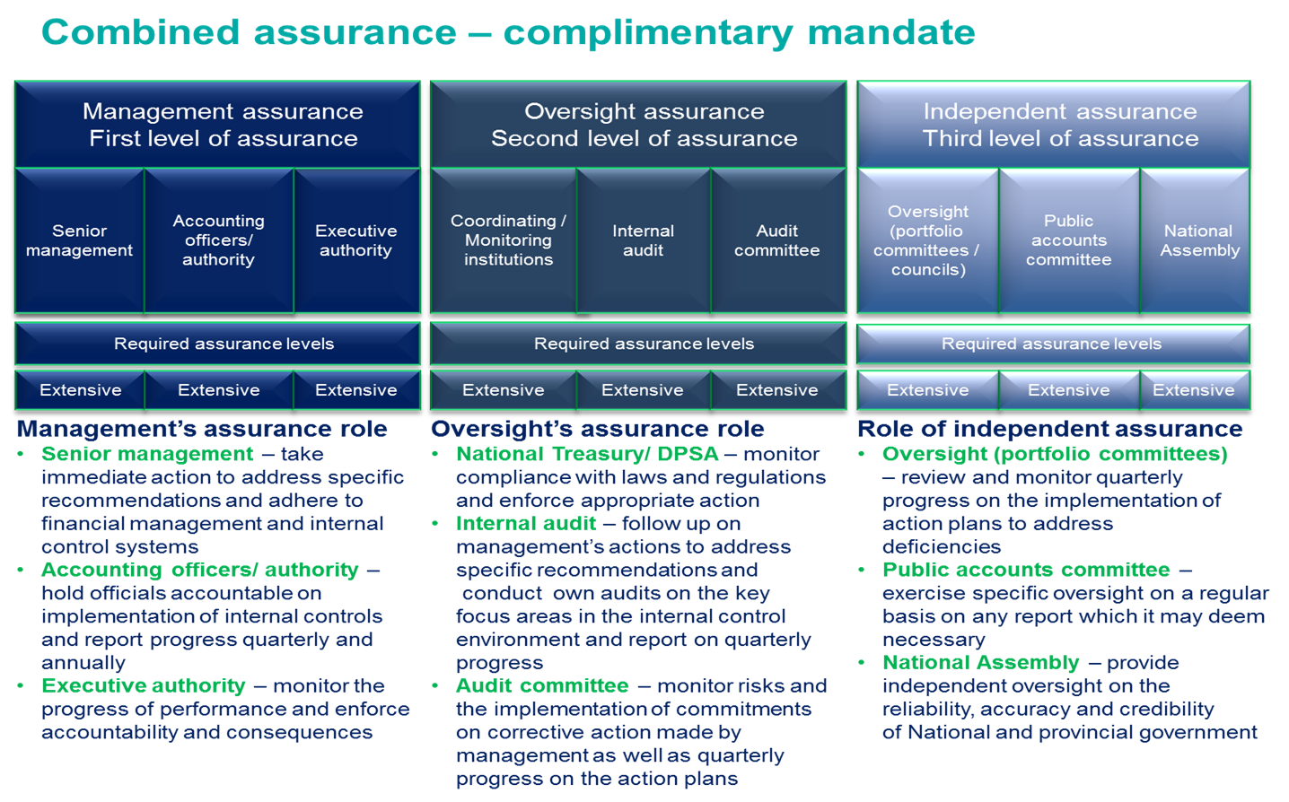

Minister’s commitments and progress on these commitments

The following are commitments made by the minister and their progress:
Focus area | Commitment | Made by | Date | Status
None | Appointment of director-general | Minister | January 2016 | Not implemented
None | Appointments of the vacant posts in management | Minister | February 2016 | In progress
Supply chain management | Policy and procedures to be revised  Consequence management to be implemented against officials not complying with regulation. | Acting Director General | August 2014 | Complete
Annual financial statements | The review of the AFS is to be done by two senior officials, the internal audit firm and the Audit Committee before submitting them to the AG. | Chief Financial Officer | April 2016 | Complete
Predetermined objectives | Ensure that proper record keeping of supporting documents, easily retrieved and verified for audit | Acting Director General | February 2016 | In progress

STATUS LEGEND
Commitment has been implemented
Commitment in progress
Commitment has not been implemented

Assessment of the Portfolio committee
The following criterion was used to evaluate the level of assurance for the Portfolio Committee:
Budgets

- Did the portfolio committee assess alignment between the department’s budget and annual performance plan?
- Were there sufficient deliberations in terms of the key projects identified in the proposed budget?
Review of the annual reports
- Did the portfolio committee assess the annual report in detail to determine the financial stability of the department (including its entities)?
- Were undesirable audit outcomes adequately interrogated and were corrective measures obtained from those charged with governance?
Performance information and service delivery

- Did the portfolio committee assess the quality of the performance report, followed up on the AGSA’s findings, ensured that all predetermined targets were reported and/or achieved, followed and reviewed the entity/department’s service delivery improvement programme (if applicable)?
Stability of the portfolio committee

- Was the composition of the committee (as well as the chairperson) stable to ensure that previous commitments made by the department (incl. entities) are effectively followed up?

