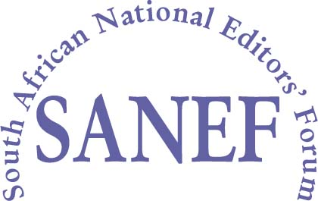
• Block A, 1 Richmond Forum, Ground Floor, Cedar Avenue, Richmond, Johannesburg •
• Tel 011 482 5771 / 6775 • Fax 011 484 9132 • 046 338 NPO • www.sanef.org.za • director@sanef.org.za •

Suggested Aments to the Film and Publications Amendment Bill, 2015 [B37-2015]

1. The South African National Editors Forum wishes to submit suggested wording changes to the Film and Publications Amendment Bill, 2015 [B37-2015] (“the FPA Bill”) to ensure that online publications of members of the Press Council are excluded from the classification requirements of the ambit of the FPA Bill.

2. The FPA Bill proposed to amend section 16(1) of the Films and Publications Act, 1996 (“the Act”) by including the word “magazine”. Essentially section 16(1) of the FPA Bill aims to exclude newspapers and magazines published by a member of a body that is recognised by the Press Ombudsman. Such a body is of course the Press Council of South Africa which body is now defined in a new proposed definition but the term does not find its way into proposed amended section 16. We are also of the view that the online material that members of the Press Council wish to be exempt in terms of section 16 of the PBA does not fall squarely within the current definitions of a “newspaper” in the Act or the proposed new definition of “magazine” in the FPA Bill.

3. Consequently we propose that the proposed amendments to section 16 of the FPA Bill be further amended to read as follows: (Our additions/removals from the existing draft text in red and underlined):

“(1) Any person may request, in the prescribed manner, that a publication, other than a publication [bona fide] [newspaper or magazine] that is published by member of the Press Council of South Africa [body, that is recognised by the Press Ombudsman,] and which member subscribes[,] and adheres[,] to a code of conduct that must be enforced by that body, and, other than an advertisement that falls within the jurisdiction of the Advertising Standards Authority of South Africa, which [is to be or] is being distributed in the Republic, be classified in terms of this section.”

To be clear, the new section 16(1) is intended to read as follows:
(1) Any person may request, in the prescribed manner, that a publication, other than a publication that is published by member of the Press Council of South Africa and which member subscribes, and adheres, to a code of conduct that must be enforced by that body, and, other than an advertisement that falls within the jurisdiction of the Advertising Standards Authority of South Africa, which is being distributed in the Republic, be classified in terms of this section.”

4. The next important step is to make consequential amendments to the proposed existing definition of “Publication” in the Act and in respect of the proposed amendments thereto contained in the FPA Bill.

5. We are of the view that the definition of Publication needs to be amended as follows:

5.1. by amending sub-section (a) of the definition currently contained in the Act such that it reads as follows: “any newspaper, magazine, book, periodical, pamphlet, poster or other printed matter;”;
5.2. by further amending proposed sub-section (i) of the definition proposed in the FPA Bill such that it reads as follows: “any website, social media, message or communication, including [a] an audio, visual, or audio-visual (that is, including video) presentation (whether live-streamed, streamed or otherwise) placed on any distributed network including, but not confined to, the [Internet] internet;”.

6. In our view these fairly straight forward amendments would bring all of the publications (that is, a hard or soft copy newspaper, hard or soft copy magazine as well as all online content) of a member of the Press Council of South Africa (print, broadcasting and/or online) within the exemption provided for in section 16 of the Act from having to be classified under the Act.

