6. REPORT OF THE PORTFOLIO COMMITTEE ON HOME AFFAIRS ON THE ANNUAL PERFORMANCE PLAN AND BUDGET VOTE 5 OF THE DEPARTMENT OF HOME AFFAIRS, DATED 19 APRIL 2016
The Portfolio Committee on Home Affairs (the Committee) having met with the Department of Home Affairs (DHA), the Electoral Commission of South Africa (IEC) and the Government Printing Works (GPW) on their Annual Performance Plans (APPs) and budgets for 2016/17, reports as follows:
1. Introduction
Parliament of the Republic of South Africa, through the Portfolio Committee on Home Affairs, conducts oversight over the DHA, the IEC and GPW. The Committee met with the DHA on 15 March and also with the IEC and GPW on 5 April, 2016 to receive briefings on the Annual Performance Plans for 2016/17 financial year as well their related budgets. The total budget of the DHA is R7.167 billion for 2016/17 financial year. This includes transfers to the IEC and GPW.
The mandate of the DHA is derived from the Constitution and various acts of Parliament and policy documents. The DHA’s services are divided into two broad categories: civic services and immigration services. Both must ensure the efficient determination and safeguarding of the identity and status of citizens and foreigners, and provide for the management of immigration to ensure security, promote development and fulfil South Africa’s international obligations
The Civic Affairs branch is the custodian of the National Population Register (NPR), which contains the records of all citizens and permanent residents, including changes in status such as marriage and death. Services to citizens include issuing enabling documents after their status is confirmed, such as birth and death certificates and travel documents. The verification of identity is a service that is also rendered to all government institutions, banks and other private sector institutions. Transfers to the GPW and IEC also form part of the Citizen Affairs budget sub-programme.
The Immigration Affairs branch determines the status and identity of foreigners, regulates immigration through the permitting and movement control systems and provides consular services abroad. Immigration officers are present at ports of entry and regional offices in provinces. The branch also has an inspectorate function which is responsible for enforcing the Immigration Act (No. 13 of 2002) and its Regulations. Immigration Affairs is also responsible for processing and determining the status of asylum seekers and refugees and operates centres nationally in this regard.
1.1. Remarks by Home Affairs on their 2015/2016 APP and Budget
The Minister of Home Affairs: Mr M Gigaba, made the opening remarks.The Director-General (DG) of the DHA: Mr Mkuseli Apleni, made the presentation. The Minister indicated that the APP was presented at the crucial time where the Minister of Finance has indicated that all South Africans and departments should tighten their belts with regard to spending. The DHA will thus reprioritise resources whilst continuing to strive to improve the quality of services. The priorities for the Minister of Home Affairs for 2016/17 financial year are:
• The modernisation programme.
• The implementation of the Border Management Agency (BMA).
• Improving the frontline office services.
• Reviewing the immigration policy.
• The overhaul of the physical infrastructure of Ports of Entry.

In implementing, the above and the targets for 2016/2017, the DHA would be very strict with regards to financial management. The minister further indicated that the DHA is now included in the security cluster.
2. The Department of Home Affairs 2016/2017 Annual Performance Plan
The DG took the Committee through the government planning system, starting with the National Development Plan (NDP), the Medium-Term Strategic Framework (MTSF), the Ministerial priorities and how they link with the MTSF and the plans of the DHA, the Strategic Plan and the APP.
MTSF priorities are based on the electoral mandate. The Electoral Mandate is: decent work and sustainable livelihoods; education; health; rural development, food security and land reform and fight against crime and corruption. The DHA commitments in the MTSF 2014 to 2019 focus, inter alia, on the following key areas reflected in the 2016/17 budget vote 5:
• South Africa’s borders are effectively defended, protected, secured and well-managed. This includes establishment of a Border Management Agency (BMA) and developing an over-arching strategy to defend, protect, secure and ensure well-managed borders.
• Identity of all persons in SA are known and secured. This would be achieved through ensuring that registration at birth is the only entry point for South Africans to the new identity system (NIS). Also to ensure that systems are in place to enable the capturing of biometric data of all travellers who enter or exit SA legally.
• Improve and streamline regulations to reduce the burden of importing core and critical skills needed for the economy. This would be achieved through review of the immigration policy and legislation that supports the importation of economically important skills.

The Government has 14 outcomes and the DHA contributes directly to four outcomes which are:
Outcome 3: All people in South Africa are and feel safe;
Outcome 4: Decent employment through inclusive economic growth;
Outcome 12: An efficient, effective and development oriented public service; and
Outcome 14: Nation building and social cohesion.
The Director-General reported that the BMA will be established by 1 April 2017. The draft BMA Bill was still at the National Economic Development and Labour Council (NEDLAC). It was reported that the following issues were raised at NEDLAC:
• Agencification (The tendency to create separate non-departmental agencies to provide government services).
• The uncontested powers of the Minister of Home Affairs.
• The lack of right to strike by BMA members.
• The need for conflict resolution mechanisms.
The DHA has three programmes namely, Administration, Services to citizens and Immigration Services. The Director-General indicated that the targets for 2016/2017 have been reduced from 36 to 32. The targets on birth registration and Smart ID Card have, however, remained unchanged from 2015/2016.
It was further emphasised that the DHA classification as a security department would be used to further negotiate for related staff and budget allocations. The network problems encountered at the frontline office between the State Information Technology Agency (SITA) and the DHA also been brought to Cabinet. Cabinet has approved the exemption from using SITA in principle, however, DHA has been requested to discuss the implications with SITA before approval. The Minister and the DG indicated that the frequency of the SITA related network problems had damaged the DHA’s reputation.
The birth, marriage and death (BMD) processes would be developed into the Live Capture. The Live Capture for Refugee Smart Card and Travel documents would be developed and tested. The Director-General indicated that BMD as well as the issuance of refugee Identity and travel documents needed to be automated to address service backlogs and security issues. The permitting system at foreign missions also needed to be brought online.
The DHA will maintain the vacancy rate below 10 percent by 31 March 2017 as required. There would be twenty awareness initiatives on ethics, fraud prevention and counter fraud and corruption conducted. It was reported that 64 percent of the reported cases of fraud and corruption would be finalised within 90 working days. The DHA would finalise and refer 620 files to State Security Agency (SSA) for vetting.
The feasibility study, including the financial model for the building of the Refugee Reception Offices (RROs) closer to land borders would be completed and submitted to the Minister of Home Affairs. All Ports of Entry will be equipped with the biometric systems by 2018/2019 and the Immigration and Refugees Acts will have been assented and signed by the President in 2018/2019 based on the Green and White Paper soon to be released by the DHA.
Premium Visa and Permit Service Centres for Corporate Accounts will be established in Durban, Port Elizabeth and potentially Cape Town, to facilitate fast-tracking of services to large investors. The target for issuance of Permanent Residence Permits (PRP) would be 85 percent of applications adjudicated within eight (8) months for applications collected within this time period. The above includes the PRP of people with the critical skills, general work permit and business permits. Eighty percent of the business and general work visas would be adjudicated within eight (8) weeks.
The DG further indicated that 90 percent of the 750 000 births would be registered within 30 days and 100 percent of births would be registered within 30 days by 2018/2019 and processes were in place to improve on current rates. The DHA will issue 2.2 million Smart ID Card to citizens of 16 years of age and above and 90 percent of first Identity Documents (IDs) should be issued within 54 working days. The DHA plans to issue 95 percent of Re-issued IDs within 47 working days.
3. Budget Analysis
The spending focus over the medium term will be on the DHA repositioning itself as a highly secure, professional and modern organisation through increasing its immigration enforcement capacity, modernising and integrating its information systems, and increasing and improving its client interfaces. It should be noted that the current fiscal context is within continuing difficult global and domestic economic conditions. Therefore, government is firm in its commitment to sound fiscal management in the face of the challenging economy.
Given that, the government is continuing with the approach of using the expenditure ceiling as a fiscal anchor, which was adopted in 2012. All government institutions have been encouraged to manage costs pressures like inflation and exchange rates with greater efficiency.
The 2016 State of the Nation Address (SONA) was delivered against the backdrop of a continued global economic downturn and the possibility of an investment downgrade for South Africa from international rating agencies. The President announced a number of austerity measures to reduce expenditure by Government departments, which include: limiting international travel partnered with strong motivations to the benefit for the country for any international trips, reducing the size of delegations for international trips, restrictions on conferences, entertainment and social functions, as well as abolishing budget vote dinners hosted by departments.
SONA 2016 makes specific reference to the following five Home Affairs-related initiatives to be considered in the plans and related budget of the Department:
• Significant work must be undertaken in order to promote an inclusive and a non-racial society.
• The country should take advantage of the recent changes in visa regulations to boost inbound tourism.
• While the preference is that employers should prioritise local workers, the South African migration policy must also make it possible to import scarce skills. In this regard, the draft migration policy will be presented to Cabinet during the course of 2016.
• South African citizens over the age of 18 should register for the local government elections during the voter registration weekends. A special invitation was extended to the youth, in particular those who are turning 18 years of age during the course of 2016.
• Faster growth is required in order to achieve job creation and reducing inequality.
The DHA budget shows a decrease from R7.3 billion to R7.1 billion between the 2015/16 and 2016/17 financial years. When taking into account the inflation rate, this shows a real decrease of more than 8.65 percent in its allocated budget for the year under review (when considering the inflation rate). The total budget of DHA includes allocations to its related entities; the IEC and the GPW.

Table: Budget per programme
Programme
R million
2015/16
2016/17
Programme 1: Administration
1 887.0
2 222.9
335.9
198.3
17.80
10.51
Programme 2: Citizen Affairs
4 826.5
3 901.6
- 924.9
- 1 166.5
-19.16
-24.17
Programme 3: Immigration Affairs
645.2
1 042.7
397.5
332.9
61.61
51.6
TOTAL
7 358.7
7 167.2
- 191.5
- 635.2
-2.6
-8.63
Real Percent
change in
2016/17
Budget
Nominal
Increase /
Decrease in
2016/17
Real
Increase /
Decrease in
2016/17
Nominal
Percent
change in
2016/17

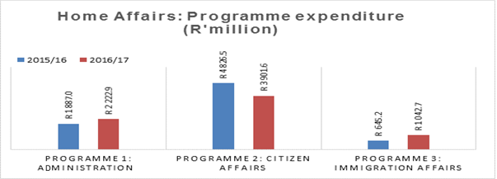

In total, the DHA budget is reduced by R191.5 million from 2015/16 to 2016/17 (as indicated across the three programmes in the table above).

3.1. Programme analysis

3.1.1. Programme 1: Administration
Programme 1 allocation increases by 10.5 percent (taking into account the cost of inflation/ real increase) from the previous financial year. Total expenditure for 2016/17 is R2.2 billion (compared to R1.887 billion the previous year). Expenditure under Programme 1 is dominated by the Transversal Information Technology Management sub-programme forming 39 percent of the programme budget followed by the Corporate Services sub-programme at 21 percent.
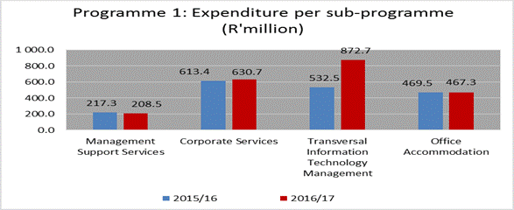
The only sub-programme which experiences real growth from the previous year, is Transversal Information Technology Management which grows by 54 percent. This expenditure is in line with the MTSF imperative which is aimed at ensuring that the Identity of all persons in SA is known and secured, as well as Outcome 1.1 and 1.2, which consider the following:
- All eligible citizens are issued with enabling documents relating to identity and status.
- An integrated and digitised National Identity System (NIS) that is secure and contains biometric details of every person recorded on the system.
After inflation (6.6 percent) the following real increases/ decreases are recorded per sub-programme:
- Ministry: 7.3 percent (decline)
- Management Support Services: 10 percent (decline)
- Corporate Services: 3.6 percent (decline)
- Transversal Information Technology Management: 54 percent (increase)
- Office Accommodation: 6.6 percent (decline)

3.2.1. Programme 2: Citizen Affairs

Programme 2 remains the biggest of the three main programmes in the DHA, constituting 54.4 percent of the overall departmental budget. The programme’s allocation shrinks from R4.8 billion the previous year, to R3.9 billion. Overall expenditure under Programme 2 declines by 24 percent in real terms from the previous financial year. Expenditure is dominated by allocations to the following sub-programmes under Programme 2: Services Delivery to Provinces (R1.75 billion) and the Electoral Commission (R1.59 billion)
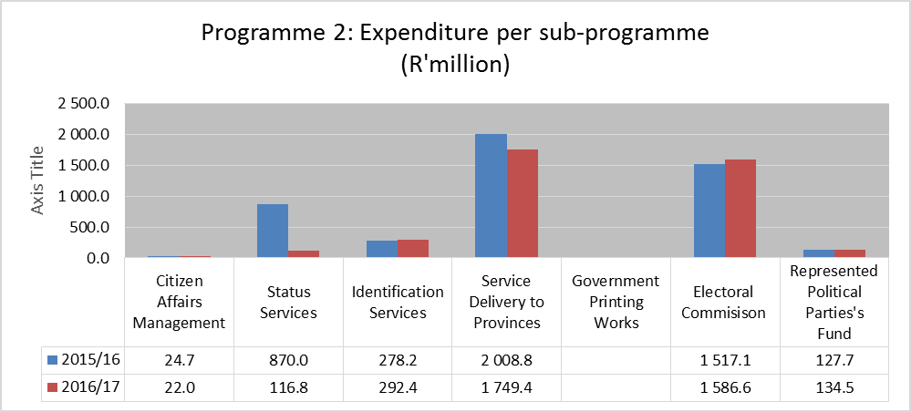
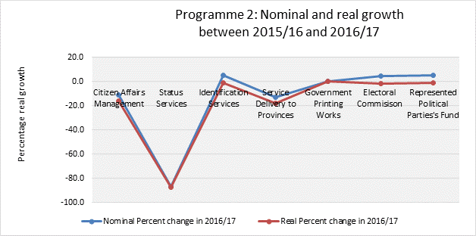
Nominal growth is recorded for the Identification Services (5 percent), the Electoral Commission (4.6 percent), and Represented Political Parties Fund (5.3 percent) sub-programmes. Identification Services increases from R278.2 million to R292.4 million, while Electoral Commission increases from R1.517 billion to R1.586 billion. However, taking into account the effects of inflation, all three sub-programmes experiences a decline in real terms. The rest of the sub-programmes decreased both in nominal and real terms, as indicated by the figure above.
The Status Services sub-programme experiences the biggest decline in its funding, i.e. 87 percent (real terms) from the previous financial year. This is the sub-programme tasked with one of the main mandates of the Department, i.e. maintaining an accurate register of all citizens and immigrants who have acquired the right to permanent residence; registering births, deaths and marriages; providing travel and citizenship documents; providing financial assistance to citizens abroad who wish to return to South Africa but have no means of doing so; and determining and granting citizenship.

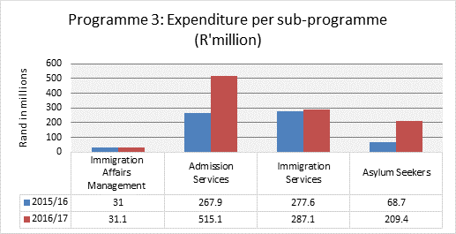
3.1.1. Programme 3: Immigration Affairs
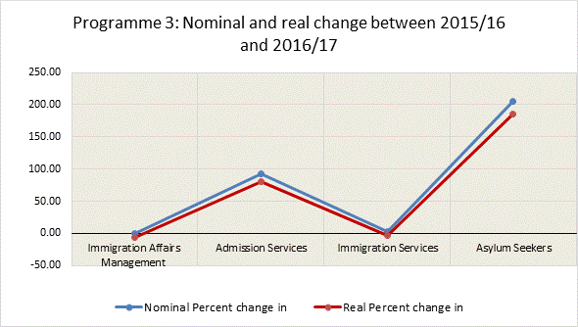
Programme 3, while the smallest of the three main programme in terms of monetary value, experiences the strongest growth both in nominal and real terms.
Expenditure grows with 51 percent (real growth) from R645 million the previous year, to over 1.042 billion in the current year.

Almost half of expenditure under Programme 3 is allocated towards the Admission Services sub-programme (49.4 per cent). This sub-programme is tasked to better manage immigration in a way that balances South Africa’s openness to travellers, as well as developmental and security imperatives.
Without exception, all four sub-programmes under Programme 3 are experiencing positive nominal growth. However, given the effects of inflation, the Immigration Affairs Management and Immigration Services sub-programmes are both experiencing small decreases from the previous financial year, i.e. -6 and -3 percent respectively. Real growth under Programme 3 is driven by the following two sub-programmes: Admission Services (80 percent) and Asylum Seekers (186 percent).These expenditures are in line with NDP which requires the DHA to facilitate the acquisition of the critical skills and to play a role in enabling regional development by working with SADC countries to improve the efficient, secure and managed movements of people.
The increases in both the admission services and asylum seekers sub-programmes is commendable given that the DHA historical underfunding as well as the forthcoming increased responsibility and enforcement capacity of the Border Management Agency. This will also assist the DHA in addressing the challenges encountered during the course of 2015/16 within the immigration services.
4. The Government Printing Works (GPW)
Dr AD Mbewu: the Chief Executive Officer and Mr R Barnard: the Chief Financial Officer, made the presentation on behalf of the GPW. It was indicated that the GPW strives to make a significant contribution to the 14 National Outcomes of government and the goals of the NDP. It specifically contribute to the National Outcomes by creating a better South Africa and contributed to a better and safer Africa and the world; an efficient, effective and development oriented public service and an empowered, fair and inclusive citizenship; decent employment through inclusive economic growth and a skilled and capable workforce to support an inclusive growth path.
The work of the GPW supports Chapter 13 of the NDP by building a capable state. The GPW operates in terms of the Public Service Act of 1994, where it derives its legislative mandate. The GPW was established as a Government Component in 2009. As a Government component, the GPW delivers security printing services to government. The Chief Executive Officer of GPW reports to the Minister of Home Affairs.
The CEO indicated that the development of the Strategic Plan for 2017/2021 was guided by the policy priorities of government and the DHA. The Strategic Plan has three outcome-oriented goals, namely, to further develop the Government Component organisation to become a State Owned Company; to optimise processes and facilities to increase operational effectiveness and improve customer service; and to have an efficient, effective and well-trained workforce.
The CEO reported that a draft State Printers’ Bill has been produced and it would probably be introduced in Parliament July 2016. The Bill stipulates that all government security printing will be done by the GPW unless the Ministers of Home Affairs and State Security grant exemption. The Bill will further allow the GPW with the flexibility in setting market-related salaries in order to attract and retain skilled artisans.
The GPW has completed the Visagie Street Printing Campus at a total cost of R788 million. The Pavilion 7 facility is being converted into a Dispatch Centre for passports and Smart ID Cards and it is due for completion by the end of 2017. In the implementation of the Dispatch Centre, there will be no human intervention in the production of Smart ID Cards from the time of Live Capture details of applicants at the offices of the DHA to the courier.
The High Speed Printing and Examination Papers Factory is being constructed at Pavilion 3. It was reported that the total cost of this Factory and the Dispatch Centre is R257 million and it will be completed by the end of 2016. The renovation of the building into an Administration Building next to the Visagie Street facility will cost between R10 and R15 million and the cost to purchase it was R49 million. This is expected to be completed by the end of 2016.
The Electronic Government Gazette (e-Gazette) was launched in 2012 and customers can now submit material for gazetting electronically. This will save thousands of tonnes of paper every year. The website can be accessed at: www.gpwonline.co.za.
The GPW operates on business principles and has doubled its budget since 2009 when it was converted into a Government Component and it is ready to complete its transformation to a State Owned Company over the next few years. The CEO reported that the launch of the Smart ID Card has been a success. In the 2015/16, the GPW has produced 2 315 323 Smart ID Cards and it is on track to produce 40 million more Smart ID Cards over the next five years. The Smart ID Card is replacing the green ID Books. The GPW reported that it had been difficult to procure security printing business in the rest of the African continent but it continues to print the African Union passport.
For the financial year 2016/17, the priorities for GPW are to further develop the enabling legislation and complete the business case for the transformation into State Owned Company; the production of security printed materials according to customer requirements and local and international standards; further development and utilisation of a secure operating facility and the completion of Human Resource initiatives to produce adequately trained employees.
5. The Electoral Commission of South Africa (IEC)
GM Mashinini: The Chairperson of the Electoral Commission led the delegation. Ms Fiona Rowley-Withey: Deputy CEO made the presentation. It was reported that the IEC had three Strategic Goals:
- Strengthening governance, institutional excellence, professionalism and enabling business processes, at all levels of the organisation.
- Achieving pre-eminence in the area of managing elections and referenda, including the strengthening of a cooperative relationship with political parties.
- Strengthening electoral democracy.
It was reported that the IEC will have 980 permanent staff by the end of the 2016/17 financial and there would be 120 bursaries awarded. The IEC intends to have an unqualified audit opinion by 31 March 2017. Local government elections will be held within 90 days and Proportional Representation seats will be replaced within 35 days. The date of the vacancy is the date on which the IEC receives the notification. In terms of the law, the election results have to be released within 7 days after the election. It was reported that as at 31 March 2016, the IEC had 26 139 122 registered voters on the voters’ roll. This number could increase due to the registration weekend of 9 and 10 April 2016. The voters roll will continue to be verified every month against the National Population Register.
The IEC planned to replace the bar code scanners (so-called the Zip Zip machines) after the Local Government Elections in 2016. The current machines will still be used for by-elections after the Local Government Elections this year.
The Local Government Elections will take place on 3rd of August 2016. There will be 263 454 staff to assist with the elections. There will be 22 563 voting stations countrywide. The IEC is expecting 60 percent of registered voters to turnout during the Local Government Elections which translates into 15 683 473 voters. It aims to reach an audience of an estimated 2.5 million via television and radio. There would also be 60 000 civic and democracy initiatives per year. The number of recorded spoilt ballot papers is expected to be 1.6 percent of the total votes cast.

Below is the summary of the budget in respect of the Strategic Goals:
Strategic Goals | 2016/17  R000s | 2017/18  R000s | 2018/19  R000s
1. Strengthening governance, institutional excellence, professionalism and enabling business processes, at all levels of the organisation. | 485 909 | 535 225 | 581 019
2. Achieving pre-eminence in the area of managing elections and referenda, including the strengthening of a cooperative relationship with political parties. | 959 200 | 482 650 | 884 452
2. Strengthening electoral democracy. | 200 985 | 133 633 | 380 581
Grand total | 1 646 094 | 1 151 508 | 1 846 052

The IEC gave an update with regard to the Tlokwe Electoral Court judgement relating to the need to add the particularities/address of the voters into the voters’ roll. The IEC reported that it has appealed the Electoral Court judgement to the Constitutional Court to apply for the direct access to get clarity on whether addresses of voters should be added to the voters’ roll retrospectively. The IEC reported that approximately 8 million households in South Africa do not have known addresses.
Depending on the outcome of the appeal to the Constitutional Court judgement, there could be changes in relation to the IEC budget. The IEC was concerned about the practicality of accessing the addresses of historically registered voters to the voters’ roll.
6. Committee observations
The Committee appreciated the presentations made by the Department of Home Affairs, the Electoral Commission and the Government Printing Works and engaged with them and made the following observations:
6.1. Department of Home Affairs
6.1.1. The Committee noted that there are still acting Provincial Managers, especially for North West and Mpumalanga Provinces.
6.1.2. The network problems between the Department of Home Affairs and SITA continues to be problematic however Cabinet has approved in principle for the exemptions for DHA to use the services of SITA.
6.1.2. The budget of the Department of Home Affairs has been significantly reduced and therefore the DHA is underfunded.
6.1.3. There were reports in the media of identity theft and genuine mistakes where ID books have been tampered with.
6.1.4. Corrections to enabling documents were taking too long to rectify and was inconveniencing people.
6.1.6. The confrontation between locals and foreign nationals.
6.1.7. The stealing and looting from the foreign owners’ shops.
6.1.8. The illegal possession of arms by foreign nationals and taking law in their hands.
6.2. The Government Printing Works
6.2.1. The CEO’s contract would come to an end on 31st of December 2016.
6.2.2. The State Printers Bill would probably be introduced in July 2016, to convert the GPW from Government Component into State Owned Company.
6.2.3. The level of risk at the GPW is high in relation to processes and staff.
6.3. The Electoral Commission of South Africa
6.3.1. Some indicators did not have quarterly targets, which makes it difficult to establish if progress is being made during the year.
6.3.2. There will be a second and final Registration Weekend on 9 and 10 April 2016 before 2016 Local Government Elections.

7. Recommendations
Based on the continuous engagement with the Department of Home Affairs, the Government Printing Works and the Electoral Commission, the Committee recommends the following:
7.1. The Department of Home Affairs
The Committee recommends that the Department of Home Affairs should:
7.1.1. Consider filling all critical funded positions within the Department of Home Affairs.
7.1.2. Engage SITA on the modalities of the exemptions from using the SITA network at frontline offices of the DHA.
7.1.3. Engage with National Treasury for funding to accommodate the mandate of the DHA in line with its security cluster status.
7.1.4. Expedite queries with regards to members of the public in relation to corrections in enabling documents.
7.2. The Government Printing Works
The Committee recommends that the Government Printing Works should:
7.2.1. Ensure that all staff are vetted to prevent breaches to security and corruption in the printing of Smart ID Cards, passports and other security printing.
7.2.2. Ensure that the construction and renovation of its projects remains corruption free.
7.3. The Electoral Commission of South Africa
The Committee recommends that the IEC should:
7.3.1. Ensure that all obstacles are dealt with in relation to upcoming Local Government Election.
7.3.2. Report to the Committee as soon as possible on the implications of the Constitutional Court judgement once a ruling is made.
7.4. It is recommended that all political parties should assist the IEC to conduct credible, free and fair elections.

8. The Committee recommends that the House approves the 2016/17 Budget of the Department of the Home Affairs.
Report to be considered.

