REPORT TO THE PORTFOLIO AND SELECT COMMITTEES ON
COOPERATIVE GOVERNANCE AND TRADITIONAL AFFAIRS

PREPARATIONS AND READINESS FOR THE
2016 LOCAL GOVERNMENT ELECTIONS

- PURPOSE

  - To update the Committees on Cooperative Governance and Traditional Affairs (“the Committee”) on work that the Ministry of Cooperative Governance and Traditional Affairs, and the Department of Cooperative Governance (“the Department”) is presently dealing with in relation to the preparations for the 2016 local government elections (LGEs).

  - This memorandum deals with the following matters:

- The role of the Minister;
- Major boundary determinations confirmed by the Municipal Demarcation Board (“the MDB”);
- Role of the Provinces;
- Matters to be managed during the transition;
- Municipal Demarcation Transition Committee (“the MDTC”);
- Other Structural Arrangements to Support Preparations for the 2016 Local Government Elections;
- Assignment of addresses; and
- Recommendations.

- ROLE OF THE MINISTER

  - In terms of section 20 of the Structures Act, the number of councillors of a municipal council must be determined in accordance with a formula determined by the Minister by Notice in the Government Gazette, based on the number of registered voters on the municipal segment of the national common voters’ roll. Formulae was published in the Government Gazette on 9 September 2014, as follows:

CATEGORY | FORMULA
METROPOLITAN MUNICIPALITIES: | Y = X / 10000 + 50
LOCAL MUNICIPALITIES:
BELOW 7501 VOTERS | Y = 5
BETWEEN 7500 AND 100001 VOTERS | Y = X / 2055 + 2
MORE THAN 100000 VOTERS | Y = X / 8333 + 48
DISTRICT MUNICIPALITIES:
BELOW 100001 VOTERS | Y = X/10000 + 10
MORE THAN 100000 | Y = X/15000 + 15

  - In terms of section 24 of the Structures Act, the Minister, after consulting the Electoral Commission, must, by Notice in the Government Gazette, call and set a date for an election of all municipal councils within 90 days of the expiry of the term of municipal councils.

Further, the Notice may be published either before or after the term of expiry of municipal councils.

Discussions in this regard between the Ministry and the Electoral Commission have been held.

  - In line with past practice, Cabinet approved that the Inter-Ministerial Task Team on Municipal Elections (“the IMTToME”), and the Technical Task Team on Municipal Elections (“the TTToME”) be established.

The main objective of the Task Teams is to coordinate all government activities in preparation of the LGEs.

The IMTToME was convened by the Minister on 25 February, 09 March and 01 April 2016 and will consist of the following Ministries:

  - Ministry of Justice and Constitutional Development
  - Ministry of Home Affairs;
  - Ministry of Police;
  - Ministry of State Security; and
  - Ministry of Communications.

The Chairperson of the IEC, the SALGA and the MDB also form part of the IMTToME.

  - The TTToME, is chaired by the Director-General: DCoG, and consists of the following Departments:

  - Department of Justice and Constitutional Development;
  - Department of Home Affairs;
  - Department of Police;
  - Department of State Security; and
  - Department of Communications.

The CEOs of the IEC, the SALGA and the MDB also form part of the TTToME.

The TTToME met on 12 June 2015, 22 January 2016 and 9 March 2016.

  - The IMTToME of 25 February 2016 and 9 March 2016 resolved that the TTToME should find a solution to a challenge relating to households without formal addresses in light of the Constitutional Court and Electoral Court judgements.

- MAJOR BOUNDARY REDETERMINATIONS CONFIRMED BY THE MUNICIPAL DEMARCATION BOARD

  - During 2013, the MDB confirmed the outer boundaries of municipalities in preparations for the 2016 local government elections.

In respect of Gauteng:

Westonaria and Randfontein Local Municipalities will be amalgamated into a single local municipality (reduction of 1 municipality).

In respect of KwaZulu-Natal:

The following municipalities have been amalgamated (reduction of 7 municipalities):
  - Vulamehlo and Umdoni;
  - Hlabisa and The Big 5 False Bay;
  - Umtshezi and Imbabazane;
  - Ezinqoleni and Hibiscus Coast;
  - Emnambithi / Ladysmith and Indaka;
  - Kwa Sani and Ingwe; and
  - Ntambanana / Mthonjaneni /Umhlathuze.

  - Between February and April 2015, the Minister requested the MDB, in terms of section 22(2) of the Demarcation Act, to determine or redetermine the boundaries of various municipalities with the view to optimise their financial viability. In total, after consultation with the MECs for local government, 34 requests were made to the MDB by the Minister, as follows:

PROVINCE | NO. | PROVINCE | NO.
KZN | 11 | LIM | 5
EC | 5 | MP | 5
FS | 2 | NW | 4
GP | 1 | NC | 1

  - On 27 and 28 August 2015 the MDB confirmed decisions in respect of 12 cases.

On 21 October 2015 the MDB confirmed the redetermination of Ikwezi/Baviaans/Camdeboo.

PROVINCE | NO. | PROVINCE | NO.
KZN | 1 | LIM | 4
EC | 4 | MP | 1
FS | 1 | NW | 1
GP | - | NC | 1

The MDB Confirmed 10 cases, and varied 3 cases (2 in Limpopo, and 1 in Eastern Cape).

  - The following scenario will prevail with regards to the number of municipalities post the 2016 LGE:

PROVINCE | CAT A | CAT B | CAT C | TOTAL
EC | 2 | 31 (-6) | 6 | 39
FS | 1 | 18 (-1) | 4 | 23
GT | 3 | 6 (-1) | 2 | 11
KZN | 1 | 43 (-7) | 10 | 54
LIM | 0 | 22 (-3) | 5 | 27
MP | 0 | 17 (-1) | 3 | 20
NC | 0 | 26 (-1) | 5 | 31
NW | 0 | 18 (-1) | 4 | 22
WC | 1 | 24 | 5 | 30
TOTAL | 8 | 205 (-21) | 44 | 257 (-21)
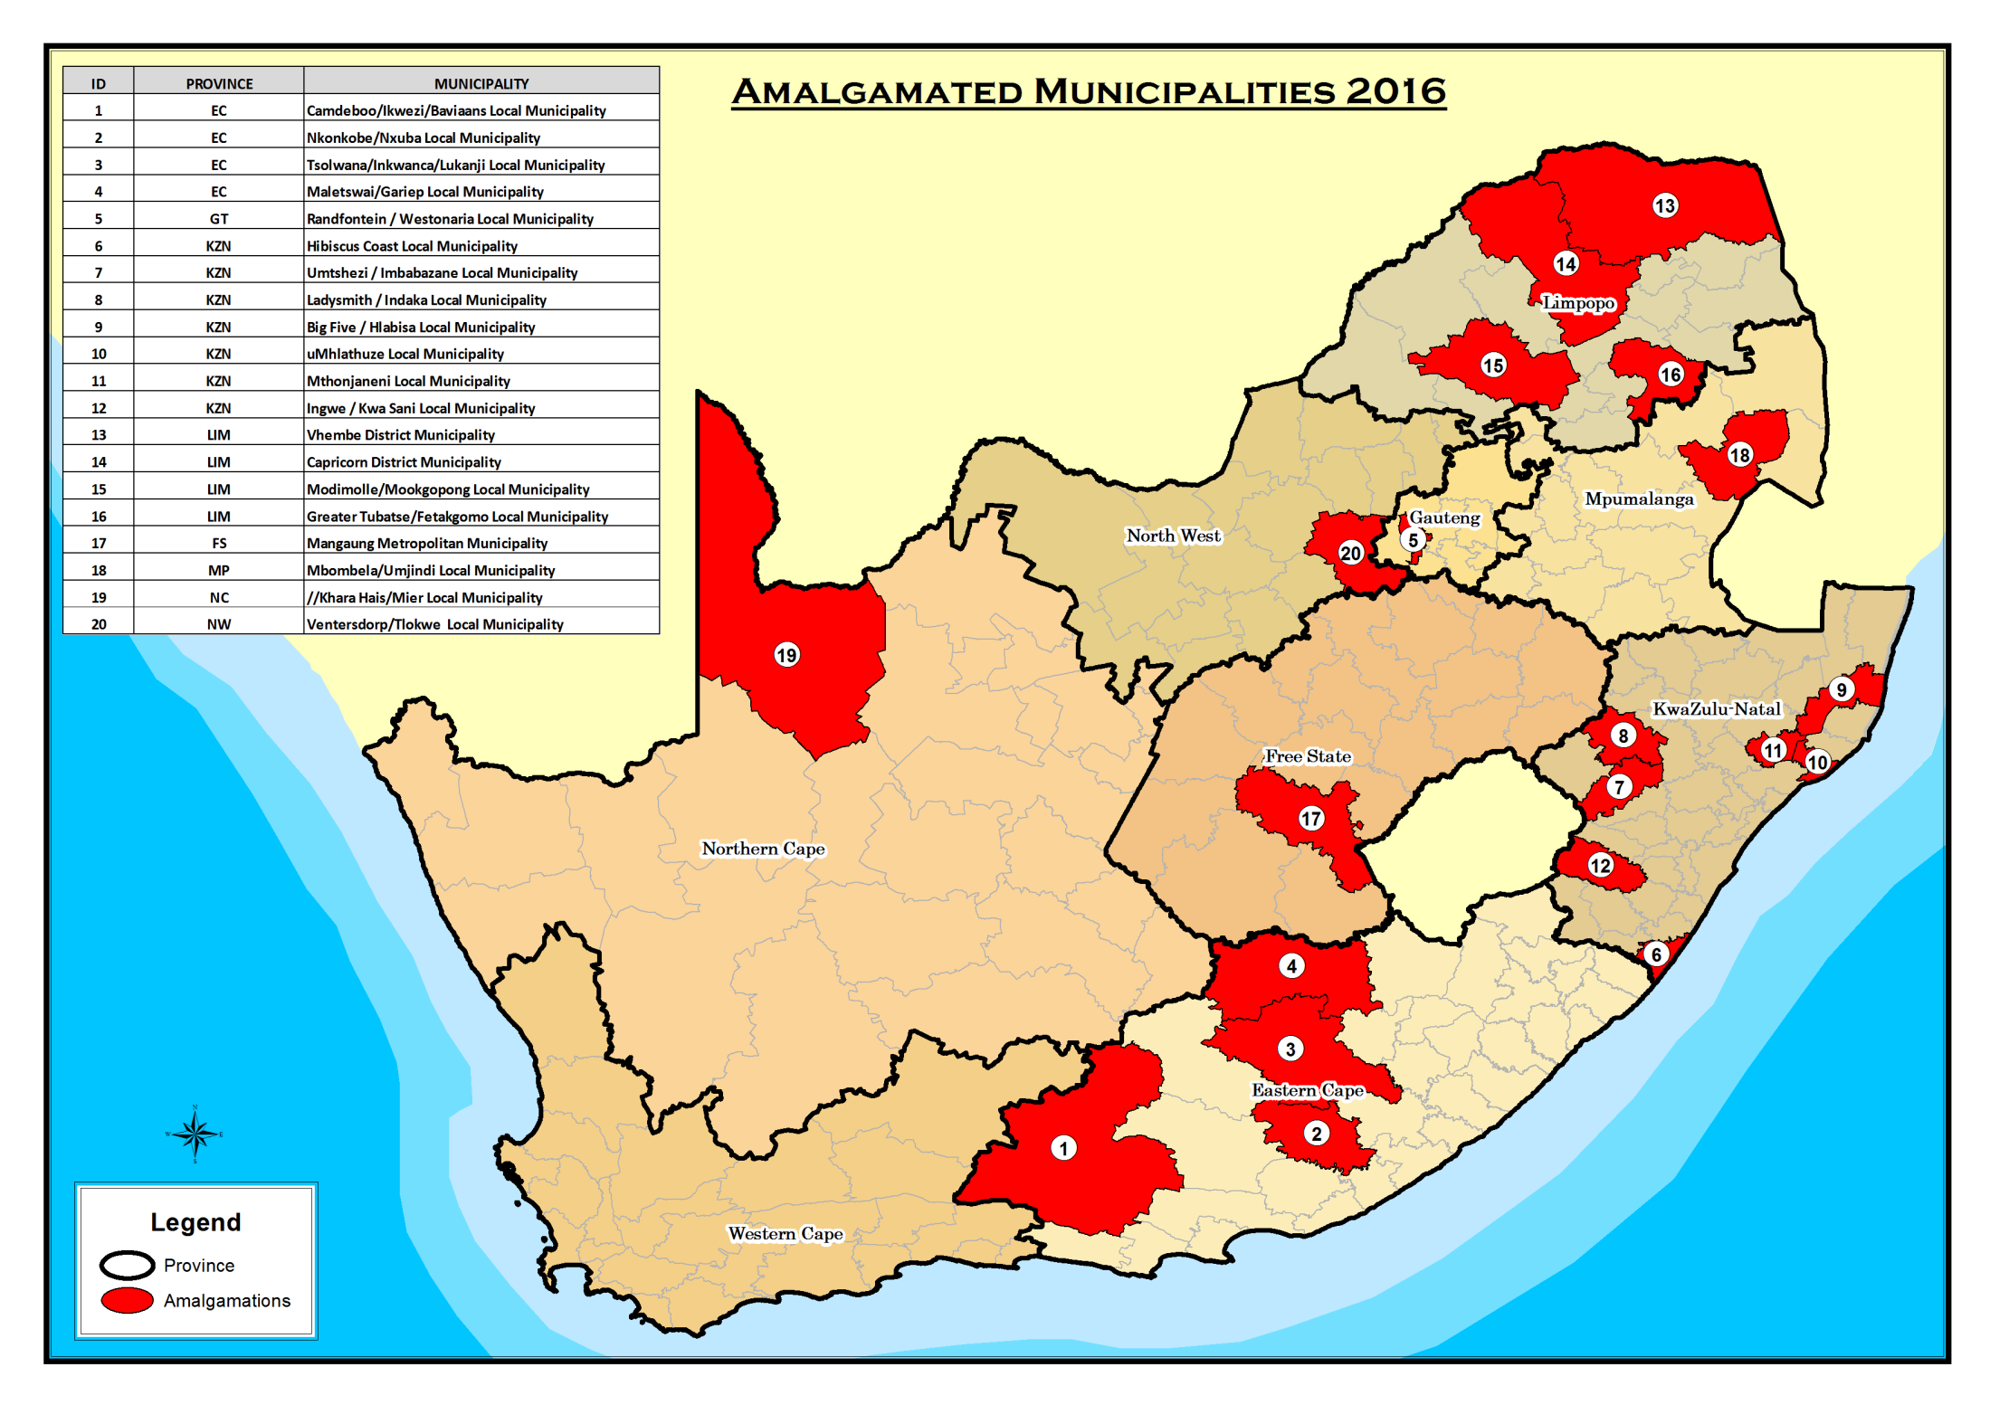
- MATTERS TO BE MANAGED DURING THE TRANSITION

  - There are various matters that need to be addressed with respect to those municipalities where their boundaries have been redetermined. A project management schedule (“the PMS”) has been developed to track progress been made by the affected municipalities and provinces in the various areas. These areas include the following matters:

- Legal;
- Human resources;
- Finance;
- Communication;
- Integrated development planning;
- Institutional; and
- Revision of Section 12 Notices (in terms of the Municipal Structures Act).

  - Progress made with respect to the matters contained in the PMS is tracked by provinces and reported-on at the Municipal Demarcation Transition Committee (“the MDTC”).

- MUNICIPAL DEMARCATION TRANSITION COMMITTEE (MDTC)

  - The MDTC, Chaired by the Director-General: DCoG, met on 29 October 2015 and 21 January 2016. The MDTC is comprised of the following Departments / Organisations:

  - Provinces;
  - National Treasury;
  - Other sector departments;
  - SALGA;
  - MDB;
  - IEC; and
  - Labour (IMATU, SAMWU).

Progress reports in accordance with the PMS, were submitted by all provinces. Sector departments, organised labour, SALGA, MDB and IEC also submitted reports.

5.2 KwaZulu-Natal Province:

- Provincial Business Units took over the chairpersonship of the under-performing Task Teams;
- Rationalisation of valuation rolls, and financial systems, have been commenced-with;
- Asset registers were being compiled in terms of GRAP requirements;
- Business plans for the 2015/16 and 2016/17 financial years have been completed;
- Organograms for the new municipalities were being finalised; and
- Job descriptions were being drafted for the posts on the proposed organograms.

5.3 Eastern Cape Province:

- CMCs are not meeting as often as they should;
- Several engagements held at political level;
- Funding remains a challenge;
- The Baviaans, Camdeboo and Ikwezi merger was behind schedule – the Mayor of Baviaans has not been participating in any of the CMCs;
- Some activities are at a more advanced stage over others;
- Some funding (R2 million) has been available by the province;
- “Seats” and names of municipalities are being considered; and
- Commitment to fast-track finalisation of all activities.

5.4 Limpopo Province:

- Organised labour only participating at district / local level, and not at provincial level;
- Greater progress has been noted in the Vhembe and Waterberg districts, over the Capricorn and Sekhukhune districts;
- Some challenges were being experienced in the “New” municipality, which was also being affected by litigation instituted by the Masia Traditional Council;
- The Provincial Executive Council was attending to challenges being experienced in the Malamulele area; and
- There is consistent participation in transition meetings by organised labour and SALGA.

5.5 Mpumalanga Province:

- Regular meetings of the Technical CMCs;
- The DCoG has facilitated support from GIZ to assist in the development of the organogram;
- Participation from stakeholders in the various transition processes must be improved; and
- Commitment to fast-track the finalisation of all activities.

5.6 North West Province:

- Regular meetings of the CMCs – meets every second Wednesday;
- All the local government KPAs and B2B Pillars are addressed by the workstreams; and
- The Political CMC meets monthly - is convened and chaired by the MEC for CoGTA, and co-chaired by the Dr Kenneth Kaunda District Municipality Executive Mayor – Members are, mayors of affected municipalities, MECs for Finance, and Public Works and Roads, and Chairperson of SALGA.

5.7 Free State Province:

- Lists of by-laws and policies of both municipalities have been documented, and is on-track to being rationalised;
- The record management systems of both municipalities are being integrated;
- A list of all existing contracts of both municipalities is being compiled – a list of all existing civil and labour cases is also being compiled;
- The process of developing an organogram for the new municipality has started - the Provincial Department is still to determine costs relating to relocation, salary after placement, leave payment and other related human resources costs;
- A valuator has been appointed to oversee the finalisation of the valuation roll;
- The financial management and billing systems of both municipalities are being rationalised; and
- The asset registers of both municipalities are being updated.

5.8 Northern Cape Province:

- Some activities are at a more advanced stage over others;
- Will have a Head Office with two satellite offices;
- List of existing by-laws and policies of the affected municipalities was completed in October 2015 and the process to rationalise these by-laws will be completed in March 2016. The revised by-laws will be published post the LGE;
- The process to transfer assets and records will be finalised in March 2016;
- A list of existing contracts of the affected municipalities was compiled in October 2015;
- The Provincial CMC has considered the functions of each member of staff of the affected municipalities in October 2015 - it is now developing the organogram for the new municipality; and
- The process to rationalise the financial management and billing systems of the affected municipalities will be concluded in March 2016.

5.9 Gauteng Province:

- Sector departments were not attending meetings;
- Certain processes were held in abeyance due to the pending litigation with regards to the Sedibeng area;
- Section 14(5) Notice is being revised – to be published on
20 February 2016;
- Determination of the “seat” for the Head Office and name of the municipality being considered;
- List of existing by-laws and policies of both municipalities have been documented, and is in the process being rationalised;
- List of all contracts of the two municipalities compiled; and
- Still to consider the functions of staff members in both municipalities, and to develop a draft organogram for the new municipality.

5.10 National Treasury:

- The NT has revised the budget allocations of the affected municipalities;
- The LGES formula has been updated and allocations recalculated to take into account the new municipalities (LGES favours small and rural municipalities);
- Although the allocations have been revised, municipalities are guaranteed to still receive at least 95% of their indicative allocations for 2016/17 – will be published in the 2016 DORA;
- The timing of the LGE will have implications for preparation and adoption of municipal budgets - each municipality should develop its individual budget for the 2016/17 financial year (Circular 78 issued on 7 December 2015); and
- A MDTG of R408 million was made available for the 2016/17 and 2017/18 financial years (R297 million and R111 million, respectively).

  - Organised Labour:

SAMWU:

- Cautioned that if the process is not properly managed, it could pose challenges in municipalities;
- Collective agreements that are in place must be adhered-to;
- Identified that there was no expertise / capacity at the municipal level to draw new organisational structures; and
- Undertook to encourage its municipal and provincial structures to attend and participate in the transition processes.

IMATU:

- Indicated that its focus will be on HR matters, and more so on placement and migration.

5.12 Reports were also received from: IEC; MDB; SALGA; DTA; GCIS; and DoH.

- ASSIGNMENT OF ADDRESSES

6.1 In light of the Electoral Court decision of 23 February 2016, on 25 February 2016 the IMTToME established a Sub-committee (of the TTToME) to explore options and develop proposals to assign addresses to households without formal addresses. The Sub-committee that was established consists of the following Departments / Institutions to develop proposals with the assignment of addresses:
    - Telecommunications and Postal Services, Human Settlements, Home Affairs, Public Service and Administration, Science and Technology, Water and Sanitation, Rural Development and Land Reform, Social Development; and
    - IEC, ESKOM, SALGA, STATSSA, South African Post Office (SAPO), TELKOM.

6.2 The Sub-Committee is led by STATS SA and SAPO – work in this regard has commenced. Noting the limitations of available data, STATS SA has proposed assigning geo-coded identifiers by using segmentation by place name using the Dwelling Frame to assign addresses to households.

6.3 It must be further noted that the assignment of addresses does not fall within the mandate of the IEC.

- RECOMMENDATIONS

It is recommended that the Committees:

  - Note the contents of the memorandum; and

  - Support the various processes in preparation for the 2016 local government elections.

